Supplementary Material 1
Sex-specific changes in the hippocampal proteome of Negr1^{-/-} mice: insight into the mechanisms of neuropsychiatric disorders
Srirathi Muthuraman¹, Mohan Jayaram¹, Liisi Promet¹, Toomas Jagomäe¹, Arun Kumar Devarajan², Andreas-Christian Hade³, Mari-Anne Philips¹, Katyayani Singh^{1*}, Eero Vasar¹

Supplementary Table S1.1: Top 12 Upregulated proteins in male and female Negr1^{-/-} hippocampus with their Gene, UniProt ID, Protein Name, P-value (pval), and differential abundance (Regulation).
Gene | UniProt ID | Protein Name | pval | Regulation
Isca1 | Q9D924 | Iron-sulfur cluster assembly 1 homolog, mitochondrial | 0.0017 | Upregulated in males
Fdxr | Q61578 | NADPH:adrenodoxin oxidoreductase, mitochondrial | 0.00219 | Upregulated in males
Skp1 | Q9WTX5 | S-phase kinase-associated protein 1 | 0.0029 | Upregulated in males
Scrg1 | O88745 | Scrapie-responsive protein 1 | 0.0049 | Upregulated in males
Rtn4rl2 | Q7M6Z0 | Reticulon-4 receptor-like 2 | 0.0052 | Upregulated in males
Ddx23 | D3Z0M9 | DEAD-Box Helicase 23 | 0.0055 | Upregulated in males
Cxadr | P97792 | Coxsackievirus and adenovirus receptor homolog | 0.0070 | Upregulated in males
Ppid | Q9CR16 | Peptidyl-prolyl cis-trans isomerase D | 0.0076 | Upregulated in males
Ankrd17 | Q99NH0 | Ankyrin repeat domain-containing protein 17 | 0.0092 | Upregulated in males
Hagh | Q99KB8 | Hydroxyacylglutathione hydrolase, mitochondrial | 0.0105 | Upregulated in males
Map1lc3b | Q9CQV6 | Microtubule-associated proteins 1A/1B light chain 3B | 0.0123 | Upregulated in males
Tomm5 | B1AXP6 | Mitochondrial import receptor subunit TOM5 homolog | 0.0128 | Upregulated in males
Hccs | P53702 | Cytochrome c-type heme lyase | 0.0002 | Downregulated in males
Top2b | Q64511 | DNA topoisomerase 2-beta | 0.0008 | Downregulated in males
Arhgef18 | Q6P9R4 | Rho guanine nucleotide exchange factor 18 | 0.001 | Downregulated in males
Agfg1 | Q8K2K6 | Arf-GAP domain and FG repeat-containing protein 1 | 0.0018 | Downregulated in males
Ergic1 | Q9DC16 | Endoplasmic reticulum-Golgi intermediate compartment protein 1 | 0.0023 | Downregulated in males
Ilvbl | Q8BU33 | Acetolactate synthase-like protein | 0.0023 | Downregulated in males
Smarcal1 | Q8BJL0 | SWI/SNF-related matrix-associated actin-dependent regulator of chromatin subfamily A-like protein 1 | 0.0028 | Downregulated in males
Myo1d | Q5SYD0 | Unconventional myosin-Id | 0.004 | Downregulated in males
Asns | Q61024 | Asparagine synthetase [glutamine-hydrolyzing] | 0.0041 | Downregulated in males
Pvalb | Q545M7 | Parvalbumin alpha | 0.0041 | Downregulated in males
Ncoa5 | Q91W39 | Nuclear receptor coactivator 5 | 0.0051 | Downregulated in males
Evi5l | Q3U1G0 | Ecotropic Viral Integration Site 5 Like | 0.0053 | Downregulated in males
Parl | Q5XJY4 | Presenilins-associated rhomboid-like protein, mitochondrial;P-beta | 0.0007 | Upregulated in females
Samhd1 | Q60710 | Deoxynucleoside triphosphate triphosphohydrolase SAMHD1 | 0.0023 | Upregulated in females
Bcar1 | Q61140 | Breast cancer anti-estrogen resistance protein 1 | 0.0064 | Upregulated in females
Uqcr11 | Q9CPX8 | Cytochrome b-c1 complex subunit 10 | 0.0066 | Upregulated in females
Brinp2 | Q6DFY8 | BMP/retinoic acid-inducible neural-specific protein 2 | 0.0073 | Upregulated in females
Mmgt1 | Q8K273 | Membrane magnesium transporter 1 | 0.0092 | Upregulated in females
Lsm12 | Q9D0R8 | Protein LSM12 homolog | 0.01 | Upregulated in females
Ppm1k | Q8BXN7 | Protein phosphatase 1K, mitochondrial | 0.016 | Upregulated in females
Clptm1 | Q8VBZ3 | Cleft lip and palate transmembrane protein 1 homolog | 0.0168 | Upregulated in females
Snx32 | Q80ZJ7 | Sorting nexin-32 | 0.018 | Upregulated in females
Golph3 | Q9CRA5 | Golgi phosphoprotein 3 | 0.0182 | Upregulated in females
Nedd4 | P46935 | E3 ubiquitin-protein ligase NEDD4 | 0.0183 | Upregulated in females
Zwint | Q9CQU5 | ZW10 interactor | 0.0013 | Downregulated in females
Armh3 | Q6PD19 | Armadillo Like Helical Domain Containing 3 | 0.002 | Downregulated in females
Rap1gds1 | E9Q912 | Rap1 GTPase-GDP Dissociation Stimulator 1 | 0.0023 | Downregulated in females
Arfip1 | G5E8V9 | Arfaptin-1 | 0.0026 | Downregulated in females
Nrbf2 | Q8VCQ3 | Nuclear receptor-binding factor 2 | 0.0037 | Downregulated in females
Rplp2 | P99027 | 60S acidic ribosomal protein P2 | 0.004 | Downregulated in females
Rpl10 | Q6ZWV3 | Ribosomal protein;60S ribosomal protein L10a | 0.0047 | Downregulated in females
Rgs14 | P97492 | Regulator of G-protein signaling 14 | 0.0056 | Downregulated in females
Aftph | Q80WT5 | Aftiphilin | 0.0061 | Downregulated in females
Kcna4 | Q61423 | Potassium voltage-gated channel subfamily A member 4 | 0.0066 | Downregulated in females
Folh1 | O35409 | Glutamate carboxypeptidase 2 | 0.0072 | Downregulated in females
Trappc10 |  | Trafficking protein particle complex subunit 10 | 0.009 | Downregulated in females

Supplementary Table S1.2: Common differentially abundant proteins in both male and female hippocampus with their protein codes (Protein), Protein name, Differential abundance, and Neurological relevance with citation (references below the table)

Protein | Protein name | Differential abundance | Neurological relevance | Citations
Bcat2 | Branched-chain-amino-acid aminotransferase, mitochondrial | Downregulated in both male and female hippocampus | Supports neurotransmitter balance and central nervous system function. | Choi et al., 2024
Ca2;Car2 | Carbonic anhydrase 2 | Downregulated in both male and female hippocampus | Involved in neurodevelopment and depletion of Ca2 is associated with the pathogenesis of cerebral calcifications and mental retardation. | Kida et al., 2006
Ermn | Ermin | Downregulated in both male and female hippocampus | Marker of myelinating oligodendroglia and also plays a role in cytoskeletal rearrangements. | Brockschnieder et al., 2006
Ero1l | ERO1-like protein alpha | Downregulated in both male and female hippocampus | Involved in the endoplasmic reticulum stress response and contributes to the neuroprotective mechanism. | Jin et al., 2025
Fam45a | Fam45a | Downregulated in both male and female hippocampus | Plays a crucial role in neurite outgrowth. | Li et al., 2025
Lsm12 | Protein LSM12 homolog | Downregulated in male hippocampus and upregulated in female hippocampus | Functions in neuroprotective pathways sustaining nucleocytoplasmic transport. | Lee et al., 2020
Nanp | N-acylneuraminate-9-phosphatase | Downregulated in both male and female hippocampus
Sf1 | Splicing factor 1 | Downregulated in both male and female hippocampus | Involved in the neurodevelopmental disorder. | Bou-Rouphael et al., 2025
Snx32 | Sorting nexin-32 | Upregulated in both male and female hippocampus | Regulates cargo sorting and neurite outgrowth. | Sugatha et al., 2023
References:
- Choi BH, Hyun S, Koo SH. The role of BCAA metabolism in metabolic health and disease. Experimental & Molecular Medicine. 2024 Jul 1;56(7):1552–9. https://doi.org/10.1038/s12276-024-01263-6
- Kida E, Palminiello S, Wisniewski KE, Walus M, Albertini G, Wierzba-Bobrowicz T, et al. Carbonic Anhydrase II in the Developing and Adult Human Brain. Journal of Neuropathology and Experimental Neurology. 2006 Jul 1;65(7):664–74. https://doi.org/10.1097/01.jnen.0000225905.52002.3e
- Brockschnieder D, Riethmacher D, Sabanay H, Peles E. Ermin, A Myelinating Oligodendrocyte-Specific Protein That Regulates Cell Morphology. The Journal of Neuroscience. 2006 Jan 18;26(3):757–62. https://doi.org/10.1523/jneurosci.4317-05.2006
- Jin H, Chen L, Huan Y, Chu G, Zhao H, Gong S, et al. Functional characterization of key protein biomarkers in spontaneous intracerebral hemorrhage pathogenesis: Structure and function of NUAK1 protein and ERO1L protein macromolecules. International journal of biological macromolecules. 2025 May 1;309(Pt 2):142959. https://doi.org/10.1016/j.ijbiomac.2025.142959
- Li A, Zhang J, Ma C, Qi L, Hu Q, Li Q, et al. Endosomal protein DENND10 promotes developmental competence of neurite extension. iScience. 2025 May 1;28(5):112385. https://doi.org/10.1016/j.isci.2025.112385
- Lee J, Kim YK, Yoon KJ, Park TE, Lim C, Lee G, et al. LSM12-EPAC1 defines a neuroprotective pathway that sustains the nucleocytoplasmic RAN gradient. PLOS Biology. 2020 Dec 23;18(12):e3001002. https://doi.org/10.1371/journal.pbio.3001002
- Bou-Rouphael J, Cospain A, Courtin T, Keren B, Marie C, Lesieur-Sebellin M, et al. Heterozygous pathogenic variants in the splicing factor SF1 lead to a large spectrum of neurodevelopmental disorders. American journal of human genetics. 2025 Nov 1;112(11):2605–24. https://doi.org/10.1016/j.ajhg.2025.09.001
- Sugatha J, Jose A, Raj P, Datta S, Swaminathan U, Jaimon E, et al. Insights into cargo sorting by SNX32 and its role in neurite outgrowth. eLife. 2023 May 9;12. https://doi.org/10.7554/elife.84396

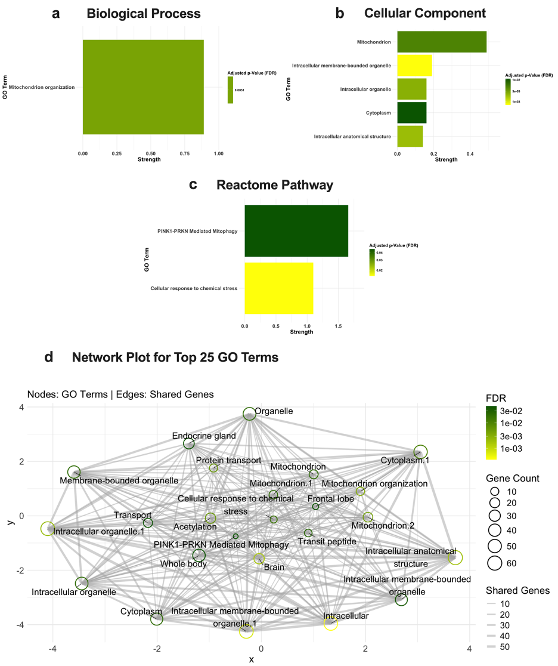
Supplementary Figure 1: Male Gene Ontology (GO) Enrichment Analysis for significantly upregulated proteins (p-value <0.05) in male Negr1^{-/-} mice using STRING analysis. GO term enrichment for (a) Biological Process, (b) Cellular Component and (c) Reactome Pathway. Bar plots show the top enriched GO terms, with the x-axis representing enrichment strength, and bar color indicates the FDR (false discovery rate). (d) displays a network plot of the top 25 GO enrichment terms. Nodes represent GO terms, and edges represent shared genes between terms. Node size corresponds to gene count, edge thickness indicates the number of shared genes, and node color indicates the FDR.

