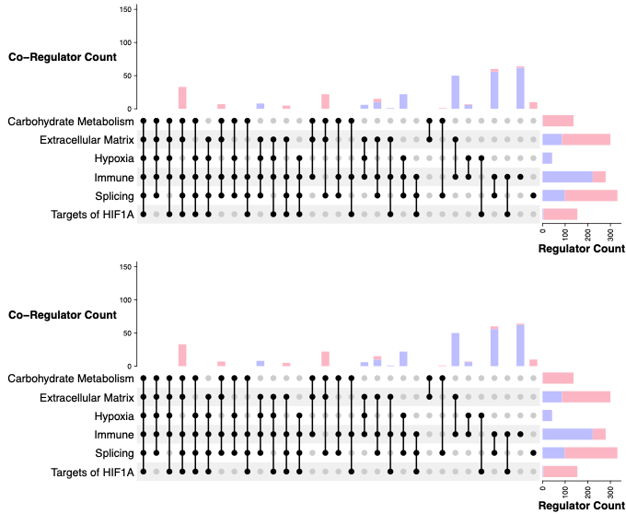

S1 Figure. Sex-specific co-regulation obtained using PANDA+BLOBFISH in REMBRANDT Co-regulation of differentially targeted pathways in female (red) and male (blue) GBMs. “Regulator Count” refers to the number of TFs regulating unique genes in each pathway category, and “Co-Regulator Count” refers to the number of TFs co-regulating unique genes in multiple pathway categories. The filled circles in each column represent the sets of co-regulated pathway categories.

