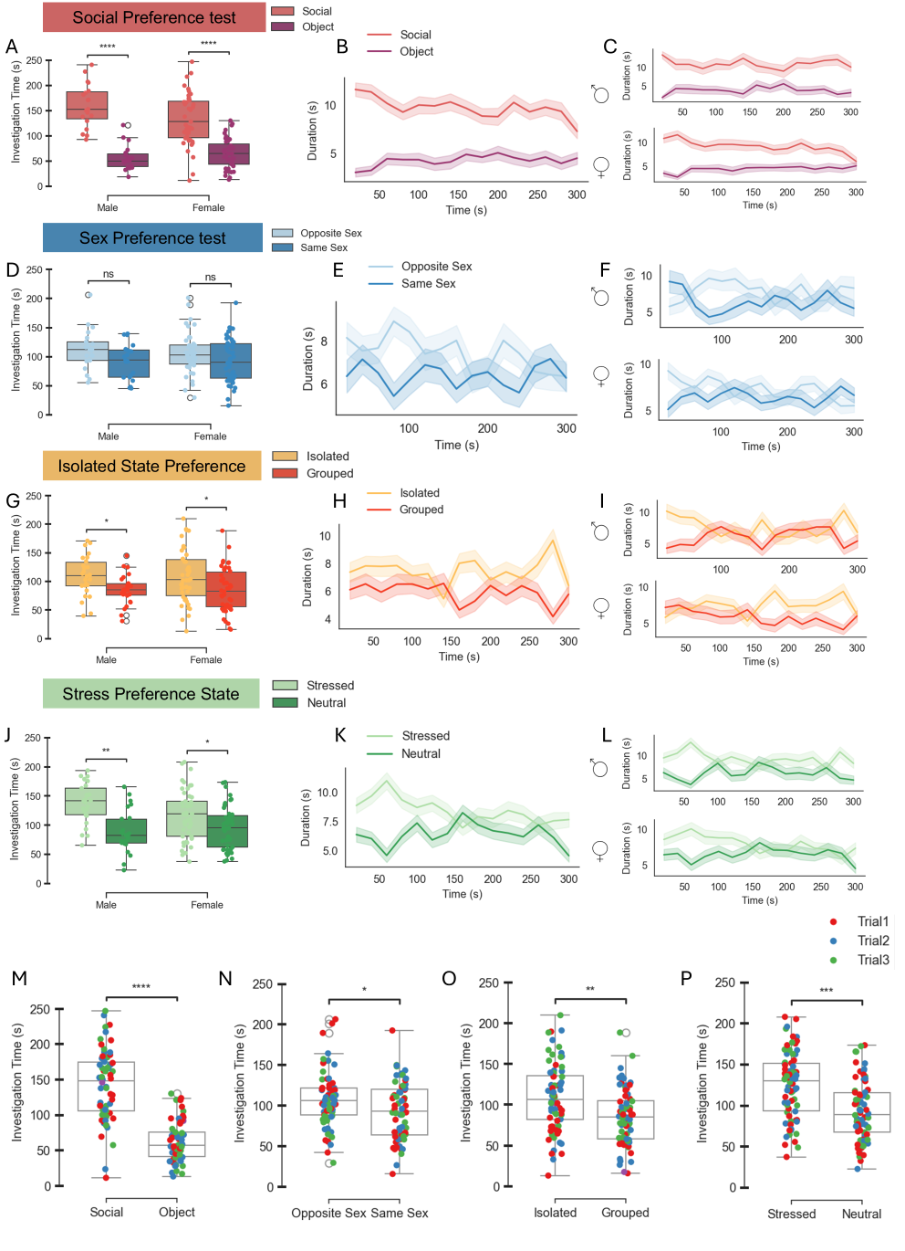

Figure S1.
A–C. Investigation behaviour during the social preference (SP) test. A, mean investigation time (± SEM) for each stimulus, shown separately for females and males (females: t = 6.48, p < 0.001; males: t = 7.15, p < 0.001). B, time spent with each stimulus over the 5-min test, pooled across sexes. C, same as B, shown separately for males (top) and females (bottom).
D–F. Same as A–C for the sex preference (SxP) test. D, females: t = 1.39, p = 0.17; males: t = 1.61, p = 0.122.
G–I. Same as A–C for the isolation-state preference (ISP) test. G, females: t = 2.44, p = 0.019; males: t = 2.45, p = 0.021.
J–L. Same as A–C for the stress-state preference (SSP) test. J, females: t = 2.40, p = 0.024; males: t = 3.68, p = 0.0018.
M–P. Mean investigation time (± SEM) during the SP (M), SxP (N), ISP (O), and SSP (P) tests. Individual data points represent sessions and are colour-coded according to trial number (red: Trial 1; blue: Trial 2; green: Trial 3).

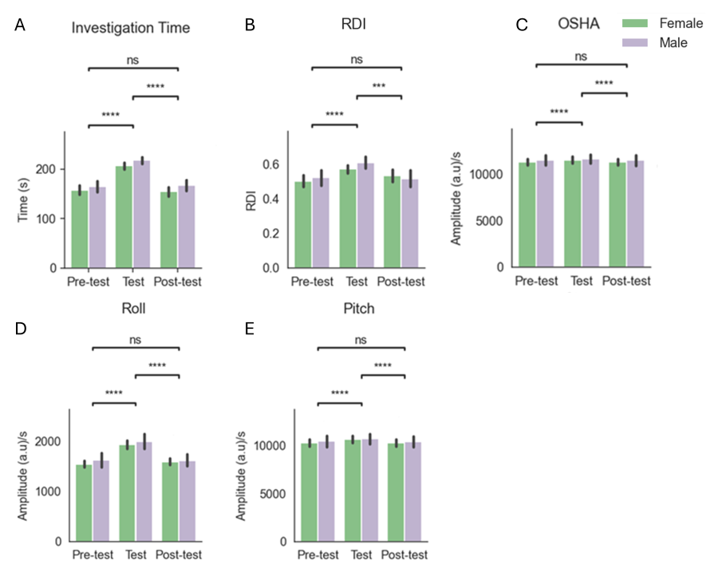
Figure S2.
A–E. Mean (± SEM) behavioural and movement-related signals across Pre-test, Test, and Post-test stages. Measures include investigation time (A), RDI (B), OSHA (C), Roll (D), and Pitch (E). Post hoc Wilcoxon tests with FDR correction following a significant main effect of Stage in a mixed linear model revealed significant differences for: A, Pre-test vs Test (W = 284, p < 0.001) and Test vs Post-test (W = 242, p < 0.001); B, Pre-test vs Test (W = 1285, p < 0.001) and Test vs Post-test (W = 1334, p < 0.001); C, Pre-test vs Test (W = 3504, p < 0.001) and Test vs Post-test (W = 6521, p < 0.001); D, Pre-test vs Test (W = 4068, p < 0.001) and Test vs Post-test (W = 4406, p < 0.001); E, Pre-test vs Test (W = 9414, p < 0.001) and Test vs Post-test (W = 9018, p < 0.001).

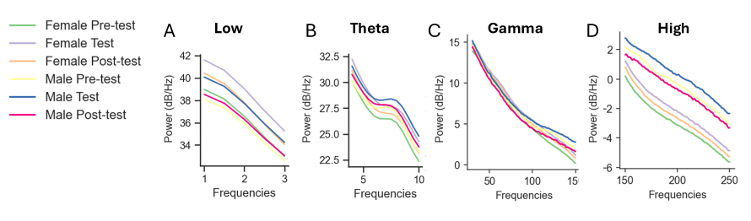
Figure S3.
A–D. Average PSD profiles across stages and sex for different LFP frequency bands. A, low-frequency band; B, theta band; C, gamma band; D, high-frequency band. Curves represent female Pre-test (green), female Test (purple), female Post-test (orange), male Pre-test (yellow), male Test (blue), and male Post-test (red).

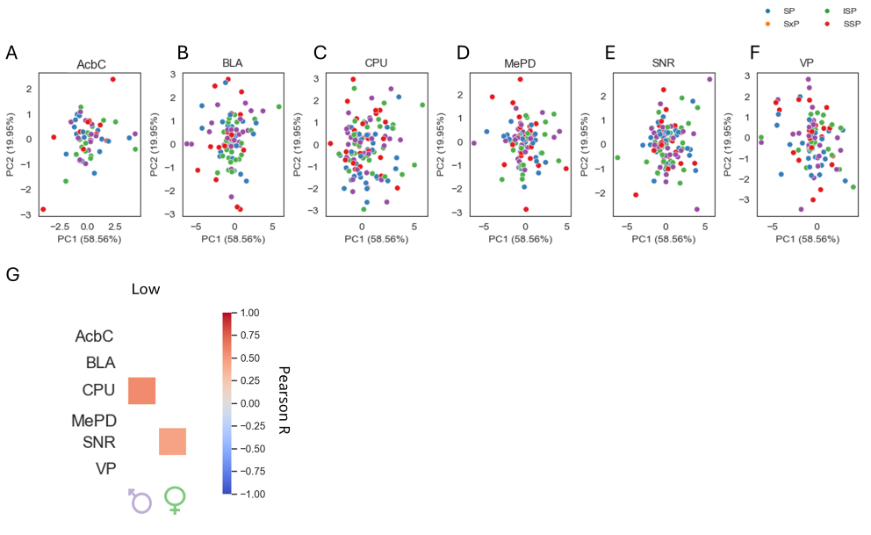
Figure S4.
A–F. PCA was performed on the electrophysiological features from all brain regions. The first two principal components (PC1 and PC2) explained 47.48% and 27.7% of the total variance, respectively. Each point represents an individual session and is colour-coded by test (SP: blue; SxP: orange; ISP: green; SSP: red). PCA was performed separately for each brain region: A, accumbens core (AcbC); B, basolateral amygdala (BLA); C, caudate putamen (CPU); D, posterodorsal medial amygdala (MePD); E, substantia nigra reticulata (SNR); and F, ventral pallidum (VP).
G. Correlation matrix between ODHA at bout onset (−1 to 2 s) and mean low-frequency LFP power (1–3 Hz) in each brain region. The correlation scale is shown on the right.
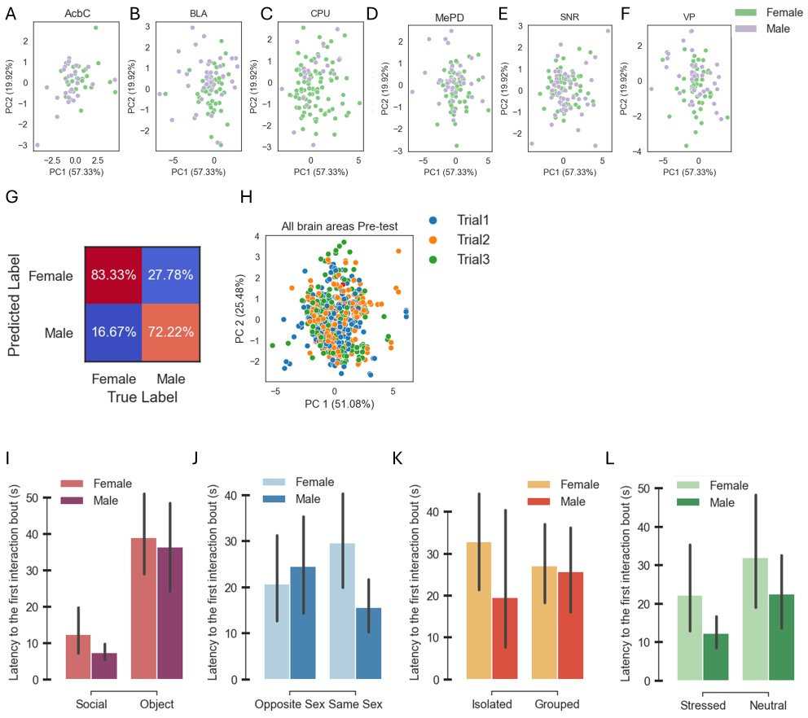
Figure S5.
A–F. PCA was performed on the Δ electrophysiology features of each brain area (mean electrophysiology feature during test stage minus mean electrophysiology during the pre-test stage. The first two principal components (PC1 and PC2) explained 57.33% and 19.92% of the total variance, respectively. Each point represents an individual session, colour-coded by sex (female in green, male in purple). Each brain area was plotted separately: (A) Accumbens core (AcbC), (B) basolateral amygdala (BLA), (C) caudate putamen (CPU), (D) posterior-dorsal medial amygdala (MePD), (E) substantia nigra reticulata (SNR), and (F) ventral pallidum (VP).
G. Confusion matrix for a binary Random Forest classifier model predicting sex from Δ electrophysiology-derived data across all tests during the 5 min of the pre-test stage. Each category's percentage is displayed at the center of each cell (Female: χ = 5.3, p = 0.021; Male: χ = 4.63, p = 0.03; Chi-square test).
H. PCA performed on electrophysiological features from all brain regions combined. Each point represents an individual session and is colour-coded according to trial number (red: Trial 1; blue: Trial 2; green: Trial 3).
I–L. Mean latency to the first investigation bout (± SEM) for each stimulus, shown separately for females and males across social discrimination tests: SP (I), SxP (J), ISP (K), and SSP (L).

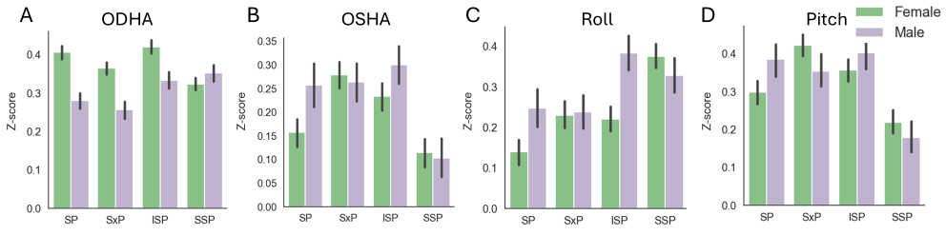
Figure S6.
A–D. Mean (± SEM) z-scored behavioural signals during the first minute of interaction across Stage and Sex. Baseline was defined as the 1-min interval preceding stimulus insertion. Signals include A, ODHA; B, OSHA; C, Roll; and D, Pitch.

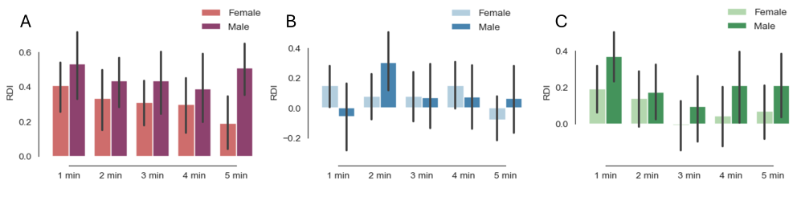
Figure S7.
A–C. Mean (± SEM) RDI across sex and time during the social discrimination tests: A, social preference (SP) test; B, sex preference (SxP) test; C, stress-state preference (SSP) test.
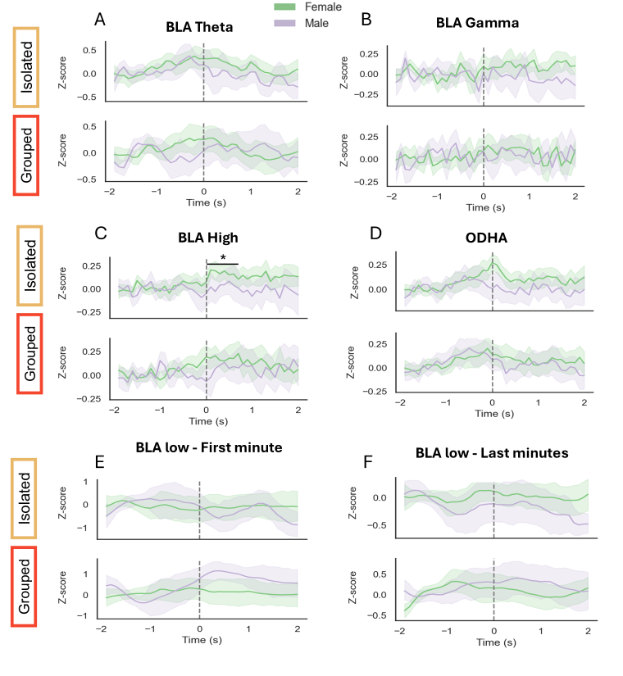
Figure S8.
A–F. Mean (± SEM) z-scored electrophysiological and behavioural signals aligned to the onset of investigation bouts during the ISP test. Time 0 marks the start of the bout, and the baseline was defined as the interval from −2 to −1 s. Signals were calculated separately for females (green) and males (purple) and are shown for the isolated (top) and grouped (bottom) stimuli. A, BLA LFP theta power during the last four minutes of the test; B, BLA LFP gamma power during the last four minutes; C, BLA LFP high-frequency power (150–250 Hz) during the last four minutes; D, ODHA signal; E, BLA LFP low-frequency power during the first minute of the test; F, BLA LFP low-frequency power during the last four minutes of the test. Post hoc t-tests with FDR correction revealed a significant sex difference for the isolated stimulus in C from 0 to 1 s (t = 2.10, p = 0.044).

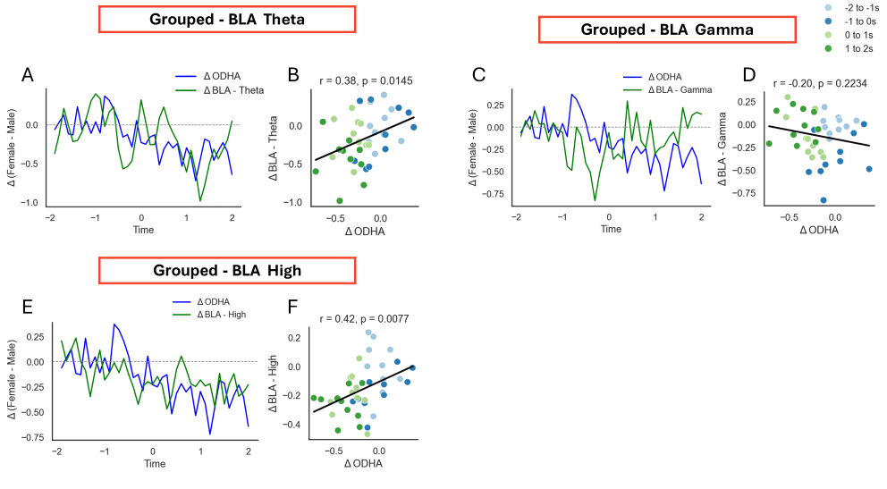
Figure S9.
A–F. Relationship between ΔODHA and ΔBLA LFP power during investigation bouts with the grouped stimulus. A, C, and E show time traces of ΔODHA (female minus male z-score; blue) and ΔBLA LFP power (female minus male z-score; green) aligned to the onset of approach, for theta-frequency (A), gamma-frequency (C), and high-frequency (E) bands. B, D, and F show the corresponding scatter plots between ΔODHA (x-axis) and ΔBLA LFP power (y-axis). Each point represents one time point and is colour-coded according to time within the event. Regression lines indicate the fitted linear model. Pearson correlation coefficients were calculated, and significance was assessed using permutation testing with 10,000 shuffles: theta band (B), r = 0.38, p = 0.014; gamma band (D); high-frequency band (F), r = 0.42, p = 0.008.

