Supplementary Table 1. Exploratory Subgroup Analyses of the FAI-OA Association by Sex/Menopause Strata with FDR Correction Within Subgroups
Stratum | Subgroup Variable | Subgroup Level | OR (95% CI) | GLM p-value | GLM FDR | RCS linear p-value | RCS non-linear p-value | RCS linear FDR | RCS non-linear FDR | Association Type†
Male | BMI category | Non-obese | 0.53 (0.27–1.02) | 0.068 | 0.203 | 0.245 | 0.423 | 0.473 | 0.635 | NS
 |  | Overweight | 0.82 (0.48–1.38) | 0.452 | 0.452 | 0.321 | 0.421 | 0.473 | 0.635 | NS
 |  | Obese | 1.33 (0.78–2.28) | 0.303 | 0.452 | 0.473 | 0.900 | 0.473 | 0.900 | NS
 | Diabetes status | Non-diabetic | 0.84 (0.61–1.15) | 0.285 | 0.550 | 0.116 | 0.440 | 0.232 | 0.881 | NS
 |  | Diabetic | 1.19 (0.67–2.13) | 0.550 | 0.550 | 0.641 | 0.908 | 0.641 | 0.908 | NS
 | Estradiol tertile | Low | 0.74 (0.50–1.11) | 0.156 | 0.234 | 0.482 | 0.553 | 0.482 | 0.829 | NS
 |  | Medium | 0.73 (0.37–1.44) | 0.374 | 0.374 | 0.468 | 0.935 | 0.482 | 0.935 | NS
 |  | High | 2.15 (1.13–4.11) | 0.026 | 0.079 | 0.006 | 0.133 | 0.019 | 0.400 | Linear§
 | Age group | 20–50 y | 0.49 (0.24–0.97) | 0.049 | 0.098 | 0.043 | 0.762 | 0.086 | 0.762 | NS‡
 |  | ≥50 y | 0.76 (0.55–1.05) | 0.111 | 0.111 | 0.165 | 0.506 | 0.165 | 0.762 | NS
Premenopausal Female | BMI category | Non-obese | 0.46 (0.23–0.95) | 0.044 | 0.131 | 0.845 | 0.101 | 0.845 | 0.302 | NS‡
 |  | Overweight | 0.54 (0.20–1.43) | 0.220 | 0.330 | 0.032 | 0.354 | 0.095 | 0.531 | NS‡
 |  | Obese | 0.92 (0.60–1.41) | 0.701 | 0.701 | 0.544 | 0.576 | 0.816 | 0.576 | NS
 | Diabetes status | Non-diabetic | 0.77 (0.50–1.18) | 0.236 | 0.236 | 0.038 | 0.020 | 0.038 | 0.020 | Non-linear
 |  | Diabetic | — | — | — | — | — | — | — | Analysis failed¶
 | Estradiol tertile | Low | 0.57 (0.38–0.87) | 0.014 | 0.043 | 0.309 | 0.707 | 0.309 | 0.707 | NS
 |  | Medium | 0.84 (0.41–1.70) | 0.625 | 0.625 | 0.293 | 0.186 | 0.309 | 0.280 | NS
 |  | High | 0.67 (0.31–1.46) | 0.323 | 0.484 | 0.055 | 0.105 | 0.164 | 0.280 | NS
Postmenopausal Female | BMI category | Non-obese | 0.90 (0.65–1.23) | 0.499 | 0.499 | 0.009 | 0.008 | 0.027 | 0.023 | Non-linear
 |  | Overweight | 0.74 (0.58–0.94) | 0.018 | 0.053 | 0.070 | 0.334 | 0.104 | 0.334 | NS‡
 |  | Obese | 0.90 (0.71–1.15) | 0.424 | 0.499 | 0.995 | 0.295 | 0.995 | 0.334 | NS
 | Diabetes status | Non-diabetic | 0.83 (0.72–0.96) | 0.020 | 0.040 | 0.402 | 0.688 | 0.402 | 0.688 | NS
 |  | Diabetic | 0.93 (0.66–1.29) | 0.653 | 0.653 | 0.152 | 0.053 | 0.305 | 0.106 | NS
 | Estradiol tertile | Low | 0.84 (0.65–1.08) | 0.174 | 0.261 | 0.088 | 0.210 | 0.132 | 0.315 | NS
 |  | Medium | 0.88 (0.66–1.17) | 0.372 | 0.372 | 0.743 | 0.895 | 0.743 | 0.895 | NS
 |  | High | 0.78 (0.57–1.07) | 0.134 | 0.261 | 0.033 | 0.053 | 0.098 | 0.160 | NS
Table Notes:

† Association type determined by 3-knot RCS: NS = no significant linear or non-linear association (FDR ≥ 0.05); Linear = linear term significant (FDR < 0.05); Non-linear = non-linear term significant (FDR < 0.05). Bold values indicate nominal P < 0.05; bold with FDR < 0.05 indicates statistically significant after multiple comparison correction within the stratum.

‡ Nominal P < 0.05 but did not survive FDR correction; interpreted as suggestive trend requiring validation in independent cohorts.

§ Nominal linear association identified in the high-estradiol male subgroup (OR = 2.15, FDR-adjusted P = 0.079); this finding did not survive FDR correction and should not be interpreted as a confirmed interaction.

¶ Diabetic pre-menopausal females (n = 28 with events) had insufficient sample size for reliable RCS estimation; analysis not performed.

Overall note: All subgroup analyses are exploratory and were not used for variable selection in the primary models. Variable selection for main models was performed using Boruta + LASSO with 10-fold cross-validation on the training set, independent of subgroup findings. Within each sex-menopause stratum, all subgroup analyses employed the identical covariate set as the primary model, with stratification by the subgrouping variable (BMI category, diabetes status, estradiol tertile, or age group). All subgroup findings with FDR-adjusted P ≥ 0.05 should be interpreted as hypothesis-generating and require independent validation; even those with FDR < 0.05 represent exploratory observations within subgroups and should not be over-interpreted as confirming interactions.

Supplementary Table 2. Linear Interaction Tests Between FAI and Key Covariates
Stratum | Interaction Term | β (SE) | OR (95% CI) | LRT p-value | FDR within stratum | Interpretation
Male | FAI × BMI | 0.0157 | 1.016 (0.979–1.054) | 0.391 | 0.521 | No significant interaction
 | FAI × HOMA-IR | 0.0143 | 1.014 (0.780–1.320) | 0.908 | 0.908 | No significant interaction
 | FAI × Age | 0.0211 | 1.021 (1.001–1.042) | 0.039 | 0.154 | Nominal interaction, not significant after FDR
 | FAI × Vitamin D | 0.0037 | 1.004 (0.997–1.010) | 0.242 | 0.484 | No significant interaction
Premenopausal females | FAI × BMI | 0.0329 | 1.033 (1.000–1.068) | 0.056 | 0.223 | No significant interaction
 | FAI × HOMA-IR | 0.2775 | 1.320 (0.809–2.153) | 0.273 | 0.337 | No significant interaction
 | FAI × Age | –0.0267 | 0.974 (0.935–1.013) | 0.188 | 0.337 | No significant interaction
 | FAI × Vitamin D | 0.0063 | 1.006 (0.993–1.020) | 0.337 | 0.337 | No significant interaction
Postmenopausal females | FAI × BMI | –0.0080 | 0.992 (0.972–1.013) | 0.432 | 0.675 | No significant interaction
 | FAI × HOMA-IR | 0.0054 | 1.005 (0.859–1.177) | 0.941 | 0.941 | No significant interaction
 | FAI × Age | –0.0035 | 0.996 (0.986–1.007) | 0.506 | 0.675 | No significant interaction
 | FAI × Vitamin D | 0.0018 | 1.002 (0.998–1.006) | 0.392 | 0.675 | No significant interaction
Table Note: No linear interaction survived FDR correction (all FDR ≥ 0.05), confirming that linear interaction models are insufficient to capture the complex hormone interplay. This motivated our use of non-linear methods (RCS, GAM) in the primary analysis. All continuous variables were mean-centred before interaction construction. Models used survey-weighted logistic regression accounting for NHANES complex survey design (PSU, stratum, examination weights).

Supplementary Table 3. Non-Linear Interaction Between FAI and Estradiol on Osteoarthritis Risk: Pointwise Contrasts
Population | Model | Estradiol Level | FAI Comparison | OR (95% CI)† | P-value | Model-fit P²
Male | GAM | –1 SD | +1 SD vs Mean | 0.92 (0.65–1.32) | 0.677 | 0.0369
 |  | Mean | +1 SD vs Mean | 1.07 (0.83–1.37) | 0.602
 |  | +1 SD | +1 SD vs Mean | 1.22 (0.92–1.61) | 0.168
 | RCS | –1 SD | +1 SD vs Mean | 0.96 (0.58–1.58) | 0.862 | <0.001
 |  | Mean | +1 SD vs Mean | 1.00 (0.72–1.40) | 0.998
 |  | +1 SD | +1 SD vs Mean | 1.31 (0.91–1.88) | 0.151
Premenopausal females | GAM | –1 SD | +1 SD vs Mean | 0.75 (0.49–1.17) | 0.628 | 0.0528
 |  | Mean | +1 SD vs Mean | 0.75 (0.51–1.17) | 0.475
 |  | +1 SD | +1 SD vs Mean | 0.86 (0.57–1.29) | 0.560
 | RCS | –1 SD | +1 SD vs Mean | 0.40 (0.21–0.77) | 0.006 | <0.001
 |  | Mean | +1 SD vs Mean | 1.14 (0.65–2.00) | 0.671
 |  | +1 SD | +1 SD vs Mean | 1.14 (0.65–2.00) | 0.458
Postmenopausal females | GAM | –1 SD | +1 SD vs Mean | 1.01 (0.76–1.28) | 0.901 | 0.021
 |  | Mean | +1 SD vs Mean | 0.93 (0.80–1.08) | 0.724
 |  | +1 SD | +1 SD vs Mean | 0.86 (0.79–1.11) | 0.260
 | RCS | –1 SD | +1 SD vs Mean | 1.22 (0.85–1.74) | 0.275 | <0.001
 |  | Mean | +1 SD vs Mean | 0.93 (0.78–1.11) | 0.417
 |  | +1 SD | +1 SD vs Mean | 0.75 (0.51–1.09) | 0.126
Table Notes:

† ORs estimated at fixed estradiol levels comparing FAI +1 SD with FAI at the mean. No individual OR reached statistical significance (all P ≥ 0.05) after accounting for multiple comparisons.

² Overall model likelihood-ratio test (RCS) or smoothing-term significance (GAM).

Interpretive note: The significant model-fit P-values (GAM smooth term or RCS overall test) indicate that the joint non-linear surface captures meaningful structure beyond what can be summarized by pointwise OR comparisons at specific estradiol levels. The absence of significant pairwise contrasts does not negate the overall interaction pattern; rather, it suggests the interaction operates as a continuous gradient rather than as discrete threshold effects—consistent with our primary interpretation that regional patterns, not sharp cut-offs, constitute the core finding.

Supplementary Table 4. Marginal Contribution of FAI, Estradiol, and Core Covariates to OA Prediction Models by Sex–Menopause Strata (Nested 5 × 10-Fold Cross-Validation + Permutation Test)
Stratum | Variable | Permutation P-value¹ | Mean |SHAP|² | Importance Rank³ | Significant⁴
Male | FAI_cleaned | 0.03 | 0.0135 | 11/12 | Yes
 | LBXEST_cleaned | 0.05 | 0.1257 | 8/12 | No
 | BMXBMI_cleaned | <0.001§ | 0.0621 | 9/12 | Yes
 | RIDAGEYR | <0.001§ | 0.0507 | 10/12 | Yes
 | race_tertiary¶ | 0.005 | 0.4433‖ | 2/12 | Yes
 | INDFMPIR | 0.02 | 0.1392 | 7/12 | Yes
 | vitamin_d_cleaned | 0.01 | 0.0053 | 12/12 | Yes
Premenopausal Female | FAI_cleaned | 0.275 | 0.2675 | 6/12 | No
 | LBXEST_cleaned | 0.295 | 0.0641 | 11/12 | No
 | BMXBMI_cleaned | 0.01 | 0.0656 | 9/12 | Yes
 | RIDAGEYR | 0.06 | 0.0802 | 8/12 | No
 | race_tertiary¶ | <0.001§ | 0.9185‖ | 1/12 | Yes
 | INDFMPIR | 0.03 | 0.0826 | 7/12 | Yes
 | vitamin_d_cleaned | — | 0.0022 | 12/12 | No
Postmenopausal Female | FAI_cleaned | 0.215 | 0.1855 | 5/12 | No
 | LBXEST_cleaned | 0.19 | 0.0654 | 6/12 | No
 | BMXBMI_cleaned | 0.015 | 0.0549 | 7/12 | Yes
 | RIDAGEYR | — | 0.0379 | 8/12 | No
 | race_tertiary¶ | <0.001§ | 0.9460‖ | 1/12 | Yes
 | INDFMPIR | 0.115 | 0.0217 | 10/12 | No
 | vitamin_d_cleaned | 0.04 | 0.0022 | 12/12 | Yes
Table Notes:

FAI and estradiol show minimal standalone predictive contributions across all strata. In males, although FAI reached nominal permutation significance (P = 0.03), its mean |SHAP| (0.0135) and importance rank (11/12) indicate negligible practical impact relative to the pre-specified mean |SHAP| > 0.02 threshold for potentially meaningful predictive contribution. This apparent discrepancy—statistical significance without substantive predictive value—highlights that FAI's role in OA is predominantly interaction-driven rather than acting as an independent predictor. This finding motivated our focus on non-linear interaction modeling in the main analysis.

Notes:¹ Permutation test (200 replicates); significance threshold α = 0.05.
² Mean|SHAP| is model-internal standardized score for relative comparison only; pre-specified threshold for potentially meaningful contribution: mean |SHAP|> 0.02.
³ Rank among top 12 features within each stratum.
⁴ "Yes" indicates permutation P < 0.05 and variable retained in final model.
§ When exact P not listed, "<0.001" denotes far below 0.05.
¶ Includes three dummies (Non-Hispanic Black, Hispanic, Other/Multiracial); highest SHAP value shown.
‖ Cumulative SHAP contribution for dummy set, hence value > 1.

Supplementary Table 5. Exploratory 6×6 Interaction Grid of Estradiol–FAI Synergy/Antagonism on OA Risk, by Stratum
General note for Supplementary Table 5: This table presents the complete 6×6 interaction grid for each stratum. Grid cells with n < 10 (Reliability: Low) are exploratory single-point estimates and do not inform the primary regional classifications presented in Table 3. Only quadrant-level aggregated means are used for the primary findings. Hormone level descriptors (low/mid/high) are relative to stratum-specific internal distributions. All FAI values are log-transformed and Winsorized. Abbreviations: Syn = Synergy; Ant = Antagonism; Add = Additive.

(A) Males

Estrogen Bin | FAI Bin | n | Estrogen Center | FAI Center | Mean Total SHAP | Interaction Effect | Interaction Type | Risk Direction | Reliability | Role in Main Analysis
2 | 6 | 2 | 1.88 | 4.12 | –0.0546 | –0.0635 | Antagonism | Risk Decreasing | Low | Exploratory, not used
3 | 3 | 2 | 2.37 | 2.61 | 0.0762 | 0.0684 | Synergy | Risk Increasing | Low | Exploratory, not used
3 | 4 | 2 | 2.34 | 3.17 | 0.0620 | 0.0524 | Synergy | Risk Increasing | Low | Exploratory, not used
3 | 5 | 6 | 2.46 | 3.57 | –0.0227 | –0.0283 | Antagonism | Risk Decreasing | Medium | Exploratory, not used
3 | 6 | 3 | 2.41 | 3.94 | –0.0500 | –0.0544 | Antagonism | Risk Decreasing | Low | Exploratory, not used
4 | 3 | 3 | 2.86 | 2.72 | 0.0988 | 0.0966 | Synergy | Risk Increasing | Low | Exploratory, not used
4 | 4 | 18 | 2.86 | 3.14 | 0.0150 | 0.0130 | Synergy | Risk Increasing | High | Regional inference
4 | 5 | 35 | 2.89 | 3.56 | 0.0036 | 0.0013 | Additive | — | High | Regional inference
4 | 6 | 20 | 2.92 | 4.07 | –0.0318 | –0.0335 | Antagonism | Risk Decreasing | High | Regional inference
5 | 3 | 2 | 3.31 | 2.62 | 0.0951 | 0.0988 | Synergy | Risk Increasing | Low | Exploratory single-cell peak; not used for primary classification
5 | 4 | 23 | 3.30 | 3.14 | 0.0495 | 0.0522 | Synergy | Risk Increasing | High | Regional inference
5 | 5 | 36 | 3.30 | 3.55 | 0.0130 | 0.0153 | Synergy | Risk Increasing | High | Regional inference
5 | 6 | 28 | 3.34 | 4.10 | –0.0553 | –0.0541 | Antagonism | Risk Decreasing | High | Regional inference
6 | 5 | 11 | 3.72 | 3.68 | –0.0323 | –0.0278 | Antagonism | Risk Decreasing | Medium | Exploratory, not used
6 | 6 | 7 | 3.83 | 4.16 | –0.0355 | –0.0298 | Antagonism | Risk Decreasing | Low | Exploratory, not used
(B) Premenopausal Females

Estrogen Bin | FAI Bin | n | Estrogen Center | FAI Center | Mean Total SHAP | Interaction Effect | Interaction Type | Risk Direction | Reliability | Role in Main Analysis
1 | 1 | 3 | 1.13 | –1.41 | 0.0116 | 0.0046 | Additive | — | Low | Exploratory, not used
1 | 2 | 7 | 1.02 | –0.88 | –0.0118 | –0.0142 | Antagonism | Risk Decreasing | Medium | Exploratory, not used
1 | 3 | 2 | 0.75 | –0.58 | –0.0012 | 0.0027 | Additive | — | Low | Exploratory, not used
2 | 1 | 3 | 2.46 | –1.58 | 0.0039 | –0.0099 | Additive | — | Low | Exploratory, not used
2 | 2 | 2 | 1.71 | –0.83 | 0.0100 | 0.0044 | Additive | — | Low | Exploratory, not used
2 | 3 | 3 | 2.48 | –0.39 | –0.0015 | –0.0006 | Additive | — | Low | Exploratory, not used
2 | 4 | 5 | 2.20 | 0.05 | –0.0148 | –0.0111 | Antagonism | Risk Decreasing | Medium | Exploratory, not used
2 | 5 | 5 | 2.24 | 0.78 | 0.0315 | 0.0479 | Synergy | Risk Increasing | Medium | Exploratory, not used
3 | 2 | 4 | 3.89 | –0.97 | 0.0128 | 0.0012 | Additive | — | Low | Exploratory, not used
3 | 3 | 15 | 3.59 | –0.32 | 0.0124 | 0.0097 | Additive | — | High | Regional inference
3 | 4 | 22 | 3.75 | 0.20 | –0.0072 | –0.0059 | Additive | — | High | Regional inference
3 | 5 | 11 | 3.63 | 0.69 | 0.0018 | 0.0084 | Additive | — | High | Regional inference
3 | 6 | 20 | 3.70 | 1.33 | –0.0243 | –0.0162 | Antagonism | Risk Decreasing | High | Regional inference
4 | 2 | 3 | 4.98 | –0.99 | 0.0198 | 0.0028 | Additive | — | Low | Exploratory, not used
4 | 3 | 13 | 4.86 | –0.34 | –0.0011 | –0.0078 | Additive | — | High | Regional inference
4 | 4 | 23 | 4.98 | 0.15 | 0.0228 | 0.0206 | Synergy | Risk Increasing | High | Regional inference
4 | 5 | 25 | 4.79 | 0.65 | –0.0092 | –0.0058 | Additive | — | High | Regional inference
4 | 6 | 14 | 4.86 | 1.19 | –0.0077 | –0.0011 | Additive | — | High | Regional inference
5 | 2 | 2 | 6.51 | –0.80 | –0.0190 | –0.0304 | Antagonism | Risk Decreasing | Low | Exploratory, not used
5 | 3 | 3 | 6.05 | –0.26 | 0.0109 | 0.0035 | Additive | — | Low | Exploratory, not used
5 | 4 | 2 | 6.12 | 0.11 | –0.0271 | –0.0292 | Antagonism | Risk Decreasing | Low | Exploratory, not used
5 | 5 | 5 | 5.86 | 0.79 | –0.0037 | 0.0001 | Additive | — | Medium | Exploratory, not used
6 | 2 | 3 | 8.22 | –0.77 | 0.0409 | 0.0179 | Synergy | Risk Increasing | Low | Exploratory single-cell peak; not used for primary classification
6 | 3 | 2 | 7.91 | –0.44 | 0.0263 | 0.0072 | Additive | — | Low | Exploratory, not used
(C) Postmenopausal Females

Estrogen Bin | FAI Bin | n | Estrogen Center | FAI Center | Mean Total SHAP | Interaction Effect | Interaction Type | Risk Direction | Reliability | Role in Main Analysis
1 | 1 | 4 | 0.34 | –1.75 | 0.1690 | 0.0746 | Synergy | Risk Increasing | Low | Regional inference (low-low quadrant)
1 | 2 | 6 | 0.57 | –1.27 | 0.1130 | 0.0498 | Synergy | Risk Increasing | Medium | Regional inference (low-low quadrant)
1 | 3 | 13 | 0.62 | –0.71 | 0.0051 | –0.0346 | Antagonism | Risk Decreasing | High | Regional inference (low-low quadrant)
1 | 4 | 20 | 0.60 | –0.16 | –0.0440 | –0.0642 | Antagonism | Risk Decreasing | High | Regional inference
1 | 5 | 8 | 0.48 | 0.38 | 0.0067 | 0.0027 | Additive | — | Medium | Exploratory, not used
2 | 2 | 2 | 1.35 | –1.28 | 0.1583 | 0.1062 | Synergy | Risk Increasing | Low | Regional inference (low-low quadrant)
2 | 3 | 17 | 1.51 | –0.64 | –0.0281 | –0.0537 | Antagonism | Risk Decreasing | High | Regional inference (low-low quadrant)
2 | 4 | 20 | 1.49 | –0.12 | –0.0306 | –0.0397 | Antagonism | Risk Decreasing | High | Regional inference
2 | 5 | 13 | 1.58 | 0.41 | –0.0209 | –0.0106 | Antagonism | Risk Decreasing | High | Regional inference
2 | 6 | 10 | 1.67 | 1.05 | –0.0154 | 0.0164 | Synergy | Risk Decreasing | High | Regional inference
3 | 3 | 2 | 2.31 | –0.52 | 0.0919 | 0.0747 | Synergy | Risk Increasing | Low | Exploratory, not used
3 | 4 | 6 | 2.18 | –0.08 | 0.2194 | 0.2185 | Synergy | Risk Increasing | Medium | Exploratory single-cell peak; does not alter regional classification
3 | 5 | 26 | 2.27 | 0.44 | 0.0081 | 0.0260 | Synergy | Risk Increasing | High | Regional inference
3 | 6 | 19 | 2.39 | 1.09 | –0.0125 | 0.0253 | Synergy | Risk Decreasing | High | Regional inference
4 | 4 | 5 | 3.27 | –0.10 | –0.0652 | –0.0556 | Antagonism | Risk Decreasing | Medium | Exploratory, not used
4 | 5 | 7 | 3.02 | 0.40 | 0.0157 | 0.0402 | Synergy | Risk Increasing | Medium | Exploratory, not used
4 | 6 | 5 | 2.96 | 1.03 | 0.1094 | 0.1580 | Synergy | Risk Increasing | Medium | Exploratory, not used
5 | 4 | 2 | 4.46 | –0.00 | –0.1871 | –0.1697 | Antagonism | Risk Decreasing | Low | Exploratory, not used
5 | 5 | 3 | 4.00 | 0.64 | –0.0980 | –0.0569 | Antagonism | Risk Decreasing | Low | Exploratory, not used
6 | 4 | 4 | 5.16 | –0.23 | –0.1262 | –0.0996 | Antagonism | Risk Decreasing | Low | Exploratory, not used
6 | 6 | 2 | 5.46 | 1.05 | –0.0714 | –0.0022 | Additive | — | Low | Exploratory, not used

Supplementary Figure 1

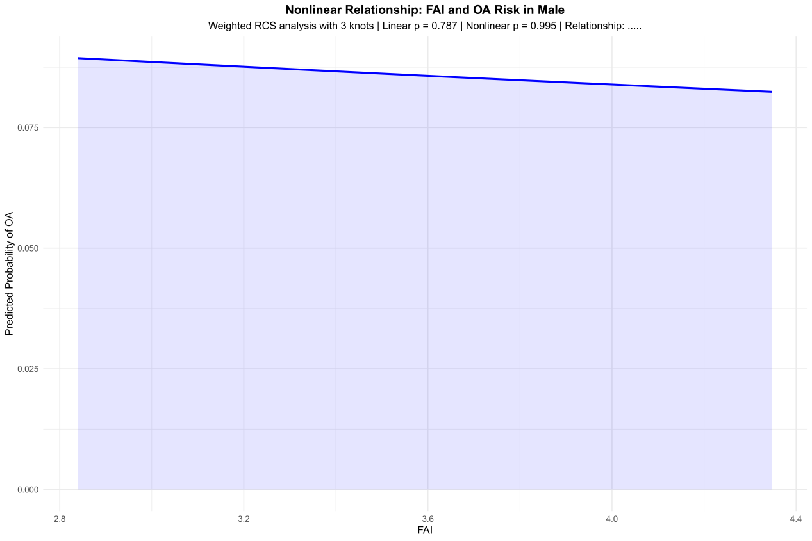
Supplementary Figure 1a. Weighted restricted cubic spline of FAI versus OA risk in males. Linear term P = 0.787, non-linear term P = 0.995. Interpretation: No significant association; the curve remains essentially flat across the FAI range.

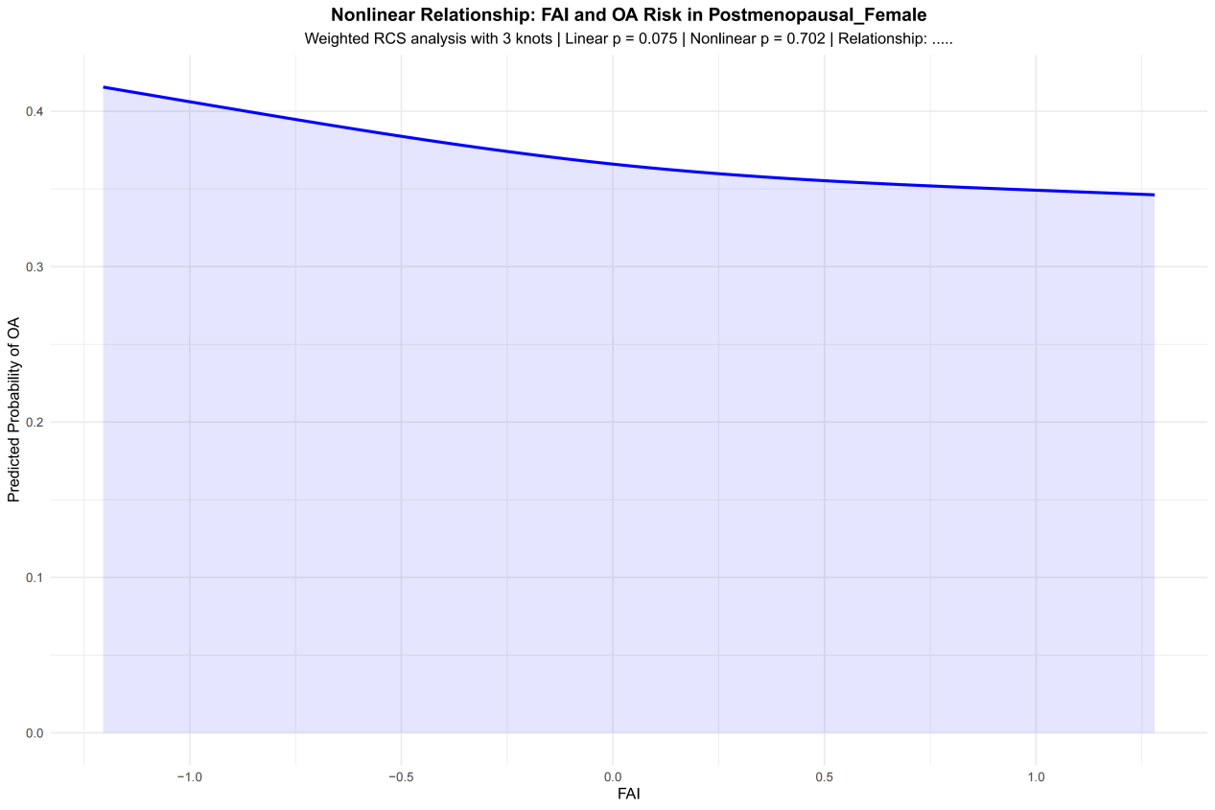

Supplementary Figure 1b. Weighted restricted cubic spline of FAI (log-transformed and Winsorized) versus OA risk in post-menopausal females. Linear term P = 0.075, non-linear term P = 0.702. Interpretation: The downward slope is suggestive but not statistically significant in the unstratified analysis; stratification by estradiol tertile reveals context-dependent effects (see Supplementary Table 1 and Figure 2).
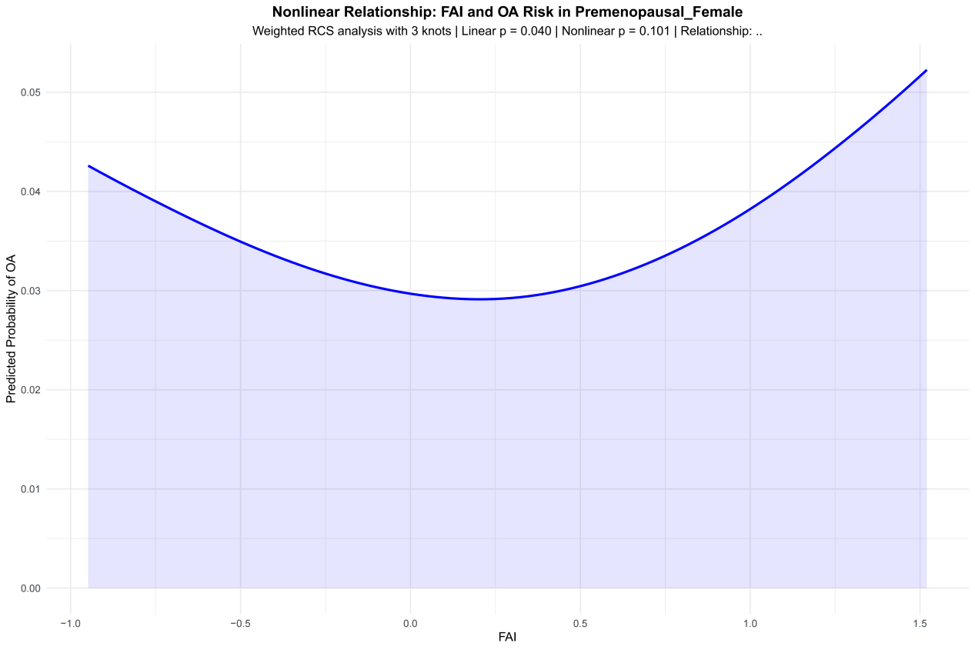
Supplementary Figure 1c. Weighted restricted cubic spline of FAI versus OA risk in pre-menopausal females. Linear term P = 0.040, non-linear term P = 0.101. Interpretation: A suggestive linear trend is present (nominal P < 0.05), but this did not survive multiple comparison correction in the primary model; the non-linear component is not significant.
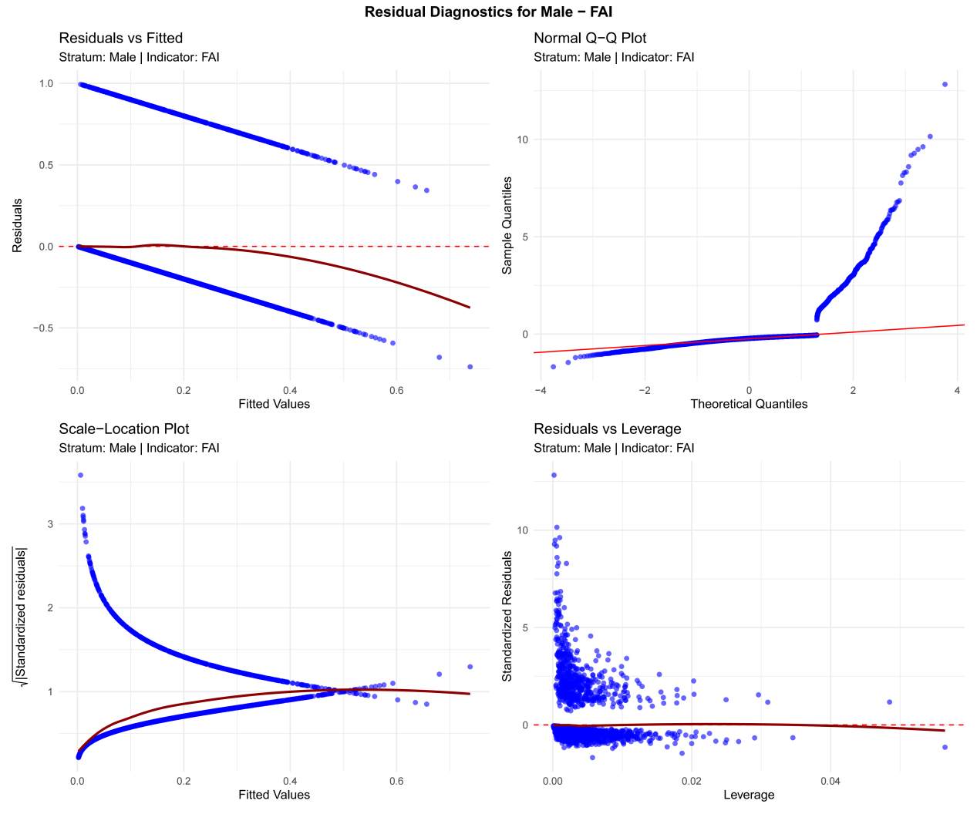

1d: residual_diagnostics_Male_FAI_weighted.pdf
Weighted residual diagnostics for the male FAI model: residual-vs-fitted, Q-Q, scale-location and residual-vs-leverage plots show no obvious anomalies; model assumptions are adequately met.

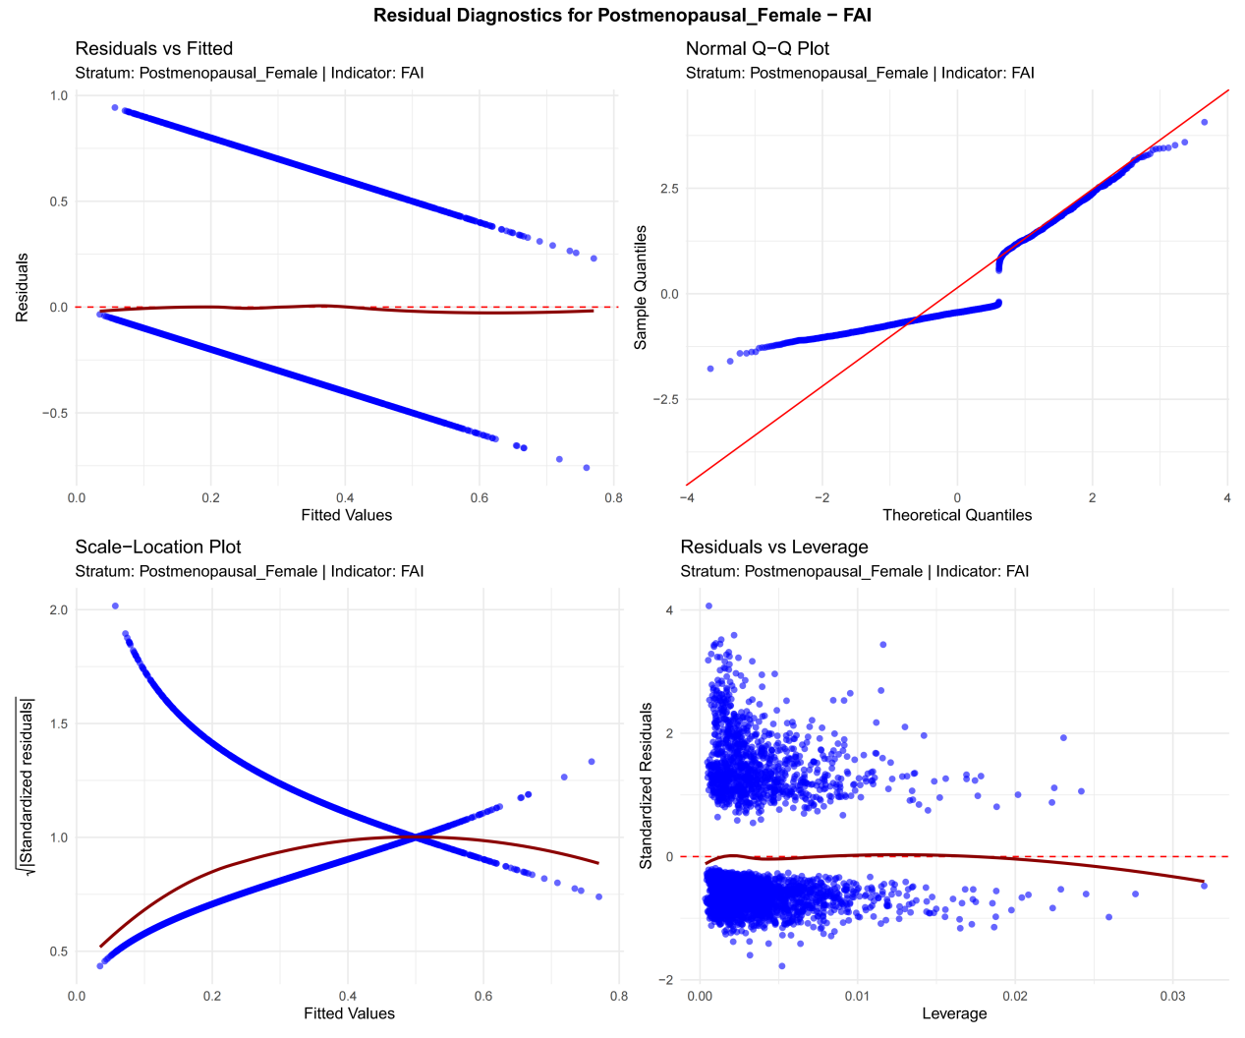
1e: residual_diagnostics_Postmenopausal_Female_FAI_weighted.pdf
Weighted residual diagnostics for the postmenopausal female FAI model: residuals are randomly scattered, the Q–Q plot is approximately linear, and leverage values fall within a reasonable range, indicating good model fit.

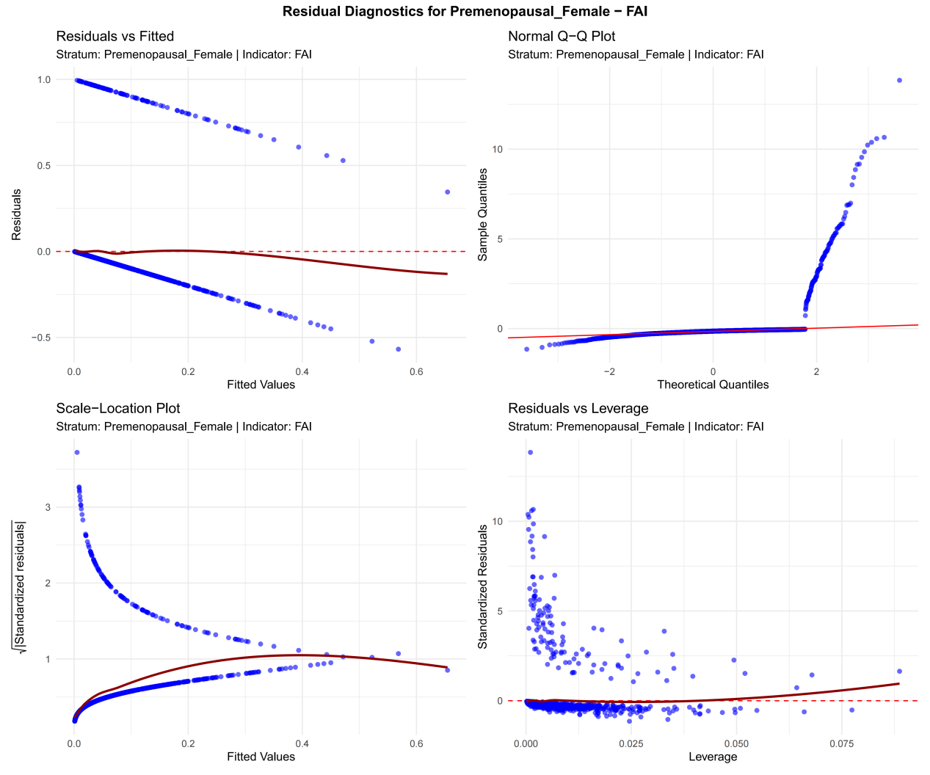
1f: residual_diagnostics_Premenopausal_Female_FAI_weighted.pdf
Weighted residual diagnostics for the pre-menopausal female FAI model: four-panel plots show evenly distributed residuals, acceptable normality, no extreme high-leverage points.

Supplementary Figure 2
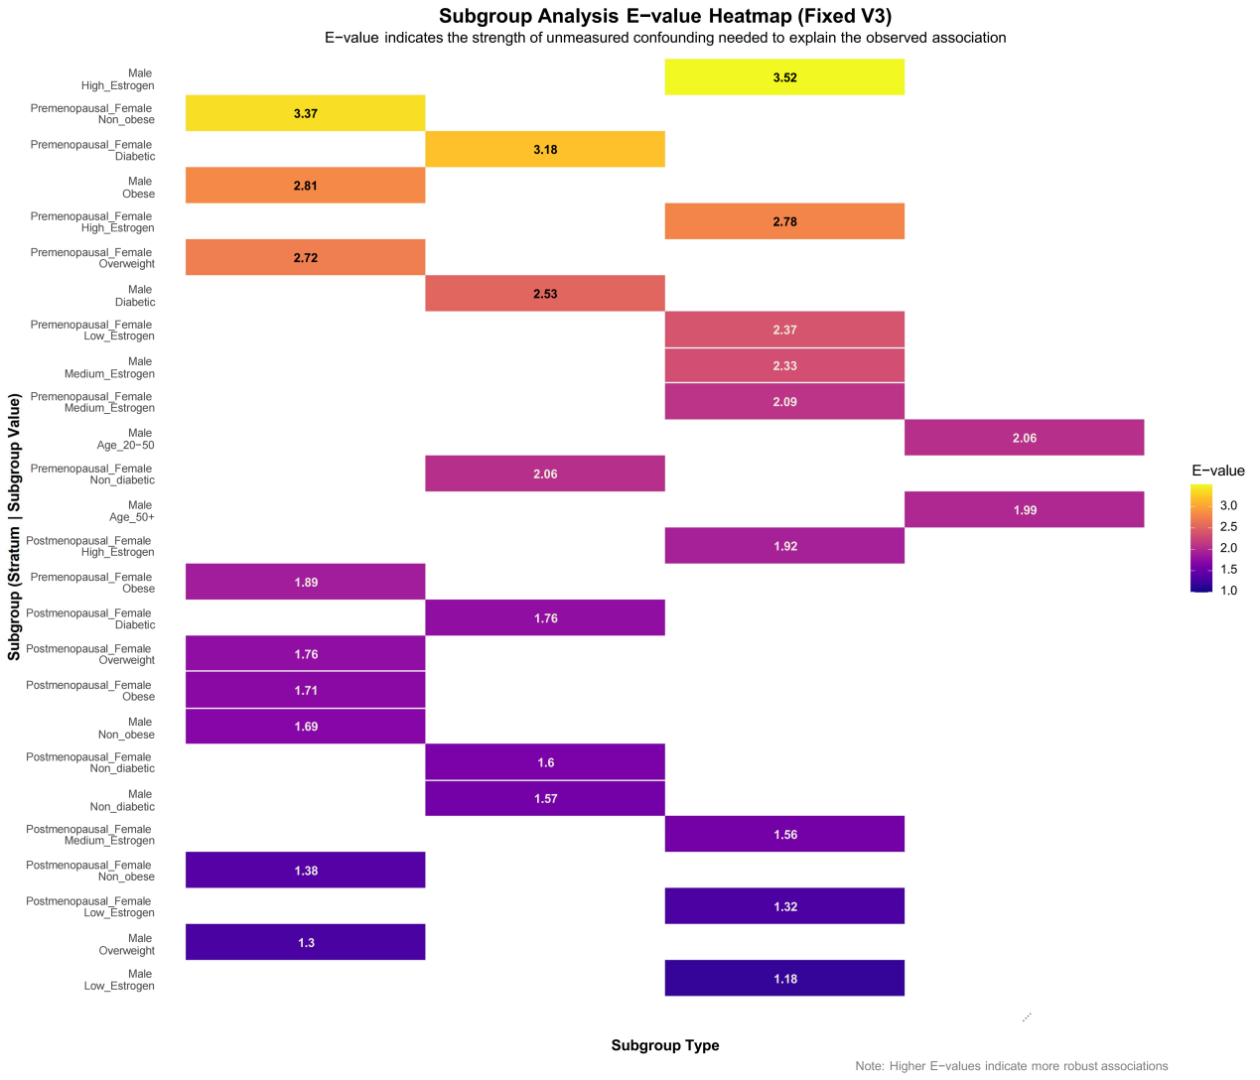Supplementary Figure 2. Heat-map of E-value point estimates by sex–stratum (males, pre-menopausal females, post-menopausal females) and subgroup type (BMI category, diabetes status, estradiol tertile). Color gradient from blue (E-value ≈ 1) to red (E-value ≥ 3) indicates increasing E-value magnitude; numeric values are subgroup-specific E-values. E-value ≥ 2.5 (deep red) implies relatively stronger unmeasured confounding would be required to nullify the observed association, whereas < 1.5 (light blue) suggests greater sensitivity to potential confounders.

Interpretation: Most subgroups show moderate E-values (1.5–2.5), indicating that the observed associations are sensitive to potential unmeasured confounding and should be interpreted cautiously. The E-values presented here quantify sensitivity to unmeasured confounding for subgroup-specific point estimates; they should not be interpreted as evidence of robustness for any individual subgroup finding, given the exploratory nature of these post-hoc analyses and the lack of FDR correction across the heat-map. This reinforces that subgroup findings are exploratory and require independent validation. X-axis: subgroup type; Y-axis: stratum–subgroup combinations.

