Supplemental data

Supplementary method 1. Definitions of healthy lifestyle behaviors and healthy lifestyle score groups 3
Supplementary method 2. Detailed definitions of indicators used to construct SES 4
Supplementary method 3. Implementation of causal mediation analysis using marginal structural models 5
Supplementary Table 1. The UK biobank definition of Cardiovascular-kidney-metabolic (CKM) syndrome stages 6
Supplementary Table 2. The China Health and Retirement Longitudinal Study (CHARLS) classification and definition of CKM syndrome stages 7
Supplementary Table 3. Model fit statistics and class distribution for Latent Class Analysis of socioeconomic status (SES) in the UK Biobank and CHARLS cohort 10
Supplementary Figure 1. Flowchart of participant selection for UK Biobank study 11
Supplementary Figure 2. Flowchart of participant selection for CHARLS study 12
Supplementary Figure 3. Verification of the proportional hazards assumption for sex differences for the UK Biobank and CHARLS cohorts 13
Supplementary Figure 4. Directed acyclic graph (DAG) illustrating the relationship between sex and cardiovascular disease 15
Supplementary Table 4. Proportion of missing data for key covariates before multiple imputation in UK Biobank and CHARLS 16
Supplementary Table 5. Follow-up attrition strictly stratified by sex and CKM stages across survey waves in CHARLS 18
Supplementary Figure 5. Standardized mean differences for baseline covariates before and after propensity score matching in the UK Biobank and CHARLS 19
Supplementary Table 6. Baseline characteristics comparison between included and excluded participants due to missing variables to define CKM syndrome stages in UK Biobank and CHARLS 21
Supplementary Table 7. Baseline characteristics of participants with CKM stage 0 by sex in UK Biobank and CHARLS 25
Supplementary Table 8. Baseline characteristics of participants with CKM stage 1 by sex in UK Biobank and CHARLS 28
Supplementary Table 9. Baseline characteristics of participants with CKM stage 2 by sex in UK Biobank and CHARLS 31
Supplementary Table 10. Baseline characteristics of participants with CKM stage 3 by sex in UK Biobank and CHARLS 35
Supplementary Figure 6. Adjusted Kaplan-Meier curves for cumulative incidence of CVD by sex and by different CKM stages 39
Supplementary Table 11. Results of analysis of CVD risk in different sex and ethnic subgroups in patients with CKM stage 0-3 in the UK Biobank 42
Supplementary Table 12. Sensitivity analysis results of sex differences in CVD risks in participants with CKM stage 0-3 43
Supplementary Table 13. Comparison of adjusted hazard ratios for cardiovascular outcomes between Interval-Censored and Standard Cox Proportional Hazards Models for the CHARLS 44
Supplementary Table 14. Comparison of adjusted hazard ratios for cardiovascular outcomes between IPCW-weighted Cox models and standard Cox proportional hazards models for the CHARLS 45
Supplementary Table 15. E-values for the associations between sex and cardiovascular disease in participants with CKM Stage 0-3 in UK Biobank and CHARLS 46
Supplementary Table 16. Sex differences in risk of incident cardiovascular disease in participants with different CKM syndrome stages defined by the China-PAR risk equation for the CHARLS 47
Supplementary Figure 7. Subgroup analysis results of sex differences in CVD risks by socioeconomic status and healthy lifestyle score 48

Supplementary method 1. Definitions of healthy lifestyle behaviors and healthy lifestyle score groups

We aimed to construct a composite healthy lifestyle score based on five modifiable healthy lifestyle behaviors. For the UK Biobank, the score included five lifestyle factors: 1) healthy diet, defined as meeting at least five recommended dietary components for cardiovascular health;^{[1]} 2) adequate physical activity, defined as ≥ 150 minutes of moderate-intensity, ≥ 75 minutes of vigorous-intensity activity, or an equivalent combination per week;^{[2]} 3) healthy sleep duration of 7-9 hours per night;^{[3]} 4) never smoking;^{[4]} and 5) moderate alcohol consumption, defined as > 0 to ≤ 14 g/day for women and > 0 to ≤ 28 g/day for men.^{[5]}
Due to the absence of dietary data in CHARLS, the lifestyle behavior score was based on the remaining four lifestyle factors. The definitions for adequate physical activity and never smoking were identical to those used in UK Biobank. However, healthy sleep duration was defined more narrowly as 7-8 hours per night.^{[6]} For alcohol consumption, never drinking was categorized as the healthy behavior in CHARLS.
For each lifestyle behavior, we assigned 1 point for a healthy level and 0 for an unhealthy level. A healthy behavior score (HBS) was calculated by summing up individual scores for all the five aforementioned lifestyle behaviors, where a higher HBS reflected a healthier lifestyle.
For the UK Biobank cohort, participants were subsequently stratified into three groups based on their HBS: low HBS group (0-1), medium HBS group (2-3), and high HBS group (4-5). For the CHARLS, similar stratification was performed, but the score ranges were adapted to reflect the distribution within this specific population, consistent with previous research.^{[1,7]} Participants were categorized into low HBS group (0-1), medium HBS group (2), and high HBS group (3-4).

Supplementary method 2. Detailed definitions of indicators used to construct SES

In the UK Biobank, the SES variable was derived from three key indicators: total household income before tax, education qualification, and employment status.^{[1,8]} Total household income was reported by participants and categorized into predefined levels (< £18,000; £18,000-£30,999; £31,000-£51,999; £52,000-£100,000; > £100,000; do not know, or prefer not to answer). Education qualification was recorded as college or university degree; advanced levels, advanced subsidiary levels, or equivalent; ordinary levels, general certificate of secondary education, or equivalent; certificate of secondary education or equivalent; national vocational qualification, higher national diploma, higher national certificate, or equivalent; other professional qualifications; and none of the above; and prefer not to answer. Given that the UK Biobank baseline assessment captured general employment status rather than detailed occupational information, employment status was categorized as employed or unemployed, where employed included those in paid employment or self-employed, retired, doing unpaid or voluntary work, and full-time or part-time student.^{[1]} Individuals who chose ‘do not know’ or ‘prefer not to answer’ were excluded from the analysis.
In the CHARLS, annual total household income, occupation, education level, and health insurance were used to quantify SES.^{[1,9]} The annual total household income is the sum of all income at the household level including income from earning income, capital income, pension income, income from government transfers, other income and the total income from other household members.^{[10]} The annual total household income was divided into three levels (low, middle, and high) according to the tertiles. Occupations were categorized as non-agricultural workers, agricultural workers, and unemployed (including unemployed, retired, and never worked). Education level was grouped into four categories: no completion of primary school; Sishu, home school or elementary school; middle school; and high school and above. Health insurance status was defined as having public health insurance or no insurance.

Supplementary method 3. Implementation of causal mediation analysis using marginal structural models

Our causal mediation analysis used marginal structural models (MSM) in three main steps for each mediator (SES and HBS).^{[11,12]}
1) Modeling the mediator and calculating weights. We first developed a regression model to predict the mediator based on the exposure (sex) and a comprehensive set of baseline confounders. The confounders included age, ethnicity (UK Biobank), medication use (antihypertensive, antidiabetic, and lipid-lowering), body mass index, systolic blood pressure, HbA1c, HDL-cholesterol, and eGFR. From the predicted probabilities derived from this model, we calculated stabilized inverse probability of treatment weights for each participant. These weights are designed to create a pseudo-population.
2) Fitting the weighted outcome model. We fitted a weighted Cox proportional hazards model for incident CVD as the outcome, incorporating the calculated weights.
3) Decomposition of effects. The coefficients from the weighted MSM were used to compute the natural direct effect and the natural indirect effect on the log-hazard ratio scale, based on the counterfactual framework.

Supplementary Table 1. The UK biobank definition of Cardiovascular-kidney-metabolic (CKM) syndrome stages^{[13]}

Stage | Detailed definitions
CKM stage 0 | - Normal body mass index, waist circumference, glucose, blood pressure, lipid profiles, and no evidence of chronic kidney disease (CKD) or cardiovascular disease (CVD).
CKM stage 1 | - With ≥ 1 of the following:  - body mass index ≥ 25 kg/m²;  - waist circumference ≥ 88/102 cm in females/males;  - prediabetes: fasting blood glucose ≥ 100-124 mg/dL or HbA1c between 5.7% and 6.4%.  - And no other metabolic risk factors (including hypertension, hypertriglyceridemia (≥ 135 mg/dL), metabolic syndrome, or diabetes), CKD, or CVD;
CKM stage 2 | - Any of Hypertriglyceridemia (≥135 mg/dL), hypertension, diabetes or metabolic syndrome (at least 3 of the following: elevated waist circumference, low HDL cholesterol [< 40 mg/dL for males or < 50 mg/dL for females], Fasting triglycerides ≥ 150 mg/dL, elevated blood pressure [systolic blood pressure ≥ 130 mmHg, diastolic blood pressure ≥ 80 mmHg or use of antihypertensive medications], prediabetes); or  - CKD: Intermediate or high risk of CKD in accordance with KDIGO criteria.^{[13]}
CKM stage 3 | - CKD*: Very high-risk CKD stage; or  - Based on AHA recommendation: Subclinical risk of progression of CVD, i.e., Predicted 10-year CVD risk ≥7.5% for participants aged < 50 years from SCORE 2 [Systematic Coronary Risk Estimation 2], CVD risk ≥ 10% for participants aged 50 - 69 years from SCORE 2, and CVD risk ≥ 15% for participants aged ≥ 70 years from SCORE 2-OP [Systematic Coronary Risk Estimation 2 - Older Persons].^{[14–16]}
* Given that laboratory measurements (eGFR and urine albumin-to-creatinine ratio) were obtained at a single baseline visit, our definitions of CKD risk represent an operational CKM risk classification rather than a confirmed clinical diagnosis of CKD, which typically requires persistent abnormalities over at least three months.

Supplementary Table 2. The China Health and Retirement Longitudinal Study (CHARLS) classification and definition of CKM syndrome stages^{[13]}

Stage | Detailed definitions
CKM stage 0 | - Body mass index (BMI) less than 23 kg/m²; and Normal waist circumference: < 80 cm and < 90 cm for females and males; and  - Normal glucose, blood pressure and lipid profiles; and  - No metabolic risk factors (hypertension, hypertriglyceridemia [≥135 mg/dL], metabolic syndrome, prediabetes, or diabetes); and  - No chronic kidney disease (CKD) or cardiovascular disease (CVD).
CKM stage 1 | - BMI: BMI ≥ 23 kg/m²; or  - Waist circumference: Females: ≥ 80 cm, Males: ≥ 90 cm; or  - Prediabetes: Glycosylated hemoglobin: 5.7% to < 6.5%; Fasting blood glucose: 100 mg/dL to < 126 mg/dL; and  - No other metabolic risk factors (hypertension, hypertriglyceridemia [≥135 mg/dL], metabolic syndrome, diabetes); and  - No CKD or CVD.
CKM stage 2 | - Any of metabolic risk factors: Hypertriglyceridemia (≥135 mg/dL); hypertension; diabetes; metabolic syndrome (at least 3 of the following: elevated waist circumference, low HDL cholesterol [ < 40 mg/dL for males or < 50 mg/dL for females], fasting triglycerides ≥ 150 mg/dL, elevated blood pressure [systolic blood pressure ≥ 130 mmHg, diastolic blood pressure ≥ 80 mmHg or use of antihypertensive medications], prediabetes); or  - CKD: Intermediate or high risk of CKD in accordance with KDIGO criteria.^{[13]}
CKM stage 3 | - CKD*: Very high-risk CKD stage; or  - Based on AHA recommendation: Subclinical risk of progression of CVD, i.e., Predicted 10-year CVD risk ≥ 20%, estimated from the AHA’s PREVENT (Predict Risk of Cardiovascular Disease EVENTs) base model.^{[17]}
* Given that laboratory measurements (eGFR and urine albumin-to-creatinine ratio) were obtained at a single baseline visit, our definitions of CKD risk represent an operational CKM risk classification rather than a confirmed clinical diagnosis of CKD, which typically requires persistent abnormalities over at least three months.

References:
1. Zhang YB, Chen C, Pan XF, Guo J, Li Y, Franco OH, et al. Associations of healthy lifestyle and socioeconomic status with mortality and incident cardiovascular disease: Two prospective cohort studies. BMJ. 2021 Apr 14;n604.
2. Bull FC, Al-Ansari SS, Biddle S, Borodulin K, Buman MP, Cardon G, et al. World health organization 2020 guidelines on physical activity and sedentary behaviour. Br J Sports Med. 2020 Nov 25;54(24):1451–62.
3. Watson NF, Badr MS, Belenky G, Bliwise DL, Buxton OM, Buysse D, et al. Recommended amount of sleep for a healthy adult: A joint consensus statement of the American academy of sleep medicine and sleep research society. J Clin Sleep Med. 2015 Jun 15;11(06):591–2.
4. Overview | smoking: Reducing and preventing tobacco use | quality standards | NICE. [cited 2025 Jul 15]. Available from: https://www.nice.org.uk/guidance/qs82
5. Snetselaar LG, de Jesus JM, DeSilva DM, Stoody EE. Dietary guidelines for Americans, 2020-2025: Understanding the scientific process, guidelines, and key recommendations. Nutr Today. 2021 Nov;56(6):287–95.
6. Song Y, Liu H, Gu K, Liu Y. Association between nighttime sleep duration, nap time, and mild cognitive impairment in Chinese older adults: A cross-sectional study. BMC Public Health. 2024 Sep 2;24(1):2381.
7. Han H, Cao Y, Feng C, Zheng Y, Dhana K, Zhu S, et al. Association of a healthy lifestyle with all-cause and cause-specific mortality among individuals with type 2 diabetes: A prospective study in UK biobank. Diabetes Care. 2021 Dec 2;45(2):319–29.
8. Ye X, Wang Y, Zou Y, Tu J, Tang W, Yu R, et al. Associations of socioeconomic status with infectious diseases mediated by lifestyle, environmental pollution and chronic comorbidities: A comprehensive evaluation based on UK biobank. Infect Dis Poverty. 2023 Jan 30;12(1):5.
9. Guo C, Liu Z, Fan H, Wang H, Zhang X, Fan C, et al. Associations of healthy lifestyle and three latent socioeconomic status patterns with physical multimorbidity among middle-aged and older adults in China. Prev Med. 2023 Oct;175:107693.
10. Feng Z, Cramm JM, Jin C, Twisk J, Nieboer AP. The longitudinal relationship between income and social participation among Chinese older people. SSM - Population Health. 2020 Aug;11:100636.
11. VanderWeele TJ. Marginal structural models for the estimation of direct and indirect effects. Epidemiology. 2009 Jan;20(1):18–26.
12. Valente MJ, Rijnhart JJM, Smyth HL, Muniz FB, MacKinnon DP. Causal mediation programs in R, M plus , SAS, SPSS, and stata. Struct Equ Model. 2020 Aug 3;27(6):975–84.
13. Ndumele CE, Rangaswami J, Chow SL, Neeland IJ, Tuttle KR, Khan SS, et al. Cardiovascular-kidney-metabolic health: A presidential advisory from the American heart association. Circulation. 2023 Nov 14;148(20):1606–35.
14. Visseren FLJ, Mach F, Smulders YM, Carballo D, Koskinas KC, Bäck M, et al. 2021 ESC guidelines on cardiovascular disease prevention in clinical practice. European Journal of Preventive Cardiology. 2021 Sep 24;29(1):5–115.
15. SCORE2 working group and ESC Cardiovascular risk collaboration, Hageman S, Pennells L, Ojeda F, Kaptoge S, Kuulasmaa K, et al. SCORE2 risk prediction algorithms: New models to estimate 10-year risk of cardiovascular disease in europe. Eur Heart J. 2021 Jun 13;42(25):2439–54.
16. SCORE2-OP working group and ESC Cardiovascular risk collaboration, De Vries TI, Cooney MT, Selmer RM, Hageman SHJ, Pennells LA, et al. SCORE2-OP risk prediction algorithms: Estimating incident cardiovascular event risk in older persons in four geographical risk regions. Eur Heart J. 2021 Jun 13;42(25):2455–67.
17. Khan SS, Matsushita K, Sang Y, Ballew SH, Grams ME, Surapaneni A, et al. Development and validation of the American heart association’s PREVENT equations. Circulation. 2024 Feb 6;149(6):430–49.

Supplementary Table 3. Model fit statistics and class distribution for Latent Class Analysis of socioeconomic status (SES) in the UK Biobank and CHARLS cohort*

Model | AIC | BIC | G² | Entropy | Class Population Shares (%)
UK Biobank
2 Classes | 2,023,583.00 | 2,023,827.00 | 11,792.95 | 0.65 | Class 1: 43.42%  Class 2: 56.58%
3 Classes (Selected) | 2,013,619.00 | 2,013,991.00 | 1,805.45 | 0.62 | Low SES: 46.77%  Middle SES: 30.17%  High SES: 23.06%
4 Classes | 2,012,481.00 | 2,012,980.00 | 643.17 | 0.58 | Class 1: 38.84%  Class 2: 18.04%  Class 3: 21.88%  Class 4: 21.25%
CHARLS
2 Classes | 41,616.20 | 41,720.03 | 172.68 | 0.86 | Class 1: 58.20%  Class 2: 41.80%
3 Classes (Selected) | 41,499.28 | 41,658.48 | 39.75 | 0.82 | Low SES: 47.15%  Middle SES: 34.45%  High SES: 18.39%
4 Classes | 41,488.82 | 41,703.39 | 13.29 | 0.74 | Class 1: 42.10%  Class 2: 31.50%  Class 3: 22.80%  Class 4: 3.60%
* AIC, Akaike Information Criterion; BIC, Bayesian Information Criterion; G², Likelihood Ratio / Deviance Statistic;
Bold text indicates the optimal model selected for main analyses. Model selection was primarily based on the lowest BIC, high classification accuracy (Entropy > 0.80), and epidemiological interpretability without creating overly small or redundant categories.

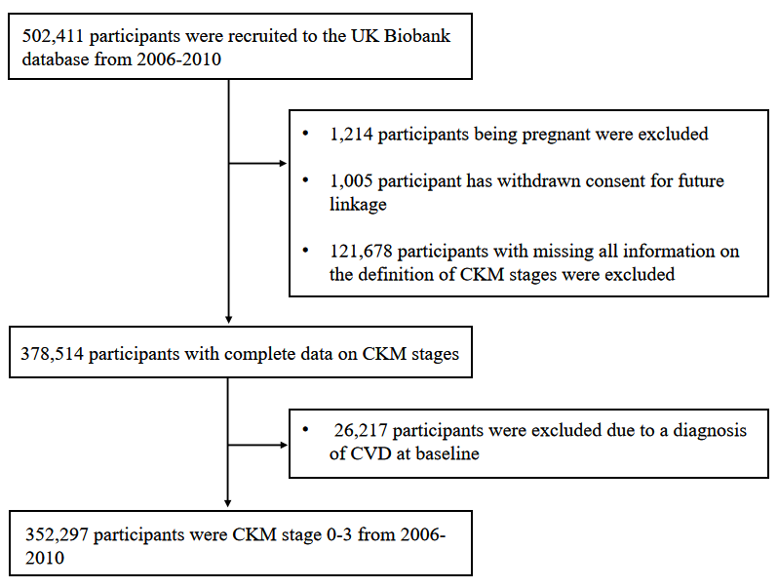
Supplementary Figure 1. Flowchart of participant selection for UK Biobank study

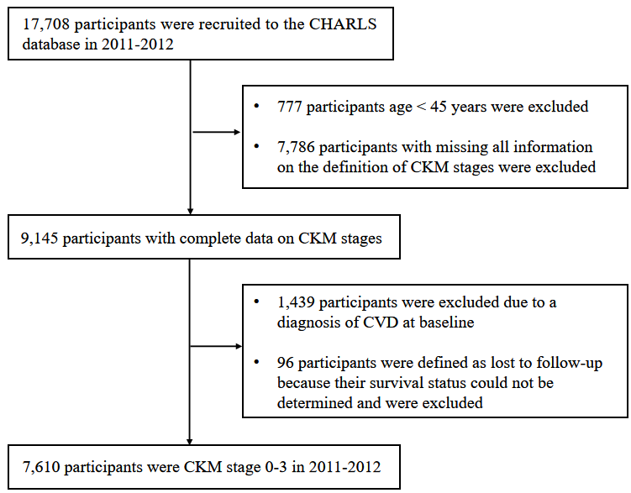
Supplementary Figure 2. Flowchart of participant selection for CHARLS study

Supplementary Figure 3. Verification of the proportional hazards assumption for sex differences for the UK Biobank and CHARLS cohorts*

- Results for UK Biobank
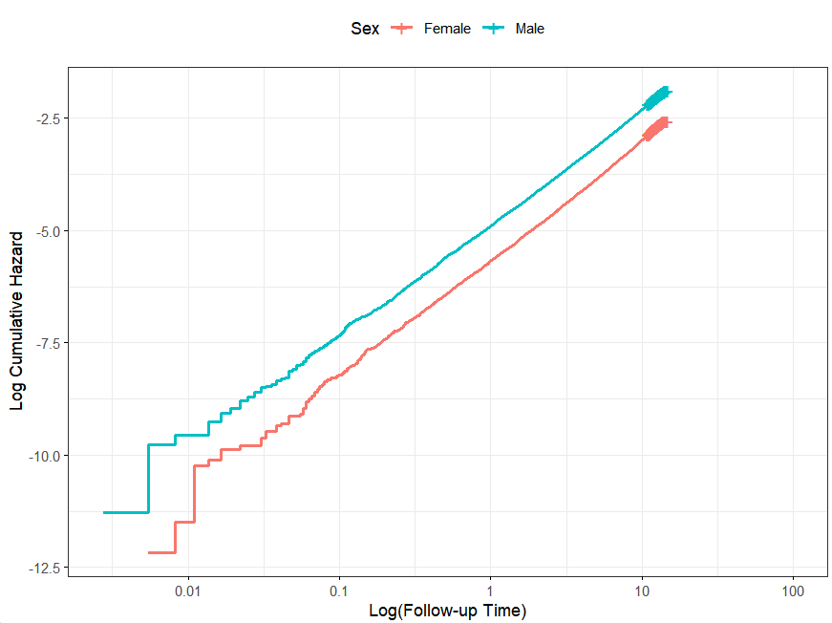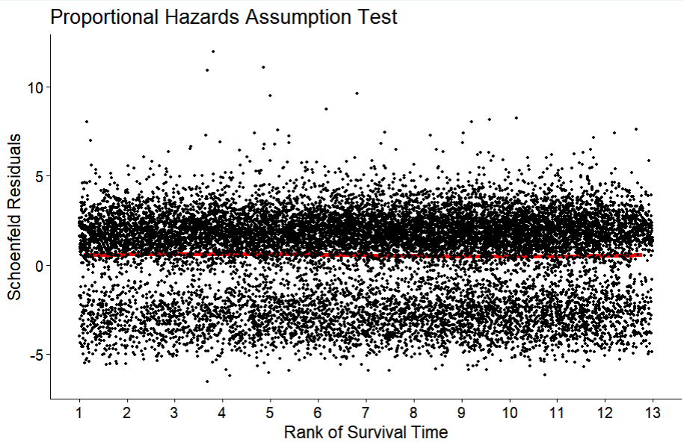

- Results for CHARLS

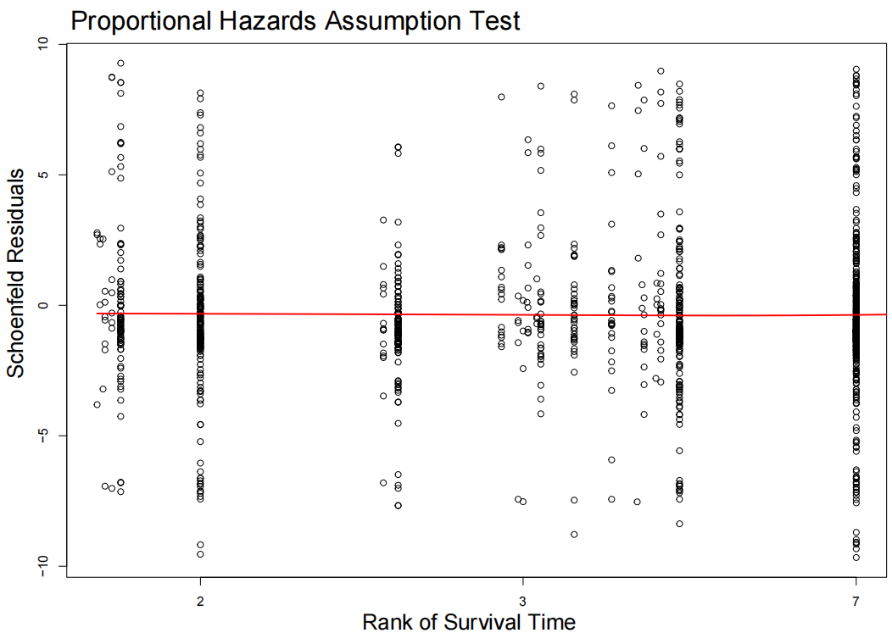
* Log-log plot showing log (cumulative hazard) versus log (follow-up time) for males (blue line) and females (pink line). The parallel trajectories across the entire follow-up period confirm that the proportional hazards assumption for sex holds true without time-varying non-proportionality.
Supplementary Figure 4. Directed acyclic graph (DAG) illustrating the relationship between sex and cardiovascular disease*
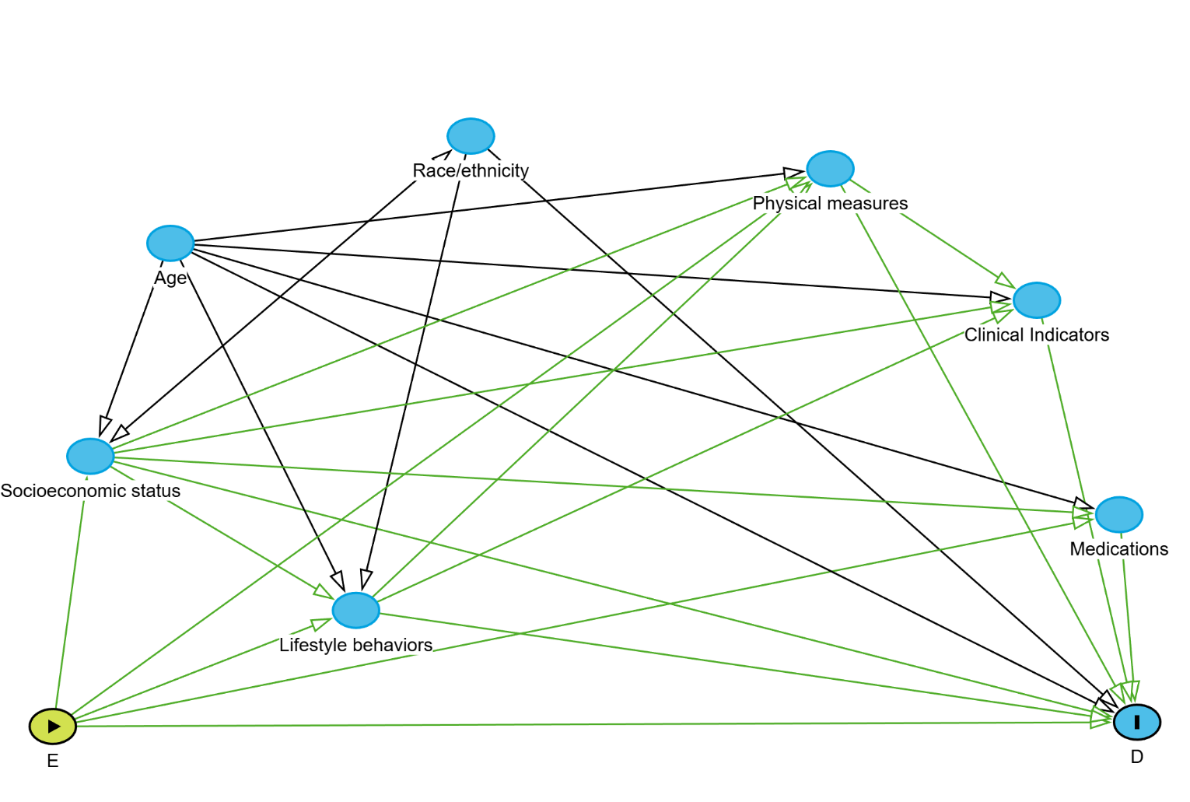
* Sex exposure (E) was represented by green nodes with a triangle symbol. The outcome of CVD (D) was shown as a blue node with a thick black vertical line. Blue nodes depicted ancestors of the outcome, comprising potential confounders (age and race/ethnicity) and mediators (socioeconomic status, lifestyle behaviors, physical measures, clinical indicators, and medication use). Directed arrows indicate hypothesized causal pathways connecting sex to CVD risk.
Socioeconomic status included education level, Townsend deprivation index and employment for UK Biobank; and included education level, annual total household income and occupation for CHARLS. Lifestyle behaviors included healthy diet (for UK Biobank only), healthy sleep duration, never smoking, moderate alcohol consumption, adequate physical activity. Medications use included antihypertensive medication, antidiabetic and lipid-lowering medication. Physical measures included body mass index, waist circumference, and systolic blood pressure. Clinical indicators included HbA1c, total cholesterol, high density lipoprotein-cholesterol, triglycerides, and eGFR.

Supplementary Table 4. Proportion of missing data for key covariates before multiple imputation in UK Biobank and CHARLS

Variables | UK Biobank  (No. of missingness) | UK Biobank  (% of missingness) | CHARLS  (No. of missingness) | CHARLS  (% of missingness)
Healthy alcohol | 110,969 | 31.50 | 4 | 0.05
Healthy physical activity | 72,832 | 20.67 | 0 | 0.00
Healthy diet | 7,449 | 2.11 | -* | -*
Education level | 3,952 | 1.12 | 0 | 0.00
Healthy sleep | 2,443 | 0.69 | 0 | 0.00
Healthy smoking | 1,673 | 0.47 | 1 | 0.01
Race/ethnicity | 1,634 | 0.46 | -* | -*
Townsend deprivation index or income | 414 | 0.12 | 0 | 0.00
eGFR | 43 | 0.01 | 0 | 0.00
Age | 0 | 0.00 | 0 | 0.00
Hypertension | 0 | 0.00 | 0 | 0.00
Diabetes | 0 | 0.00 | 0 | 0.00
Hypertriglyceridemia | 0 | 0.00 | 0 | 0.00
Chronic kidney disease | 0 | 0.00 | 0 | 0.00
Cancer | 0 | 0.00 | 0 | 0.00
Use of antihypertensive medication | 0 | 0.00 | 1 | 0.01
Use of diabetes medication | 0 | 0.00 | 89 | 1.17
Use of lipid-lowering medication | 0 | 0.00 | 88 | 1.16
BMI | 0 | 0.00 | 0 | 0.00
Systolic blood pressure | 0 | 0.00 | 0 | 0.00
HbA1c | 0 | 0.00 | 0 | 0.00
HDL-C | 0 | 0.00 | 0 | 0.00
Triglycerides | 0 | 0.00 | 0 | 0.00
* Data for this indicator are not available in CHARLS.

Supplementary Table 5. Follow-up attrition strictly stratified by sex and CKM stages across survey waves in CHARLS*

Waves | Sex | CKM Stages | Interviewed (N) | Lost to follow-up (N) | Newly deceased (N) | Previously deceased (N)
Wave 2 | Males | Stage 0-1 | 1,129 | 19 | 12 | -
Wave 2 | Males | Stage 2 | 2,076 | 26 | 36 | -
Wave 2 | Males | Stage 3 | 334 | 10 | 20 | -
Wave 2 | Females | Stage 0-1 | 1,227 | 16 | 6 | -
Wave 2 | Females | Stage 2 | 2,602 | 47 | 26 | -
Wave 2 | Females | Stage 3 | 110 | 3 | 7 | -
Wave 3 | Males | Stage 0-1 | 1,090 | 27 | 31 | 12
Wave 3 | Males | Stage 2 | 1,985 | 61 | 56 | 36
Wave 3 | Males | Stage 3 | 287 | 16 | 41 | 20
Wave 3 | Females | Stage 0-1 | 1,188 | 39 | 16 | 6
Wave 3 | Females | Stage 2 | 2,509 | 87 | 53 | 26
Wave 3 | Females | Stage 3 | 95 | 5 | 13 | 7
Wave 4 | Males | Stage 0-1 | 981 | 83 | 53 | 43
Wave 4 | Males | Stage 2 | 1,778 | 161 | 107 | 92
Wave 4 | Males | Stage 3 | 220 | 25 | 58 | 61
Wave 4 | Females | Stage 0-1 | 1,113 | 95 | 19 | 22
Wave 4 | Females | Stage 2 | 2,299 | 213 | 84 | 79
Wave 4 | Females | Stage 3 | 80 | 4 | 16 | 20
* CKM stage 0 and 1 were combined to match the analytical framework as requested. “Lost to follow-up” is defined as participants who did not complete the interview in the respective wave but were not known to be deceased. “Newly deceased” refers to participants who died during the specific survey interval, while “Previously deceased” tracks the cumulative mortality from prior waves, ensuring the total N for each stratum remains constant across all follow-up waves.

Supplementary Figure 5. Standardized mean differences for baseline covariates before and after propensity score matching in the UK Biobank and CHARLS

(A) Results for UK Biobank
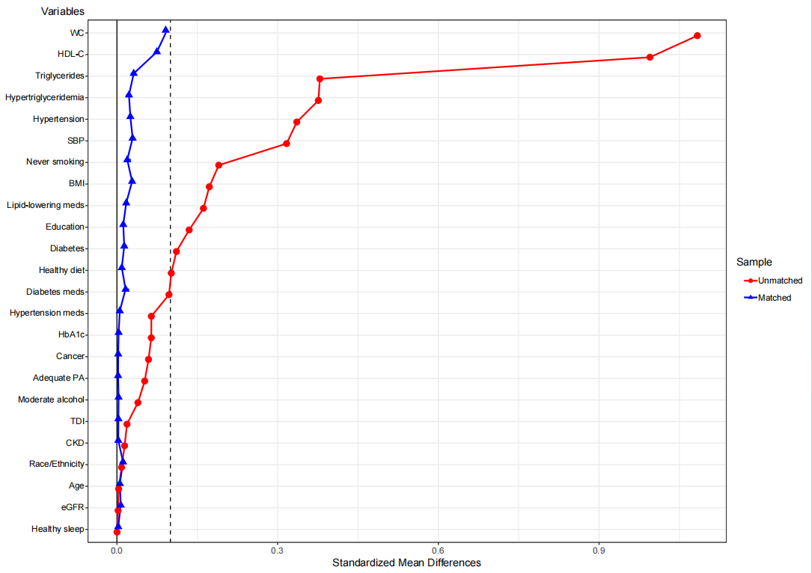

(B) Results for CHARLS
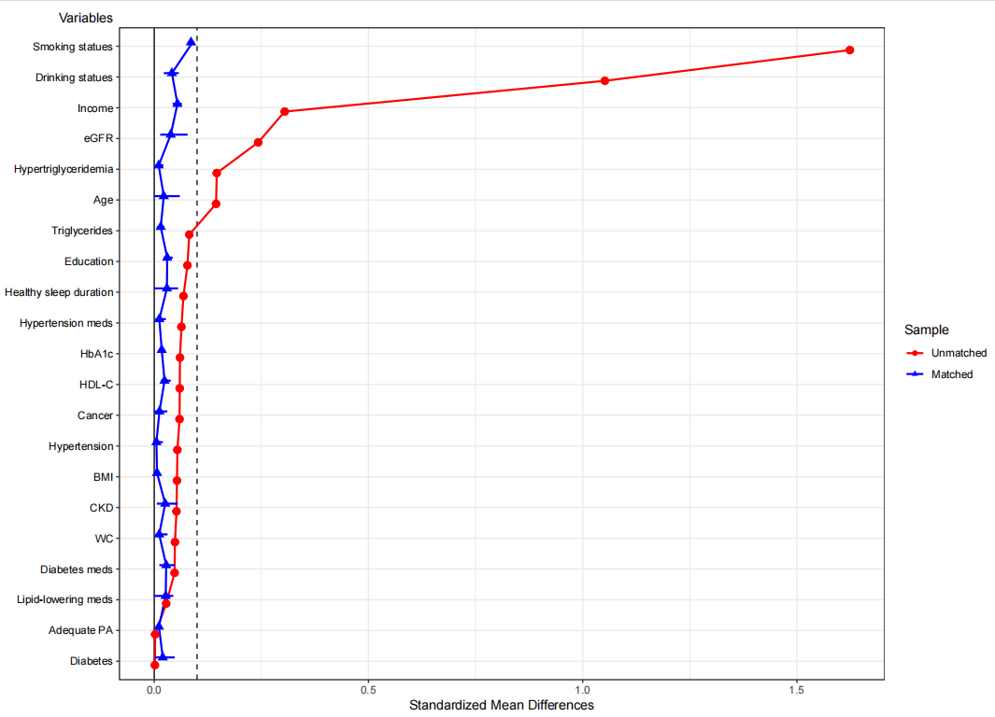

Supplementary Table 6. Baseline characteristics comparison between included and excluded participants due to missing variables to define CKM syndrome stages in UK Biobank and CHARLS*

 | UK Biobank |  | CHARLS
Characteristics | Total included population  (n = 352,297) | Total excluded population (n = 121,678) | Total included population  (n = 7,610) | Total excluded population (n = 7,786)
Age, mean (SD), years | 56.21 (8.08) | 56.45 (8.09) | 58.81 (9.31) | 58.89 (10.27)
Sex, n (%) | 195,288 (55.43) | 68,723 (56.48) | 3,988 (52.40) | 3,787 (49.76)
White race/ethnicity, n (%) | 332,646 (94.86) | 114,281 (93.79) | -³ | -³
Education level, n (%)
College or higher | 156,269 (44.86) | 53,191 (45.39) | -³ | -³
Below college | 192,076 (55.14) | 63,998 (54.61) | -³ | -³
High school or above | -³ | -³ | 724 (9.51) | 1,288 (16.56)
Below high school | -³ | -³ | 6,886 (90.49) | 6,492 (83.44)
Currently employed, n (%) | 323,163 (92.72) | 116,409 (95.57) | -³ | -³
Agricultural Occupations, n (%) | -³ | -³ | 3,438 (45.76) | 2,123 (28.34)
Having insurance, n (%) | -³ | -³ | 7,071 (93.19) | 7,530 (99.22)
Townsend deprivation index, mean (SD)¹ | -1.38 (3.03) | -1.16 (3.21) | -³ | -³
Household annual income, n (%)²
Low income | -³ | -³ | 1,614 (33.30) | 1,274 (30.11)
Middle income | -³ | -³ | 1,617 (33.36) | 1,349 (31.88)
High income | -³ | -³ | 1,616 (33.34) | 1,608 (38.01)
Healthy diet, n (%) | 50,531 (14.65) | 17,369 (14.99) | -³ | -³
Healthy sleep duration, n (%) | 238,799 (68.26) | 81,601 (67.23) | 1,687 (22.17) | 1,396 (17.93)
Never smoking, n (%) | 195,307 (55.70) | 67,350 (55.30) | 4,577 (60.15) | 4,488 (58.65)
Moderate alcohol consumption, n (%) | 148,855 (61.68) | 50,311 (61.49) | 4,402 (57.88) | 4,399 (57.58)
Adequate physical activity, n (%) | 181,174 (64.83) | 59,540 (64.37) | 2,765 (36.33) | 2,220 (28.51)
Hypertension, n (%) | 273,984 (77.77) | 80,410 (65.54) | 2,803 (36.83) | 2,681 (34.43)
Diabetes, n (%) | 18,500 (5.25) | 7,711 (6.29) | 1,378 (18.11) | 973 (12.50)
Hypertriglyceridemia, n (%) | 168,580 (47.85) | 43,078 (47.90) | 2,418 (31.77) | 760 (36.42)
Chronic kidney disease, n (%) | 7,036 (2.00) | 2,543 (2.07) | 130 (1.71) | 421 (5.56)
Cancer, n (%) | 16,828 (4.78) | 7,638 (6.23) | 77 (1.01) | 99 (1.27)
Premature menopause, n (%) | 390 (0.11) | 56 (0.05) | 1,619 (21.27) | 1,908 (24.51)
Polycystic ovarian syndrome, n (%) | 129 (0.04) | 129 (0.04) | -³ | -³
Adverse pregnancy outcomes, n (%) | 2,839 (0.81) | 822 (0.67) | -³ | -³
Erectile dysfunction, n (%) | 1,714 (0.49) | 661 (0.54) | -³ | -³
Depression, n (%) | 21,904 (6.22) | 7,856 (6.40) | 454 (5.97) | 433 (5.56)
Use of antihypertensive medication, n (%) | 66,282 (18.81) | 28,128 (22.93) | 1,189 (15.63) | 1,493 (19.74)
Use of diabetes medication, n (%) | 11,045 (3.14) | 4,895 (3.99) | 421 (5.60) | 579 (7.85)
Use of lipid-lowering medication, n (%) | 46,312 (13.15) | 20,662 (16.84) | 262 (3.48) | 363 (4.89)
BMI, mean (SD), kg/m² | 27.30 (4.71) | 27.50 (4.94) | 23.28 (3.35) | 24.46 (5.09)
Waist circumference, mean (SD), cm | 89.87 (13.28) | 90.10 (13.63) | 83.92 (12.17) | 84.11 (12.92)
Systolic blood pressure, mean (SD), mmHg | 139.74 (19.62) | 139.56 (19.87) | 128.87 (21.18) | 130.36 (21.60)
Diastolic blood pressure, mean (SD), mmHg | 82.40 (10.63) | 82.04 (10.77) | 75.02 (12.10) | 75.98 (12.26)
HbA1c, mean (SD), % | 5.43 (0.58) | 5.46 (0.64) | 5.25 (0.80) | 5.24 (0.87)
Total Cholesterol, mean (SD), mmol/L | 5.76 (1.11) | 5.68 (1.15) | 5.00 (0.98) | 4.95 (1.06)
HDL-C, mean (SD), mmol/L | 1.46 (0.38) | 1.44 (0.38) | 1.34 (0.40) | 1.28 (0.40)
LDL-C, mean (SD), mmol/L | 3.61 (0.85) | 3.54 (0.87) | 3.00 (0.90) | 2.96 (0.89)
Triglycerides, mean (SD), mmol/L | 1.74 (1.02) | 1.75 (1.03) | 1.46 (1.08) | 1.69 (1.77)
eGFR, mean (SD), mL/min/1.73 m² | 91.27 (13.08) | 90.96 (13.77) | 108.67 (28.34) | 108.95 (34.32)
*Data are presented as mean ± SD or n (%). SD = standard deviation; BMI = body mass index; HbA1c = glycated hemoglobin; HDL-C = high density lipoprotein-cholesterol; LDL-C = low density lipoprotein-cholesterol; eGFR = estimated glomerular filtration rate
¹ The Townsend Deprivation Index a composite measure of deprivation based on four key variables unemployment, non-car ownership, non–home ownership, and household overcrowding. Numerically greater values indicate more deprivation.
² The annual total household income was divided into three levels (low, middle, and high) according to the tertiles.
³ Data not available.

Supplementary Table 7. Baseline characteristics of participants with CKM stage 0 by sex in UK Biobank and CHARLS*

 | UK Biobank |  |  |  | CHARLS
Characteristics | Total population  (n = 28,697) | Females  (n = 22,283) | Males  (n = 6,414) | P-value | Total population  (n = 739) | Females  (n = 293) | Males  (n = 446) | P-value
Age, mean (SD), years | 51.49 (7.63) | 51.21 (7.48) | 52.48 (8.04) | <.001 | 57.39 (8.46) | 55.66 (8.61) | 58.52 (8.17) | <.001
White race/ethnicity, n (%) | 27,298 (95.47) | 21,257 (95.69) | 6,041 (94.72) | <.001 | -³ | -³ | -³ | -³
Education level, n (%) |  |  |  | <.001 |  |  |  | 0.19
College or higher | 15,444 (54.17) | 11,575 (52.27) | 3,869 (60.81) |  | -³ | -³ | -³
Below college | 13,064 (45.83) | 10,571 (47.73) | 2,493 (47.73) |  | -³ | -³ | -³
High school or above | -³ | -³ | -³ |  | 82 (11.10) | 27 (9.22) | 55 (12.33)
Below high school | -³ | -³ | -³ |  | 657 (88.90) | 266 (90.78) | 391 (87.67)
Currently employed, n (%) | 25,998 (91.50) | 20,032 (90.79) | 5,966 (93.98) | <.001 | -³ | -³ | -³ | -³
Agricultural Occupations, n (%) | -³ | -³ | -³ | -³ | 400 (54.64) | 169 (58.28) | 231 (52.26) | <.001
Having insurance, n (%) | -³ | -³ | -³ | -³ | 695 (94.56) | 272 (93.15) | 423 (95.49) | 0.17
Townsend deprivation index, mean (SD)¹ | -1.41 (3.00) | -1.49 (2.94) | -1.12 (3.18) | <.001 | -³ | -³ | -³ | -³
Household annual income, n (%)² |  |  |  | -³ |  |  |  | 0.78
Low income | -³ | -³ | -³ |  | 143 (30.23) | 52 (28.42) | 91 (31.38)
Middle income | -³ | -³ | -³ |  | 172 (36.36) | 69 (37.70) | 103 (35.52)
High income | -³ | -³ | -³ |  | 158 (33.40) | 62 (33.88) | 96 (33.10)
Healthy diet, n (%) | 4,786 (16.90) | 3,714 (16.85) | 1,072 (17.07) | 0.68 | -³ | -³ | -³ | -³
Healthy sleep duration, n (%) | 21,145 (73.99) | 16,534 (74.48) | 4,611 (72.25) | <.001 | 160 (21.65) | 53 (18.09) | 107 (23.99) | 0.06
Never smoking, n (%) | 17,827 (62.32) | 13,942 (62.77) | 3,885 (60.78) | <.001 | 354 (47.90) | 279 (95.22) | 75 (16.82) | <.001
Moderate alcohol consumption, n (%) | 13,337 (65.93) | 9,673 (62.58) | 3,664 (76.80) | <.001 | 377 (51.01) | 238 (81.23) | 139 (31.17) | <.001
Adequate physical activity, n (%) | 16,354 (67.17) | 12,471 (66.41) | 3,883 (69.74) | <.001 | 269 (36.40) | 115 (39.25) | 154 (34.53) | 0.19
Cancer, n (%) | 996 (3.47) | 789 (3.54) | 207 (3.23) | 0.23 | 6 (0.81) | 4 (1.37) | 2 (0.45) | 0.18
Polycystic ovarian syndrome, n (%) | 11 (0.04) | 11 (0.05) | -³ | -³ | -³ | -³ | -³ | -³
Adverse pregnancy outcomes, n (%) | 236 (0.82) | 236 (1.06) | -³ | -³ | -³ | -³ | -³ | -³
Erectile dysfunction, n (%) | 33 (0.11) | -³ | 33 (0.51) | -³ | -³ | -³ | -³ | -³
Depression, n (%) | 1,689 (5.89) | 1,395 (6.26) | 294 (4.58) | <.001 | 48 (6.50) | 29 (9.90) | 19 (4.26) | <.001
BMI, mean (SD), kg/m² | 22.29 (1.74) | 22.20 (1.75) | 22.63 (1.67) | <.001 | 20.04 (1.85) | 19.84 (2.06) | 20.17 (1.68) | 0.02
Waist circumference, mean (SD), cm | 75.22 (7.25) | 72.85 (5.59) | 83.44 (6.28) | <.001 | 74.87 (8.33) | 72.10 (8.63) | 76.68 (7.61) | <.001
Systolic blood pressure, mean (SD), mmHg | 115.74 (8.54) | 114.87 (8.66) | 118.75 (7.35) | <.001 | 114.43 (11.98) | 112.65 (12.10) | 115.61 (11.77) | <.001
Diastolic blood pressure, mean (SD), mmHg | 70.02 (5.82) | 69.80 (5.88) | 70.75 (5.56) | <.001 | 67.79 (8.97) | 66.44 (8.74) | 68.67 (9.02) | <.001
HbA1c, mean (SD), % | 5.19 (0.28) | 5.19 (0.28) | 5.21 (0.27) | <.001 | 4.98 (0.35) | 4.96 (0.36) | 5.00 (0.34) | 0.15
Total Cholesterol, mean (SD), mmol/L | 5.42 (0.96) | 5.48 (0.97) | 5.23 (0.89) | <.001 | 4.64 (0.81) | 4.73 (0.83) | 4.58 (0.79) | 0.01
HDL-C, mean (SD), mmol/L | 1.69 (0.37) | 1.75 (0.36) | 1.48 (0.32) | <.001 | 1.52 (0.39) | 1.57 (0.37) | 1.49 (0.39) | 0.01
LDL-C, mean (SD), mmol/L | 3.26 (0.72) | 3.26 (0.72) | 3.26 (0.69) | 0.78 | 2.78 (0.72) | 2.83 (0.70) | 2.75 (0.73) | 0.10
Triglycerides, mean (SD), mmol/L | 0.95 (0.27) | 0.93 (0.26) | 1.00 (0.27) | <.001 | 0.88 (0.28) | 0.91 (0.29) | 0.86 (0.27) | 0.01
eGFR, mean (SD), mL/min/1.73 m² | 96.04 (11.34) | 95.95 (11.45) | 96.36 (10.94) | 0.01 | 119.60 (22.72) | 123.58 (23.53) | 116.98 (21.80) | <.001
*Data are presented as mean ± SD or n (%)
SD = standard deviation; BMI = body mass index; HbA1c = glycated hemoglobin; HDL-C = high density lipoprotein-cholesterol; LDL-C = low density lipoprotein-cholesterol; eGFR = estimated glomerular filtration rate
¹ The Townsend Deprivation Index a composite measure of deprivation based on four key variables unemployment, non-car ownership, non–home ownership, and household overcrowding. Numerically greater values indicate more deprivation.
² The annual total household income was divided into three levels (low, middle, and high) according to the tertiles.
³ Data not available.
Supplementary Table 8. Baseline characteristics of participants with CKM stage 1 by sex in UK Biobank and CHARLS*

 | UK Biobank |  |  |  | CHARLS
Characteristics | Total population  (n = 22,482) | Females  (n = 16,320) | Males  (n = 6,162) | P-value | Total population  (n = 1,641) | Females  (n = 940) | Males  (n = 701) | P-value
Age, mean (SD), years | 52.52 (7.88) | 52.35 (7.75) | 52.96 (8.20) | <.001 | 55.59 (7.73) | 54.81 (7.71) | 56.62 (7.64) | <.001
White race/ethnicity, n (%) | 20,908 (93.39) | 15,267 (93.93) | 5,641 (91.95) | <.001 | -³ | -³ | -³ | -³
Education level, n (%) |  |  |  | <.001 |  |  |  | <.001
College or higher | 15,444 (54.17) | 11,575 (52.27) | 3,869 (60.81) |  | -³ | -³ | -³
Below college | 13,064 (45.83) | 10,571 (47.73) | 2,493 (47.73) |  | -³ | -³ | -³
High school or above | -³ | -³ | -³ |  | 168 (10.24) | 67 (7.13) | 101 (14.41)
Below high school | -³ | -³ | -³ |  | 1,473 (89.76) | 873 (92.87) | 600 (85.59)
Currently employed, n (%) | 20,526 (92.34) | 14,766 (91.54) | 5,760 (94.47) | <.001 | -³ | -³ | -³ | -³
Agricultural Occupations, n (%) | -³ | -³ | -³ | -³ | 779 (48.30) | 463 (50.00) | 316 (46.00) | <.001
Having insurance, n (%) | -³ | -³ | -³ | -³ | 1,548 (94.51) | 884 (94.24) | 664 (94.86) | 0.59
Townsend deprivation index, mean (SD)¹ | -1.25 (3.07) | -1.28 (3.03) | -1.18 (3.18) | 0.02 | -³ | -³ | -³ | -³
Household annual income, n (%)² |  |  |  | -³ |  |  |  | 0.56
Low income | -³ | -³ | -³ |  | 306 (31.19) | 163 (29.80) | 143 (32.95)
Middle income | -³ | -³ | -³ |  | 356 (36.29) | 204 (37.29) | 152 (35.02)
High income | -³ | -³ | -³ |  | 319 (32.52) | 180 (32.91) | 139 (32.02)
Healthy diet, n (%) | 3,165 (14.36) | 2,430 (15.13) | 735 (12.29) | <.001 | -³ | -³ | -³ | -³
Healthy sleep duration, n (%) | 15,537 (69.47) | 11,345 (69.90) | 4,192 (68.33) | 0.02 | 373 (22.73) | 214 (22.77) | 159 (22.68) | 0.98
Never smoking, n (%) | 12,929 (57.75) | 9,573 (58.92) | 3,356 (54.67) | <.001 | 1,065 (64.90) | 887 (94.36) | 178 (25.39) | <.001
Moderate alcohol consumption, n (%) | 9,436 (63.77) | 6,277 (61.37) | 3,159 (69.12) | <.001 | 999 (60.91) | 774 (82.34) | 225 (32.14) | <.001
Adequate physical activity, n (%) | 11,978 (64.89) | 8,293 (62.84) | 3,685 (70.03) | <.001 | 634 (38.63) | 363 (38.62) | 271 (38.66) | 0.99
Cancer, n (%) | 848 (3.77) | 633 (3.88) | 215 (3.49) | 0.17 | 20 (1.22) | 13 (1.38) | 7 (1.00) | 0.48
Polycystic ovarian syndrome, n (%) | 18 (0.08) | 18 (0.11) | -³ | -³ | -³ | -³ | -³ | -³
Adverse pregnancy outcomes, n (%) | 159 (0.71) | 159 (0.97) | -³ | -³ | -³ | -³ | -³ | -³
Erectile dysfunction, n (%) | 48 (0.21) | -³ | 48 (0.78) | -³ | -³ | -³ | -³ | -³
Depression, n (%) | 1,572 (6.99) | 1,296 (7.94) | 276 (4.48) | <.001 | 98 (5.97) | 62 (6.60) | 36 (5.14) | 0.22
BMI, mean (SD), kg/m² | 26.95 (3.25) | 26.96 (3.44) | 26.92 (2.73) | 0.42 | 23.48 (10.57) | 24.02 (13.63) | 22.76 (3.37) | 0.01
Waist circumference, mean (SD), cm | 86.11 (9.96) | 72.85 (5.59) | 83.44 (6.28) | <.001 | 82.78 (11.34) | 83.04 (11.40) | 82.44 (11.27) | 0.29
Systolic blood pressure, mean (SD), mmHg | 117.65 (7.73) | 116.77 (7.92) | 119.99 (6.67) | <.001 | 116.95 (11.02) | 115.76 (10.98) | 118.53 (10.88) | <.001
Diastolic blood pressure, mean (SD), mmHg | 71.64 (5.32) | 71.47 (5.38) | 72.09 (5.15) | <.001 | 70.52 (9.25) | 70.01 (8.88) | 71.21 (9.68) | 0.01
HbA1c, mean (SD), % | 5.30 (0.35) | 5.30 (0.34) | 5.31 (0.36) | 0.04 | 5.13 (0.40) | 5.13 (0.40) | 5.13 (0.39) | 0.92
Total Cholesterol, mean (SD), mmol/L | 5.51 (0.98) | 5.59 (0.99) | 5.32 (0.92) | <.001 | 4.82 (0.90) | 4.91 (0.89) | 4.70 (0.91) | <.001
HDL-C, mean (SD), mmol/L | 1.56 (0.35) | 1.63 (0.35) | 1.37 (0.29) | <.001 | 1.45 (0.37) | 1.46 (0.34) | 1.43 (0.42) | 0.14
LDL-C, mean (SD), mmol/L | 3.42 (0.74) | 3.40 (0.73) | 3.43 (0.75) | 0.01 | 2.99 (0.80) | 3.07 (0.79) | 2.89 (0.80) | <.001
Triglycerides, mean (SD), mmol/L | 1.04 (0.27) | 1.03 (0.26) | 1.08 (0.27) | <.001 | 0.95 (0.28) | 0.98 (0.28) | 0.92 (0.28) | <.001
eGFR, mean (SD), mL/min/1.73 m² | 93.83 (12.02) | 93.94(12.23) | 93.53 (11.45) | 0.02 | 120.27 (25.38) | 122.05 (26.03) | 117.90 (24.29) | <.001
*Data are presented as mean ± SD or n (%)
SD = standard deviation; BMI = body mass index; HbA1c = glycated hemoglobin; HDL-C = high density lipoprotein-cholesterol; LDL-C = low density lipoprotein-cholesterol; eGFR = estimated glomerular filtration rate
¹ The Townsend Deprivation Index a composite measure of deprivation based on four key variables unemployment, non-car ownership, non–home ownership, and household overcrowding. Numerically greater values indicate more deprivation.
² The annual total household income was divided into three levels (low, middle, and high) according to the tertiles.
³ Data not available.

Supplementary Table 9. Baseline characteristics of participants with CKM stage 2 by sex in UK Biobank and CHARLS*

 | UK Biobank |  |  |  | CHARLS
Characteristics | Total population  (n = 283,547) | Females  (n = 154,878) | Males  (n = 128,669) | P-value | Total population  (n = 4,752) | Females  (n = 2,636) | Males  (n = 2,116) | P-value
Age, mean (SD), years | 56.48 (7.82) | 57.24 (7.64) | 55.56 (7.93) | <.001 | 58.59 (8.48) | 58.93 (9.00) | 58.17 (7.76) | <.001
White race/ethnicity, n (%) | 267,534 (94.80) | 146,417 (94.92) | 121,117 (94.66) | <.001 | -³ | -³ | -³ | -³
Education level, n (%) |  |  |  | <.001 |  |  |  | <.001
College or higher | 127,222 (45.39) | 65,143 (51.20) | 62,079 (48.80) |  | -³ | -³ | -³
Below college | 153,051 (54.61) | 91,698 (59.91) | 61,353 (40.09) |  | -³ | -³ | -³
High school or above | -³ | -³ | -³ |  | 450 (9.47) | 167 (6.34) | 283 (13.37)
Below high school | -³ | -³ | -³ |  | 4,302 (90.53) | 2,469 (93.66) | 1,833 (86.63)
Currently employed, n (%) | 260,014 (92.71) | 140,843 (91.93) | 119,171 (93.66) | <.001 | -³ | -³ | -³ | -³
Agricultural Occupations, n (%) | -³ | -³ | -³ | -³ | 2,126 (45.22) | 1,209 (46.48) | 917 (43.67) | <.001
Having insurance, n (%) | -³ | -³ | -³ | -³ | 4,394 (92.72) | 2,424 (92.20) | 1,970 (93.36) | 0.13
Townsend deprivation index, mean (SD)¹ | -1.40 (3.02) | -1.41 (2.99) | -1.38 (3.07) | <.001 | -³ | -³ | -³ | -³
Household annual income, n (%)² |  |  |  | -³ |  |  |  | 0.33
Low income | -³ | -³ | -³ |  | 980 (32.44) | 566 (33.51) | 414 (31.08)
Middle income | -³ | -³ | -³ |  | 993 (32.87) | 551 (32.62) | 442 (33.18)
High income | -³ | -³ | -³ |  | 1048 (34.69) | 572 (33.87) | 476 (35.74)
Healthy diet, n (%) | 40,475 (14.59) | 24,579 (16.17) | 15,896 (12.68) | <.001 | -³ | -³ | -³ | -³
Healthy sleep duration, n (%) | 190,224 (67.59) | 103,212 (67.24) | 87,012 (68.02) | <.001 | 533 (22.39) | 267 (21.650 | 266 (23.19) | 0.37
Never smoking, n (%) | 159,453 (56.53) | 92,393 (59.96) | 67,060 (52.40) | <.001 | 2,952 (62.13) | 2,438 (92.52) | 514 (24.29) | <.001
Moderate alcohol consumption, n (%) | 118,496 (61.24) | 56,324 (59.67) | 62,172 (62.73) | <.001 | 2,790 (57.84) | 2,181 (82.80) | 609 (28.78) | <.001
Adequate physical activity, n (%) | 143,673 (64.43) | 74,970 (63.40) | 68,703 (65.59) | <.001 | 1,719 (36.17) | 946 (35.89) | 773 (36.53) | 0.65
Hypertension, n (%) | 256,550 (90.48) | 139,506 (90.07) | 117,044 (90.97) | <.001 | 2,439 (51.33) | 1,410 (53.49) | 1,029 (48.63) | <.001
Diabetes, n (%) | 17,053 (6.01) | 7,678 (4.96) | 9,375 (7.29) | <.001 | 1,150 (24.20) | 657 (24.92) | 493 (23.30) | 0.19
Hypertriglyceridemia, n (%) | 155,679 (54.90) | 76,028 (49.09) | 79,651 (61.90) | <.001 | 2,239 (47.12) | 1,319 (50.04) | 920 (43.48) | <.001
Chronic kidney disease, n (%) | 5,881 (2.07) | 3,789 (2.45) | 2,092 (1.63) | <.001 | 74 (1.56) | 38 (1.44) | 36 (1.70) | 0.47
Cancer, n (%) | 13,709 (4.83) | 8,762 (5.66) | 4,947 (3.84) | <.001 | 47 (0.99) | 33 (1.25) | 14 (0.66) | 0.04
Polycystic ovarian syndrome, n (%) | 100 (0.04) | 100 (0.06) | -³ | -³ | -³ | -³ | -³ | -³
Adverse pregnancy outcomes, n (%) | 2,424 (0.85) | 2,424 (1.57) | -³ | -³ | -³ | -³ | -³ | -³
Erectile dysfunction, n (%) | 1,407 (0.50) | -³ | 1,407 (1.09) | -³ | -³ | -³ | -³ | -³
Depression, n (%) | 17,856 (6.30) | 11,763 (7.60) | 6,093 (4.74) | <.001 | 31 (6.49) | 15 (12.61) | 16 (4.46) | <.001
Use of antihypertensive medication, n (%) | 60,987 (21.51) | 27,190 (21.13) | 33,797 (22.82) | <.001 | 972 (20.46) | 591 (22.42) | 381 (18.01) | <.001
Use of diabetes medication, n (%) | 10,303 (3.63) | 4,346 (2.81) | 5,957 (4.63) | <.001 | 362 (7.70) | 218 (8.37) | 144 (6.87) | 0.05
Use of lipid-lowering medication, n (%) | 41,461 (14.62) | 19,259 (12.43) | 22,202 (17.26) | <.001 | 227 (4.83) | 136 (5.22) | 91 (4.34) | 0.16
BMI, mean (SD), kg/m² | 27.77 (4.76) | 27.65 (5.20) | 27.91 (4.15) | <.001 | 24.34 (15.00) | 24.51 (9.77) | 24.14 (19.65) | 0.43
Waist circumference, mean (SD), cm | 91.13 (13.02) | 86.23(12.48) | 97.03 (11.06) | <.001 | 85.52 (12.14) | 85.70 (12.40) | 85.29 (11.81) | 0.25
Systolic blood pressure, mean (SD), mmHg | 142.22 (18.23) | 142.03 (18.24) | 145.45 (15.58) | <.001 | 133.16 (20.95) | 133.70 (21.86) | 132.49 (19.74) | 0.05
Diastolic blood pressure, mean (SD), mmHg | 84.00 (9.79) | 83.21 (9.81) | 84.95 (9.68) | <.001 | 77.40 (12.26) | 76.70 (12.01) | 78.28 (12.52) | <.001
HbA1c, mean (SD), % | 5.46 (0.61) | 5.45 (0.56) | 5.46 (0.66) | <.001 | 5.34 (0.90) | 5.35 (0.92) | 5.28 (0.86) | 0.01
Total Cholesterol, mean (SD), mmol/L | 5.80 (1.12) | 5.99 (1.12) | 5.58 (1.09) | <.001 | 5.13 (1.00) | 5.25 (1.00) | 4.97 (0.98) | <.001
HDL-C, mean (SD), mmol/L | 1.45 (0.38) | 1.58 (0.38) | 1.29 (0.31) | <.001 | 1.28 (0.39) | 1.30 (0.37) | 1.27 (0.41) | 0.02
LDL-C, mean (SD), mmol/L | 3.64 (0.86) | 3.72 (0.87) | 3.55 (0.83) | <.001 | 3.06 (0.95) | 3.16 (0.94) | 2.93 (0.93) | <.001
Triglycerides, mean (SD), mmol/L | 1.83 (1.02) | 1.68 (0.88) | 2.02 (1.13) | <.001 | 1.71 (1.19) | 1.74 (1.09) | 1.67 (1.30) | 0.07
eGFR, mean (SD), mL/min/1.73 m² | 91.02 (12.96) | 90.45 (13.16) | 91.72 (12.68) | <.001 | 105.04 (28.07) | 107.92 (29.65) | 101.45 (25.52) | <.001
*Data are presented as mean ± SD or n (%)
SD = standard deviation; BMI = body mass index; HbA1c = glycated hemoglobin; HDL-C = high density lipoprotein-cholesterol; LDL-C = low density lipoprotein-cholesterol; eGFR = estimated glomerular filtration rate
¹ The Townsend Deprivation Index a composite measure of deprivation based on four key variables unemployment, non-car ownership, non–home ownership, and household overcrowding. Numerically greater values indicate more deprivation.
² The annual total household income was divided into three levels (low, middle, and high) according to the tertiles.
³ Data not available.

Supplementary Table 10. Baseline characteristics of participants with CKM stage 3 by sex in UK Biobank and CHARLS*

 | UK Biobank |  |  |  | CHARLS
Characteristics | Total population  (n = 17,571) | Females  (n = 1,807) | Males  (n = 15,764) | P-value | Total population  (n = 478) | Females  (n = 119) | Males  (n = 359) | P-value
Age, mean (SD), years | 64.29 (5.33) | 65.49 (4.37) | 64.15 (5.42) | <.001 | 74.29 (8.36) | 74.48 (10.87) | 74.23 (7.35) | 0.82
White race/ethnicity, n (%) | 16,906 (96.68) | 1,746 (96.95) | 15,160 (96.65) | 0.51 | -³ | -³ | -³ | -³
Education level, n (%) |  |  |  | <.001 |  |  |  | 0.04
College or higher | 6,840 (39.59) | 496 (28.02) | 6,344 (40.91) |  | -³ | -³ | -³
Below college | 10,439 (60.41) | 1,274 (71.98) | 9,165 (59.09) |  | -³ | -³ | -³
High school or above | -³ | -³ | -³ |  | 7 (1.46) | 0 (0.00) | 7 (1.95)
Below high school | -³ | -³ | -³ |  | 471 (98.54) | 119 (100.00) | 352 (98.05)
Currently employed, n (%) | 16,625 (95.29) | 1,740 (97.10) | 14,885 (95.09) | <.001 | -³ | -³ | -³ | -³
Agricultural Occupations, n (%) | -³ | -³ | -³ | -³ | 133 (28.48) | 23 (19.83) | 110 (31.34) | 0.02
Having insurance, n (%) | -³ | -³ | -³ | -³ | 434 (91.18) | 106 (89.08) | 328 (91.88) | 0.35
Townsend deprivation index, mean (SD)¹ | -1.22 (3.13) | -0.90 (3.15) | -1.26 (3.13) | <.001 | -³ | -³ | -³ | -³
Household annual income, n (%)² |  |  |  | -³ |  |  |  | 0.52
Low income | -³ | -³ | -³ |  | 185 (49.73) | 50 (54.35) | 135 (48.21)
Middle income | -³ | -³ | -³ |  | 96 (25.81) | 20 (21.74) | 76 (27.14)
High income | -³ | -³ | -³ |  | 91 (24.46) | 22 (23.91) | 69 (24.64)
Healthy diet, n (%) | 2,105 (12.31) | 279 (15.96) | 17,722 (11.90) | <.001 | -³ | -³ | -³ | -³
Healthy sleep duration, n (%) | 11,893 (68.06) | 1,144 (64.34) | 10,749 (68.48) | <.001 | 93 (19.46 | 21 (17.65) | 72 (77.42) | 0.56
Never smoking, n (%) | 5,098 (29.02) | 589 (32.61) | 4,509 (28.61) | <.001 | 206 (43.10) | 108 (90,76) | 98 (27.30) | <.001
Moderate alcohol consumption, n (%) | 7,586 (59.27) | 555 (62.22) | 7,031 (59.05) | 0.06 | 236 (49.48) | 105 (88.24) | 131 (36.59) | <.001
Adequate physical activity, n (%) | 9,169 (67.11) | 810 (66.18) | 8,359 (67.20) | 0.47 | 143 (29.92) | 27 (22.69) | 116 (32.31) | 0.05
Hypertension, n (%) | 17,434 (99.22) | 1,798 (99.50) | 15,636 (99.19) | 0.15 | 364 (76.15) | 108 (90.76) | 256 (71.31) | <.001
Diabetes, n (%) | 1,447 (8.24) | 144 (7.97) | 1,303 (8.27) | 0.66 | 228 (47.70) | 64 (53.78) | 164 (45.68) | 0.13
Hypertriglyceridemia, n (%) | 12,901 (73.42) | 1,274 (70.50) | 11,627 (73.76) | <.001 | 179 (37.45) | 73 (61.34) | 106 (29.53) | <.001
Chronic kidney disease, n (%) | 1,155 (6.57) | 280 (15.50) | 875 (5.55) | <.001 | 56 (11.72) | 16 (13.45) | 40 (11.14) | 0.50
Cancer, n (%) | 1,275 (7.26) | 165 (9.13) | 1,110 (7.04) | <.001 | 4 (0.84) | 0 (0.00) | 4 (0.84) | 0.13
Polycystic ovarian syndrome, n (%) | -³ | -³ | -³ | -³ | -³ | -³ | -³ | -³
Adverse pregnancy outcomes, n (%) | 20 (0.11) | 20 (1.11) | -³ | -³ | -³ | -³ | -³ | -³
Erectile dysfunction, n (%) | 226 (1.26) | -³ | 226 (1.43) | -³ | -³ | -³ | -³ | -³
Depression, n (%) | 787 (4.48) | 132 (7.30) | 655 (4.16) | <.001 | 31 (6.49) | 15 (12.61) | 16 (4.46) | <.001
Use of antihypertensive medication, n (%) | 5,295 (30.13) | 698 (38.63) | 4,597 (29.16) | <.001 | 217 (45.40) | 75 (63.03) | 142 (39.55) | <.001
Use of diabetes medication, n (%) | 742 (4.22) | 77 (4.26) | 665 (4.22) | 0.93 | 59 (12.63) | 23 (19.83) | 36 (10.26) | 0.01
Use of lipid-lowering medication, n (%) | 3,525 (20.06) | 370 (20.48) | 3,155 (20.01) | 0.64 | 35 (7.49) | 11 (9.48) | 24 (6.84) | 0.35
BMI, mean (SD), kg/m² | 28.30 (4.08) | 28.39 (5.08) | 28.29 (3.95) | 0.44 | 23.08 (4.06) | 24.31 (4.33) | 22.67 (3.89) | <.001
Waist circumference, mean (SD), cm | 98.17 (11.13) | 89.62 (12.38) | 99.15 (10.55) | <.001 | 85.91 (13.61) | 89.65 (13.05) | 84.67 (13.58) | <.001
Systolic blood pressure, mean (SD), mmHg | 167.08 (20.03) | 177.28 (25.43) | 165.91 (18.97) | <.001 | 149.75 (26.78) | 162.44 (24.91) | 145.27 (25.86) | <.001
Diastolic blood pressure, mean (SD), mmHg | 90.51 (11.07) | 90.13 (11.76) | 90.55 (10.99) | 0.15 | 78.04 (14.29) | 82.25 (14.55) | 76.33 (13.80) | <.001
HbA1c, mean (SD), % | 5.60 (0.66) | 5.69 (0.70) | 5.59 (0.66) | <.001 | 5.45 (1.08) | 5.84 (1.18) | 5.39 (1.03) | 0.03
Total Cholesterol, mean (SD), mmol/L | 5.98 (1.22) | 6.44 (1.33) | 5.93 (1.19) | <.001 | 4.87 (1.01) | 5.01 (1.06) | 4.82 (0.99) | 0.07
HDL-C, mean (SD), mmol/L | 1.23 (0.29) | 1.42 (0.33) | 1.21 (0.27) | <.001 | 1.20 (0.37) | 1.09 (0.32) | 1.23 (0.37) | <.001
LDL-C, mean (SD), mmol/L | 3.87 (0.92) | 4.13 (1.02) | 3.84 (0.90) | <.001 | 2.87 (0.95) | 2.91 (1.10) | 2.85 (0.90) | 0.59
Triglycerides, mean (SD), mmol/L | 2.38 (1.32) | 2.22 (1.12) | 2.40 (1.35) | <.001 | 1.66 (1.40) | 2.07 (1.38) | 1.53 (1.38) | <.001
eGFR, mean (SD), mL/min/1.73 m² | 84.20 (15.15) | 78.58 (20.23) | 84.84 (14.32) | <.001 | 88.04 (27.35) | 86.09 (27.30) | 88.69 (27.37) | 0.37
*Data are presented as mean ± SD or n (%)
SD = standard deviation; BMI = body mass index; HbA1c = glycated hemoglobin; HDL-C = high density lipoprotein-cholesterol; LDL-C = low density lipoprotein-cholesterol; eGFR = estimated glomerular filtration rate
¹ The Townsend Deprivation Index a composite measure of deprivation based on four key variables unemployment, non-car ownership, non–home ownership, and household overcrowding. Numerically greater values indicate more deprivation.
² The annual total household income was divided into three levels (low, middle, and high) according to the tertiles.
³ Data not available.

Supplementary Figure 6. Adjusted Kaplan-Meier curves for cumulative incidence of CVD by sex and by different CKM stages¹
(A) Results for UK Biobank

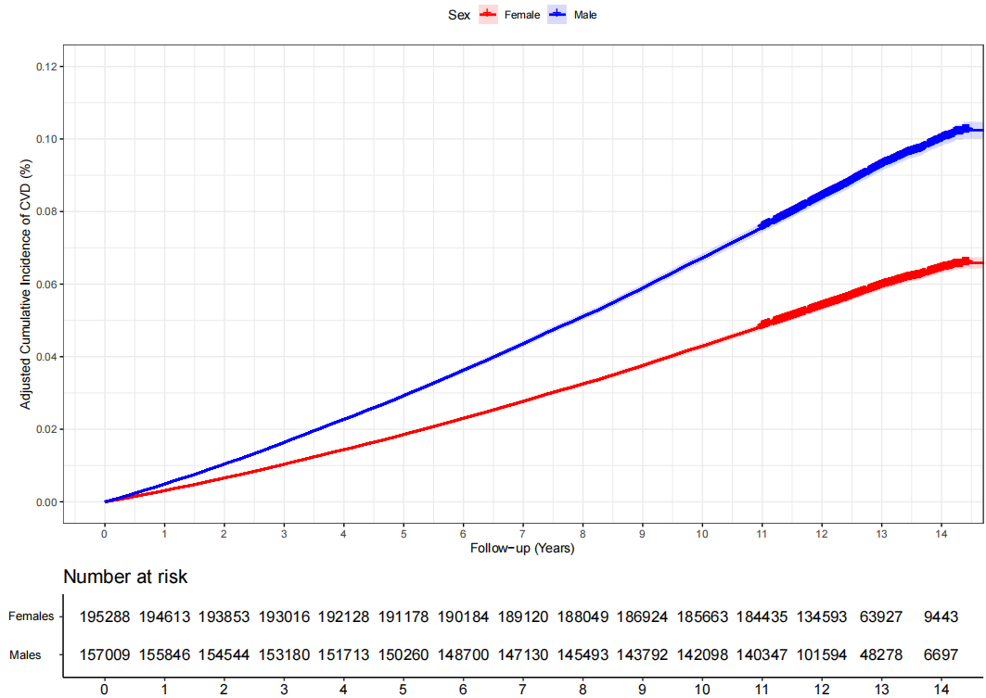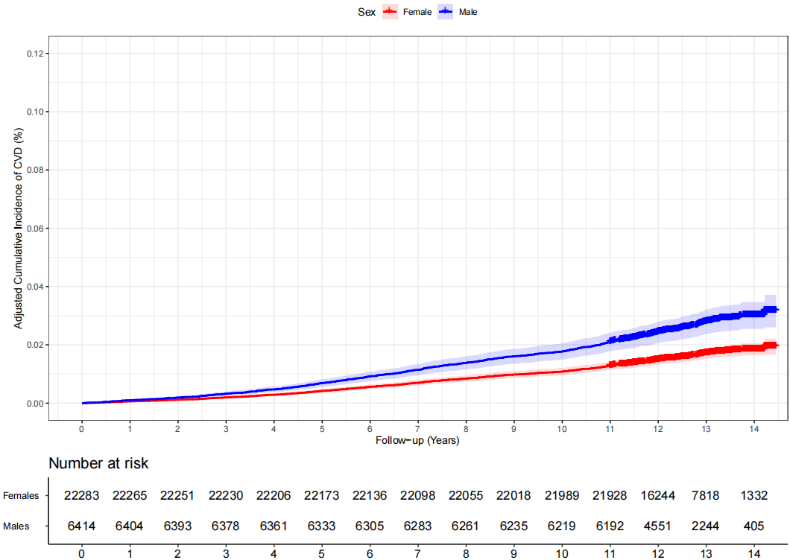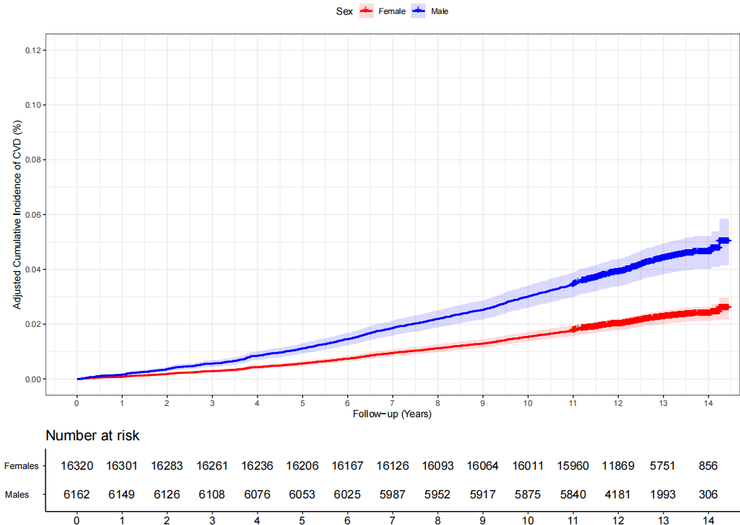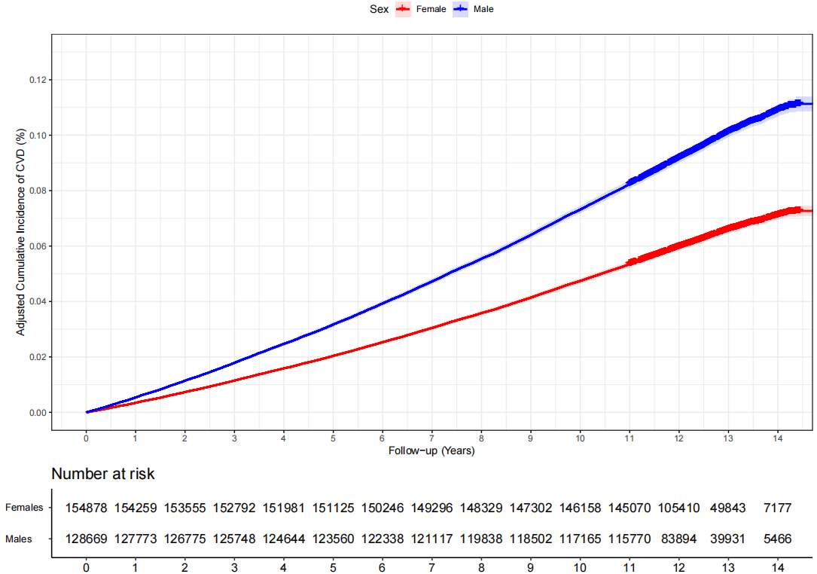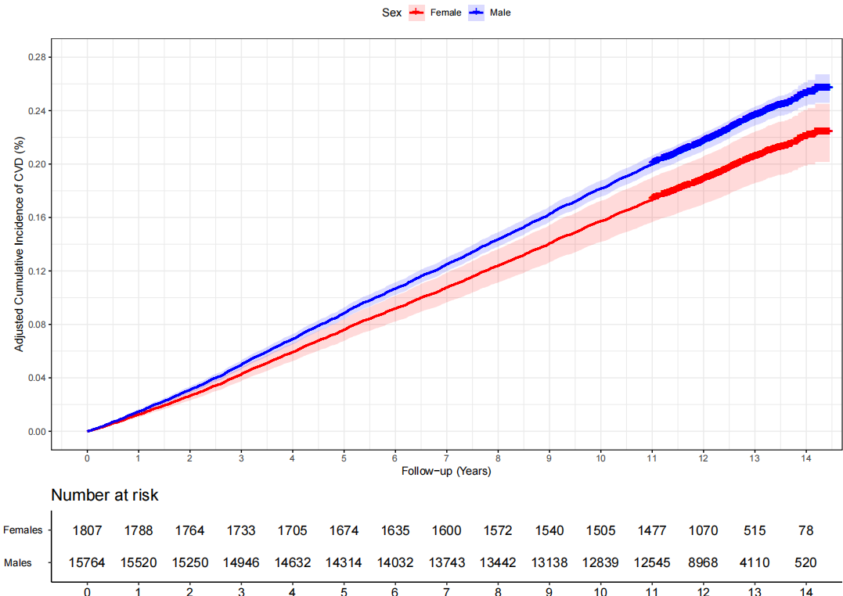
CKM Stage 0-3
CKM Stage 0
CKM Stage 1
CKM Stage 2
CKM Stage 3
(B) Results for CHARLS
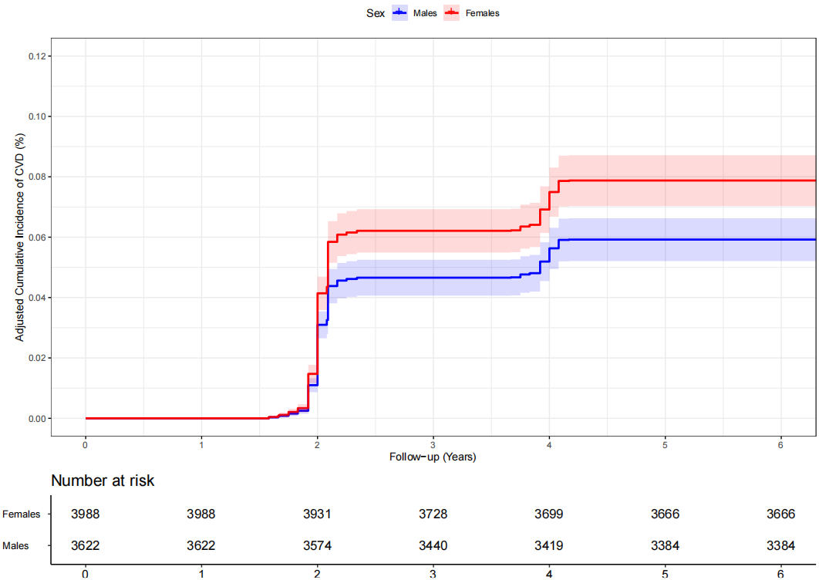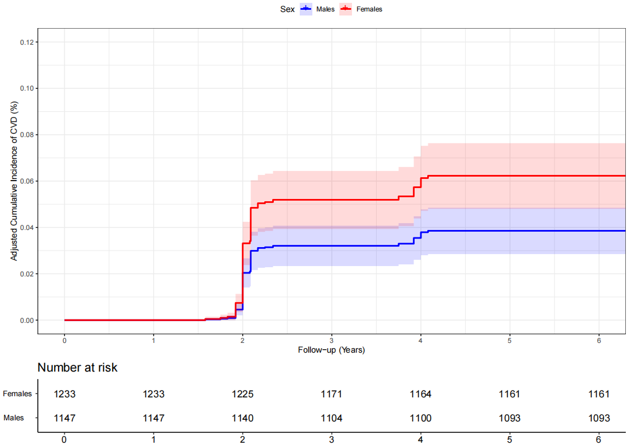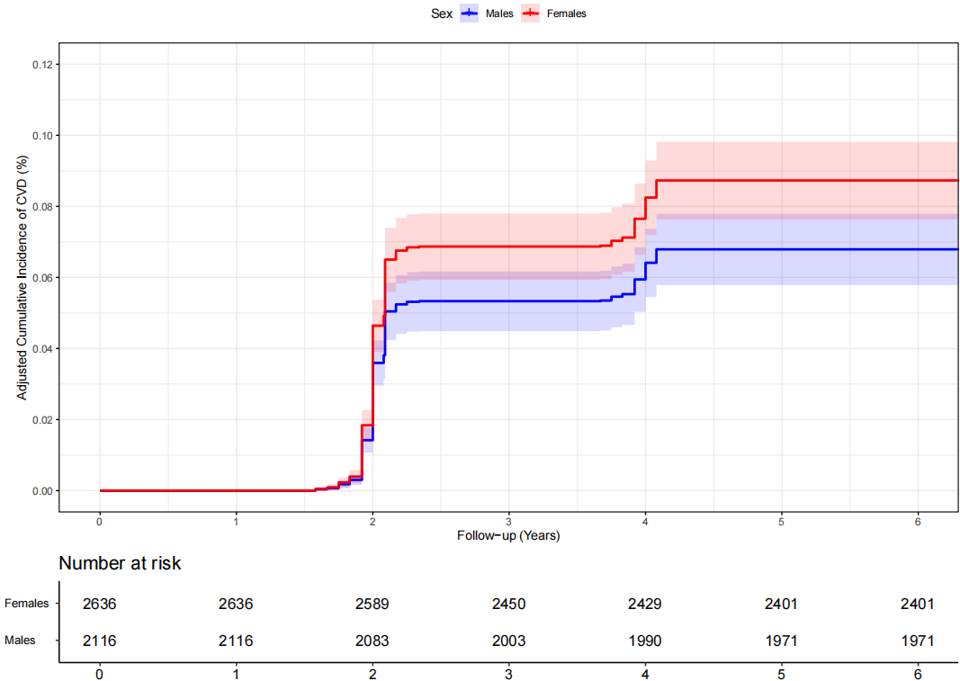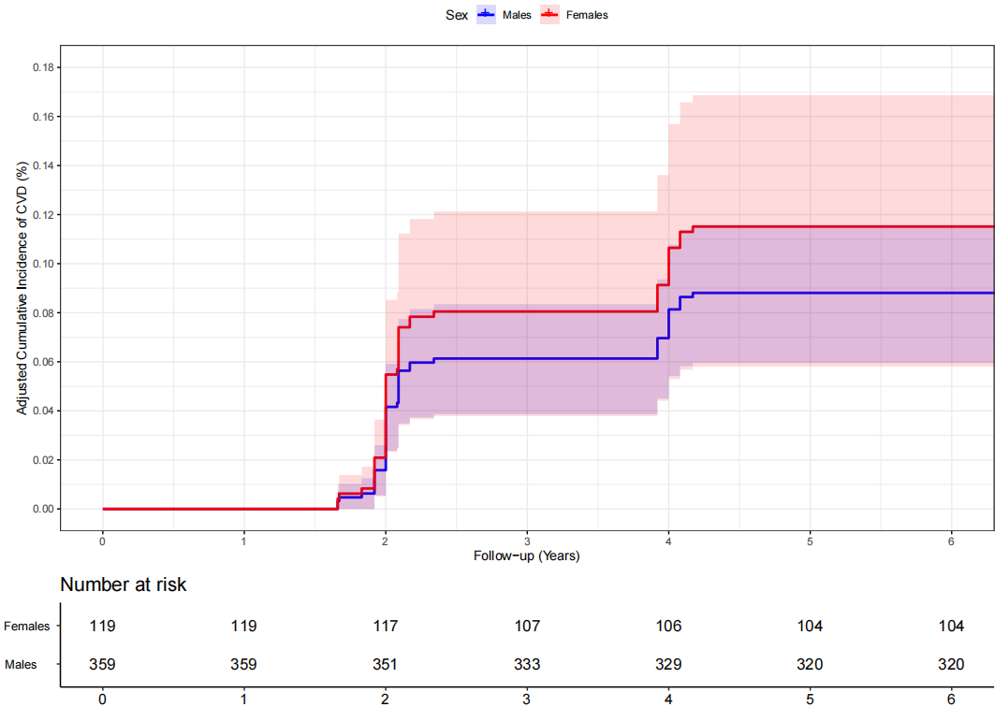
CKM Stage 0-3
CKM Stage 0-1
CKM Stage 2
CKM Stage 3
¹ Models adjusted for age, race/ethnicity (for UK Biobank only), education level, Townsend deprivation index and employment (for UK Biobank only), annual total household income and occupation (for CHARLS only), healthy diet (for UK Biobank only), healthy sleep duration, never smoking, moderate alcohol consumption, adequate physical activity, use of antihypertensive medication/diabetes medication/lipid-lowering medication, body mass index, systolic blood pressure, HbA1c, high density lipoprotein-cholesterol, triglycerides, eGFR.

Supplementary Table 11. Results of analysis of CVD risk in different sex and ethnic subgroups in patients with CKM stage 0-3 in the UK Biobank

Race/ethnicity subgroup | No. of events/total participants | Parsimonious model¹ |  | Fully-adjusted model²
Race/ethnicity subgroup | No. of events/total participants | Adjusted hazard ratio (95% CI) | P-value | Adjusted hazard ratio (95% CI) | P-value
White group (n = 332,646)
Females | 12,141/ 184,687 | Reference |  | Reference
Males | 18,341/ 147,959 | 1.98 (1.94-2.03) | <.001 | 1.97 (1.90-2.04) | <.001
Others (n = 10,208)
Females | 344/ 5,926 | Reference |  | Reference
Males | 373/ 4,282 | 1.57 (1.35-1.82) | <.001 | 1.49 (1.07-2.08) | 0.02
Asian group (n = 7,809)³
Females | 298/ 3,903 | Reference |  | Reference
Males | 584/ 3,906 | 2.11 (1.82-2.44) | <.001 | 1.90 (1.26-2.87) | <.001
For Chinese only (n = 1,145)
Females | 22/ 722 | Reference |  | Reference
Males | 18/ 423 | 1.34 (0.69-2.61) | 0.40 | 1.45 (0.28-7.47) | 0.66
¹ Model adjusted for age, education level, Townsend deprivation index in UK Biobank, adjustment of age, education level, annual total household income in CHARLS.
² Model adjusted for age, education level, Townsend deprivation index and employment (UK Biobank), annual total household income and occupation (CHARLS), healthy diet (UK Biobank), healthy sleep, never smoking, moderate alcohol consumption, adequate physical activity, use of antihypertensive medication/diabetes medication/lipid-lowering medication, body mass index, systolic blood pressure, HbA1c, high density cholesterol, triglycerides, eGFR.
³ Including 1,145 Chinese and 6,664 non-Chinese

Supplementary Table 12. Sensitivity analysis results of sex differences in CVD risks in participants with CKM stage 0-3

Sensitivity analyses | UK Biobank |  | CHARLS
Sensitivity analyses | Adjusted hazard ratio (95% CI)¹ | P-value | Adjusted hazard ratio (95% CI)¹ | P-value
Filling in the missing values of the covariates
Females | Reference |  | Reference
Males | 1.56 (1.51-1.61) | <.001 | 0.74 (0.63-0.88) | <.001
Excluding participants who developed CVD events within the first two years of follow-up
Females | Reference |  | Reference
Males | 1.74 (1.65-1.83) | <.001 | 0.70(0.59-0.84) | <.001
Excluding participants with family history of cardiovascular disease
Females | Reference |  | -² | -²
Males | 1.93 (1.75-2.12) | <.001 | -² | -²
Excluding participants younger than 45 years from the UK Biobank
Females | Reference |  | -² | -²
Males | 1.75 (1.67-1.83) | <.001 | -² | -²
Running the competing risk analysis
Females | Reference |  | Reference
Males | 1.74 (1.66-1.83) | <.001 | 0.75 (0.64-0.88) | <.001
Using propensity score matching technique
Females | Reference |  | Reference
Males | 1.52 (1.45-1.59) | <.001 | 0.74 (0.61-0.90) | 0.01
Excluding participants with any sex-specific risk enhancers
Females | Reference |  | Reference
Males | 1.75 (1.67-1.84) | <.001 | 0.69 (0.58-0.83) | <.001
¹ The model adjusted for age, race/ethnicity (for UK Biobank only), education level, Townsend deprivation index and employment (for UK Biobank only), annual total household income and occupation (for CHARLS only), healthy diet (for UK Biobank only), healthy sleep duration, never smoking, moderate alcohol consumption, adequate physical activity, use of antihypertensive medication/diabetes medication/lipid-lowering medication, body mass index, systolic blood pressure, HbA1c, high density lipoprotein-cholesterol, triglycerides, eGFR
² Data not available.

Supplementary Table 13. Comparison of adjusted hazard ratios for cardiovascular outcomes between Interval-Censored and Standard Cox Proportional Hazards Models for the CHARLS

 | No. of events/total participants | Interval-Censored Proportional Hazards Model |  | Cox proportional hazards model
 | No. of events/total participants | Adjusted hazard ratio (95% CI)¹ | P-value | Adjusted hazard ratio (95% CI)¹ | P-value
Primary outcome
For cardiovascular disease
Females | 800 / 3,988 | Reference |  | Reference
Males | 579 / 3,622 | 0.736 (0.623-0.870) | <.001 | 0.740 (0.626-0.874) | <.001
Secondary outcome
Stroke
Females | 204 / 3,988 | Reference |  | Reference
Males | 193 / 3,622 | 0.715 (0.527-0.971) | 0.031 | 0.717 (0.529-0.973) | 0.033
¹ The model adjusted for age, education level, annual total household income and occupation, healthy sleep duration, never smoking, moderate alcohol consumption, adequate physical activity, use of antihypertensive medication/diabetes medication/lipid-lowering medication, body mass index, systolic blood pressure, HbA1c, high density lipoprotein-cholesterol, triglycerides, eGFR.

Supplementary Table 14. Comparison of adjusted hazard ratios for cardiovascular outcomes between IPCW-weighted Cox models and standard Cox proportional hazards models for the CHARLS

 | No. of events/total participants | IPCW Weighted Model |  | Unweighted model
 | No. of events/total participants | Adjusted hazard ratio (95% CI)¹ | P-value | Adjusted hazard ratio (95% CI)¹ | P-value
Primary outcome
For cardiovascular disease
Females | 800 / 3,988 | Reference |  | Reference
Males | 579 / 3,622 | 0.768 (0.659-0.894) | <.001 | 0.761 (0.643-0.901) | <.001
Secondary outcome
Stroke
Females | 204 / 3,988 | Reference |  | Reference
Males | 193 / 3,622 | 0.723 (0.549- 0.953) | 0.031 | 0.720 (0.530-0.978) | 0.033
¹ The model adjusted for age, education level, annual total household income and occupation, healthy sleep duration, never smoking, moderate alcohol consumption, adequate physical activity, use of antihypertensive medication/diabetes medication/lipid-lowering medication, body mass index, systolic blood pressure, HbA1c, high density lipoprotein-cholesterol, triglycerides, eGFR.

Supplementary Table 15. E-values for the associations between sex and cardiovascular disease in participants with CKM Stage 0-3 in UK Biobank and CHARLS*

 | Point estimate of E-value | Low limit of estimated E-value
UK Biobank
Primary outcome
Cardiovascular disease | 3.19 | 3.14
Secondary outcomes
Coronary heart disease | 3.30 | 3.22
Myocardial infarction | 4.57 | 4.44
Stroke | 2.30 | 2.21
CHARLS
Primary outcome
Cardiovascular disease | 2.05 | 1.56
Secondary outcomes
Stroke | 2.15 | 1.21
* The E-value quantifies the minimum strength of association that an unmeasured confounder would need to have with both the exposure (sex) and the outcome (e.g., CVD), conditional on the measured covariates, to explain away the observed association (i.e., reducing the hazard ratio to 1.0). The lower limit for the estimated E-value represents the minimum strength of unmeasured confounding required to shift the confidence interval to include the null value. Larger E-values indicate that the observed association is more robust to unmeasured confounding.

Supplementary Table 16. Sex differences in risk of incident cardiovascular disease in participants with different CKM syndrome stages defined by the China-PAR risk equation for the CHARLS

CKM stage | Sex group | Fully-adjusted model¹
CKM stage | Sex group | Adjusted hazard ratio (95% CI) | P-value | P for interaction
CHARLS (n = 7,610, including 3,988 females and 3,622 males)
For cardiovascular disease |  |  |  | 0.96
Stage 0-1 | Females | Reference | -
Stage 0-1 | Males | 0.59 (0.40-0.86) | 0.01
Stage 2 | Females | Reference | -
Stage 2 | Males | 0.77 (0.62-0.96) | 0.02
Stage 3 | Females | Reference | -
Stage 3 | Males | 0.69 (0.51-0.93) | 0.02
For stroke |  |  |  | 0.86
Stage 0-1 | Females | Reference | -
Stage 0-1 | Males | 0.72 (0.35-1.46) | 0.01
Stage 2 | Females | Reference | -
Stage 2 | Males | 0.85 (0.55-1.31) | 0.46
Stage 3 | Females | Reference | -
Stage 3 | Males | 0.68 (0.39-1.19) | 0.18
¹ The model adjusted for age, education level, annual total household income and occupation, healthy sleep duration, never smoking, moderate alcohol consumption, adequate physical activity, use of antihypertensive medication/diabetes medication/lipid-lowering medication, body mass index, systolic blood pressure, HbA1c, high density lipoprotein-cholesterol, triglycerides, eGFR.

Supplementary Figure 7. Subgroup analysis results of sex differences in CVD risks by socioeconomic status and healthy lifestyle score

(A) Results for UK Biobank
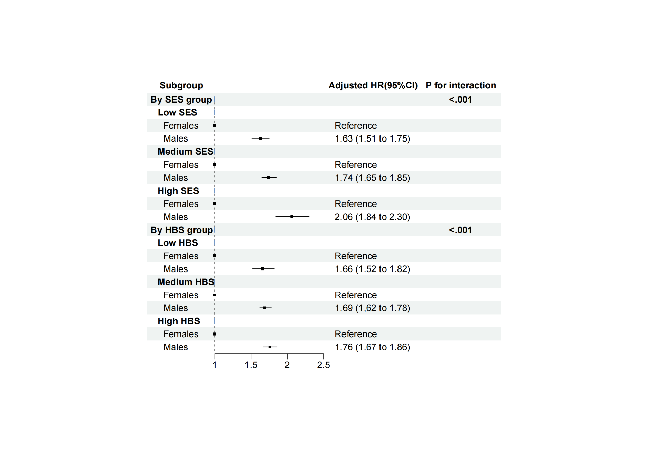
(B) Results for CHARLS
