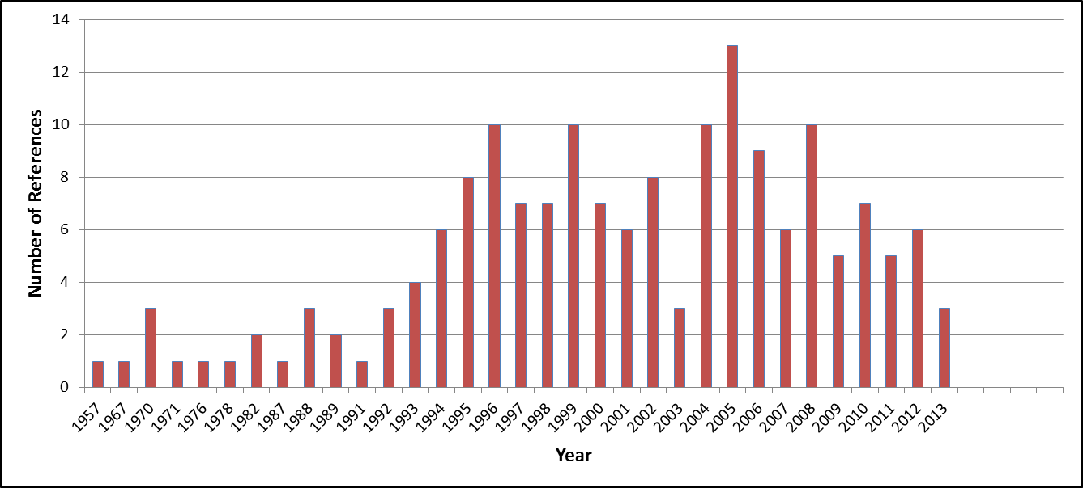

Journal | Count
Journal of Natural Products | 49
Phytochemistry | 32
Journal of Ethnopharmacology | 13
Tetrahedron Letters | 9
Tetrahedron | 9
Biochemical Systematics and Ecology | 6
South African Journal of Botany | 5
Theses | 5
Bioorganic & Medicinal Chemistry Letters | 4
Canadian Journal of Chemistry | 4
South African Journal of Chemistry | 3
Chemical Communications | 2
Helvetica Chimica Acta | 2
Journal of the American Chemical Society | 2
Natural Product Research | 2
South African Journal of Science | 2
The Journal of Organic Chemistry | 2
Annals of the New York Academy of Sciences | 1
Bioorganic & Medicinal Chemistry | 1
Book Chapters | 1
Cancer Cell International | 1
Chemical and Pharmaceutical Bulletin | 1
Experientia | 1
Fitoterapia | 1
Journal of Medicinal Chemistry | 1
Journal of Pharmacy and Pharmacology | 1
Journal of the Chemical Society | 1
Life Sciences | 1
Molecules | 1
Narurforsch | 1
Natural Product Letters | 1
Organic Letters | 1
Phytochemical communication | 1
Plant Medica | 1
Steroids | 1
The Journal of Biological Chemistry | 1

