Compilation and Operation manual (ChemEngine)
========================
BUILD OUTPUT DESCRIPTION
========================

When you build an Java application project that has a main class, the IDE
automatically copies all of the JAR
files on the projects classpath to your projects dist/lib folder. The IDE
also adds each of the JAR files to the Class-Path element in the application
JAR files manifest file (MANIFEST.MF).

To run the project from the command line, go to the dist folder and
type the following:

java -jar "ChemEngine.jar"

To distribute this project, zip up the dist folder (including the lib folder)
and distribute the ZIP file.

Notes:

To compile and execute the program please follow the steps:

1) Download ChemEngine_source.zip

unzip to ChemEngine folder

2) Download lib.zip folder

unzip all the jar files to ChemEngine\lib folder

open the ChemEngine project in Netbeans

Select all the libraries (jars) from lib folder

ChemEngine>Project properties>Libraries>Add Jar/folders > OK

ChemEngine>Source Packages>chemengine>ChemEngineGUI (Run)

To Transform PDF to Molecules in GUI

Select the pdf file and click

* If two JAR files on the project classpath have the same name, only the first
JAR file is copied to the lib folder.
* Only JAR files are copied to the lib folder.
If the classpath contains other types of files or folders, these files (folders)
are not copied.
* If a library on the projects classpath also has a Class-Path element
specified in the manifest,the content of the Class-Path element has to be on
the projects runtime path.
* To set a main class in a standard Java project, right-click the project node
in the Projects window and choose Properties. Then click Run and enter the
class name in the Main Class field. Alternatively, you can manually type the
class name in the manifest Main-Class element.

Figure-1: Netbean interface for compiling ChemEngine
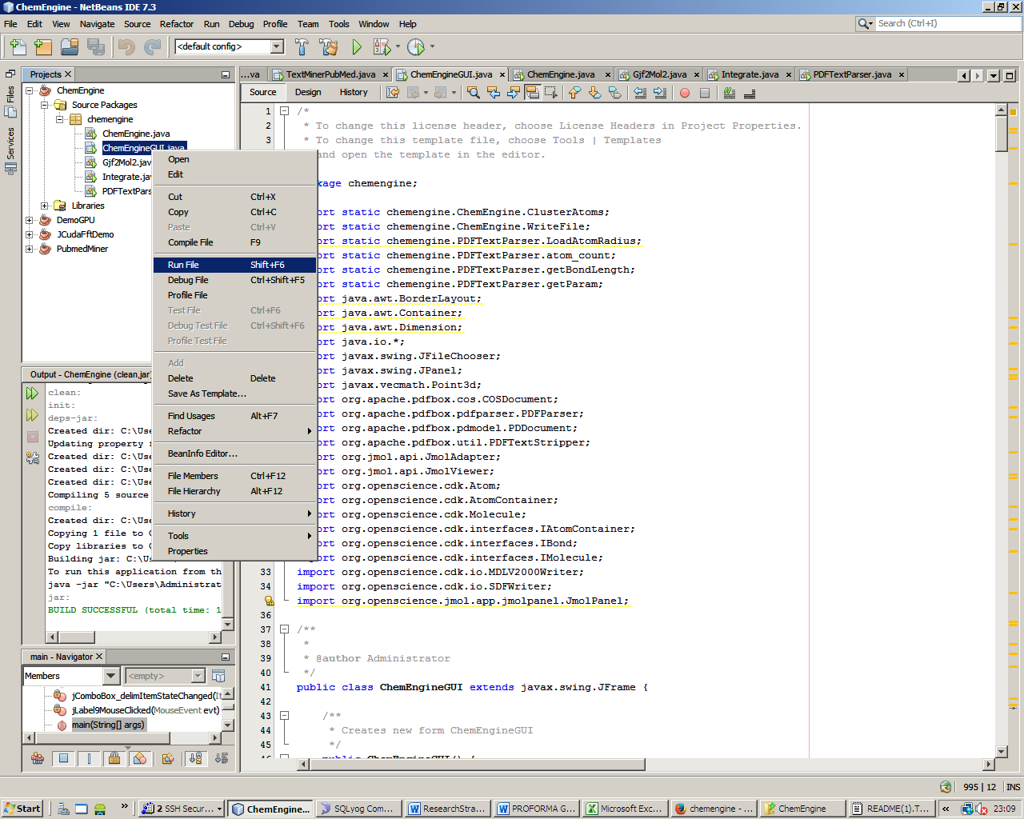
Figure-2: User Interface of ChemEngine (Browse and select PDF file) with default regular expression
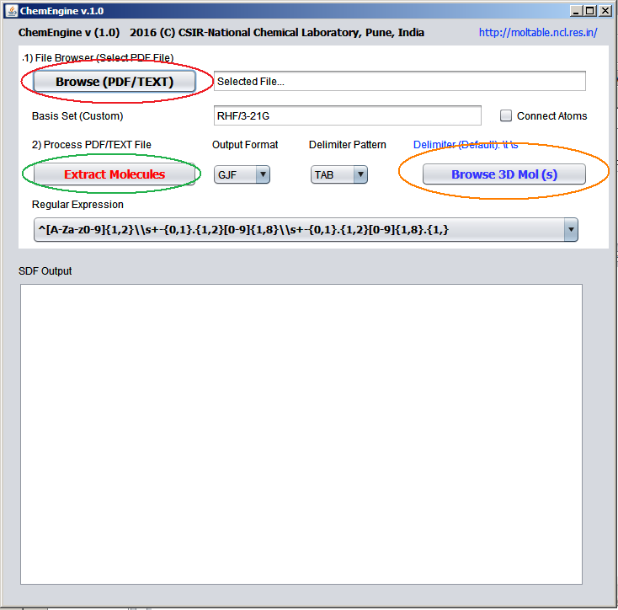
Figure-3; Select the Pdf file
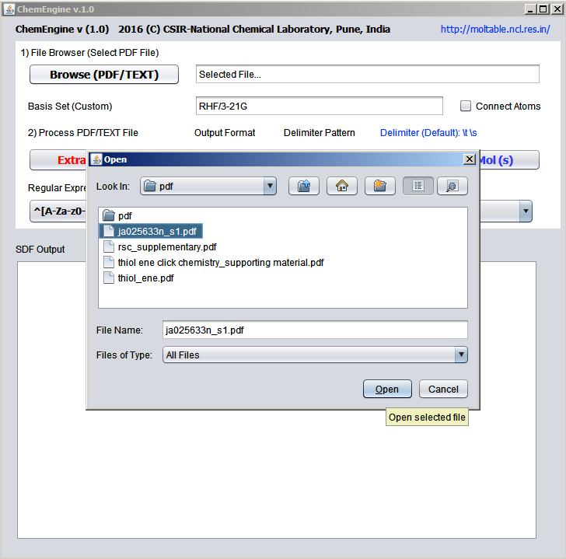
Figure-4: Select and click the button Extract Molecules to process the data from the selected pdf file
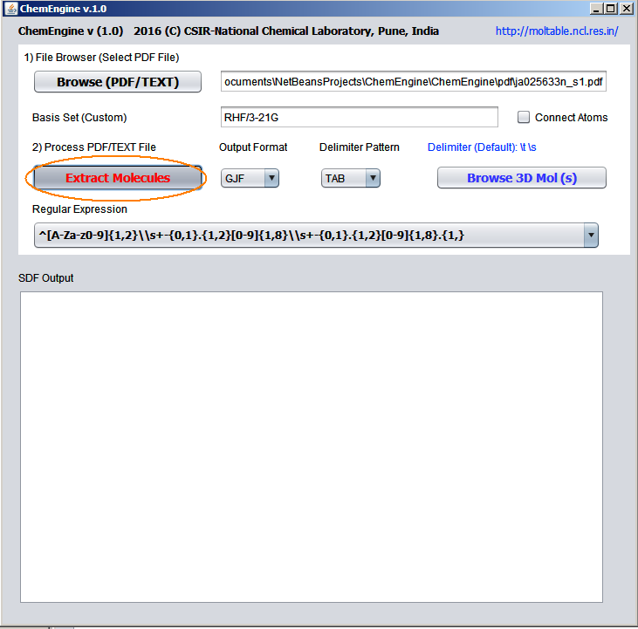
Figure-5: The generated SDF files are displayed in the Text Area
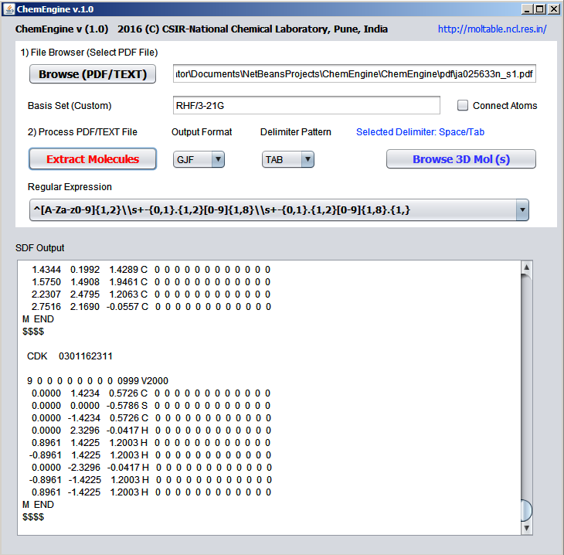
Figure-6: On click of Browse 3D mol(s) button, the output 3D molecules are displayed in the Jmol interface
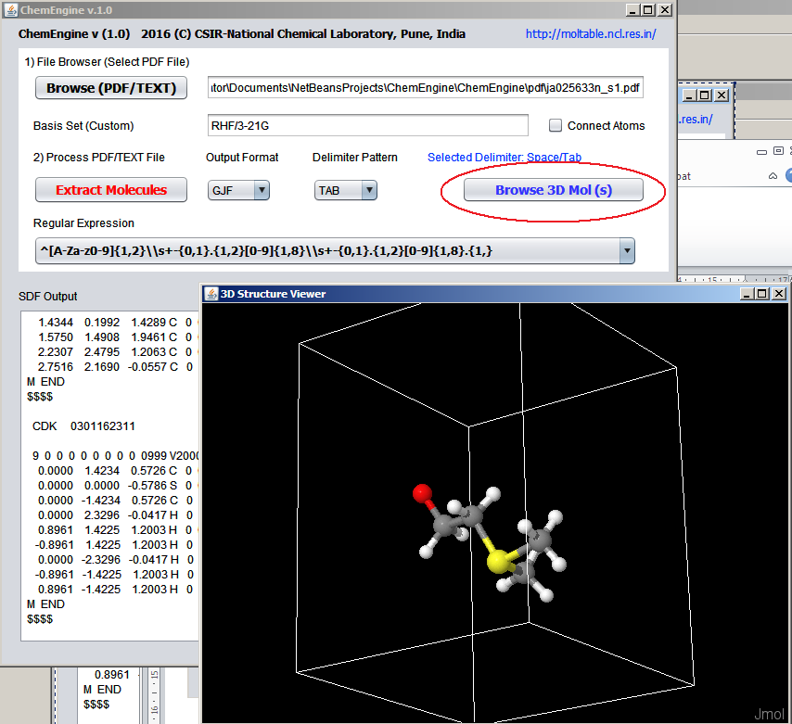

Contact:
Dr M Karthikeyan
karthincl@gmail.com
http://moltable.ncl.res.in/

