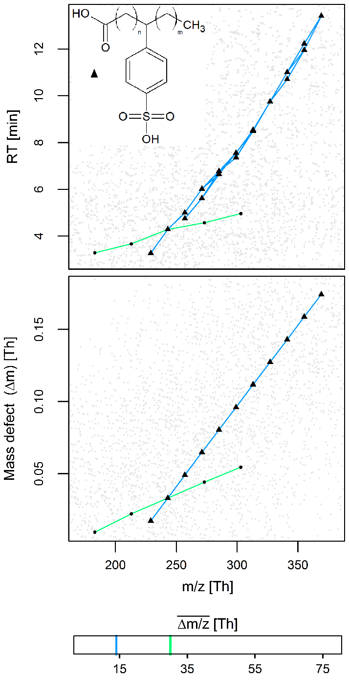

Figure S2. Peaks of 18 partly isobaric homologues of the SPAC surfactant (black triangles, molecular structure in top panel) and the resulting 31 superjacent series detected at $\overline{∆m/z}$ ≈ 14.016 Th (blue lines). Note that these series and isobaric peaks overlay each other in the lower panel. Another yet unidentified series at $\overline{∆m/z}$ ≈ 30.011 Th intersects with one SPAC homologue and may indicate the existence of homologue units other than CH₂ (green line). All other peaks are shown in gray.

