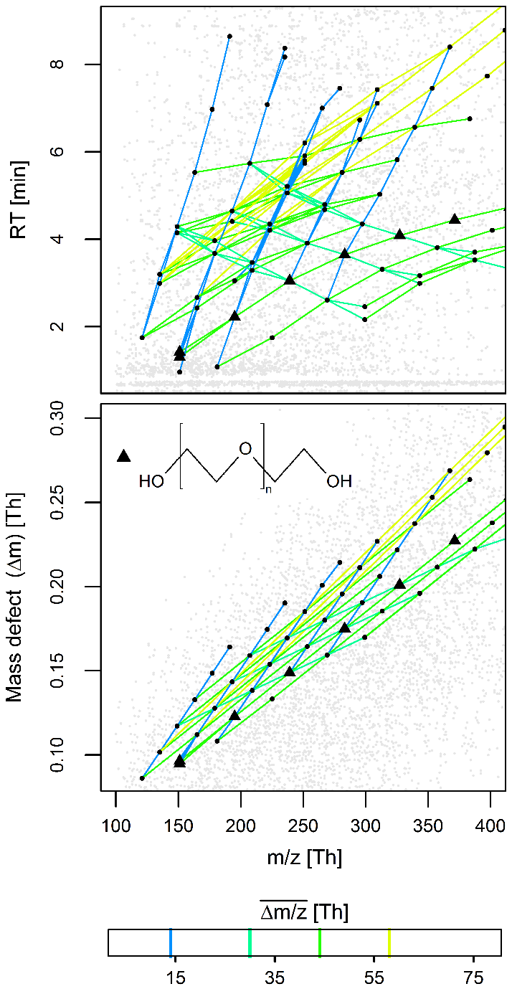

Figure S3. Meshed structure of yet unidentified series peaks (black dots) relatable through mass differences of $\overline{∆m/z}$ = 14.016, 30.011, 44.026 and 58.042 Th to an identified PEG series (black triangles, molecular structure shown in the lower panel). All other measured peaks are shown in gray. The series were selected from SOM nodes 6-11 of Figure 2 (main text) and Figure S-4 (Additional file 13), e.g., the pairs of series with $\overline{∆m/z}$ = 30.011 and 44.026 Th map onto SOM node 6 whereas pairs of series with $\overline{∆m/z}$ = 14.016 and 58.042 Th map onto other SOM regions such as node 4.

