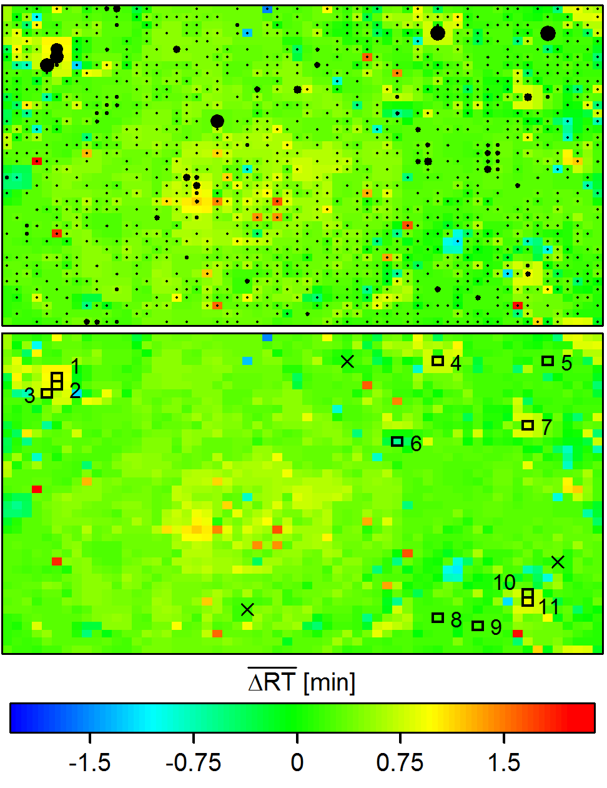

Figure S4. SOM results for all series pairs detected in the STP sample with ID=1 (positive mode), complementing Figure 2 in the main article. Coloring of top and bottom panels depict the $\overline{∆{RT}_{x}}$ and $\overline{∆{RT}_{y}}$ values at the SOM grid nodes, respectively. Sizes of the black dots in the top panel indicate frequencies of monoisotopic series pairs mapped onto the nodes. In turn, black squares in the bottom panel either indicate the three nodes with highest frequencies at low intersection angles (θ<0.08π, nodes 1-3) or nodes with highest mapping frequencies containing 50% of all monoisotopic series pairs at large intersection angles (θ≥0.08π, nodes 4-11). The series mapped onto the latter nodes are shown in Figure 3. Moreover, crosses highlight the mapping nodes of the superjacent series shown in Figure S-6 (Additional File 15).

