Molecular structures enumeration and virtual screening in the chemical space with RetroPath2.0

Mathilde Koch¹, Thomas Duigou¹, Pablo Carbonell², Jean-Loup Faulon^{1,2,3,*}
1 Micalis Institute, INRA, AgroParisTech, Université Paris-Saclay, 78350 Jouy-en-Josas, France
2 SYNBIOCHEM Centre, Manchester Institute of Biotechnology, University of Manchester, Manchester, UK
3 CNRS-UMR8030 / Laboratoire iSSB, Université Paris-Saclay, Évry 91000, France
*: Corresponding author
Mathilde Koch, Micalis, Institut National de la Recherche Agronomique, Domaine de Vilvert, 78352 Jouy-en-Josas, France; E-mail address: mathilde.koch@inra.fr
Thomas Duigou, Micalis, Institut National de la Recherche Agronomique, Domaine de Vilvert, 78352 Jouy-en-Josas, France; E-mail address: thomas.duigou@inra.fr
Pablo Carbonell, SYNBIOCHEM Centre, Manchester Institute of Biotechnology, University of Manchester, 131 Princess Street Manchester M1 7DN, UK; E-mail address: pablo.carbonell@manchester.ac.uk
Jean-Loup Faulon, Micalis, Institut National de la Recherche Agronomique, Domaine de Vilvert, 78352 Jouy-en-Josas, France; E-mail address: jean-loup.faulon@inra.fr

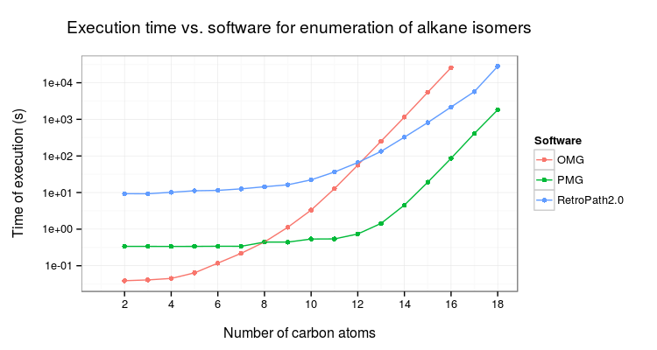
Figure S1 : Execution time for each tested software on the enumeration of alkane isomers.

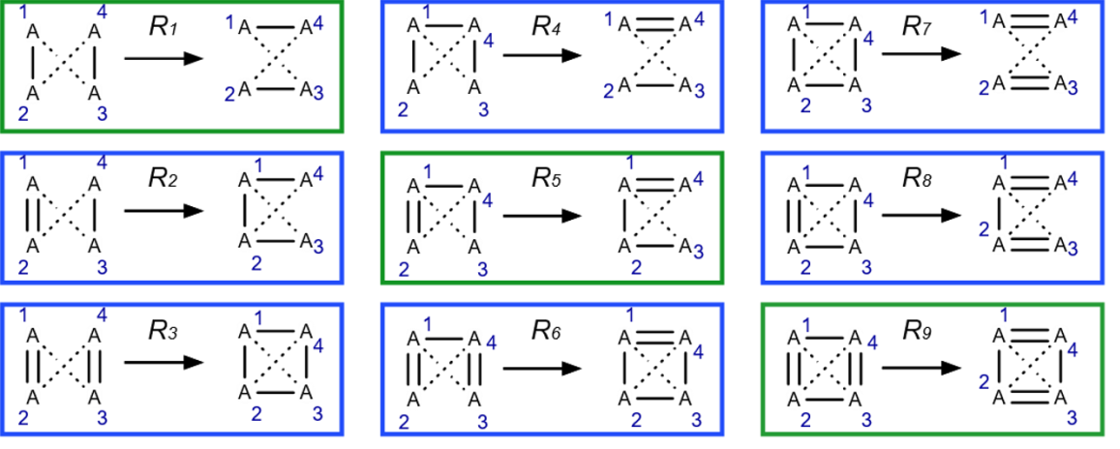

Figure S2. Isomer transformation rule set. Reduced set excluding triple bonds. Reactions in green move bonds around without creating or deleting cycles. Reactions in blue change bond order by creating or deleting at least one cycle. To each reaction corresponds a reverse reaction. The reverse reaction of R₁ is R₁, for R₂ it is R₄, for R₃ : R₇, for R₅: R₅, for R₆ : R₈ and the reverse reaction of R₉ is R₉. The bond order a₁₃ and a₂₄ can take any value from 0 to 3.

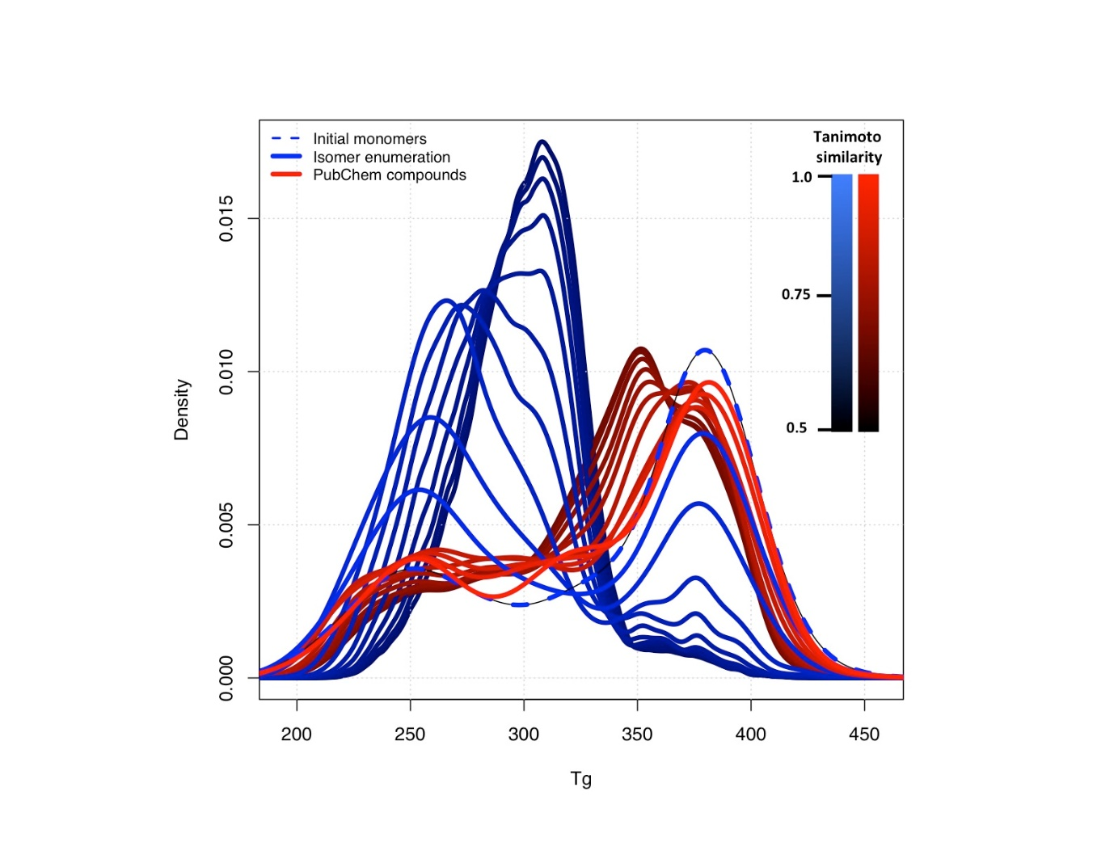
Figure S3: Distributions of predicted T_{g} values for enumerated isomers and for isomers found in PubChem with varying Tanimoto threshold. Distribution of predicted polymer glass transition temperature T_{g} for enumerated isomers and for isomers found in Pubchem of a reference set of 158 monomers with a Tanimoto similarity greater than a threshold varying between 0.5 and 1.

