Supporting Information
Molecular generative model based on conditional variational autoencoder for de novo molecular design
Jaechang Lim¹, Seongok Ryu¹, Jinwoo Kim¹, and Woo Youn Kim^{1,2}
¹Department of Chemistry, KAIST, 291 Daehak-Ro, Yuseong-Gu, Daejeon, 34141, Republic of Korea
²KI for Artificial Intelligence, KAIST 291 Daehak-ro, Yuseong-gu, Daejeon, Republic of Korea

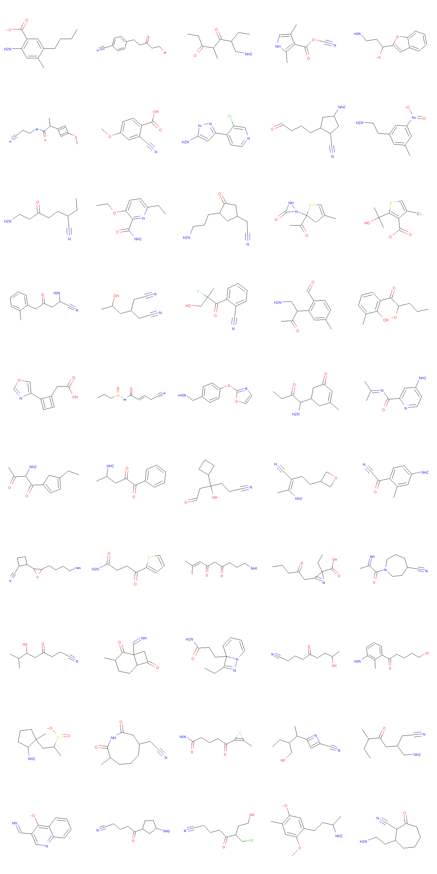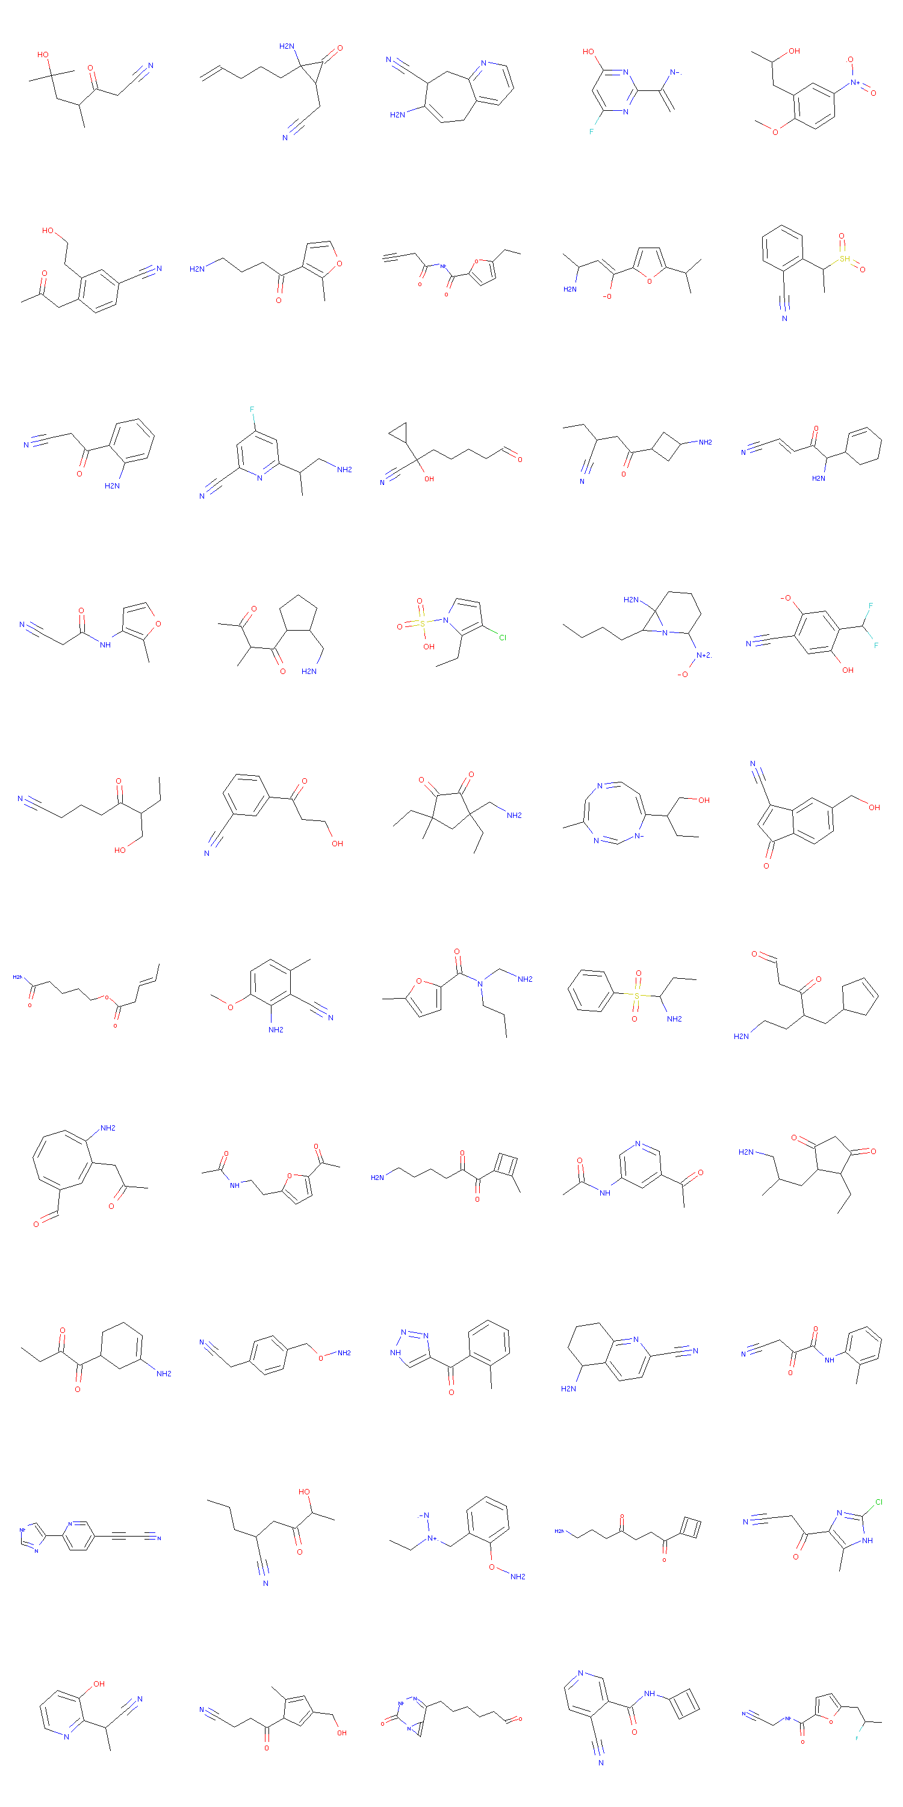
Figure 1S. 100 molecules whose 5 properties are same as those of Aspirin
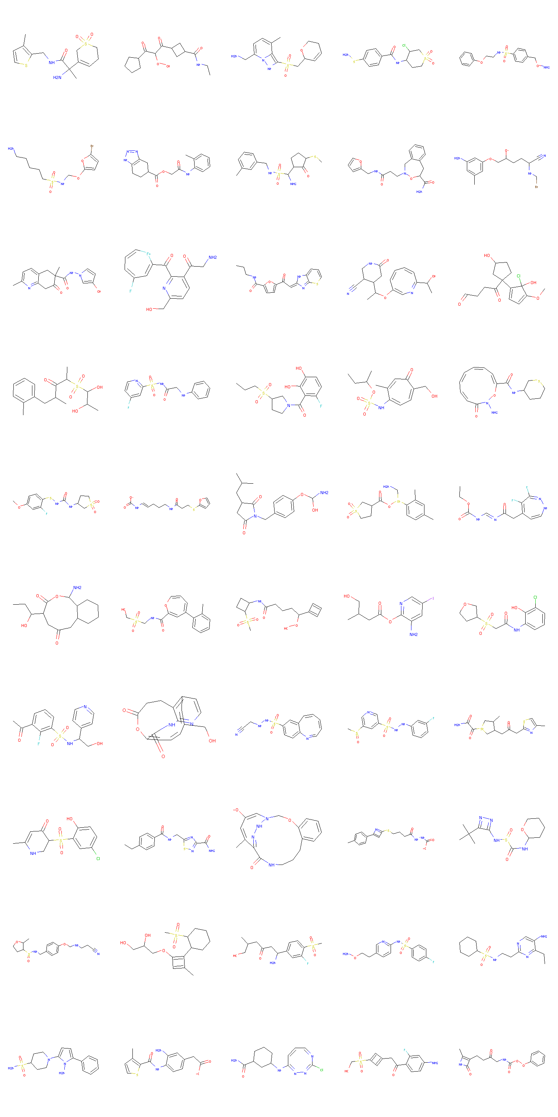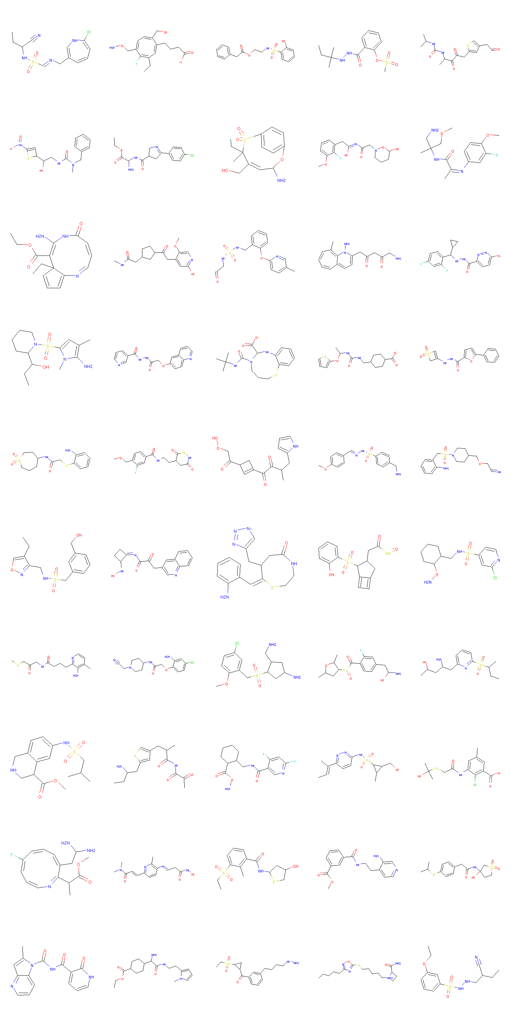
Figure 2S. 100 molecules whose 5 properties are same as those of Tamiflu
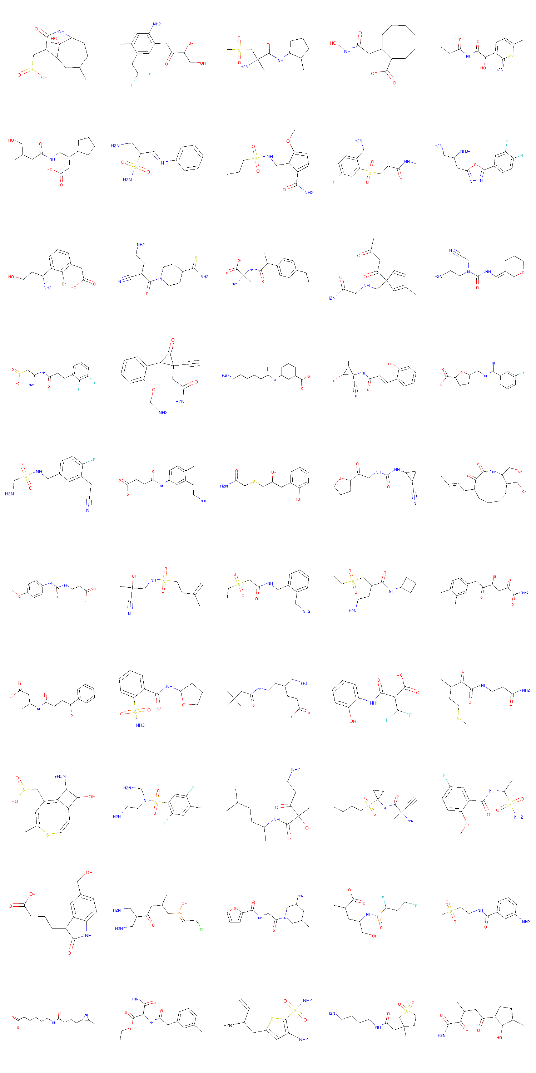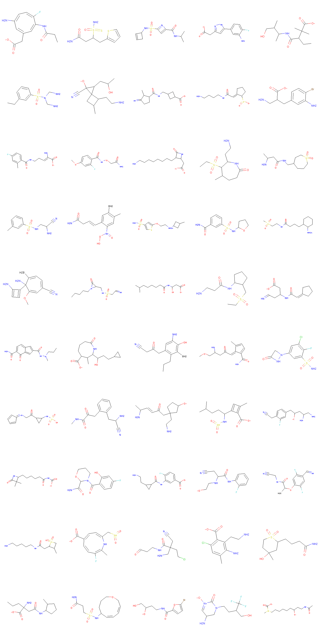
Figure 3S. 100 molecules whose 5 properties are same as those of Lenalidomide
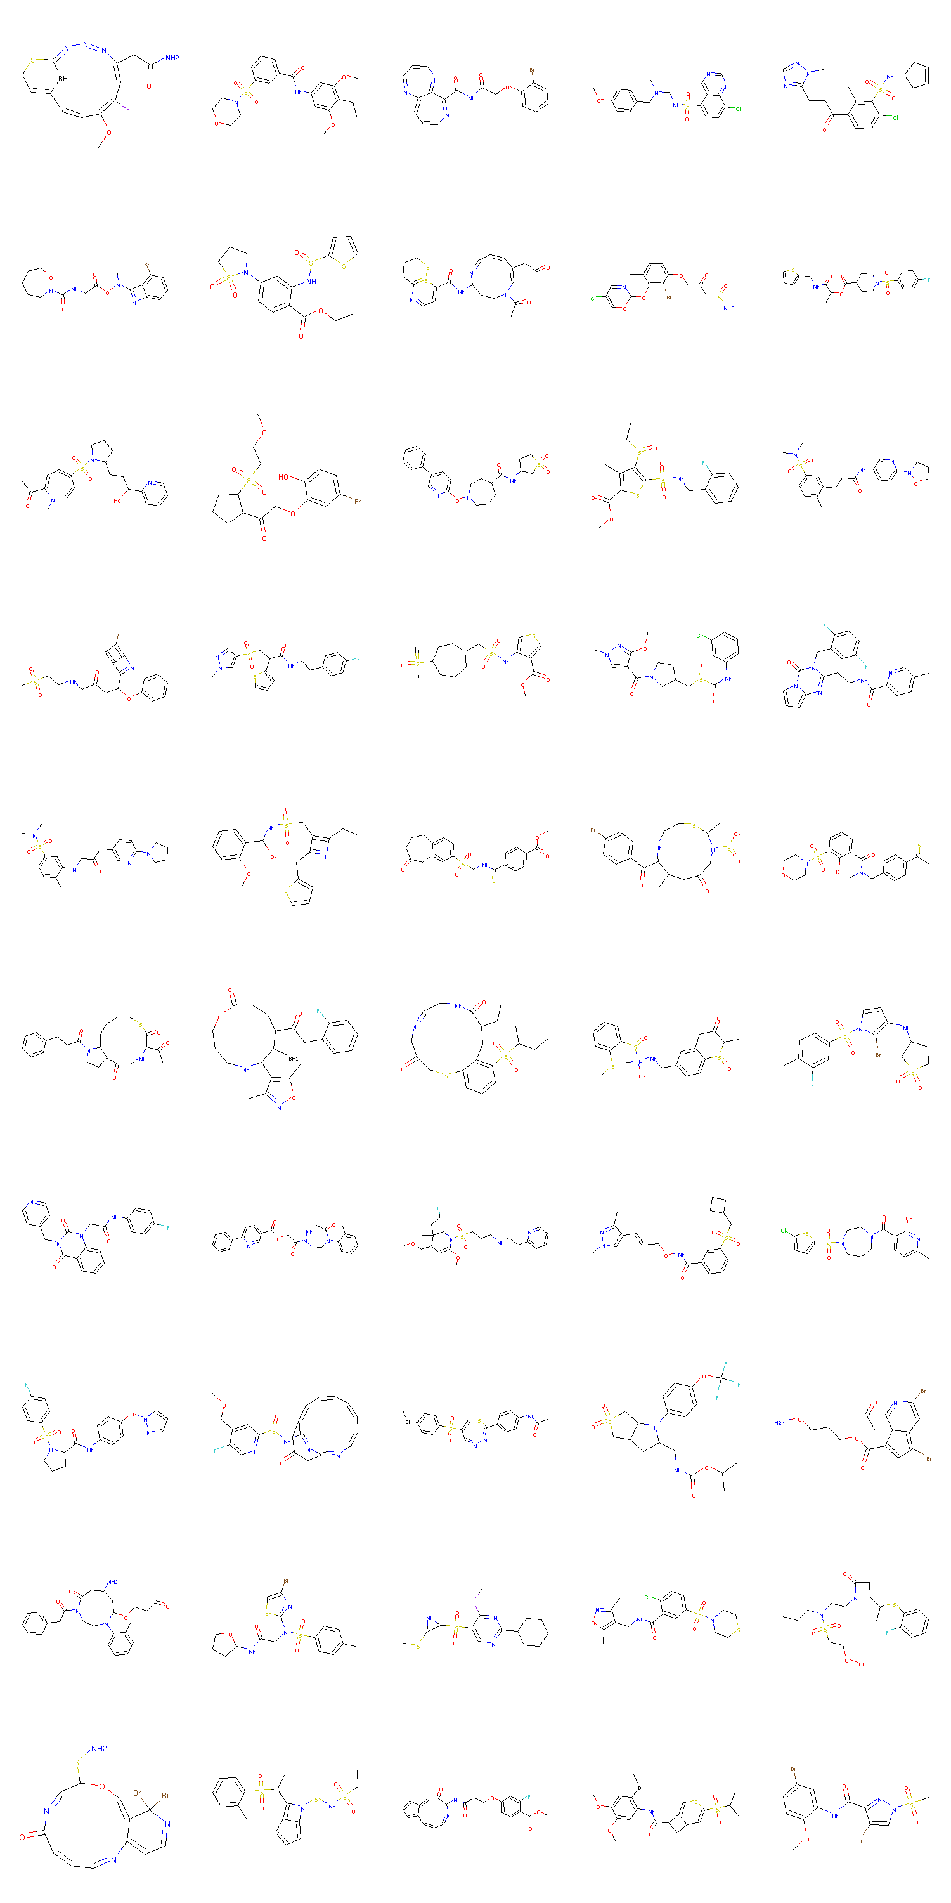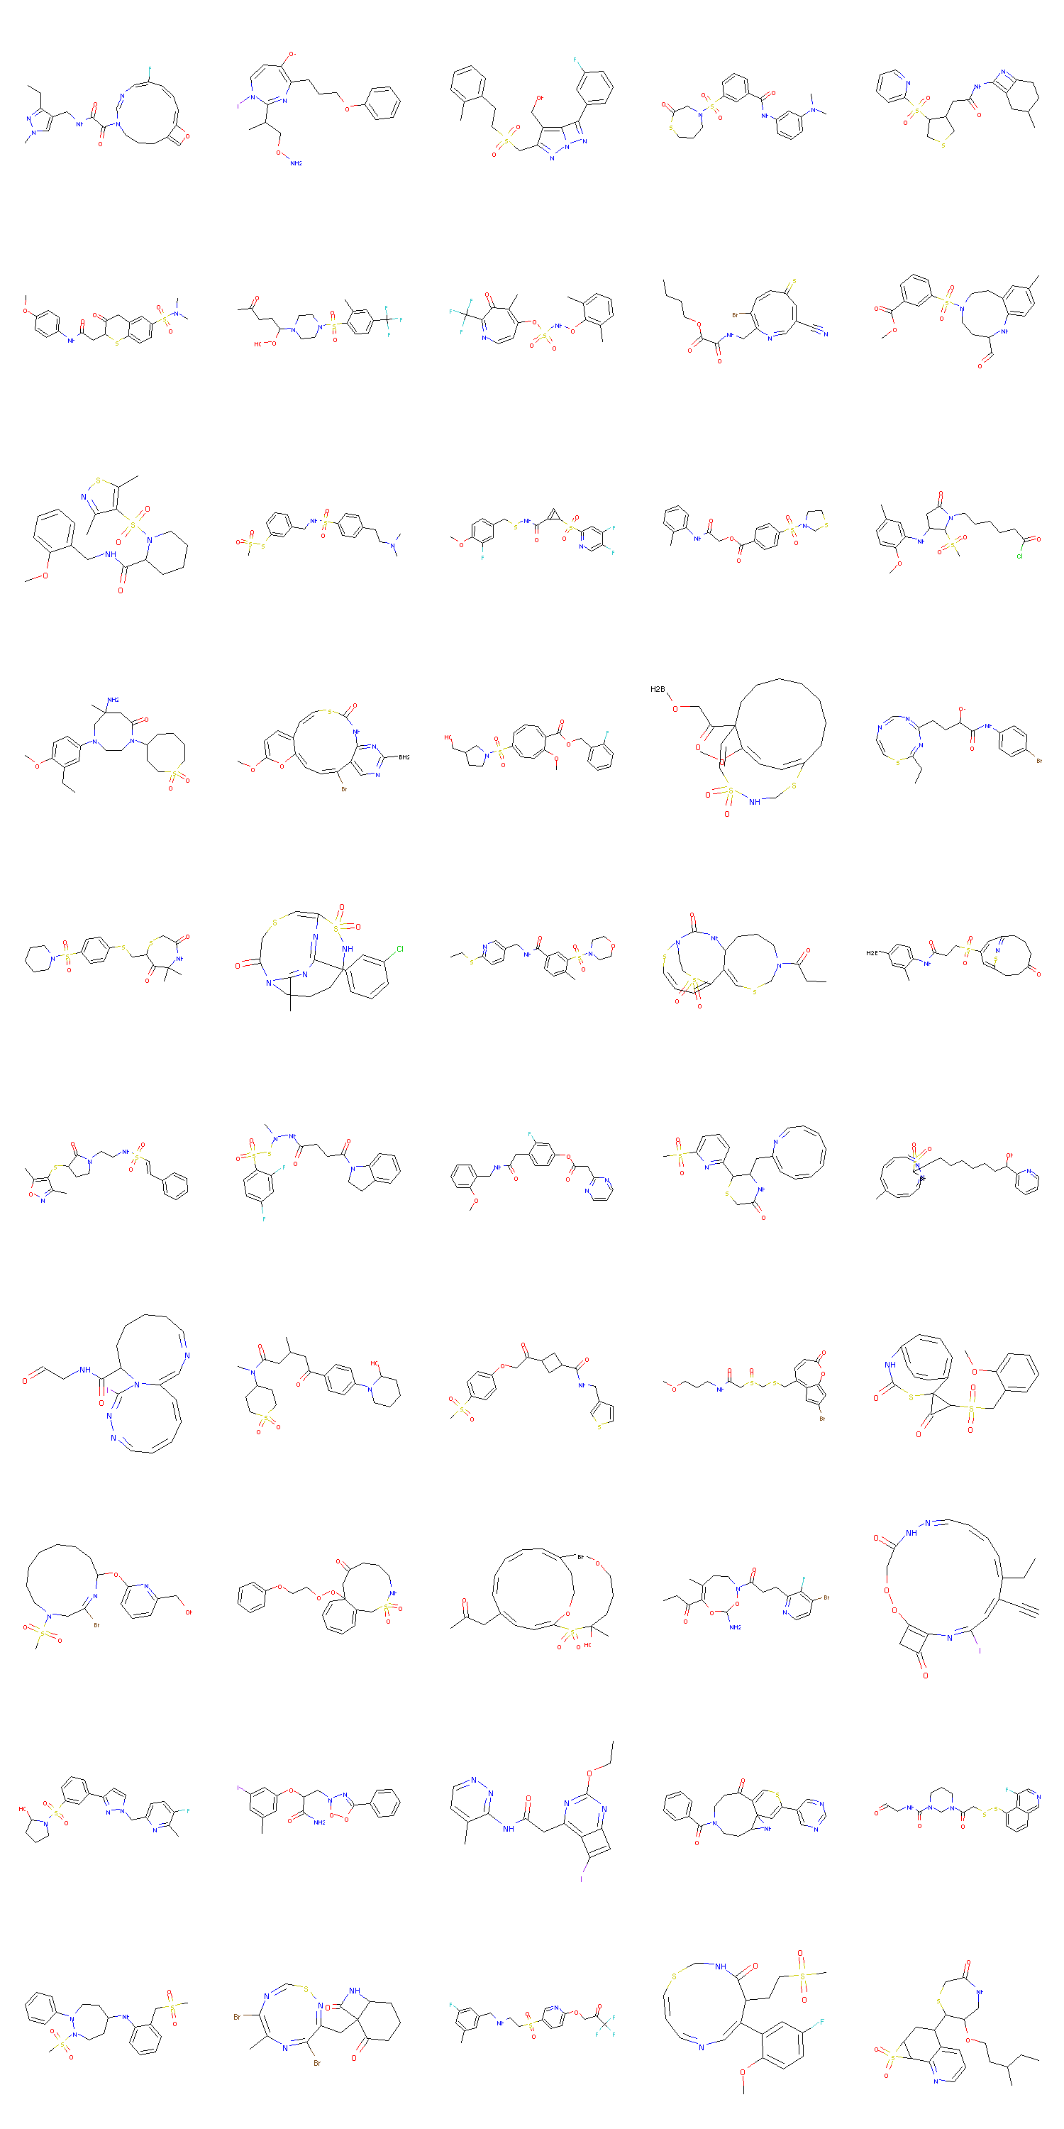
Figure 4S. 100 molecules whose 5 properties are same as those of Rivaroxaban
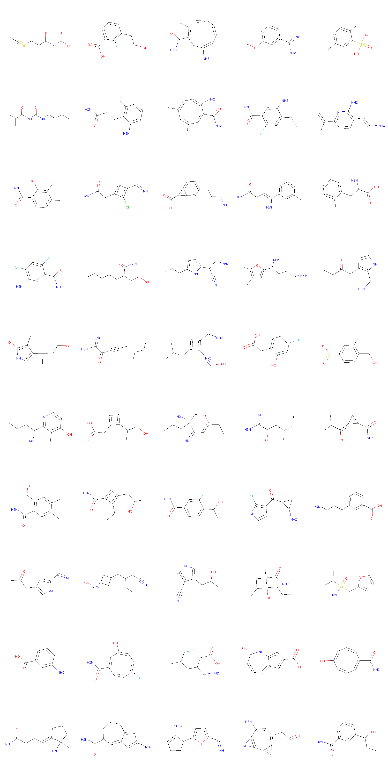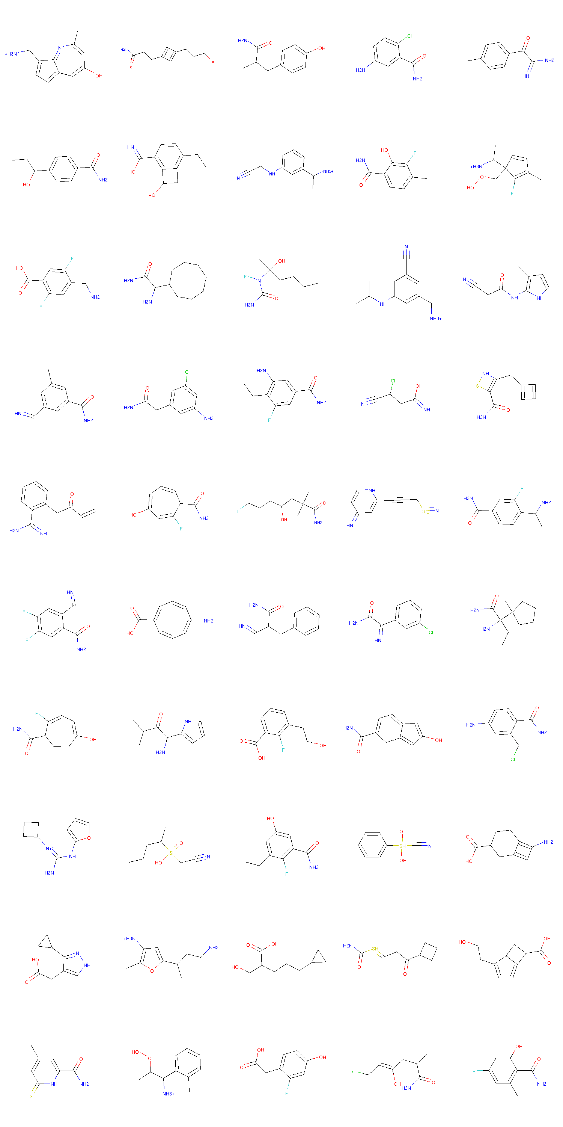
Figure 5S. 100 molecules whose 5 properties are same as those of Pregalalin

