Additional File 5, 4 Figures, 1 Table

“MS-Ready” structures for non-targeted high-resolution mass spectrometry screening studies
Andrew D. McEachran^{1,2*}, Kamel Mansouri^{1,2,3}, Chris Grulke², Emma L. Schymanski⁴, Christoph Ruttkies⁵ and Antony J. Williams^{2*}

¹Oak Ridge Institute for Science and Education (ORISE) Research Participation Program, U.S. Environmental Protection Agency, 109 T.W. Alexander Dr., Research Triangle Park, NC 27711 USA
²National Center for Computational Toxicology, Office of Research and Development, U.S. Environmental Protection Agency, 109 T.W. Alexander Dr., Research Triangle Park, NC 27711 USA
³ Current address: Integrated Laboratory Systems, Inc., 601 Keystone Dr, Morrisville, NC 27650, USA
⁴Luxembourg Centre for Systems Biomedicine (LCSB), University of Luxembourg, 6, avenue du Swing, L-4367 Belvaux, Luxembourg.
⁵Department of Stress and Development Biology, Leibniz Institute of Plant Biochemistry (IPB), Weinberg 3, 06120 Halle (Saale), Germany.

Email addresses:
Kamel Mansouri: kamel.mansouri@nih.gov
Chris Grulke: grulke.chris@epa.gov
Emma L. Schymanski: emma.schymanski@uni.lu
Christoph Ruttkies: christoph.ruttkies@ipb-halle.de

Andrew D. McEachran
mceachran.andrew@epa.gov
Mail Drop D143-02
109 T.W. Alexander Dr.
Research Triangle Park, NC 27711 USA
Phone: 1-919-541-3001

Antony J. Williams
williams.antony@epa.gov
Mail Drop D143-02
109 T.W. Alexander Dr.
Research Triangle Park, NC 27711 USA
Phone: 1-919-541-1033

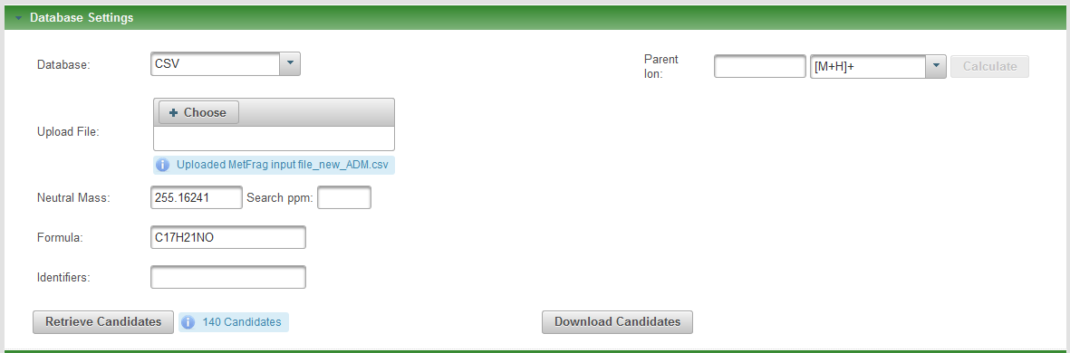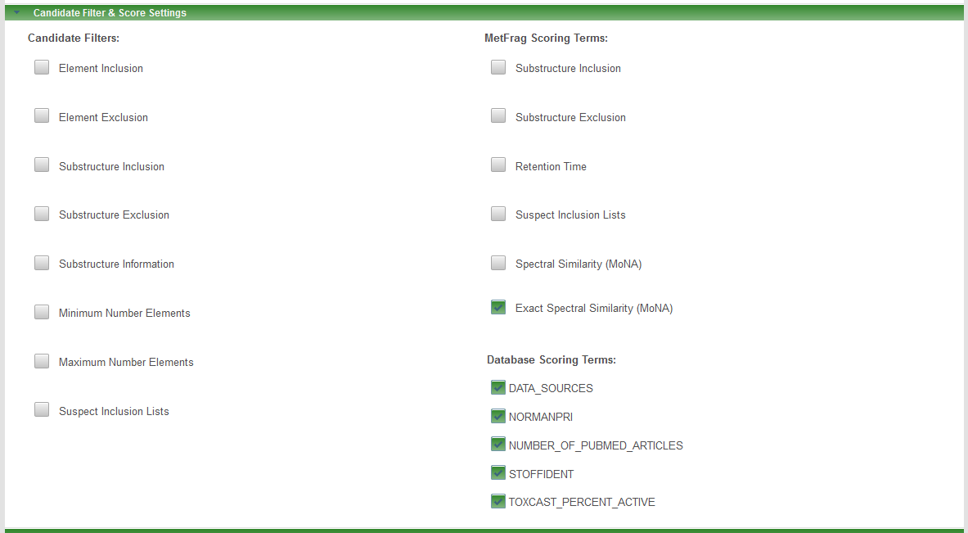
Figure S5: Automatic inclusion of additional Database Scoring Terms in MetFrag after upload of the CompTox Dashboard export file.

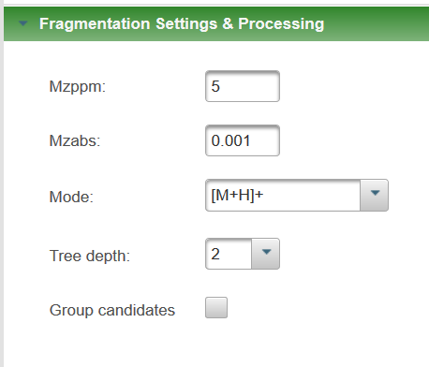 | 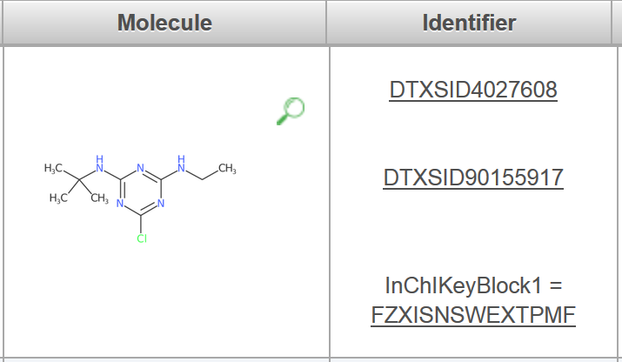
Figure S6. Left: The group candidate option (deselected). Right: Results with active “group candidate” option. The results from the top scoring candidate are presented, but all identifiers are displayed in the “identifier” window.

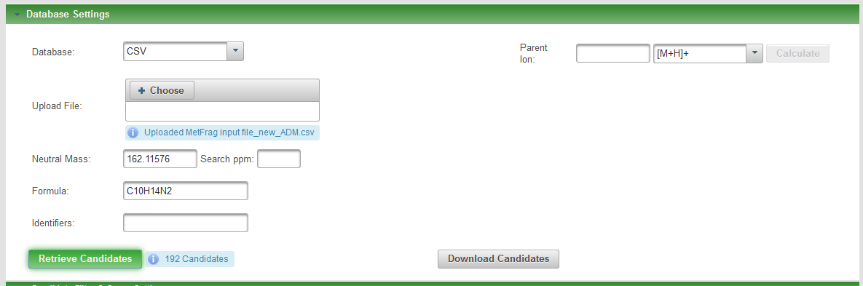
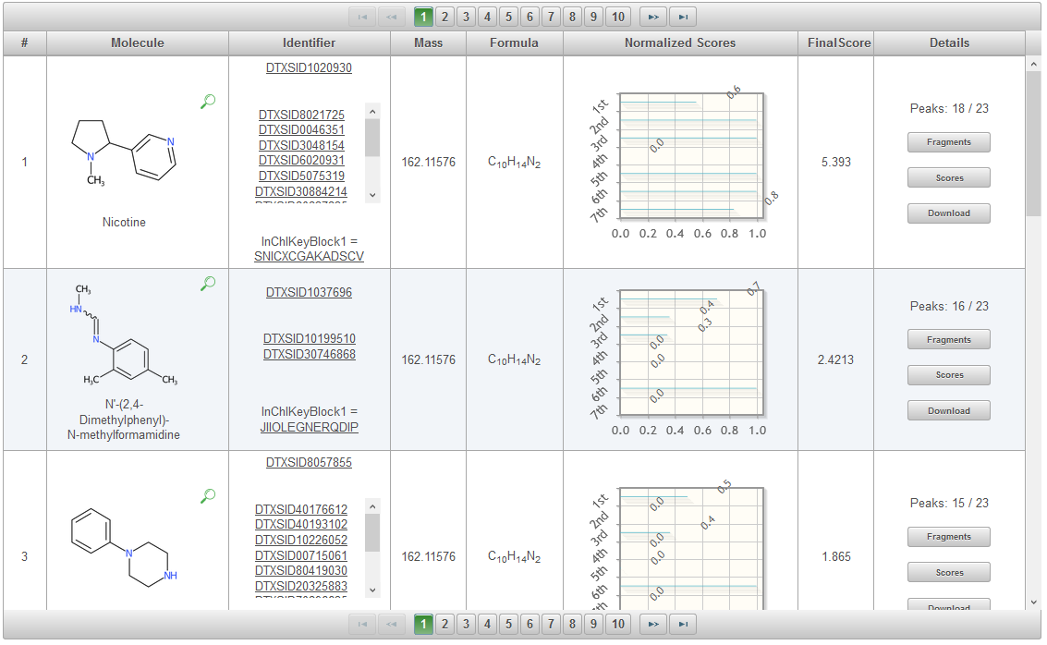
Figure S7. MetFrag input (top) and results (bottom) retrieved with the MS-Ready search for C10H14N2. The score categories are (1st to 7th): MetFrag Fragmentation, Exact Spectral Similarity, Data Sources, Presence in NORMAN Priority list, Number of PubMed Articles, Presence in STOFF-IDENT, and Percent Active ToxCast Assays. Spectral data for Nicotine was retrieved from MassBank (https://massbank.eu/MassBank/jsp/RecordDisplay.jsp?id=EQ300804&dsn=Eawag). Nicotine has the highest score (5.39).

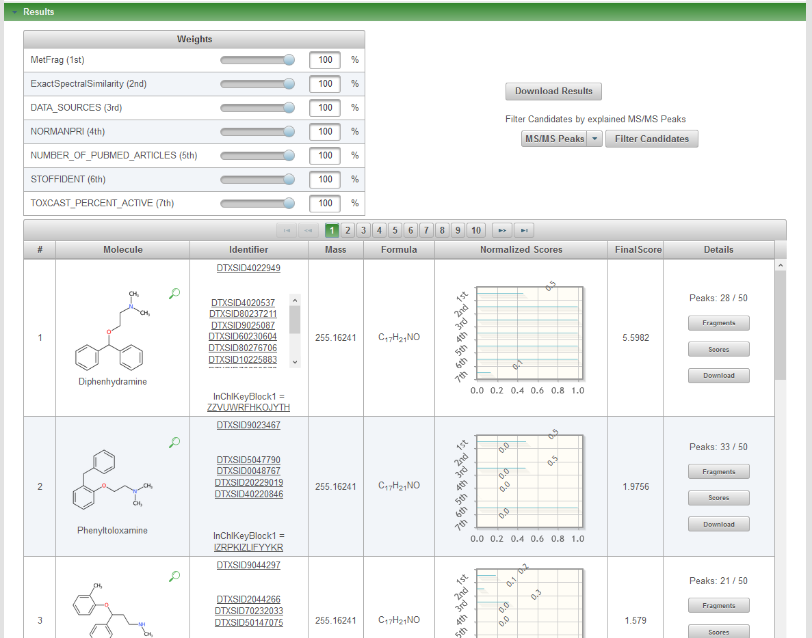
Figure S8. MetFrag input (top) and results (bottom) retrieved with the MS-Ready search for C17H21NO. The score categories are (1st to 7th): MetFrag Fragmentation, Exact Spectral Similarity, Data Sources, Presence in NORMAN Priority list, Number of PubMed Articles, Presence in STOFF-IDENT, and Percent Active ToxCast Assays. Spectral data for Diphenhydramine was retrieved from MassBank (https://massbank.eu/MassBank/jsp/RecordDisplay.jsp?id=EQ335208&dsn=Eawag). Diphenhydramine has the highest score (5.60).

Table S4: MetFrag results for the query C₇H₁₂ClN₅. The highest scoring entry for each field have been bolded. The highest total score is for Simazine, but the correct answer desethylterbutylazine is second and has the best spectral scores (MetFrag Raw Score, Exact MS Similarity).

Identifier | Score | MetFrag Raw Score | # Expl  Peaks | Exact MS Similarity | Data Sources | NORMAN  Priority | PubMed Articles | Toxcast Active | STOFF Ident
DTXSID4021268 | 4.98 | 121.74 | 4 | 0.29 | 107.0 | 0.0 | 335.0 | 3.53 | 1.0
DTXSID80184211 | 4.26 | 177.80 | 6 | 1.0 | 28.0 | 1.0 | NA | NA | 1.0
DTXSID20407557 | 2.05 | 177.80 | 6 | 0.0 | 5.0 | 0.0 | NA | NA | 1.0
DTXSID20190518 | 1.03 | 177.80 | 6 | 0.0 | 3.0 | 0.0 | NA | NA | 0.0
DTXSID9062774 | 0.80 | 124.98 | 4 | 0.0 | 10.0 | 0.0 | NA | NA | 0.0
DTXSID10192147 | 0.74 | 124.57 | 4 | 0.0 | 4.0 | 0.0 | NA | NA | 0.0
DTXSID50615441 | 0.61 | 106.83 | 5 | 0.0 | 1.0 | 0.0 | NA | NA | 0.0
DTXSID40527281 | 0.15 | 24.73 | 3 | 0.0 | 1.0 | 0.0 | NA | NA | 0.0
DTXSID20585369 | 0.09 | 14.65 | 2 | 0.0 | 1.0 | 0.0 | NA | NA | 0.0
DTXSID60337288 | 0.07 | 6.64 | 2 | 0.0 | 4.0 | 0.0 | NA | NA | 0.0
DTXSID20500259 | 0.04 | 6.02 | 1 | 0.0 | 1.0 | 0.0 | NA | NA | 0.0

