 | logP | MW | RTB | HBA | HBD
R2 score | 0.7774 | 0.9999 | 0.9713 | 0.9561 | 0.9999
Figure S1: Correlation between physical properties as calculated by Pipeline Pilot and RDKit descriptors on 200k ChEMBL 23 random compounds.

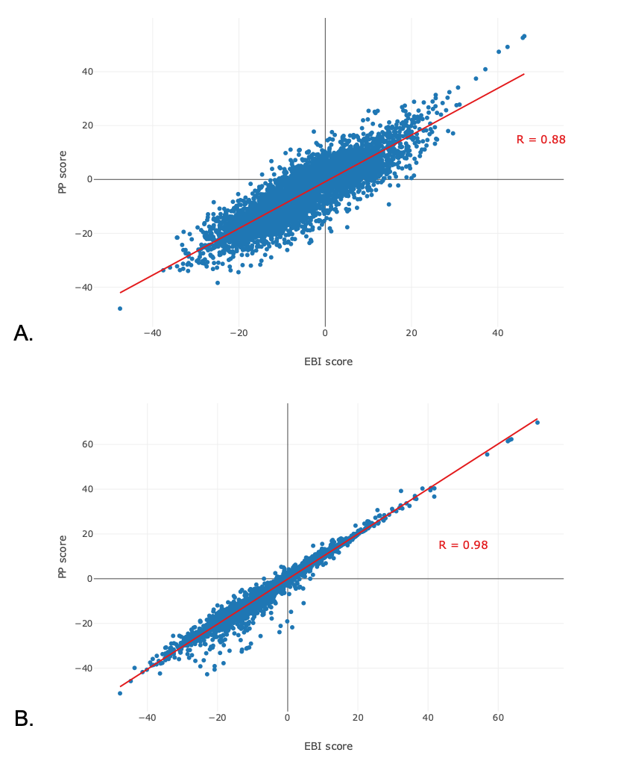
Figure S2: Correlation analysis between prediction scores returned for the eMolecules validation set by the Pipeline Pilot and the internal models trained with the MMV – St. Jude dataset. (A) Training and validation compounds are described with FCFP6 fingerprints only or RDKit equivalent; (B) Training and validation compounds are described with ECFP6 fingerprints only or RDKit equivalent.

