Additional file 1
The Impact of Cross-Docked Poses on Performance of Machine Learning Classifier for Protein-Ligand Binding Pose Prediction

Chao Shen^{1,2}, Xueping Hu¹, Junbo Gao¹, Xujun Zhang¹, Haiyang Zhong¹, Zhe Wang¹, Lei Xu⁴, Yu Kang^{1,*}, Dongsheng Cao^{3,*}, Tingjun Hou^{1,2,*}
¹Innovation Institute for Artificial Intelligence in Medicine of Zhejiang University, College of Pharmaceutical Sciences, Zhejiang University, Hangzhou 310058, Zhejiang, P. R. China
²State Key Lab of CAD&CG, Zhejiang University, Hangzhou 310058, Zhejiang, P. R. China
³Xiangya School of Pharmaceutical Sciences, Central South University, Changsha 410013, Hunan, P. R. China
⁴Institute of Bioinformatics and Medical Engineering, School of Electrical and Information Engineering, Jiangsu University of Technology, Changzhou 213001, China

Corresponding authors

Tingjun Hou

Tel: +86-571-88208412

E-mail: tingjunhou@zju.edu.cn
Dongsheng Cao
Tel: +86-731-89824761

E-mail: oriental-cds@163.com

Yu Kang

Tel: +86-571-88208412

E-mail: yukang@zju.edu.cn
Table S1. The tuned hyper-parameters in XGBoost.
Hyper-parameters | Range
learning rate (eta) | [0.005, 0.5]
number of boosting stages (n_estimators) | [50, 3050]
maximum depth of a tree (max_depth) | [5, 20]
minimum loss reduction required to make a further partition on a leaf node of the tree (gamma) | [0, 1]
minimum sum of instance weight needed for a child (min_child_weight) | [1, 11]
subsample ratio of the training instances (subsample) | [0.5, 1]
subsample ratio of columns (colsample_bytree) | [0.5, 1]
subsample ratio of columns for each level (colsample_bylevel) | [0.5, 1]
subsample ratio of columns for each node (colsample_bynode) | [0.5, 1]
L2 regularization term on weights (lambda) | [0, 1]
L1 regularization term on weights (alpha) | [0, 1]

Table S2. Comparison of the performance of machine learning classifiers and regressors based on the refined-core splitting of the PDBbind-ReDocked dataset. The standard deviations were calculated based on the random sampling of 1000 redundant copies with replacements.
Method | Preditor | inter-AUROC | intra-AUROC | inter-Rs | intra-Rs | SR₁ | SR₃
NNscore_  XGB | Classifier | 0.856 ± 0.005 | 0.814 ± 0.008 | 0.692 ± 0.007 | 0.438 ± 0.012 | 0.735 ± 0.014 | 0.809 ± 0.012
NNscore_  XGB | Regressor | 0.845 ± 0.005 | 0.812 ± 0.008 | 0.695 ± 0.007 | 0.472 ± 0.012 | 0.733 ± 0.013 | 0.802 ± 0.012
NNscore-Vina_  XGB | Classifier | 0.819 ± 0.006 | 0.770 ± 0.008 | 0.621 ± 0.008 | 0.356 ± 0.013 | 0.677 ± 0.014 | 0.775 ± 0.013
NNscore-Vina_  XGB | Regressor | 0.802 ± 0.006 | 0.763 ± 0.009 | 0.616 ± 0.009 | 0.386 ± 0.012 | 0.666 ± 0.014 | 0.767 ± 0.013
Vina_  XGB | Classifier | 0.792 ± 0.006 | 0.742 ± 0.009 | 0.577 ± 0.009 | 0.345 ± 0.013 | 0.672 ± 0.013 | 0.766 ± 0.013
Vina_  XGB | Regressor | 0.763 ± 0.006 | 0.707 ± 0.009 | 0.521 ± 0.010 | 0.279 ± 0.014 | 0.645 ± 0.015 | 0.752 ± 0.015
NNscore+Rank_  XGB | Classifier | 0.861 ± 0.005 | 0.821 ± 0.007 | 0.703 ± 0.007 | 0.457 ± 0.012 | 0.751 ± 0.013 | 0.812 ± 0.012
NNscore+Rank_  XGB | Regressor | 0.843 ± 0.005 | 0.812 ± 0.008 | 0.701 ± 0.007 | 0.462 ± 0.012 | 0.732 ± 0.014 | 0.809 ± 0.013
E3FP_  XGB | Classifier | 0.639 ± 0.007 | 0.522 ± 0.011 | 0.259 ± 0.013 | 0.034 ± 0.015 | 0.469 ± 0.017 | 0.635 ± 0.017
E3FP_  XGB | Regressor | 0.630 ± 0.007 | 0.525 ± 0.011 | 0.282 ± 0.012 | 0.053 ± 0.015 | 0.507 ± 0.017 | 0.659 ± 0.017
ECIF_  XGB | Classifier | 0.838 ± 0.005 | 0.813 ± 0.008 | 0.631 ± 0.008 | 0.429 ± 0.012 | 0.705 ± 0.012 | 0.784 ± 0.013
ECIF_  XGB | Regressor | 0.804 ± 0.006 | 0.762 ± 0.008 | 0.619 ± 0.009 | 0.394 ± 0.012 | 0.649 ± 0.013 | 0.749 ± 0.014
ELEM_  XGB | Classifier | 0.727 ± 0.007 | 0.651 ± 0.009 | 0.426 ± 0.011 | 0.217 ± 0.013 | 0.538 ± 0.015 | 0.670 ± 0.016
ELEM_  XGB | Regressor | 0.720 ± 0.007 | 0.656 ± 0.010 | 0.439 ± 0.012 | 0.240 ± 0.014 | 0.553 ± 0.016 | 0.691 ± 0.016
ECIF+Vina_  XGB | Classifier | 0.875 ± 0.005 | 0.849 ± 0.007 | 0.708 ± 0.007 | 0.487 ± 0.011 | 0.764 ± 0.012 | 0.822 ± 0.012
ECIF+Vina_  XGB | Regressor | 0.844 ± 0.005 | 0.815 ± 0.008 | 0.690 ± 0.008 | 0.455 ± 0.012 | 0.720 ± 0.013 | 0.793 ± 0.013
ECIF+Vina+  Rank_XGB | Classifier | 0.872 ± 0.005 | 0.851 ± 0.007 | 0.713 ± 0.007 | 0.498 ± 0.012 | 0.778 ± 0.012 | 0.826 ± 0.012
ECIF+Vina+  Rank_XGB | Regressor | 0.847 ± 0.005 | 0.829 ± 0.007 | 0.702 ± 0.007 | 0.463 ± 0.013 | 0.740 ± 0.013 | 0.811 ± 0.013

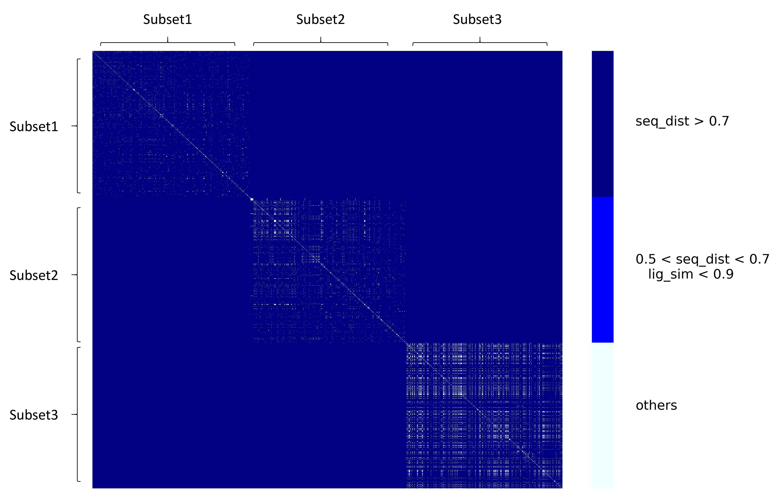
Figure S1. The similarity matrix between the different subsets when conducting 3-fold clustered cross-validation (CCV) of the PDBbind-ReDocked dataset. The seq_dist and lig_sim represent the sequence distance and ligand similarity between any two proteins/ligands, respectively.

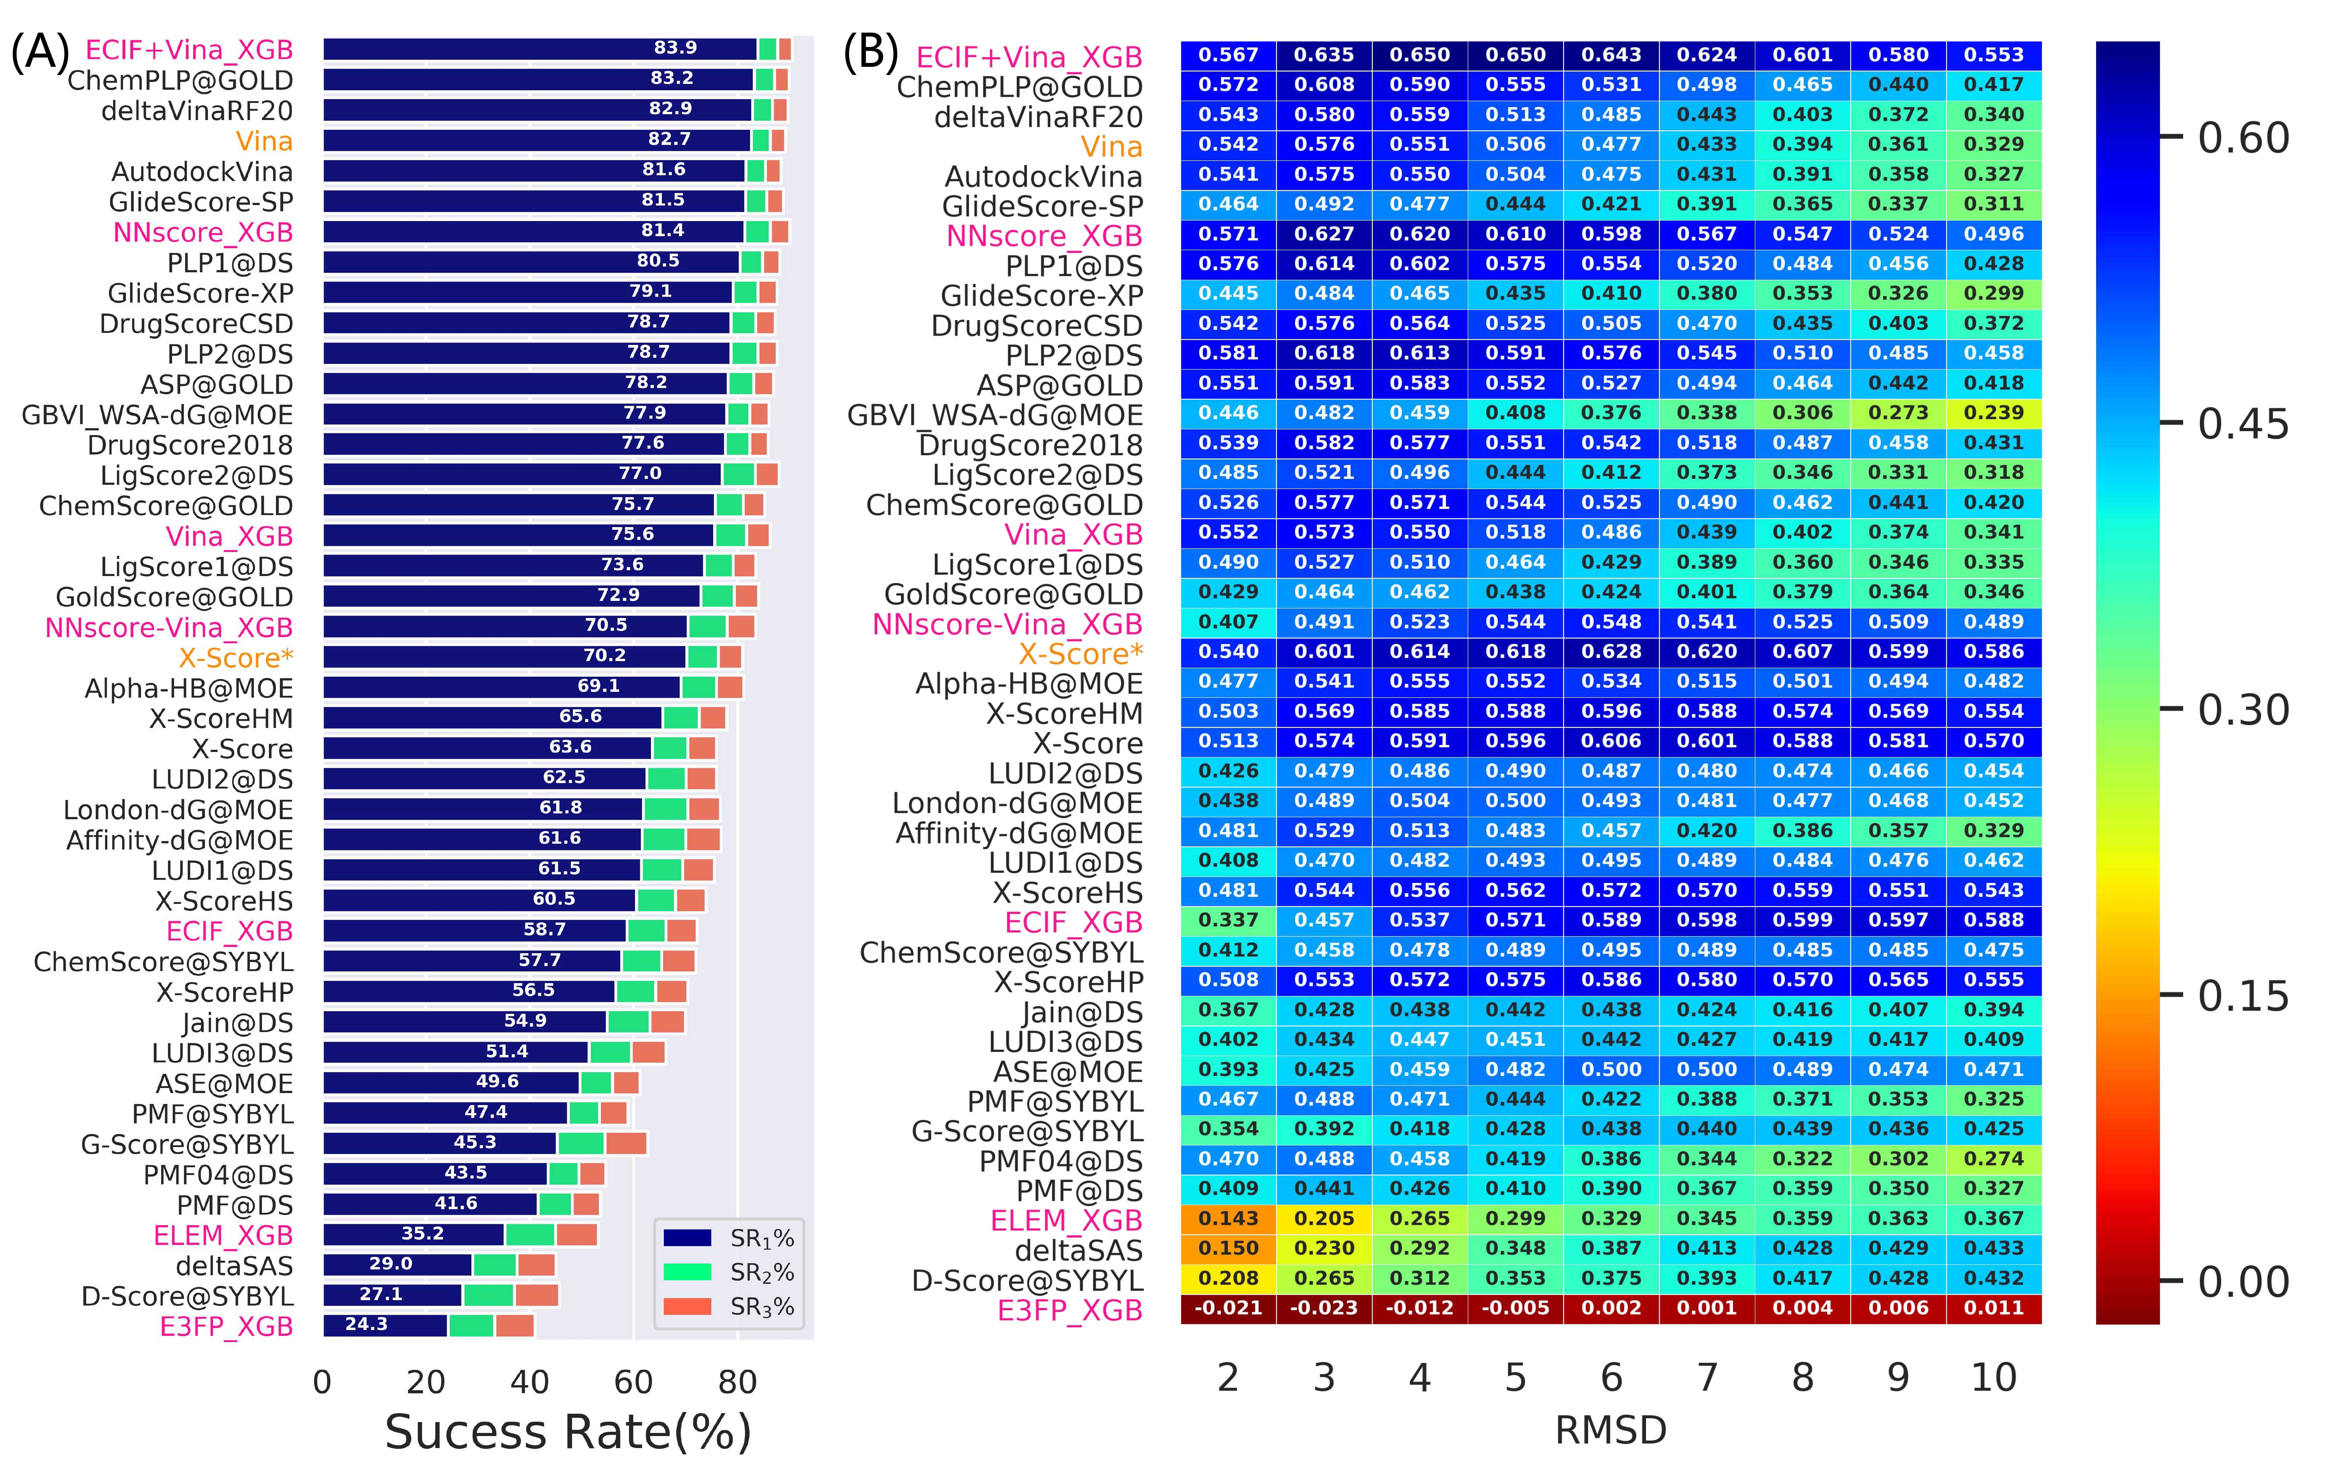
Figure S2. The performance in terms of (A) top1, top2 and top3 success rates, and (B) binding funnel analysis when the models are trained on the PDBbind-ReDocked-Refined set and tested on CASF-Docking set. The RMSDs are calculated using obrms utility in Openbabel. The methods colored in pink and orange are calculated in this study, while the predicted scores of the others are just copied from original paper. The averages of the random sampling of 1000 redundant copies with replacements are shown in the figure. For binding funnel analysis, the x-axis indicates the RMSD range (e.g., [0−2Å], [0−3 Å], and etc.) where the Spearman correlation coefficients between the RMSD values and the predicted scores are calculated.

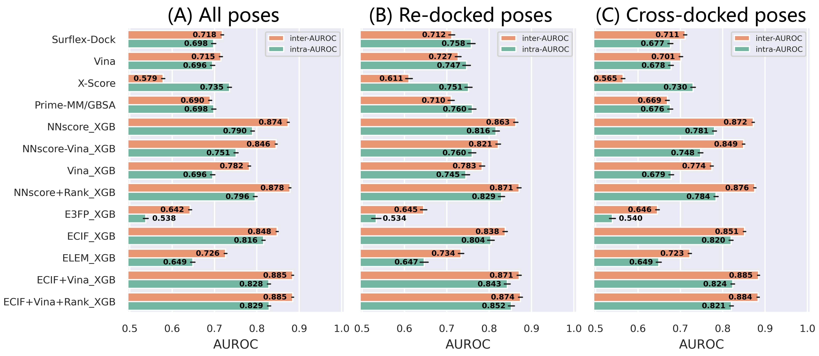
Figure S3. The AUROC values of the models trained on PDBbind-ReDocked-Refined and tested on PDBbind-CrossDocked-Core-s, based on (A) all poses, (B) re-docked poses, and (C) cross-docked poses. The error bars represent the standard deviation of the random sampling of 1000 redundant copies with replacements.

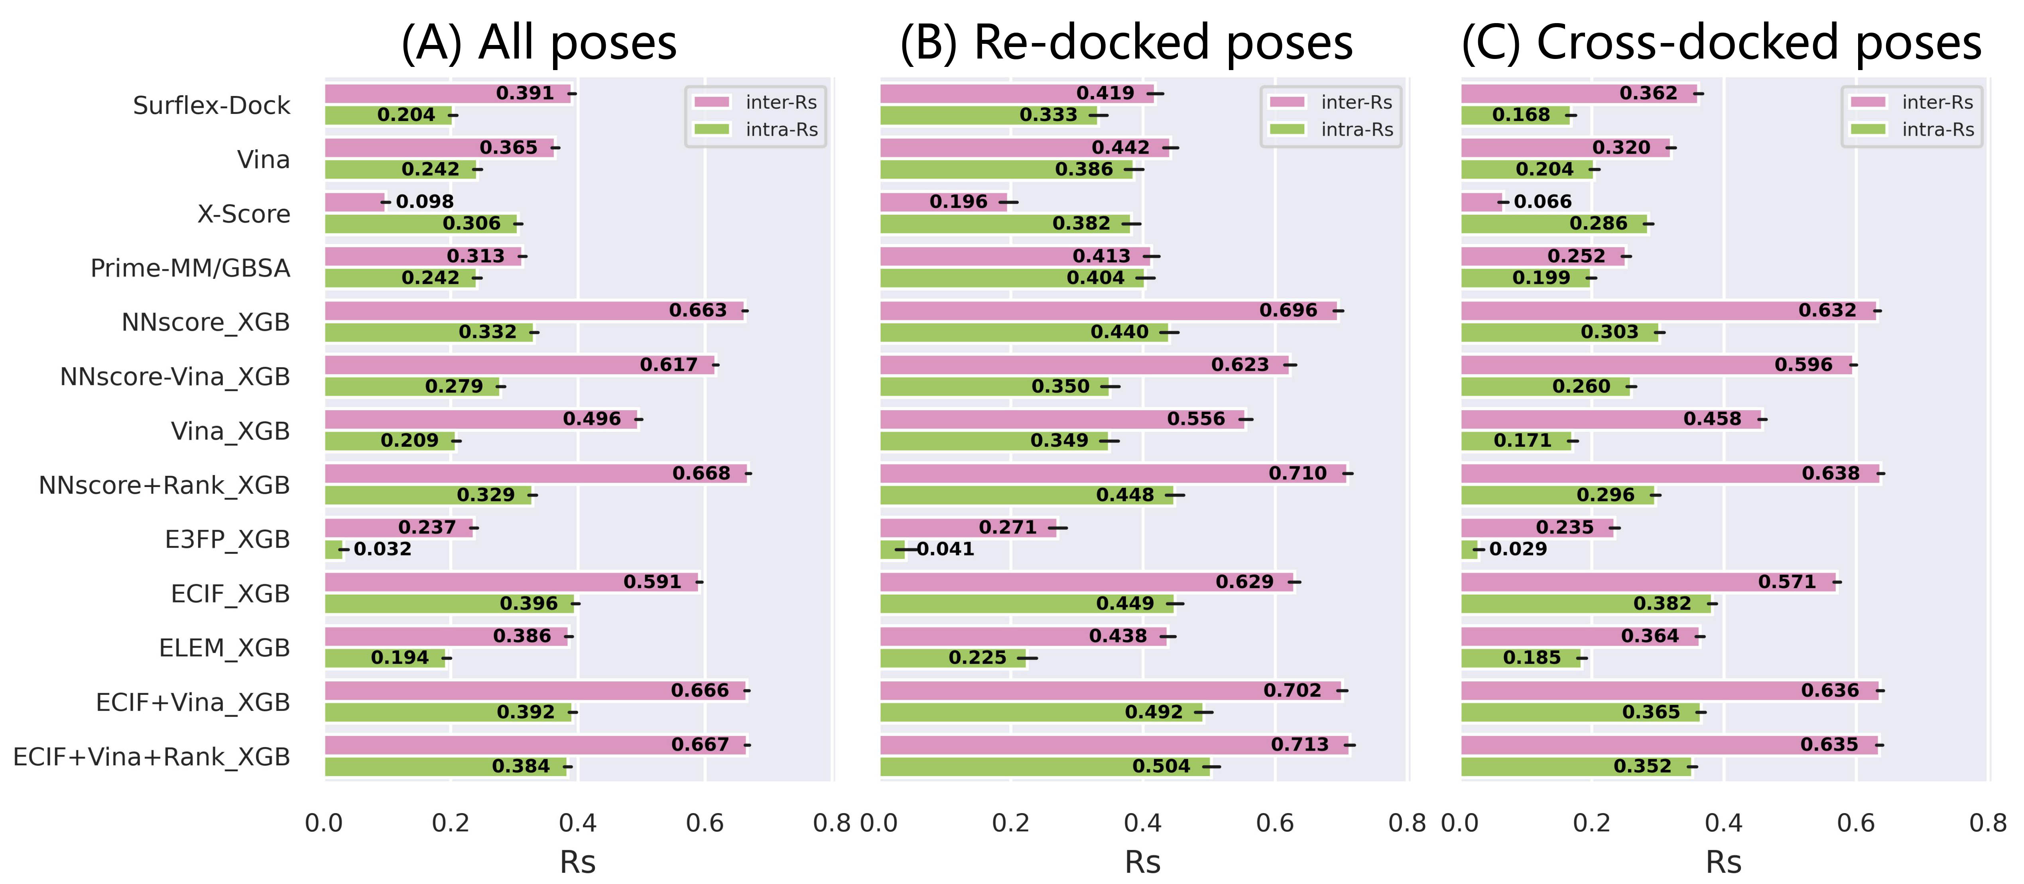
Figure S4. The Rs values of the models trained on PDBbind-ReDocked-Refined and tested on PDBbind-CrossDocked-Core-s, based on (A) all poses, (B) re-docked poses, and (C) cross-docked poses. The error bars represent the standard deviation of the random sampling of 1000 redundant copies with replacements.

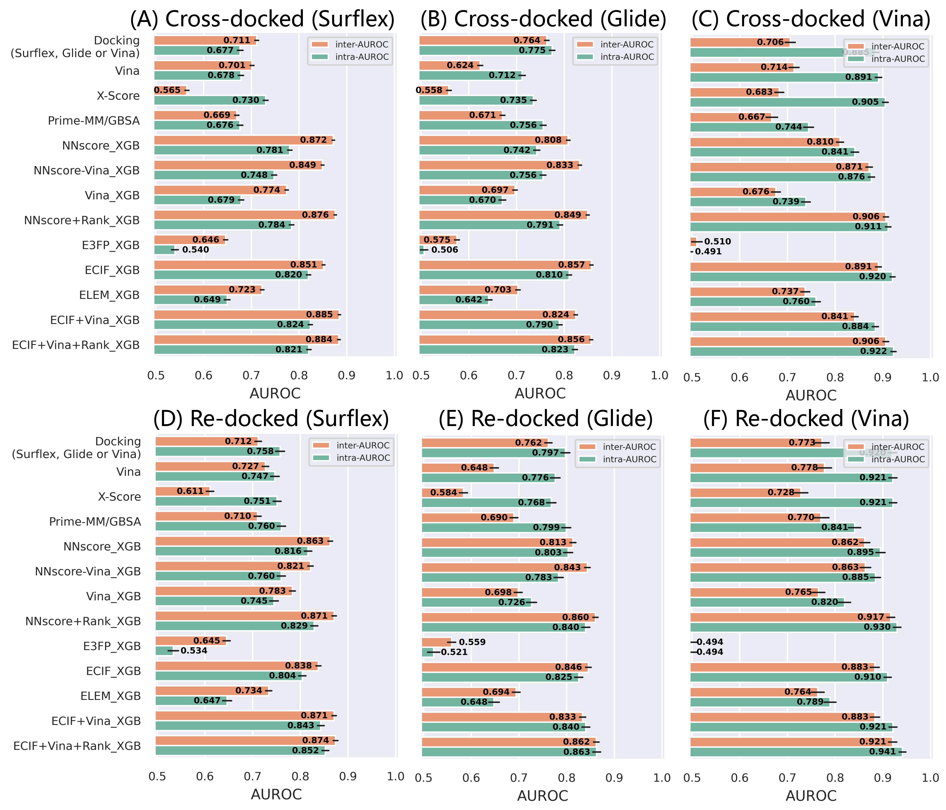
Figure S5. The AUROC values of the models trained on PDBbind-ReDocked-Refined and tested on the (A) cross-docked and (D) re-docked poses in PDBbind-CrossDocked-Core-s, the (B) cross-docked and (E) re-docked poses in PDBbind-CrossDocked-Core-g, and the (C) cross-docked and (F) re-docked pose in PDBbind-CrossDocked-Core-v. The error bars represent the standard deviation of the random sampling of 1000 redundant copies with replacements.

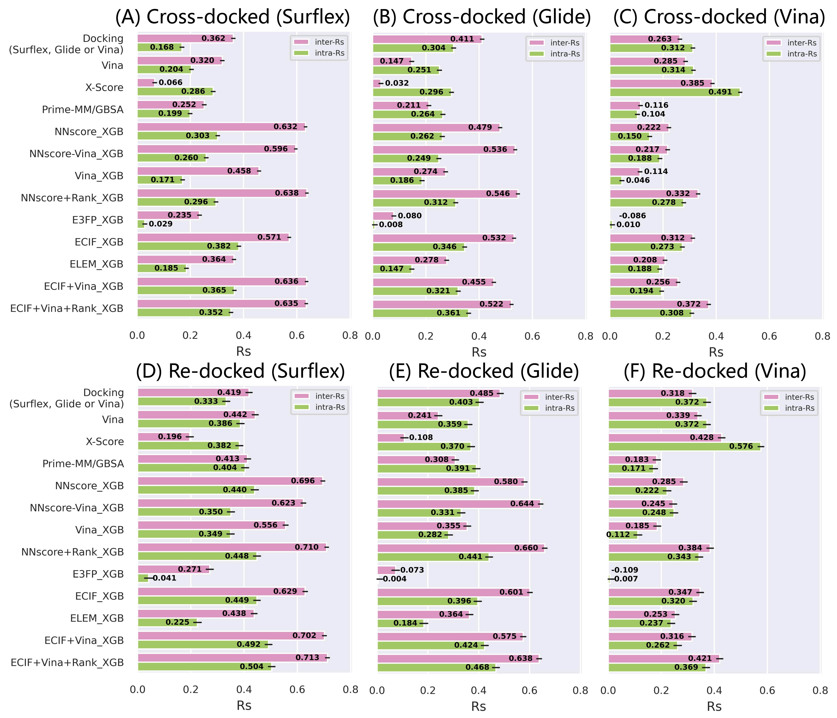
Figure S6. The Rs values of the models trained on PDBbind-ReDocked-Refined and tested on the (A) cross-docked and (D) re-docked poses in PDBbind-CrossDocked-Core-s, the (B) cross-docked and (E) re-docked poses in PDBbind-CrossDocked-Core-g, and the (C) cross-docked and (F) re-docked pose in PDBbind-CrossDocked-Core-v. The error bars represent the standard deviation of the random sampling of 1000 redundant copies with replacements.

