Additional file 1
Deep Scaffold Hopping with Multi-modal Transformer Neural Networks
Shuangjia Zheng^{1#}, Zengrong Lei^{2#}, Haitao Ai², Hongming Chen³, Daiguo Deng²*, Yuedong Yang¹*

¹School of Data and Computer Science, Sun Yat-sen University, China, 132 East Circle at University City, Guangzhou 510006, China
²Fermion Technology Co., Ltd, 1088 Newport East Road, Guangzhou 510335, China
³Centre of Chemistry and Chemical Biology, Guangzhou Regenerative Medicine and Health Guangdong Laboratory, Guangzhou 510530, China

Corresponding Authors
*Email: yangyd25@mail.sysu.edu.cn (Y.Y).
*Email: deco@fulmz.com (D.D).

Table S1. 3D GNN’s initial atom features calculated using RDKit.
Feature | Description | Size
Atom type | Atom type | 15
Degree | The number of heavy atom neighbors | 7
Number of hydrogens | The number of neighboring hydrogens | 5
Formal charge | Atomic formal charge | 7
Chirality | Unspecified, tetrahedral CW/CCW, or other | 4
Hybridization | sp, sp2, sp3, sp3d, or sp3d2 | 5
Aromaticity | Whether atom is part of an aromatic system. | 1

Table S2. Key hyperparameters, parameters for the best model in bold.
Parameter | Values
Batch size | 2048, 4096, 8192
Number of layers | 2, 4, 6, 8
Hidden states | 128, 256, 512
Attention heads | 2, 4, 6, 8
Label smoothing | 0 ~ 1 (0)
Optimizer | SGD, Adam, Adagrad
Starting learning rate | 0.001 ~ 2 (1)
Decay factor | 0 ~ 1 (0.5)
Warming steps | 4000~8000 (4750)
Drop out | 0 ~ 1 (0.1)

Table S3. Details of selected targets in internal datasets. Molecule Amount denotes the total amount of bioactivity instances in each target. Training Pairs Amount is the total amount of scaffold hopping pairs in the training sets per target. R² and RMSE are the performance of their virtual profiling models.

Metrics | ChEMBL Target
Metrics | CHEMBL267 (Tyrosine-protein kinase SRC) | CHEMBL2835 (Tyrosine-protein kinase JAK1) | CHEMBL3267 (PI3-kinase p110-gamma subunit) | CHEMBL4501 (Ribosomal protein S6 kinase 1)
Abvs. | SRC | JAK1 | PI3G | S6K1
Molecule Amount | 3172 | 3764 | 1913 | 1787
Training Pairs Amount | 4281 | 5309 | 2631 | 2305
R² | 0.74 | 0.72 | 0.70 | 0.73
RMSE | 0.67 | 0.60 | 0.60 | 0.61

Table S4. Performance comparison of models on the Tyrosine-protein kinase JAK1 (CHEMBL2835).
Models | Metrics
Models | Validity (%) | Success rate (%) | Constraint  success rate  (%) | Improvement | Uniqueness (%)
LBVS | 100 | 10.2 | 1.5 | -1.82 | 100
MMPA | 100 | 15.7 | 6.6 | 0.29 | 98.6
Seq2seq | 34.6 | 32.6 | 13.4 | 0.28 | 16.9
G2G | 99.5 | 27.7 | 13.1 | 1.11 | 13.9
DeepHop | 95.8 | 73.2 | 35.4 | 0.41 | 66.2

Table S5. Performance comparison of models on the Tyrosine-protein kinase SRC (CHEMBL267).
Models | Metrics
Models | Validity (%) | Success rate (%) | Constraint  success rate  (%) | Improvement | Uniqueness (%)
LBVS | 100 | 40.1 | 7.8 | -0.89 | 100
MMPA | 91.1 | 32.9 | 15.8 | 0.47 | 100
Seq2seq | 32.9 | 38.3 | 23.0 | 1.39 | 18.9
G2G | 99.4 | 32.3 | 16.1 | 0.32 | 16.4
DeepHop | 91.8 | 68.8 | 44.9 | 0.94 | 66.6

Table S6. Performance comparison of models on the PI3-kinase p110-gamma subunit (CHEMBL3267).
Models | Metrics
Models | Validity (%) | Success rate (%) | Constraint  success rate  (%) | Improvement | Uniqueness (%)
LBVS | 100 | 43.8 | 17.5 | -0.47 | 100
MMPA | 100 | 45.6 | 10.5 | 0.11 | 100
Seq2seq | 36.6 | 33.9 | 16.1 | 0.61 | 21.1
G2G | 100 | 43.9 | 15.8 | 0.37 | 38.6
DeepHop | 95.0 | 71.9 | 29.8 | 0.71 | 75.6

Table S7. Performance comparison of models on the Ribosomal protein S6 kinase 1 (CHEMBL4501).
Models | Metrics
Models | Validity (%) | Success rate (%) | Constraint  success rate  (%) | Improvement | Uniqueness (%)
LBVS | 100 | 44.4 | 14.8 | -0.60 | 100
MMPA | 98.1 | 41.5 | 20.8 | 0.36 | 100
Seq2seq | 12.8 | 11.8 | 3.9 | 0.79 | 14.5
G2G | 100 | 29.6 | 13.9 | 1.70 | 2.6
DeepHop | 92.8 | 46.3 | 24.1 | 1.16 | 74.5

Table S8. Details of selected targets in external datasets. Training Pairs Amount is the total amount of scaffold hopping pairs in the training sets per target. R² and RMSE are the performance of their virtual profiling models.
Metrics | ChEMBL Target
Metrics | Homologs |  |  | Non-Homologs
Metrics | CHEMBL 4225  (Dual specificity protein kinase CLK2) | CHEMBL 2041  (Tyrosine-protein kinase receptor RET) | CHEMBL 2292  (Tyrosine-phosphorylation kinase 1A) | CHEMBL 2208 (MAP activated kinase 2) | CHEMBL 4523 (Serine/threonine-protein kinase PIM2) | CHEMBL 2147 (Serine/threonine-protein kinase PIM1)
Training Pairs | 531 | 755 | 1109 | 859 | 2324 | 4363
R² | 0.67 | 0.66 | 0.67 | 0.69 | 0.69 | 0.69
RMSE | 0.51 | 0.73 | 0.57 | 0.60 | 0.54 | 0.59

Table S9. The independent tests by DeepHop-noGNN.

Metrics | ChEMBL Target
Metrics | Homologs |  |  | Non-homologs
Metrics | CHEMBL 4225 | CHEMBL 2041 | CHEMBL 2292 | CHEMBL 2208 | CHEMBL 4523 | CHEMBL 2147
Success Rate | 0.664 | 0.528 | 0.683 | 0.012 | 0.067 | 0.094
Constraint Success | 0.381 | 0.425 | 0.322 | 0.012 | 0.011 | 0.036
Improvement | 0.409 | 1.012 | 0.807 | -0.152 | -0.988 | -1.518

Table S10. The independent tests by DeepHop-noProtein.

Metrics | ChEMBL Target
Metrics | Homologs |  |  | Non-homologs
Metrics | CHEMBL 4225 | CHEMBL 2041 | CHEMBL 2292 | CHEMBL 2208 | CHEMBL 4523 | CHEMBL 2147
Success Rate | 0.325 | 0.241 | 0.292 | 0.048 | 0.109 | 0.054
Constraint Success | 0.201 | 0.153 | 0.182 | 0.036 | 0.088 | 0.028
Improvement | 0.283 | 0.521 | 0.244 | -0.518 | -1.105 | -0.674

Details of deep QSAR models’ architecture.
DMPNN-multi-task. We constructed a multitask regression directed graph neural networks for the kinase bioactivity prediction following the implementation of Yang’s work¹. DMPNN is a kind of message-passing graph neural network that passing messages with directed edges (bonds) rather than those with vertices. It has been shown promising results in molecular property predictions¹.
Table S9. Key hyperparameters, parameters for the best model in bold.
Parameter | Values
Batch size | 32, 64, 128
Number of GNN layers | 2, 3, 4
Hidden states | 128, 256, 512
Optimizer | SGD, Adam, Adagrad
Learning rate | 0.001
Drop out | 0 ~ 1 (0.1)

DNN-multi-task. Following Xiong’s work², we implemented a multitask regression DNN architecture with shared hidden layers across all tasks, where each task represents the bioactivity to be predicted against a specific kinase. Extended connectivity fingerprints (ECFP) of radius 2 with 1024 bits were adopted to featurize each molecule and fed into the input layer. It has been shown state-of-the-art results in virtual kinome-wide polypharmacology profiling¹.
Table S10. Key hyperparameters, parameters for the best model in bold.
Parameter | Values
Batch size | 32, 64, 128
Number of layers | 2, 3, 4, 5
Hidden states | 512, 1024, 2048
Optimizer | SGD, Adam, Adagrad
Starting learning rate | 0.0001, 0.0005, 0.001
Decay factor | 0 ~ 1 (0.002)
Drop out | 0 ~ 1 (0.5)

We re-implemented these two models with Pytorch (version 0.4.0) and Tensorflow (version 1.6.0), respectively. All trainings are performed on standard NVIDIA GPUs. The code is developed in Python 3.6. For comparison, we also reported the results of the two models using the single-task training strategy (referred to as DMPNN-single and DNN-single).

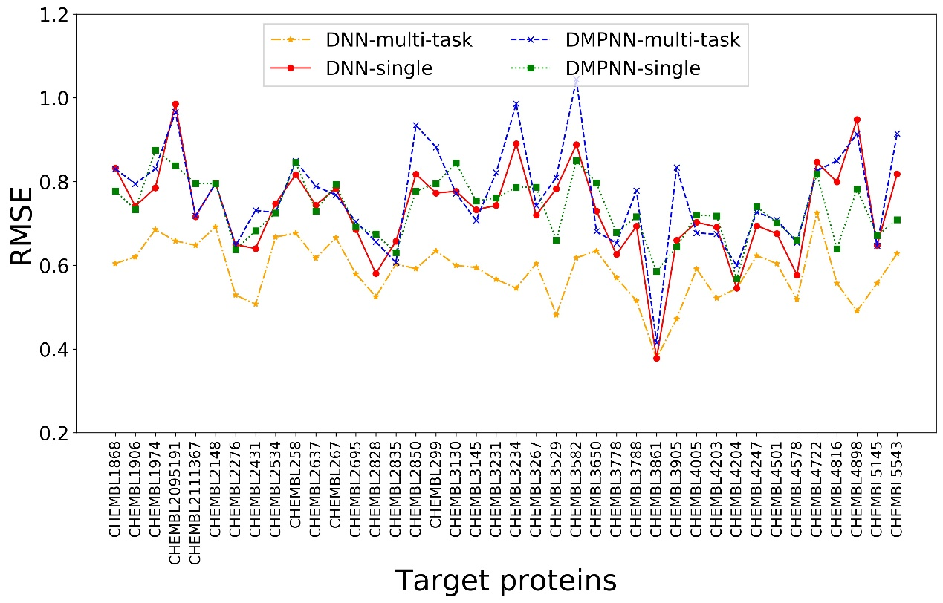
Figure S1. The RMSE results of four models over 40 target proteins. The DMPNN model was based on Yang’s work¹ and the DNN-multi-task was based on Xiong’s work². For each modeling method we used single-task and multi-task settings, respectively. We finally used DNN-multi-task as the virtual profiling models.

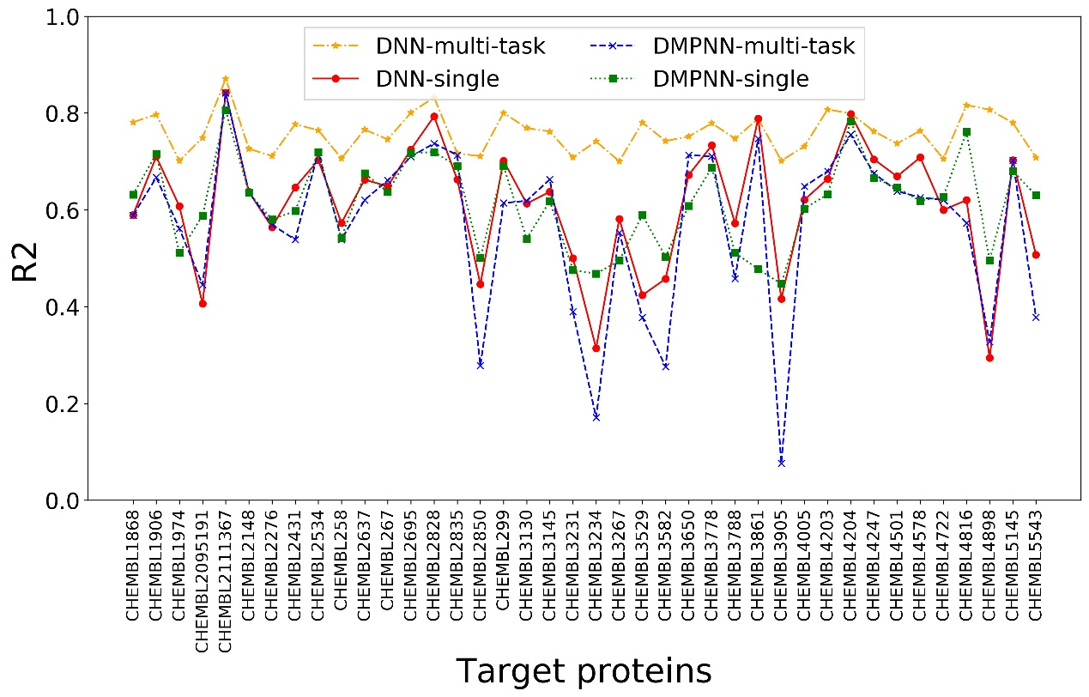
Figure S2. The R² results of four models over 40 target proteins.

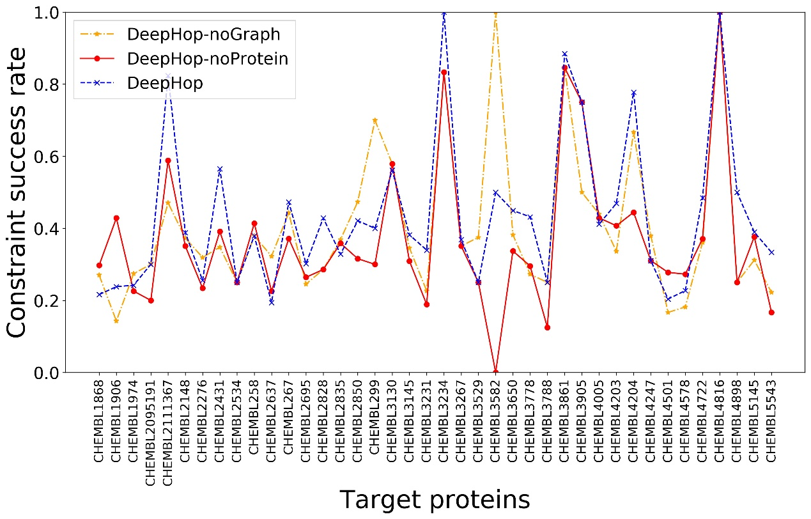
Figure S3. Performance of DeepHop model on the scaffold hopping datasets over 40 kinases protein compared to the DeepHop-noGraph and DeepHop-noProtein.

Table S11. Key hyperparameters for the seq2seq model.
Parameter | Values
Batch size | 32
Optimizer | Adam
Starting learning rate | 0.0001
Max gradient norm | 5.0
Attention dim | 512
layers | 4
Embedding dim | 512
Max sequence length | 140
Drop out | 0.8
Table S12. Key hyperparameters for the G2G model.
Parameter | Values
Batch size | 32
Optimizer | Adam
Starting learning rate | 0.001
Message passing layer | 6
Embedding dim | 300
Graph decoder layer | 3
Latent code dimension | 8

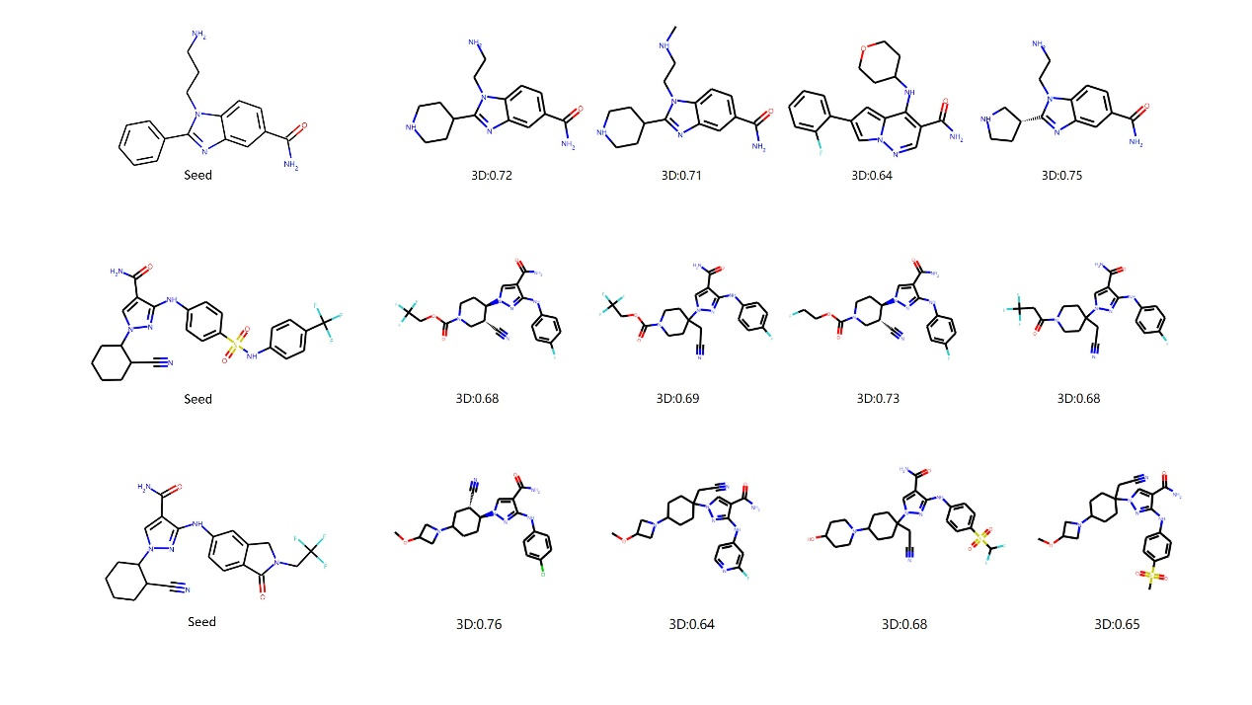
Figure S4. Example of top-4 successful hops ((2D scaffold similarity ≤ 0.6)∩(3D similarity (X; Y) ≥ 0.6)∩Activity Improvement ≥ 1 ) with three test molecules generated by DeepHop for CHEMBL267.

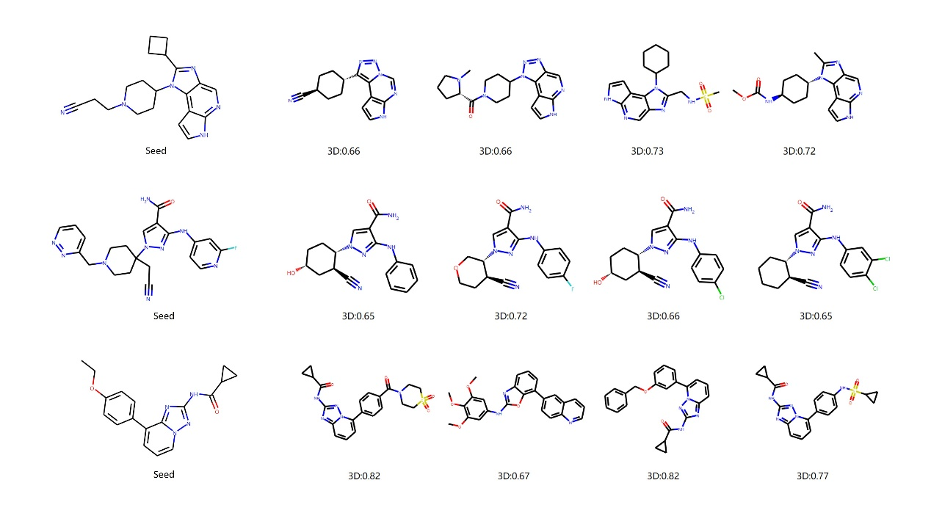
Figure S5. Example of top-4 successful hops ((2D scaffold similarity ≤ 0.6)∩(3D similarity (X; Y) ≥ 0.6)∩Activity Improvement ≥ 1 ) with three test molecules generated by DeepHop for CHEMBL267.

Reference

1. Yang, K.; Swanson, K.; Jin, W.; Coley, C.; Eiden, P.; Gao, H.; Guzman-Perez, A.; Hopper, T.; Kelley, B.; Mathea, M., Analyzing learned molecular representations for property prediction. Journal of chemical information and modeling 2019, 59 (8), 3370-3388.
2. Li, X.; Li, Z.; Wu, X.; Xiong, Z.; Yang, T.; Fu, Z.; Liu, X.; Tan, X.; Zhong, F.; Wan, X.; Wang, D.; Ding, X.; Yang, R.; Hou, H.; Li, C.; Liu, H.; Chen, K.; Jiang, H.; Zheng, M., Deep Learning Enhancing Kinome-Wide Polypharmacology Profiling: Model Construction and Experiment Validation. J Med Chem 2020, 63 (16), 8723-8737.

