Supporting Information
Random-Forest Model for Drug Target-Interaction Prediction via Kullbeck–Leibler Divergence

Sangjin Ahn^{a,b}, Sieun Leeª and Mi-hyun Kim^{a,*}

ªGachon Institute of Pharmaceutical Science and Department of Pharmacy, College of Pharmacy, Gachon University, 191 Hambakmoeiro, Yeonsu-gu, Incheon, Republic of Korea
^{b}Department of Financial Engineering, College of Business, Ajou University, Suwon, 16499, Republic of Korea
* Author for correspondence
E-mail: kmh0515@gachon.ac.kr
Table of Contents

- Dataset Description(S.Table1)
- The Overlapped Ligands Among Targets (S.Table2)
- The Confusion Matrix of KLD-RF Models for Test Data (S.Table3)
- Computation of Kullbeck-Leibler Divergence Vectors
- Structural Information of Q-Q Density Models by Each Target (S.Table4, S.Fig1)
- The Pair-Plot & Robustness for 3D KLD-RF Model (S.Fig2, S.Fig3)
- Statistical Performance of 2D-RF model in predicting DTI (S.Table5)
- Statistical Performance of SwissTarget model in predicting DTI (S.Table6)
- Dataset Description (S.Table1)
Generated conformers using Omega of Openeye
Target  Info.  [Q]CHEMBL  (Name) | No. of  Compounds  (Raw) | No. of  Compounds*  (Successful Generation of Conformers using Omega) | Conformer  Population  Size  (E3FP) | Sampling**
[Q1] CHEMBL2366517  (HIV-1 Protease) | 660 | 581 | 94421 | 15000
[Q2] CHEMBL4303  (Heat shock protein 90 kDa beta) | 601 | 524 | 84375 | 15000
[Q3] CHEMBL4153  (Sigma opioid receptor) | 8 | 5 | 634 | 634
[Q4] CHEMBL3119  (Transient receptor potential  cation C subfamily V4) | 394 | 363 | 61060 | 15000
[Q5] CHEMBL339  (Dopamine D2 receptor) | 2416 | 2005 | 287494 | 15000
[Q6] CHEMBL274  (CC-Chemokine Receptor 5) | 3813 | 2751 | 429802 | 15000
[Q7] CHEMBL1781  (DNA topoisomerase I) | 511 | 440 | 29493 | 15000
[Q8] CHEMBL5251  (Tyrosine-protein kinase BTK) | 2834 | 2231 | 379529 | 15000
[Q9] CHEMBL1978  (Cytochrome P450 (CYP) 1B1) | 2767 | 2047 | 140781 | 15000
[Q10] CHEMBL4142  (Fibroblast growth factor receptor 1) | 1131 | 1055 | 200052 | 15000
[Q11] CHEMBL2056  (Dopamine D1 receptor) | 1021 | 901 | 67314 | 15000
[Q12] CHEMBL2973  (Rho-associated protein kinase 2) | 2386 | 1836 | 297138 | 15000
[Q13] CHEMBL1667684  (Neuraminidase - Influenza A virus) | 78 | 45 | 8557 | 8557
[Q14] CHEMBL2842  (Serinethreonine-protein kinasemTOR) | 4596 | 4139 | 602995 | 15000
[Q15] CHEMBL204  (Hepsin serine protease) | 3236 | 1777 | 291887 | 15000
[Q16] CHEMBL5023  (p53-binding protein Mdm-2) | 2900 | 2089 | 175930 | 15000
[Q17] CHEMBL203  (Epidermal growth factor receptor) | 12496 | 8936 | 1254040 | 15000

Generated conformers using RDKit*
Target  Info.  [Q]CHEMBL  (Name) | No. of  Compounds  (Raw) | No. of  Compounds  (Successful Generation of Conformers)** | Conformer  Population  Size  (E3FP) | Sampling***
[Q1] CHEMBL2366517  (HIV-1 Protease) | 660 | 581 | 1551 | 1551
[Q2] CHEMBL4303  (Heat shock protein 90 kDa beta) | 601 | 524 | 1195 | 1195
[Q3] CHEMBL4153  (Sigma opioid receptor) | 8 | 5 | 8 | 8
[Q4] CHEMBL3119  (Transient receptor potential  cation C subfamily V4) | 394 | 363 | 925 | 925
[Q5] CHEMBL339  (Dopamine D2 receptor) | 2416 | 2005 | 3830 | 3830
[Q6] CHEMBL274  (CC-Chemokine Receptor 5) | 3813 | 2751 | 6897 | 6897
[Q7] CHEMBL1781  (DNA topoisomerase I) | 511 | 440 | 764 | 764
[Q8] CHEMBL5251  (Tyrosine-protein kinase BTK) | 2834 | 2231 | 5474 | 5474
[Q9] CHEMBL1978  (Cytochrome P450 (CYP) 1B1) | 2767 | 2047 | 3328 | 3328
[Q10] CHEMBL4142  (Fibroblast growth factor receptor 1) | 1131 | 1055 | 2681 | 2681
[Q11] CHEMBL2056  (Dopamine D1 receptor) | 1021 | 901 | 1554 | 1554
[Q12] CHEMBL2973  (Rho-associated protein kinase 2) | 2386 | 1836 | 4066 | 4066
[Q13] CHEMBL1667684  (Neuraminidase - Influenza A virus) | 78 | 45 | 144 | 144
[Q14] CHEMBL2842  (Serinethreonine-protein kinasemTOR) | 4596 | 4139 | 8857 | 8857
[Q15] CHEMBL204  (Hepsin serine protease) | 3236 | 1777 | 7510 | 7510
[Q16] CHEMBL5023  (p53-binding protein Mdm-2) | 2900 | 2089 | 5191 | 5191
[Q17] CHEMBL203  (Epidermal growth factor receptor) | 12496 | 8936 | 19057 | 19057
*The conformers were generated under the condition.
cids = AllChem.EmbedMultipleConfs(molslist[i][j], clearConfs=True, numConfs=3, pruneRmsThresh=1)
**The data was used for 2D similarity calculation.
***The data was used for 3D similarity calculation.

- The Overlapped Ligands Among Targets (S.Table2)
 | Q1 | Q2 | Q3 | Q4 | Q5 | Q6 | Q7 | Q8 | Q9 | Q10 | Q11 | Q12 | Q13 | Q14 | Q15 | Q16 | Q17
Q1 | Self | 0 | 0 | 0 | 0 | 5 | 0 | 0 | 3 | 0 | 5 | 0 | 0 | 0 | 0 | 0 | 6
Q2 | 0 | Self | 0 | 0 | 0 | 0 | 1 | 0 | 1 | 1 | 0 | 1 | 0 | 1 | 0 | 0 | 1
Q3 | 0 | 0 | Self | 0 | 2 | 1 | 0 | 0 | 0 | 0 | 1 | 0 | 0 | 0 | 0 | 0 | 1
Q4 | 0 | 0 | 0 | Self | 0 | 0 | 0 | 0 | 0 | 0 | 0 | 0 | 0 | 0 | 0 | 0 | 0
Q5 | 0 | 0 | 2 | 0 | Self | 24 | 1 | 0 | 0 | 0 | 37 | 0 | 0 | 0 | 0 | 5 | 24
Q6 | 11 | 0 | 2 | 0 | 104 | Self | 33 | 1 | 112 | 0 | 874 | 6 | 0 | 20 | 1 | 2 | 898
Q7 | 0 | 1 | 0 | 0 | 1 | 7 | Self | 0 | 2 | 0 | 7 | 0 | 0 | 0 | 0 | 0 | 11
Q8 | 0 | 0 | 0 | 0 | 0 | 1 | 0 | Self | 0 | 24 | 1 | 25 | 0 | 25 | 0 | 0 | 233
Q9 | 2 | 1 | 0 | 0 | 0 | 14 | 2 | 0 | Self | 0 | 14 | 0 | 0 | 0 | 2 | 0 | 24
Q10 | 0 | 1 | 0 | 0 | 0 | 0 | 0 | 64 | 0 | Self | 0 | 14 | 0 | 4 | 0 | 0 | 113
Q11 | 11 | 0 | 2 | 0 | 113 | 871 | 33 | 1 | 112 | 0 | Self | 6 | 0 | 20 | 1 | 2 | 899
Q12 | 0 | 1 | 0 | 0 | 0 | 1 | 0 | 29 | 0 | 18 | 1 | Self | 0 | 5 | 0 | 0 | 141
Q13 | 0 | 0 | 0 | 0 | 0 | 0 | 0 | 0 | 0 | 0 | 0 | 0 | Self | 0 | 0 | 0 | 0
Q14 | 0 | 1 | 0 | 0 | 0 | 5 | 0 | 29 | 0 | 9 | 5 | 6 | 0 | Self | 0 | 0 | 407
Q15 | 0 | 0 | 0 | 0 | 0 | 1 | 0 | 0 | 2 | 0 | 1 | 0 | 0 | 0 | Self | 0 | 4
Q16 | 0 | 0 | 0 | 0 | 20 | 2 | 0 | 0 | 0 | 0 | 2 | 0 | 0 | 0 | 0 | Self | 2
Q17 | 13 | 1 | 2 | 0 | 104 | 871 | 34 | 233 | 127 | 81 | 875 | 83 | 0 | 283 | 3 | 0 | Self

- The Confusion Matrix for Test Data (S.Table3)
3D KLD-RF Model
 | Q1 | Q2 | Q3 | Q4 | Q5 | Q6 | Q7 | Q8 | Q9 | Q10 | Q11 | Q12 | Q13 | Q14 | Q15 | Q16 | Q17
Q1 | 2759 | 0 | 0 | 0 | 3 | 27 | 9 | 2 | 19 | 0 | 21 | 2 | 0 | 6 | 91 | 12 | 3
Q2 | 1 | 2948 | 0 | 1 | 26 | 4 | 5 | 11 | 17 | 2 | 2 | 33 | 0 | 15 | 10 | 3 | 23
Q3 | 0 | 0 | 133 | 0 | 7 | 0 | 0 | 0 | 0 | 0 | 1 | 0 | 0 | 0 | 0 | 0 | 0
Q4 | 0 | 2 | 0 | 2913 | 12 | 14 | 1 | 11 | 15 | 0 | 7 | 9 | 0 | 54 | 14 | 3 | 3
Q5 | 2 | 5 | 2 | 8 | 2744 | 40 | 4 | 9 | 17 | 0 | 52 | 26 | 0 | 10 | 17 | 19 | 13
Q6 | 41 | 3 | 0 | 4 | 53 | 2361 | 9 | 17 | 20 | 0 | 309 | 20 | 0 | 37 | 48 | 43 | 14
Q7 | 20 | 3 | 0 | 0 | 3 | 0 | 2895 | 1 | 22 | 0 | 26 | 1 | 0 | 2 | 5 | 2 | 10
Q8 | 1 | 5 | 0 | 6 | 7 | 24 | 4 | 2556 | 11 | 28 | 1 | 44 | 0 | 92 | 18 | 8 | 135
Q9 | 27 | 4 | 0 | 3 | 24 | 16 | 44 | 2 | 2778 | 0 | 59 | 35 | 0 | 25 | 20 | 2 | 12
Q10 | 0 | 1 | 0 | 0 | 4 | 15 | 2 | 79 | 4 | 2688 | 0 | 52 | 0 | 28 | 10 | 6 | 101
Q11 | 65 | 13 | 0 | 3 | 141 | 128 | 35 | 6 | 114 | 0 | 2349 | 11 | 0 | 17 | 58 | 19 | 52
Q12 | 1 | 8 | 0 | 3 | 17 | 26 | 8 | 37 | 23 | 5 | 4 | 2731 | 0 | 69 | 32 | 9 | 48
Q13 | 0 | 0 | 0 | 0 | 0 | 0 | 0 | 0 | 0 | 0 | 0 | 0 | 1759 | 0 | 0 | 0 | 0
Q14 | 2 | 7 | 0 | 5 | 7 | 23 | 3 | 58 | 16 | 3 | 6 | 50 | 0 | 2616 | 33 | 10 | 75
Q15 | 84 | 10 | 0 | 4 | 47 | 66 | 13 | 20 | 71 | 0 | 58 | 68 | 0 | 108 | 2359 | 45 | 30
Q16 | 27 | 4 | 0 | 0 | 2 | 42 | 5 | 37 | 5 | 0 | 9 | 18 | 0 | 24 | 40 | 2790 | 16
Q17 | 12 | 14 | 0 | 10 | 26 | 30 | 24 | 239 | 74 | 32 | 182 | 122 | 0 | 143 | 69 | 30 | 2054

2D KLD-RF Model
 | Q1 | Q2 | Q3 | Q4 | Q5 | Q6 | Q7 | Q8 | Q9 | Q10 | Q11 | Q12 | Q13 | Q14 | Q15 | Q16 | Q17
Q1 | 125 | 0 | 0 | 0 | 0 | 11 | 1 | 0 | 6 | 0 | 0 | 0 | 0 | 0 | 0 | 0 | 13
Q2 | 0 | 70 | 0 | 0 | 8 | 4 | 0 | 2 | 8 | 0 | 1 | 3 | 0 | 5 | 0 | 1 | 34
Q3 | 0 | 0 | 0 | 0 | 0 | 1 | 0 | 0 | 0 | 0 | 0 | 0 | 0 | 0 | 0 | 0 | 0
Q4 | 0 | 0 | 0 | 70 | 0 | 1 | 0 | 3 | 0 | 0 | 0 | 1 | 0 | 0 | 0 | 0 | 3
Q5 | 0 | 0 | 0 | 0 | 439 | 22 | 0 | 0 | 7 | 0 | 4 | 3 | 0 | 5 | 0 | 4 | 34
Q6 | 2 | 1 | 1 | 0 | 18 | 485 | 1 | 1 | 7 | 0 | 80 | 2 | 0 | 2 | 1 | 0 | 115
Q7 | 1 | 0 | 0 | 0 | 2 | 1 | 66 | 0 | 9 | 0 | 0 | 0 | 0 | 1 | 0 | 0 | 31
Q8 | 0 | 0 | 0 | 0 | 0 | 0 | 0 | 434 | 1 | 4 | 0 | 7 | 0 | 24 | 0 | 0 | 98
Q9 | 3 | 2 | 0 | 0 | 8 | 5 | 2 | 0 | 402 | 0 | 0 | 2 | 0 | 8 | 0 | 4 | 66
Q10 | 0 | 0 | 0 | 0 | 0 | 2 | 0 | 3 | 3 | 195 | 0 | 2 | 0 | 5 | 0 | 0 | 47
Q11 | 1 | 1 | 0 | 0 | 10 | 92 | 1 | 0 | 7 | 0 | 12 | 1 | 0 | 2 | 1 | 2 | 104
Q12 | 0 | 0 | 0 | 0 | 2 | 6 | 0 | 6 | 3 | 0 | 0 | 368 | 0 | 19 | 0 | 0 | 53
Q13 | 0 | 0 | 0 | 0 | 0 | 0 | 0 | 0 | 0 | 0 | 0 | 0 | 10 | 0 | 5 | 0 | 0
Q14 | 0 | 0 | 0 | 0 | 0 | 11 | 0 | 11 | 7 | 0 | 0 | 3 | 0 | 885 | 0 | 1 | 108
Q15 | 0 | 0 | 0 | 0 | 0 | 0 | 0 | 0 | 0 | 0 | 0 | 0 | 0 | 0 | 744 | 0 | 2
Q16 | 6 | 0 | 0 | 0 | 7 | 7 | 0 | 0 | 5 | 0 | 0 | 1 | 0 | 2 | 0 | 495 | 37
Q17 | 1 | 2 | 1 | 0 | 12 | 108 | 0 | 46 | 28 | 12 | 89 | 36 | 0 | 97 | 1 | 5 | 1842

3D KLD-RF Model with Out-of-Set VDR
 | VDR | Q1 | Q2 | Q3 | Q4 | Q5 | Q6 | Q7 | Q8 | Q9 | Q10 | Q11 | Q12 | Q13 | Q14 | Q15 | Q16 | Q17
VDR | 24 | 0 | 0 | 0 | 0 | 0 | 0 | 0 | 0 | 0 | 0 | 0 | 0 | 0 | 0 | 0 | 0 | 0
Q1 | 0 | 2767 | 3 | 0 | 0 | 1 | 27 | 8 | 1 | 24 | 0 | 27 | 1 | 0 | 5 | 79 | 15 | 0
Q2 | 0 | 3 | 2863 | 0 | 1 | 26 | 4 | 3 | 7 | 16 | 1 | 3 | 30 | 0 | 10 | 9 | 3 | 24
Q3 | 0 | 0 | 0 | 133 | 0 | 5 | 0 | 0 | 0 | 0 | 0 | 0 | 0 | 0 | 0 | 0 | 0 | 0
Q4 | 0 | 0 | 0 | 0 | 2908 | 14 | 20 | 1 | 11 | 19 | 0 | 6 | 10 | 0 | 43 | 11 | 3 | 6
Q5 | 0 | 3 | 9 | 3 | 6 | 2747 | 48 | 2 | 10 | 16 | 0 | 60 | 25 | 0 | 6 | 18 | 15 | 11
Q6 | 0 | 35 | 4 | 1 | 2 | 51 | 2369 | 8 | 12 | 20 | 1 | 324 | 21 | 0 | 33 | 50 | 28 | 13
Q7 | 0 | 21 | 0 | 0 | 0 | 1 | 2 | 2918 | 0 | 27 | 1 | 34 | 2 | 0 | 1 | 12 | 3 | 7
Q8 | 0 | 1 | 2 | 0 | 4 | 5 | 15 | 1 | 2566 | 7 | 22 | 3 | 47 | 0 | 100 | 23 | 9 | 102
Q9 | 0 | 23 | 3 | 0 | 2 | 23 | 14 | 35 | 2 | 2798 | 1 | 62 | 27 | 0 | 22 | 28 | 4 | 16
Q10 | 0 | 0 | 2 | 0 | 0 | 3 | 11 | 1 | 84 | 9 | 2759 | 2 | 44 | 0 | 35 | 4 | 4 | 104
Q11 | 0 | 73 | 13 | 0 | 0 | 157 | 120 | 31 | 5 | 99 | 0 | 2291 | 3 | 0 | 14 | 47 | 17 | 59
Q12 | 0 | 1 | 12 | 0 | 4 | 13 | 23 | 2 | 46 | 15 | 7 | 4 | 2659 | 0 | 60 | 19 | 10 | 46
Q13 | 0 | 0 | 0 | 0 | 0 | 0 | 0 | 0 | 0 | 0 | 0 | 0 | 0 | 1789 | 0 | 0 | 0 | 0
Q14 | 0 | 3 | 4 | 0 | 4 | 12 | 37 | 2 | 57 | 12 | 2 | 8 | 38 | 0 | 2660 | 31 | 10 | 93
Q15 | 0 | 91 | 13 | 0 | 3 | 32 | 92 | 14 | 28 | 53 | 1 | 56 | 87 | 0 | 106 | 2401 | 41 | 34
Q16 | 0 | 29 | 6 | 0 | 0 | 5 | 40 | 5 | 44 | 6 | 0 | 11 | 25 | 0 | 21 | 52 | 2679 | 24
Q17 | 0 | 11 | 17 | 0 | 7 | 23 | 47 | 29 | 219 | 81 | 32 | 162 | 111 | 0 | 140 | 60 | 18 | 2107

3D KLD-RF Model (using RDKit Generated Conformers)
 | Q1 | Q2 | Q3 | Q4 | Q5 | Q6 | Q7 | Q8 | Q9 | Q10 | Q11 | Q12 | Q13 | Q14 | Q15 | Q16 | Q17
Q1 | 242 | 0 | 0 | 0 | 3 | 14 | 6 | 0 | 13 | 0 | 0 | 0 | 0 | 0 | 85 | 0 | 16
Q2 | 0 | 214 | 0 | 1 | 12 | 7 | 0 | 5 | 10 | 0 | 2 | 11 | 0 | 8 | 12 | 2 | 30
Q3 | 0 | 0 | 0 | 0 | 6 | 0 | 0 | 0 | 0 | 0 | 0 | 0 | 0 | 0 | 0 | 0 | 0
Q4 | 0 | 0 | 0 | 165 | 6 | 11 | 0 | 3 | 3 | 1 | 0 | 5 | 0 | 1 | 2 | 3 | 15
Q5 | 0 | 1 | 0 | 0 | 755 | 61 | 0 | 6 | 15 | 6 | 3 | 22 | 0 | 8 | 24 | 11 | 61
Q6 | 11 | 0 | 0 | 1 | 48 | 1193 | 1 | 19 | 46 | 0 | 69 | 15 | 0 | 21 | 115 | 17 | 148
Q7 | 7 | 0 | 0 | 0 | 1 | 7 | 97 | 1 | 7 | 0 | 1 | 0 | 0 | 3 | 15 | 6 | 41
Q8 | 1 | 2 | 0 | 0 | 0 | 8 | 0 | 1073 | 7 | 7 | 2 | 32 | 0 | 50 | 15 | 5 | 132
Q9 | 6 | 1 | 0 | 0 | 20 | 19 | 5 | 3 | 640 | 1 | 5 | 13 | 0 | 10 | 29 | 7 | 80
Q10 | 0 | 0 | 0 | 0 | 0 | 2 | 0 | 17 | 3 | 542 | 0 | 13 | 0 | 10 | 7 | 0 | 72
Q11 | 8 | 3 | 0 | 0 | 36 | 132 | 1 | 0 | 34 | 1 | 40 | 5 | 0 | 5 | 35 | 5 | 79
Q12 | 0 | 0 | 0 | 1 | 4 | 19 | 0 | 12 | 17 | 1 | 1 | 810 | 0 | 32 | 23 | 0 | 92
Q13 | 2 | 0 | 0 | 0 | 0 | 0 | 0 | 0 | 0 | 0 | 0 | 0 | 35 | 0 | 4 | 0 | 0
Q14 | 1 | 0 | 0 | 0 | 3 | 11 | 0 | 24 | 6 | 1 | 2 | 11 | 0 | 2130 | 6 | 10 | 92
Q15 | 15 | 1 | 0 | 0 | 22 | 82 | 3 | 13 | 34 | 2 | 4 | 50 | 0 | 34 | 1478 | 14 | 139
Q16 | 5 | 1 | 0 | 0 | 3 | 38 | 0 | 21 | 21 | 0 | 1 | 6 | 0 | 8 | 38 | 1048 | 55
Q17 | 6 | 1 | 0 | 0 | 14 | 73 | 2 | 57 | 17 | 16 | 15 | 28 | 0 | 44 | 73 | 15 | 4411

SwissTarget Model*
 | Q1 | Q2 | Q3 | Q4 | Q5 | Q6 | Q7 | Q8 | Q9 | Q10 | Q11 | Q12 | Q13 | Q14 | Q15 | Q16 | Q17
Q1 | 229 | 0 | 0 | 0 | 3 | 27 | 0 | 0 | 27 | 0 | 4 | 1 | 0 | 1 | 18 | 2 | 21
Q2 | 0 | 436 | 0 | 0 | 13 | 3 | 1 | 1 | 12 | 1 | 1 | 11 | 0 | 9 | 9 | 0 | 26
Q3 | 0 | 0 | 0 | 0 | 3 | 0 | 0 | 0 | 0 | 1 | 1 | 0 | 0 | 0 | 0 | 0 | 0
Q4 | 0 | 1 | 0 | 307 | 1 | 5 | 0 | 1 | 9 | 0 | 3 | 5 | 0 | 6 | 0 | 1 | 15
Q5 | 0 | 0 | 0 | 0 | 1701 | 107 | 0 | 7 | 3 | 0 | 2 | 1 | 0 | 2 | 2 | 14 | 145
Q6 | 0 | 0 | 0 | 0 | 6 | 1971 | 0 | 1 | 7 | 0 | 3 | 0 | 0 | 12 | 15 | 1 | 669
Q7 | 4 | 0 | 0 | 0 | 5 | 31 | 252 | 2 | 14 | 0 | 5 | 6 | 0 | 0 | 7 | 3 | 45
Q8 | 0 | 0 | 0 | 1 | 1 | 5 | 0 | 1605 | 0 | 2 | 0 | 11 | 0 | 20 | 10 | 0 | 364
Q9 | 0 | 0 | 0 | 0 | 7 | 113 | 0 | 0 | 1665 | 0 | 0 | 8 | 0 | 10 | 29 | 0 | 182
Q10 | 0 | 0 | 0 | 0 | 1 | 3 | 0 | 15 | 1 | 901 | 0 | 7 | 0 | 10 | 2 | 1 | 102
Q11 | 3 | 0 | 0 | 0 | 73 | 287 | 0 | 3 | 48 | 0 | 97 | 8 | 0 | 8 | 32 | 7 | 286
Q12 | 0 | 0 | 0 | 0 | 4 | 19 | 0 | 11 | 0 | 1 | 2 | 1609 | 0 | 21 | 11 | 1 | 145
Q13 | 0 | 0 | 0 | 0 | 0 | 1 | 0 | 0 | 0 | 0 | 2 | 0 | 58 | 0 | 1 | 0 | 2
Q14 | 0 | 0 | 0 | 0 | 0 | 3 | 0 | 13 | 3 | 1 | 0 | 2 | 0 | 3671 | 3 | 1 | 350
Q15 | 0 | 0 | 0 | 0 | 4 | 42 | 0 | 2 | 13 | 0 | 1 | 7 | 0 | 36 | 2167 | 7 | 374
Q16 | 0 | 0 | 0 | 0 | 0 | 24 | 0 | 0 | 0 | 0 | 0 | 0 | 0 | 9 | 10 | 1793 | 51
Q17 | 1 | 0 | 0 | 0 | 2 | 28 | 0 | 5 | 3 | 0 | 0 | 1 | 0 | 12 | 7 | 1 | 8444
* Scoring Function (s₁, s₂) = (1+exp[-a₀-a₁s₁-a₂s₂])⁻¹
s1 = 2D similarity, s2 = 3D similarity
a₀, a₁, a₂ were decided from supplementary information of the literature of Nucleic Acids Research 42, W32–W38 (2014).
Predicted class of each query was assigned based on the highest ranked probability value calculated from scoring function. In detail, each query can have 31,164 query-ligand pairs and give 31,164 probability values from the scoring function. Thus, the ligand pair showing the highest possibility value was chosen and the target of the ligand was assigned to predicted class of the query.
- Computation of Kullbeck-Leibler Divergence Vectors

Let p(x) be a density from Q-L vector and q(x) be from Q-Q matrix,
The Kullbeck-Leibler Divergence(cite) for nonparametric density is defined by:

$$D\left(P\left\|Q\right.\right) := \int_{-∞}^{∞}{\ln\left(\frac{p\left(x\right)}{q\left(x\right)}\right)p\left(x\right)dx}$$
for x_i in (0, 1) where x1, …x_100

For each p(x), we obtain 17 divergence calculated by candidate targets, The divergence vector for each ligand is labeled by their own target as shown in the next examples.

Drugs | KLDQ1 | KLDQ2 | KLDQ3 | KLDQ4 | KLDQ5 | KLDQ6 | KLDQ7 | KLDQ8 | KLDQ9 | KLDQ10 | KLDQ11 | KLDQ12 | KLDQ13 | KLDQ14 | KLDQ15 | KLDQ16 | KLDQ17
CHEMBL3126454_0 | 0.59333 | 0.903644 | 3.847702 | 2.2452 | 1.353567 | 0.88767 | 0.124954 | 2.457438 | 0.622791 | 3.606968 | 0.161093 | 2.3451 | 5.951562 | 2.443589 | 0.83235 | 1.076318 | 1.389519
CHEMBL3126453_0 | 0.319358 | 0.617718 | 2.163279 | 1.448611 | 1.319439 | 0.668798 | 0.100405 | 1.80478 | 0.476255 | 3.324672 | 0.194852 | 2.110077 | 7.222029 | 1.983163 | 0.519279 | 0.566461 | 1.050486
CHEMBL3799995_0 | 0.617898 | 0.779734 | 4.100718 | 2.2965 | 1.803264 | 1.214501 | 0.230805 | 3.475001 | 0.780587 | 3.876629 | 0.072032 | 1.278461 | 6.73808 | 2.889051 | 0.628621 | 1.773783 | 1.152712
CHEMBL572988_0 | 0.36622 | 0.369239 | 2.353694 | 1.253695 | 1.11142 | 0.769719 | 0.531816 | 1.881659 | 0.1645 | 2.137363 | 0.348618 | 1.439828 | 7.307991 | 1.854418 | 0.576496 | 1.317806 | 1.165088
CHEMBL556509_0 | 0.223933 | 0.196037 | 1.443353 | 0.320509 | 0.428653 | 0.105264 | 0.232352 | 0.264721 | 0.163272 | 1.069166 | 0.09811 | 0.157102 | 5.023408 | 0.239203 | 0.119151 | 0.353498 | 0.319624

- Structural Information of Q-Q density models by each target (S.Table4, S.Fig1)
S.Table4) The Table of Descriptive statistics by Targets
Target | KDE Model (Mean-Std)
[Q1] CHEMBL2366517 (HIV-1 Protease) | 0.127-0.051
[Q2] CHEMBL4303 (Heat shock protein 90 kDa beta) | 0.126-0.070
[Q3] CHEMBL4153 (Sigma opioid receptor) | 0.195-0.128
[Q4] CHEMBL3119 (Transient receptor potential cation C subfamily V4) | 0.154-0.076
[Q5] CHEMBL339 (Dopamine D2 receptor) | 0.124-0.045
[Q6] CHEMBL274 (CC-Chemokine Receptor 5) | 0.123-0.041
[Q7] CHEMBL1781 (DNA topoisomerase I) | 0.113-0.078
[Q8] CHEMBL5251 (Tyrosine-protein kinase BTK) | 0.139-0.045
[Q9] CHEMBL1978 (Cytochrome P450 (CYP) 1B1) | 0.108-0.049
[Q10] CHEMBL4142 (Fibroblast growth factor receptor 1) | 0.185-0.086
[Q11] CHEMBL2056 (Dopamine D1 receptor) | 0.098-0.040
[Q12] CHEMBL2973 (Rho-associated protein kinase 2) | 0.145-0.054
[Q13] CHEMBL1667684 (Neuraminidase - Influenza A virus) | 0.3-0.077
[Q14] CHEMBL2842 (Serinethreonine-protein kinasemTOR) | 0.140-0.052
[Q15] CHEMBL204 (Hepsin serine protease) | 0.117-0.039
[Q16] CHEMBL5023 (p53-binding protein Mdm-2) | 0.132-0.053
[Q17] CHEMBL203 (Epidermal growth factor receptor) | 0.126-0.044

S.Fig1) The Overall Density Structure re of 17 Q-Q Matrix
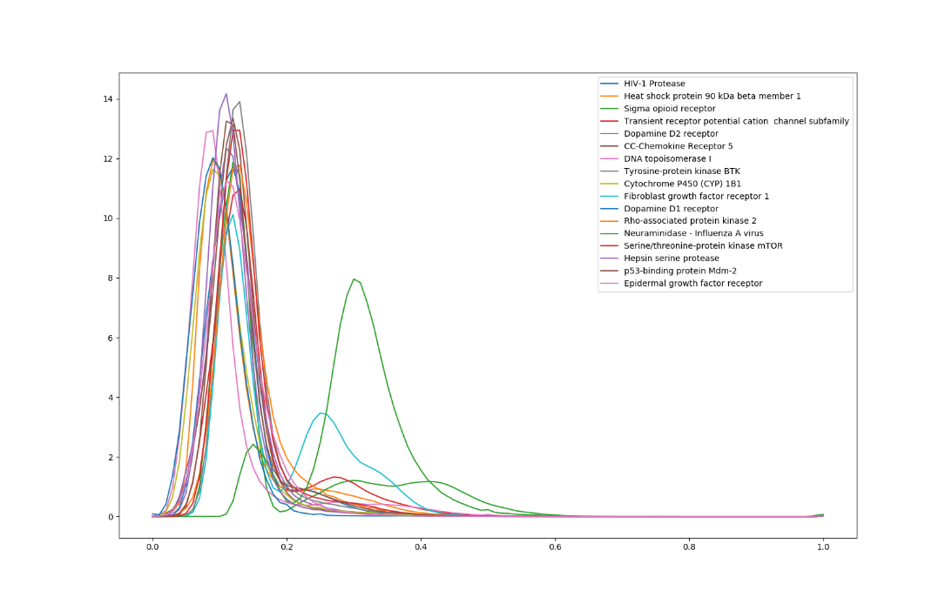

- The Pair-plot & Robustness for 3D KLD-RF Model (S.Fig2, S.Fig3)
S.Fig2) The pair-plots, which can be obtained from the Random Forest model, represent the detailed information of classifier.
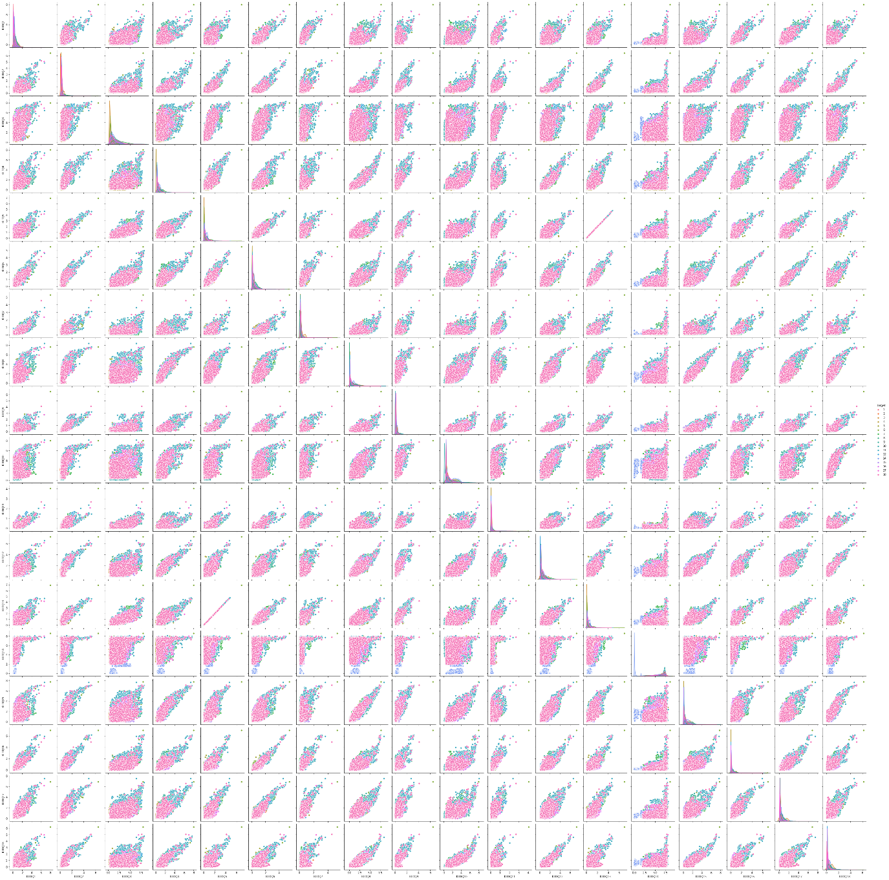

S.Fig3) Robustness of KLD-RF Model with Radom 10 Seeds.
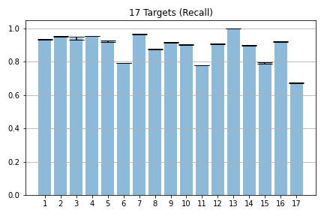

- Statistical Performance of 2D-RF model in predicting DTI (S.Table5)
Target No. | Precision | Recall | F1-score
Q1 | 0.9 | 0.8 | 0.85
Q2 | 0.92 | 0.51 | 0.66
Q3* | - | - | -
Q4 | 1 | 0.9 | 0.95
Q5 | 0.87 | 0.85 | 0.86
Q6 | 0.64 | 0.68 | 0.66
Q7 | 0.93 | 0.59 | 0.73
Q8 | 0.86 | 0.76 | 0.81
Q9 | 0.82 | 0.8 | 0.81
Q10 | 0.92 | 0.76 | 0.83
Q11 | 0.06 | 0.05 | 0.06
Q12 | 0.86 | 0.81 | 0.83
Q13 | 1 | 0.67 | 0.8
Q14 | 0.84 | 0.86 | 0.85
Q15 | 0.99 | 1 | 0.99
Q16 | 0.97 | 0.88 | 0.92
Q17 | 0.71 | 0.81 | 0.76
Test set of Q* is one data.

- Statistical Performance of SwissTarget model in predicting DTI (S.Table6)
Target No. | Precision |  | Recall |  | F1-score
Target No. | SwissTarget | 3D-KLD | SwissTarget | 3D-KLD | SwissTarget | 3D-KLD
Q1 | 0.97 | 0.91 | 0.69 | 0.93 | 0.80 | 0.92
Q2 | 1.00 | 0.97 | 0.83 | 0.95 | 0.91 | 0.96
Q3 | NA* | 0.99 | 0.00 | 0.95 | NA* | 0.97
Q4 | 1.00 | 0.98 | 0.87 | 0.95 | 0.93 | 0.97
Q5 | 0.93 | 0.88 | 0.86 | 0.92 | 0.89 | 0.9
Q6 | 0.74 | 0.84 | 0.73 | 0.79 | 0.74 | 0.81
Q7 | 1.00 | 0.95 | 0.67 | 0.97 | 0.80 | 0.96
Q8 | 0.96 | 0.83 | 0.79 | 0.87 | 0.87 | 0.85
Q9 | 0.92 | 0.87 | 0.83 | 0.91 | 0.87 | 0.89
Q10 | 0.99 | 0.97 | 0.86 | 0.9 | 0.92 | 0.94
Q11 | 0.80 | 0.76 | 0.11 | 0.78 | 0.20 | 0.77
Q12 | 0.96 | 0.85 | 0.88 | 0.9 | 0.92 | 0.87
Q13 | 1.00 | 1 | 0.91 | 1 | 0.95 | 1
Q14 | 0.96 | 0.81 | 0.91 | 0.9 | 0.93 | 0.85
Q15 | 0.93 | 0.84 | 0.82 | 0.79 | 0.87 | 0.81
Q16 | 0.98 | 0.93 | 0.95 | 0.92 | 0.96 | 0.93
Q17 | 0.75 | 0.79 | 0.99 | 0.67 | 0.86 | 0.73
Q3 has TP=FP=0 and FN=5, TN=31,160. Thus, Precision and F1 score are not available.

