Additional file
SESNet: sequence-structure feature-integrated deep learning method for data-efficient protein engineering

Table S1. Spearman correlation in Figure 2A. Comparison to other supervised and unsupervised models for fitness prediction on the single-site mutants of 20 datasets. The one marked in bold denotes the best performance.
 | ESM-IF1 | ESM-1v | MSA Transformer | ESM-1b | ECNet | SESNet
BLAT_ECOLX | 0.673 | 0.692 | 0.538 | 0.847 | 0.826 | 0.903
P84126_THETH | 0.519 | 0.564 | 0.656 | 0.844 | 0.792 | 0.858
RL40B_YEAST | 0.372 | 0.365 | 0.647 | 0.809 | 0.802 | 0.872
TIM_SULSO | 0.506 | 0.617 | 0.613 | 0.772 | 0.737 | 0.790
TRPC_THEMA | 0.392 | 0.488 | 0.462 | 0.767 | 0.727 | 0.783
YAP1_HUMAN | 0.485 | 0.361 | -0.007 | 0.731 | 0.670 | 0.775
DLG4_RAT | 0.468 | 0.531 | 0.224 | 0.676 | 0.737 | 0.748
BG_STRSQ | 0.665 | 0.670 | 0.727 | 0.530 | 0.740 | 0.747
IF1_ECOLI | 0.337 | 0.356 | 0.363 | 0.719 | 0.630 | 0.726
PTEN_HUMAN | 0.559 | 0.458 | 0.366 | 0.688 | 0.684 | 0.715
UBC9_HUMAN | 0.485 | 0.518 | 0.425 | 0.643 | 0.690 | 0.710
RASH_HUMAN | 0.070 | 0.131 | 0.089 | 0.631 | 0.599 | 0.656
AMIE_PSEAE | 0.295 | 0.537 | 0.523 | 0.599 | 0.526 | 0.632
SUMO1_HUMAN | 0.543 | 0.548 | 0.565 | 0.593 | 0.605 | 0.609
TPMT_HUMAN | 0.560 | 0.531 | 0.530 | 0.533 | 0.541 | 0.579
GAL4_YEAST | 0.326 | 0.476 | 0.386 | 0.550 | 0.514 | 0.561
MK01_HUMAN | 0.155 | 0.164 | 0.182 | 0.410 | 0.375 | 0.491
KKA2_KLEPN | 0.204 | 0.198 | 0.153 | 0.405 | 0.370 | 0.446
MTH3_HAEAESTABILIZED | 0.423 | 0.488 | 0.564 | 0.350 | 0.419 | 0.430
B3VI55_LIPST | 0.291 | 0.272 | 0.316 | 0.369 | 0.351 | 0.412
AVERAGE | 0.416 | 0.448 | 0.416 | 0.623 | 0.617 | 0.672

Table S2. Spearman correlation in Figure 2B. Fitness prediction of double-site mutants by unsupervised models (ESM-IF1, ESM-1v and MSA transformer), or supervised models (ECNet and ESM-1b) and SESNet trained on the data of single-site mutants. The one marked in bold denotes the best performance.
 | ESM-IF1 | ESM-1v | MSA Transformer | ESM-1b | ECNet | SESNet
FOSJUN | 0.532 | 0.464 | 0.366 | 0.927 | 0.855 | 0.927
TDP43 | 0.158 | 0.026 | 0.117 | 0.914 | 0.865 | 0.924
GB1 | 0.337 | 0.105 | 0.329 | 0.872 | 0.830 | 0.907
RRM | 0.443 | 0.536 | 0.509 | 0.877 | 0.743 | 0.881
WW | 0.415 | 0.399 | 0.441 | 0.701 | 0.692 | 0.733
GFP | 0.455 | 0.010 | 0.386 | 0.562 | 0.416 | 0.598
AVERAGE | 0.390 | 0.257 | 0.358 | 0.809 | 0.733 | 0.828

Table S3. Spearman correlation in Figure 2C. Prediction of quadruple variants of avGFP using models trained on single, double, triple-site mutants and all the above three.
 | ESM-1b | ECNet | SESNet
single | 0.770 | 0.512 | 0.772
double | 0.847 | 0.802 | 0.850
triple | 0.852 | 0.824 | 0.854
single+double+triple | 0.859 | 0.830 | 0.861
AVERAGE | 0.832 | 0.742 | 0.834

Table S4. Detailed information on the proteins listed in the dataset of Tables 1-3. The protein fitness classification and the number of sites being mutated of each protein.
protein fitness classification | dataset | Mutants (number of sites being mutated)
catalysis | B3VI55_LIPST | 6541 (1)
catalysis | MTH3_HAEAESTABILIZED | 1957 (1)
catalysis | KKA2_KLEPN | 5278 (1)
catalysis | MK01_HUMAN | 5463 (1)
catalysis | AMIE_PSEAE | 6289(1)
catalysis | RASH_HUMAN | 3040 (1)
catalysis | UBC9_HUMAN | 2281 (1)
catalysis | BG_STRSQ | 3000 (1)
catalysis | TRPC_THEMA | 1520 (1)
catalysis | TIM_SULSO | 1520 (1)
catalysis | P84126_THETH | 1520 (1)
catalysis | BLAT_ECOLX | 5468 (1)
protein stability | PTEN_HUMAN | 3014 (1)
protein stability | TPMT_HUMAN | 2659 (1)
peptide binding | DLG4_RAT | 1578 (1)
peptide binding | YAP1_HUMAN | 363 (1)
peptide binding | WW | 629(1), 9713(2)
protein binding | F7YBW7 | 38 (1), 499 (2), 2798 (3), 5859 (4)
protein binding | IF1_ECOLI | 1439(1)
protein binding | SUMO1_HUMAN | 1329 (1)
protein binding | RL40B_YEAST | 1176 (1)
DNA binding | FOSJUN | 1215(1), 107618(2)
DNA binding | GAL4_YEAST | 1193(1)
RNA binding | RRM | 1064(1), 36522(2)
RNA binding | TDP43 | 965(1), 52272(2)
Ig-G binding | GB1 | 1026(1), 516433(2)
fluorescence | GFP | 1084(1), 12777(2), 12336(3), 9387(4),  6825(5), 4298(6), 2526(7), 1364(8), 627(9),  299(10), 118(11), 43(12), 23(13), 5(14), 2(15)

Table S5. Ablation study results. Ablation study was performed in the testing when we removed each of the three modules in the integrated model. The average spearman correlation of all datasets shows that model including all the three components are the most accurate, and all three parts contribute positively to the performance of the integrated model, with the global encoder contributing the most.
 | without structure module | without global encoder | without local encoder | SESNet
BLAT_ECOLX | 0.899 | 0.303 | 0.872 | 0.903
P84126_THETH | 0.849 | 0.399 | 0.840 | 0.858
RL40B_YEAST | 0.829 | 0.344 | 0.769 | 0.872
TIM_SULSO | 0.785 | 0.228 | 0.765 | 0.790
TRPC_THEMA | 0.769 | 0.436 | 0.780 | 0.783
YAP1_HUMAN | 0.756 | 0.189 | 0.769 | 0.775
DLG4_RAT | 0.722 | 0.157 | 0.782 | 0.748
BG_STRSQ | 0.427 | 0.198 | 0.540 | 0.747
IF1_ECOLI | 0.717 | 0.224 | 0.679 | 0.726
PTEN_HUMAN | 0.668 | 0.318 | 0.637 | 0.715
UBC9_HUMAN | 0.638 | 0.255 | 0.635 | 0.710
RASH_HUMAN | 0.637 | 0.246 | 0.653 | 0.656
AMIE_PSEAE | 0.629 | 0.203 | 0.640 | 0.632
SUMO1_HUMAN | 0.592 | 0.294 | 0.591 | 0.609
TPMT_HUMAN | 0.535 | 0.245 | 0.541 | 0.579
GAL4_YEAST | 0.543 | 0.210 | 0.563 | 0.561
MK01_HUMAN | 0.392 | 0.125 | 0.486 | 0.491
KKA2_KLEPN | 0.435 | 0.120 | 0.446 | 0.446
MTH3_HAEAESTABILIZED | 0.394 | 0.252 | 0.409 | 0.430
B3VI55_LIPST | 0.390 | 0.193 | 0.386 | 0.412
AVERAGE | 0.630 | 0.247 | 0.639 | 0.672

Table S6. Ablation study of the pre-trained model tested on GFP datasets. The spearman correlation was predicted by our models which is pre-trained on single-site and numerous double-sites variants generated by the unsupervised model ESM-IF1.
 | without global encoder  and structure module | without local encoder  and structure module | SESNet
2 sites | 0.458 | 0.389 | 0.463
3 sites | 0.453 | 0.447 | 0.538
4 sites | 0.381 | 0.499 | 0.608
5 sites | 0.295 | 0.537 | 0.657
6 sites | 0.217 | 0.555 | 0.683
7 sites | 0.163 | 0.566 | 0.698
8 sites | 0.130 | 0.570 | 0.704
9 sites | 0.113 | 0.573 | 0.707
10 sites | 0.104 | 0.574 | 0.708
11 sites | 0.100 | 0.574 | 0.709
12 sites | 0.099 | 0.575 | 0.709
AVERAGE | 0.228 | 0.533 | 0.653

Table S7. Hyperparameter configurations for different dataset.
 | single-site datasets | multiple-sites dataset
Hidden-size | 256 | 512
Mini-batch size | 32 | 32
Learning rate | 5e-4 | 5e-5
Warmup steps | 2000 | 2000
Dropout | 0.2 | 0.2
Max epochs | 1500 | 1500
Patience for early stop | 150 | 150

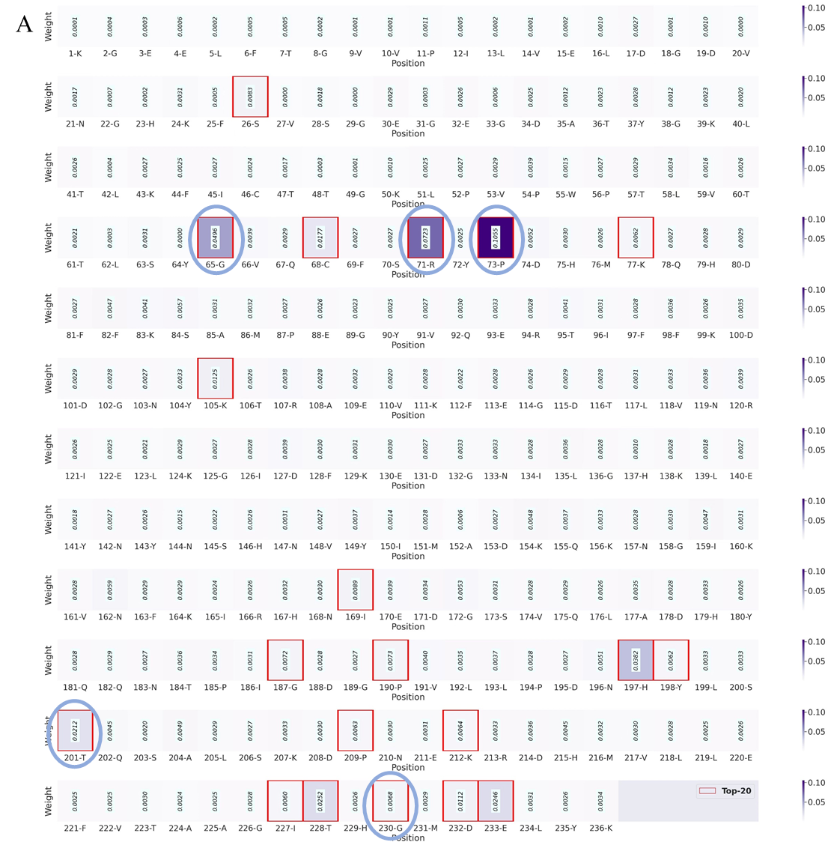

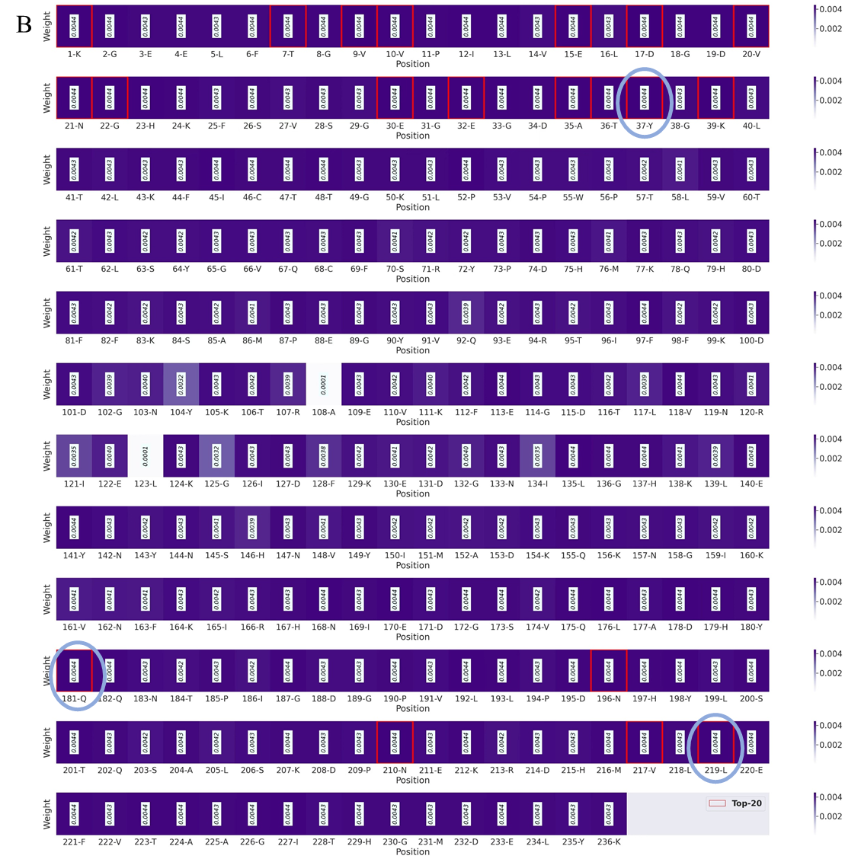
Figure S1. Attention score of sites on the wildtype sequence. Attention scores of sites generated by SESNet (A) and the model without the structure module (B) trained on the 1084 single-site mutants of the dataset of GFP. We picked up the top 20 attention-score AA sites predicted by SESNet with and without structure module, respectively. When the structural module is present, there are five sites (marked by the blue ellipse in the subgraph A) identified by our model accords with the key AA sites discovered by experiments (mentioned in main text). However, this number is reduced to three when we remove the structural module from the model (marked by the blue ellipse in the subgraph B).

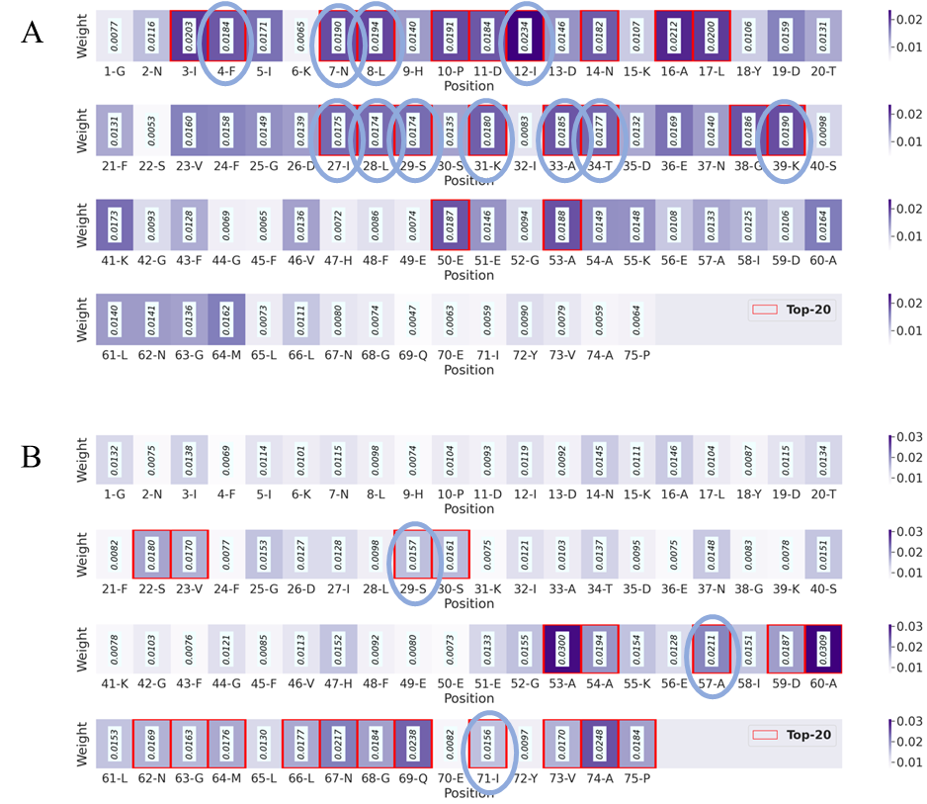
Figure S2. Attention score of sites on the wildtype sequence. Attention scores of sites generated by SESNet (A) and the model when removing the structure encoder (B) trained on the 1064 single-site mutants of the dataset of RRM. We picked up the top-20 attention-score AA sites predicted by SESNet model with and without the structure module, respectively. When the structural module is present, there are 11 sites (marked with blue ellipse in the subgraph A) predicted by the model accord with the key AA sites discovered by experiments (mentioned in main text). In contrast, when removing the structure module, 3 of the predicted top-20 AA sites accord with the experimentally discovered (see the subgraph B).
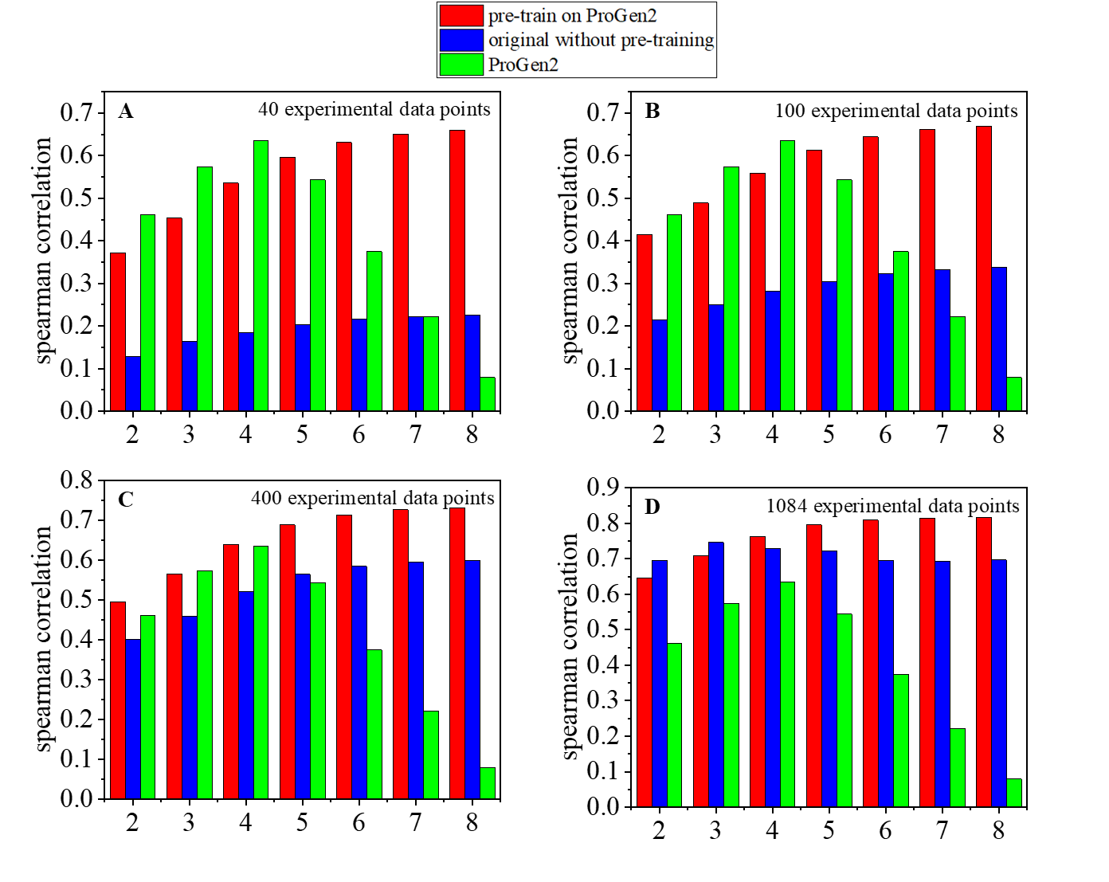
Figure S3. Results of models pre-trained on the dataset generated by the unsupervised model ProGen2 (ref), and then fine-tuned on different number of experimental data points. A-D: The spearman correlation of fitness prediction on multiple sites (2-8 sites) mutants by finetuning on 40, 100, 400, 1084 experimental single-site variants from dataset of GFP. Here, the red and blue bars represent the results of the model with and without pre-training, respectively. And the green bars correspond to the results of the unsupervised model ProGen2 as a control.

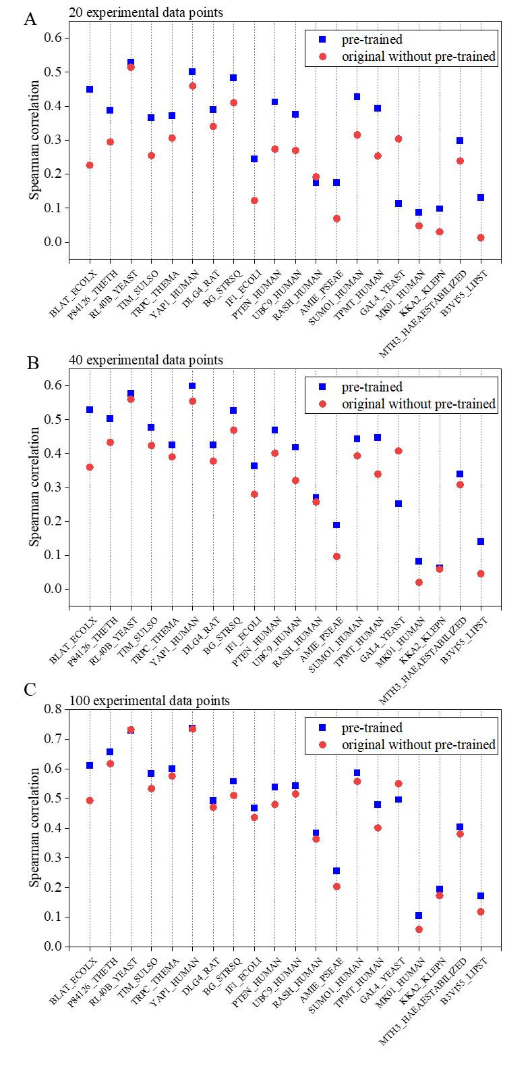
Figure S4. Results of models trained on different number of single-site experimental variants. A-C: The spearman correlation of fitness prediction on single-site mutants by finetuning on 20, 40, 100 single-site variants from different datasets. Where the blue and red symbols represent the results of the pre-trained model and the original model without pretraining, respectively.

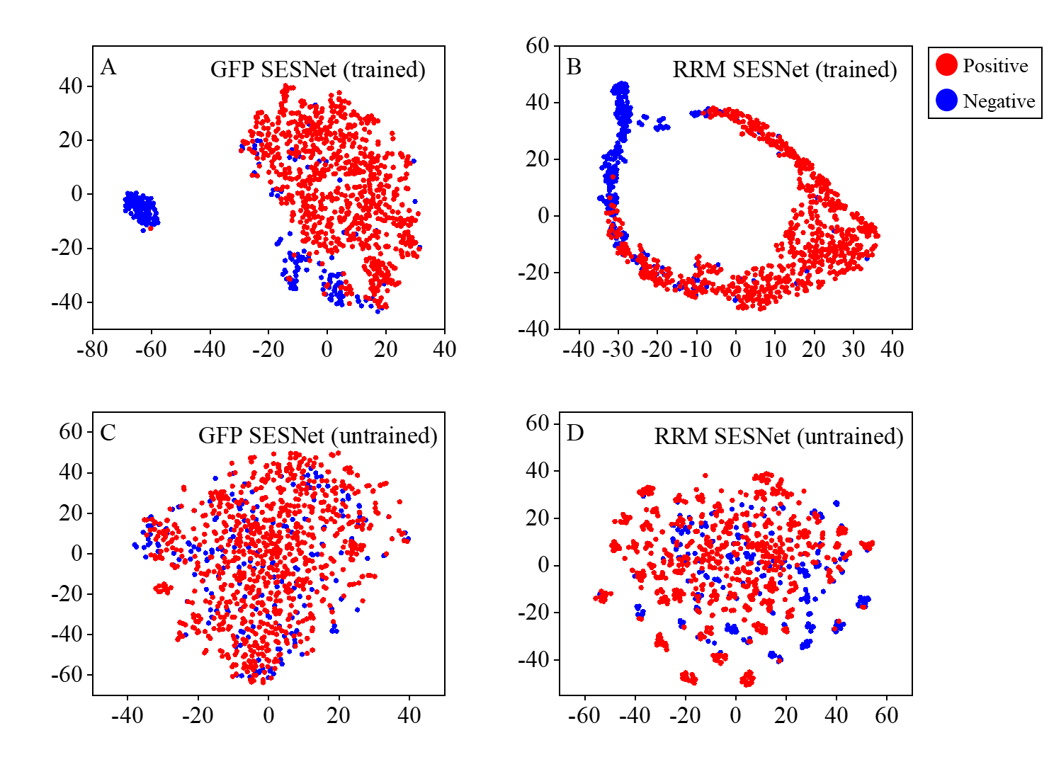
Figure S5. Variant sequence representations of trained and untrained SESNet by the experimental data. Each point represents a variant, where the positive and negative variants are colored as red and blue, respectively. The models were trained on single-site mutants from the dataset of GFP and RRM. Here a red point represents a mutant whose experimental fitness value is higher than that of the wild type, while the blue point gives mutant whose experimental fitness value is lower than the wild type. As can be seen in A and B, after training by part of the experimental data set, the positive and negative mutants can be separated into different spaces. In contrast, those representations from untrained model with random parameter initialization (C and D) do not reflect any clear separation between the positive and negative mutants as expected. This comparison shows that our model can learn to distinguish functional fitness of mutants into a latent representation space with supervised training.

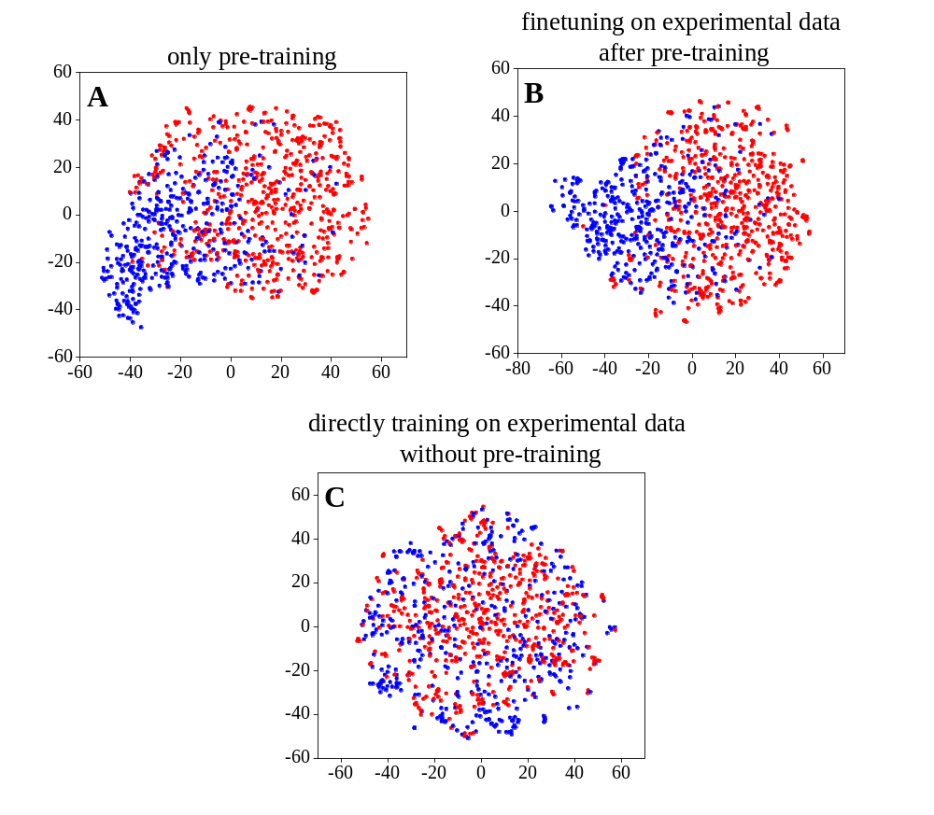
Figure S6. Representations of variants in different training ways. A: The representations from the pre-trained models without fine-tuning by any experimental data. B: the representations from the pre-trained models, which is further finetuned on 40 single-site experimental mutants. C: the representations from the model directly trained on 40 single-site experimental mutants without pre-training.

