Additional file
DeepSAT: Learning Molecular Structures from Nuclear Magnetic Resonance Data
Hyun Woo Kim^{1,2}, Chen Zhang^{1,3}, Raphael Reher^{1,4}, Mingxun Wang^{5,6,7}, Kelsey L Alexander^{1,8}, Louis-Félix Nothias⁹, Yoo Kyong Han¹⁰, Hyeji Shin¹⁰, Ki Yong Lee^{1,10}, Kyu Hyeong Lee², Myeong Ji Kim², Pieter C. Dorrestein⁵, William H Gerwick^{*1,5} and Garrison W Cottrell^{*3}
¹Center for Marine Biotechnology and Biomedicine, Scripps Institution of Oceanography, University of California San Diego, La Jolla, CA, USA.
²College of Pharmacy and Integrated Research Institute for Drug Development, Dongguk University-Seoul, Gyeonggi-do, Republic of Korea
³Department of Computer Science and Engineering, University of California, San Diego, La Jolla, CA, USA.
⁴Institute of Pharmaceutical Biology and Biotechnology, University of Marburg, Marburg, Germany.
⁵Skaggs School of Pharmacy and Pharmaceutical Sciences, University of California San Diego, La Jolla, CA, USA.
⁶Ometa Labs LLC, San Diego, CA, USA.
⁷Department of Computer Science, University of California Riverside, Riverside, CA, USA
⁸Department of Chemistry and Biochemistry, University of California San Diego, La Jolla, CA, USA.
⁹Institut de Chimie de Nice, Université Côte d’Azur, UMR 7272 CNRS, 06108, Nice, France.
¹⁰College of Pharmacy, Korea University, Sejong, Republic of Korea.

*Co-corresponding authors.

Table of contents
1. Introduction of the DeepSAT website
2. Chemical diversity of publicly available NMR databases
3. Constructed HSQC from experimental spectra
4. Model training optimization
5. Compound class prediction results
6. Precision, recall and F1 scores @K of DeepSAT analysis
7. Top1 annotation results of the molecules from DeepSAT analysis in different solvent condition
8. Compound list of experimental HSQC spectra
9. Experimental HSQC spectra in CDCl3 and MeOD
10. Structure elucidation of previously unreported compounds from A. pilosa and Dictyota sp.

1. Introduction of DeepSAT webpage
1.1. Data input
DeepSAT webpage (https://deepsat.ucsd.edu) was designed to provide easy-to-use user interface for structure annotation. The input format is in the form of an NMR peak list; comma-separated or tab-separated formats are supported. After the NMR peak list is input, the experimental type of HSQC needs to be selected between normal HSQC and Multiplicity HSQC. The molecular weight (optional) can be input if users know the molecular weight of the compound. In this case, the input molecular weight is used for annotation instead of the predicted one.
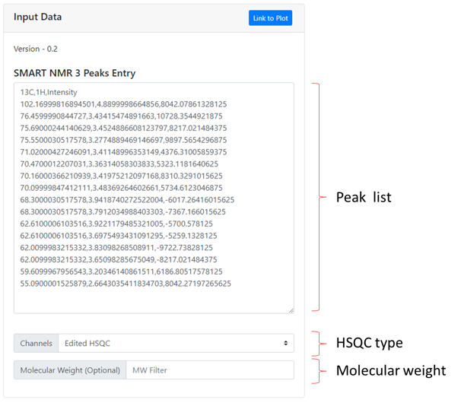
Figure S1 Input data window from DeepSAT

1.2. Analysis and results
Once the HSQC peak list, HSQC type and molecular weight (optional) are submitted, the DeepSAT analysis is automatically processed, and results are provided with compound class, compound names, molecular weight, cosine score, and molecular structures.
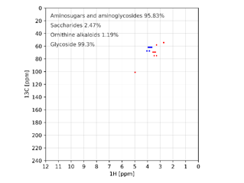
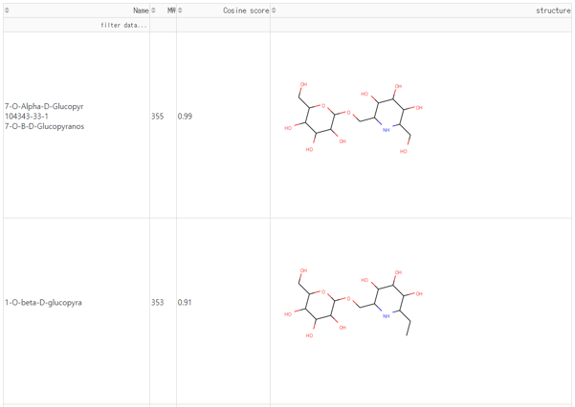
Figure S2 Analysis results from DeepSAT

1.3. User's Guide for DeepSAT Analysis
- The current version of DeepSAT as of 05/16/2021 consists of 2D NMR spectra from 144,254 natural products.
- One DeepSAT analysis should take < 20 seconds.
- If your results are unsatisfactory, please try to process your data again manually (go to How to process a raw HSQC spectrum to an NMR table and then delete noise and duplicate annotations, add peaks missed by auto-peak picking etc.)

1.3.1. How to process a raw HSQC spectrum to an NMR table with MestreNova
1. Open your raw HSQC spectrum in MestreNova (preferences: modern view)
- Drag&Drop your HSQC file (for Bruker data you find your spectrum under: pdata/1/2rr)
- Depending on purity and concentration of your sample and acquisition time, your spectrum will look more or less clean, and may need additional processing (see 2.)
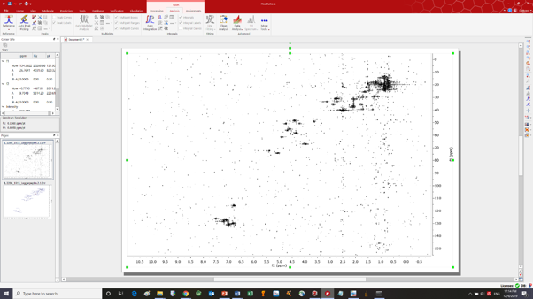
Figure S3 Opening HSQC data file with MestreNova

2. For processing your HSQC spectrum click on 'Processing' tab
- click on 'Auto Phase Correction' (optional: correct manually)
- click on 'Auto Baseline Correction'
- click on 'More Processing' --> click on 'Reduce t1 noise' You should see a clean spectrum now.
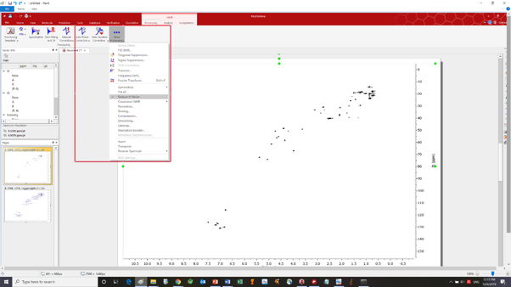
Figure S4 Processing HSQC spectrum
3. Annotate HSQC spectrum with chemical shifts (1H,13C)
- click on 'Analysis' tab
- click on Auto Peak Picking (Important: Check by manually adding missed peaks and removing duplicated, nonsense and solvent peak annotations). Now each peak should be annotated with two numbers separated by comma (1H, 13C chemical shifts)
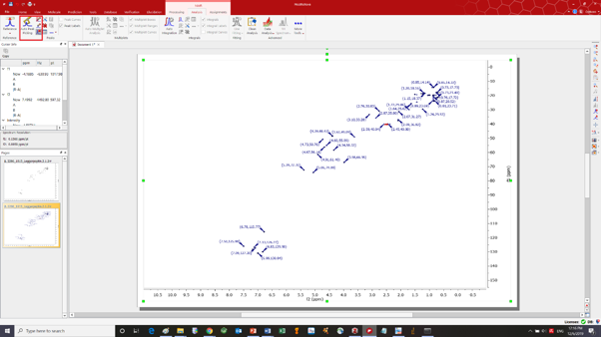
Figure S5 Peak picking from HSQC spectrum

4. Generate NMR table from annotated HSQC spectrum
- click on 'Analysis' tab
- click on 'NMR Peaks Table'
- right click on table, setup report, setup table
- customize table by unchecking every value except f2 (change visible name to 1H), f1 (change visible name to 13C), and Intensity (optional for normal HSQC, essential for Multiplicity-HSQC)
- copy all (ctrl+A)
- click on 'copy peaks' and choose 'copy table'

5. Run SMART Analysis directly
- copy and paste the table (ctrl+C,ctrl+V) directly to the peak list section of https://deepsat.ucsd.edu
- Important: Apply one backslash to remove the additional space character that is imported with the NMR table from MestreNova.
- Select experiment type (Normal HSQC or Multiplicity HSQC)
- (Optional) If you know the molecular weight of your compounds, please enter it.
- Once the data and experimental condition are submitted, analysis is automatically processed.
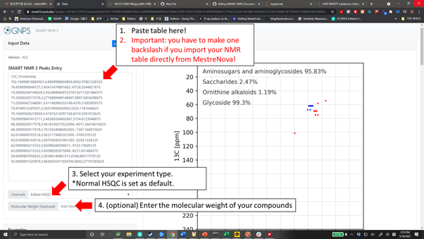
Figure S6 Run DeepSAT directly on the webpage
6. The results will be provided from DeepSAT Analysis on the right side

- Please feel free to play around with the processing parameters such as including/excluding noise signals or signals from other minor compounds in case of mixtures or explore the differences of SMART results when referencing your spectra compared to tables without referencing. Overall SMART is designed to be very robust towards any of these changes as its training is not only based on the absolute position of the peaks, but the relative position of each peak towards every other peak.

1.3.2. How to process a raw HSQC spectrum to an NMR table with Excel.
- Please prepare your NMR peak lists of each compound using Excel or preferably notepad/wordpad. The first row will be left for strings “1H”, “13C”, and "Intensity" (optional) as table head (The order of header is nothing to do with the analysis results).
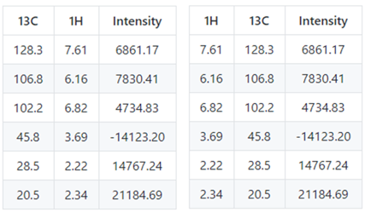
Figure S7 NMR table format for running DeepSAT
- In the NMR table files, wherever there are diastereotopic protons on a methylene carbon (i.e., CH2 with two distinct proton shifts), please add a separate entry for both the carbon and proton:
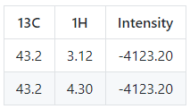
Figure S8 NMR table format for diastereotopic protons

1.3.3. How to process a raw HSQC spectrum to a NMR table with Notepad/wordpad
- SMART supports comma-separated values and tap-separated values for analysis. Your table should appear like this:
for comma-separated values:

1H,13C,Intensity
1.09,14.3,132
2.21,22.2,155
3.41,56.9,239
7.21,128.6,443
7.29,123.4,563

or for tap-separated values:

1H 13C Intensity
1.09 14.3 132
2.21 22.2 155
3.41 56.9 239
7.21 128.6 443
7.29 123.4 563

1.3.4. Copy peak lists from Excel sheets for SMART Analysis
- If you save or prepare your peak lists with Excel files, the data are easily submitted to DeepSAT by copying and pasting the table.
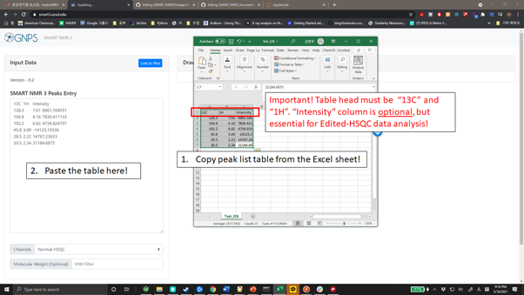
Figure S9 Copy and paste the peak lists directly from Excel sheets.

2. Chemical diversity of publicly available NMR databases using uniform manifold approximation and projection (UMAP)
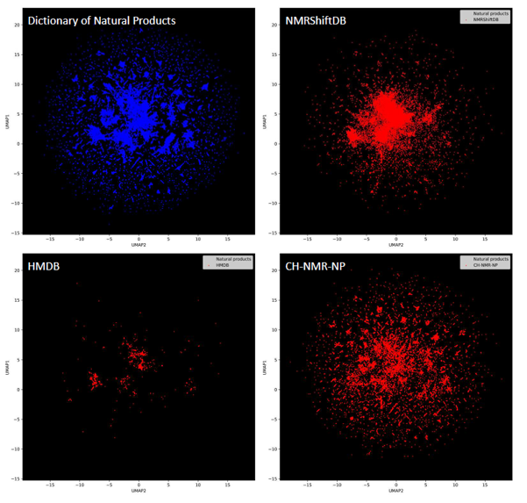
Figure S10 Chemical diversity of molecular structures from reposited NMR spectra in the NMRShiftDB (n=44,315), HMDB (n = 4,036), CH-NMR-NP (n = 35,500) by comparing with Dictionary of Natural Products.
3. Constructed HSQC from experimental spectra
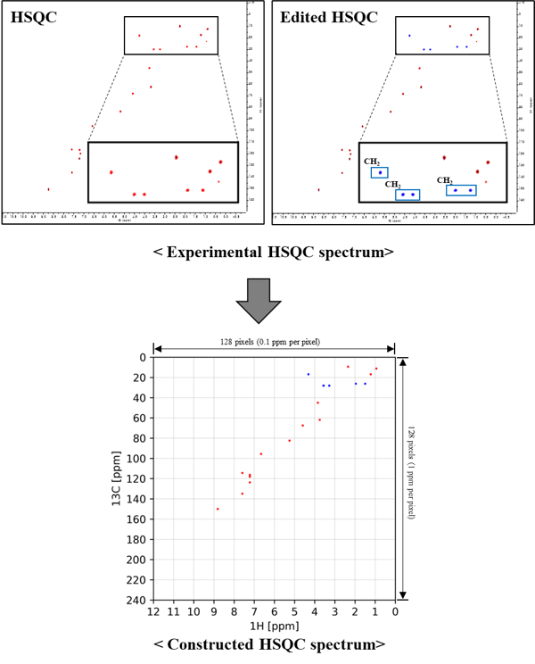

4. Model training optimization
4.1. Image resolution for the convolutional neural network
In order to choose the best image resolution for the convolutional neural network training, three resolutions (64 × 64, 128 × 128, and 192 × 192) of image were tested. Among them, the training from 128 × 128 image resolution showed the best results in the fingerprint and molecular weight predictions.
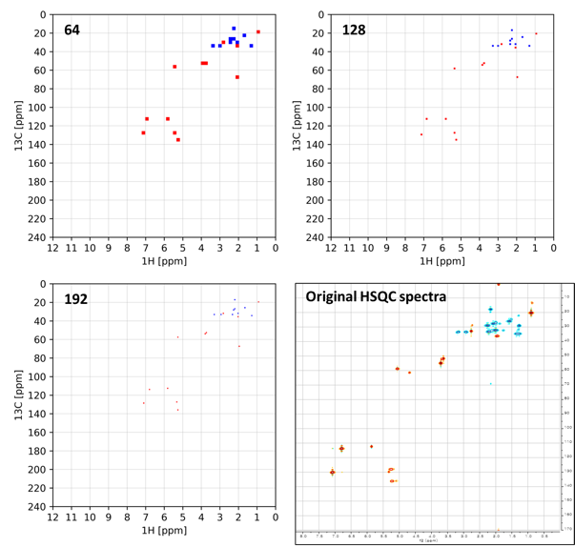
Figure S11 Three constructed HSQC spectra images with different resolutions and the original HSQC spectrum.
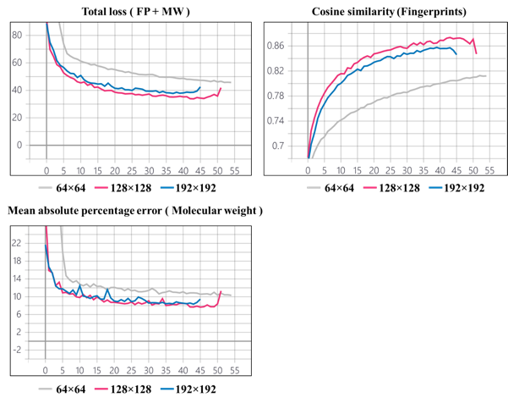
Figure S12 Total loss and performance metrics from training with different image resolutions.

4.2. Data sampling from computed HSQC data for dataset expansion
4.2.1 HSQC spectra computation by using the ACD/Spectrus Processor program
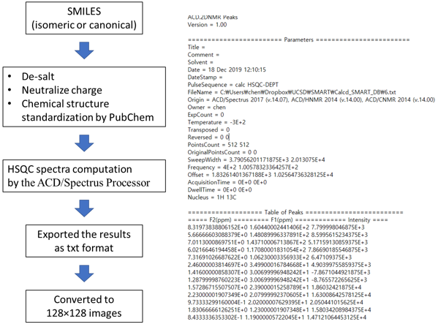
Figure S13 HSQC spectra computation workflow (left) and its text-formatted output (right)

4.2.2 Confirmation of performance improvement in the training by using computed HSQC spectra.
To confirm that the training set with computed HSQC data improved performance, the training results from two datasets with and without computed HSQC data were compared to each other. As we expected, the expanded dataset with computed HSQC data showed the best training results.
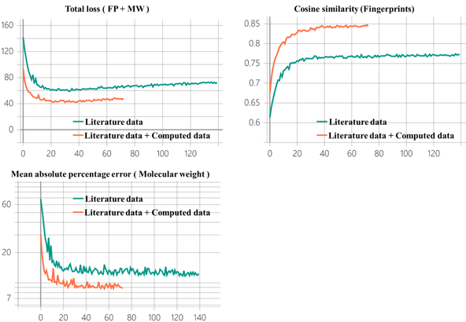
Figure S14 Total loss and performance metrics from the training with/without computed HSQC spectra. Validation data was prepared the from literature data and the same in both experiments.

Table S1 Hyperparameters for training the deep neural networks for DeepSAT
Optimizer | Adam
Activation functions | ReLu (hidden layers)  Sigmoid (fingerprint prediction layer)  Softmax (classification layer)
Loss function | Binary cross-entropy (fingerprint prediction)  Sparse categorical cross entropy (classification)  Mean absolute percentage error (molecular weight regression)
Regularization | L2 regularizer (0.0001, fully connected layer)
Learning rate | 0.00001
Batch normalization | Used
Dropout rate | 0.2
Batch size | 16

5. Compound class prediction results
Table S2 Precision, recall and F1-Score of class prediction results from normal HSQC data. For the purposes of this model, we ignored the 11 superclasses in NPClassifier that were not represented in our data. All the results reported here are based on a 59-way classification.
No. | Class | Precision | Recall | F1-score
1 | Amino acid glycosides | 0.867 | 0.722 | 0.788
2 | Aminosugars and aminoglycosides | 1.000 | 0.565 | 0.722
3 | Anthranilic acid alkaloids | 0.713 | 0.713 | 0.713
4 | Apocarotenoids | 0.770 | 0.851 | 0.809
5 | Aromatic polyketides | 0.799 | 0.840 | 0.819
6 | Carotenoids (C40) | 0.990 | 0.910 | 0.948
7 | Chromanes | 0.912 | 0.752 | 0.824
8 | Coumarins | 0.739 | 0.889 | 0.807
9 | Cyclic polyketides | 0.899 | 0.738 | 0.811
10 | Diarylheptanoids | 0.912 | 0.881 | 0.897
11 | Diazotetronic acids and derivatives | 0.800 | 0.533 | 0.640
12 | Diphenyl ethers (DPEs) | 0.727 | 0.800 | 0.762
13 | Diterpenoids | 0.949 | 0.938 | 0.943
14 | Eicosanoids | 1.000 | 0.973 | 0.986
15 | Fatty Acids and Conjugates | 0.830 | 0.824 | 0.827
16 | Fatty acyl glycosides | 0.917 | 0.917 | 0.917
17 | Fatty acyls | 0.855 | 0.851 | 0.853
18 | Fatty amides | 0.946 | 0.778 | 0.854
19 | Fatty esters | 0.830 | 0.557 | 0.667
20 | Flavonoids | 0.918 | 0.925 | 0.922
21 | Glycerolipids | 0.941 | 0.979 | 0.960
22 | Glycerophospholipids | 0.930 | 1.000 | 0.964
23 | Guanidine alkaloids | 0.842 | 0.800 | 0.821
24 | Histidine alkaloids | 0.818 | 0.450 | 0.581
25 | Isoflavonoids | 0.948 | 0.932 | 0.940
26 | Lignans | 0.965 | 0.918 | 0.941
27 | Linear polyketides | 0.963 | 0.892 | 0.926
28 | Lysine alkaloids | 0.737 | 0.828 | 0.780
29 | Macrolides | 0.980 | 0.943 | 0.961
30 | Meroterpenoids | 0.775 | 0.855 | 0.813
31 | Monoterpenoids | 0.907 | 0.822 | 0.862
32 | Naphthalenes | 0.879 | 0.533 | 0.664
33 | Nicotinic acid alkaloids | 0.916 | 0.731 | 0.813
34 | Nucleosides | 0.983 | 1.000 | 0.991
35 | Oligopeptides | 0.975 | 0.994 | 0.984
36 | Ornithine alkaloids | 0.894 | 0.789 | 0.838
37 | Phenolic acids (C6-C1) | 0.780 | 0.773 | 0.776
38 | Phenylethanoids (C6-C2) | 0.941 | 0.941 | 0.941
39 | Phenylpropanoids (C6-C3) | 0.750 | 0.926 | 0.829
40 | Phloroglucinols | 0.932 | 0.885 | 0.908
41 | Polycyclic aromatic polyketides | 0.807 | 0.888 | 0.846
42 | Polyethers | 0.884 | 1.000 | 0.938
43 | Polyols | 0.800 | 0.632 | 0.706
44 | Proline alkaloids | 0.750 | 0.643 | 0.692
45 | Pseudoalkaloids (transamidation) | 0.840 | 0.782 | 0.810
46 | Saccharides | 0.818 | 0.931 | 0.871
47 | Sesquiterpenoids | 0.866 | 0.935 | 0.899
48 | Sesterterpenoids | 0.946 | 0.921 | 0.933
49 | Small peptides | 0.758 | 0.851 | 0.802
50 | Spingolipids | 0.933 | 0.990 | 0.960
51 | Steroids | 0.962 | 0.974 | 0.968
52 | Stilbenoids | 0.921 | 0.894 | 0.907
53 | Styrylpyrones | 0.905 | 1.000 | 0.950
54 | Terphenyls | 0.821 | 0.793 | 0.807
55 | Triterpenoids | 0.979 | 0.972 | 0.975
56 | Tryptophan alkaloids | 0.853 | 0.955 | 0.901
57 | Tyrosine alkaloids | 0.954 | 0.903 | 0.928
58 | Xanthones | 0.892 | 0.734 | 0.805
59 | beta-lactams | 1.000 | 1.000 | 1.000

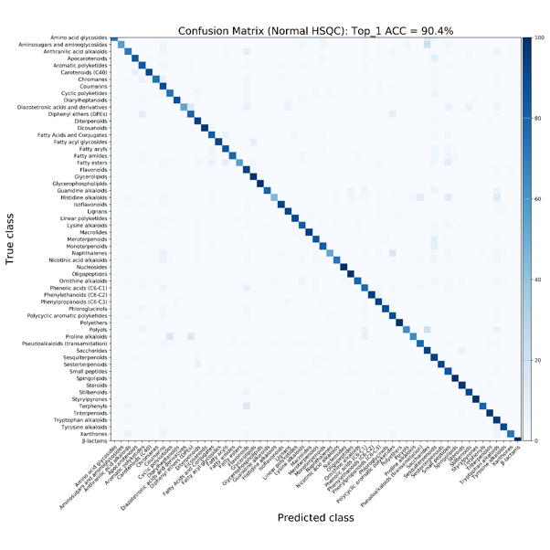
Figure S15 Confusion matrix of classification results using DeepSAT with normal HSQC data.

Table S3. Precision, recall and F1-Score of class prediction results from multiplicity edited HSQC data. For the purposes of this model, we ignored the 11 superclasses in NPClassifier that were not represented in our data. All the results reported here are based on a 59-way classification.

No. | Class | Precision | Recall | F1-score
1 | Amino acid glycosides | 0.682 | 0.833 | 0.750
2 | Aminosugars and aminoglycosides | 0.773 | 0.739 | 0.756
3 | Anthranilic acid alkaloids | 0.646 | 0.689 | 0.667
4 | Apocarotenoids | 0.612 | 0.896 | 0.727
5 | Aromatic polyketides | 0.875 | 0.808 | 0.840
6 | Carotenoids (C40) | 0.981 | 0.937 | 0.959
7 | Chromanes | 0.763 | 0.847 | 0.803
8 | Coumarins | 0.915 | 0.826 | 0.868
9 | Cyclic polyketides | 0.820 | 0.786 | 0.803
10 | Diarylheptanoids | 0.926 | 0.847 | 0.885
11 | Diazotetronic acids and derivatives | 0.667 | 0.400 | 0.500
12 | Diphenyl ethers (DPEs) | 0.765 | 0.650 | 0.703
13 | Diterpenoids | 0.945 | 0.962 | 0.953
14 | Eicosanoids | 0.974 | 1.000 | 0.987
15 | Fatty Acids and Conjugates | 0.771 | 0.865 | 0.815
16 | Fatty acyl glycosides | 0.900 | 0.750 | 0.818
17 | Fatty acyls | 0.695 | 0.931 | 0.796
18 | Fatty amides | 0.946 | 0.778 | 0.854
19 | Fatty esters | 0.822 | 0.759 | 0.789
20 | Flavonoids | 0.892 | 0.932 | 0.912
21 | Glycerolipids | 0.979 | 0.969 | 0.974
22 | Glycerophospholipids | 0.907 | 0.975 | 0.940
23 | Guanidine alkaloids | 1.000 | 0.750 | 0.857
24 | Histidine alkaloids | 0.700 | 0.700 | 0.700
25 | Isoflavonoids | 0.967 | 0.885 | 0.924
26 | Lignans | 0.957 | 0.948 | 0.953
27 | Linear polyketides | 0.920 | 0.944 | 0.932
28 | Lysine alkaloids | 0.742 | 0.779 | 0.760
29 | Macrolides | 0.980 | 0.943 | 0.961
30 | Meroterpenoids | 0.888 | 0.812 | 0.848
31 | Monoterpenoids | 0.888 | 0.845 | 0.866
32 | Naphthalenes | 0.719 | 0.700 | 0.709
33 | Nicotinic acid alkaloids | 0.819 | 0.827 | 0.823
34 | Nucleosides | 0.982 | 0.931 | 0.956
35 | Oligopeptides | 0.977 | 0.983 | 0.980
36 | Ornithine alkaloids | 0.745 | 0.867 | 0.801
37 | Phenolic acids (C6-C1) | 0.730 | 0.836 | 0.780
38 | Phenylethanoids (C6-C2) | 1.000 | 0.882 | 0.938
39 | Phenylpropanoids (C6-C3) | 0.798 | 0.926 | 0.857
40 | Phloroglucinols | 0.938 | 0.769 | 0.845
41 | Polycyclic aromatic polyketides | 0.849 | 0.867 | 0.858
42 | Polyethers | 1.000 | 0.974 | 0.987
43 | Polyols | 0.867 | 0.684 | 0.765
44 | Proline alkaloids | 0.889 | 0.571 | 0.696
45 | Pseudoalkaloids (transamidation) | 0.952 | 0.690 | 0.800
46 | Saccharides | 0.957 | 0.776 | 0.857
47 | Sesquiterpenoids | 0.939 | 0.915 | 0.926
48 | Sesterterpenoids | 0.989 | 0.816 | 0.894
49 | Small peptides | 0.951 | 0.703 | 0.808
50 | Spingolipids | 0.942 | 0.990 | 0.965
51 | Steroids | 0.980 | 0.988 | 0.984
52 | Stilbenoids | 0.922 | 0.904 | 0.913
53 | Styrylpyrones | 0.929 | 0.684 | 0.788
54 | Terphenyls | 0.647 | 0.759 | 0.698
55 | Triterpenoids | 0.975 | 0.985 | 0.980
56 | Tryptophan alkaloids | 0.931 | 0.907 | 0.919
57 | Tyrosine alkaloids | 0.911 | 0.957 | 0.933
58 | Xanthones | 0.687 | 0.815 | 0.745
59 | beta-lactams | 1.000 | 0.950 | 0.974

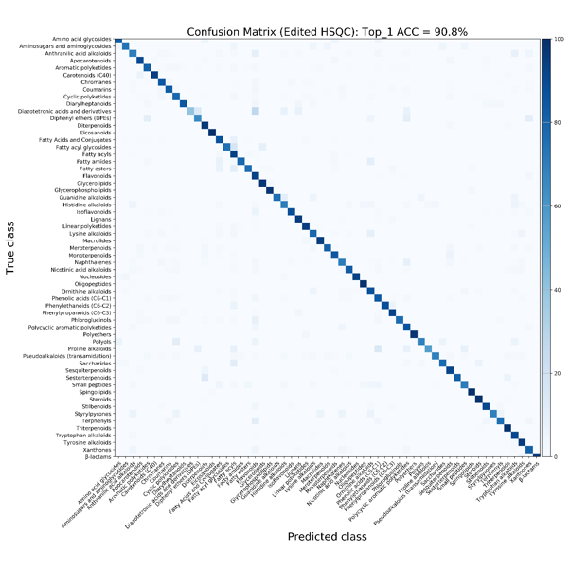
Figure S16 Confusion matrix of classification results using DeepSAT with multiplicity edited HSQC data.

6. Precision, recall and F1 scores @K of structure annotation results from DeepSAT

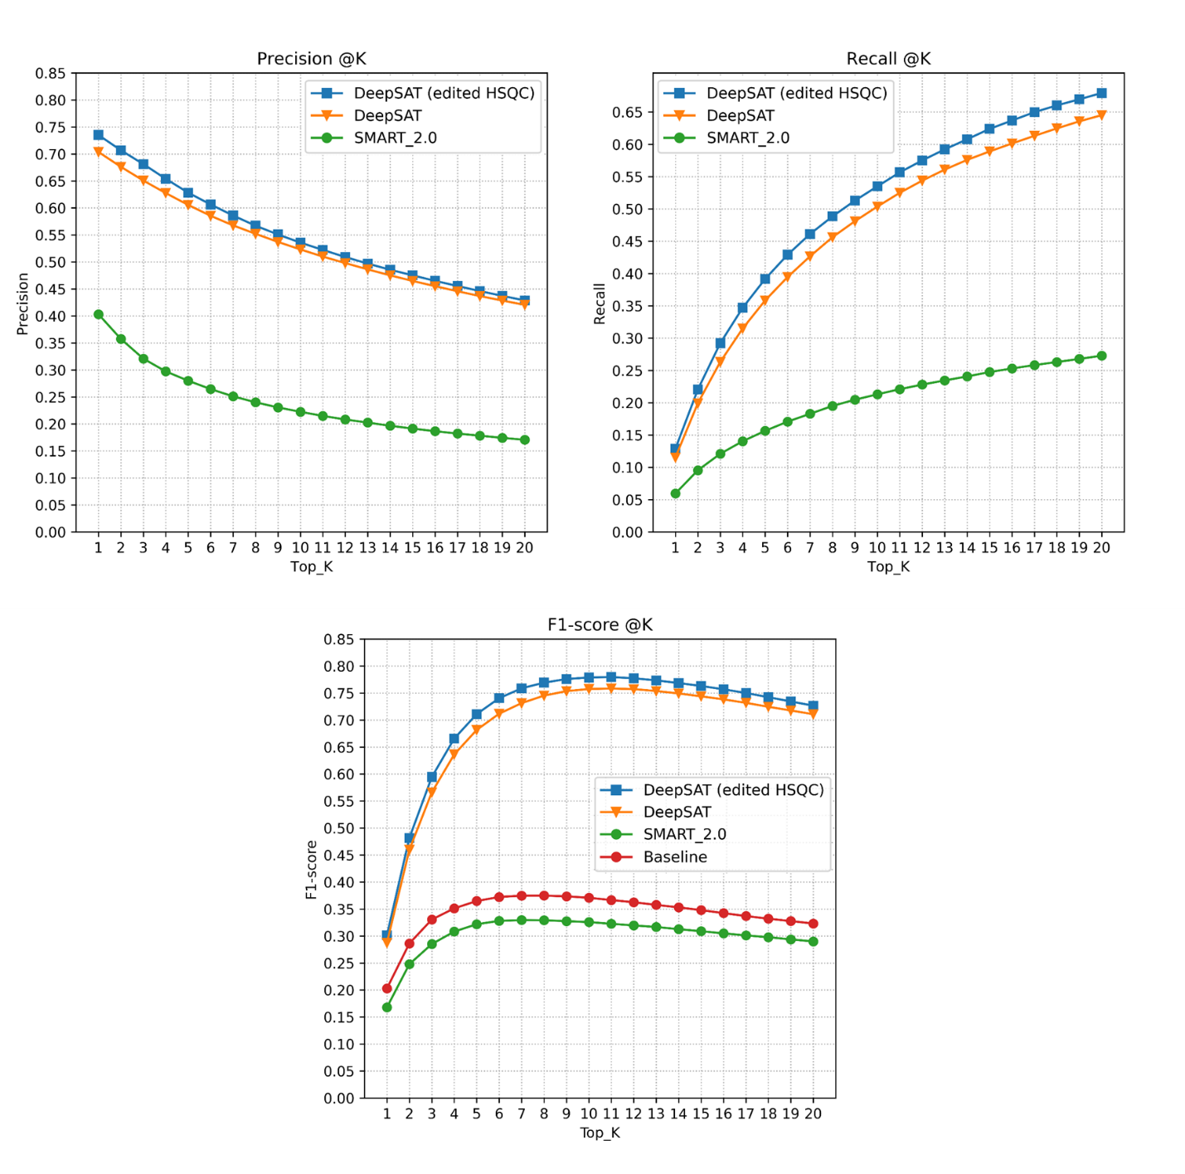
Figure S17 The precision@k, recall@k, and F1 score@K of structure annotation from DeepSAT and SMART 2.0

7. Top1 annotation results from DeepSAT analysis in different solvent conditions. (Ground truth, predicted from MeOD, predicted from CDCl₃)
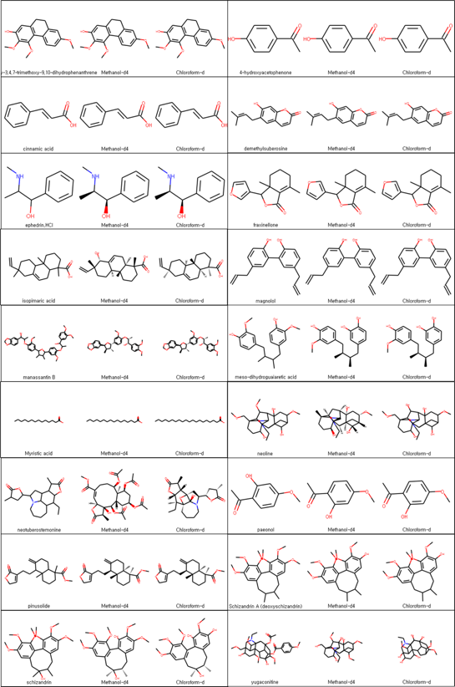
Figure S18 Top1 results from DeepSAT analysis in methanol-d₄ and chloroform-d
8. Compound list of the experimental HSQC spectra (“O” indicates that a spectrum was recorded in that solvent, “X” indicates that a spectrum was not recorded in that solvent).
NO. | Name | Molecular Formula | M.W. | HSQC data
 |  |  |  | CDCl3 | MeOD
1 | Neoline | C₂₄H₃₉NO₆ | 437.6 | O | O
2 | hypaconitine | C₃₃H₄₅NO₁₀ | 615.7 | O | X
3 | tugaconitine | C₂₃H₃₅NO₇ | 437.5 | O | O
4 | Decursin | C₁₉H₂₀O₅ | 328.4 | O | X
5 | decursinol | C₁₄H₁₄O₄ | 246.3 | O | X
6 | demethylsuberosin | C₁₄H₁₄O₃ | 230.3 | O | X
7 | isoimperatorin | C₁₆H₁₄O₄ | 270.3 | O | X
8 | isopimaric acid | C₂₀H₃₂O | 288.5 | O | O
9 | pinusolide | C₂₁H₃₀O₄ | 346.5 | O | O
10 | Schizandrin A (deoxyschizandrin) | C₂₄H₃₂O₆ | 416.5 | O | O
11 | meso-dihydroguaiaretic acid | C₂₀H₂₆O₄ | 330.4 | O | O
12 | quercetin | C₁₅H₁₀O₇ | 302.2 | X | O
13 | manassantin B | C₄₁H₄₈O₁₁ | 716.8 | O | O
14 | sauchinone | C₂₀H₂₀O₆ | 356.1 | O | X
15 | gomisin N | C₂₃H₂₈O₆ | 400.5 | O | X
16 | wuweizisu C | C₂₂H₂₄O₆ | 384.4 | O | X
17 | cinnamic acid | C₉H₈O₂ | 148.2 | O | O
18 | E-p-coumaric acid | C₉H₈O₃ | 164.2 | X | O
19 | scopolamine | C₁₇H₂₁NO₄ | 303.4 | X | O
20 | diosgenin | C₂₇H₄₂O₃ | 414.6 | O | X
21 | Catechin | C₁₅H₁₄O₆ | 290.3 | X | O
22 | ursodeoxycholic acid | C₂₄H₄₀O₄ | 392.6 | X | O
23 | Loganin | C₁₇H₂₆O₁₀ | 390.3 | X | O
24 | Puerarin | C₂₁H₂₀O₉ | 416.4 | X | O
25 | schizandrin | C₂₄H₃₂O₇ | 432.5 | O | O
26 | ephedrin.HCl | C₁₀H₁₆NOCl | 210.1 | O | O
27 | friedeline | C₃₀H₅₀O | 426.0 | O | X
28 | glut-5-enol | C₃₀H₅₀O | 426.0 | O | X
29 | a-amyrin | C₃₀H₅₀O | 426.0 | O | X
30 | b-amyrin | C₃₀H₅₀O | 426.0 | O | X
31 | gallic acid | C₇H₆O₅ | 170.0 | X | O
32 | eclalbasaponin III | C₄₈H₇₈O₁₉ | 959.1 | X | O
33 | 4-hydroxyacetophenone | C₈H₈O₂ | 136.1 | O | O
34 | fraxinellone | C₁₄H₁₆O₃ | 232.3 | O | O
35 | 2-hydroxy-3,4,7-trimethoxy-9,10-dihydrophenanthrene | C₁₇H₁₈O₄ | 286.3 | O | O
36 | erianthridin | C₁₆H₁₆O₅ | 272.0 | X | O
37 | lusianthridin | C₁₅H₁₄O₃ | 242.0 | X | O
38 | gallic acid methyl ester | C₈H₈O₅ | 184.2 | X | O
39 | nordihydroguaiaretic acid | C₁₈H₂₂O₄ | 302.4 | X | O
40 | magnolol | C₁₈H₁₈O₂ | 266.3 | O | O
41 | geniposide | C₁₇H₂₄O₁₀ | 388.4 | X | O
42 | Paeonol | C₉H₁₀O₃ | 166.2 | O | O
43 | machilin A | C₂₀H₂₂O₄ | 326.4 | O | X
44 | demethylsuberosine | C₁₄H₁₄O₃ | 230.3 | O | O
45 | asiatic acid | C₃₀H₄₈O₅ | 488.7 | X | O
46 | Galbacin | C₂₀H₂₀O₅ | 340.4 | O | X
47 | Lyoniside | C₂₇H₃₆O₁₂ | 552.6 | X | O
48 | 3-hydroxy-5,7-dimethoxy-3,4-methylenedioxyflavan | C₁₈H₁₈O₆ | 330.0 | O | X
49 | 3,4-dihydroxy-3,5,7-trimethoxyflavan | C₁₈H₂₀O₆ | 332.0 | O | X
50 | azelaic acid | C₉H₁₆O₄ | 154.0 | X | O
51 | neotuberostemonine | C₂₂H₃₃NO₄ | 375.2 | O | O
52 | Indoxyl B-D-glucoside (indican) | C₁₄H₁₇NO₆ | 295.1 | X | O
53 | 3,4-dihydroxybenzoic acid | C₇H₆O₄ | 154.1 | X | O
54 | Myristic acid | C₁₄H₂₈O₂ | 228.4 | O | O
55 | Stearic acid | C₁₈H₃₆O₂ | 284.5 | O | X
56 | platyphylloside | C₂₅H₃₂O₉ | 476.5 | X | O
57 | 3,5,7,2',6'-pentahydroxyflavanone | C₁₅H₁₂O₇ | 304.3 | X | O
58 | imperatorin | C₁₆H₁₄O₄ | 270.3 | O | X
59 | oxypeucedanin | C₁₆H₁₄O₅ | 286.3 | O | X
60 | arctigenin | C₂₁H₂₄O₆ | 372.4 | O | X

9. Experimental HSQC spectra in CDCl3 and MeOD
9.1. Experimental HSQC spectra in CDCl₃
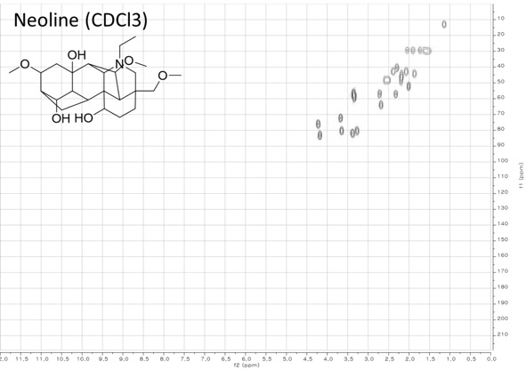
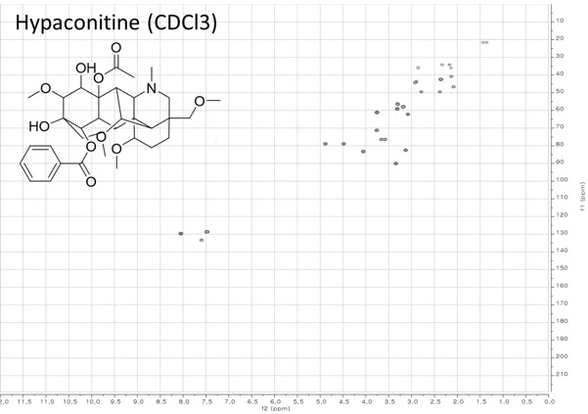
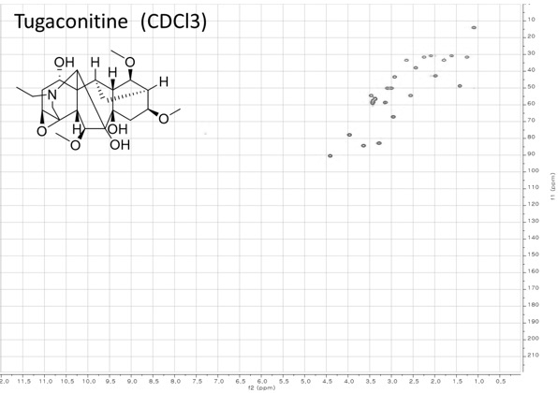
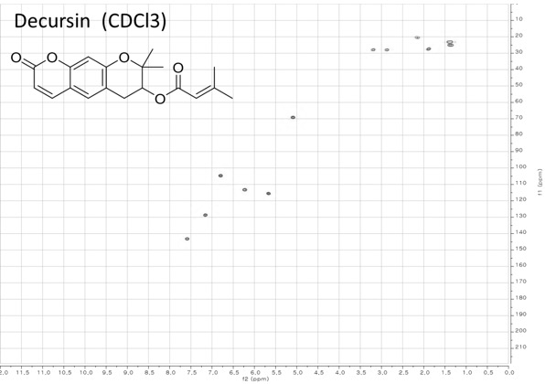

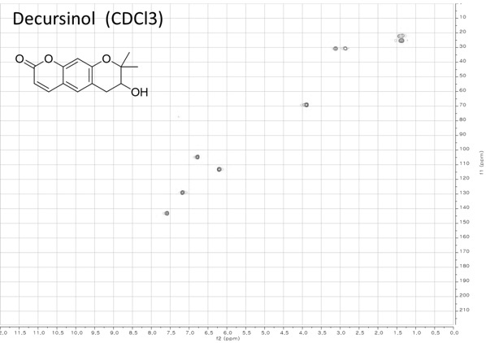
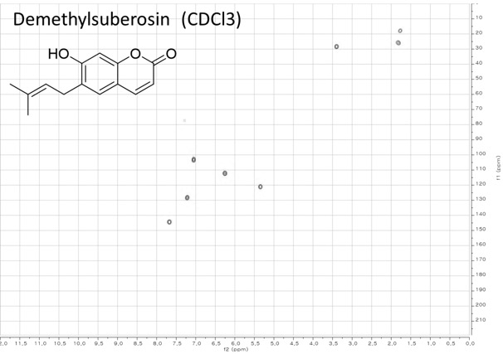

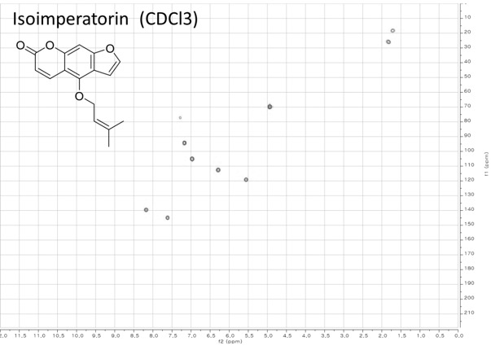
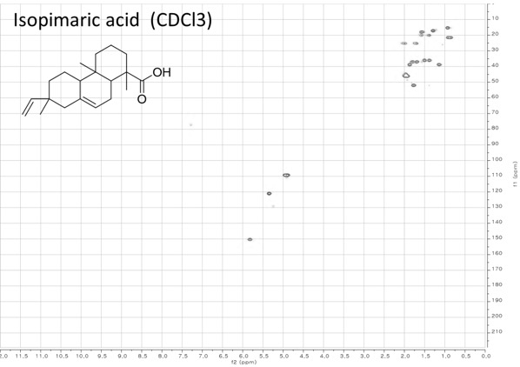

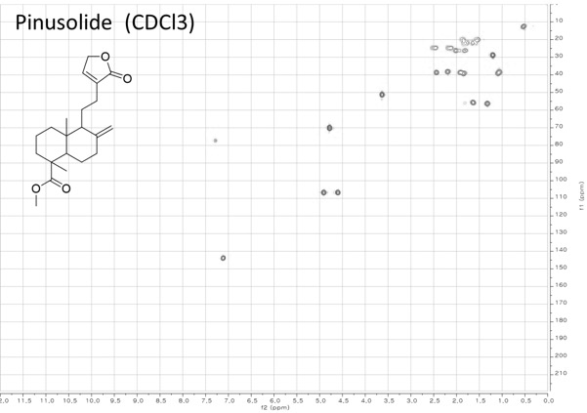
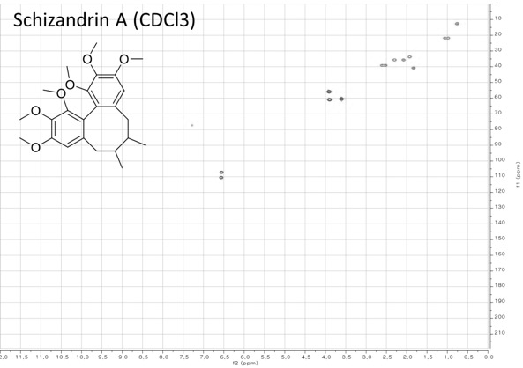

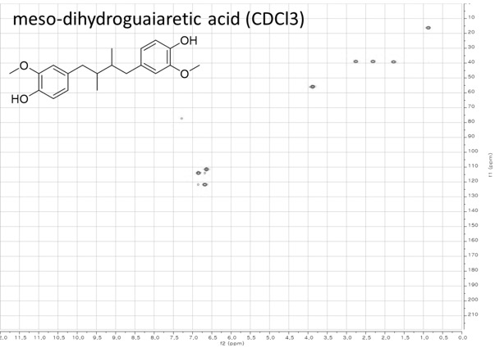
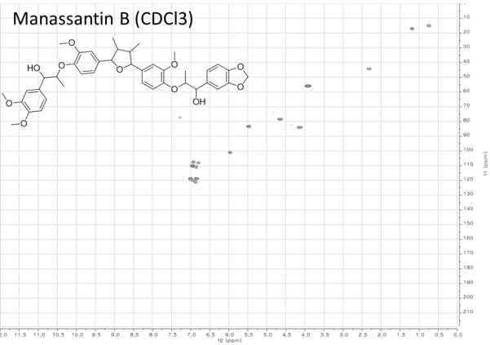

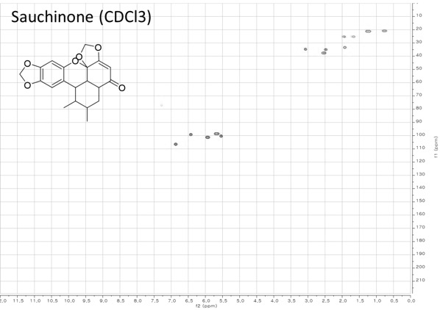
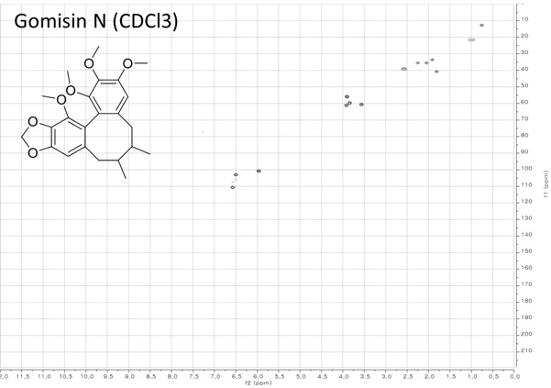

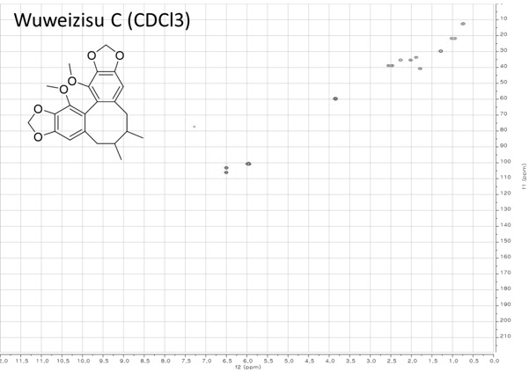
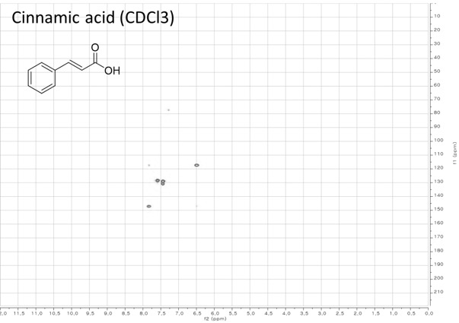

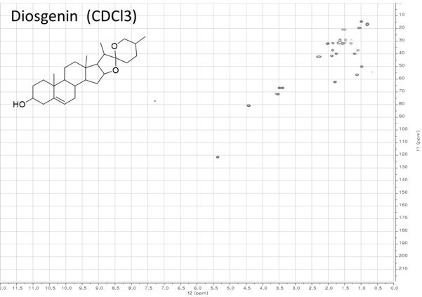
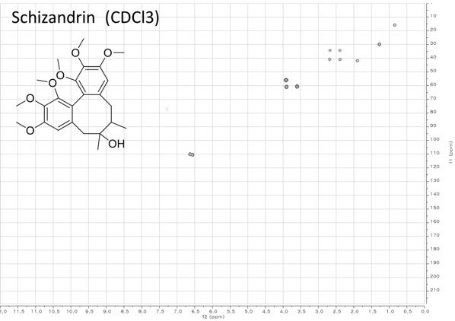

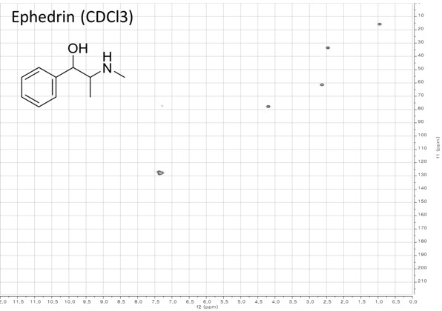
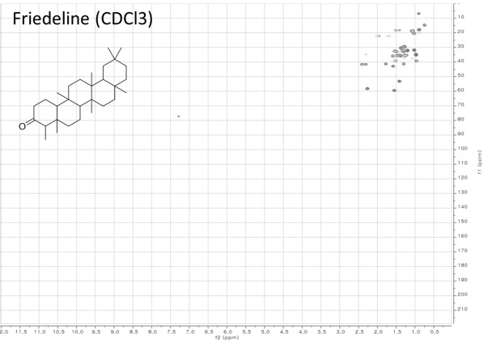

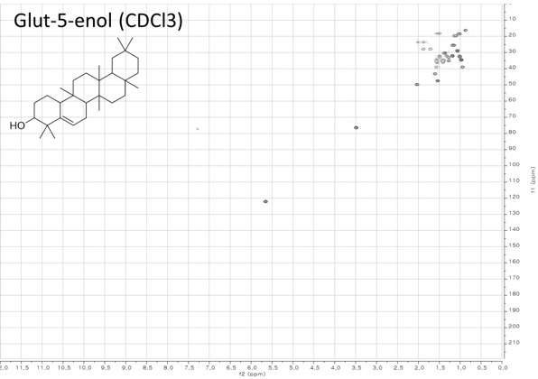
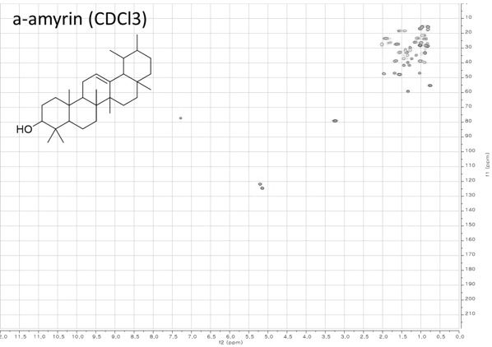
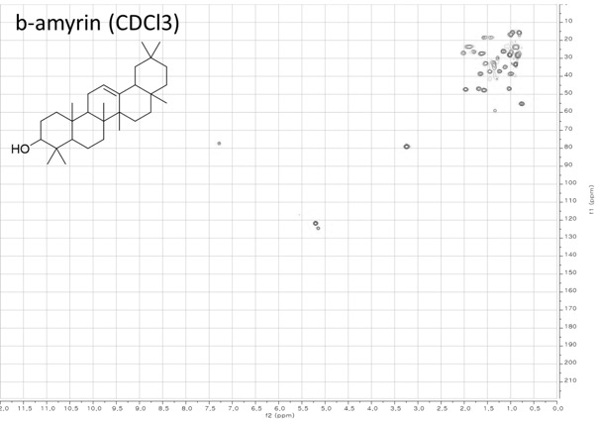
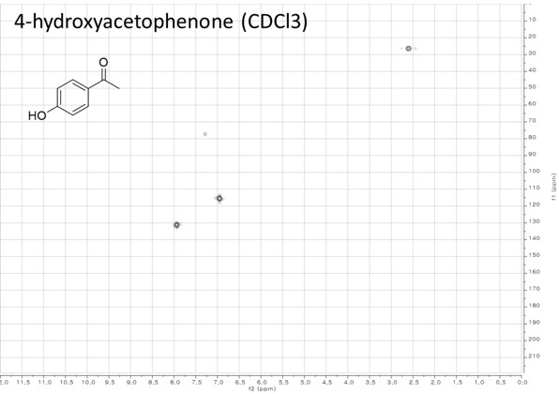
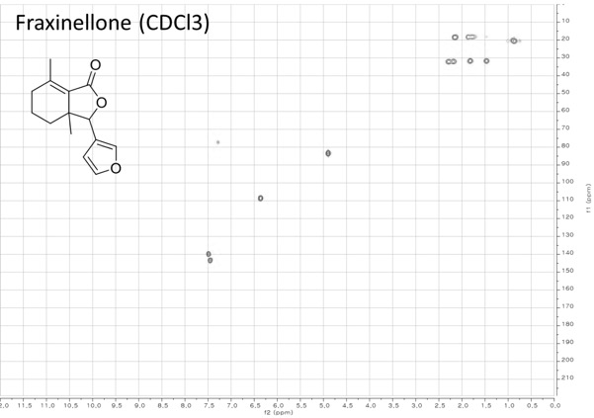
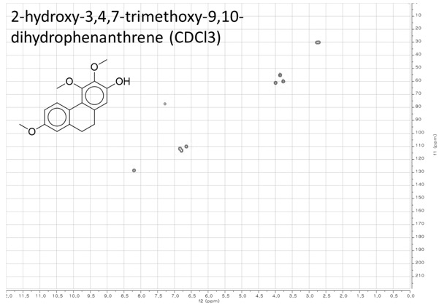
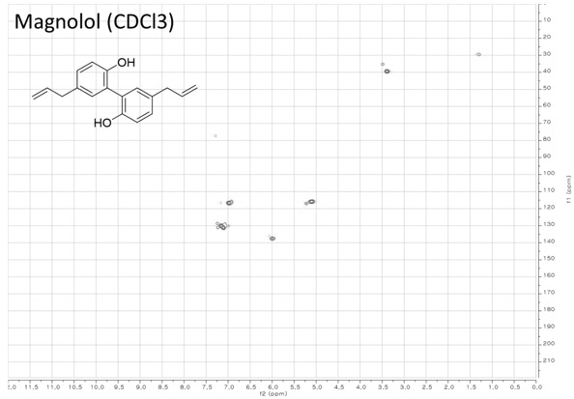
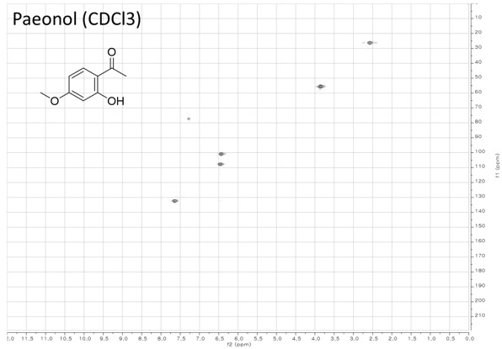
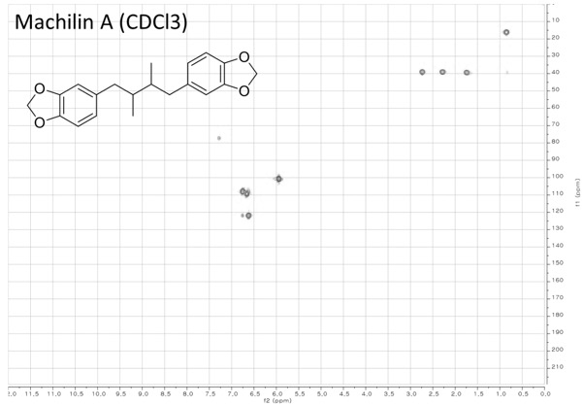
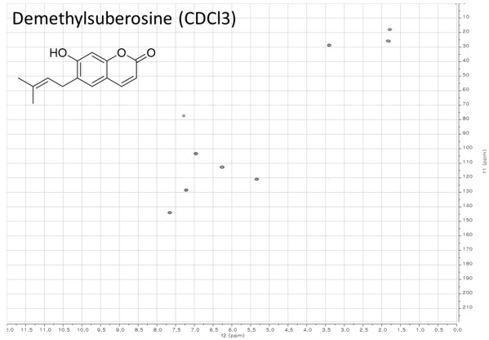
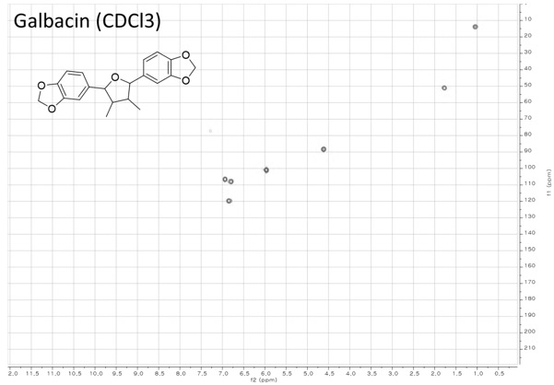
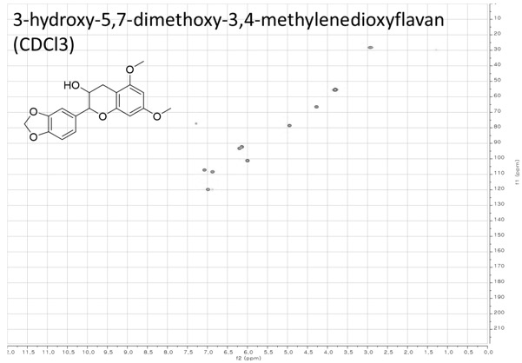
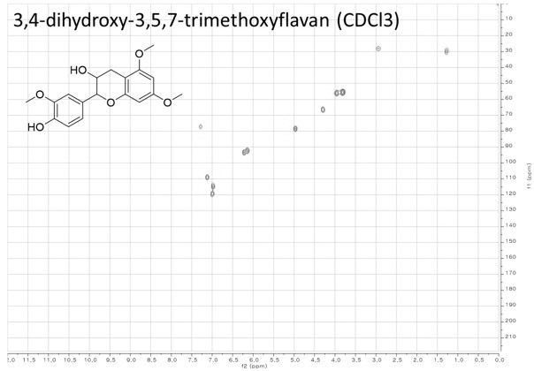
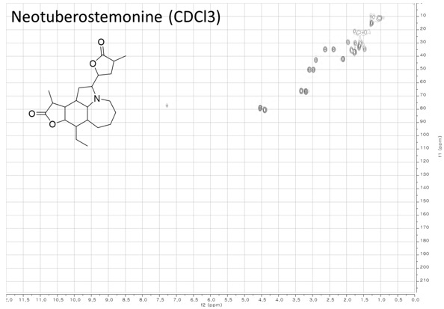
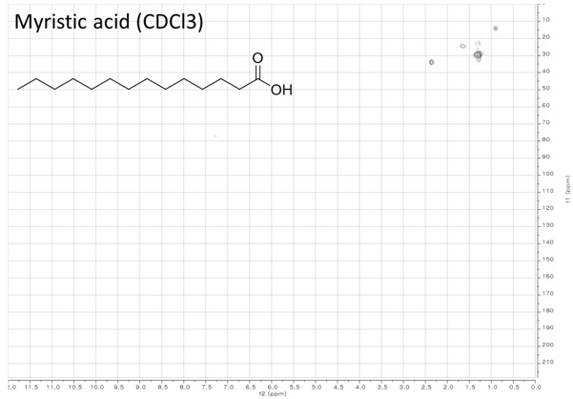
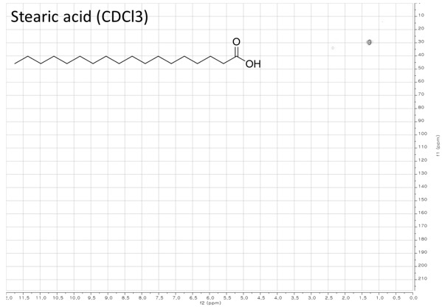
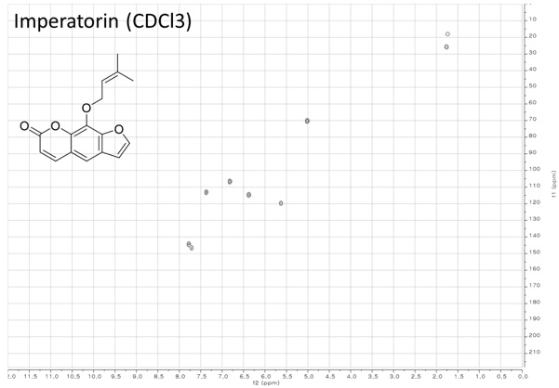
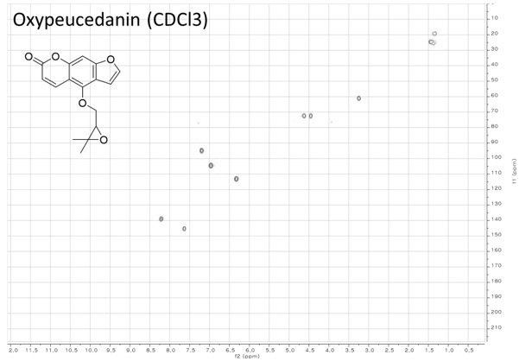
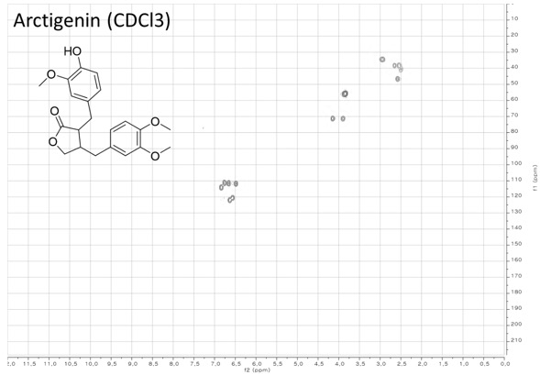

9.2. Experimental HSQC spectra in MeOD
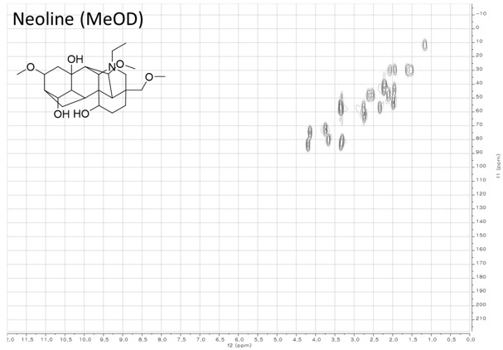

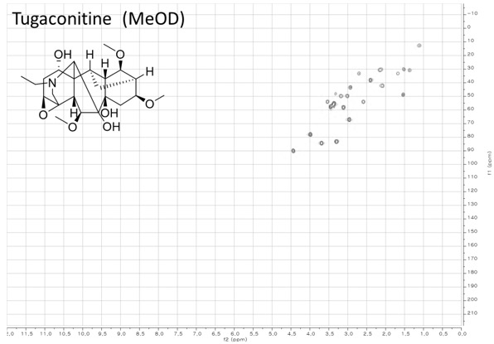
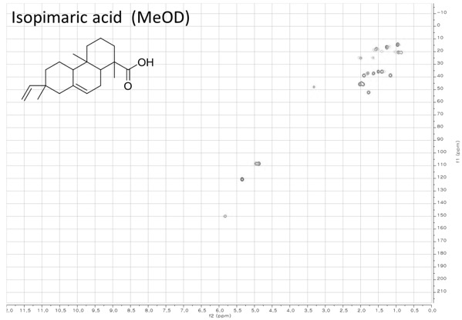
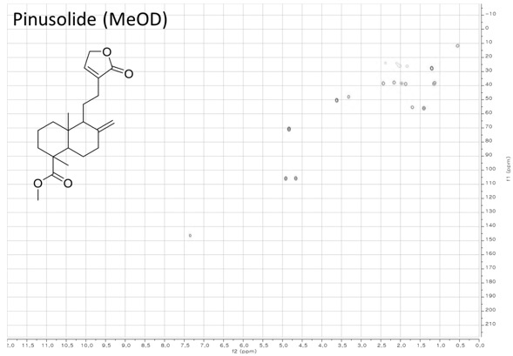
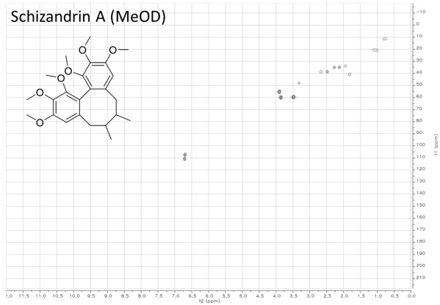
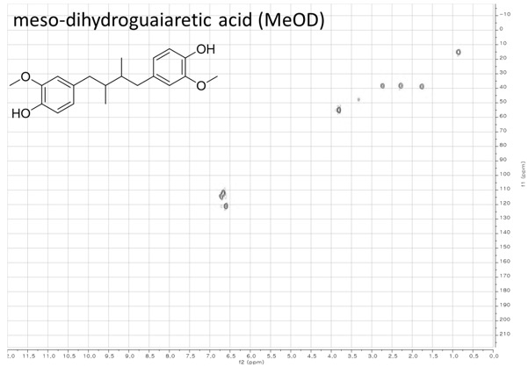
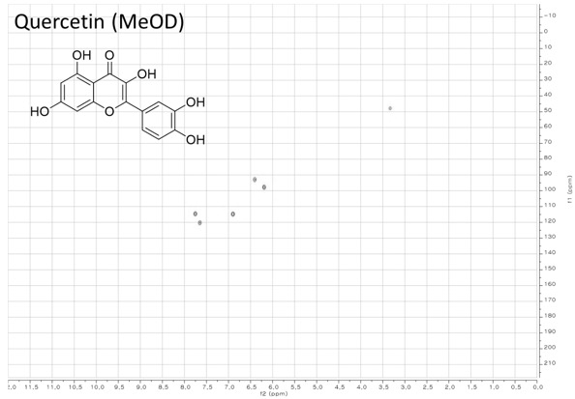
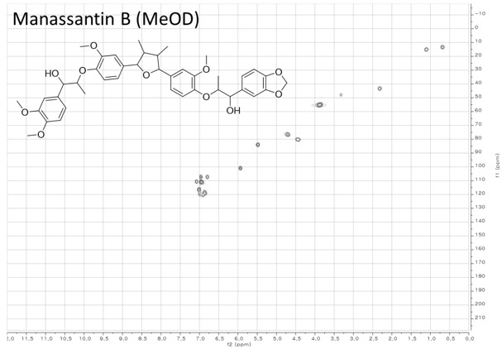
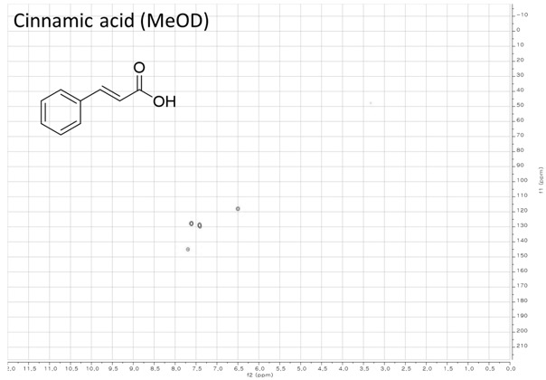
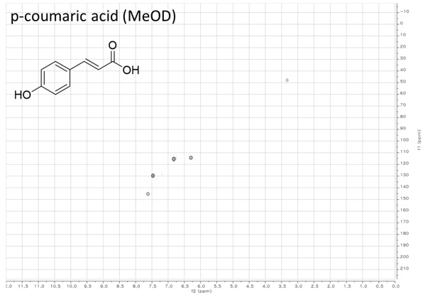
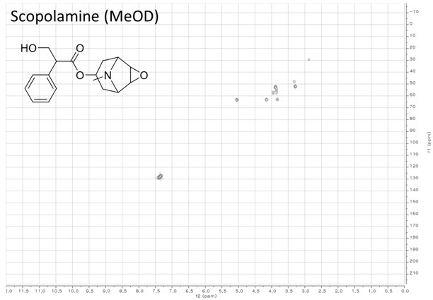
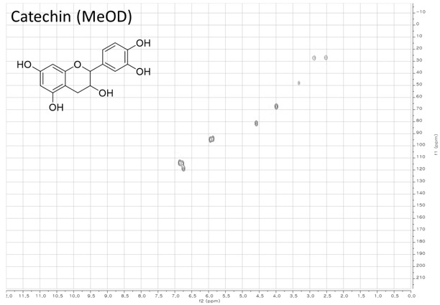
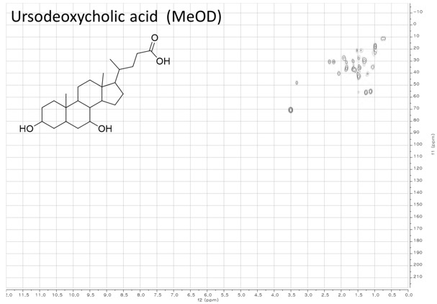
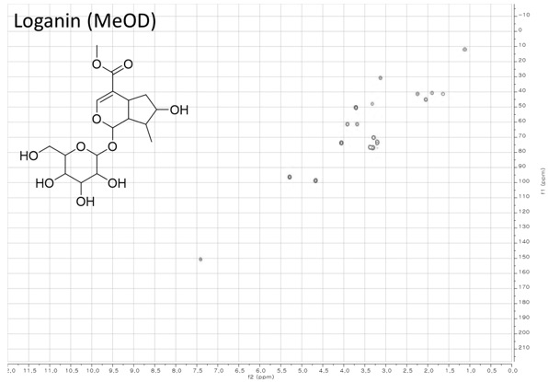
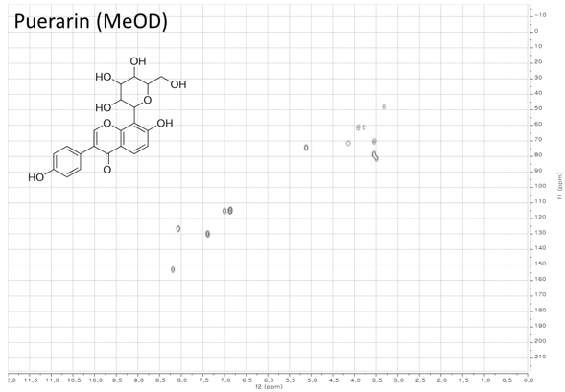
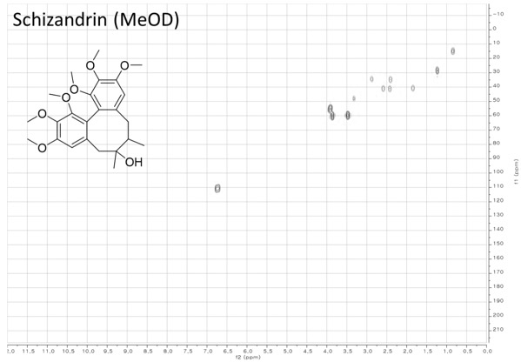
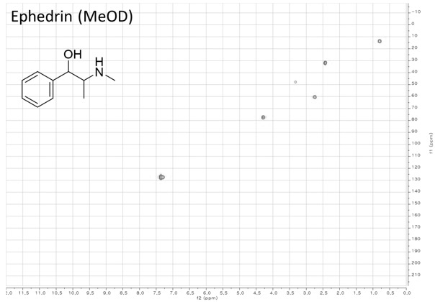
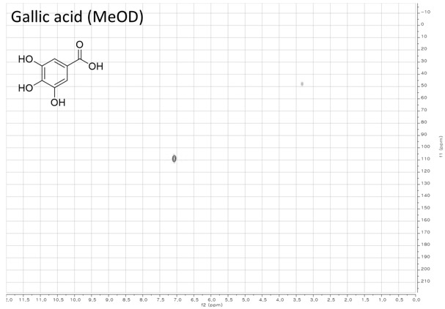
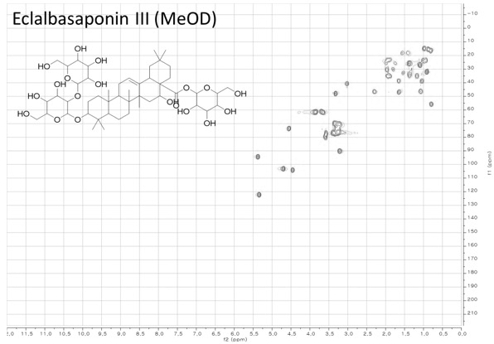
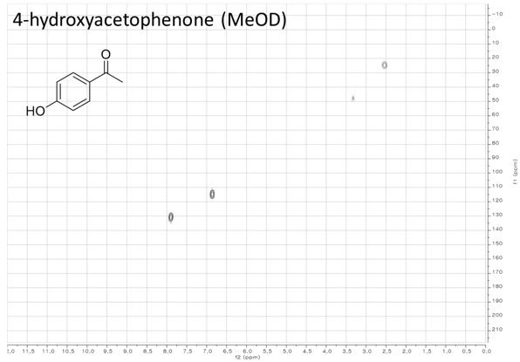
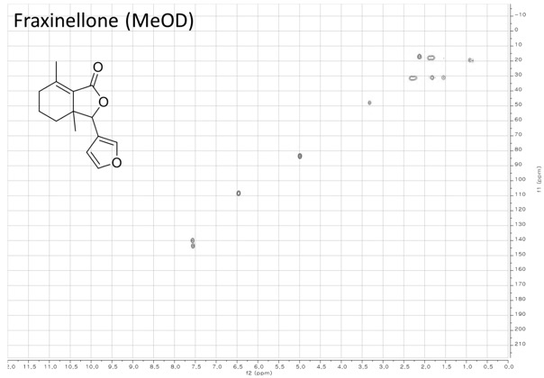
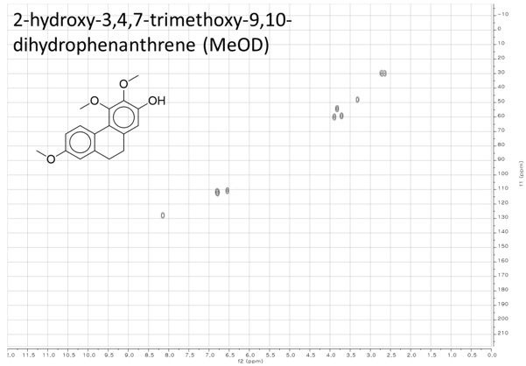
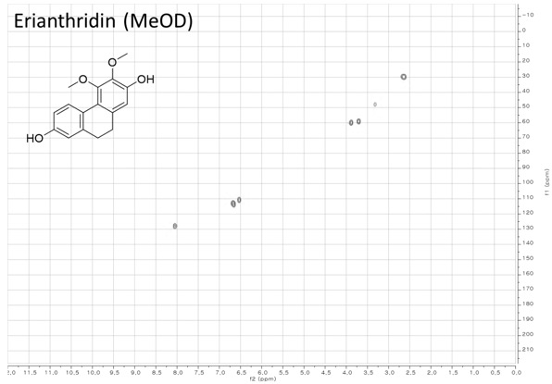
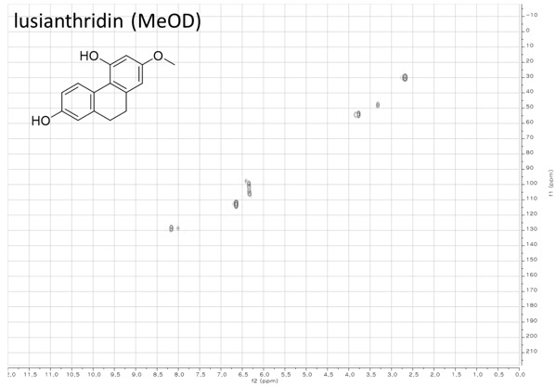
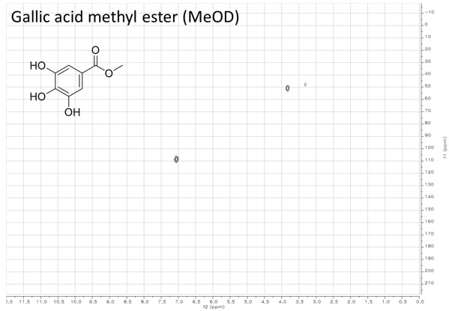
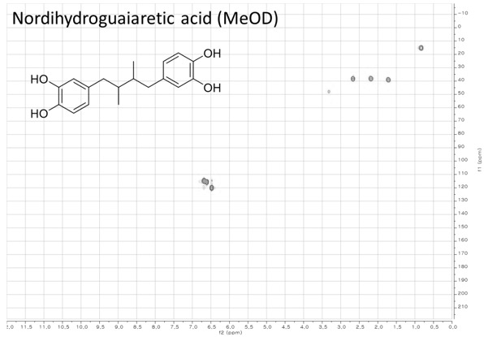
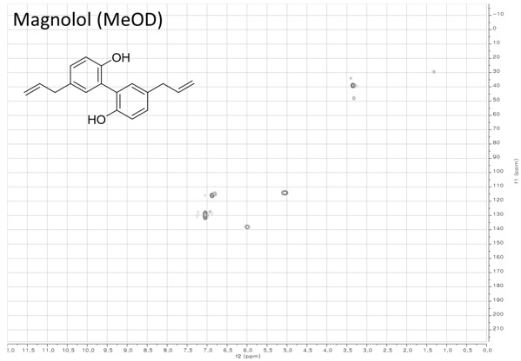
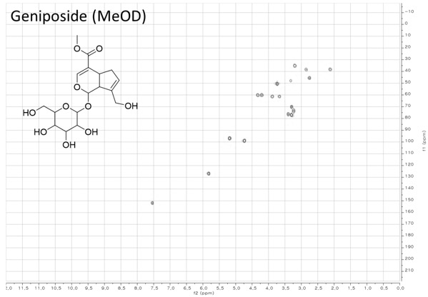
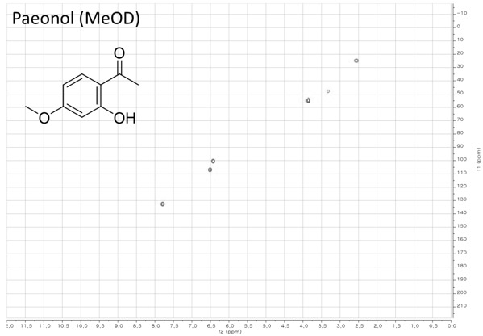
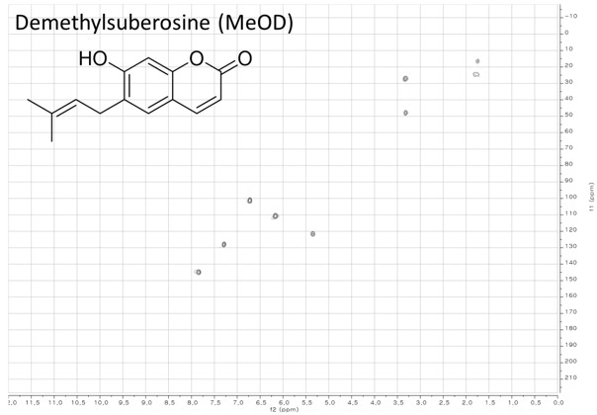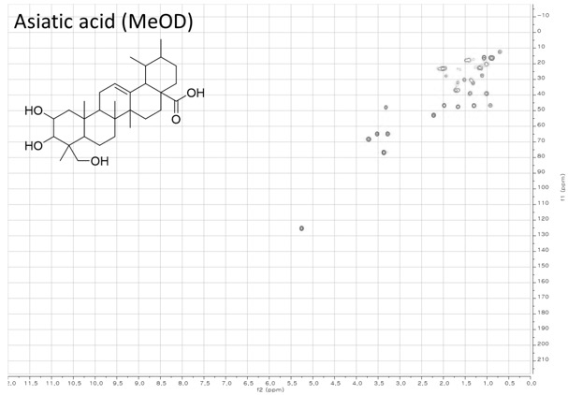
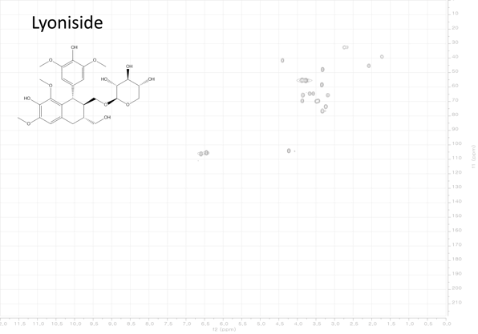
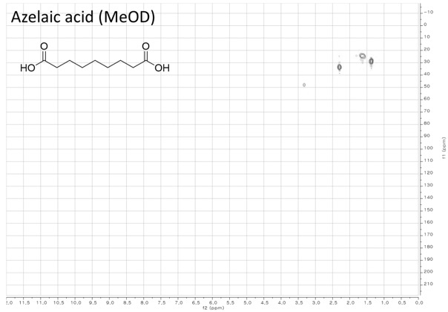
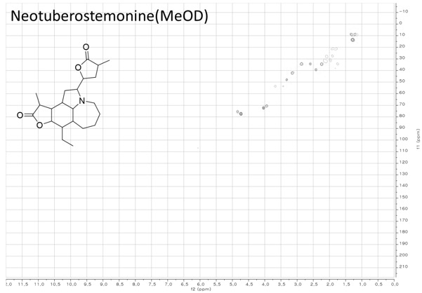
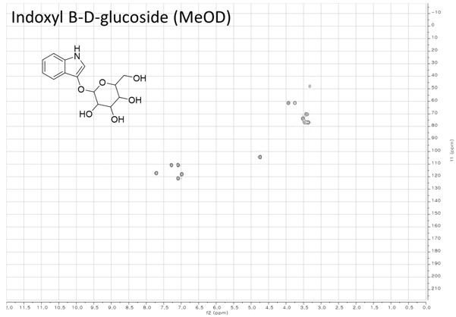
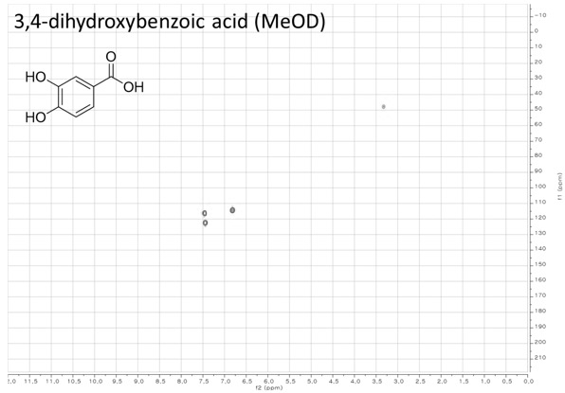
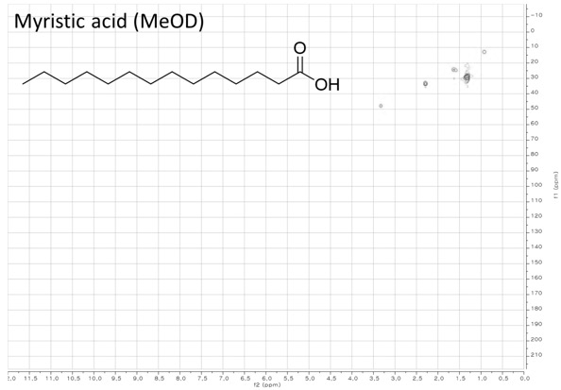
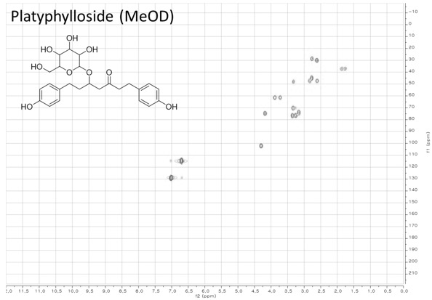

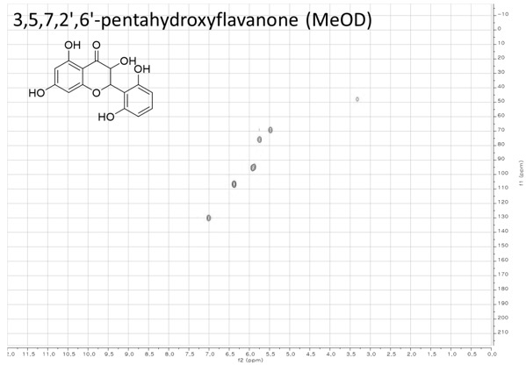

10. Structure elucidation of previously undescribed compounds from A. pilosa and Dictyota sp.
10.1. ¹H and ¹³C NMR data of compounds 1 and 2
1,2,3-trihydroxyursa-12,18-dien-28-oic acid (1) |  |  | 14,15-dihydroxy acutilol A 8-acetate (2)
position | δC | δH (J in Hz) | position | δC | δH (J in Hz)
1 | 81.5 | 3.63 (1H, brd, J = 4.6 Hz) | 1 | 139.8
2 | 76.5 | 4.51 (1H, dd, J = 4.6, 2.8 Hz) | 2 | 36.7 | 2.88 (2H, brs)
3 | 77.7 | 3.51 (1H, d, J = 2.8 Hz) | 3 | 124.4 | 5.38 (1H, brs)
4 | 39.4 |  | 4 | 144.1
5 | 54.2 | 0.96 (1H, d, J = 11.2 Hz) | 5 | 60.9 | 3.33 (1H, m)
6 | 18.5 | 1.70 (1H, m)  1.62 (1H, m) | 6 | 72.1 | 3.94 (1H, dd, J = 9.3 Hz)
7 | 35.7 | 1.67 (1H, m)  1.58 (1H, m) | 7 | 48.9 | 1.41 (1H, m)
8 | 40.3 |  | 8 | 71.5 | 5.22  (1H, td, J = 8.0, 3.4 Hz)
9 | 49.8 | 1.90 (1H, m) | 9 | 40.1 | 2.48 (2H, d, J = 8.0 Hz)
10 | 44.2 |  | 10 | 125.4
11 | 27.3 | 3.44 (1H, m)  2.45 (1H, m) | 11 | 31.5 | 1.86 (1H, m)
12 | 127.9 | 5.88 (1H, dd, J = 5.6, 2.4 Hz) | 12 | 32.6 | 1.56 (1H, m)  1.37 (1H, m)
13 | 139 |  | 13 | 28.9 | 1.52 (1H, m)  1.29 (1H, m)
14 | 45.5 |  | 14 | 79.7 | 3.25 (1H, brd, J = 9.3 Hz)
15 | 29.4 | 2.37 (1H, m)  1.35 (1H, m) | 15 | 74
16 | 36.1 | 2.63 (1H, d, J = 13.2 Hz)  1.58 (1H, m) | 16 | 25.1 | 1.13 (3H, s)
17 | 50.2 |  | 17 | 20.7 | 1.70 (3H, s)
18 | 135.2 |  | 18 | 16 | 1.87 (3H, s)
19 | 135.2 |  | 19 | 17.7 | 0.89 (3H, d, J = 6.6 Hz)
20 | 35.2 | 2.25 (1H, m) | 20 | 25.7 | 1.15 (3H, s)
21 | 27.4 | 2.25 (1H, m)  1.39 (1H, m) | 21 | 173
22 | 32.3 | 2.20 (1H, m)  1.78 (1H, m) | 22 | 21.5 | 2.08 (3H, s)
23 | 18.4 | 1.40 (3H, s)
24 | 30.8 | 1.29 (3H, s)
25 | 13.5 | 1.63 (3H, s)
26 | 19.2 | 1.20 (3H, s)
27 | 22.6 | 1.23 (3H, s)
28 | 179.1
29 | 20.1 | 1.90 (3H, s)
30 | 19.3 | 1.13 (3H, d, J = 6.9 Hz)

10.2. 1,2,3-trihydroxyursa-12,18-dien-28-oic acid (1) from A. pilosa
10.2.1. Structure elucidation of 1,2,3-trihydroxyursa-12,18-dien-28-oic acid (1)
Compound 1 was isolated with white amorphous powder. The molecular formula of C₃₀H₄₆O₅ was determined by high-resolution electospray ionization mass spectrometry (HRESIMS) ion peak at m/z 485.6750 [M – H]⁻ (calcd for C₃₀H₄₅O₅, 485.6753). Two of eight degrees of unsaturation from molecuar formula were assigned to carbon-carbon double bonds (δ_{C} 139.0 (C-13), 135.2 (C-19), 135.2 (C-18), and 127.9 (C-12)), one was from an carboxyl carbonyl (δ_{C} 170.1). Thus, the remaining five degrees of unsaturation were accommodated from a pentacyclic carbon skeleton. ¹H NMR spectrum of 1 showed six single methyl group signals at δ_{H} 1.90 (3H, s, H-29), 1.63 (3H, s, H-25), 1.40 (3H, s, H-23), 1.29 (3H, s, H-24), 1.23 (3H, s, H-27), and 1.20 (3H, s, H-26) and one doublet methyl group signal at δ_{H} 1.13 (3H, d, J = 6.9 Hz, H-30) along with three proton signals at δ_{H} 4.51 (1H, dd, J = 4.6, 2.8 Hz, H-2), 3.63 (1H, d, J = 4.5 Hz, H-1), and 3.51 (1H, d, J = 2.8 Hz, H-3) which was similar to those of goreishic acid I with one more hydroxyl group. By further analysis of ¹H-¹H COSY and ¹H-¹³C HMBC correlation, compound 1 was assigned as 1,2,3-trihydroxyursa-12,18-dien-28-oic acid.

Key ¹H-¹H COSY and HMBC correlations of compound 1

10.2.2. NMR spectra of compound 1

¹H NMR spectrum of compound 1 (600 MHz, Pyridine-d4)
¹³C NMR spectrum of compound 1 (150 MHz, pyridine-d4)

¹H-¹³C HSQC spectrum of compound 1 (600 MHz, pyridine-d4)

¹H-¹H COSY spectrum of compound 1 (600 MHz, pyridine-d4)

¹H-¹³C HMBC spectrum of compound 1 (600 MHz, pyridine-d4)

10.3. 14,15-dihydroxy acutilol A 8-acetate (2) from Dictyota sp.
10.3.1. Structure elucidation of 14,15-dihydroxy acutilol A 8-acetate (2)
Compound 2 was obtained as pale brownish amorphous solid and its molecular formula was C₂₂H₃₆O₅ which was derived from HRESIMS ion peak at m/z 381.5262 [M + H]⁺ (calcd for C₂₂H₃₇O₅, 381.5262). Two of five degrees of unsaturation from molecular formula were assigned to carbon-carbon double bonds (δ_{C} 144.1 (C-4), 139.8 (C-1), 125.4 (C-10), and 124.4 (C-3)) and one was from an ester carbonyl (δ_{C} 173.0). Thus, the remaining two degrees of unsaturation were derived from a bicyclic carbon skeleton. The ¹H-¹³C HMBC correlation between δ_{H} 2.08 (3H, s) and δ_{C} 173.0 suggested the presence of an acetate ester. By analysis of ¹H-¹H COSY and ¹H-¹³C HMBC correlation, the molecular structure of compound 2 was similar to that of acutilol A acetate, a pachydictyane diterpenoid, but the acetate ester was substituted to C-8 and molecular formula indicated that compound 2 had two more oxygen atoms. From those results, compound 2 was assigned to 14,15-dihydroxy acutilol A 8-acetate.

Key ¹H-¹H COSY and HMBC correlations of compound 2

10.3.2. NMR spectra of compound 2

¹H NMR spectrum of compound 2 (600 MHz, methanol-d4)
¹³C NMR spectrum of compound 2 (600 MHz, methanol-d4)

¹H-¹³C HSQC spectrum of compound 2 (600 MHz, methanol-d4)
¹H-¹H COSY spectrum of compound 2 (600 MHz, methanol-d4)
¹H-¹³C HMBC spectrum of compound 2 (600 MHz, methanol-d4)

