Additional Information
Practical guidelines for the use of gradient boosting for molecular property prediction
Davide Boldini,† Francesca Grisoni,‡,∥ Daniel Kuhn,§ Lukas Friedrich§ and Stephan A. Sieber*,†
† Department of Bioscience, Center for Functional Protein Assemblies (CPA), Technical University of Munich, Garching bei München, Germany
‡ Department of Biomedical Engineering, Institute for Complex Molecular Sciences, Eindhoven University of Technology, Eindhoven, Netherlands
∥ Centre for Living Technologies, Alliance TU/e, WUR, UU, UMC Utrecht, Netherlands
§ Merck Healthcare KGaA, Darmstadt, Germany

- Hyperparameter grids

XGBoost:
- max_leaves: discrete loguniform [1, 4]
- learning_rate: discrete loguniform [-3, 0]
- max_depth: discrete uniform [3, 12]
- min_child_sample: discrete loguniform [0, 5]
- min_child_weight: loguniform [-5, 5]
- reg_alpha: loguniform [-5, 2]
- reg_lambda: loguniform [-5, 2]
- max_delta_step: loguniform [-5, 2]
- colsample_bytree: uniform [0.1, 1]
- colsample_bylevel: uniform [0.1, 1]
- subsample: uniform [0.2, 1]
- scale_pos_weight: loguniform [0, 6]

LightGBM:
- colsample_bytree: uniform [0.1, 1]
- learning_rate: discrete loguniform [-3, 0]
- max_depth: discrete uniform [3, 12]
- min_child_samples: discrete loguniform [0, 5]
- min_child_weight: loguniform [-5, 5]
- min_split_gain: uniform [0, 15]
- neg_subsample: uniform [0.1, 1]
- num_leaves: discrete loguniform [1, 5]
- reg_alpha: loguniform [-5, 2]
- reg_lambda: loguniform [-5, 2]
- scale_pos_weight: loguniform [0, 6]
- subsample_freq: discrete uniform [0, 30]

CatBoost:
- learning_rate: discrete loguniform [-3, 0]
- depth: discrete uniform [3, 12]
- leaf_estimation_iterations: discrete uniform [1, 20]
- l2_leaf_reg: loguniform [-5, 2]
- random_strength: discrete uniform [1, 20]
- subsample: uniform [0.1, 1]
- sampling_frequency: choice [PerTree, PerTreeLevel]
- colsample_bylevel: uniform [0.1, 1]
- scale_pos_weight: loguniform [0, 6]
- langevin: choice [True, False]

For all GBM implementations, the number of iterations was optimized via early stopping monitoring the loss on the validation set instead of treating it as an additional hyperparametrer.

- LightGBM hyperparameter definition
- colsample_bytree: fraction of features to sample at the beginning of the construction of a given tree. Tuning it helps with regularization of the ensemble.
- learning_rate: regulates how much each tree affects the overall performance of the ensemble, or in other words how many boosting rounds are required to converge. Large learning rates help with underfitting, small learning rates can help with regularization.
- max_depth: defines the maximum depth for constructing individual trees. Large values help with underfitting, small values can help with regularization.
- min_child_samples: minimum number of samples for a given leaf node. Affects tree construction and can help with regularization.
- min_child_weight: minimal sum of hessians for a given leaf node. Affects tree construction and can help with regularization.
- min_split_gain: minimal decrease in loss required to further split a node. Affects tree construction and can help with regularization.
- neg_subsample: fraction of majority class samples to use for bagging when constructing a given tree. Helps with class imbalance and regularization.
- num_leaves: Maximum number of leaves a given tree can have. Similar to max_depth but provides more fine-grained control on the shape of the tree since LightGBM uses depth-first trees.
- reg_alpha: L1 norm regularization coefficient of the leaf weights.
- reg_lambda: L2 norm regularization coefficient of the leaf weights.
- scale_pos_weight: scaling coefficient for the minority class when computing the cross-entropy loss. Large values can offset class imbalance.
- subsample_freq: affects how often to perform bagging when training the ensemble. If set to k, bagging is performed every k trees.

- LightGBM optimal hyperparameter grid
- learning_rate: discrete loguniform [-3, 0]
- min_child_weight: loguniform [-5, 5]
- min_split_gain: uniform [0, 15]
- neg_subsample: uniform [0.1, 1]
- reg_lambda: loguniform [-5, 2]
- scale_pos_weight: loguniform [0, 6]
- subsample_freq: discrete uniform [0, 30]

- Fingerprint density analysis
Table S1 – Mean number of unique substructures per compound across datasets and bit sizes.
Dataset | 1024 bits | 2048 bits | 4096 bits
bace | 60.069397 | 60.6549911 | 61.3615341
bbbp | 42.1981354 | 42.7047577 | 43.2731743
clintox | 43.2341003 | 43.7293625 | 44.2131271
hiv | 38.9629936 | 39.3100014 | 39.698143
muv | 44.1438484 | 44.5432358 | 44.8428497
ntp | 47.7583199 | 48.243885 | 48.6402512
oxi | 47.7583199 | 48.243885 | 48.6402512
phos | 47.7583199 | 48.243885 | 48.6402512
tox21 | 29.582428 | 29.8293953 | 30.1690712
ache | 48.0531807 | 48.6305809 | 48.9977837
cox2 | 42.7222404 | 43.0679512 | 43.5656738
erbb1 | 54.7732124 | 55.2356186 | 55.6382484
herg | 55.9122353 | 56.4770508 | 56.953907
jak2 | 56.2000008 | 56.6851234 | 57.0817337
fungal | 47.7583199 | 48.243885 | 48.6402512
sider | 45.7918701 | 46.5136642 | 47.2221451

- RDKIT Molecular descriptors
Table S2 – List of calculated 2D molecular descriptors from the RDKIT package.
ID | Name | ID | Name
1 | MaxEStateIndex | 105 | HeavyAtomCount
2 | MinEStateIndex | 106 | NHOHCount
3 | MaxAbsEStateIndex | 107 | NOCount
4 | MinAbsEStateIndex | 108 | NumAliphaticCarbocycles
5 | qed | 109 | NumAliphaticHeterocycles
6 | MolWt | 110 | NumAliphaticRings
7 | HeavyAtomMolWt | 111 | NumAromaticCarbocycles
8 | ExactMolWt | 112 | NumAromaticHeterocycles
9 | NumValenceElectrons | 113 | NumAromaticRings
10 | NumRadicalElectrons | 114 | NumHAcceptors
11 | MaxPartialCharge | 115 | NumHDonors
12 | MinPartialCharge | 116 | NumHeteroatoms
13 | MaxAbsPartialCharge | 117 | NumRotatableBonds
14 | MinAbsPartialCharge | 118 | NumSaturatedCarbocycles
15 | FpDensityMorgan1 | 119 | NumSaturatedHeterocycles
16 | FpDensityMorgan2 | 120 | NumSaturatedRings
17 | FpDensityMorgan3 | 121 | RingCount
18 | BCUT2D_MWHI | 122 | MolLogP
19 | BCUT2D_MWLOW | 123 | MolMR
20 | BCUT2D_CHGHI | 124 | fr_Al_COO
21 | BCUT2D_CHGLO | 125 | fr_Al_OH
22 | BCUT2D_LOGPHI | 126 | fr_Al_OH_noTert
23 | BCUT2D_LOGPLOW | 127 | fr_ArN
24 | BCUT2D_MRHI | 128 | fr_Ar_COO
25 | BCUT2D_MRLOW | 129 | fr_Ar_N
26 | BalabanJ | 130 | fr_Ar_NH
27 | BertzCT | 131 | fr_Ar_OH
28 | Chi0 | 132 | fr_COO
29 | Chi0n | 133 | fr_COO2
30 | Chi0v | 134 | fr_C_O
31 | Chi1 | 135 | fr_C_O_noCOO
32 | Chi1n | 136 | fr_C_S
33 | Chi1v | 137 | fr_HOCCN
34 | Chi2n | 138 | fr_Imine
35 | Chi2v | 139 | fr_NH0
36 | Chi3n | 140 | fr_NH1
37 | Chi3v | 141 | fr_NH2
38 | Chi4n | 142 | fr_N_O
39 | Chi4v | 143 | fr_Ndealkylation1
40 | HallKierAlpha | 144 | fr_Ndealkylation2
41 | Ipc | 145 | fr_Nhpyrrole
42 | Kappa1 | 146 | fr_SH
43 | Kappa2 | 147 | fr_aldehyde
44 | Kappa3 | 148 | fr_alkyl_carbamate
45 | LabuteASA | 149 | fr_alkyl_halide
46 | PEOE_VSA1 | 150 | fr_allylic_oxid
47 | PEOE_VSA10 | 151 | fr_amide
48 | PEOE_VSA11 | 152 | fr_amidine
49 | PEOE_VSA12 | 153 | fr_aniline
50 | PEOE_VSA13 | 154 | fr_aryl_methyl
51 | PEOE_VSA14 | 155 | fr_azide
52 | PEOE_VSA2 | 156 | fr_azo
53 | PEOE_VSA3 | 157 | fr_barbitur
54 | PEOE_VSA4 | 158 | fr_benzene
55 | PEOE_VSA5 | 159 | fr_benzodiazepine
56 | PEOE_VSA6 | 160 | fr_bicyclic
57 | PEOE_VSA7 | 161 | fr_diazo
58 | PEOE_VSA8 | 162 | fr_dihydropyridine
59 | PEOE_VSA9 | 163 | fr_epoxide
60 | SMR_VSA1 | 164 | fr_ester
61 | SMR_VSA10 | 165 | fr_ether
62 | SMR_VSA2 | 166 | fr_furan
63 | SMR_VSA3 | 167 | fr_guanido
64 | SMR_VSA4 | 168 | fr_halogen
65 | SMR_VSA5 | 169 | fr_hdrzine
66 | SMR_VSA6 | 170 | fr_hdrzone
67 | SMR_VSA7 | 171 | fr_imidazole
68 | SMR_VSA8 | 172 | fr_imide
69 | SMR_VSA9 | 173 | fr_isocyan
70 | SlogP_VSA1 | 174 | fr_isothiocyan
71 | SlogP_VSA10 | 175 | fr_ketone
72 | SlogP_VSA11 | 176 | fr_ketone_Topliss
73 | SlogP_VSA12 | 177 | fr_lactam
74 | SlogP_VSA2 | 178 | fr_lactone
75 | SlogP_VSA3 | 179 | fr_methoxy
76 | SlogP_VSA4 | 180 | fr_morpholine
77 | SlogP_VSA5 | 181 | fr_nitrile
78 | SlogP_VSA6 | 182 | fr_nitro
79 | SlogP_VSA7 | 183 | fr_nitro_arom
80 | SlogP_VSA8 | 184 | fr_nitro_arom_nonortho
81 | SlogP_VSA9 | 185 | fr_nitroso
82 | TPSA | 186 | fr_oxazole
83 | EState_VSA1 | 187 | fr_oxime
84 | EState_VSA10 | 188 | fr_para_hydroxylation
85 | EState_VSA11 | 189 | fr_phenol
86 | EState_VSA2 | 190 | fr_phenol_noOrthoHbond
87 | EState_VSA3 | 191 | fr_phos_acid
88 | EState_VSA4 | 192 | fr_phos_ester
89 | EState_VSA5 | 193 | fr_piperdine
90 | EState_VSA6 | 194 | fr_piperzine
91 | EState_VSA7 | 195 | fr_priamide
92 | EState_VSA8 | 196 | fr_prisulfonamd
93 | EState_VSA9 | 197 | fr_pyridine
94 | VSA_EState1 | 198 | fr_quatN
95 | VSA_EState10 | 199 | fr_sulfide
96 | VSA_EState2 | 200 | fr_sulfonamd
97 | VSA_EState3 | 201 | fr_sulfone
98 | VSA_EState4 | 202 | fr_term_acetylene
99 | VSA_EState5 | 203 | fr_tetrazole
100 | VSA_EState6 | 204 | fr_thiazole
101 | VSA_EState7 | 205 | fr_thiocyan
102 | VSA_EState8 | 206 | fr_thiophene
103 | VSA_EState9 | 207 | fr_unbrch_alkane
104 | FractionCSP3 | 208 | fr_urea

- Additional figures
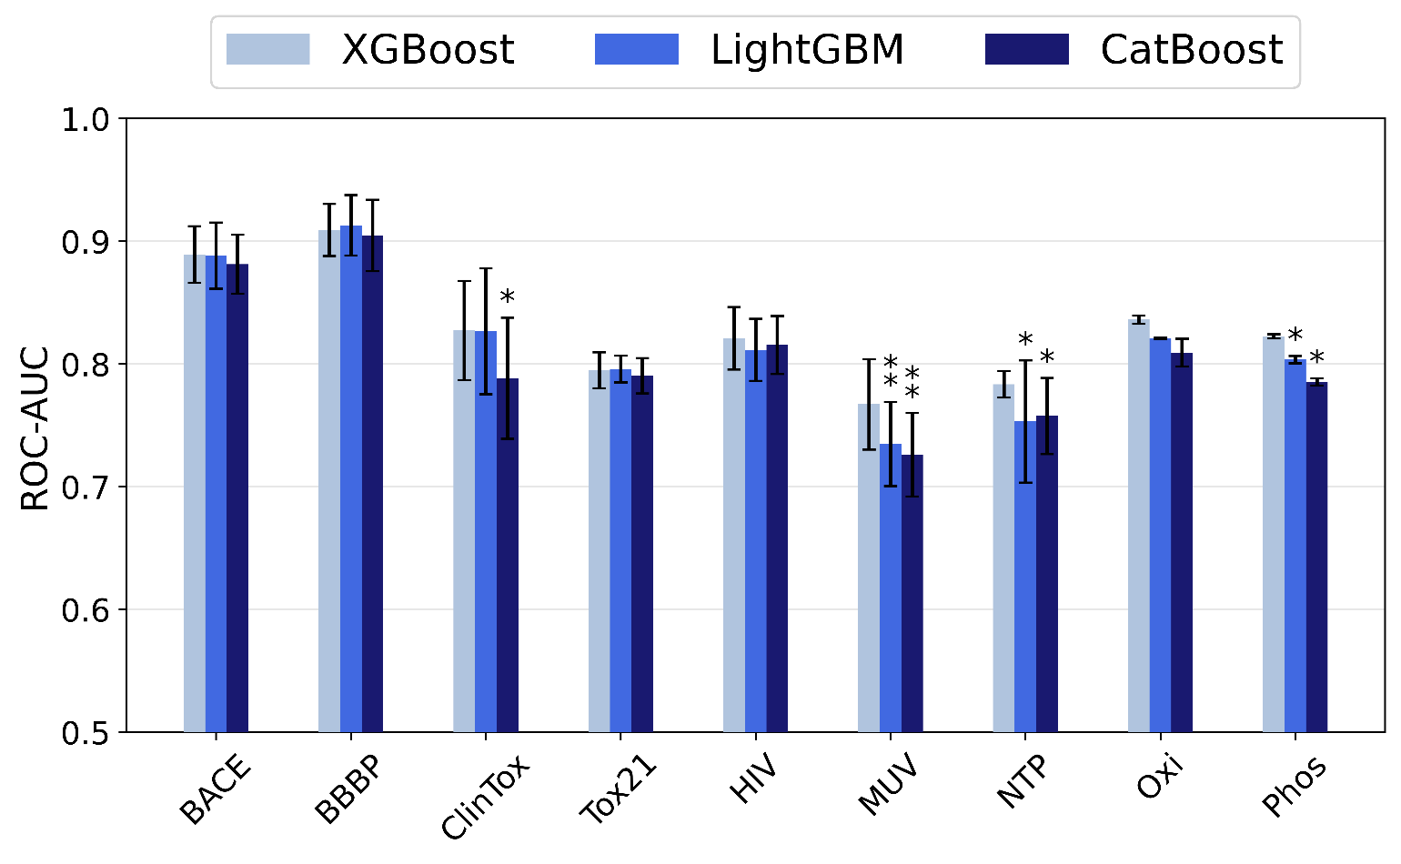
Figure S1 – Performance comparison between classification models according to ROC-AUC.

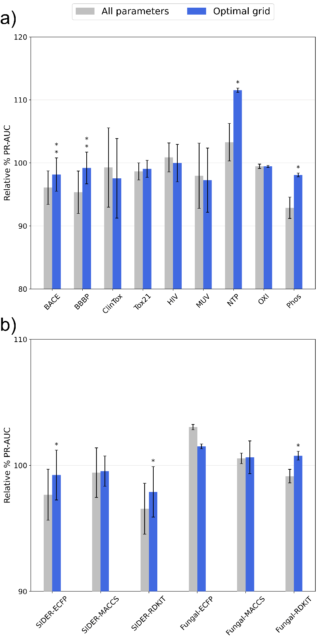
Figure S2 - LightGBM ROC-AUC comparison between carrying out hyperparameter tuning according to the optimal grid obtained from fANOVA and tuning all hyperparameters. a) Performance on the datasets used for the fANOVA analysis. b) Performance on the holdout datasets and with different molecular representations. Each approach was optimized for 30 iterations. The performance is reported in relation to the results obtained by tuning all parameters for 100 iterations. Error bars represent the standard deviation (N=50 for MoleculeNet datasets, N=5 for MolData datasets), while the asterisks denote whether the difference is significant (*: α<0.05, **: α<0.01, with Bonferroni correction).

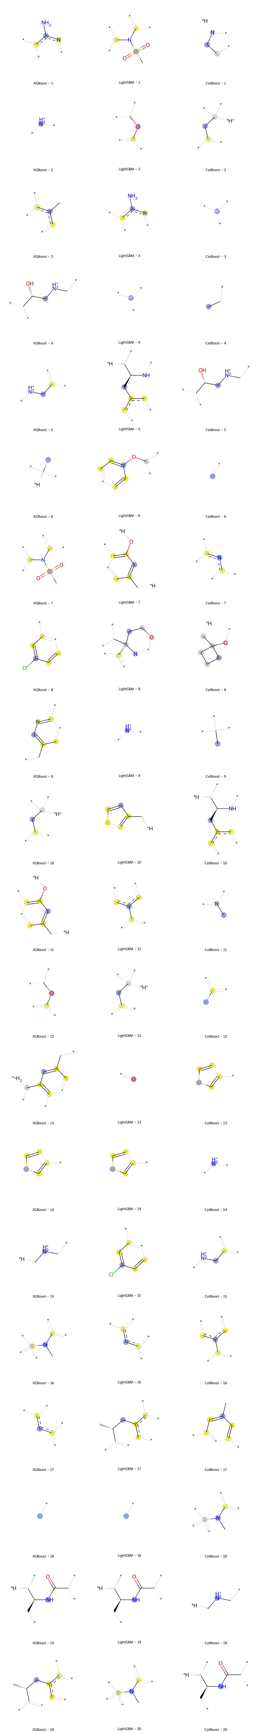
Figure S3 – Top 20 most important molecular fragments according to each GBM implementation for the BACE dataset.

