Additional file Information
Performance testing: Latency distribution and success rate at each request rate
Ramping Load: To determine the maximum throughput the Cheminformatics Microservice public instance (Intel(R) Xeon(R) Gold 6226R CPU @ 2.90GHz and 16GB of RAM) can handle, we used the Vegeta (https://github.com/tsenart/vegeta) tool to add load in small increments and measure the delivered throughput until a limit was reached. The results were then graphed to show the scalability profile. The microservice’s create 2D coordinates from SMILES endpoint was chosen as the test request, and the scalability profiles were generated for requests with input structures submitted as SMILES representations starting from 6 heavy atoms to 125 heavy atoms (randomly sampled from the COCONUT database). The scalability profiles were then inspected visually to assess the server performance (SI Figure A - K).

SMILES | Coconut ID | Heavy atom count
Echo request | - | -
O=C(N)C(F)Cl | CNP0031243 | 6
OC1CC2N(C)C(C1)C(O)C2 | CNP0205916 | 11
O=C1C=C(O)C(C(=O)C1(C)C)(C)C | CNP0103604 | 13
OOC(C=CC#CC#CC(O)C=C)CCCCCCC | CNP0171228 | 20
O=C1NC(C)C2C(NC(=O)N(C)C2C3=CC=C(C=C3)[NH+]([O-])O)N1C | CNP0469758 | 24
O=C(C1=C(O)C=C(OC)C=C1OC2OC(CO)C(O)C(O)C2O)CCC3=CC=C(O)C=C3 | CNP0267058 | 32
O=C1OC(C)CCCC(=O)CCCC=CC=2C=C(O)C(=C(O)C12)C(C3=CC(OC)=C(OC)C(OC)=C3)CC(=O)NC(C4=NC=5C=CC=CC5N4)C(C)CC | CNP0319430 | 54
O=C(O)C1OC(OC2CCC3(C)C(CCC4(C)C3CC=C5C6CC(C)(C)CCC6(C(=O)OC7OCC(O)C(O)C7OC8OC(C)C(OC9OCC(O)C(O)C9O)C(O)C8O)C(O)CC54C)C2(C)C)C(O)C(O)C1O | CNP0187011 | 74
O=C(O)CCC(NC(=O)C(NC(=O)C=1N=C(SC1)C(=O)C(C)CC)CC(C)C)C(=O)NC(C(=O)NCCCCC2NC(=O)C(NC(=O)C(NC(=O)C(NC(=O)C(NC(=O)C(NC(=O)C(NC2=O)CCCN)C(C)CC)CC=3C=CC=CC3)CC4=CN=CN4)CC(=O)O)CC(=O)N)C(C)C | CNP0170666 | 99
O=C(O)C1(OC2C(O)C(OC(CO)C2O)OC3C(O)C(OC(OC4C(OC(OC5C(O)C(O)C(OCC(NC(=O)CCCCCCCCCCCCCCC)C(O)CCCCCCCCCCCCCCC)OC5CO)C(O)C4OC6(OC(C(O)C(O)CO)C(NC(=O)C)C(O)C6)C(=O)O)CO)C3CC(=O)C)CO)OC(C(O)C(O)CO)C(NC(=O)C)C(O)C1 | CNP0001893 | 125

Note: In the following plots, all axes are logarithmic. The complete performance results are available on Zenodo - https://zenodo.org/record/8124294

- Scalability profile - Echo request
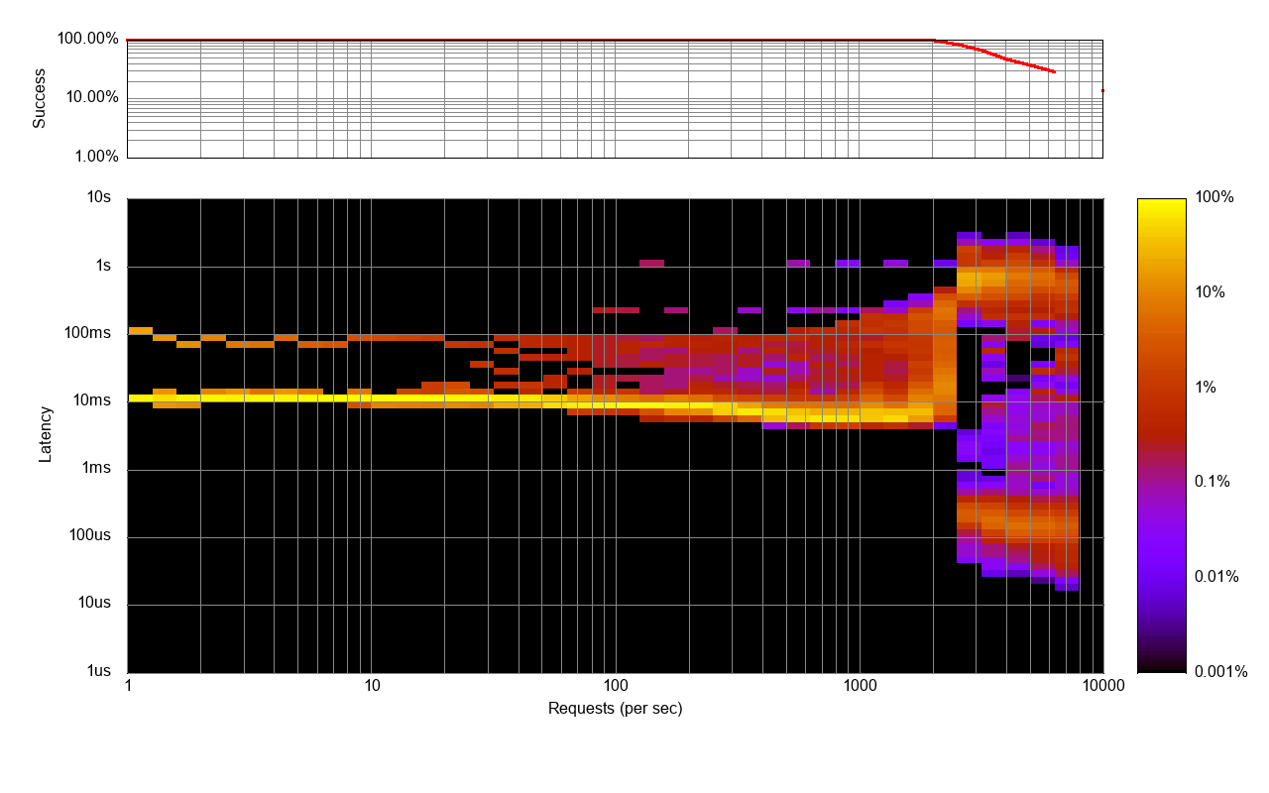
- Scalability profile - SMILES to Mol2D Conversion (6 heavy atoms)
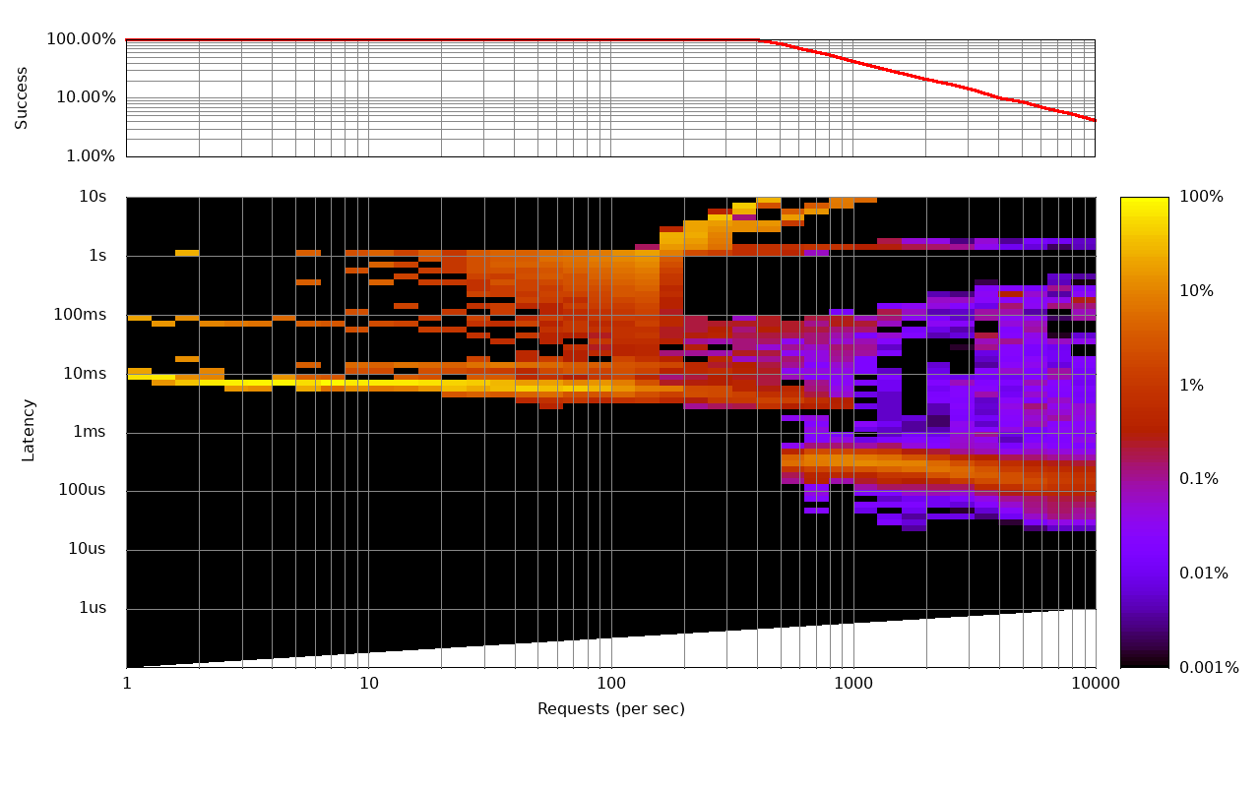

- Scalability profile - SMILES to Mol2D Conversion (11 heavy atoms)
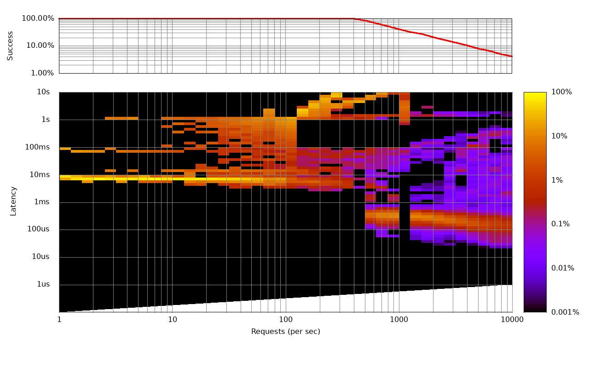
- Scalability profile - SMILES to Mol2D Conversion (13 heavy atoms)

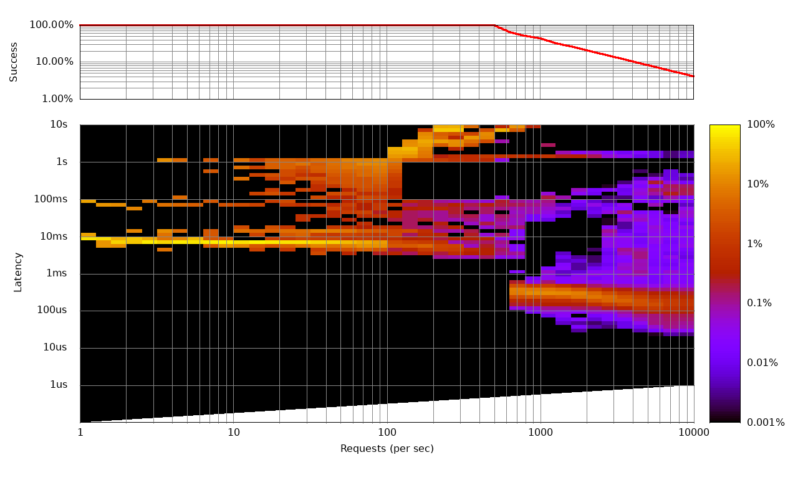
- Scalability profile - SMILES to Mol2D Conversion (20 heavy atoms)

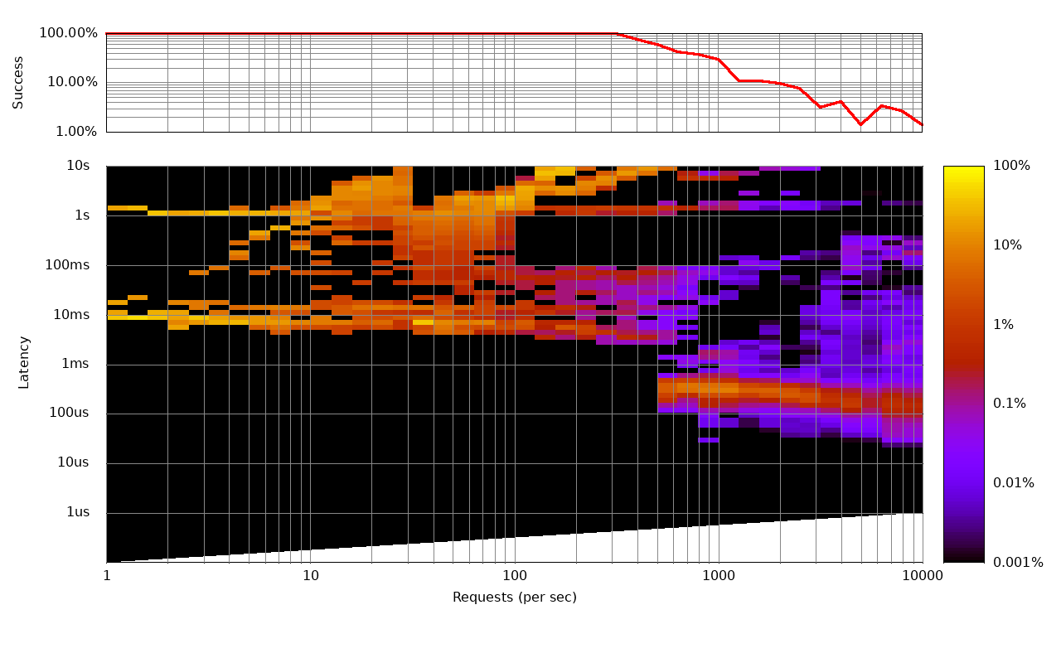
- Scalability profile - SMILES to Mol2D Conversion (24 heavy atoms)
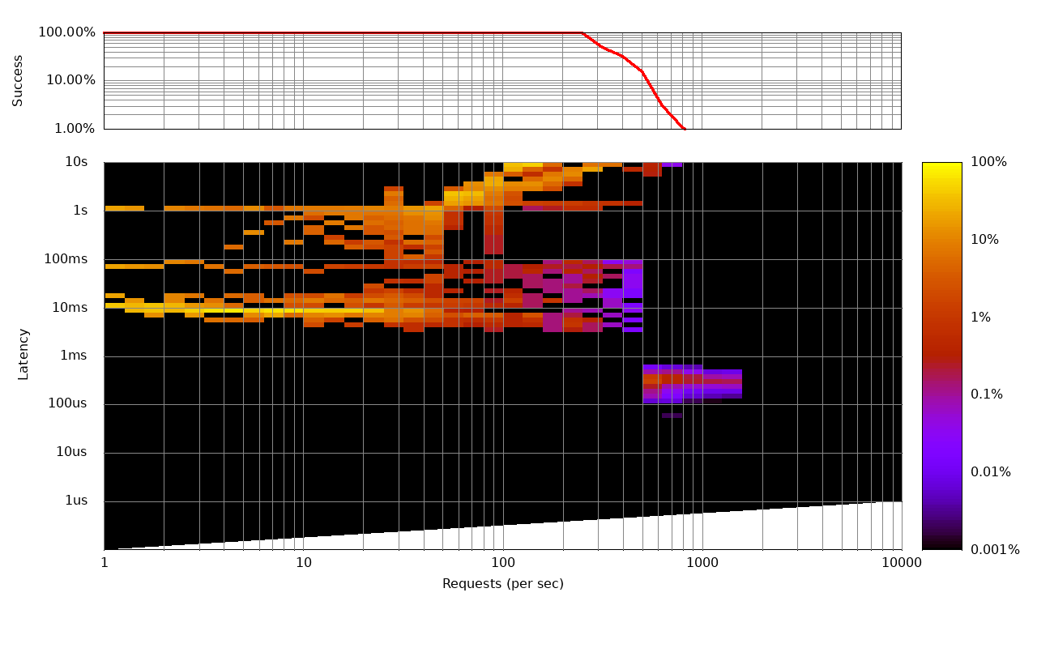
- Scalability profile - SMILES to Mol2D Conversion (32 heavy atoms)
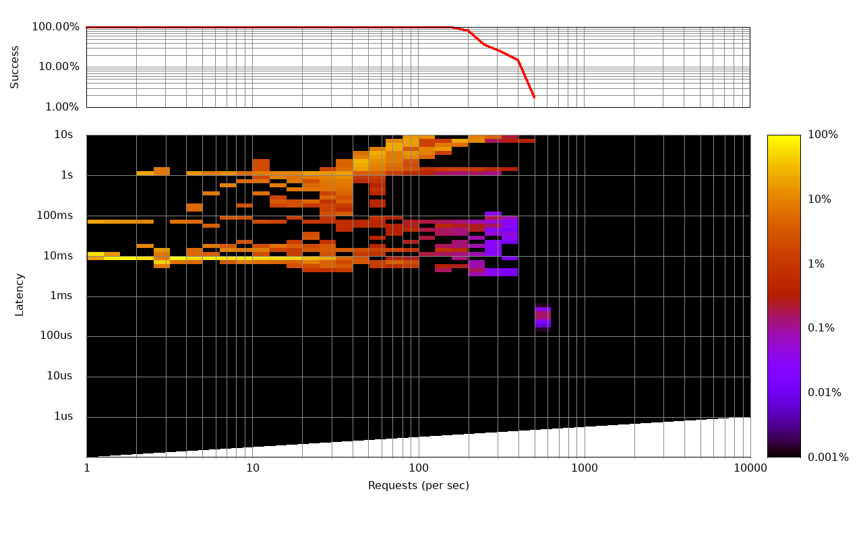
- Scalability profile - SMILES to Mol2D Conversion (54 heavy atoms)

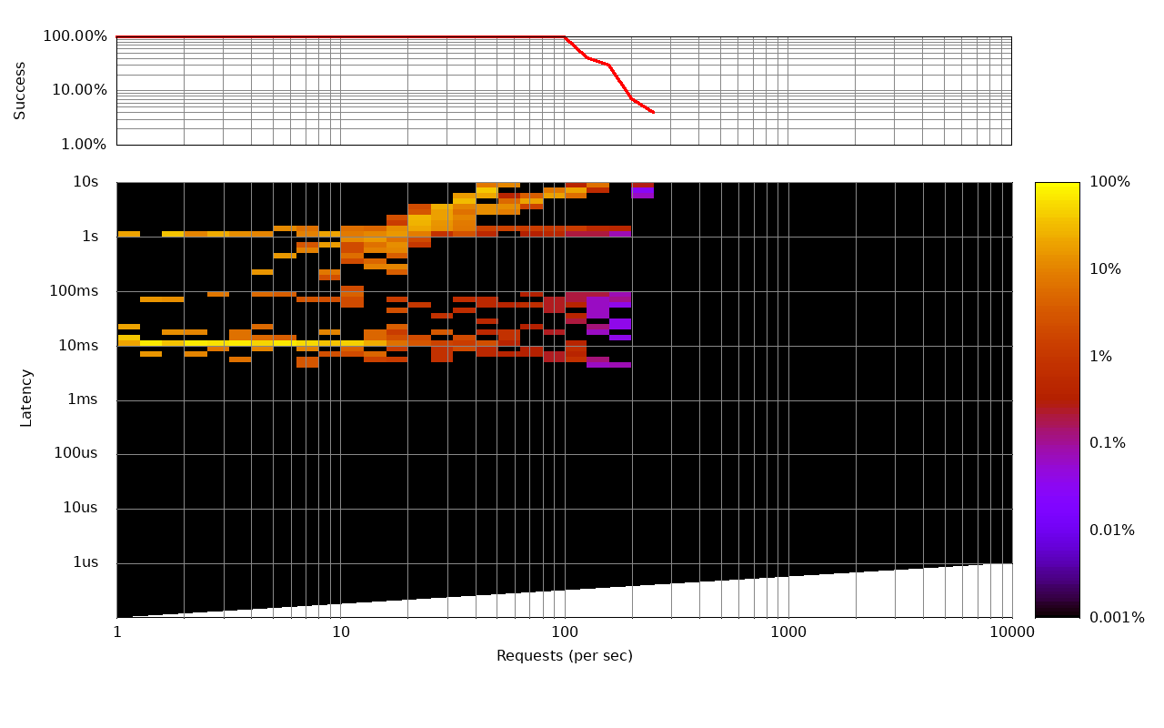
- Scalability profile - SMILES to Mol2D Conversion (74 heavy atoms)

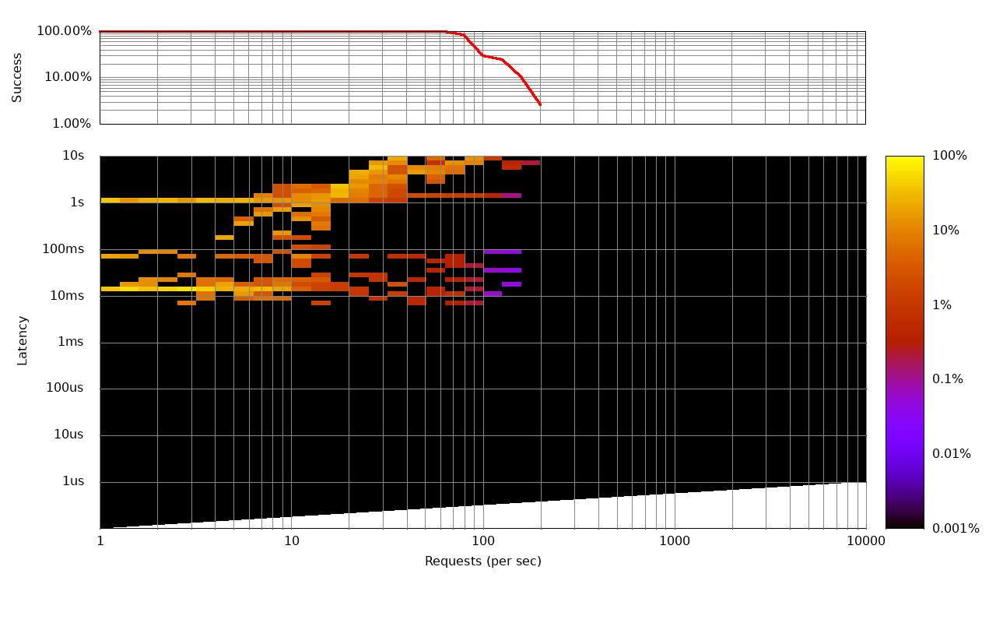
- Scalability profile - SMILES to Mol2D Conversion (99 heavy atoms)
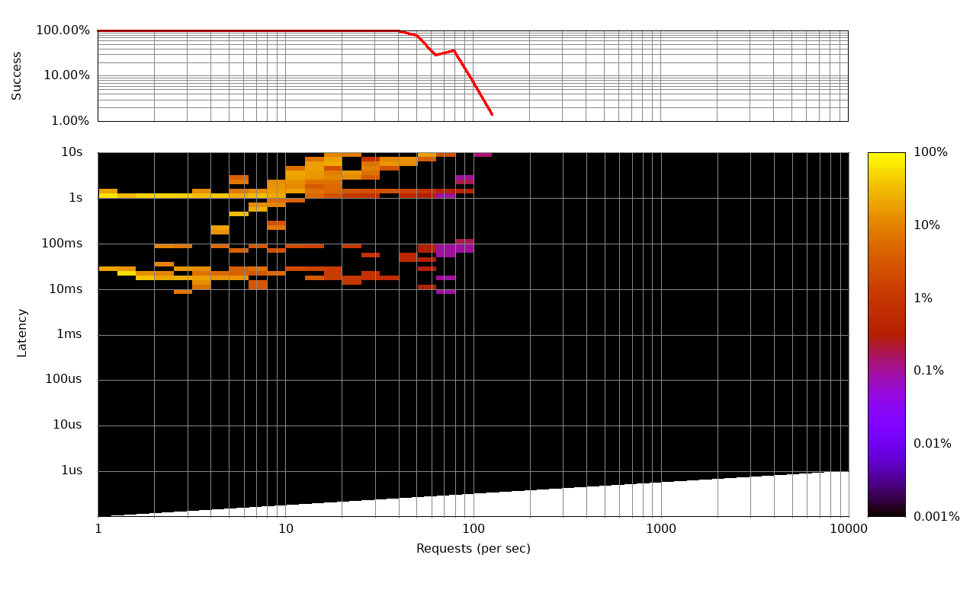
- Scalability profile - SMILES to Mol2D Conversion (125 heavy atoms)
