Geometric Deep Learning for Molecular Property Predictions with Chemical Accuracy Across Chemical Space

Maarten R. Dobbelaere¹, István Lengyel^{1,2}, Christian V. Stevens³, Kevin M. Van Geem^{1,*}
¹Laboratory for Chemical Technology, Department of Materials, Textiles and Chemical Engineering, Faculty of Engineering and Architecture, Ghent University, Technologiepark 125, 9052 Gent, Belgium
²ChemInsights LLC, Dover DE 19901, United States of America
³SynBioC Research Group, Department of Green Chemistry and Technology, Faculty of Bioscience Engineering, Ghent University, Coupure Links 653, 9000 Gent, Belgium

* Corresponding author: Kevin.VanGeem@UGent.be, Technologiepark 125, 9052 Gent, Belgium

SUPPORTING INFORMATION

Code Availability
The entire source code is provided as open-source software under MIT license in the following repository: https://www.github.com/mrodobbe/chemperium. All conclusions from the paper can be reproduced using the provided scripts. A demo notebook is available in the folder notebooks/demo.ipynb.

Data Availability
The four quantum chemical datasets generated in this work (ThermoG3, ThermoCBS, DrugLib36, ReagLib20) and the experimental dataset can be downloaded from Zenodo.

Experimental Liquid-Phase Data
Table S1: Overview of the experimental liquid-phase property data
Property | Symbol | Unit | Experimental Data | Minimal Value | Maximal Value
Normal boiling point | T_{b} | K | 6115 | 77.37 | 878.15
Octanol-water partitioning coefficient | log K_{OW} | - | 8528 | -11.96 | 10.20
Aqueous solubility | log S_{aq} | - | 7229 | -12.43 | 6.40
Critical temperature | T_{c} | K | 982 | 126.31 | 983.00
Critical pressure | P_{c} | bar | 851 | 6.00 | 218.50
Critical volume | V_{c} | Ml/mol | 279 | 93.10 | 1808.00

Effect of Cutoff Radius
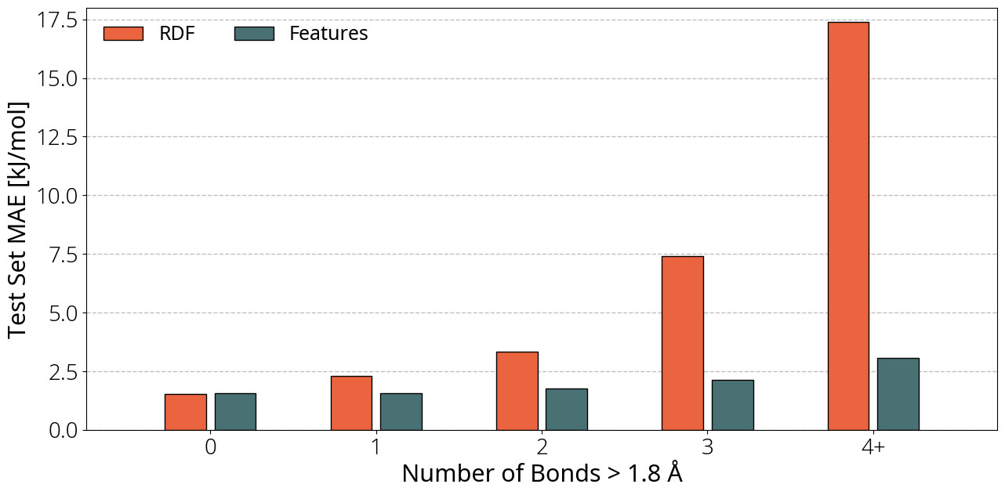
Figure S1: Predictive performance for thermochemistry predictions on a random split of test set molecules. Mean absolute error on the prediction of molecules which contain a given number of bonds with a length above 1.8 Å. 3D D-MPNNs are used of which the atoms are featurized with simple atomic features (green) and RDFs with a cutoff distance of 2.1 Å (orange).

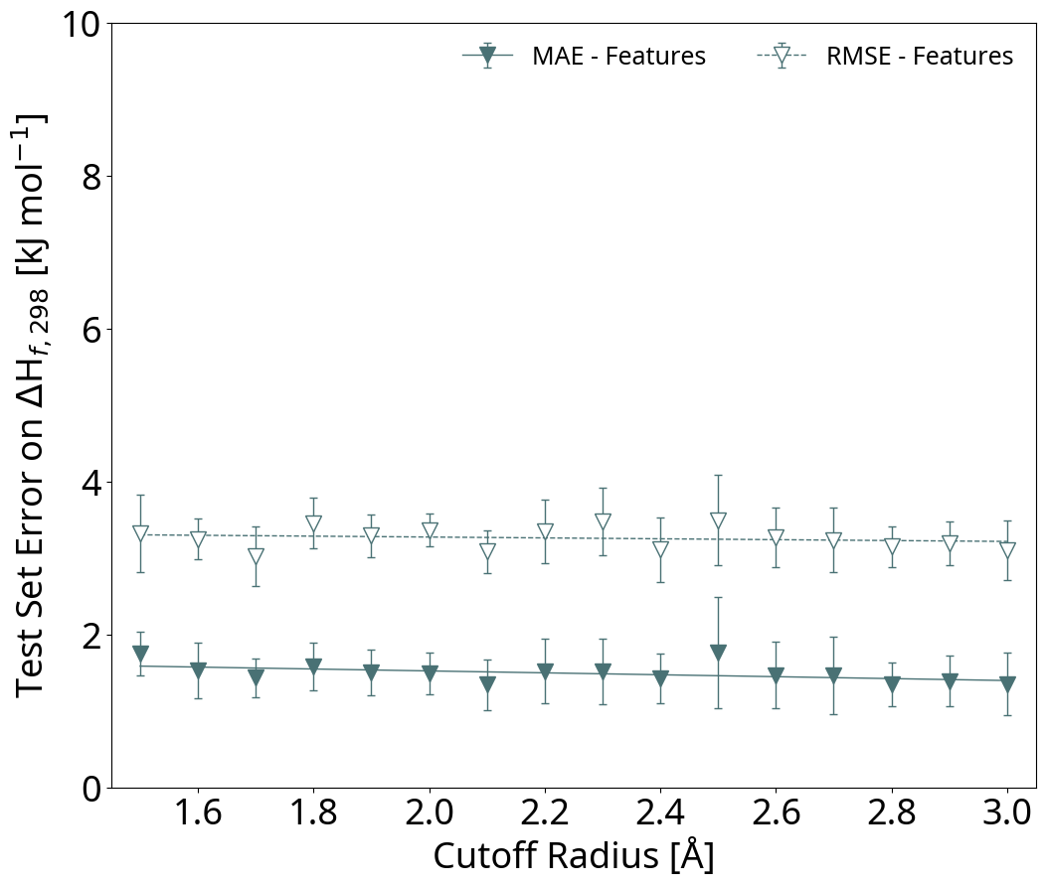
Figure S2: Predictive performance for thermochemistry predictions on a random split of test set molecules. Effect of cutoff radius on the mean absolute error (MAE) and root-mean-squared error (RMSE) using tenfold ensemble models for ThermoG3 $ΔH_{f,298 K}^{°}$ predictions. 3D D-MPNNs are used of which the atoms are featurized with simple atomic features.

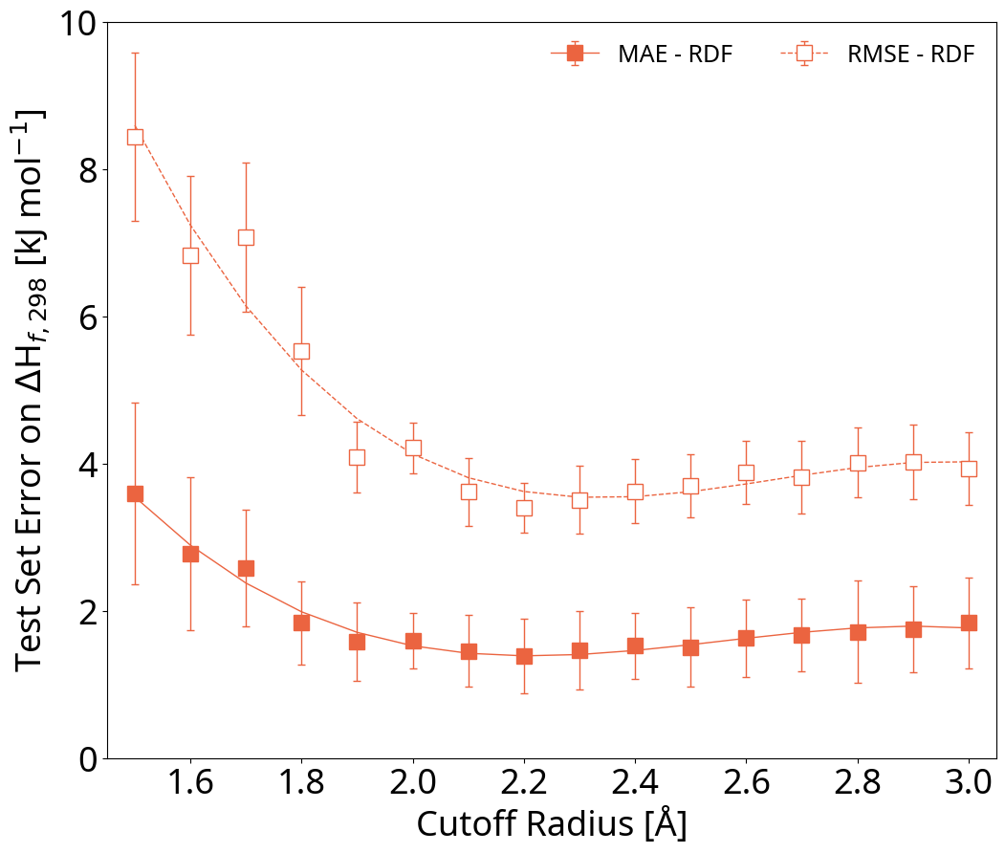
Figure S3: Predictive performance for thermochemistry predictions on a random split of test set molecules. Effect of cutoff radius on the mean absolute error (MAE) and root-mean-squared error (RMSE) using tenfold ensemble models for ThermoG3 $ΔH_{f,298 K}^{°}$ predictions. 3D D-MPNNs are used of which the atoms are featurized with RDFs.

Thermochemistry Prediction Results
Various learning methods are evaluated to determine the prediction performance on thermochemical properties. Interpolation tests are performed by selecting a random test set which contains 10% of the training set. Extrapolation tests are performed by selecting a scaffold split test set which also contains 10% of the dataset. $ΔH_{f,298K}^{°}$ predictions are done by either directly predicting this property or via $Δ$-ML. In the case of $Δ$-ML, the residual between $ΔH_{f,298K}^{°}$ calculated at low level-of-theory and $ΔH_{f,298K}^{°}$ calculated at high level-of-theory is predicted. Single-task and multitask learning are evaluated. In the case of single-task learning, the neural network has one single output value: either the $ΔH_{f,298K}^{°}$ or the $ΔH_{f,298K}^{°}$ residual. In multitask learning, the neural network has 47 output values: the $ΔH_{f,298K}^{°}$ or the $ΔH_{f,298K}^{°}$ residual, $S_{f,298K}$, and $c_{p}$ at 45 different temperatures, between 298.15 K and 1500 K. All model configurations are trained with different training set sizes to determine learning curves.

ThermoG3 Interpolation
Table S2: Performance of various D-MPNN models trained on ThermoG3 $ΔH_{f,298K}^{°}$ with different training set sizes (N) and evaluated on the same random split test set. Two types of learning are tested: directly predicting $ΔH_{f,298K}^{°}$ and predicting the $ΔH_{f,298K}^{°}$ residual ($Δ$-ML). Task indicates whether single-task learning is used or multitask learning on all thermochemistry properties. Assessment made using mean absolute error (MAE), root-mean-squared error (RMSE). All models are trained as a tenfold ensemble.
D-MPNN Configuration |  |  |  |  | $ΔH_{f,298K}^{°}$  [kJ mol⁻¹]
Model | Atom Descriptor | Task | Method | N | MAE | RMSE
2D | Features | Single | Δ-ML | 500 | 5.10 | 7.75
2D | Features | Single | Direct | 500 | 46.54 | 69.57
2D | Features | Multi | Δ-ML | 500 | 6.23 | 9.19
2D | Features | Multi | Direct | 500 | 54.06 | 81.50
3D | Features | Single | Δ-ML | 500 | 5.82 | 8.39
3D | Features | Single | Direct | 500 | 44.99 | 66.30
3D | Features | Multi | Δ-ML | 500 | 6.25 | 8.83
3D | Features | Multi | Direct | 500 | 48.17 | 70.07
3D | RDF | Single | Δ-ML | 500 | 18.50 | 25.08
3D | RDF | Single | Direct | 500 | 207.83 | 293.73
3D | RDF | Multi | Δ-ML | 500 | 11.48 | 17.57
3D | RDF | Multi | Direct | 500 | 95.28 | 161.29
2D | Features | Single | Δ-ML | 2000 | 3.13 | 5.08
2D | Features | Single | Direct | 2000 | 17.33 | 27.22
2D | Features | Multi | Δ-ML | 2000 | 3.84 | 5.73
2D | Features | Multi | Direct | 2000 | 32.00 | 47.82
3D | Features | Single | Δ-ML | 2000 | 2.82 | 4.79
3D | Features | Single | Direct | 2000 | 17.89 | 27.45
3D | Features | Multi | Δ-ML | 2000 | 4.31 | 6.16
3D | Features | Multi | Direct | 2000 | 36.01 | 47.24
3D | RDF | Single | Δ-ML | 2000 | 3.80 | 6.74
3D | RDF | Single | Direct | 2000 | 42.87 | 73.59
3D | RDF | Multi | Δ-ML | 2000 | 4.24 | 7.49
3D | RDF | Multi | Direct | 2000 | 46.03 | 71.45
2D | Features | Single | Δ-ML | 5000 | 2.26 | 4.02
2D | Features | Single | Direct | 5000 | 14.25 | 22.65
2D | Features | Multi | Δ-ML | 5000 | 3.15 | 4.94
2D | Features | Multi | Direct | 5000 | 33.71 | 41.19
3D | Features | Single | Δ-ML | 5000 | 2.16 | 4.07
3D | Features | Single | Direct | 5000 | 13.31 | 21.15
3D | Features | Multi | Δ-ML | 5000 | 3.21 | 4.99
3D | Features | Multi | Direct | 5000 | 24.45 | 33.44
3D | RDF | Single | Δ-ML | 5000 | 2.39 | 5.01
3D | RDF | Single | Direct | 5000 | 22.68 | 45.54
3D | RDF | Multi | Δ-ML | 5000 | 3.10 | 5.67
3D | RDF | Multi | Direct | 5000 | 32.76 | 52.86
2D | Features | Single | Δ-ML | 20000 | 1.65 | 3.28
2D | Features | Single | Direct | 20000 | 10.62 | 16.70
2D | Features | Multi | Δ-ML | 20000 | 2.73 | 4.42
2D | Features | Multi | Direct | 20000 | 19.90 | 26.55
3D | Features | Single | Δ-ML | 20000 | 1.64 | 3.26
3D | Features | Single | Direct | 20000 | 9.74 | 15.67
3D | Features | Multi | Δ-ML | 20000 | 2.49 | 4.11
3D | Features | Multi | Direct | 20000 | 23.14 | 29.05
3D | RDF | Single | Δ-ML | 20000 | 1.63 | 4.08
3D | RDF | Single | Direct | 20000 | 11.08 | 26.39
3D | RDF | Multi | Δ-ML | 20000 | 2.10 | 4.25
3D | RDF | Multi | Direct | 20000 | 22.06 | 36.17
2D | Features | Single | Δ-ML | 48195 | 1.42 | 3.00
2D | Features | Single | Direct | 48195 | 8.66 | 14.24
2D | Features | Multi | Δ-ML | 48195 | 2.31 | 3.78
2D | Features | Multi | Direct | 48195 | 14.26 | 21.43
3D | Features | Single | Δ-ML | 48195 | 1.36 | 2.94
3D | Features | Single | Direct | 48195 | 8.08 | 11.68
3D | Features | Multi | Δ-ML | 48195 | 1.95 | 3.47
3D | Features | Multi | Direct | 48195 | 19.99 | 25.15
3D | RDF | Single | Δ-ML | 48195 | 1.23 | 3.44
3D | RDF | Single | Direct | 48195 | 7.09 | 20.44
3D | RDF | Multi | Δ-ML | 48195 | 2.08 | 3.99
3D | RDF | Multi | Direct | 48195 | 26.31 | 35.88

Table S3: Performance of various multitask D-MPNN models trained on ThermoG3 $S_{f,298K}$ and 45 $c_{p}$ values with different training set sizes (N) and evaluated on the same random split test set. Assessment made using mean absolute error (MAE), root-mean-squared error (RMSE). All models are trained as a tenfold ensemble.
D-MPNN Configuration |  |  | $S_{f,298K}$  [J mol⁻¹ K⁻¹] |  | $c_{p,298K}$  [J mol⁻¹ K⁻¹] |  | $c_{p,1500K}$  [J mol⁻¹ K⁻¹]
Model | Atom Descriptor | N | MAE | RMSE | MAE | RMSE | MAE | RMSE
2D | Features | 500 | 7.45 | 9.82 | 2.64 | 3.54 | 3.81 | 5.57
3D | RDF | 500 | 11.41 | 17.93 | 6.02 | 11.36 | 16.65 | 29.30
3D | Features | 500 | 8.12 | 10.37 | 2.74 | 3.60 | 4.65 | 6.34
2D | Features | 2000 | 6.32 | 8.32 | 2.43 | 3.13 | 2.56 | 3.74
3D | RDF | 2000 | 6.52 | 11.47 | 2.43 | 4.53 | 4.46 | 9.41
3D | Features | 2000 | 6.12 | 8.09 | 2.12 | 2.94 | 2.68 | 3.72
2D | Features | 5000 | 5.59 | 7.49 | 1.89 | 2.83 | 1.87 | 2.85
3D | RDF | 5000 | 5.39 | 7.67 | 1.79 | 2.98 | 2.90 | 4.77
3D | Features | 5000 | 5.68 | 7.65 | 1.92 | 2.76 | 3.15 | 3.75
2D | Features | 20000 | 5.18 | 7.08 | 1.75 | 2.73 | 1.71 | 2.81
3D | RDF | 20000 | 4.53 | 6.49 | 1.39 | 2.39 | 1.86 | 2.99
3D | Features | 20000 | 5.08 | 6.93 | 1.75 | 2.49 | 1.57 | 2.59
2D | Features | 48195 | 4.68 | 6.52 | 1.49 | 2.39 | 1.38 | 2.39
3D | RDF | 48195 | 4.32 | 6.17 | 1.26 | 2.12 | 1.88 | 2.82
3D | Features | 48195 | 4.79 | 6.58 | 1.41 | 2.23 | 1.38 | 2.29

ThermoG3 Extrapolation
Table S4: Performance of various D-MPNN models trained on ThermoG3 $ΔH_{f,298K}^{°}$ with different training set sizes (N) and evaluated on the same scaffold split test set. Two types of learning are tested: directly predicting $ΔH_{f,298K}^{°}$ and predicting the $ΔH_{f,298K}^{°}$ residual ($Δ$-ML). Task indicates whether single-task learning is used or multitask learning on all thermochemistry properties. Assessment made using mean absolute error (MAE), root-mean-squared error (RMSE). All models are trained as a tenfold ensemble.
D-MPNN Configuration |  |  |  |  | $ΔH_{f,298K}^{°}$  [kJ mol⁻¹]
Model | Atom Descriptor | Task | Method | N | MAE | RMSE
2D | Features | Single | Δ-ML | 500 | 7.34 | 10.58
2D | Features | Single | Direct | 500 | 62.50 | 96.18
2D | Features | Multi | Δ-ML | 500 | 8.06 | 11.38
2D | Features | Multi | Direct | 500 | 65.55 | 94.89
3D | Features | Single | Δ-ML | 500 | 7.68 | 11.34
3D | Features | Single | Direct | 500 | 70.89 | 104.91
3D | Features | Multi | Δ-ML | 500 | 8.54 | 12.40
3D | Features | Multi | Direct | 500 | 68.70 | 100.21
3D | RDF | Single | Δ-ML | 500 | 27.11 | 37.18
3D | RDF | Single | Direct | 500 | 201.20 | 282.20
3D | RDF | Multi | Δ-ML | 500 | 13.29 | 18.95
3D | RDF | Multi | Direct | 500 | 129.78 | 189.70
2D | Features | Single | Δ-ML | 2000 | 5.58 | 8.49
2D | Features | Single | Direct | 2000 | 37.69 | 64.88
2D | Features | Multi | Δ-ML | 2000 | 6.43 | 9.22
2D | Features | Multi | Direct | 2000 | 44.61 | 70.63
3D | Features | Single | Δ-ML | 2000 | 5.70 | 8.93
3D | Features | Single | Direct | 2000 | 42.31 | 68.51
3D | Features | Multi | Δ-ML | 2000 | 6.62 | 9.80
3D | Features | Multi | Direct | 2000 | 44.73 | 69.60
3D | RDF | Single | Δ-ML | 2000 | 6.69 | 10.00
3D | RDF | Single | Direct | 2000 | 74.86 | 115.61
3D | RDF | Multi | Δ-ML | 2000 | 6.39 | 9.62
3D | RDF | Multi | Direct | 2000 | 80.83 | 127.46
2D | Features | Single | Δ-ML | 5000 | 4.57 | 7.29
2D | Features | Single | Direct | 5000 | 31.16 | 55.85
2D | Features | Multi | Δ-ML | 5000 | 5.20 | 7.60
2D | Features | Multi | Direct | 5000 | 39.00 | 62.03
3D | Features | Single | Δ-ML | 5000 | 4.44 | 7.19
3D | Features | Single | Direct | 5000 | 31.12 | 54.08
3D | Features | Multi | Δ-ML | 5000 | 5.21 | 7.85
3D | Features | Multi | Direct | 5000 | 40.28 | 63.36
3D | RDF | Single | Δ-ML | 5000 | 4.93 | 7.97
3D | RDF | Single | Direct | 5000 | 58.02 | 95.90
3D | RDF | Multi | Δ-ML | 5000 | 5.21 | 8.17
3D | RDF | Multi | Direct | 5000 | 65.32 | 106.72
2D | Features | Single | Δ-ML | 20000 | 3.78 | 6.38
2D | Features | Single | Direct | 20000 | 28.26 | 54.88
2D | Features | Multi | Δ-ML | 20000 | 4.42 | 6.79
2D | Features | Multi | Direct | 20000 | 33.68 | 56.63
3D | Features | Single | Δ-ML | 20000 | 4.06 | 6.77
3D | Features | Single | Direct | 20000 | 30.35 | 54.94
3D | Features | Multi | Δ-ML | 20000 | 4.97 | 7.28
3D | Features | Multi | Direct | 20000 | 38.58 | 60.89
3D | RDF | Single | Δ-ML | 20000 | 3.76 | 6.44
3D | RDF | Single | Direct | 20000 | 42.04 | 82.18
3D | RDF | Multi | Δ-ML | 20000 | 4.34 | 7.05
3D | RDF | Multi | Direct | 20000 | 47.23 | 87.62
2D | Features | Single | Δ-ML | 48195 | 3.34 | 5.64
2D | Features | Single | Direct | 48195 | 30.09 | 56.69
2D | Features | Multi | Δ-ML | 48195 | 4.63 | 6.92
2D | Features | Multi | Direct | 48195 | 30.99 | 54.45
3D | Features | Single | Δ-ML | 48195 | 3.61 | 6.05
3D | Features | Single | Direct | 48195 | 30.63 | 56.49
3D | Features | Multi | Δ-ML | 48195 | 4.82 | 7.44
3D | Features | Multi | Direct | 48195 | 34.30 | 56.39
3D | RDF | Single | Δ-ML | 48195 | 3.50 | 6.14
3D | RDF | Single | Direct | 48195 | 34.36 | 73.85
3D | RDF | Multi | Δ-ML | 48195 | 4.07 | 6.74
3D | RDF | Multi | Direct | 48195 | 43.57 | 81.87

Table S5: Performance of various multitask D-MPNN models trained on ThermoG3 $S_{f,298K}$ and 45 $c_{p}$ values with different training set sizes (N) and evaluated on the same scaffold split test set. Assessment made using mean absolute error (MAE), root-mean-squared error (RMSE). All models are trained as a tenfold ensemble.
D-MPNN Configuration |  |  | $S_{f,298K}$  [J mol⁻¹ K⁻¹] |  | $c_{p,298K}$  [J mol⁻¹ K⁻¹] |  | $c_{p,1500K}$  [J mol⁻¹ K⁻¹]
Model | Atom Descriptor | N | MAE | RMSE | MAE | RMSE | MAE | RMSE
2D | Features | 500 | 9.34 | 11.65 | 3.46 | 4.46 | 5.07 | 6.76
3D | RDF | 500 | 16.31 | 22.03 | 8.33 | 11.96 | 19.41 | 28.24
3D | Features | 500 | 8.60 | 11.02 | 3.43 | 4.49 | 5.43 | 7.38
2D | Features | 2000 | 8.20 | 10.19 | 2.64 | 3.57 | 3.30 | 4.48
3D | RDF | 2000 | 8.29 | 10.71 | 3.51 | 4.91 | 5.82 | 8.62
3D | Features | 2000 | 7.98 | 10.14 | 2.76 | 3.69 | 3.08 | 4.12
2D | Features | 5000 | 7.03 | 9.00 | 2.37 | 3.22 | 2.14 | 3.24
3D | RDF | 5000 | 7.76 | 9.89 | 2.75 | 3.88 | 3.86 | 5.50
3D | Features | 5000 | 6.92 | 8.80 | 2.41 | 3.25 | 2.14 | 3.24
2D | Features | 20000 | 5.89 | 7.85 | 2.25 | 3.05 | 2.52 | 3.29
3D | RDF | 20000 | 7.08 | 9.05 | 2.39 | 3.39 | 3.27 | 4.76
3D | Features | 20000 | 5.57 | 7.52 | 2.24 | 3.02 | 1.78 | 2.68
2D | Features | 48195 | 5.40 | 7.32 | 2.17 | 2.96 | 1.98 | 2.91
3D | RDF | 48195 | 6.26 | 8.18 | 2.24 | 3.07 | 2.76 | 4.16
3D | Features | 48195 | 5.11 | 7.04 | 2.13 | 2.89 | 1.50 | 2.35

ThermoCBS Interpolation
Table S6: Performance of various D-MPNN models trained on ThermoCBS $ΔH_{f,298K}^{°}$ with different training set sizes (N) and evaluated on the same random split test set. Two types of learning are tested: directly predicting $ΔH_{f,298K}^{°}$ and predicting the $ΔH_{f,298K}^{°}$ residual ($Δ$-ML). Task indicates whether single-task learning is used or multitask learning on all thermochemistry properties. Assessment made using mean absolute error (MAE), root-mean-squared error (RMSE). All models are trained as a tenfold ensemble.
D-MPNN Configuration |  |  |  |  | $ΔH_{f,298K}^{°}$  [kJ mol⁻¹]
Model | Atom Descriptor | Task | Method | N | MAE | RMSE
2D | Features | Single | Δ-ML | 500 | 4.50 | 6.22
2D | Features | Single | Direct | 500 | 42.50 | 61.19
2D | Features | Multi | Δ-ML | 500 | 4.97 | 6.81
2D | Features | Multi | Direct | 500 | 45.45 | 65.20
3D | Features | Single | Δ-ML | 500 | 4.46 | 6.09
3D | Features | Single | Direct | 500 | 42.06 | 62.71
3D | Features | Multi | Δ-ML | 500 | 5.98 | 7.83
3D | Features | Multi | Direct | 500 | 43.74 | 62.53
3D | RDF | Single | Δ-ML | 500 | 27.58 | 37.47
3D | RDF | Single | Direct | 500 | 252.28 | 349.50
3D | RDF | Multi | Δ-ML | 500 | 13.05 | 17.55
3D | RDF | Multi | Direct | 500 | 112.75 | 166.29
2D | Features | Single | Δ-ML | 2000 | 2.43 | 3.48
2D | Features | Single | Direct | 2000 | 16.94 | 27.42
2D | Features | Multi | Δ-ML | 2000 | 3.65 | 5.04
2D | Features | Multi | Direct | 2000 | 31.20 | 47.14
3D | Features | Single | Δ-ML | 2000 | 2.60 | 3.69
3D | Features | Single | Direct | 2000 | 18.29 | 29.71
3D | Features | Multi | Δ-ML | 2000 | 4.12 | 5.44
3D | Features | Multi | Direct | 2000 | 29.32 | 44.60
3D | RDF | Single | Δ-ML | 2000 | 3.56 | 5.52
3D | RDF | Single | Direct | 2000 | 40.28 | 65.51
3D | RDF | Multi | Δ-ML | 2000 | 4.27 | 6.33
3D | RDF | Multi | Direct | 2000 | 42.28 | 67.66
2D | Features | Single | Δ-ML | 5000 | 1.91 | 2.75
2D | Features | Single | Direct | 5000 | 12.44 | 21.82
2D | Features | Multi | Δ-ML | 5000 | 2.99 | 4.21
2D | Features | Multi | Direct | 5000 | 25.44 | 38.52
3D | Features | Single | Δ-ML | 5000 | 2.01 | 2.87
3D | Features | Single | Direct | 5000 | 13.20 | 22.76
3D | Features | Multi | Δ-ML | 5000 | 3.49 | 4.74
3D | Features | Multi | Direct | 5000 | 19.94 | 31.56
3D | RDF | Single | Δ-ML | 5000 | 2.19 | 3.54
3D | RDF | Single | Direct | 5000 | 22.93 | 44.04
3D | RDF | Multi | Δ-ML | 5000 | 2.76 | 4.49
3D | RDF | Multi | Direct | 5000 | 30.46 | 51.42
2D | Features | Single | Δ-ML | 20000 | 1.37 | 1.97
2D | Features | Single | Direct | 20000 | 10.25 | 17.68
2D | Features | Multi | Δ-ML | 20000 | 3.27 | 4.24
2D | Features | Multi | Direct | 20000 | 17.56 | 26.00
3D | Features | Single | Δ-ML | 20000 | 1.42 | 1.98
3D | Features | Single | Direct | 20000 | 8.63 | 15.03
3D | Features | Multi | Δ-ML | 20000 | 3.18 | 4.01
3D | Features | Multi | Direct | 20000 | 20.15 | 29.62
3D | RDF | Single | Δ-ML | 20000 | 1.43 | 2.34
3D | RDF | Single | Direct | 20000 | 11.58 | 24.07
3D | RDF | Multi | Δ-ML | 20000 | 2.04 | 3.18
3D | RDF | Multi | Direct | 20000 | 18.51 | 32.70
2D | Features | Single | Δ-ML | 47553 | 1.26 | 1.84
2D | Features | Single | Direct | 47553 | 6.94 | 13.63
2D | Features | Multi | Δ-ML | 47553 | 2.19 | 2.96
2D | Features | Multi | Direct | 47553 | 21.68 | 27.39
3D | Features | Single | Δ-ML | 47553 | 1.20 | 1.78
3D | Features | Single | Direct | 47553 | 7.83 | 13.78
3D | Features | Multi | Δ-ML | 47553 | 1.93 | 2.65
3D | Features | Multi | Direct | 47553 | 15.36 | 24.68
3D | RDF | Single | Δ-ML | 47553 | 1.06 | 1.73
3D | RDF | Single | Direct | 47553 | 7.67 | 16.96
3D | RDF | Multi | Δ-ML | 47553 | 1.84 | 2.70
3D | RDF | Multi | Direct | 47553 | 22.98 | 33.00

Table S7: Performance of various multitask D-MPNN models trained on ThermoCBS $S_{f,298K}$ and 45 $c_{p}$ values with different training set sizes (N) and evaluated on the same random split test set. Assessment made using mean absolute error (MAE), root-mean-squared error (RMSE). All models are trained as a tenfold ensemble.
D-MPNN Configuration |  |  | $S_{f,298K}$  [J mol⁻¹ K⁻¹] |  | $c_{p,298K}$  [J mol⁻¹ K⁻¹] |  | $c_{p,1500K}$  [J mol⁻¹ K⁻¹]
Model | Atom Descriptor | N | MAE | RMSE | MAE | RMSE | MAE | RMSE
2D | Features | 500 | 6.70 | 8.82 | 2.46 | 3.38 | 4.07 | 5.37
3D | RDF | 500 | 11.58 | 16.16 | 6.42 | 10.30 | 17.60 | 30.22
3D | Features | 500 | 6.80 | 8.94 | 2.51 | 3.48 | 3.79 | 5.15
2D | Features | 2000 | 5.80 | 7.81 | 2.36 | 3.08 | 2.42 | 3.62
3D | RDF | 2000 | 6.33 | 8.56 | 2.58 | 3.87 | 4.64 | 7.23
3D | Features | 2000 | 5.56 | 7.52 | 2.09 | 2.91 | 2.20 | 3.27
2D | Features | 5000 | 5.43 | 7.37 | 2.23 | 2.93 | 2.00 | 3.16
3D | RDF | 5000 | 5.95 | 8.00 | 1.88 | 3.08 | 2.87 | 4.59
3D | Features | 5000 | 5.42 | 7.38 | 2.01 | 2.85 | 2.70 | 3.86
2D | Features | 20000 | 5.37 | 7.22 | 1.96 | 2.74 | 1.69 | 2.77
3D | RDF | 20000 | 5.38 | 7.19 | 1.60 | 2.59 | 1.97 | 3.11
3D | Features | 20000 | 4.77 | 6.64 | 1.69 | 2.55 | 1.49 | 2.57
2D | Features | 47553 | 4.83 | 6.72 | 1.99 | 2.66 | 1.54 | 2.65
3D | RDF | 47553 | 4.18 | 5.94 | 1.32 | 2.20 | 1.64 | 2.64
3D | Features | 47553 | 4.46 | 6.31 | 1.56 | 2.41 | 1.33 | 2.48

ThermoCBS Extrapolation
Table S8: Performance of various D-MPNN models trained on ThermoCBS $ΔH_{f,298K}^{°}$ with different training set sizes (N) and evaluated on the same scaffold split test set. Two types of learning are tested: directly predicting $ΔH_{f,298K}^{°}$ and predicting the $ΔH_{f,298K}^{°}$ residual ($Δ$-ML). Task indicates whether single-task learning is used or multitask learning on all thermochemistry properties. Assessment made using mean absolute error (MAE), root-mean-squared error (RMSE). All models are trained as a tenfold ensemble.
D-MPNN Configuration |  |  |  |  | $ΔH_{f,298K}^{°}$  [kJ mol⁻¹]
Model | Atom Descriptor | Task | Method | N | MAE | RMSE
2D | Features | Single | Δ-ML | 500 | 6.00 | 8.19
2D | Features | Single | Direct | 500 | 63.00 | 94.23
2D | Features | Multi | Δ-ML | 500 | 6.88 | 9.04
2D | Features | Multi | Direct | 500 | 73.05 | 105.18
3D | Features | Single | Δ-ML | 500 | 6.76 | 9.23
3D | Features | Single | Direct | 500 | 68.90 | 102.01
3D | Features | Multi | Δ-ML | 500 | 7.41 | 9.77
3D | Features | Multi | Direct | 500 | 69.62 | 99.85
3D | RDF | Single | Δ-ML | 500 | 33.87 | 45.79
3D | RDF | Single | Direct | 500 | 244.58 | 330.00
3D | RDF | Multi | Δ-ML | 500 | 14.92 | 19.66
3D | RDF | Multi | Direct | 500 | 129.13 | 185.16
2D | Features | Single | Δ-ML | 2000 | 4.79 | 6.83
2D | Features | Single | Direct | 2000 | 38.78 | 63.48
2D | Features | Multi | Δ-ML | 2000 | 5.55 | 7.32
2D | Features | Multi | Direct | 2000 | 47.51 | 71.18
3D | Features | Single | Δ-ML | 2000 | 4.61 | 6.52
3D | Features | Single | Direct | 2000 | 42.69 | 67.82
3D | Features | Multi | Δ-ML | 2000 | 5.49 | 7.41
3D | Features | Multi | Direct | 2000 | 53.00 | 77.89
3D | RDF | Single | Δ-ML | 2000 | 5.96 | 8.38
3D | RDF | Single | Direct | 2000 | 80.12 | 120.89
3D | RDF | Multi | Δ-ML | 2000 | 6.30 | 8.68
3D | RDF | Multi | Direct | 2000 | 81.66 | 125.45
2D | Features | Single | Δ-ML | 5000 | 4.15 | 6.21
2D | Features | Single | Direct | 5000 | 30.57 | 55.48
2D | Features | Multi | Δ-ML | 5000 | 4.73 | 6.54
2D | Features | Multi | Direct | 5000 | 38.80 | 62.06
3D | Features | Single | Δ-ML | 5000 | 4.16 | 6.21
3D | Features | Single | Direct | 5000 | 33.01 | 57.19
3D | Features | Multi | Δ-ML | 5000 | 4.89 | 6.71
3D | Features | Multi | Direct | 5000 | 41.62 | 65.22
3D | RDF | Single | Δ-ML | 5000 | 4.26 | 6.24
3D | RDF | Single | Direct | 5000 | 57.55 | 98.53
3D | RDF | Multi | Δ-ML | 5000 | 4.87 | 6.86
3D | RDF | Multi | Direct | 5000 | 63.93 | 104.74
2D | Features | Single | Δ-ML | 20000 | 3.62 | 5.68
2D | Features | Single | Direct | 20000 | 28.68 | 54.49
2D | Features | Multi | Δ-ML | 20000 | 4.02 | 5.71
2D | Features | Multi | Direct | 20000 | 30.05 | 52.99
3D | Features | Single | Δ-ML | 20000 | 3.75 | 5.70
3D | Features | Single | Direct | 20000 | 29.85 | 54.67
3D | Features | Multi | Δ-ML | 20000 | 4.16 | 5.80
3D | Features | Multi | Direct | 20000 | 32.06 | 54.61
3D | RDF | Single | Δ-ML | 20000 | 3.51 | 5.46
3D | RDF | Single | Direct | 20000 | 43.23 | 84.50
3D | RDF | Multi | Δ-ML | 20000 | 3.99 | 5.81
3D | RDF | Multi | Direct | 20000 | 48.85 | 85.54
2D | Features | Single | Δ-ML | 47553 | 3.40 | 5.28
2D | Features | Single | Direct | 47553 | 27.96 | 54.40
2D | Features | Multi | Δ-ML | 47553 | 3.86 | 5.62
2D | Features | Multi | Direct | 47553 | 27.81 | 51.61
3D | Features | Single | Δ-ML | 47553 | 3.22 | 4.86
3D | Features | Single | Direct | 47553 | 29.96 | 55.23
3D | Features | Multi | Δ-ML | 47553 | 3.83 | 5.45
3D | Features | Multi | Direct | 47553 | 32.19 | 53.94
3D | RDF | Single | Δ-ML | 47553 | 3.20 | 5.02
3D | RDF | Single | Direct | 47553 | 36.51 | 75.46
3D | RDF | Multi | Δ-ML | 47553 | 4.40 | 6.00
3D | RDF | Multi | Direct | 47553 | 41.67 | 77.98

Table S9: Performance of various multitask D-MPNN models trained on ThermoCBS $S_{f,298K}$ and 45 $c_{p}$ values with different training set sizes (N) and evaluated on the same scaffold split test set. Assessment made using mean absolute error (MAE), root-mean-squared error (RMSE). All models are trained as a tenfold ensemble.
D-MPNN Configuration |  |  | $S_{f,298K}$  [J mol⁻¹ K⁻¹] |  | $c_{p,298K}$  [J mol⁻¹ K⁻¹] |  | $c_{p,1500K}$  [J mol⁻¹ K⁻¹]
Model | Atom Descriptor | N | MAE | RMSE | MAE | RMSE | MAE | RMSE
2D | Features | 500 | 9.42 | 11.87 | 3.58 | 4.63 | 4.65 | 6.32
3D | RDF | 500 | 18.40 | 23.40 | 8.73 | 11.90 | 19.63 | 27.91
3D | Features | 500 | 8.49 | 10.77 | 3.55 | 4.58 | 4.65 | 6.15
2D | Features | 2000 | 9.02 | 11.17 | 2.77 | 3.70 | 4.16 | 5.32
3D | RDF | 2000 | 7.79 | 10.19 | 3.37 | 4.81 | 5.83 | 8.54
3D | Features | 2000 | 7.15 | 9.21 | 2.87 | 3.76 | 3.16 | 4.30
2D | Features | 5000 | 8.10 | 10.13 | 2.57 | 3.53 | 2.45 | 3.53
3D | RDF | 5000 | 7.75 | 10.05 | 3.03 | 4.31 | 4.62 | 6.68
3D | Features | 5000 | 7.98 | 9.89 | 2.59 | 3.46 | 2.18 | 3.24
2D | Features | 20000 | 5.57 | 7.35 | 2.15 | 3.16 | 1.67 | 2.75
3D | RDF | 20000 | 6.47 | 8.48 | 2.47 | 3.46 | 3.36 | 4.68
3D | Features | 20000 | 5.51 | 7.29 | 2.10 | 2.98 | 2.84 | 3.81
2D | Features | 47553 | 4.99 | 6.81 | 1.99 | 2.95 | 1.81 | 2.78
3D | RDF | 47553 | 6.25 | 8.15 | 2.29 | 3.22 | 3.25 | 4.56
3D | Features | 47553 | 5.16 | 6.95 | 2.01 | 2.86 | 1.95 | 2.98

