Supporting Information

Protein-small molecule binding site prediction based on a pre-trained protein language model with contrastive learning

Jue Wang^{1#}, Yufan Liu^{2#}, and Boxue Tian^{1*}

¹MOE Key Laboratory of Bioinformatics, State Key Laboratory of Molecular Oncology, Beijing Frontier Research Center for Biological Structure, School of Pharmaceutical Sciences, Tsinghua University, Beijing, 100084, China
²Computer Science Program, Computer, Electrical and Mathematical Sciences and Engineering Division, King Abdullah University of Science and Technology (KAUST), Thuwal 23955-6900, Kingdom of Saudi Arabia.

#These authors contribute equally to this work.
*To whom correspondence should be addressed:
Boxue Tian: boxuetian@mail.tsinghua.edu.cn

Table of Contents

Table S1. Summary of benchmark protein-small molecule binding datasets S4
Table S2. Model performance on the UniProtSMB using different similarity thresholds S5
Table S3. Model performance with different random seeds on the UniProtSMB S6
Table S4. Model performance of 9-fold cross-validation on the UniProtSMB S7
Table S5. Comparison of TCL and InfoNCE loss on the UniProtSMB S8
Table S6. Comparison of CLAPE-SMB performance on SJC and UniProtSMB using one or five layers of MLP S9
Table S7. Proportion of sequences excluded from UniRef50 across different dataset
S10
Table S8. Model performance comparison between different test sets included in and excluded from UniRef50 on UniProtSMB S11
Figure S1. Heatmap showing the performance metrics MCC across different similarity thresholds for dataset splitting and UCLUST clustering. The x-axis represents the similarity threshold used for dataset splitting, and the y-axis represents the UCLUST clustering similarity. The color bar on the right indicates the range of MCC values from 0.65 to 0.78, with darker colors representing higher MCC values. Overall, increased similarity thresholds correspond to improved model performance. Notably, when using a higher clustering similarity and a lower splitting similarity, the test set data is less familiar to the model, yet the MCC only slightly decreases, demonstrating the model’s robustness in handling less familiar data. S12
Figure S2. Performance comparison of GraphBind, CLAPE-SMB, and DeepProSite on the SJC and UniProtSMB datasets. (a) and (b) show the MCC values on the SJC and UniProtSMB datasets, respectively. (c) and (d) display the AUROC values on the SJC and UniProtSMB datasets, respectively. The CLAPE-SMB model consistently outperforms GraphBind across both metrics, demonstrating a significant improvement in MCC and AUROC. While DeepProSite outperforms CLAPE-SMB in terms of AUROC, CLAPE-SMB achieves a slightly higher MCC than DeepProSite on the SJC dataset, though this difference is not statistically significant. In contrast, on the UniProtSMB dataset, CLAPE-SMB shows a marked improvement, significantly surpassing DeepProSite with an MCC of 0.699. Statistical significance is marked with *** (p < 0.001), ** (p < 0.01), and ns (not significant, p ≥ 0.05). S13
Figure S3. Comparison of t-SNE dimensionality reduction plots of sites predicted by randomly initialized MLP or CLAPE-SMB. (a) and (c) represent the second and third layers of randomly initialized MLP, respectively. (b) and (d) represent the second and third layers of CLAPE-SMB, respectively. S15
Figure S4. Comparison of t-SNE plots for different loss functions, including (a) TCL alone, (b) focal loss alone, and (c) combination of TCL and focal loss. S16
Figure S5. Hyperparameter optimization of loss function using a subset of the UniProtSMB test set. (a) Parameter γ was set to 5, (b) learning rate of TCL was set to 0.01, and (d) margin was set to 5 based on the highest MCC and AUROC values. (c) Distance distribution of embeddings of negative to positive and positive to negative residues, respectively. S17
Figure S6. Analysis of amino acid composition in UniProtSMB test set. (a) Proportion of each amino acid at binding and non-binding sites in ground truth data. (b) Comparison of the proportion of each amino acid at binding sites in ground truth and CLAPE-SMB predictions, with forward and reverse KL divergence of 0.0135 and 0.0137, respectively. S18
Figure S7. T-SNE plots of small molecule-binding residues based on (a) hydrophobicity and (b) charge in the first layer output of CLAPE-SMB. S19

Table S1. Summary of related benchmark protein-small molecule binding datasets
Dataset | sc-PDB | JOINED | COACH420 | CHEN11
Small molecule-binding residues | 72,579 | 21,798 | 5,376 | 3,592
Non-binding residues | 1,665,261 | 156,286 | 113,767 | 56,930
% of binding residues | 4.18 | 12.2 | 4.51 | 5.94

Table S2. Model performance on the UniProtSMB using different similarity thresholds
Similarity threshold | Rec | Pre | MCC | AUROC
30 | 0.610 | 0.720 | 0.654 | 0.961
50 | 0.651 | 0.777 | 0.704 | 0.961
90 | 0.716 | 0.832 | 0.765 | 0.978
100 | 0.758 | 0.744 | 0.744 | 0.980

Table S3. Model performance with different random seeds on the UniProtSMB
Random seed | Rec | Pre | MCC | AUROC
6 | 0.669 | 0.748 | 0.700 | 0.959
17 | 0.648 | 0.771 | 0.699 | 0.960
35 | 0.724 | 0.677 | 0.692 | 0.961
42 | 0.651 | 0.777 | 0.704 | 0.961
Average | 0.673 | 0.743 | 0.699 | 0.960
Standard deviation | 0.031 | 0.040 | 0.004 | 0.001

Table S4. Model performance of 9-fold cross-validation on the UniProtSMB
Fold | Rec | Pre | MCC | AUROC
1 | 0.665 | 0.764 | 0.705 | 0.963
2 | 0.664 | 0.765 | 0.705 | 0.963
3 | 0.661 | 0.764 | 0.704 | 0.961
4 | 0.663 | 0.757 | 0.701 | 0.961
5 | 0.670 | 0.743 | 0.698 | 0.960
6 | 0,645 | 0,767 | 0.696 | 0.959
7 | 0.668 | 0.751 | 0.701 | 0.959
8 | 0.671 | 0.754 | 0.703 | 0.959
9 | 0.651 | 0.777 | 0.704 | 0.961
Average | 0.662 | 0.760 | 0.702 | 0.961
Standard deviation | 0.008 | 0.009 | 0.003 | 0.001

Table S5: Comparison of TCL and InfoNCE loss on the UniProtSMB
Contrastive loss type | Rec | Pre | MCC | AUROC
TCL | 0.651 | 0.777 | 0.704 | 0.961
InfoNCE | 0.670 | 0.668 | 0.660 | 0.940

Table S6. Comparison of CLAPE-SMB performance on SJC and UniProtSMB using one or five layers of MLP
Layers of MLP | Dataset | MCC | AUROC
1 | SJC | 0.300 | 0.882
5 | SJC | 0.535 | 0.917
1 | UniProtSMB | 0.417 | 0.924
5 | UniProtSMB | 0.704 | 0.961

Table S7. Proportion of sequences excluded from UniRef50 across different datasets
 |  | Excluded from UniRef50 | Total | %
SJC | Train | 1,109 | 2,820 | 39.33
SJC | Valid | 135 | 352 | 38.35
SJC | Test | 155 | 352 | 44.03
SJC | Total | 1,399 | 3,524 | 39.70
UniProtSMB | Train | 815 | 3,972 | 20.52
UniProtSMB | Valid | 126 | 496 | 25.40
UniProtSMB | Test | 113 | 496 | 22.78
UniProtSMB | Total | 1,054 | 4,964 | 21.23

Table S8. Model performance comparison between different test sets included in and excluded from UniRef50 on UniProtSMB
 | Rec | Pre | MCC | AUROC
Included | 0.648 | 0.772 | 0.700 | 0.959
Excluded | 0.658 | 0.795 | 0.717 | 0.969

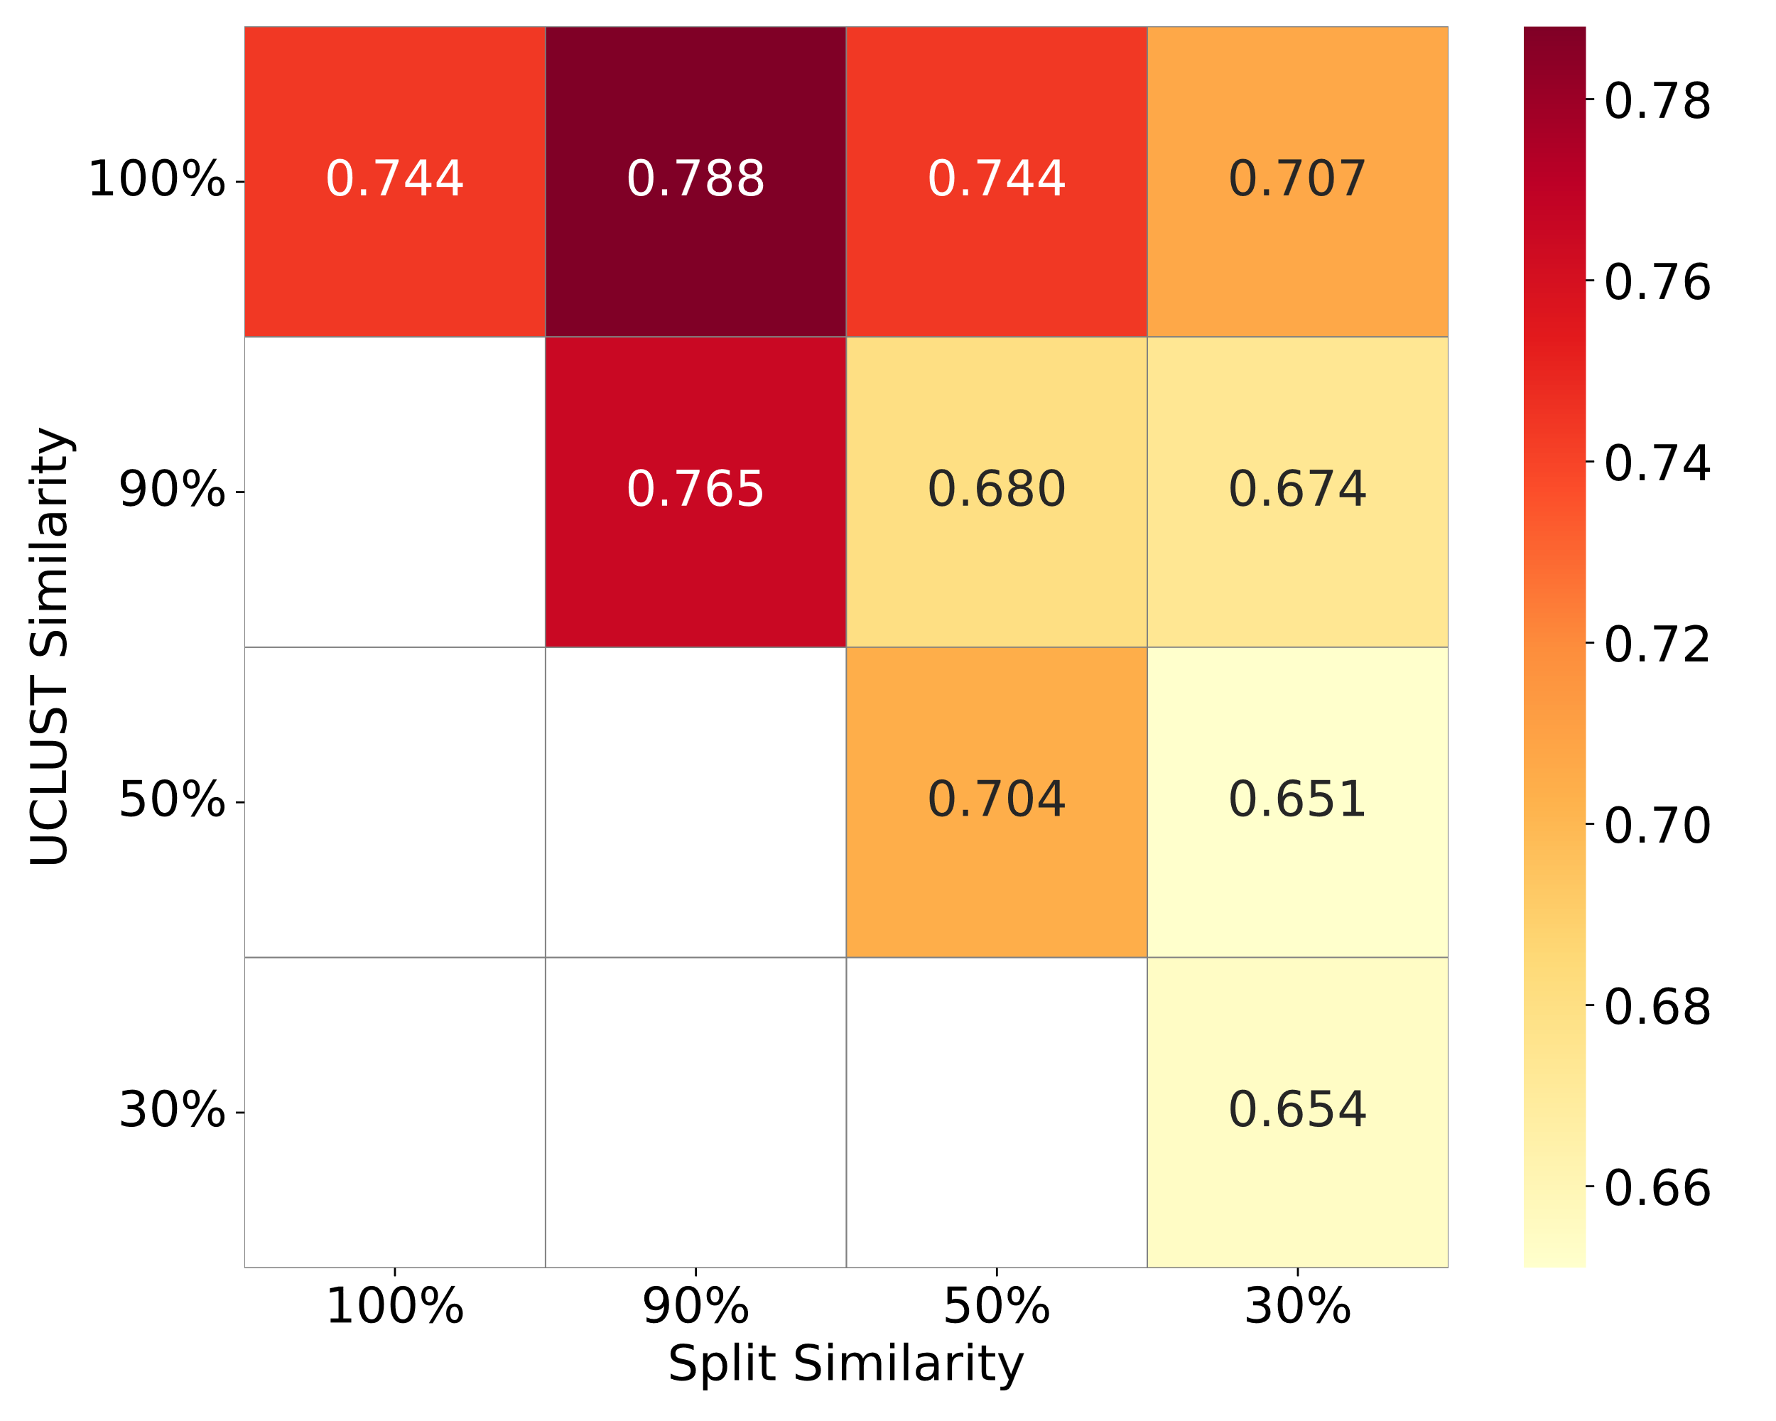
Figure S1. Heatmap showing the performance metrics MCC across different similarity thresholds for dataset splitting and UCLUST clustering. The x-axis represents the similarity threshold used for dataset splitting, and the y-axis represents the UCLUST clustering similarity. The color bar on the right indicates the range of MCC values from 0.65 to 0.78, with darker colors representing higher MCC values. Overall, increased similarity thresholds correspond to improved model performance. Notably, when using a higher clustering similarity and a lower splitting similarity, the test set data is less familiar to the model, yet the MCC only slightly decreases, demonstrating the model’s robustness in handling less familiar data.
Figure S2. Performance comparison of GraphBind, CLAPE-SMB, and DeepProSite on the SJC and UniProtSMB datasets. (a) and (b) show the MCC values on the SJC and UniProtSMB datasets, respectively. (c) and (d) display the AUROC values on the SJC and UniProtSMB datasets, respectively. The CLAPE-SMB model consistently outperforms GraphBind across both metrics, demonstrating a significant improvement in MCC and AUROC. While DeepProSite outperforms CLAPE-SMB in terms of AUROC, CLAPE-SMB achieves a slightly higher MCC than DeepProSite on the SJC dataset, though this difference is not statistically significant. In contrast, on the UniProtSMB dataset, CLAPE-SMB shows a marked improvement, significantly surpassing DeepProSite with an MCC of 0.699. Statistical significance is marked with *** (p < 0.001), ** (p < 0.01), and ns (not significant, p ≥ 0.05).
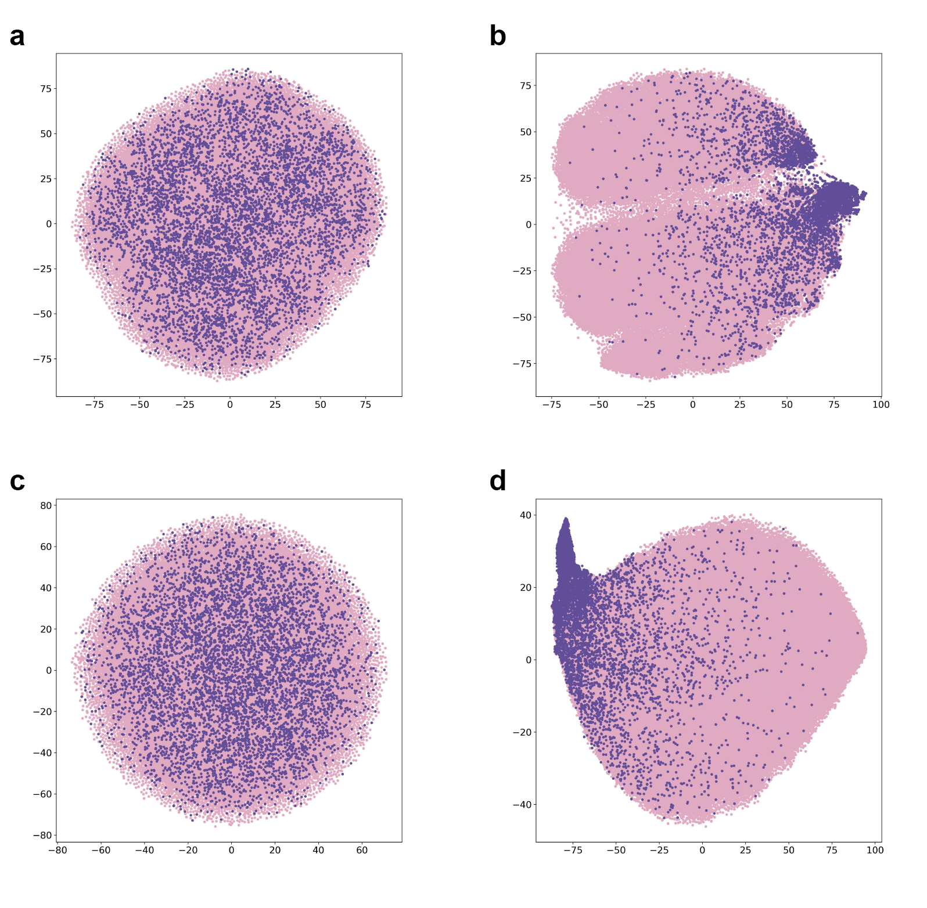
Figure S3. Comparison of t-SNE dimensionality reduction plots of sites predicted by randomly initialized MLP or CLAPE-SMB. (a) and (c) represent the second and third layers of randomly initialized MLP, respectively. (b) and (d) represent the second and third layers of CLAPE-SMB, respectively.
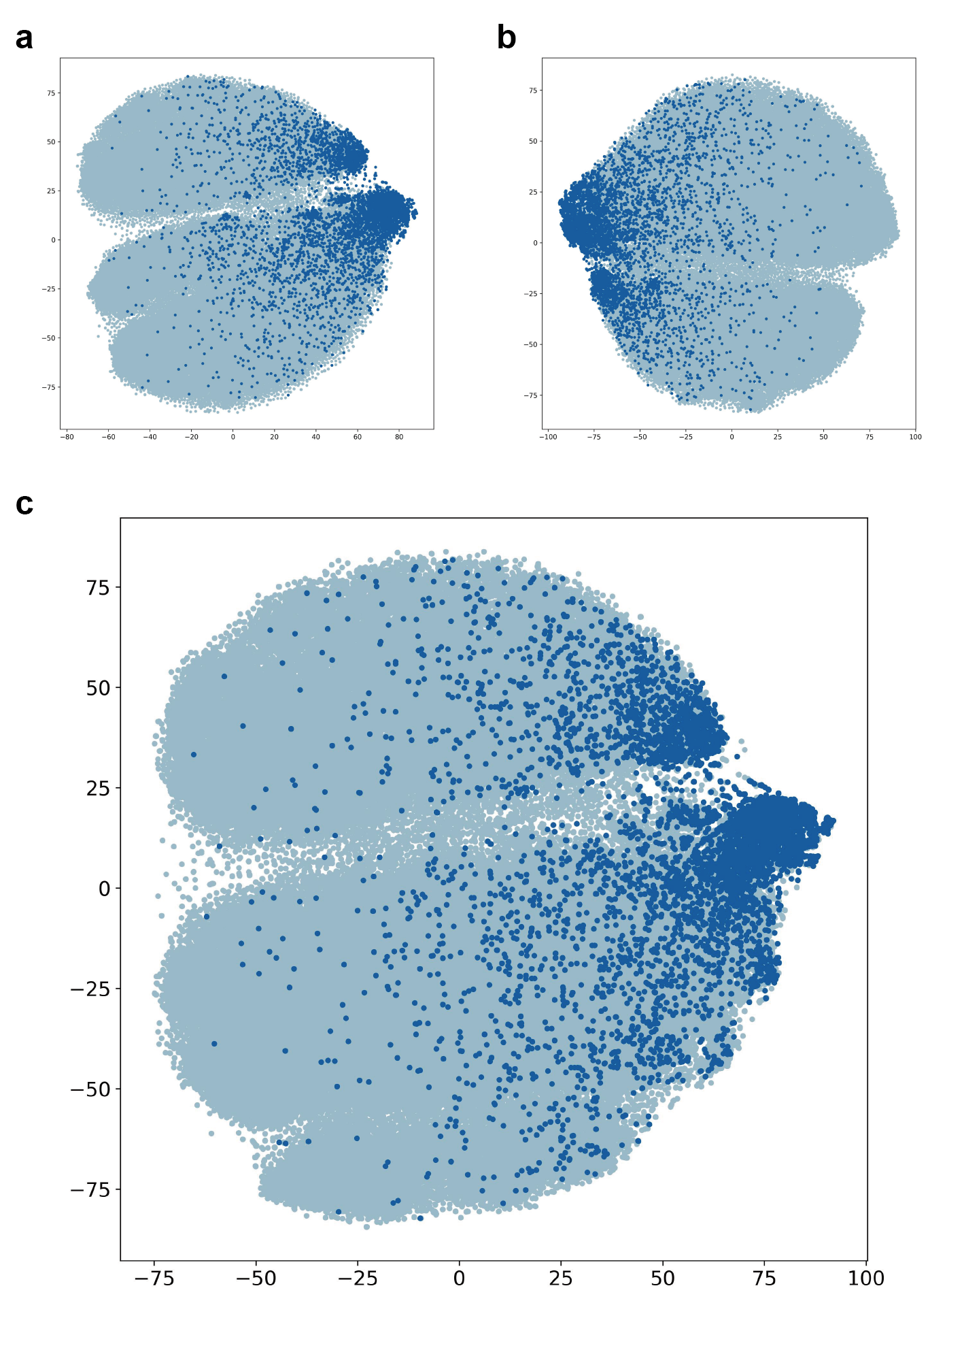
Figure S4. Comparison of t-SNE plots for different loss functions, including (a) TCL alone, (b) focal loss alone, and (c) combination of TCL and focal loss.
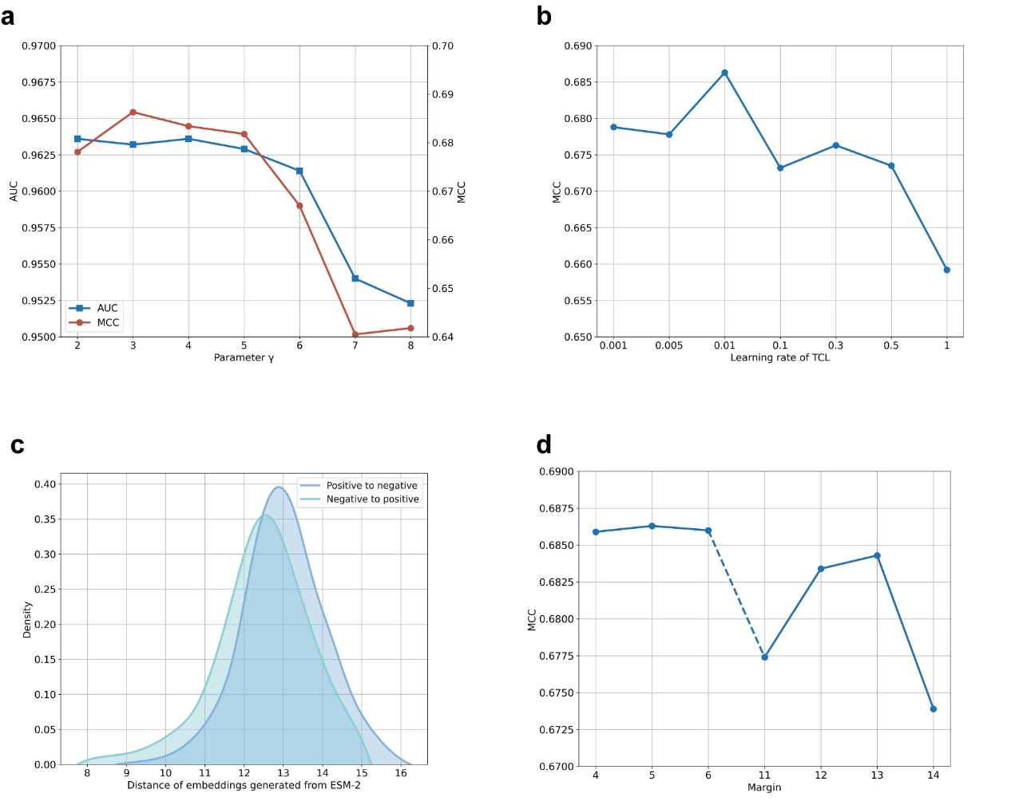
Figure S5. Hyperparameter optimization of loss function using a subset of the UniProtSMB dataset. (a) Parameter $γ$ was set to 3, (b) learning rate of TCL was set to 0.01, and (d) margin was set to 5 based on the highest MCC and AUROC values. (c) Distance distribution of embeddings of negative to positive and positive to negative residues, respectively.

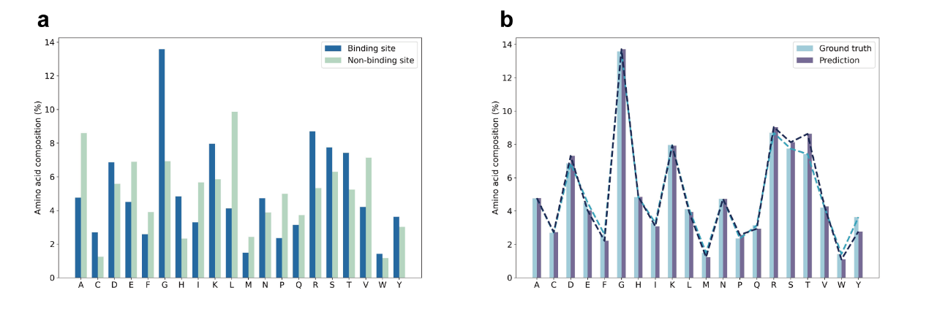
Figure S6. Analysis of amino acid composition in UniProtSMB test set. (a) Proportion of each amino acid at binding and non-binding sites in ground truth data. (b) Comparison of the proportion of each amino acid at binding sites in ground truth and CLAPE-SMB predictions, with forward and reverse KL divergence of 0.0039 and 0.0038, respectively.

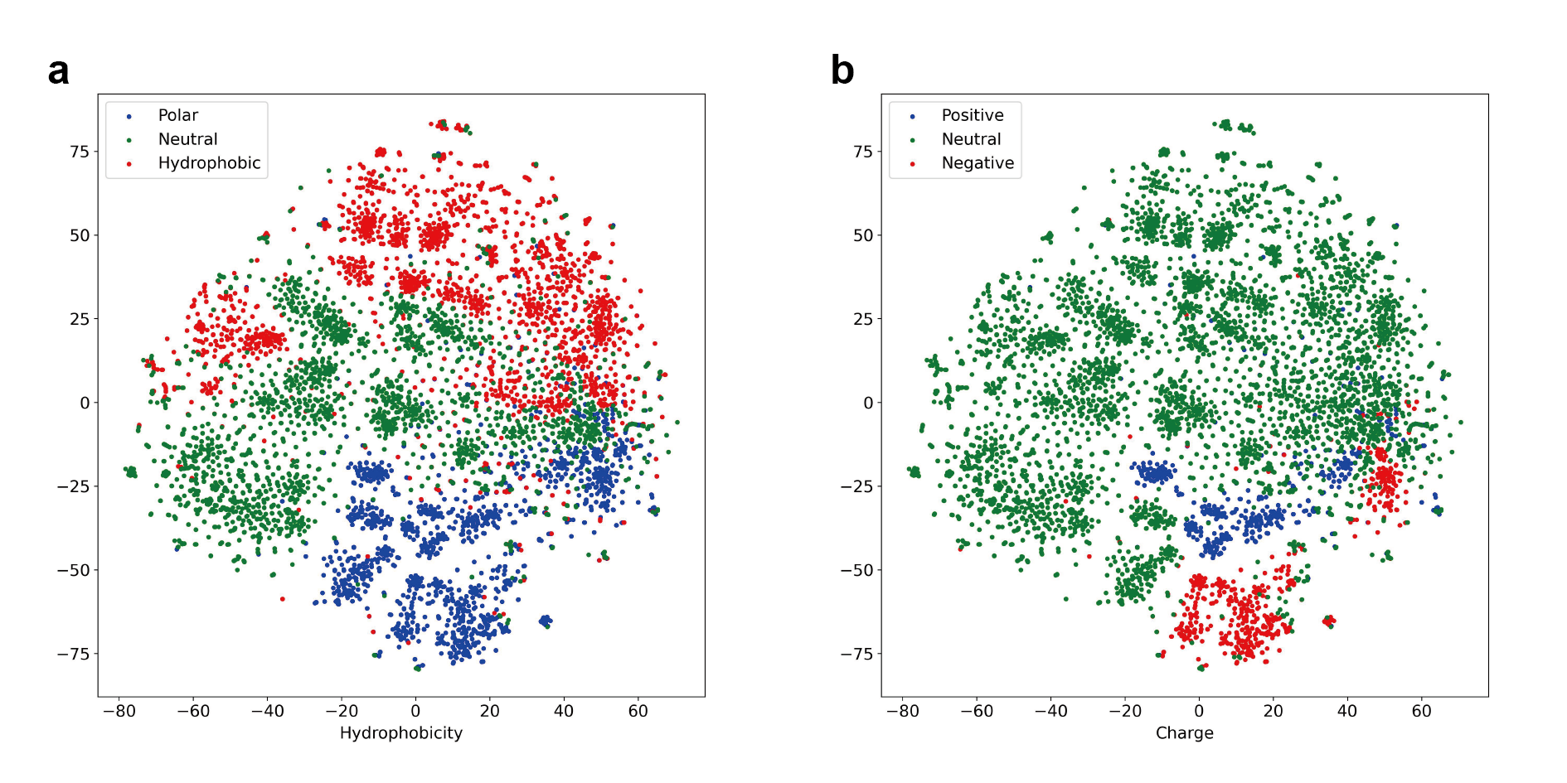
Figure S7. T-SNE plots of small molecule-binding residues based on (a) hydrophobicity and (b) charge in the first layer output of CLAPE-SMB.

