Supplementary Materials

Supplementary Material 1
Table 1: Information about the clinical trials used as an evaluation set
Clinical Trial ID | Drug(s) assessed | Fit guideline | Therapeutic benefits | Why?
NCT00988208 | Lenalidomide | TRUE | Negative | Hazard Ratio > 1
NCT00498797 | Vandetanib | TRUE | Negative | PSA response is lower for treatment 1 than control
NCT00626548 | Zibotentan | TRUE | Negative | Early efficacity was unlikely
NCT00617669 | Zibotentan | TRUE | Negative | Early efficacity was unlikely
NCT02987543 | Olaparib | TRUE | Positive | Hazard Ratio < 1
NCT02489318 | Apalutamide | TRUE | Positive | Hazard Ratio < 1
NCT00417079 | Cabazitaxel | TRUE | Positive | Overall survival is greater
NCT05197257 | 68Ga-PSMA-11 | FALSE | Neutral | Radioligand
NCT04614363 | 68 Ga-PSMA | FALSE | Neutral | Radioligand
NCT03840200 | Ipatasertib | FALSE | Neutral | No entirely on prostate cancer
NCT04089553 | Oleclumab | FALSE | Neutral | not drug like molecule, antibody
NCT03404648 | Gadobutrol | FALSE | Neutral | not for therapeutic effiacy
NCT03418324 | TRC105 | FALSE | Neutral | not drug like molecule, antibody
NCT03554317 | Nivolumab | FALSE | Neutral | not drug like molecule, antibody
NCT03735680 | ONM-100 | FALSE | Neutral | imaging
NCT03148795 | Talazoparib | TRUE | Positive | overall better
NCT00006392 | Vitamin E and selenium | FALSE | Neutral | Prevention
NCT00016913 | Multiple | FALSE | Neutral | Carboplatin and No comparaison
NCT00049257 | Multiple | FALSE | Neutral | Use of carboplatin in a single arm
NCT00060528 | Vaccine | FALSE | Neutral | not drug
NCT00106392 | Prograf | FALSE | Neutral | Not on efficacy
NCT01578655 | Custirsen | FALSE | Neutral | oligosens nucleotides

Supplementary Material 2
Four categories of features can be extracted using DiscoNet :
- Propagation-based features: simple one-to-one distances between nodes. Two types of algorithms are available, shortest paths and random walk with restart. Distances can be directed, inversely directed, or undirected.
- Topological metrics and similarities: common metrics such as degree, betweenness, or centrality are extracted, as well as node similarity based on node neighborhoods.
- Module-based: corresponds to distances from and to clusters identified within the PPI layer.
- Signature-based: corresponds between distances from and to sets of nodes defined as a signature from the PCaDB database.

Supplementary Material 3
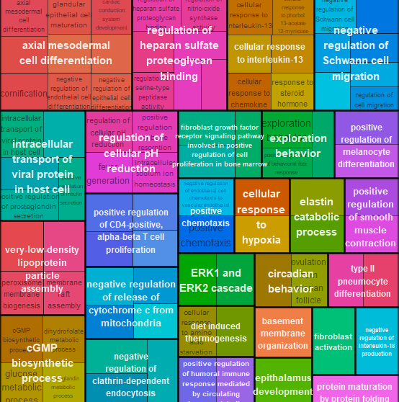
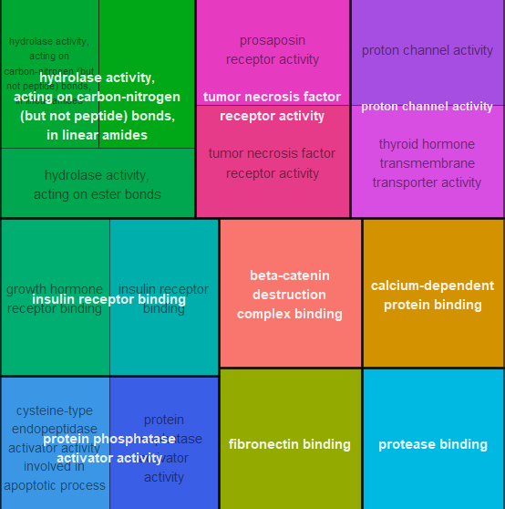
Topological distances to these GO terms were used as features by the final ensemble model to predict the 980 drug candidates. They were further grouped into broader category by the R package rrvgo.

