Supplementary Information for “Syn-MolOpt: A Synthesis Planning-Driven Molecular Optimization Method Using Data-Derived Functional Reaction Templates”

Xiaodan Yin^{1,2}, Xiaorui Wang¹, Zhenxing Wu¹, Qin Li³, Yu Kang¹, Yafeng Deng⁴, Pei Luo⁵, Huanxiang Liu³, Guqin Shi⁶, Zheng Wang⁶, Xiaojun Yao^{3,*}, Chang-Yu Hsieh^{1,*}, Tingjun Hou^{1,*}

¹College of Pharmaceutical Sciences, Zhejiang University, Hangzhou, 310058, China.
²Liangzhu Laboratory, Zhejiang University, Hangzhou 311121, China.
³Faculty of Applied Sciences, Macao Polytechnic University, Macao, 999078, China.
⁴CarbonSilicon AI Technology Co., Ltd, Hangzhou, Zhejiang 310018, China.
⁵Dr. Neher’s Biophysics Laboratory for Innovative Drug Discovery, State Key Laboratory of Quality Research in Chinese Medicine, Macau Institute for Applied Research in Medicine and Health, Macau University of Science and Technology, Macao, 999078, China.
⁶Shanghai Qilu Pharmaceutical R&D Center, 576 Libing Road, Pudong New Area District, Shanghai 310115, China.
Corresponding authors
Tingjun Hou
E-mail: tingjunhou@zju.edu.cn
Chang-Yu Hsieh
E-mail: kimhsieh@zju.edu.cn.
Xiaojun Yao
E-mail: xjyao@mpu.edu.mo

Functional group attribution analysis in four datasets
Table S1 shows the information of representative functional groups with positive and negative attributions in the Mutag, hERG, CYP3A4, and CYP2C19 datasets. In the Mutag and hERG datasets, a positive attribution indicates that the functional group enhances toxicity, while a negative attribution indicates its detoxifying effect. In the CYP3A4 and CYP2C19 datasets, positive values suggest that the functional group favors metabolic inhibition, and negative values indicate it helps alleviate metabolic inhibition. Observing the changes in molecular properties caused by the transformation (appearance or disappearance) of relevant functional groups based on functional reaction templates during the molecular optimization process is helpful to reflect the role of functional groups and functional reaction templates. According to Table S1, the attribution values of the carboxyl group (-C(=O)O) in the Mutag, hERG, CYP3A4, and CYP2C19 datasets are -0.0964, -0.4671, -0.0885, and -0.1913, respectively, indicating that it has the potential to reduce two toxicities and two metabolic inhibition. Hence, we used the carboxyl group as a case study to explore the practicality of the SME method for designing reaction templates. We examined the effectiveness of the carboxyl group and related functional reaction templates in four molecular optimization tasks: GSK3β-Mutag, GSK3β-hERG, GSK3β-CYP3A4, and GSK3β-CYP2C19. The results show that when performing these four molecular optimization tasks, in most cases, the toxicity score (or metabolic score) of the compound decreases with the introduction of the carboxyl group. Figure S1 shows some instances where the introduction of the carboxyl group led to reductions in toxicity scores (or metabolic scores) in these tasks. This demonstrates the effectiveness of the functional reaction template introducing the carboxyl group and confirms that the SME method’s prediction of the carboxyl group’s ability to mitigate both types of toxicity and metabolic inhibition is accurate.

Table S1. Attributions of functional groups in four datasets.
Dataset | Attribution | Functional group | Mean attribution | Numberª
Mutag | - | -SO2NH2 | -0.2290 | 13
Mutag | - | -SO3H | -0.1994 | 204
Mutag | - | -CF3 | -0.1979 | 66
Mutag | - | -N=C=O | -0.1187 | 18
Mutag | - | -C(=O)O | -0.0964 | 732
Mutag | + | -N=O | 0.5119 | 318
Mutag | + | -N#N | 0.3176 | 60
Mutag | + | -NO2 | 0.1358 | 1443
Mutag | + | -SO2CH3 | 0.1057 | 28
Mutag | + | -C#CH | 0.0916 | 22
hERG | - | -C(=O)O | -0.4671 | 438
hERG | - | -SO2NH2 | -0.3601 | 57
hERG | - | -NC(=O)CH3 | -0.1442 | 110
hERG | - | -NHSO2CH3 | -0.1413 | 89
hERG | - | -C(=O)CH3 | -0.1022 | 150
hERG | + | -tBu | 0.1044 | 296
hERG | + | -OEt | 0.0633 | 312
hERG | + | -cPropyl | 0.0507 | 332
hERG | + | -C#N | 0.0257 | 901
hERG | + | -SCH3 | 0.0153 | 48
CYP3A4 | - | -C(=O)O | -0.0885 | 1512
CYP3A4 | - | -SO3H | -0.0574 | 218
CYP3A4 | - | -SO2NH2 | -0.0556 | 85
CYP3A4 | - | -NC(=O)CH3 | -0.0443 | 199
CYP3A4 | - | =N-O | -0.0263 | 62
CYP3A4 | + | -C#CH | 0.094 | 40
CYP3A4 | + | -N=O | 0.086 | 14
CYP3A4 | + | =S | 0.0547 | 473
CYP3A4 | + | -OEt | 0.0533 | 671
CYP3A4 | + | -cPropyl | 0.0505 | 144
CYP2C19 | - | -C(=O)O | -0.1913 | 1378
CYP2C19 | - | -SO2NH2 | -0.1826 | 83
CYP2C19 | - | -NC(=O)CH3 | -0.166 | 174
CYP2C19 | - | -NHSO2CH3 | -0.1314 | 70
CYP2C19 | - | -SO3H | -0.107 | 202
CYP2C19 | + | -OEt | 0.0687 | 686
CYP2C19 | + | -SCH3 | 0.0586 | 126
CYP2C19 | + | -CF3 | 0.0523 | 667
CYP2C19 | + | -tBu | 0.0448 | 260
CYP2C19 | + | =S | 0.0352 | 485
ªThe number of times the functional group occurs in the dataset.
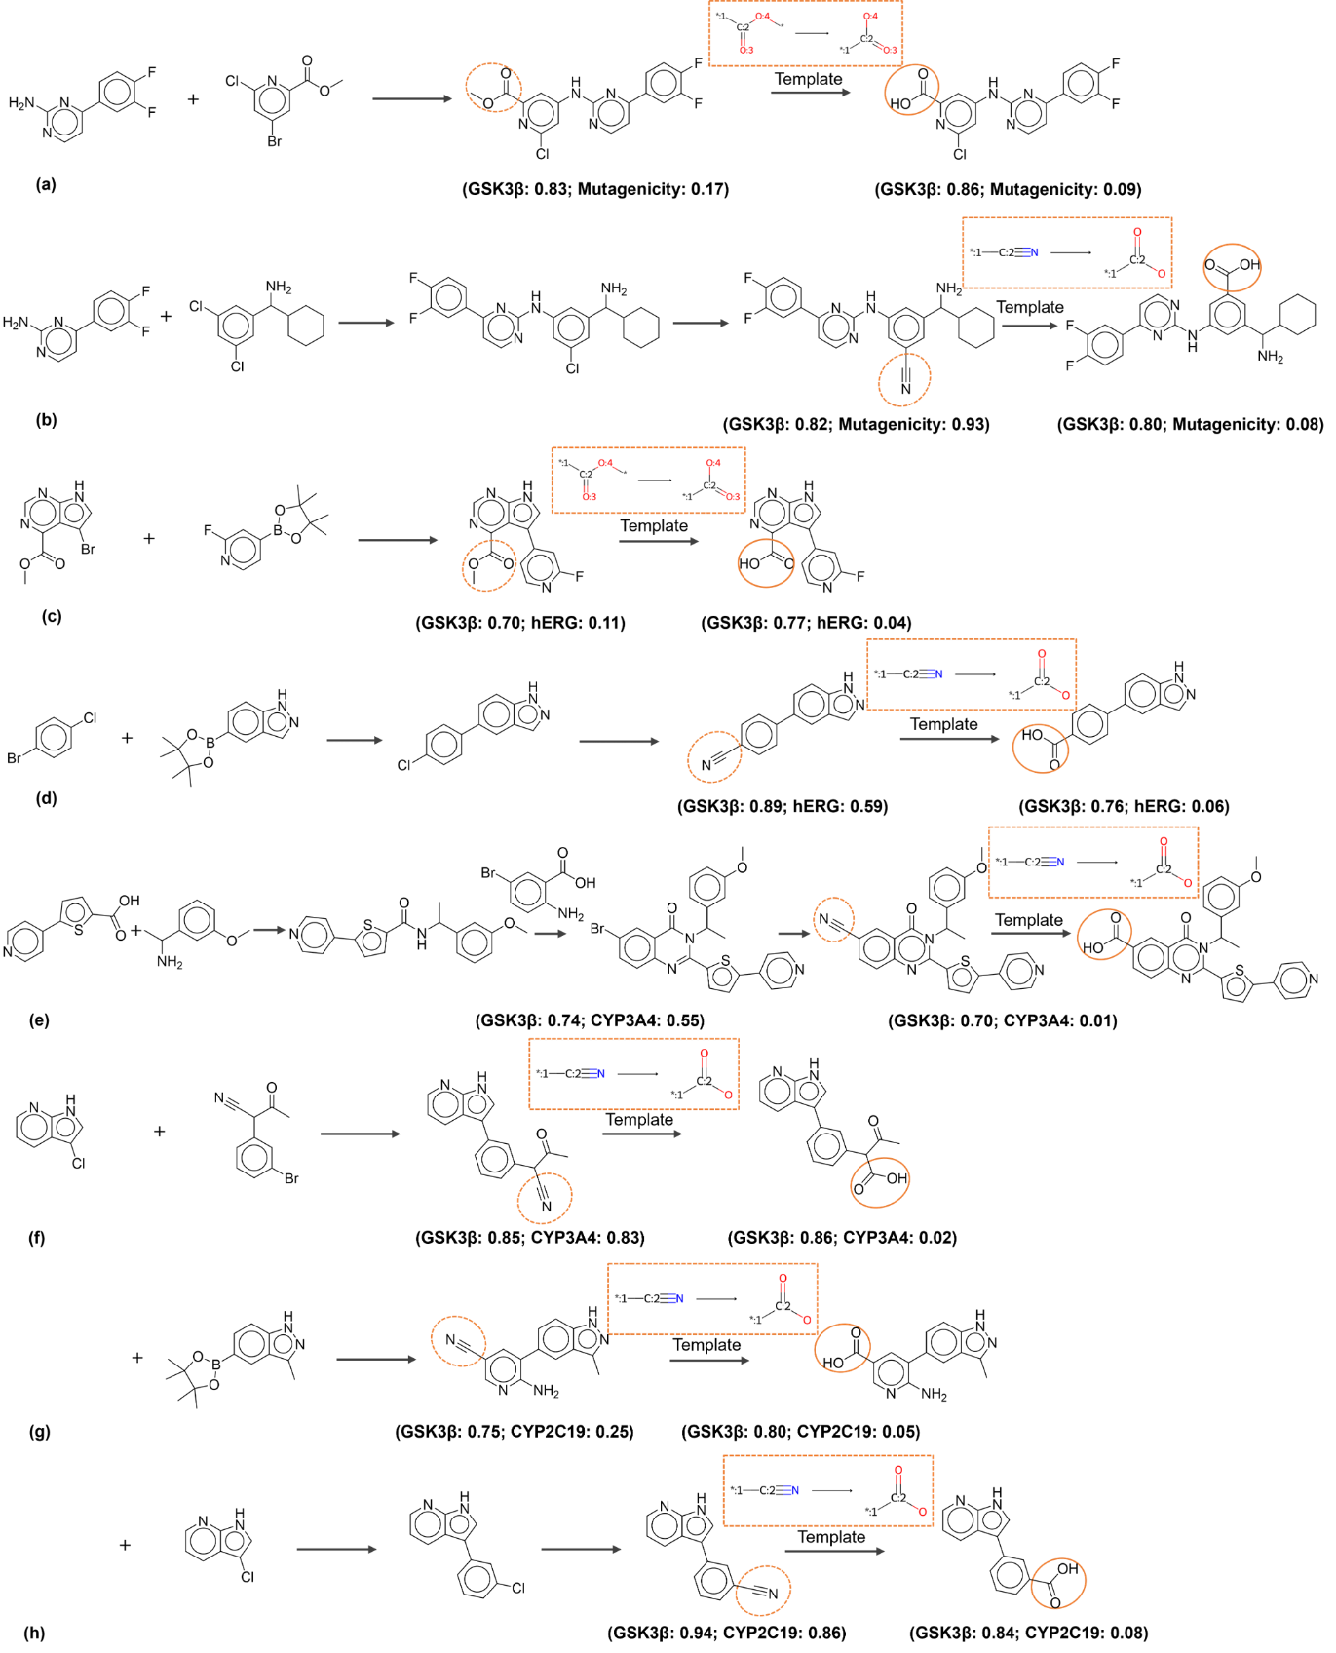
Figure S1. Visualization of the role of carboxyl groups and related functional reaction templates in four molecular optimization tasks.
Introduction to SME Method
SME¹ is a substructure masking-based explanation method that we previously introduced. It identifies key substructures within molecules and discerns their impact on model predictions, thereby helping to identify functional fragments that influence molecular properties. The implementation of SME begins with the construction of consensus models for property prediction. The construction of the consensus model is achieved by integrating RGCN² sub-models built based on different random seeds. The average value predicted by the sub-models will be used as the final output of the consensus model. RGCN is an extension of the standard graph convolutional neural network (GCN)³, which enriches and updates the messages of hidden states in the network by introducing the features of edges. The information propagation rule for each node is as follows:
$${ h}_{v}^{(l+1)}=σ(\sum_{rϵR}{\sum_{uϵN_{v}^{r}}{W_{r}^{(l)}}h_{u}^{(l)}} + W_{0}^{(l)}h_{v}^{(l)})$$
where $h_{v}^{(l+1)}$ is the state vector of the target node $v$ after $l+1$ iterations. $N_{v}^{r}$ denotes the neighbors of node $v$ under the edge type $r$, and $R$ represents the set of edge types. The neighbors of node $v$ are the nodes directly connected to node $v$. $σ()$ is the activation function, and this study utilizes the ReLU() activation function. $W_{r}^{(l)}$ is the weight for the neighboring node $u$, and $W_{0}^{(l)}$ is the weight for the target node $v$. As shown above, the information of the edges is explicitly incorporated into the RGCN. By aggregating the information from each node's neighboring nodes through attention weights, a molecular representation can be obtained, and predictions can be made based on this molecular representation through three fully connected layers. The definition of the attention weights is as follows:
${ ω}_{v}=sigmoid(W∙h_{v} +bias)$
$$molecular embedding= \sum_{v=1}^{N}{\left(ω_{v}∙h_{v}\right)}$$
where $W$ and $bias$ are the trainable parameters of the linear transformation during model training. $N$ is the number of nodes in the molecular graph. $sigmoid()$ is an activation function that constrains the attention weights $ω_{v}$ of each node between 0 and 1. $ω_{v}$ is the attention weight of node $v$, and $h_{v}$ is the feature of node $v$.
Substructure masking is then performed, where specific substructures are hidden from the model to identify which ones, when absent from the input, may have a significant impact on the model’s predictions. In SME, three types of well-defined substructures (BRICS substructures⁴, Murcko substructures⁵, and functional groups) are used as the basic units for masking. The molecular representation of the masked molecule is defined as follows:
$${molecular embedding}_{mask}=\sum_{v=1}^{N}{\left(ω_{v}∙h_{v}∙{mask}_{v}\right)}$$
$${mask}_{v}=\left\{\begin{aligned}1, &if node v is not mask \\ 0, &if node v is mask\end{aligned} \right.$$
where $N$ is the number of nodes, $ω_{v}$ is the attention weight of node $v$, and $h_{v}$ is the representation of node $v$. SME refers to the degree of influence that a masked substructure has on the overall prediction as the attribution value. The attribution value of each substructure can be determined as follows: by conducting two predictions, one before and one after applying the substructure masking on the molecular graph, the difference in the prediction values can serve as the attribution value for that substructure. The calculation formula is as follows:
$$Y=\sum_{i}^{m}{Y_{i}}$$
$$Y_{sub}=\sum_{i}^{m}{Y_{i,sub}}$$
$${ Attribution}_{sub}=Y- Y_{sub}$$
where $sub$ is the masked substructure, $m$ is the number of RGCN submodels (in this study, $m$ is set to 10), and $i$ refers to the $i^{th}$ RGCN submodel. To make the interpretability more intuitive, the attribution values of molecular substructures are normalized to values ranging between 0 and 1. We have included this description of how SME works in the Supplementary Information to help readers better understand.
Details of manually curated reaction templates
Our manual intervention to the templates mainly focuses on refining the reaction groups within the templates and keeping more generalized templates. If different reaction templates can achieve the same chemical transformation, we will select the one that is chemically plausible and can accurately describe the changes in the reaction site groups. For example, regarding the reaction of introducing carboxyl group depicted in Figure S2, both the templates ① and ② can facilitate the transformation. However, template ① introduces the carboxyl group via ester bond hydrolysis, whereas template ② does so through an ether bond. Given that template ① is more rational, we have opted to retain it. Furthermore, when there is an inclusion relationship between templates, we prefer to keep the more general one. For instance, template ④ encompasses template ③, thus we have kept template ④.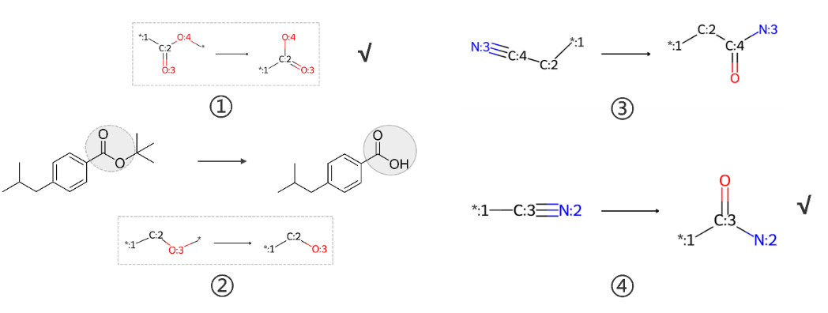
Figure S2. Visualization of the manual management of reaction templates.
Visualization of the synthesis routes for the top-10 molecules provided by Syn-MolOpt in the GSK3β-Mutag optimization task
To assess the feasibility of the synthetic routes provided by Syn-MolOpt, we conducted a thorough analysis by reviewing relevant literature and calculating the synthetic accessibility scores (SAscore)⁶ for the involved compounds. The published literature typically documents previous experimental results and synthesis methods, offering a comprehensive history of synthesis for specific or similar compounds. This allows us to verify whether the synthetic routes provided by Syn-MolOpt are supported by existing literature. Additionally, the SAscore, ranging from 1 to 10, assesses the synthesis difficulty of the compounds, with scores above 6 indicating challenging syntheses and scores below 6 suggesting easier ones. By calculating the SAscores for compounds involved in Syn-MolOpt’s suggested routes, we obtained a preliminary understanding of the synthesis challenges. As an illustration, we analyzed the feasibility of the synthetic routes for the top-10 molecules generated by Syn-MolOpt in the GSK3β-Mutag optimization task. Figure S3 visually represents the synthetic routes for these 10 molecules. We observed that each step in these synthetic pathways can be supported by relevant literature references, and the involved compounds had relatively low SAscores, with a maximum score of 3.1255. These results suggest that these routes have theoretical feasibility. However, it is important to note that experimental validation is ultimately required to confirm the practicality of any designed synthetic route. We provide experimenters with reference synthetic routes through calculations, while specific implementation details need be adjusted and optimized according to experimental conditions.
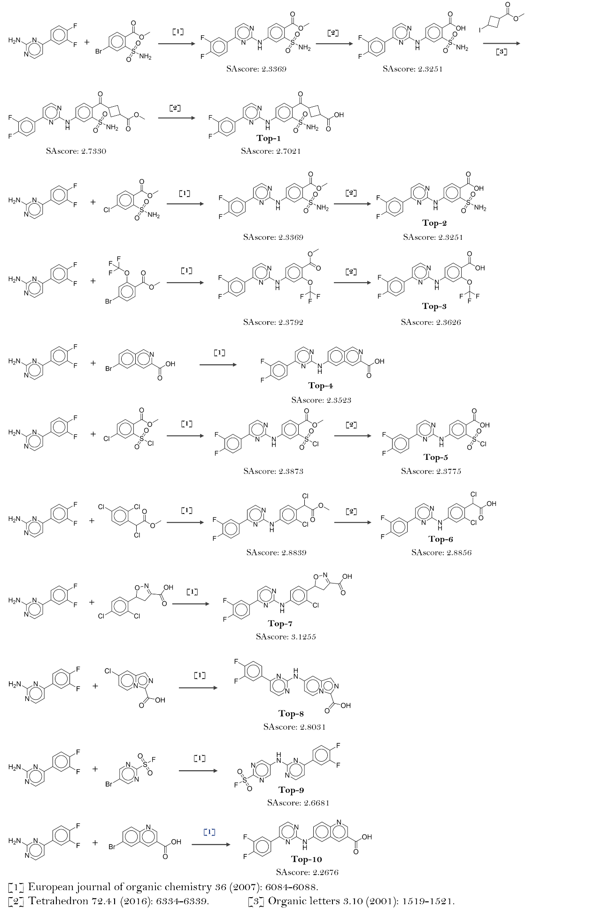
Figure S3. Visualization of the synthesis routes for the top-10 molecules provided by Syn-MolOpt in the GSK3β-Mutag optimization task.
Experimental results of JNK3-related multi-property optimization
We have conducted four multi-property optimization experiments on JNK3 similar to those on GSK3β. Table S2 provides the details of the molecules to be optimized on these four multi-property optimization experiments, where each experiment involves refining 128 molecules. The goal of optimization is to optimize molecules that bind well to JNK3 but are toxic (or metabolically inhibitory) into non-toxic (non-metabolically inhibitory) molecules that exhibit even greater binding capability to JNK3 (evidenced by higher JNK3 scores and lower Mutag/hERG/CYP3A4/CYP2C19 scores). Table S3 presents the optimization results for JNK3-Mutag, JNK3-hERG, JNK3-CYP3A4, and JNK3-CYP2C19. In the optimization tasks for JNK3-Mutag, JNK3-hERG, and JNK3-CYP3A4, Syn-MolOpt outperformed other methods in almost all metrics, except for the top-1 and top-10 JNK3 scores. In the JNK3-CYP2C19 task, HierG2G secured the best top-1 and top-10 JNK3 scores, and Modof had the best top-100 and top-128 JNK3 scores. However, as highlighted in red, HierG2G's top-1 and top-10 CYP2C19 scores, along with Modof's top-100 and top-128 CYP2C19 scores, were the highest, indicating that these methods excel in optimizing JNK3 property, but have not effectively reduced CYP2C19 inhibition. Such multi-property optimization results do not align with our intended objectives. In contrast, although Syn-MolOpt did not achieve the highest top-1 and top-10 JNK3 scores (second only to HierG2G), its top-1 and top-10 CYP2C19 scores were ideal, demonstrating Syn-MolOpt's ability to balance the optimization of both target properties.
Table S2. Details of the molecules to be optimized on four multi-property optimization experiments related to JNK3.
Experiment | Initial mean scoreª
JNK3-Mutag | JNK3: 0.793 ± 0.117 | Mutag: 0.696 ± 0.121
JNK3-hERG | JNK3: 0.812 ± 0.107 | hERG: 0.762 ± 0.133
JNK3-CYP3A4 | JNK3: 0.758 ± 0.094 | CYP3A4: 0.901 ± 0.054
JNK3-CYP2C19 | JNK3: 0.746 ± 0.092 | CYP2C19: 0.937 ± 0.029
ªThe score is the probability value.
Table S3. Overall comparison of four JNK3-related multi-property optimization tasks.
Task | JNK3-Mutag
Methods | Property |  | Top-1ª | Top-10 | Top-100 | Top-128 | Syn-ratio^{b} ↑
Modof | JNK3 ↑ |  | 0.900 | 0.859±0.085 | 0.677±0.187 | 0.575±0.259 | 0.531
Modof | Mutag ↓ |  | 0.056 | 0.288±0.219 | 0.545±0.253 | 0.525±0.258 | 0.531
HierG2G | JNK3 ↑ |  | 0.970 | 0.834±0.132 | 0.365±0.330 | 0.365±0.330 | 0.507
HierG2G | Mutag ↓ |  | 0.095 | 0.136±0.116 | 0.220±0.278 | 0.220±0.278 | 0.507
SynNet | JNK3 ↑ |  | 0.710 | 0.675±0.034 | 0.574±0.064 | 0.560±0.068 | 1.000(0.875)^{c}
SynNet | Mutag ↓ |  | 0.064 | 0.110±0.064 | 0.119±0.098 | 0.125±0.109 | 1.000(0.875)^{c}
Syn-MolOpt | JNK3 ↑ |  | 0.820 | 0.815±0.018 | 0.761±0.080 | 0.752±0.116 | 1.000(0.578)
Syn-MolOpt | Mutag ↓ |  | 0.040 | 0.084±0.056 | 0.113±0.080 | 0.116±0.088 | 1.000(0.578)
 | JNK3-hERG
Modof | JNK3 ↑ |  | 0.820 | 0.877±0.069 | 0.692±0.187 | 0.589±0.266 | 0.711
Modof | hERG ↓ |  | 0.239 | 0.492±0.174 | 0.678±0.196 | 0.663±0.222 | 0.711
HierG2G | JNK3 ↑ |  | 0.990 | 0.917±0.088 | 0.453±0.373 | 0.453±0.373 | 0.700
HierG2G | hERG ↓ |  | 0.332 | 0.275±0.184 | 0.283±0.255 | 0.283±0.255 | 0.700
SynNet | JNK3 ↑ |  | 0.740 | 0.705±0.054 | 0.624±0.075 | 0.610±0.076 | 1.000(0.742)
SynNet | hERG ↓ |  | 0.106 | 0.192±0.134 | 0.238±0.158 | 0.241±0.153 | 1.000(0.742)
Syn-MolOpt | JNK3 ↑ |  | 0.770 | 0.750±0.023 | 0.703±0.048 | 0.699±0.047 | 1.000(0.914)
Syn-MolOpt | hERG ↓ |  | 0.089 | 0.136±0.063 | 0.177±0.106 | 0.187±0.104 | 1.000(0.914)
 |  | JNK3-CYP3A4
Modof | JNK3 ↑ |  | 0.800 | 0.767±0.071 | 0.749±0.110 | 0.723±0.112 | 0.695
Modof | CYP3A4 ↓ |  | 0.048 | 0.168±0.147 | 0.664±0.333 | 0.717±0.313 | 0.695
HierG2G | JNK3 ↑ |  | 0.900 | 0.933±0.057 | 0.463±0.373 | 0.463±0.373 | 0.690
HierG2G | CYP3A4 ↓ |  | 0.080 | 0.380±0.133 | 0.449±0.328 | 0.449±0.328 | 0.690
SynNet | JNK3 ↑ |  | 0.940 | 0.677±0.099 | 0.554±0.085 | 0.544±0.088 | 1.000(0.882)
SynNet | CYP3A4 ↓ |  | 0.540 | 0.124±0.150 | 0.122±0.151 | 0.132±0.165 | 1.000(0.882)
Syn-MolOpt | JNK3 ↑ |  | 0.850 | 0.813±0.018 | 0.751±0.039 | 0.737±0.046 | 1.000(0.938)
Syn-MolOpt | CYP3A4 ↓ |  | 0.030 | 0.047±0.029 | 0.094±0.069 | 0.099±0.069 | 1.000(0.938)
 |  | JNK3-CYP2C19
Modof | JNK3 ↑ |  | 0.78 | 0.691±0.065 | 0.748±0.120 | 0.719±0.123 | 0.625
Modof | CYP2C19 ↓ |  | 0.099 | 0.155±0.121 | 0.744±0.338 | 0.781±0.315 | 0.625
HierG2G | JNK3 ↑ |  | 0.910 | 0.907±0.095 | 0.363±0.392 | 0.363±0.392 | 0.594
HierG2G | CYP2C19 ↓ |  | 0.344 | 0.598±0.262 | 0.552±0.316 | 0.552±0.316 | 0.594
SynNet | JNK3 ↑ |  | 0.810 | 0.669±0.129 | 0.487±0.136 | 0.471±0.140 | 1.000(0.813)
SynNet | CYP2C19 ↓ |  | 0.160 | 0.212±0.277 | 0.210±0.265 | 0.221±0.283 | 1.000(0.813)
Syn-MolOpt | JNK3 ↑ |  | 0.810 | 0.704±0.053 | 0.567±0.070 | 0.556±0.081 | 1.000(0.867)
Syn-MolOpt | CYP2C19 ↓ |  | 0.160 | 0.097±0.068 | 0.085±0.065 | 0.100±0.129 | 1.000(0.867)
ªTop-n is the average score for the top n output molecules.
^{b}Syn-ratio is synthesizable ratio.
^{c}The value in parentheses represents the synthesizable ratio evaluated by AiZynthFinder.
AiZynthFinder parameter selection
When utilizing AiZynthFinder to evaluate the synthesizability of molecules, we used default settings for the maximum depth (6) and search time (120 seconds). The number of iterations was set to 300 by us. Since the search algorithm used by AiZynthFinder is MCTS⁷ , as shown in Figure S4⁸, we observed that when the number of iterations approaches 300, the fraction of solved targets by the MCTS algorithm nearly reaches 1.0. Therefore, setting the number of iterations to 300 is reasonable, as additional iterations offer minimal further improvement.
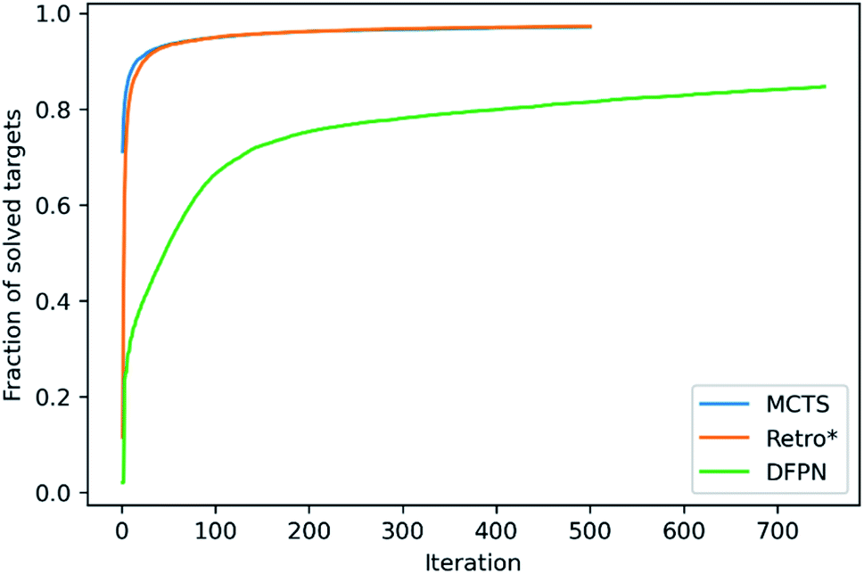
Figure S4⁸. The fraction of solved targets as a function of the number of elapsed iterations.
Idea of designing more universal functional reaction template libraries for multiple properties with Syn-MolOpt
The current Syn-MolOpt workflow can be used to design more general functional reaction templates for optimizing multiple molecular properties, though some modifications are necessary. A practical strategy involves initially designing functional reaction templates for specific molecular properties that require optimization, following the established process of the functional reaction template library. Subsequently, a diverse, chemically complex, and adequately large library of compounds should be collected, and these templates applied to single-step reaction transformations. Property predictors can then be used to monitor changes in molecular properties before and after transformation, identifying templates that enhance all targeted properties effectively. Finally, these templates should be collected and manually managed, integrating them into the Syn-MolOpt framework for multi-property molecular optimization.
Table S4. Details of the datasets for the four properties to be optimized.
Property | Data volume | Positive sample No. | Negative sample No.
Mutagenicity | 7672 | Mutagens: 4309 | Non-mutagens: 3363
hERG | 9876 | Blockers: 5090 | Non-blockers: 4786
CYP3A4 | 12328 | Inhibitors: 5110 | Non-inhibitors: 7218
CYP2C19 | 12665 | Inhibitors: 5819 | Non-inhibitors: 6846
Table S5. The performance of the models in predicting reaction action, the first reactant, reaction template, and the second reactant.
Task | Model | Toxicity-related optimization |  | Metabolism-related optimization
Task | Model | Accuracy | MSE | Accuracy | MSE
Classification | N_{act} | 0.98 | - | 0.98 | -
Classification | N_{rxn} | 0.79 | - | 0.82 | -
Regression | N_{rct-1} | - | 0.06 | - | 0.06
Regression | N_{rct-2} | - | 0.03 | - | 0.03

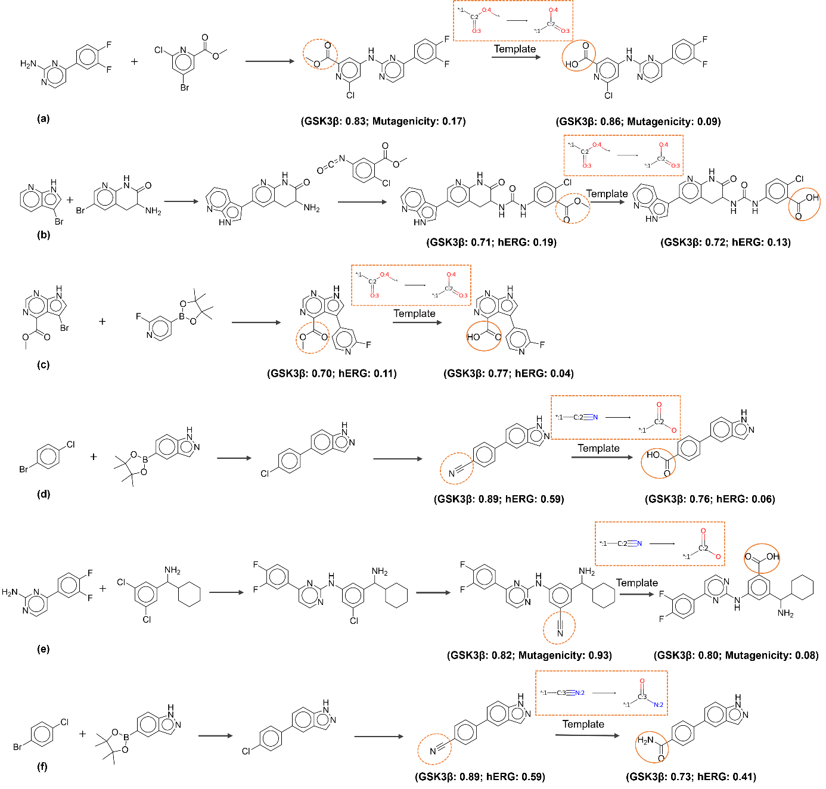
Figure S5. Visualization of examples where functional reaction templates facilitate molecular optimization.
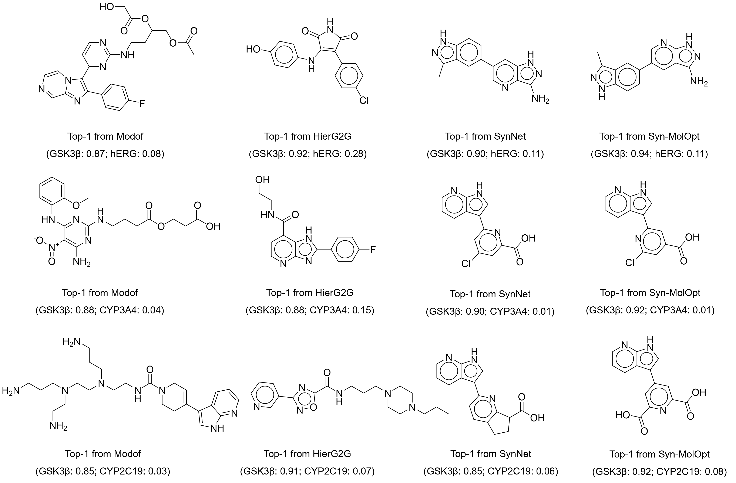
Figure S6. Visualization of the top-1 molecular structures from four methods across three molecular optimization tasks.
References
1. Wu Z, J Wang, H Du et al (2023) Chemistry-intuitive explanation of graph neural networks for molecular property prediction with substructure masking. Nat Commun 14:2585.
2. Schlichtkrull M, T N Kipf, P Bloem et al (2018) Modeling relational data with graph convolutional networks. In The semantic web: 15th international conference, ESWC 2018, Heraklion, Crete, Greece, June 3–7 pp 593-607.
3. Kearnes S, K McCloskey, M Berndl et al (2016) Molecular graph convolutions: moving beyond fingerprints. J Comput Aided Mol Des 30:595-608.
4. Degen J, C Wegscheid-Gerlach, A Zaliani et al (2008) On the art of compiling and using'drug-like'chemical fragment spaces. ChemMedChem 3:1503.
5. Bemis G W,M A Murcko (1996) The properties of known drugs. 1. Molecular frameworks. J Med Chem 39:2887-2893.
6. Ertl P,A Schuffenhauer (2009) Estimation of synthetic accessibility score of drug-like molecules based on molecular complexity and fragment contributions. J Cheminf 1:1-11.
7. Genheden S, A Thakkar, V Chadimová et al (2020) AiZynthFinder: a fast, robust and flexible open-source software for retrosynthetic planning. J Cheminf 12:70.
8. Genheden S,E Bjerrum (2022) PaRoutes: towards a framework for benchmarking retrosynthesis route predictions. Digit Discov 1:527-539.

