Supplementary Information

CLC-DB: an open-source online database of chiral ligands and catalysts

Gufeng Yu^{1,2†}, Kaiwen Yu^{1†}, Xi Wang^{1†}, Chenxi Zhang^{1†}, Yicong Luo^{1†}, Xiaohong Huo^{1*}, Yang Yang^{2*}
1. Shanghai Key Laboratory for Molecular Engineering of Chiral Drugs, Frontiers Science Center for Transformative Molecules, School of Chemistry and Chemical Engineering, Shanghai Jiao Tong University, Shanghai, 200240, China.
2. Department of Computer Science and Engineering, and Key Laboratory of Shanghai Education Commission for Intelligent Interaction and Cognitive Engineering, Shanghai Jiao Tong University, Shanghai, 200240, China.
3. Department of Computer Science, New York University, New York, 10012, United States of America

*Corresponding author(s). E-mail(s): huoxiaohong@sjtu.edu.cn; yangyang@cs.sjtu.edu.cn;
†These authors contributed equally to this work.
Contents
1. Details of Dataset in CLC-DB 2
2. User Guide to CLC-DB 3
2.1. Overview of CLC-DB 3
2.2. Search and Download of CLC-DB 4
2.3. Online Machine Learning Tool 7
3. Clustering Options 8
3.1. Dimension Reduction Methods 8
3.2. Clustering Methods 9

- Details of Dataset in CLC-DB

Item | Data type | Data resource
1 | Molecule Name
2 | CAS ID
3 | PubChem CID | Linked with PubChem
4 | Category
5 | Type of Chirality
6 | URL
7 | PubChem URL | Linked with PubChem
8 | SMILES
9 | Image | Calculated by RDKit
10 | 3D Structure | Calculated by Gaussian
11 | IUPAC Name | Calculated by RDKit
12 | InChI | Calculated by RDKit
13 | InChIKey | Calculated by RDKit
14 | Molecular Formula | Calculated by RDKit
15 | Molecular Weight | Calculated by RDKit
16 | Heavy Atom Count | Calculated by RDKit
17 | Ring Count | Calculated by RDKit
18 | H-Bond Acceptor Count | Calculated by RDKit
19 | H-Bond Donor Count | Calculated by RDKit
20 | Rotatable Bond Count | Calculated by RDKit
21 | Zero-point correction | Calculated by Multiwfn
22 | Thermal correction to Energy | Calculated by Multiwfn
23 | Thermal correction to Enthalpy | Calculated by Multiwfn
24 | Thermal correction to Gibbs Free Energy | Calculated by Multiwfn
25 | Sum of electronic and zero-point Energies | Calculated by Multiwfn
26 | Sum of electronic and thermal Energies | Calculated by Multiwfn
27 | Sum of electronic and thermal Enthalpies | Calculated by Multiwfn
28 | Sum of electronic and thermal Free Energies | Calculated by Multiwfn
29 | HOMO Energy (eV) | Calculated by Multiwfn
30 | LUMO Energy (eV) | Calculated by Multiwfn
31 | HOMO-LUMO Gap (eV) | Calculated by Multiwfn
32 | Mulliken charges for each atom | Calculated by Multiwfn
33 | Hirshfeld charges for each atom | Calculated by Multiwfn
34 | Description | Generated by GPT-4
Table S1. The list of 34 different types of information

Index | Category | Index | Category
1 | BIDIME and BIBOP Ligands | 17 | Salen Ligands
2 | Duphos and BPE Ligands | 18 | Other Chiral Nitrogen Ligands
3 | Sadphos Ligands | 19 | Chiral Diphenols
4 | Atropisomeric Bisphosphine Ligands | 20 | Other Chiral Oxygen Ligands
5 | Chiral Ferrocenyl Phosphine Ligands | 21 | Mono-oxazoline Ligands
6 | Chiral Phosphoramidite Ligands | 22 | Ferrocenyl-oxazoline Ligands
7 | Other P-Chiral Ligands | 23 | BOX Ligands
8 | Other C-Chiral Ligands | 24 | TOX Ligands
9 | Chiral Phosphoric Acids | 25 | PHOX Ligands
10 | Proline-Based Organocatalysts | 26 | SOX Ligands
11 | MacMillan Imidazolidinone Organocatalysts | 27 | Other Oxazoline Ligands
12 | Cinchona Alkaloids | 28 | Chiral NHCs Ligands
13 | Chiral Hydrogen-Bonding Organocatalysts | 29 | Chiral NHCs Catalysts
14 | NHTf | 30 | Chiral Phase-Transfer Catalysts
15 | Other Organocatalysts | 31 | Chiral Aminophosphine Ligands
16 | Chiral Bis-nitrogen Ligands | 32 | none
Table S2. The list of 32 different categories of chiral ligand and catalyst

- User Guide to CLC-DB
  - Overview of CLC-DB
The navigation bar offers efficient access to the database.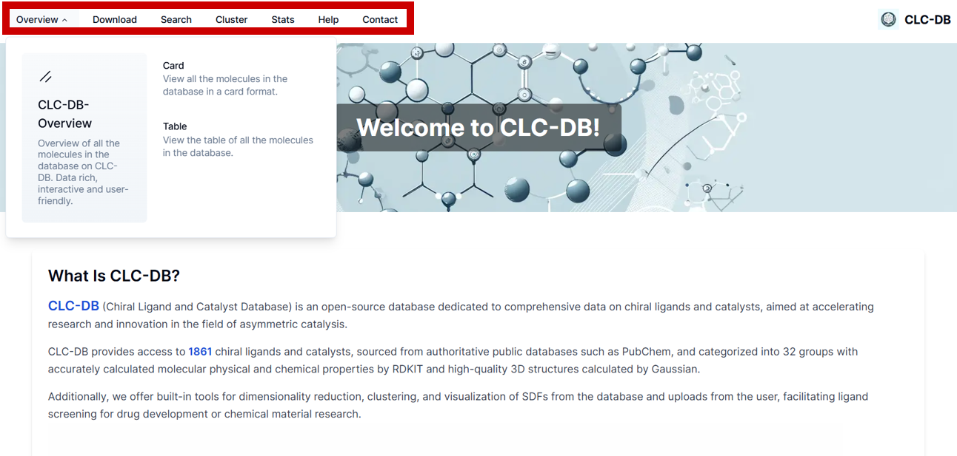

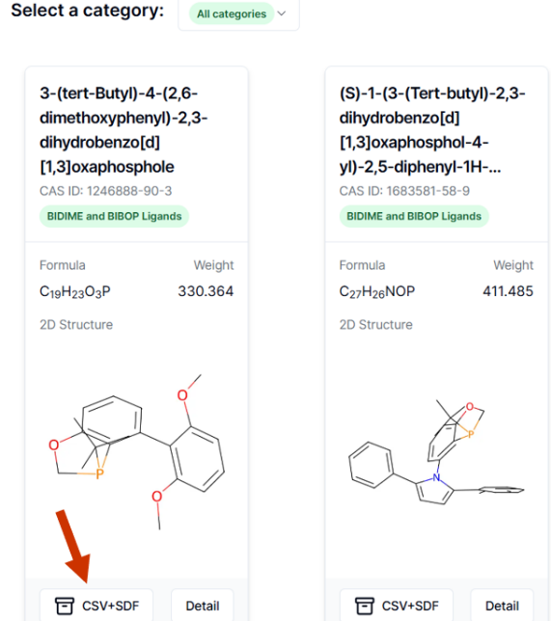
Click the "Overview" button to access information in card or table formats, suitable for casual browsing. Users can download or review detailed information on specific molecules of interest.
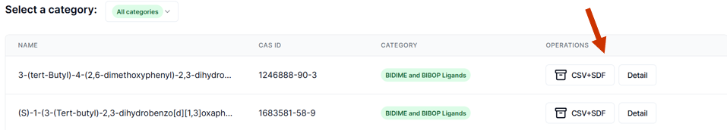

  - Search and Download of CLC-DB
The "Download" tab is designed for batch downloading. Similar to the "Overview" tab, it allows users to select multiple molecules from a single category, from within a page, or from the entire database.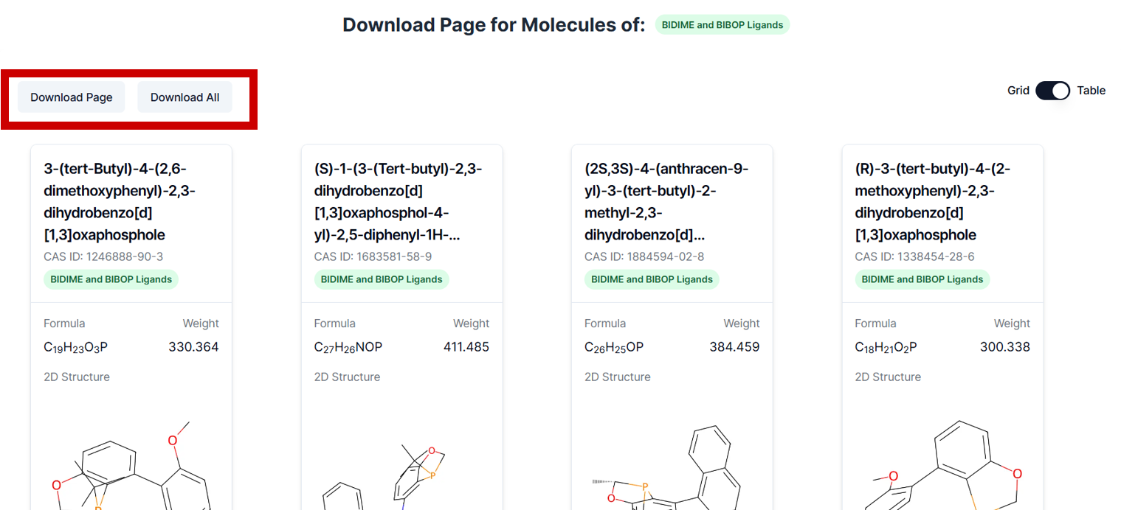

It provides a folder of SDF files along with a consolidated Excel spreadsheet containing basic information. Please note that downloading CSV files separately will result in individual files, necessitating manual row merging. Conversely, utilizing the Download option allows for the acquisition of a combined CSV file.
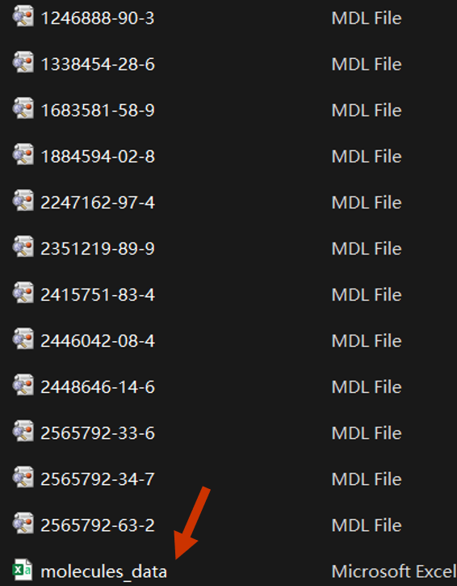

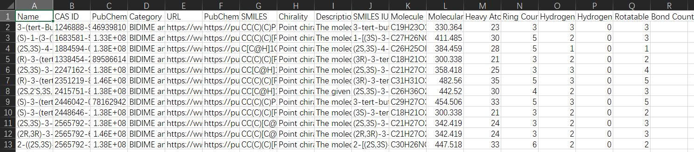

Users can search for CAS ID, Name, or SMILE. Please note that the system supports partial keyword searches and will automatically match all relevant results.
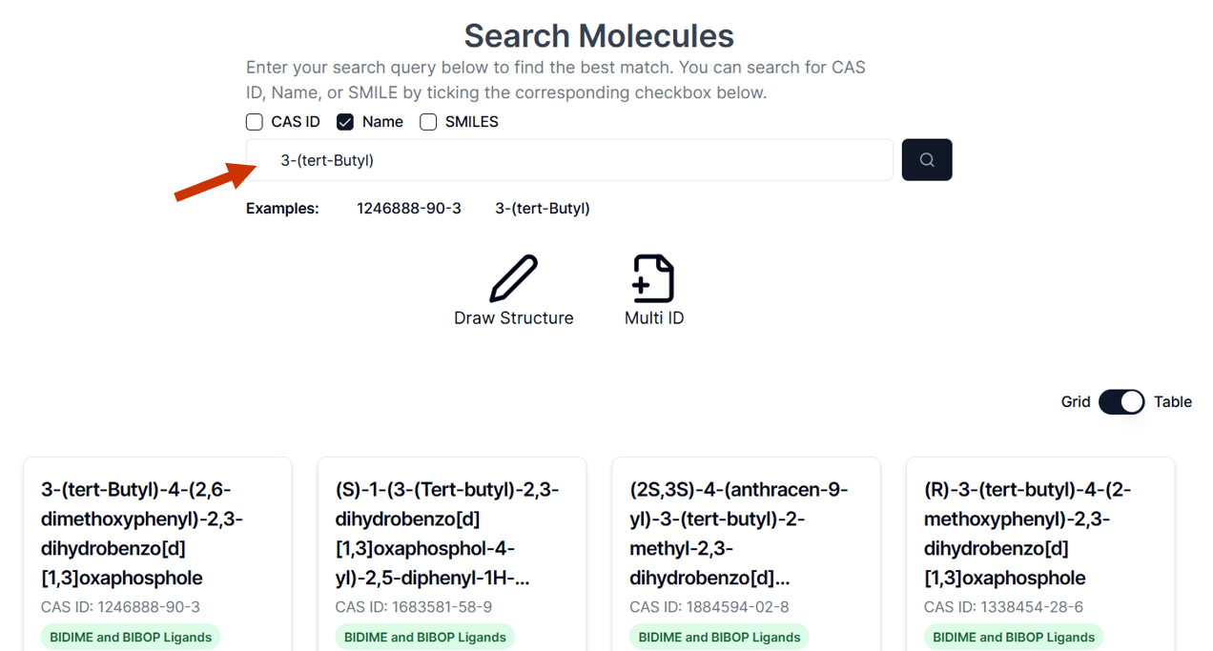

Users can draw a molecular structure which will then be converted into SMILES format for searching, where partial searches are also supported.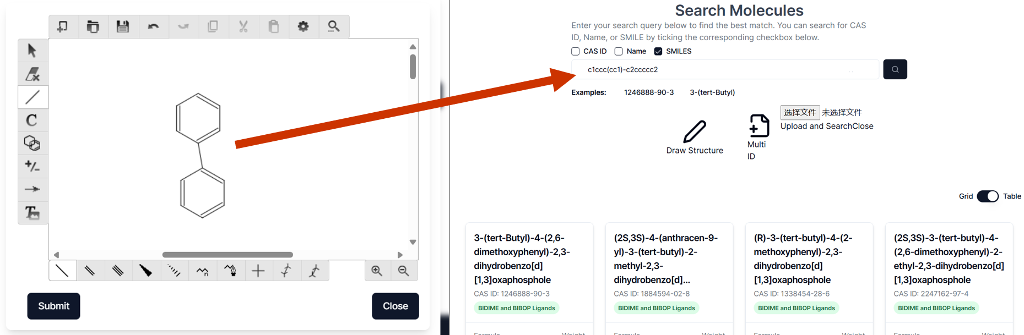

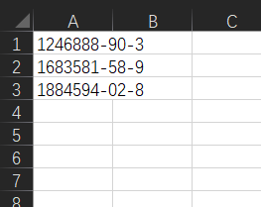
The database also facilitates multi-search capabilities by allowing users to upload a CSV file containing multiple IDs.
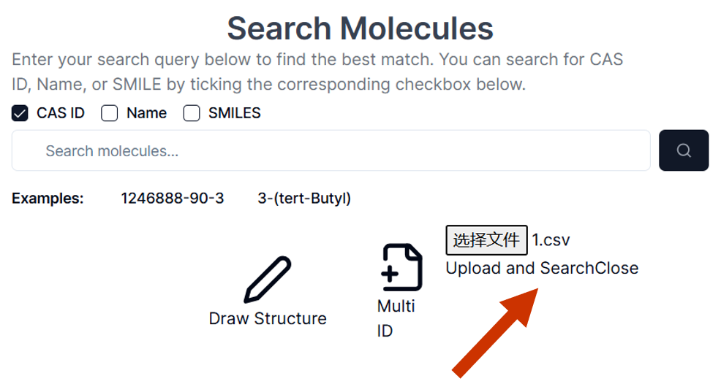
  - Online Machine Learning Tool
Clustering is a central feature of this database. Due to the high-quality 3D coordinate information computed, users can download SDF files and perform dimensionality reduction and clustering to guide experiments.

The database supports ligand screening experiments as follows:

First, download all pertinent SDF files, both those that have been completed and those pending testing, and upload them to the online clustering tool.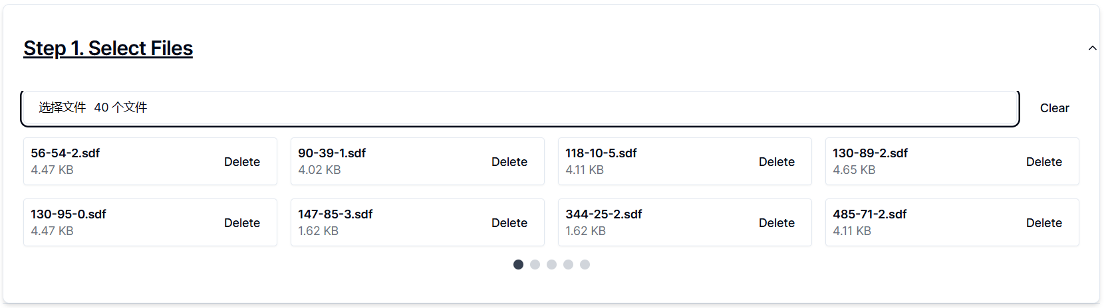

Second, select descriptors for clustering, choose the dimensionality reduction method, clustering algorithm, and adjust their corresponding parameters. The system offers a visual adjustment bar for user convenience, enabling multiple experiments to achieve optimal results. 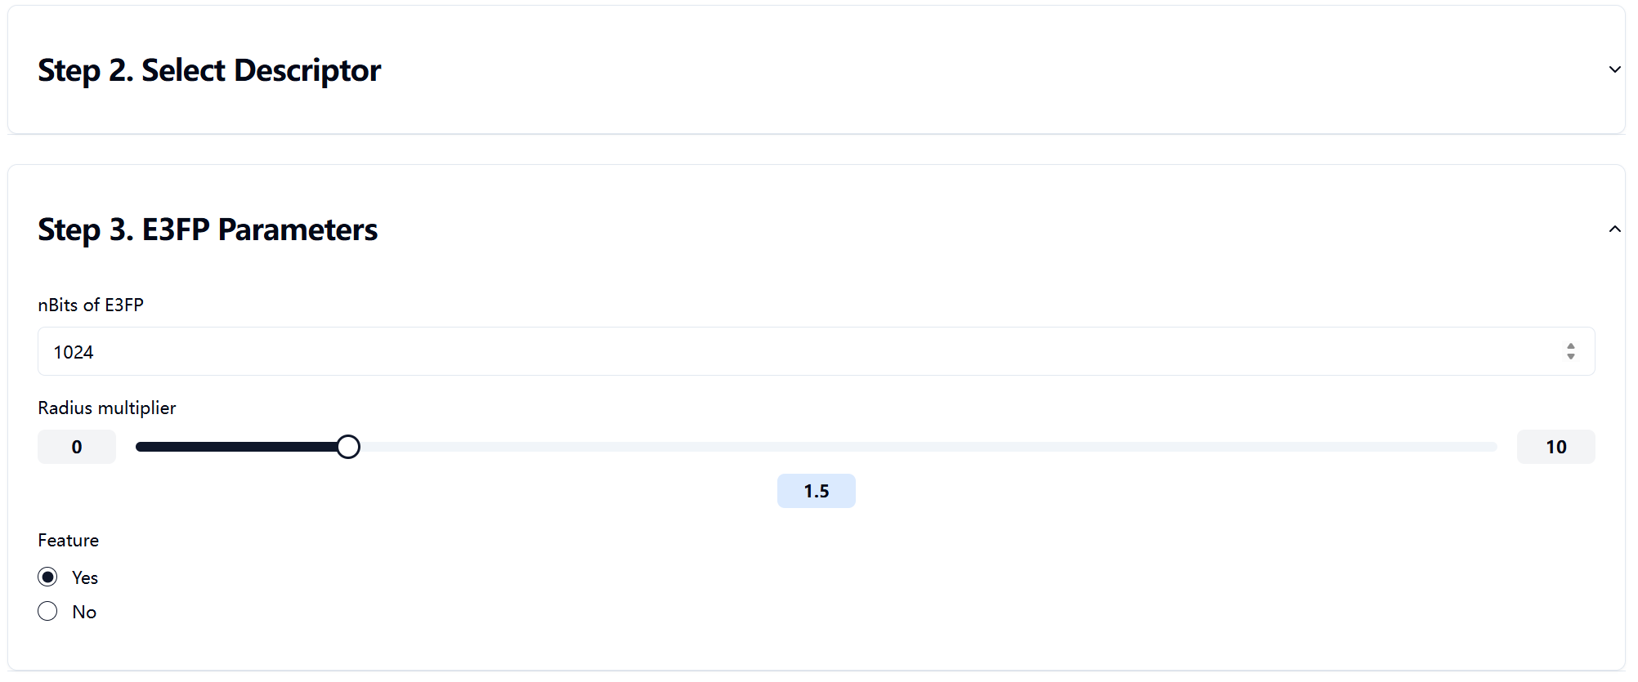
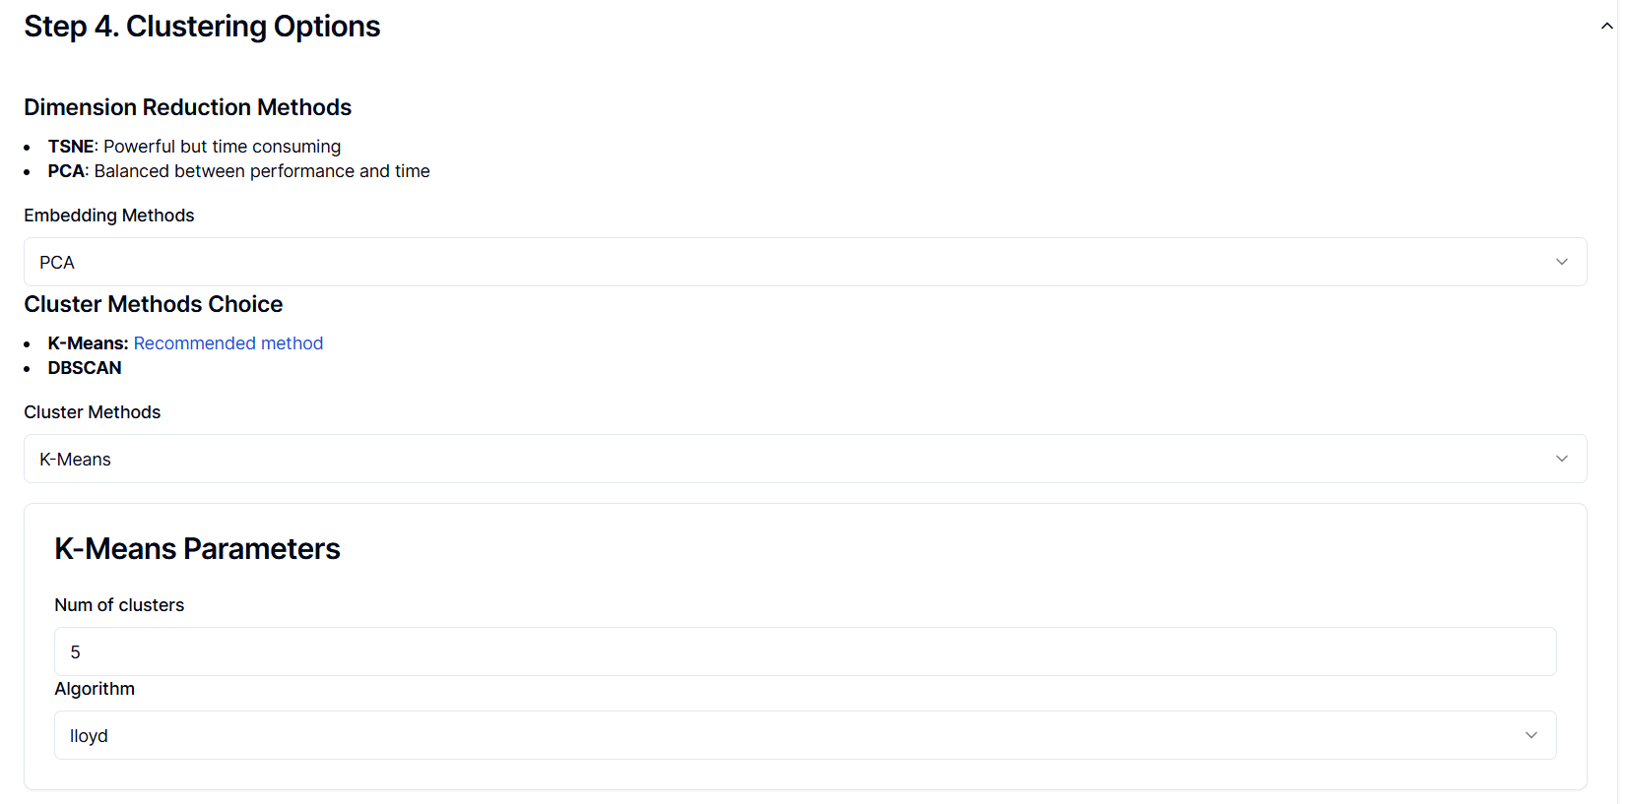

Lastly, based on the clustering outcomes, select ligands for the next experiment. Generally, it is advisable to prioritize ligands that are similar to those with high yields and distinct from those with low yields. This approach is likely to facilitate the rapid identification of optimal ligands.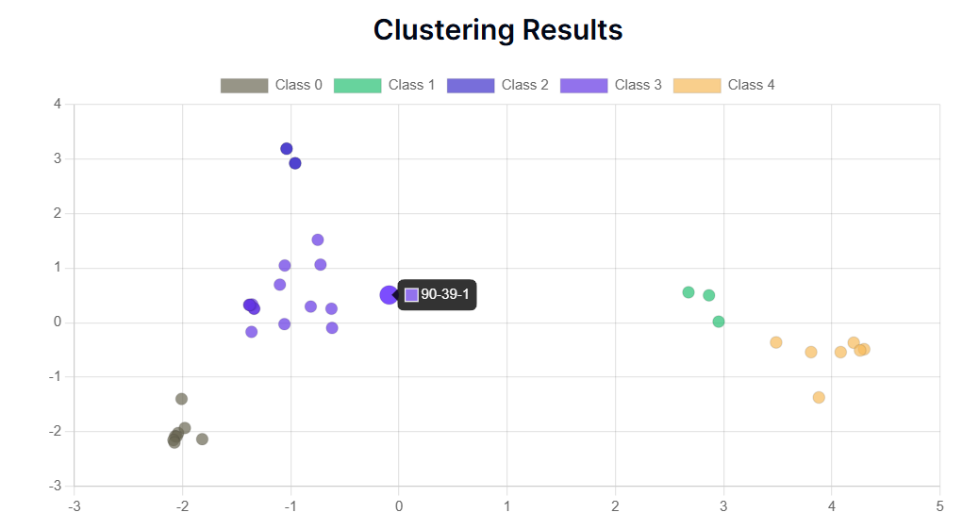

- Clustering Options
  - Dimension Reduction Methods
t-SNE (t-Distributed Stochastic Neighbor Embedding) is a non-linear dimension reduction technique widely used for the visualization of high-dimensional datasets. It is particularly adept at preserving the local structures of the data while revealing clusters at a global scale. t-SNE operates by converting similarities in the high-dimensional space X into probability distributions in a lower-dimensional space Y. The similarity between each data point x_{i} and others in the high-dimensional space is measured through a Gaussian kernel:
$$s_{ij}=\exp\left(-\frac{||x_{i}-x_{j}{||}^{2}}{2σ_{i}^{2}}\right)$$
where $σ_{i}$ is the bandwidth parameter associated with the point x_{i}.
The objective in the low-dimensional space is to maintain the similarity as perceived in the high-dimensional space, which is achieved by minimizing the Kullback-Leibler divergence:
$$C=\sum_{i<j}{p_{ij}}\log\left(\frac{p_{ij}}{q_{ij}}\right)$$
where p_{ij} and q_{ij} represent the probability distributions in the high-dimensional and low-dimensional spaces, respectively.
t-SNE is highly effective for exploring complex patterns and identifying clusters in data that are not linearly separable.

PCA (Principal Component Analysis) is a linear dimensionality reduction method that seeks to identify the principal axes of variation in a dataset. It achieves this by performing a covariance or correlation matrix analysis to find orthogonal vectors, known as principal components, which capture the maximum variance in the data. Each principal component is a linear combination of the original variables, with the first component explaining the most variance, followed by the second, and so forth.
It begins by calculating the covariance matrix $Σ$:
$$Σ=\frac{1}{n-1}\sum_{k=1}^{n}{\left(x_{k}-μ\right){\left(x_{k}-μ\right)}^{T}}$$
where $x_{k}$ denotes the data points and $μ$ is the mean vector of the data.
Then the principal components are determined by solving the maximization problem for the eigenvalues:
$$\max_{v}{}\frac{v^{T}Σv}{v^{T}v}$$
PCA is particularly useful for reducing the dimensionality of large datasets while retaining the most significant features of the data distribution. It is a valuable tool for noise reduction, data compression, and revealing the underlying structure of the data.

  - Clustering Methods
K-means is an iterative, partitioning algorithm that partitions the data into K distinct, non-overlapping clusters. The algorithm seeks to minimize the within-cluster variance, known as the sum of squared distances from each point to its assigned cluster centroid. The objective function of K-means is given by:
$$J=\sum_{i=1}^{K}{\sum_{x∈C_{i}}{||}x}-μ_{i}{||}^{2}$$
where $C_{i}$ is the set of points assigned to cluster i, $μ_{i}$ is the centroid of cluster i, and $|x-μ_{i}|$ is the Euclidean distance between a point x and the centroid $μ_{i}$. The centroids are updated by taking the mean of all points in the cluster:
$$μ_{i}=\frac{1}{\left|C_{i}\right|}\sum_{x∈C_{i}}{x}$$
The K-means algorithm begins with an initialization of centroids, typically at random, and then alternates between assigning points to the nearest centroid and recalculating centroids until convergence.

DBSCAN (Density-Based Spatial Clustering of Applications with Noise) is a density-based clustering algorithm that finds a number of clusters starting from the estimated density distribution of corresponding data space. Unlike K-means, DBSCAN does not require the specification of the number of clusters beforehand and can find arbitrarily shaped clusters. It defines clusters as areas of high density separated by areas of low density. The core concept is the $ϵ$-neighborhood, which includes all points within a distance $ϵ$ from a given point:
$$N_ϵ(p) = \{x ∈D | ||x - p|| ≤ϵ\}$$
where D is the dataset and p is a point in the dataset.
A point p is a core point if it has a minimum number of points MinPts within its $ϵ$-neighborhood. This neighborhood is dense if it contains at least MinPts points. Two points p and q are directly density-reachable if q is in the $ϵ$-neighborhood of p and vice versa. A cluster is formed by expanding from a core point, including all points that are density-reachable from p, and recursively including all points that are density-reachable from those points.
DBSCAN is robust to outliers, as points that are not part of a cluster are classified as noise. This property makes DBSCAN particularly useful for datasets with complex structures and outliers.

