Supplementary Materials to
HepatoToxicity Portal (HTP): An Integrated Database of Drug-Induced Hepatotoxicity Knowledgebase and Graph Neural Network-Based Prediction Model
Jiyeon Han,^{1†} Wonho Zhung,^{2†} Insoo Jang,^{3†} Joongwon Lee,² Min Ji Kang,⁴ Timothy Dain Lee,⁵ Seung Jun Kwack,⁶ Kyu-Bong Kim,⁷ Daehee Hwang,⁵ Byungwook Lee,³ Hyung Sik Kim,^{8*} Woo Youn Kim,^{2*} Sanghyuk Lee^{1, 4*}

--- Contents ---
Supplementary Materials
Database download and filtering
Preprocessing for the comparison to former studies

Supplementary Figures
Supplementary Fig. S1. Pipeline for PubChem CID annotation
Supplementary Fig. S2. Category selection for MedDRA annotation
Supplementary Fig. S3. Overlapping compounds among 9 databases
Supplementary Fig. S4. Statistics of MedDRA annotation in HTK-KB
Supplementary Fig. S5. Distribution of HTP-Pred score of overall compounds along with corresponding HTP-KB scores

Supplementary Materials

Database Download and Filtering

Drug Induced Liver Injury Rank (DILIrank)
DILIrank is a pivotal resource listing the hepatotoxicity risk associated with drugs registered with the FDA, providing crucial data for researchers investigating hepatotoxicity. The dataset encompasses a total of 1036 drugs classified into four risk categories: 192 in the vMost-DILI-concern, 278 in the vLess-DILI-concern, 312 in the vNo-DILI-concern, and 254 in the Ambiguous-DILI-concern group. Downloaded on January 27, 2022, the dataset underwent annotation, with CIDs assigned through Json files obtained from PubChem's 'Data sources' section. Matching results were cross-referenced, and any unmatched entries were filled by conducting searches in PubChem using the drug names. In cases where multiple CIDs corresponded to a single compound, the most relevant CID was selected. Drug labels containing PDF files from the FDA's approved drug list were downloaded to facilitate MedDRA term annotation. Liver toxicity-related records were identified, matched with the Preferred Term (PT) in MedDRA, and key reference sentences were documented for annotations. The determination of whether a small molecule is hepatotoxic or non-hepatotoxic was based on DILIrank classifications, designating vMost-DILI-concern as primary toxic molecules and vNo-DILI-concern for non-toxic molecules. For molecules falling into vLess-DILI-concern and Ambiguous-DILI-concern classes, manual curation was performed. As DILIrank relies on FDA-approved drugs, the overall confidence class for molecules was annotated as 'Clinical'. In cases where ambiguity persisted in toxicity judgments despite curation of drug labels, reference content was added without assigning a toxicity score. For web server configuration and database characterization, 'LTKB ID,' 'FDA approved year,' 'Severity class,' and 'DILI Concern' were selected from the original data.

LiverTox
LiverTox, an NIH-established hepatotoxicity-specific database, systematically compiles diverse case studies and literature references on substances with liver toxicity, offering detailed insights into each substance's mechanisms of action and toxicity likelihood scores. The database encompasses information on herbal and dietary supplements in addition to conventional drugs, providing a comprehensive perspective on hepatotoxic compounds. Given that LiverTox supports several chemical formulas and structures within a broader drug category, we retrieved the bulk XML file from the FTP server and parsed each file into multiple compounds based on CASID and PubChem Substance ID (SID). PubChemPy was employed to convert SID to CID. To assess the toxicity of substances, the 'Hepatotoxicity' and 'Mechanism of injury' sections of the PDF files were consulted. MedDRA terms were annotated based on the descriptions in these sections. As LiverTox references not only clinical studies on patients but also various animal experiments, each dataset underwent meticulous examination, and appropriate classifications ('in vivo,' 'in vitro') were assigned. For webserver configuration, only the 'LiverTox Score' was selected to provide users with direct access to diverse additional liver-related information in the PDF files.

Integrated Risk Information System (IRIS)
IRIS, administered by the U.S. EPA, functions as a comprehensive database identifying health hazards associated with chemicals in diverse environments. It supplies Reference Concentration (RfC) and Reference Dose (RfD), essential for assessing toxicity values indicative of continuous inhalation exposure and daily oral exposure posing potential risks to human health. Additionally, IRIS provides cancer descriptors, including critical tumor types, used in filtering the hepatotoxicity effects of individual chemicals. To annotate PubChem CIDs, chemicals were processed through PubChemPy using respective CASIDs. IRIS offers summary PDF files that encapsulate a broad spectrum of experimental results and case studies, and related MedDRA terms were annotated accordingly. Given that IRIS incorporates both clinical instances and animal experimental results, it provides scores categorized as 'in vivo' and 'Clinical'. For webserver configuration, we selected the 'Toxicity Value Type,' 'Toxicity Value,' and 'Exposure Route' to characterize the dataset.

InvitroDB
InvitroDB is a component of the CompTox Chemicals Dashboard developed under the U.S. EPA, contributing to the Bioactivity section. It offers information on high-throughput assays, encompassing details such as assay targets, study design, and experimental endpoints. From the list of available assays, our selection focused on those supported by 'Apredica,' 'Attagene,' 'NovaScreen,' 'NCGC Tox21 Project,' 'Life Technologies,' 'CellzDirect,' 'EPA Center for Computational Toxicology and Exposure labs,' and 'Eurofins.' We obtained CSV files for each assay and annotated chemicals within these files using the EPA-provided CID list sourced from the PubChem 'Data Source' section. Key columns, namely 'hitc (hit call)' and 'chit (chemical-level hit call),' were chosen as they indicate the reference cut-off for individual assays and the outcome for each sample in the experiment. The 'flag' column, expressing the credibility of each experiment's quality with nine subclasses, was also considered. Hepatotoxicity judgments were made based on criteria such as a chemical having 0 flags, positive 'hitc,' and positive 'chit,' classifying it as a hepatotoxicity-positive compound. Conversely, a compound with 0 values for both 'hitc' and 'chit' in all sub-assays was classified as hepatotoxicity-negative. Instances not fitting into either category were labeled as 'N/A,' indicating the ambiguity of judgment. All importance scores for InvitroDB's data were annotated as 'in vitro.' Given the challenges in assigning MedDRA terms to 'in vitro' experiments, all terms retained the designation 'ETC.' In configuring the web server, we decided to filter the provided Excel file, emphasizing the query compound and presenting it comprehensively to users, with a specific focus on the target and endpoint of each experiment.

Chemical Effects in Biological Systems (CEBS)
The CEBS is a database for various experiments on environmental health science derived from National Toxicity Program (NTP) under U.S. Department of Health and human Services. Since stored experiments were diverse, we read experiment description from CEBS and finally selected total 6 datasets among 34 experiments according to relevance with hepatotoxicity : ‘Benchmark Dose Analysis for Neoplastic and Non-neoplastic Lesions’, ‘Comet Assay Conclusions’, ‘List of Chemicals with Threshold Limit Values Primarily Based on Sensory Irritation’, ‘Statistically Analyzed NTP Pathology Lesions (with Incidence)’, ‘Identification of p53 Activators in a Human Microarray Compendium, Tox21 Positive Results’, and ‘Identification of p53 Activators in a Human Microarray Compendium with Significant Biomarker Correlation’. Using CASID as the primary identifier for distinguishing substances provided by the CEBS, PubChemPy was employed for CID annotation. The assessment of hepatotoxicity varied across experiments due to the absence of a standardized reference file format. Given that all datasets were presented in CSV format, we selected the primary reference columns for each file, incorporating them into the web server implementation process. It is noteworthy that CEBS predominantly offers data from animal experiments, resulting in all scores for CEBS samples being uniformly designated as 'in vivo.'

Agency for Toxic Substances and Disease Registry (ATSDR)
ATSDR, a federal public health agency under the U.S. Department of Health and Human Services, gathers information related to environmental health emergencies. It compiles toxicological profiles that delineate the organ-specific health effects resulting from exposure to various substances. The CASID provided by ATSDR was collected, and CIDs were annotated using PubChemPy. Given that ATSDR supplies profiles in PDF format, we downloaded the complete set of files and manually curated each file to extract appropriate sentences for MedDRA annotation. Since the profiles organize experimental results by organ-based paragraphs, we focused on the section related to hepatic effects. Determination of hepatotoxicity was based on detailed experimental method contents, including the route of exposure, concentration, target organism, and outcomes. Notably, ATSDR profiles encompass not only samples classified as 'clinical' but also include 'in vivo' content. Accordingly, an importance score was assigned based on the relevance of the reference. As the database lacks specific curation content, the web server configuration adopts a method of providing complete PDF files.

Side Effect Resource (SIDER)
SIDER stands out as a prominent repository of adverse effects associated with marketed medications. The compilation of data is grounded in public documents and package inserts enclosed with drug packaging, detailing the frequency of side effects at the level of MedDRA terms. Given that SIDER aligns its drug information with PubChem CID, there was no necessity for reassignment. The identification of liver-related compounds was effortlessly accomplished by utilizing a predefined MedDRA term within our MedDRA terminology tree. Considering that SIDER's data primarily stems from product labels, the importance scores for all compounds were uniformly categorized as 'clinical.' In the configuration of the web server, we determined to support all PDF files relevant to specific MedDRA terms. Consequently, we formatted the titles of PDF files using a combination of CID, MedDRA PT, and the original file name from SIDER.

Toxin and Toxin Target Database (T3DB)
T3DB, a toxin-target-focused database, is supported by the Canadian Institutes of Health Research, Canada Foundation for Innovation, and The Metabolomics Innovation Centre (TMIC). This database provides a wealth of information on specific compounds, including their chemical taxonomy, toxicity references, and biological targets. Users can gain a comprehensive understanding of the interconnections among 'compound-target gene-toxicity.' We obtained the complete CSV file and selected several columns, such as 'Lethal Dose,' 'Minimum Risk Level,' 'Toxicity Level,' 'Health Effects' and 'Symptoms,' and 'Mechanism of Toxicity,' to assess hepatotoxicity. However, the primary column used for determining toxicity and MedDRA terms varied for each compound, prompting additional highlighting effects in the detailed subpage within the web server configuration. Given that T3DB encompasses diverse references related to toxicity, the importance scores of T3DB samples were categorized across all types: ‘in vitro,’ ‘in vivo,’ and ‘clinical.’

DrugBank
DrugBank stands as a comprehensive database that integrates both bioinformatics and cheminformatics resources. Initially supported by the Canadian Institutes of Health Research, it undergoes active annual updates. While it offers data suitable for academic use, accessing upgraded content can be challenging, and essential features in the database are partially commercial. In this context, we concentrated solely on the contents of the 'toxicity tag' in the XML file, examining if there was any mention of the liver or hepatotoxicity. Samples chosen for determining toxicity were subsequently annotated with MedDRA terms, and the overall importance score of the database was categorized as 'clinical.' For the webserver application, we chose to support only the key sentences used in determining toxicity.

Preprocessing for the comparison to former studies
Many of the tools accept the SMILES notation as the primary input for a compound. However, in certain instances, alternative input formats for compound structure are also accepted. In such cases, we converted the input of the compound as necessary and conducted predictions accordingly. The output typically comprises binary prediction results alongside their associated confidence scores. Where specific binary classifications were unattainable, we devised interpretive rules for result analysis.
ToxSTAR employs SMILES input to generate prediction results for four indicators related to liver injury: Cholestasis, Cirrhosis, Hepatitis, and Steatosis. A compound is regarded hepatotoxic if it yields positive values for at least one of these disease indicators.
admetSAR utilizes SMILES input to predict Absorption, Distribution, Metabolism, Excretion, and Toxicity (ADME/T) outcomes based on datasets and models. Given our focus on liver toxicity prediction, we prioritized the "Hepatotoxicity" section, which quantifies the likelihood of hepatotoxic effects.
PRediction Of TOXicity of chemicals (ProTox-3.0) accepts SMILES input and offers various prediction options to users. We selected the "Hepatotoxicity" option for our analysis, yielding toxicity predictions with binary classifications and confidence scores.
eMolTox accepts SMILES input and allows users to select prediction endpoints. For our analysis, we focused on "Hepatotoxicity." As their model utilizes diverse biological indicators in prediction process, the specific indicators referenced in the results are presented alongside the binary toxicity predictions.
Hepatotoxicity prediction using Ensemble Learning methods (Hepatopred-EL) requires SMILES input for the query compound and allows users to select ensemble model components. Following selection of options including random forest, support vector machine, and XGBoost, the prediction results provide binary hepatotoxicity classifications and probability scores.
Deep-DILI is a code-based hepatotoxicity prediction tool relying on an ensemble model. Input is accepted in the form of Structure Data File (SDF), a merged chemical structure format. We utilized the U.S. FDA-supported Mold2 application to convert our SMILES dataset into individual SDF files. Subsequently, we applied the provided GitHub code to obtain binary predictions and probability scores for each compound.

Supplementary Figures
Supplementary Fig. S1. Pipeline for PubChem CID annotation
The pipeline depicts the additional PubChem CID annotation methods for individual databases. In case the reference of direct CID annotation lacks, we used PubChemPy to annotate with the input of SID, CASID, and SMILES.
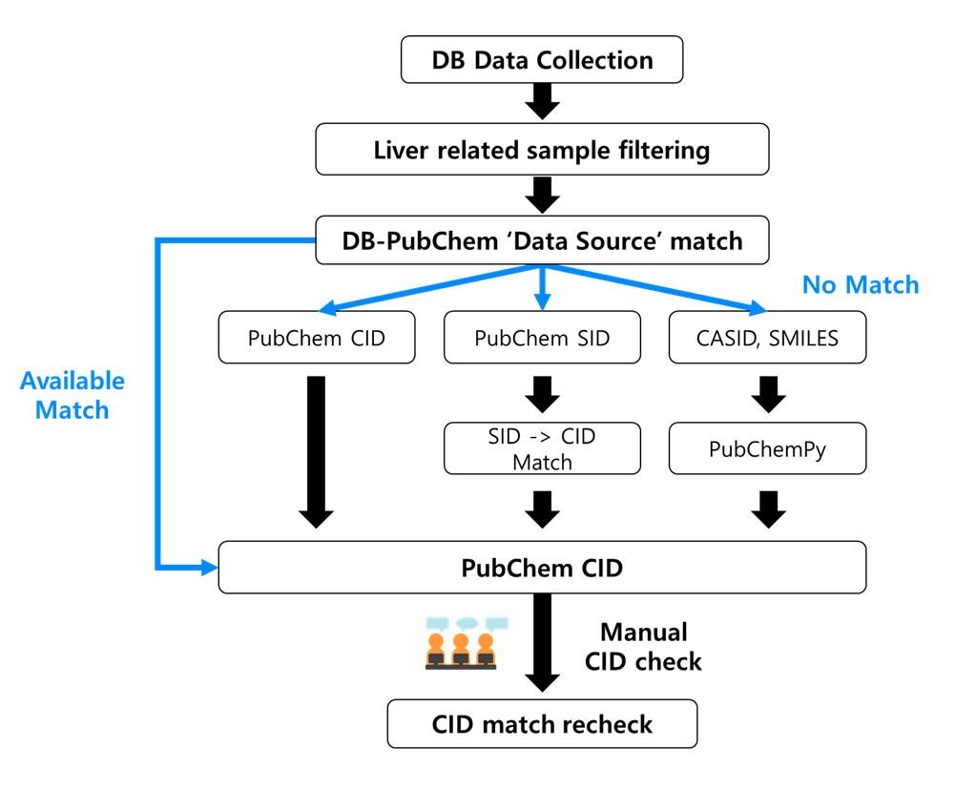

Supplementary Fig. S2. Category selection for MedDRA annotation
The MedDRA terms employed within our database are restricted to those related to hepatic conditions. The figure shows the hierarchical framework of the MedDRA system, with pink highlighted boxes denoting the designated levels incorporated into the database. Illustrated examples of these terms are provided on the right side.
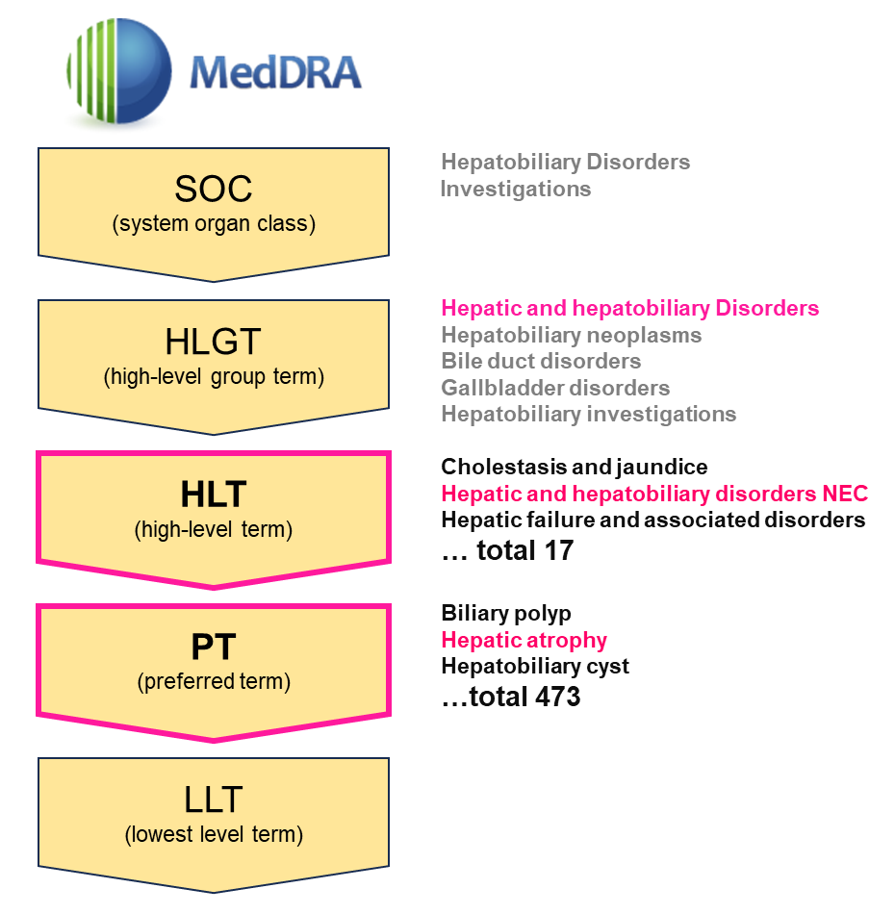

Supplementary Fig. S3. Overlapping compounds among 9 databases
A The upset plot illustrates the overlapping compounds among nine databases. Black circles represent the involvement of each database, while the bar plot above indicates the number of compounds in each intersection. The bar plot on the left shows the total number of compounds in each database. To provide clearer insights, as it is challenging to visualize all database overlaps simultaneously, we have separated the overlap visualizations by compound class: B (Clinical), C (In vivo), and D (In vitro).
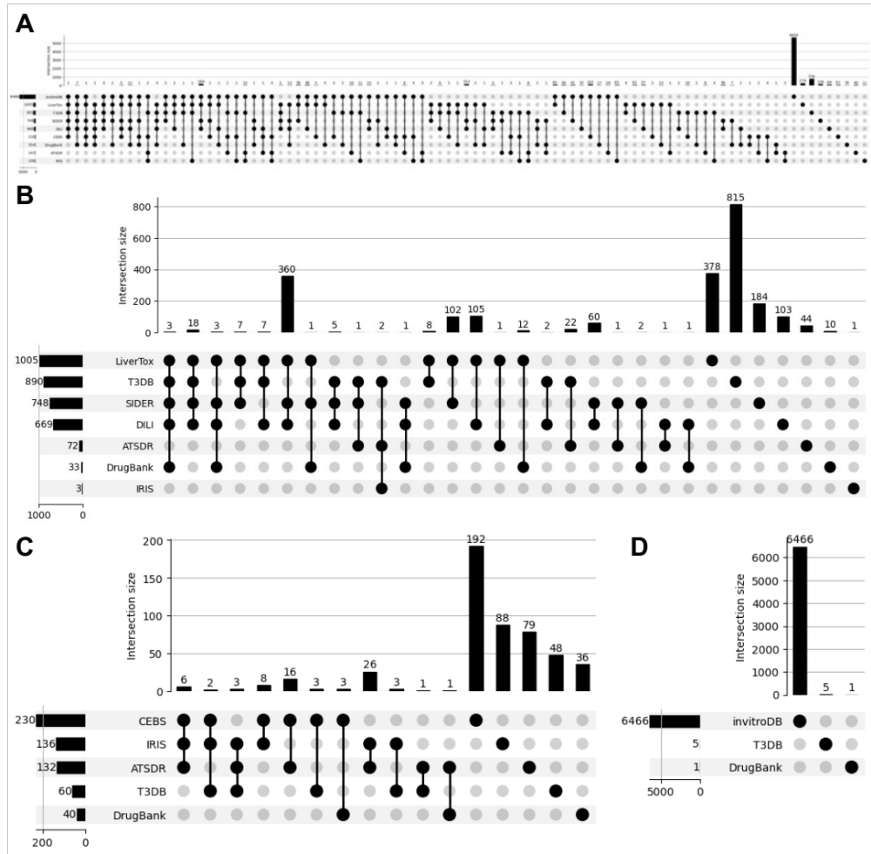

Supplementary Fig. S4. Statistics of MedDRA annotation in HTK-KB
Pie plot of MedDRA terms used for annotating compounds in HTP-KB. The inner ring indicates categories in the High-Level Terms (HLT), whereas the outer ring shows the Preferred Terms (PT).
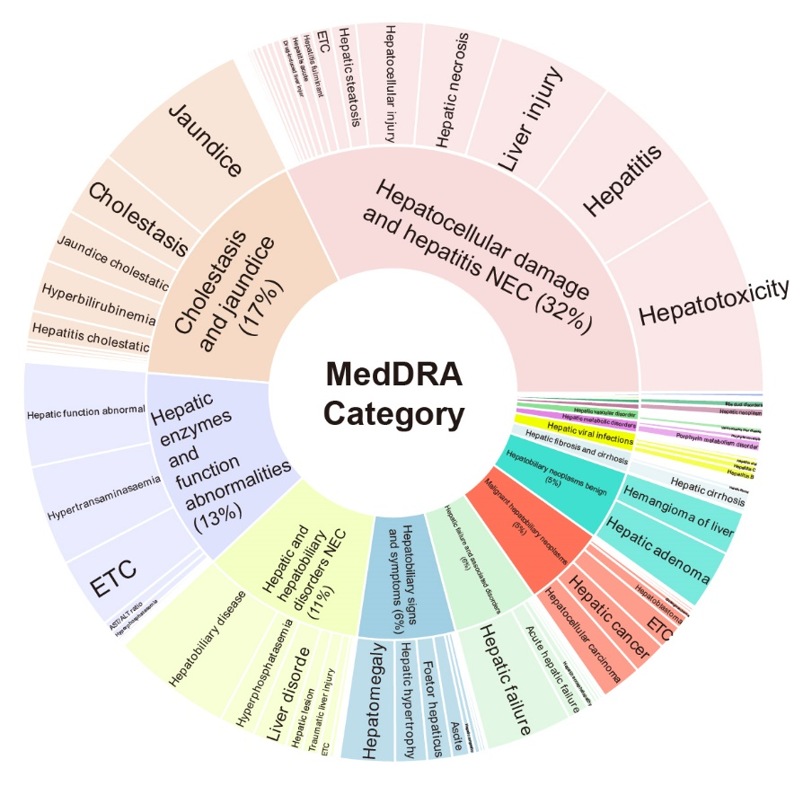

Supplementary Fig. S5. Distribution of HTP-Pred score of overall compounds along with corresponding HTP-KB scores
The violin plot shows the concordance between our HTP-Pred results and HTP-KB curation scores. The three groups accord to the HTP-DB curation results, distinguishing hepatotoxicity negative (KB score: -7~0), moderately positive (KB score: 0~7), and highly positive (KB score: >7).
