Learning motif features and topological structure of molecules for metabolic pathway prediction
Jianguo Hu^{1,#}, Yiqing Zhang^{1,#}, Jinxin Xie¹, Zhen Yuan¹, Zhangxiang Yin¹, Shanshan Shi¹, Honglin Li^{1,2,3,}*, Shiliang Li^{1,2,}*
¹Shanghai Key Laboratory of New Drug Design, School of Pharmacy, East China University of Science and Technology, Shanghai 200237, China.
²Innovation Center for AI and Drug Discovery, School of Pharmacy, East China Normal University, Shanghai 200062, China.
³Lingang Laboratory, Shanghai 200031, China.

# These authors contributed equally: Jianguo Hu, Yiqing Zhang
* Corresponding author. Email: hlli@ecust.edu.cn, slli403@163.com

Supplementary

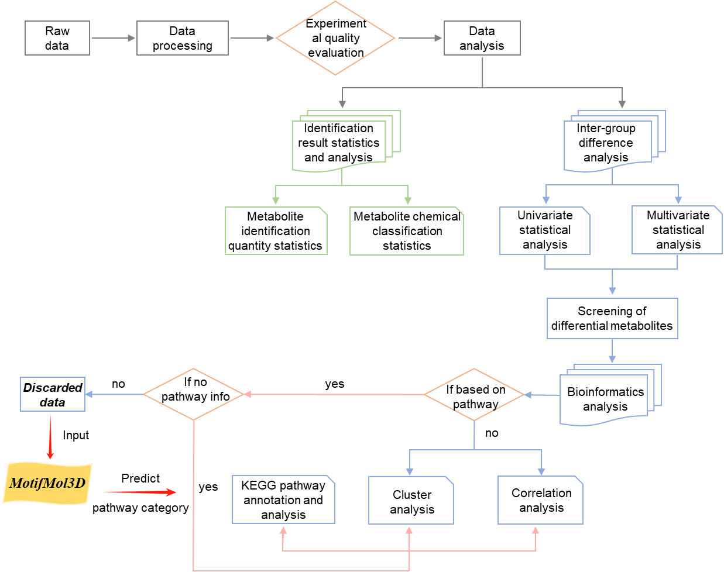
Figure S1. Proposed integrated workflow for metabolomics data analysis with MotifMol3D

