xBitterT5: An explainable transformer-based framework with multimodal inputs for identifying bitter-taste peptides
Nguyen Doan Hieu Nguyen^{1†}, Nhat Truong Pham^{1†}, Duong Thanh Tran¹, Leyi Wei², Adeel Malik^{3,*}, Balachandran Manavalan^{1,*}

¹Department of Integrative Biotechnology, College of Biotechnology and Bioengineering, Sungkyunkwan University, Suwon, Gyeonggi-do, 16419, Republic of Korea
²Center for Artificial Intelligence Driven Drug Discovery, Faculty of Applied Science, Macao Polytechnic University, Macau, China
³Institute of Intelligence Informatics Technology, Sangmyung University, Seoul, 03016, Republic of Korea

†These authors contributed equally to this work.
*Corresponding authors
Adeel Malik (adeel@procarb.org)
Balachandran Manavalan (bala2022@skku.edu)
Supplementary figures
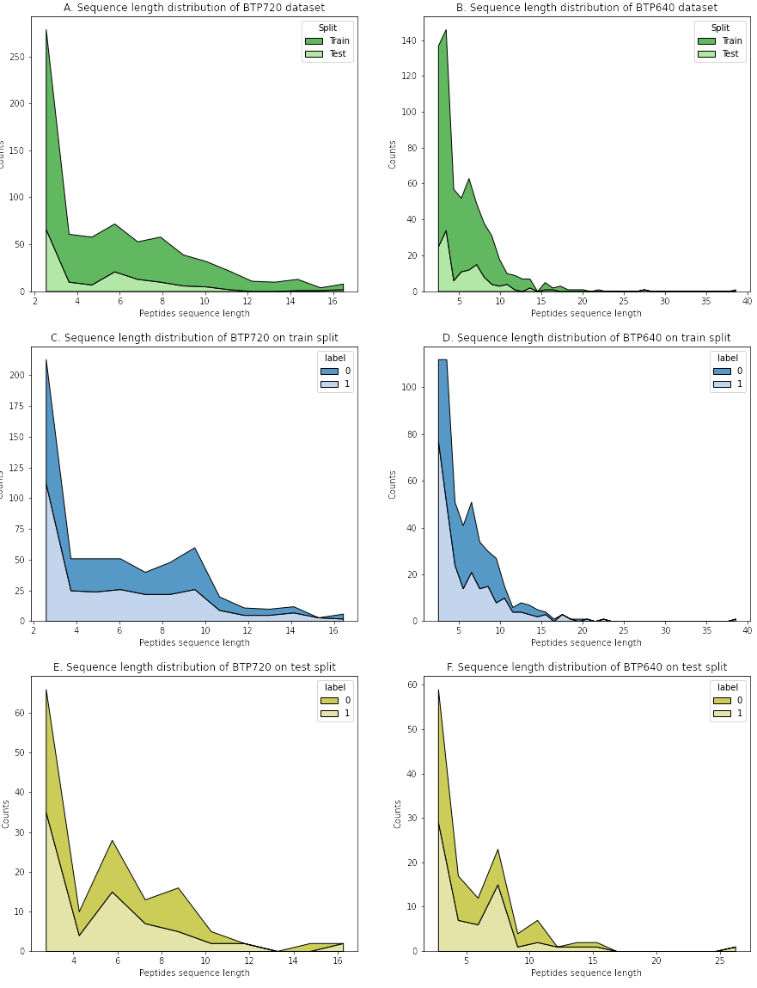
Figure S1. Length distribution of peptide sequences across two benchmark datasets, BTP640 and BTP720. The distributions reveal that bitter peptide sequences are relatively short, with mean lengths of 5.303 and 5.608 for BTP640 and BTP720, respectively. This presents challenges for models that utilize peptide sequences as input, making it difficult to extract meaningful features.

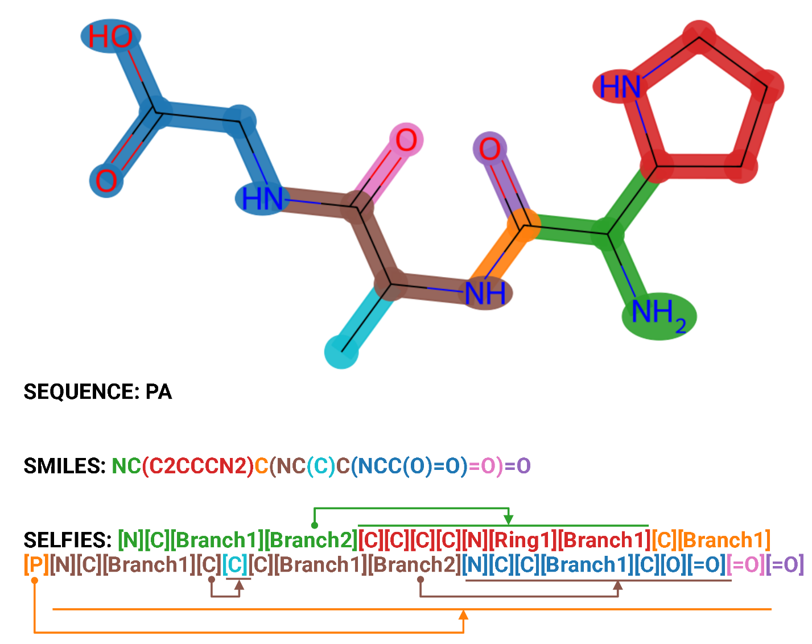
Figure S2. Comparison between SMILES and SELFIES molecular string for the same peptide sequence. It can be observed that SELFIES exhibits a distinct superiority in its capacity to represent molecular structures with greater detail and precision. For instance, the SELFIES representation shows a clear superiority over the SMILES molecular string when depicting the molecule's structure. It conveys branches and rings using the tokens “[Branch<x>]” and “[Ring<x>]”, where “<x>” signifies that the following x symbols are used, while SMILES format uses paired numbers to form a ring. Furthermore, SELFIES incorporates index symbols, such as “[P]”, to enhance the supplementary molecular representation. This innovation significantly improves molecules' structural depiction, facilitating a more comprehensive understanding of their molecular characteristics.

Supplemental tables
Table S1. Configurations of fully connected layers for each pretrained model.
Pretrained model | Name on Hugging Face | Number of nodes in fully connected layers
ProtT5-XL-BFD | Rostlab/prot_t5_xl_bfd | 1024, 256, 64, 16
ProtT5-XL-UniRef50 | Rostlab/prot_t5_xl_uniref50 | 1024, 256, 64, 16
MolT5-Base | laituan245/molt5-base | 768, 192, 48, 12
BioT5+-Base | QizhiPei/biot5-plus-base | 768, 192, 48, 12

Table S2. Performance of xBitterT5-640 on the BTP720 dataset after removing duplicated peptide sequences existing in the BTP640 training dataset.
ACC | SP | PRE | SN | F1 | MCC | AUC
0.5 | 0.378 | 0.370 | 0.752 | 0.496 | 0.129 | 0.565

Table S3. The comparison of the predicted labels between xBitterT5 models and existing methods on the known bitter peptides (BPs) in Group A. (* denotes the peptide present in the BTP640 training set; NA denotes not applicable.)
Sequence | xBitterT5-720 | xBitterT5-640 | CPM-BP | iBitter-SCM | iBitter-Fuse | BERT4Bitter
YLEQLLR* | BP | NA | BP | NA | NA | NA
FALPQYLK | BP | Non-BP | BP | Non-BP | Non-BP | Non-BP
LHLPLPLL | BP | Non-BP | BP | Non-BP | Non-BP | Non-BP
LPLPLLQSW | BP | Non-BP | BP | Non-BP | Non-BP | Non-BP
PFPGPIPNS* | BP | NA | BP | NA | NA | NA
VYPFPGPIPN | BP | BP | BP | BP | BP | BP
YLGYLEQLLR* | BP | NA | BP | NA | NA | NA
VENLHLPLPLL | BP | BP | BP | Non-BP | Non-BP | BP
MPFPKYPVEPF* | BP | NA | BP | NA | NA | NA
AIPPKKNQDKTEIPTIN | BP | BP | BP | Non-BP | Non-BP | Non-BP
APKHKEMPFPKYPVEPF* | BP | NA | BP | NA | NA | NA
FALPQYL | BP | Non-BP | BP | Non-BP | Non-BP | Non-BP
FFVAPFPEVFGKE | BP | BP | BP | BP | BP | BP
EMPFPKYP | BP | BP | BP | BP | BP | Non-BP

Table S4. The hyperparameter grid in the 10-fold cross-validation process to find the most optimal set of configurations.
Hyperparameter | Search range
Dropout rate | 0.05, 0.1, 0.15, 0.2
Learning rate | 0.0005, 0.0002, 0.0001
Training batch size | 1, 2, 4, 8, 16, 32
Warmup ratio | 0.05, 0.1, 0.15
Weight decay | 0.0, 0.01, 0.001
Number of trainable decoder layers | 0, 1, 2, 3

Table S5. The optimal sets of configurations for training xBitterT5-640 and xBitterT5-720.
Hyperparameter | xBitterT5-640 | xBitterT5-720
Dropout rate | 0.05 | 0.05
Learning rate | 0.0005 | 0.0005
Training batch size | 16 | 8
Warmup ratio | 0.05 | 0.05
Weight decay | 0.01 | 0.01
Number of trainable decoder layers | 3 | 3

