Predicting the Critical Micelle Concentration of Binary Surfactant Mixtures using Machine Learning

Aditya Choudhary,^{a *} Saaketh Desai,^{b} Methun Kamruzzaman,^{c} Alexander Landera,^{c} Koushik Ghosh,ª Kunal Poorey^{c *}
ªSandia National Laboratories, Albuquerque, NM, United States
^{b}Center for Integrated Nanotechnologies, Sandia National Laboratories, Albuquerque, NM, United States
^{c}Sandia National Laboratories, Livermore, CA, United States

*Corresponding Author: achoudh@sandia.gov (A.C.), kpoorey@sandia.gov (K.P.)

Methodology
Feature selection. In this study, we employed RF and xGBoost as base estimators for BorutaPy to ensure optimal feature selection. The number of descriptors before and after feature selection for each aggregation scheme, are provided in Table S1.

Table S1. Number of features before and after applying the BorutaPy feature selection method.
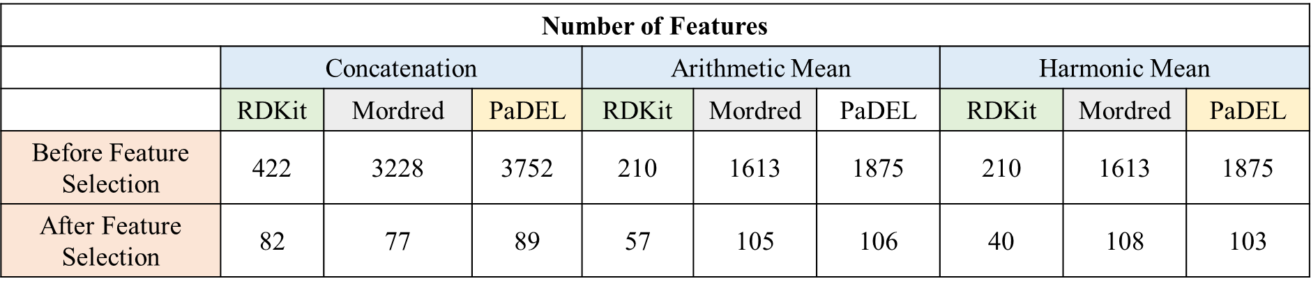

CMC prediction of single surfactant system
We evaluated three machine learning models, random forest, XGBoost, and artificial neural networks (ANN), in combination with different molecular descriptor sets generated using RDKit, Mordred, and PaDEL (Figure S1). The optimized hyperparameters for RF and XGBoost is provided in Table S2 and S3, respectively. For predicting the CMC of single surfactants, the ANN model using RDKit descriptors achieved the lowest mean squared error (MSE), indicating the best overall performance. For this model, training MSE = 0.015 (R² = 0.986), validation MSE = 0.277 (R² = 0.826), and test MSE = 0.137 (R² = 0.907).
Table S2. Hyperparameters used for the Random Forest (RF) model, including the number of estimators (n_estimators) and maximum tree depth (max_depth).
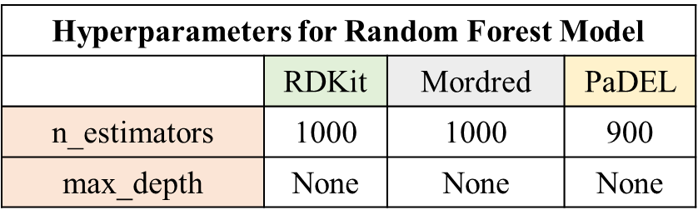

Table S3. Hyperparameters used for the XGBoost model, including the number of estimators (n_estimators), learning rate (learning_rate), maximum tree depth (max_depth), column subsampling rate (colsample_bytree), and L1 regularization term (alpha).
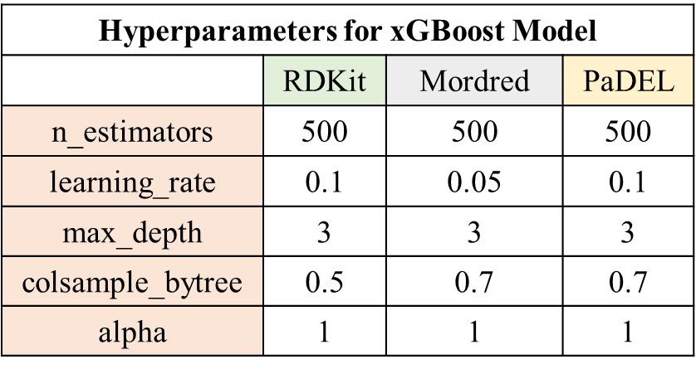

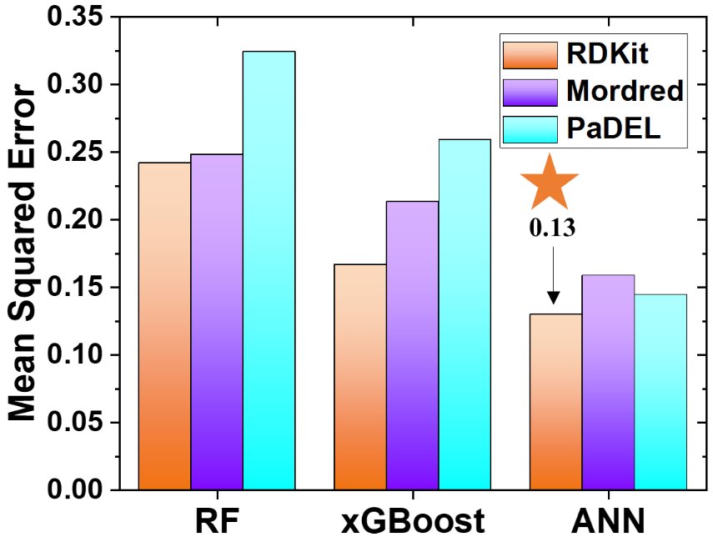
Figure S1. Comparison of mean squared error (MSE) for predicting the critical micelle concentration (CMC, log μM) of single surfactant using different machine learning models (Random Forest, xGBoost, and artificial neural network [ANN])

Our best-performing model was a fully connected feedforward artificial neural network (ANN) trained on RDKit descriptors. The architecture comprised four hidden layers with 256, 128, 64, and 32 neurons, respectively, each followed by ReLU activation functions. The model was trained for 1050 epochs using a batch size of 32 and a learning rate of 0.0001, optimized using the Adam optimizer. To ensure generalization and prevent overfitting, we monitored the training and validation loss across epochs (Figure S2). The error gap between the training and validation sets remained stable over time, indicating consistent model performance and effective regularization. The final model achieved training MSE = 0.015 (R² = 0.986), validation MSE = 0.277 (R² = 0.826), and test MSE = 0.137 (R² = 0.907).

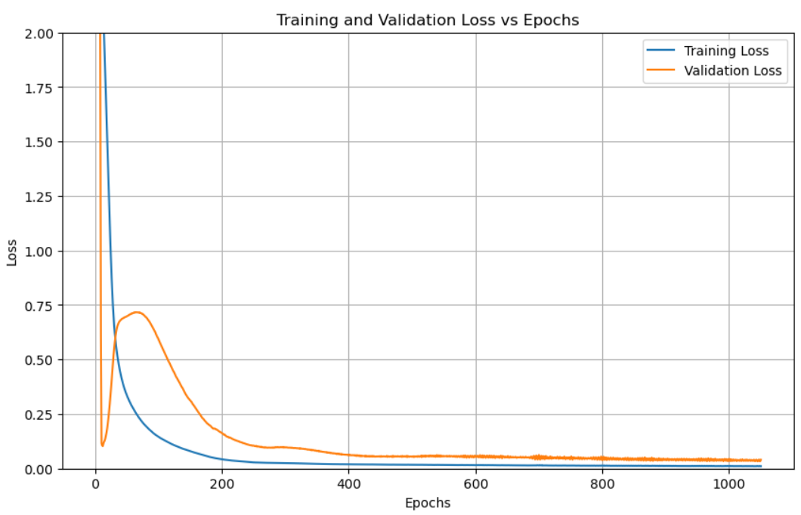
Figure S2. Training and validation loss as a function of epochs for the best-performing ANN model in predicting CMC of single surfactant system.

The SHAP analysis (Figure S3) reveals the most important features determining the CMC values.
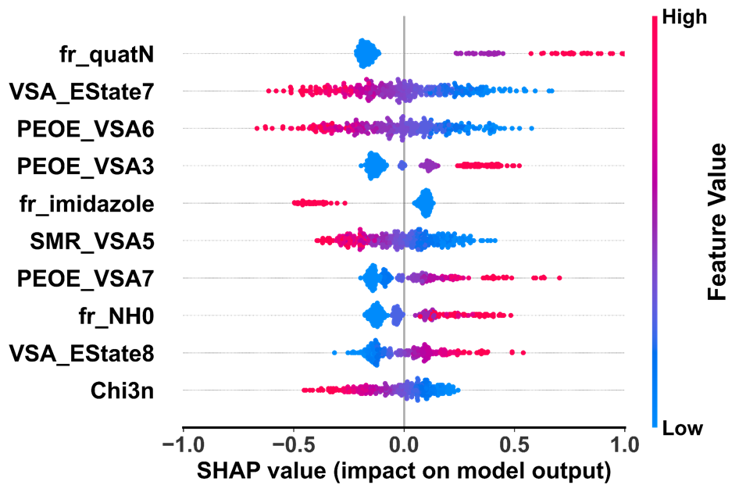
Figure S3. The SHAP (SHapley Additive exPlanations) summary plot for the best-performing model, showing the ten most important molecular descriptors influencing CMC prediction. Each point represents a sample, colored by feature value (red: high, blue: low); the horizontal position indicates the SHAP value (impact on model output).

Interpolating CMC at intermediate mole fraction
We evaluated three machine learning models, random forest, XGBoost, and artificial neural networks (ANN), in combination with different molecular descriptor sets generated using RDKit, Mordred, and PaDEL. The optimized hyperparameters for RF and xGBoost is given in Table S4 and S5.
Table S4. Hyperparameters used for the Random Forest (RF) model, including the number of estimators (n_estimators) and maximum tree depth (max_depth).
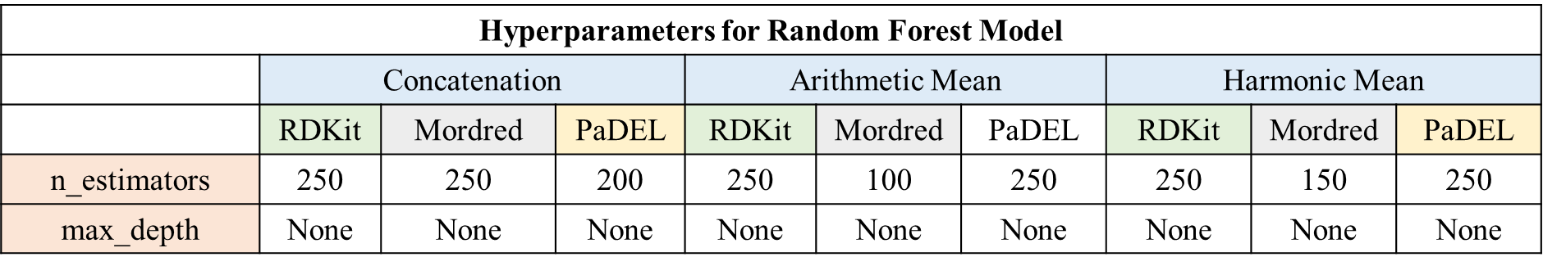

Table S5. Hyperparameters used for the XGBoost model, including the number of estimators (n_estimators), learning rate (learning_rate), maximum tree depth (max_depth), column subsampling rate (colsample_bytree), and L1 regularization term (alpha).
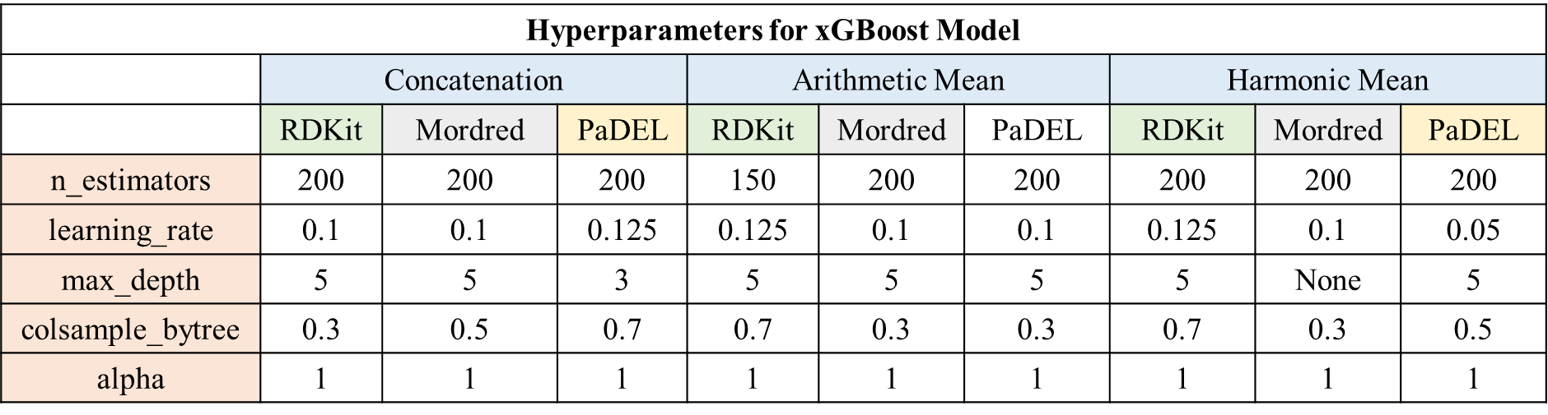

Our best-performing model is a fully connected feedforward artificial neural network (ANN) trained on PaDEL descriptors. The ANN architecture comprised five hidden layers with 512, 256, 256, 128, and 64 neurons, respectively, each followed by ReLU activation functions. The model was trained for 1300 epochs using a batch size of 32 and a learning rate of 0.00005, optimized using the Adam optimizer. To ensure generalization and prevent overfitting, we monitored the training and validation loss across epochs (Figure S4). The error gap between the training and validation sets remained stable over time, indicating consistent model performance and effective regularization. The final model achieved training MSE = 0.0228 (R² = 0.985), validation MSE = 0.1507 (R² = 0.918), and test MSE = 0.099 (R² = 0.941)
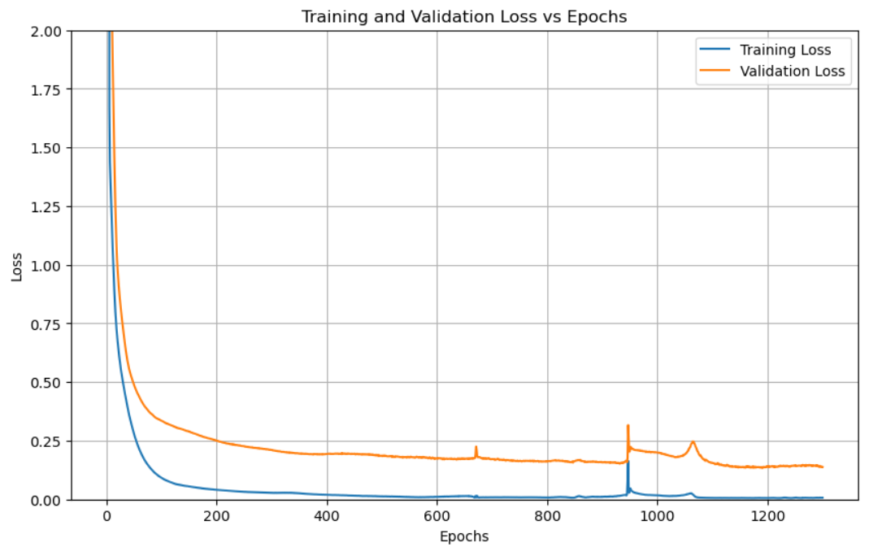
Figure S4. Training and validation loss as a function of epochs for the best-performing ANN model in interpolating CMC at intermediate mole fraction of binary surfactant mixture.

The SHAP analysis (Figure S5) reveals the most important features determining the CMC values.

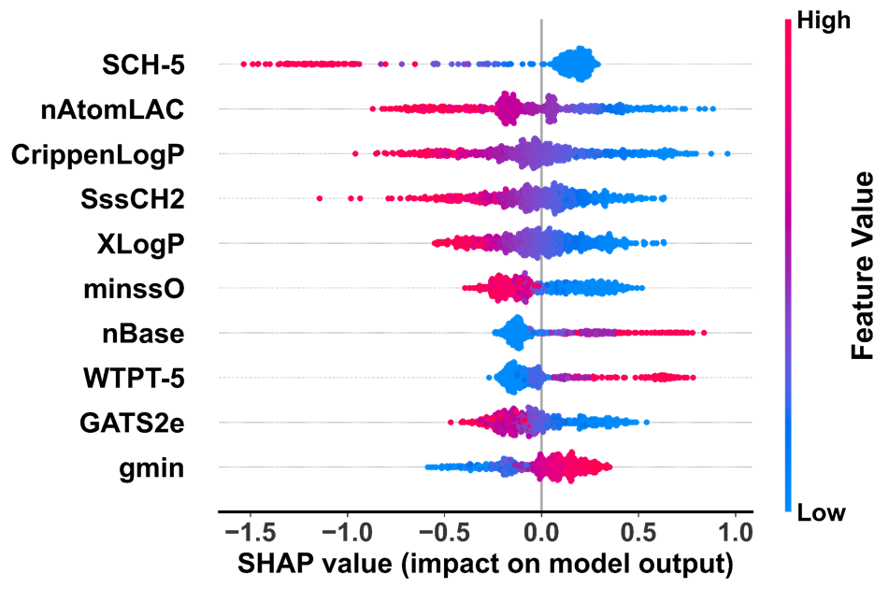
Figure S5. The SHAP (SHapley Additive exPlanations) summary plot for the best-performing model, showing the ten most important molecular descriptors influencing CMC prediction. Each point represents a sample, colored by feature value (red: high, blue: low); the horizontal position indicates the SHAP value (impact on model output).

Predicting CMC for unseen surfactant mixtures
We evaluated three machine learning models, random forest, XGBoost, and artificial neural networks (ANN), in combination with different molecular descriptor sets generated using RDKit, Mordred, and PaDEL. The optimized hyperparameters for RF and xGBoost is given in Table S6 and S7.

Table S6. Hyperparameters used for the Random Forest (RF) model, including the number of estimators (n_estimators) and maximum tree depth (max_depth).
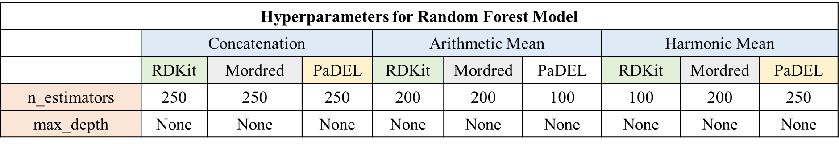

Table S7. Hyperparameters used for the XGBoost model, including the number of estimators (n_estimators), learning rate (learning_rate), maximum tree depth (max_depth), column subsampling rate (colsample_bytree), and L1 regularization term (alpha).
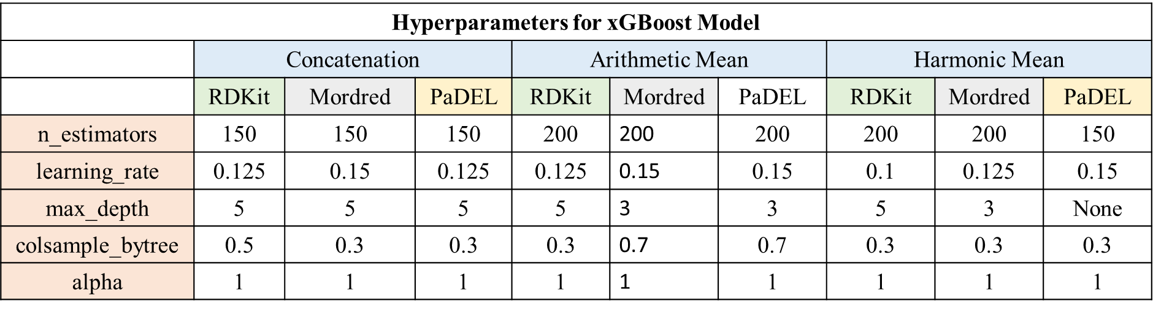

Our best-performing model was a fully connected feedforward artificial neural network (ANN) trained on Mordred descriptors. The architecture comprised five hidden layers with 512, 512, 256, 128, and 64 neurons, respectively, each followed by ReLU activation functions. The model was trained for 300 epochs using a batch size of 32 and a learning rate of 0.00005, optimized using the Adam optimizer. To ensure generalization and prevent overfitting, we monitored the training and validation loss across epochs (Figure S6). The error gap between the training and validation sets remained stable over time, indicating consistent model performance and effective regularization. The final model achieved training MSE = 0.0581 (R² = 0.961), validation MSE = 0.2191 (R² = 0.822), and test MSE = 0.236 (R² = 0.896)

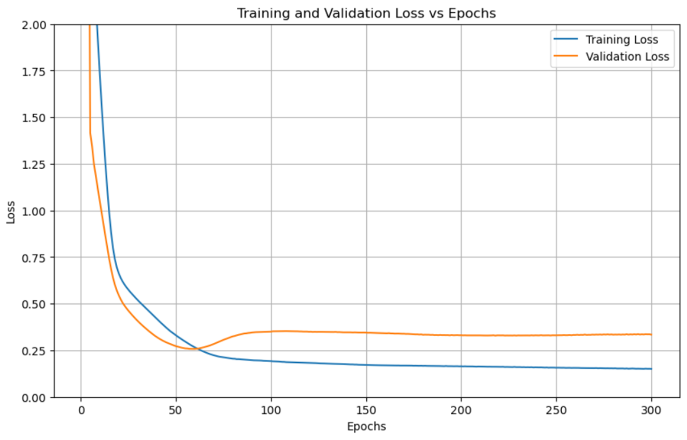
Figure S6. Training and validation loss as a function of epochs for the best-performing ANN model in predicting CMC for unseen binary surfactant mixtures.

