A Framework for Evaluating Explainable AI in Antimicrobial Drug Discovery
Abdulmujeeb T. Onawole¹, Mark A.T. Blaskovich^{1,2} and Johannes Zuegg¹*

¹Centre for Superbug Solutions, Institute for Molecular Bioscience, The University of Queensland, Brisbane, Queensland, Australia.
²ARC Centre for Agricultural and Environmental Solutions to Antimicrobial Resistance, Institute for Molecular Bioscience, The University of Queensland, Brisbane, Queensland, Australia.
*Correspondence to j.zuegg@uq.edu.au

Supplementary Material
Datset preparation 2
Training dataset and cross-validation 6
Feature-based representation and model 6
Sequence-based representation and model 8
Graph-based representation and model 10
Fragment-based explainability 12

Datset preparation

Table S1: Molecular property statistics for active and inactive compounds in the S. aureus dataset (n=43,777). Six properties shown with numbers (N), Median, Min Max, and Mean: molecular weight (MW), partition coefficient (LogP), hydrogen bond donors (HBD), hydrogen bond acceptors (HBA), topological polar surface area (TPSA), and rotatable bond count.
Property | Class | N | Median | Min | Max | Mean ± SD
MW | Active | 29349 | 421.47 | 73.10 | 703.64 | 430.82 ± 106.26
MW | Inactive | 14428 | 385.42 | 58.08 | 703.27 | 394.48 ± 110.55
LogP | Active | 29349 | 3.61 | -9.81 | 16.42 | 3.64 ± 2.22
LogP | Inactive | 14428 | 3.57 | -10.19 | 14.79 | 3.55 ± 2.14
HBD | Active | 29349 | 2 | 0 | 15 | 1.85 ± 1.59
HBD | Inactive | 14428 | 1 | 0 | 15 | 1.63 ± 1.64
HBA | Active | 29349 | 6 | 0 | 22 | 5.86 ± 2.64
HBA | Inactive | 14428 | 5 | 0 | 19 | 5.39 ± 2.46
TPSA | Active | 29349 | 86.99 | 0 | 389.61 | 90.95 ± 43.83
TPSA | Inactive | 14428 | 77.49 | 0 | 390.14 | 83.58 ± 42.31
RotBonds | Active | 29349 | 5.00 | 0.00 | 41.00 | 5.93 ± 4.13
RotBonds | Inactive | 14428 | 5.00 | 0.00 | 39.00 | 5.50 ± 3.97

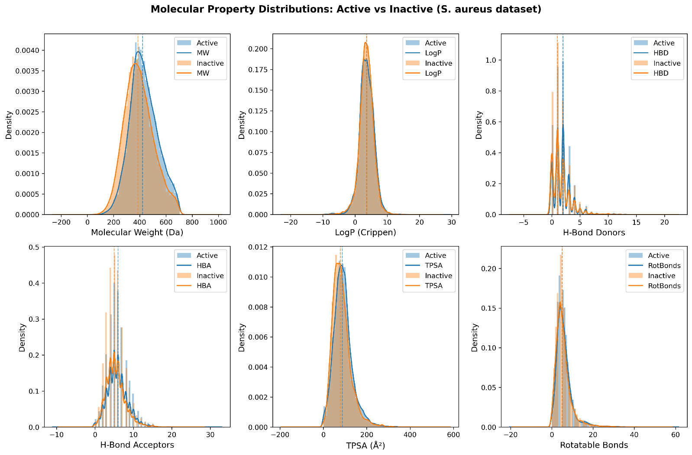
Fig. S1: Molecular property distributions for active (blue) and inactive (orange) compounds in the S. aureus dataset (n=43,777). Six properties shown: molecular weight (MW), partition coefficient (LogP), hydrogen bond donors (HBD), hydrogen bond acceptors (HBA), topological polar surface area (TPSA), and rotatable bond count. Distributions are shown as kernel density estimates.

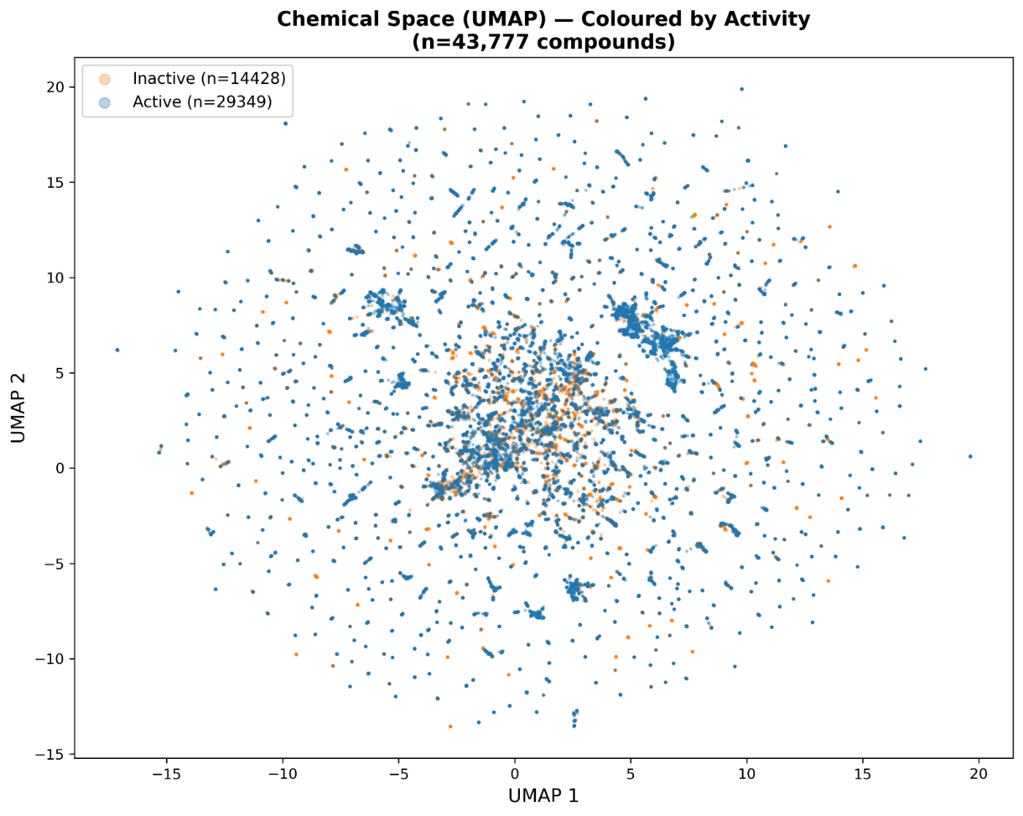
Fig. S2: UMAP projection of Morgan fingerprints (radius=2, 2048 bits, Jaccard metric) for all 43,777 compounds, coloured by activity label. Blue: active (MIC ≤ 64 µg/mL); orange: inactive (MIC > 64 µg/mL). Substantial intermixing throughout the chemical space is consistent with the prevalence of activity cliff pairs in this antibacterial dataset.

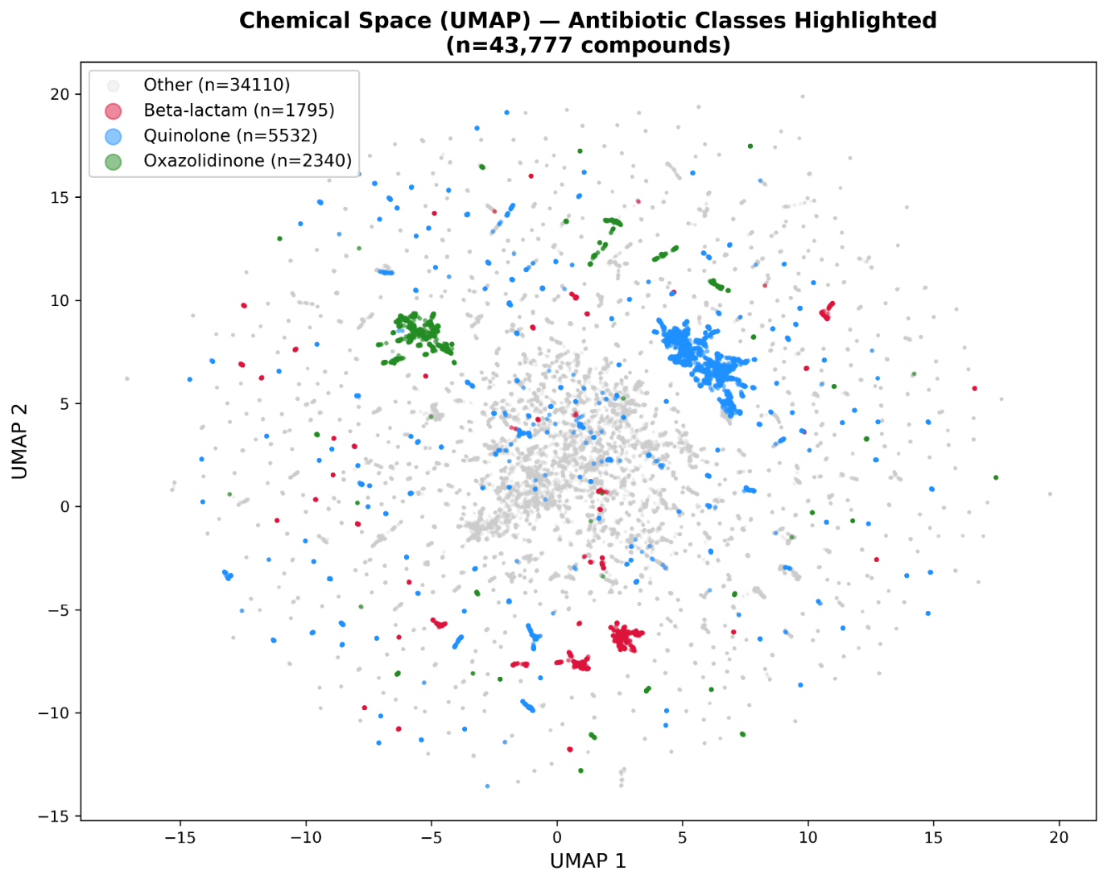
Fig. S3: UMAP projection (same embedding as Figure S2) with antibiotic class highlighted. Quinolones (n=5,532, red), oxazolidinones (n=2,340, green), and β-lactams (n=1,795, blue) form partially distinct structural clusters while retaining scattered members throughout broader chemical space.

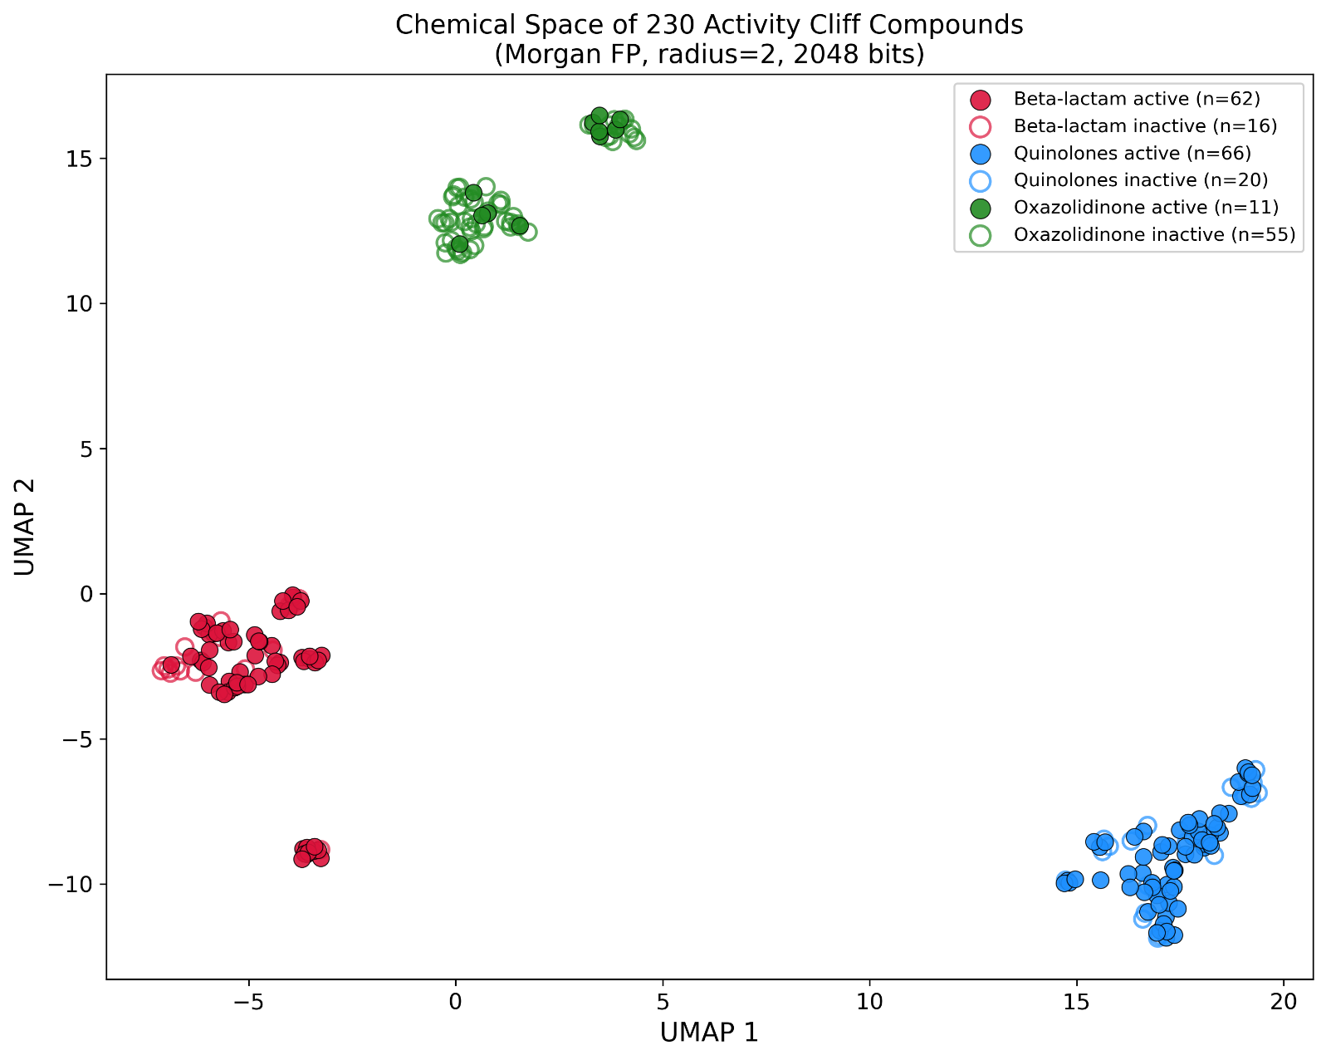
Fig. S4: UMAP projection of Morgan fingerprints (radius=2, 2048 bits, Jaccard metric) for the 230 unique compounds from 300 activity cliff pairs, coloured by antibiotic class (red: β-lactam; blue: quinolones; green: oxazolidinones) with filled markers for active compounds (MIC ≤ 64 µg/mL) and open markers for inactive analogues (MIC > 64 µg/mL). The three antibiotic classes form distinct clusters, confirming structural diversity across the evaluation dataset. Within each cluster, active and inactive compounds overlap extensively, consistent with the activity cliff design where paired compounds share the same scaffold but differ in activity due to peripheral substituent modifications.

Training dataset and cross-validation

Feature-based representation and model
Table S2. Performance comparison of 24 machine learning classifiers using LazyPredict for S. aureus antimicrobial activity classification.

Model | Accuracy | Balanced Accuracy | AUC_{ROC} | F1 Score | MCC
RandomForestClassifier | 0.820 | 0.783 | 0.883 | 0.869 | 0.585
ExtraTreesClassifier | 0.817 | 0.788 | 0.865 | 0.865 | 0.583
BaggingClassifier | 0.799 | 0.769 | 0.864 | 0.850 | 0.543
KNeighborsClassifier | 0.786 | 0.743 | 0.833 | 0.845 | 0.504
ExtraTreeClassifier | 0.777 | 0.752 | 0.762 | 0.832 | 0.501
DecisionTreeClassifier | 0.776 | 0.753 | 0.762 | 0.830 | 0.500
NuSVC | 0.782 | 0.721 | 0.834 | 0.847 | 0.484
SVC | 0.748 | 0.660 | 0.804 | 0.830 | 0.390
LGBMClassifier | 0.746 | 0.657 | 0.807 | 0.830 | 0.384
GaussianNB | 0.480 | 0.585 | 0.637 | 0.410 | 0.196
NearestCentroid | 0.564 | 0.601 | 0.601 | 0.600 | 0.193
BernoulliNB | 0.629 | 0.597 | 0.640 | 0.714 | 0.188
LogisticRegression | 0.679 | 0.561 | 0.689 | 0.792 | 0.174
AdaBoostClassifier | 0.677 | 0.563 | 0.688 | 0.789 | 0.172
CalibratedClassifierCV | 0.680 | 0.560 | 0.688 | 0.793 | 0.172
LinearDiscriminantAnalysis | 0.679 | 0.558 | 0.688 | 0.793 | 0.169
LinearSVC | 0.681 | 0.554 | 0.688 | 0.796 | 0.167
RidgeClassifierCV | 0.682 | 0.552 | 0.688 | 0.798 | 0.167
RidgeClassifier | 0.682 | 0.552 | 0.688 | 0.798 | 0.167
SGDClassifier | 0.663 | 0.542 | 0.639 | 0.781 | 0.120
Perceptron | 0.586 | 0.551 | 0.583 | 0.679 | 0.099
QuadraticDiscriminantAnalysis | 0.368 | 0.521 | 0.641 | 0.120 | 0.089
PassiveAggressiveClassifier | 0.586 | 0.517 | 0.530 | 0.700 | 0.036
DummyClassifier | 0.668 | 0.500 | 0.500 | 0.801 | 0.000

Table S3. Test set evaluation of Random Forest models from 5×5 cross-validation (selected 5 models are in bold).
CV ID | AUC_{ROC} | Precision | MCC
CV1 R1 | 0.866 | 0.924 | 0.558
CV1 R2 | 0.863 | 0.922 | 0.517
CV1 R3 | 0.863 | 0.920 | 0.544
CV1 R4 | 0.868 | 0.924 | 0.553
CV1 R5 | 0.867 | 0.921 | 0.559
CV2 R1 | 0.868 | 0.922 | 0.553
CV2 R2 | 0.870 | 0.924 | 0.545
CV2 R3 | 0.867 | 0.921 | 0.548
CV2 R4 | 0.869 | 0.924 | 0.553
CV2 R5 | 0.869 | 0.925 | 0.572
CV3 R1 | 0.865 | 0.924 | 0.558
CV3 R2 | 0.869 | 0.924 | 0.549
CV3 R3 | 0.862 | 0.918 | 0.559
CV3 R4 | 0.865 | 0.923 | 0.536
CV3 R5 | 0.865 | 0.920 | 0.553
CV4 R1 | 0.865 | 0.920 | 0.529
CV4 R2 | 0.868 | 0.923 | 0.554
CV4 R3 | 0.868 | 0.923 | 0.548
CV4 R4 | 0.868 | 0.924 | 0.549
CV4 R5 | 0.868 | 0.923 | 0.536
CV5 R1 | 0.865 | 0.925 | 0.519
CV5 R2 | 0.861 | 0.921 | 0.550
CV5 R3 | 0.862 | 0.922 | 0.534
CV5 R4 | 0.865 | 0.923 | 0.521
CV5 R5 | 0.866 | 0.924 | 0.534

Sequence-based representation and model
Table S4. Hyperparameter optimization results for Convolutional Neural Network (CNN)
N | Layers | Filters | Kernel size | Dropout | Learning rate | Best epoch | Loss | AUC_{ROC}
0 | 2 | 32 | 3 | 0.1082 | 0.0041 | 5 | 0.412 | 0.748
1 | 1 | 128 | 5 | 0.2169 | 0.0001 | 100 | 0.419 | 0.690
2 | 2 | 256 | 7 | 0.4863 | 0.0015 | 89 | 0.359 | 0.807
3 | 3 | 128 | 3 | 0.2247 | 0.0003 | 100 | 0.373 | 0.779
4 | 3 | 64 | 3 | 0.1181 | 0.0001 | 100 | 0.402 | 0.726
5 | 3 | 128 | 7 | 0.4089 | 0.0000 | 100 | 0.380 | 0.771
6 | 2 | 64 | 5 | 0.2324 | 0.0000 | 100 | 0.418 | 0.691
7 | 3 | 64 | 5 | 0.4084 | 0.0002 | 100 | 0.376 | 0.774
8 | 1 | 128 | 5 | 0.2642 | 0.0011 | 100 | 0.399 | 0.734
9 | 3 | 64 | 3 | 0.4570 | 0.0003 | 100 | 0.397 | 0.736
10 | 2 | 256 | 7 | 0.3402 | 0.0045 | 95 | 0.360 | 0.805
11 | 2 | 256 | 7 | 0.3494 | 0.0049 | 100 | 0.359 | 0.800
12 | 2 | 256 | 7 | 0.4974 | 0.0015 | 95 | 0.356 | 0.811
13 | 2 | 256 | 7 | 0.4867 | 0.0011 | 81 | 0.358 | 0.811
14 | 2 | 256 | 7 | 0.4334 | 0.0010 | 55 | 0.358 | 0.809
15 | 2 | 256 | 7 | 0.4961 | 0.0006 | 100 | 0.358 | 0.808
16 | 1 | 32 | 7 | 0.3654 | 0.0019 | 100 | 0.395 | 0.740
17 | 2 | 256 | 7 | 0.4643 | 0.0005 | 100 | 0.359 | 0.807
18 | 2 | 256 | 7 | 0.3012 | 0.0023 | 74 | 0.363 | 0.812
19 | 2 | 256 | 7 | 0.1588 | 0.0026 | 74 | 0.381 | 0.807
20 | 1 | 32 | 7 | 0.2836 | 0.0006 | 100 | 0.408 | 0.717
21 | 2 | 256 | 7 | 0.3886 | 0.0025 | 83 | 0.365 | 0.806
22 | 2 | 256 | 7 | 0.3098 | 0.0012 | 92 | 0.375 | 0.809
23 | 2 | 256 | 7 | 0.4404 | 0.0008 | 100 | 0.360 | 0.812
24 | 2 | 256 | 7 | 0.4387 | 0.0007 | 100 | 0.361 | 0.806
25 | 2 | 256 | 7 | 0.1711 | 0.0004 | 85 | 0.373 | 0.808
26 | 2 | 256 | 7 | 0.3218 | 0.0001 | 100 | 0.365 | 0.794
27 | 2 | 256 | 7 | 0.4018 | 0.0024 | 89 | 0.359 | 0.810
28 | 1 | 32 | 5 | 0.4651 | 0.0004 | 100 | 0.416 | 0.698
29 | 2 | 32 | 3 | 0.3760 | 0.0031 | 74 | 0.402 | 0.728
30 | 2 | 256 | 3 | 0.4335 | 0.0009 | 87 | 0.388 | 0.751
31 | 2 | 256 | 7 | 0.4871 | 0.0017 | 100 | 0.359 | 0.810
32 | 2 | 256 | 7 | 0.4695 | 0.0015 | 100 | 0.359 | 0.810
33 | 2 | 256 | 7 | 0.4931 | 0.0033 | 100 | 0.355 | 0.807
34 | 2 | 128 | 7 | 0.4349 | 0.0009 | 100 | 0.360 | 0.801
35 | 2 | 256 | 7 | 0.4604 | 0.0019 | 100 | 0.361 | 0.810
36 | 3 | 256 | 7 | 0.2697 | 0.0014 | 100 | 0.384 | 0.820
37 | 3 | 128 | 5 | 0.2563 | 0.0001 | 100 | 0.377 | 0.774
38 | 3 | 64 | 3 | 0.2160 | 0.0008 | 100 | 0.381 | 0.771
39 | 3 | 256 | 7 | 0.1908 | 0.0035 | 87 | 0.392 | 0.812
40 | 3 | 64 | 5 | 0.1730 | 0.0033 | 100 | 0.360 | 0.802
41 | 3 | 256 | 7 | 0.2055 | 0.0012 | 100 | 0.409 | 0.820
42 | 3 | 256 | 7 | 0.2023 | 0.0013 | 63 | 0.415 | 0.815
43 | 3 | 256 | 7 | 0.1992 | 0.0002 | 72 | 0.402 | 0.828
44 | 3 | 256 | 7 | 0.1212 | 0.0002 | 70 | 0.434 | 0.826
45 | 3 | 128 | 7 | 0.1041 | 0.0002 | 89 | 0.393 | 0.823
46 | 3 | 128 | 3 | 0.1049 | 0.0002 | 100 | 0.377 | 0.780
47 | 3 | 128 | 7 | 0.1176 | 0.0001 | 76 | 0.362 | 0.785
48 | 3 | 128 | 7 | 0.1358 | 0.0001 | 100 | 0.386 | 0.815
49 | 3 | 128 | 7 | 0.1254 | 0.0000 | 100 | 0.368 | 0.788

Table S5. Test set evaluation of CNN models from 5×5 cross-validation (selected 5 models are in bold)
CV ID | AUC_{ROC} | Precision | MCC
CV1 R1 | 0.860 | 0.918 | 0.543
CV1 R2 | 0.862 | 0.921 | 0.550
CV1 R3 | 0.861 | 0.919 | 0.515
CV1 R4 | 0.861 | 0.919 | 0.550
CV1 R5 | 0.869 | 0.924 | 0.552
CV2 R1 | 0.864 | 0.920 | 0.526
CV2 R2 | 0.862 | 0.919 | 0.547
CV2 R3 | 0.864 | 0.922 | 0.540
CV2 R4 | 0.863 | 0.920 | 0.533
CV2 R5 | 0.867 | 0.923 | 0.538
CV3 R1 | 0.867 | 0.923 | 0.547
CV3 R2 | 0.864 | 0.920 | 0.543
CV3 R3 | 0.854 | 0.916 | 0.505
CV3 R4 | 0.790 | 0.880 | 0.376
CV3 R5 | 0.864 | 0.919 | 0.539
CV4 R1 | 0.860 | 0.918 | 0.540
CV4 R2 | 0.862 | 0.920 | 0.537
CV4 R3 | 0.864 | 0.920 | 0.551
CV4 R4 | 0.863 | 0.918 | 0.539
CV4 R5 | 0.857 | 0.915 | 0.539
CV5 R1 | 0.864 | 0.921 | 0.535
CV5 R2 | 0.860 | 0.921 | 0.523
CV5 R3 | 0.862 | 0.919 | 0.543
CV5 R4 | 0.865 | 0.923 | 0.530
CV5 R5 | 0.862 | 0.918 | 0.563

Graph-based representation and model
Table S6. Hyperparameter optimization for Relational Graph Convolutional Network (RGCN)
N | Learning rate | Weight decay | RGCN hidden  features | FFN hidden features | FFN dropout | RGCN dropout | Best epoch | Loss | AUC_{ROC}
0 | 0.00073 | 0.00001 | 128-256 | 64 | 0.4 | 0.5 | 33 | 0.601 | 0.692
1 | 0.00234 | 0.00002 | 64-128-256 | 64 | 0.3 | 0.2 | 57 | 0.530 | 0.786
2 | 0.00012 | 0.00001 | 64-64-128 | 64 | 0.3 | 0.3 | 99 | 0.599 | 0.698
3 | 0.00052 | 0.00000 | 256-256 | 64 | 0.2 | 0.1 | 63 | 0.525 | 0.820
4 | 0.00011 | 0.00000 | 64-128 | 32 | 0.1 | 0.2 | 91 | 0.553 | 0.752
5 | 0.00610 | 0.00004 | 128-128-256 | 64 | 0.5 | 0.3 | 23 | 0.610 | 0.656
6 | 0.00053 | 0.00082 | 128-256 | 64 | 0.2 | 0.2 | 32 | 0.566 | 0.747
7 | 0.00030 | 0.00015 | 64-128 | 32 | 0.3 | 0.2 | 99 | 0.581 | 0.744
8 | 0.00747 | 0.00000 | 64-128-256 | 32 | 0.3 | 0.4 | 70 | 0.595 | 0.699
9 | 0.00595 | 0.00022 | 256-256 | 32 | 0.5 | 0.5 | 17 | 0.625 | 0.642
10 | 0.00191 | 0.00000 | 256-256 | 64 | 0.2 | 0.1 | 53 | 0.502 | 0.816
11 | 0.00159 | 0.00000 | 256-256 | 64 | 0.2 | 0.1 | 56 | 0.522 | 0.801
12 | 0.00164 | 0.00000 | 256-256 | 64 | 0.2 | 0.1 | 53 | 0.463 | 0.843
13 | 0.00035 | 0.00000 | 256-256 | 64 | 0.2 | 0.1 | 63 | 0.486 | 0.831
14 | 0.00030 | 0.00001 | 256-256 | 64 | 0.2 | 0.1 | 83 | 0.501 | 0.825
15 | 0.00026 | 0.00001 | 128-128-256 | 64 | 0.4 | 0.1 | 64 | 0.632 | 0.728
16 | 0.00024 | 0.00003 | 64-64-128 | 64 | 0.1 | 0.4 | 99 | 0.573 | 0.738
17 | 0.00041 | 0.00001 | 256-256 | 64 | 0.2 | 0.1 | 60 | 0.492 | 0.826
18 | 0.00019 | 0.00002 | 256-256 | 32 | 0.2 | 0.1 | 29 | 0.530 | 0.775
19 | 0.00092 | 0.00006 | 256-256 | 64 | 0.2 | 0.1 | 62 | 0.517 | 0.809
20 | 0.00016 | 0.00000 | 64-128 | 64 | 0.4 | 0.3 | 77 | 0.631 | 0.658
21 | 0.00039 | 0.00001 | 256-256 | 64 | 0.2 | 0.1 | 72 | 0.472 | 0.834
22 | 0.00041 | 0.00001 | 256-256 | 64 | 0.2 | 0.1 | 36 | 0.499 | 0.820
23 | 0.00072 | 0.00001 | 256-256 | 64 | 0.2 | 0.1 | 40 | 0.503 | 0.800
24 | 0.00035 | 0.00001 | 256-256 | 64 | 0.2 | 0.4 | 58 | 0.564 | 0.764
25 | 0.00020 | 0.00000 | 64-64-128 | 64 | 0.5 | 0.5 | 54 | 0.621 | 0.642
26 | 0.00054 | 0.00006 | 128-128-256 | 32 | 0.1 | 0.1 | 38 | 0.506 | 0.823
27 | 0.00112 | 0.00001 | 64-128-256 | 64 | 0.2 | 0.1 | 44 | 0.497 | 0.819
28 | 0.00023 | 0.00000 | 128-256 | 64 | 0.2 | 0.1 | 49 | 0.534 | 0.782
29 | 0.00312 | 0.00001 | 128-256 | 64 | 0.4 | 0.5 | 48 | 0.563 | 0.734
30 | 0.00084 | 0.00002 | 256-256 | 64 | 0.2 | 0.1 | 60 | 0.478 | 0.832
31 | 0.00041 | 0.00001 | 256-256 | 64 | 0.2 | 0.1 | 66 | 0.546 | 0.801
32 | 0.00062 | 0.00001 | 256-256 | 64 | 0.2 | 0.1 | 51 | 0.506 | 0.808
33 | 0.00015 | 0.00001 | 256-256 | 64 | 0.2 | 0.1 | 94 | 0.475 | 0.840
34 | 0.00036 | 0.00000 | 256-256 | 64 | 0.2 | 0.3 | 63 | 0.516 | 0.791
35 | 0.00030 | 0.00001 | 64-128-256 | 64 | 0.3 | 0.1 | 61 | 0.589 | 0.752
36 | 0.00118 | 0.00000 | 64-64-128 | 64 | 0.1 | 0.2 | 57 | 0.515 | 0.801
37 | 0.00044 | 0.00003 | 256-256 | 64 | 0.5 | 0.1 | 61 | 0.600 | 0.735
38 | 0.00011 | 0.00000 | 64-128 | 32 | 0.2 | 0.3 | 99 | 0.581 | 0.720
39 | 0.00065 | 0.00000 | 128-128-256 | 64 | 0.4 | 0.4 | 99 | 0.582 | 0.741
40 | 0.00015 | 0.00000 | 128-256 | 64 | 0.3 | 0.2 | 68 | 0.554 | 0.754
41 | 0.00048 | 0.00001 | 256-256 | 64 | 0.2 | 0.1 | 49 | 0.504 | 0.815
42 | 0.00033 | 0.00001 | 256-256 | 64 | 0.2 | 0.1 | 56 | 0.511 | 0.812
43 | 0.00041 | 0.00000 | 256-256 | 64 | 0.2 | 0.1 | 51 | 0.519 | 0.798
44 | 0.00026 | 0.00001 | 256-256 | 32 | 0.2 | 0.5 | 92 | 0.553 | 0.752
45 | 0.00057 | 0.00038 | 256-256 | 64 | 0.2 | 0.1 | 49 | 0.446 | 0.852
46 | 0.00021 | 0.00002 | 256-256 | 64 | 0.2 | 0.1 | 93 | 0.513 | 0.813
47 | 0.00020 | 0.00009 | 64-128-256 | 64 | 0.5 | 0.1 | 89 | 0.606 | 0.738
48 | 0.00013 | 0.00002 | 64-128 | 64 | 0.1 | 0.2 | 99 | 0.550 | 0.765
49 | 0.00029 | 0.00002 | 256-256 | 32 | 0.3 | 0.1 | 49 | 0.597 | 0.738

Table S7: Test set evaluation of RGCN models from 5×5 cross-validation (selected 5 models are in bold)
CV ID | AUC_{ROC} | Precision | MCC
CV1 R1 | 0.966 | 0.983 | 0.766
CV1 R2 | 0.908 | 0.953 | 0.607
CV1 R3 | 0.876 | 0.934 | 0.554
CV1 R4 | 0.829 | 0.908 | 0.474
CV1 R5 | 0.939 | 0.969 | 0.690
CV2 R1 | 0.831 | 0.909 | 0.464
CV2 R2 | 0.768 | 0.870 | 0.371
CV2 R3 | 0.839 | 0.916 | 0.480
CV2 R4 | 0.926 | 0.962 | 0.664
CV2 R5 | 0.849 | 0.921 | 0.492
CV3 R1 | 0.975 | 0.988 | 0.807
CV3 R2 | 0.982 | 0.991 | 0.831
CV3 R3 | 0.792 | 0.886 | 0.409
CV3 R4 | 0.899 | 0.947 | 0.607
CV3 R5 | 0.974 | 0.987 | 0.794
CV4 R1 | 0.931 | 0.964 | 0.674
CV4 R2 | 0.947 | 0.973 | 0.711
CV4 R3 | 0.984 | 0.992 | 0.845
CV4 R4 | 0.930 | 0.963 | 0.676
CV4 R5 | 0.823 | 0.903 | 0.462
CV5 R1 | 0.813 | 0.898 | 0.433
CV5 R2 | 0.980 | 0.990 | 0.819
CV5 R3 | 0.847 | 0.918 | 0.485
CV5 R4 | 0.964 | 0.982 | 0.762
CV5 R5 | 0.946 | 0.973 | 0.705

Fragment-based explainability

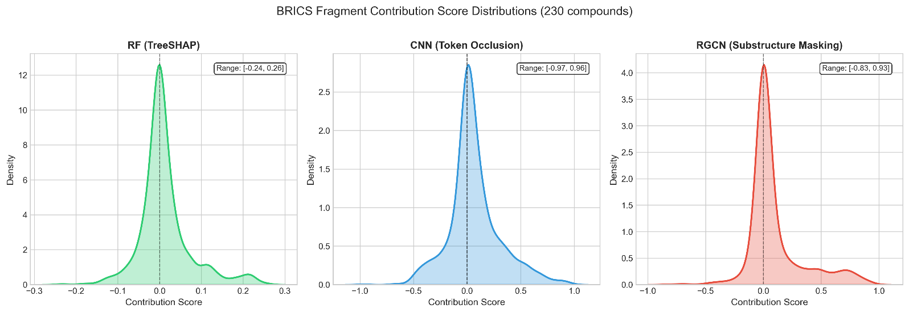
Fig. S4: Distrubtion of the BRICS fragment contribution scores for 230 unique compounds from the activity cliff, for the different models.

Table S8: Fragment number of compounds per antibtiotic class
Antibiotic class | Fragment (n) | Actives | Inactives | Unique  Fragments | Common Fragments | Active only Fragments | Inactive only Fragments
Beta-lactam | 78 | 62 | 16 | 69 | 16 | 43 | 10
Quinolones | 86 | 66 | 20 | 82 | 18 | 47 | 17
Oxazolidinone | 66 | 11 | 55 | 69 | 14 | 8 | 47
All | 230 | 139 | 91 | 186 | 40 | 83 | 63

Fragment (n): number of compounds per class. Unique Fragments: distinct BRICS fragments observed across all compounds in the class. Common Fragments: fragments present in at least one active and one inactive compound. Active-only / Inactive-only Fragments: fragments found exclusively in active (MIC ≤ 64 µg/mL) or inactive (MIC > 64 µg/mL) compounds respectively. BRICS fragmentation is deterministic and model-independent; identical fragments were confirmed across RF, CNN, and RGCN for all 230 compounds. The low proportion of common fragments (40/186, 21.5%) indicates that activity cliff pairs differ substantially in their peripheral substructures despite sharing the same core scaffold.

