Transformer-Accelerated Discovery of Inhibitors Targeting the RpsAΔ438 Deletion in PZA-Resistant Tuberculosis

Supplementary Figure 1. Training and validation MCC learning curves (a) and ROC curves for the training and independent test sets (b) of the selected Transformer model Seed_8_Rank_1, demonstrating stable training dynamics, controlled generalization gap, and robust discriminative performance.

Supplementary Figure 2. Performance comparison of 18 Random Forest models across six independent stratified data splits (Seeds 8–64), showing test-set AUC, accuracy, MCC, F1 score, precision, sensitivity, specificity, and Youden index for the top three hyperparameter configurations per split.
Supplementary Figure 3. Performance comparison of 18 XGBoost models across six independent stratified data splits (Seeds 8–64), showing test-set AUC, accuracy, MCC, F1 score, precision, sensitivity, specificity, and Youden index for the top three hyperparameter configurations per split.
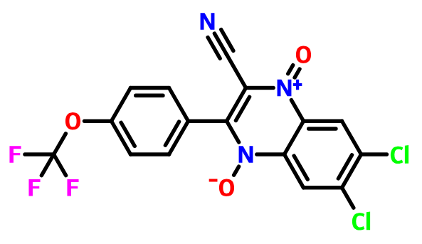
Supplementary Figure 4. Chemical structure of the representative test-set compound CHEMBL523618 used for attention visualization and interpretability analysis of the Transformer model.

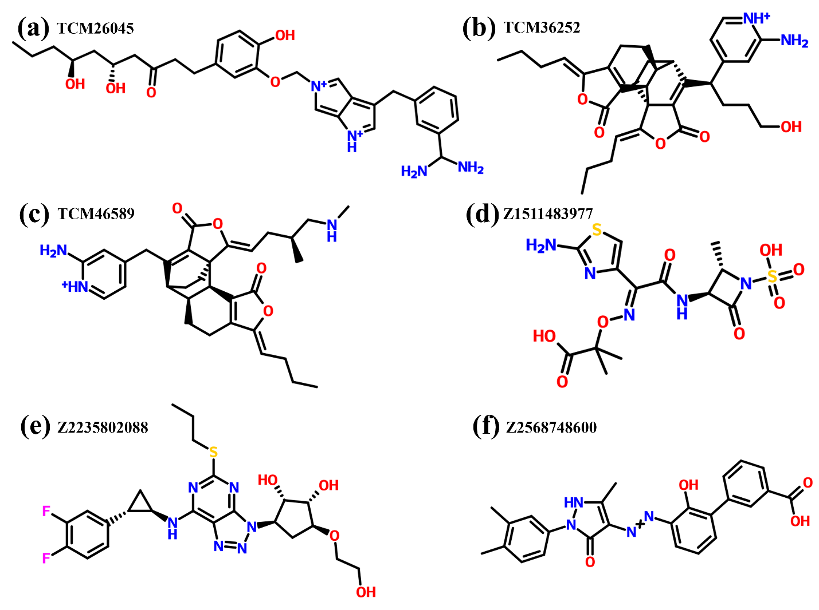
Supplementary Figure 5. The top-ranked compounds screened from the TCM and FDA databases via molecular docking.

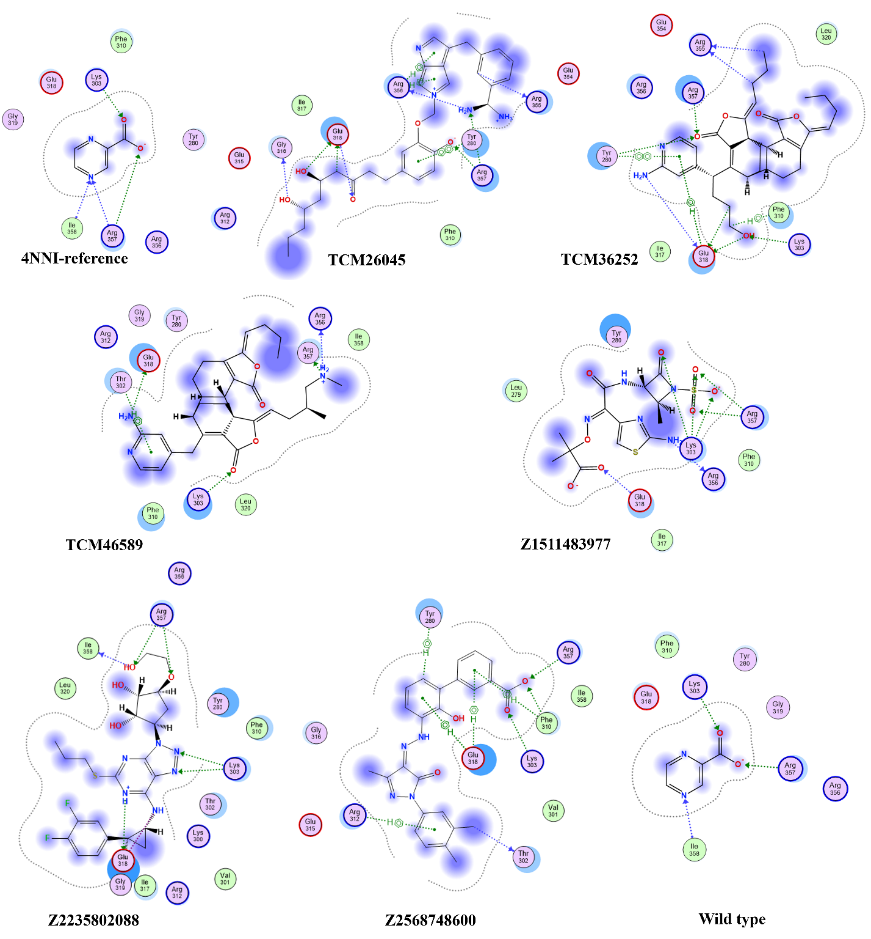
Supplementary Figure 6. 2D Interaction of Top-Ranked Compounds with RpsAΔ438
Supplementary Figure 7. Attention heatmap of the top-ranked compounds. (a) TCM26045, (b) TCM36252, (c) TCM46589, (d)Z1511483977, (e) Z2235802088, (f) Z2568748600, (g) Reference (Pyrazinoic acid).
Supplementary Figure 8. Representative snapshots of RpsA_{Δ438}–ligand complexes extracted at 0, 100, 250, and 400 ns from molecular dynamics simulations, illustrating time-dependent ligand binding behavior and structural stability of the reference and selected screened compounds.
Supplementary Table 1. ADMET profiling of top-ranked compounds with evaluation of drug-likeness and toxicity risk
^{Compd} | ^{MW} | ^{HBA} | ^{HBD} | ^{logP} | ^{hERG} | ^{hERG (10um)} | ^{DILI} | ^{Ames} | ^{ROA} | ^{FDAMDD} | ^{SkinSen} | ^{Carcinog} | ^{EC} | ^{EI} | ^{Resp} | ^{Neurotox} | ^{Ototox} | ^{Hematotox} | ^{Nephrotox} | ^{Genotox} | ^{RPMI-8226} | ^{A549} | ^{HEK293}
^{TCM}  ²⁶⁰⁴⁵ | ^{547.29} | ⁹ | ⁷ | ^{1.55} | ^{0.73} | ^{0.52} | ^{0.03} | ^{0.42} | ^{0.87} | ^{1.00} | ^{1.00} | ^{0.08} | ^{0.00} | ^{0.01} | ^{0.98} | ^{0.84} | ^{0.91} | ^{0.62} | ^{0.93} | ^{1.00} | ^{0.17} | ^{0.09} | ^{0.30}
^{TCM}  ³⁶²⁵² | ^{544.29} | ⁷ | ³ | ^{3.78} | ^{0.02} | ^{0.13} | ^{1.00} | ^{0.69} | ^{0.02} | ^{0.69} | ^{1.00} | ^{0.87} | ^{0.00} | ^{0.83} | ^{0.91} | ^{0.08} | ^{0.79} | ^{0.62} | ^{1.00} | ^{0.89} | ^{0.28} | ^{0.09} | ^{0.06}
^{TCM}  ⁴⁶⁵⁸⁹ | ^{529.29} | ⁷ | ³ | ^{3.04} | ^{0.11} | ^{0.28} | ^{1.00} | ^{0.46} | ^{0.33} | ^{0.90} | ^{1.00} | ^{0.76} | ^{0.00} | ^{0.16} | ^{0.98} | ^{0.54} | ^{0.81} | ^{0.80} | ^{1.00} | ^{0.95} | ^{0.32} | ^{0.64} | ^{0.14}
^{Z1511483977} | ^{435.05} | ¹³ | ⁵ | ^{-0.61} | ^{0.00} | ^{0.01} | ^{0.99} | ^{0.29} | ^{0.08} | ^{0.06} | ^{0.64} | ^{0.47} | ^{0.00} | ^{0.33} | ^{0.53} | ^{0.06} | ^{0.89} | ^{0.60} | ^{0.79} | ^{1.00} | ^{0.01} | ^{0.00} | ^{0.01}
^{Z2235802088} | ^{522.19} | ¹⁰ | ⁴ | ^{4.26} | ^{0.45} | ^{0.66} | ^{1.00} | ^{0.64} | ^{0.15} | ^{0.27} | ^{0.22} | ^{0.84} | ^{0.00} | ^{0.01} | ^{0.52} | ^{0.25} | ^{0.99} | ^{0.50} | ^{1.00} | ^{0.99} | ^{0.15} | ^{0.20} | ^{0.85}
^{Z2568748600} | ^{442.16} | ⁸ | ³ | ^{3.81} | ^{0.06} | ^{0.18} | ^{0.96} | ^{0.67} | ^{0.33} | ^{0.45} | ^{0.70} | ^{0.63} | ^{0.00} | ^{0.88} | ^{0.85} | ^{0.86} | ^{0.71} | ^{0.72} | ^{0.87} | ^{1.00} | ^{0.02} | ^{0.02} | ^{0.16}
*Compd, compound; MW, molecular weight; HBA, hydrogen bond acceptors; HBD, hydrogen bond donors; logP, octanol–water partition coefficient; hERG, human ether-à-go-go-related gene inhibition; DILI, drug-induced liver injury; Ames, Ames mutagenicity test; ROA, route of administration; FDA-MDD, FDA maximum recommended daily dose; SkinSens, skin sensitization; Carcinog, carcinogenicity; EC, endocrine disruption; EI, eye irritation; Resp, respiratory toxicity; Neurotox, neurotoxicity; Ototox, ototoxicity; Hematotox, hematotoxicity; Nephrotox, nephrotoxicity; Genotox, genotoxicity.

