I2M: A Box-Based Detection Framework for Molecular Structure Recognition from Images
Bowen Tang, ^{‡a,b} Jing Peng, ^{‡a} Tong Wu,^{‡c} WenFan Wu, ^{d} Wenxing Lv, ^{e} Ruiquan Ge, ^{f} Ho Leung Ng, ^{g} Hongyu Hu, ^{*h} Siyu Zhou, ^{*i} Yuqing Qian ^{*i}

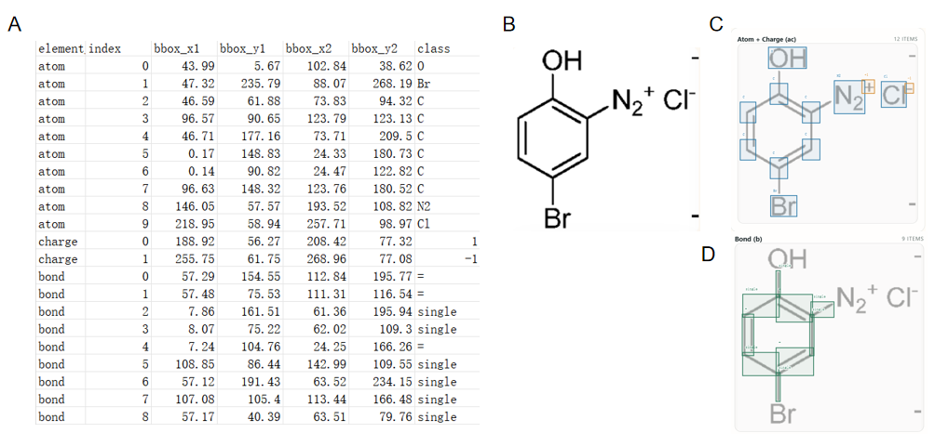
Fig.S1 an example of training image and related annotations. A: an example of training annotations, B: an example of training image, C: atom and charge annotation align on the image, D: bond annotations align on the image.

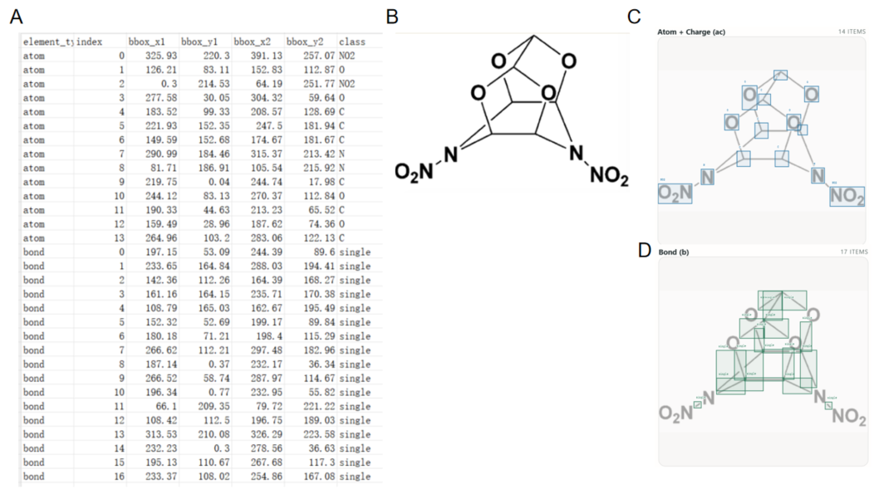
Fig.S2 a pair of training image and related annotations. A: training annotations, B: training image, C: atom and charge annotation align on the image, D: bond annotations align on the image.

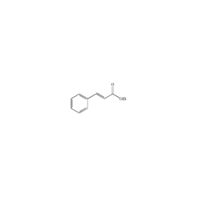
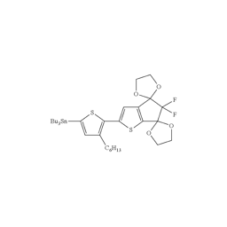
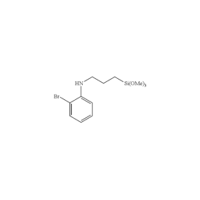
A
B
C
D

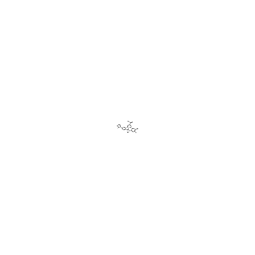

Fig.S3 Samples from the Saker dataset that are visually indistinguishable to the human eye. A: the molecular structure is hardly determined with eyes ( from 46128.png); B Not clear with Bu₃Se or Bu₃Sn; C: may be Si(OMe)₃; D: May be CO2 or other O?.

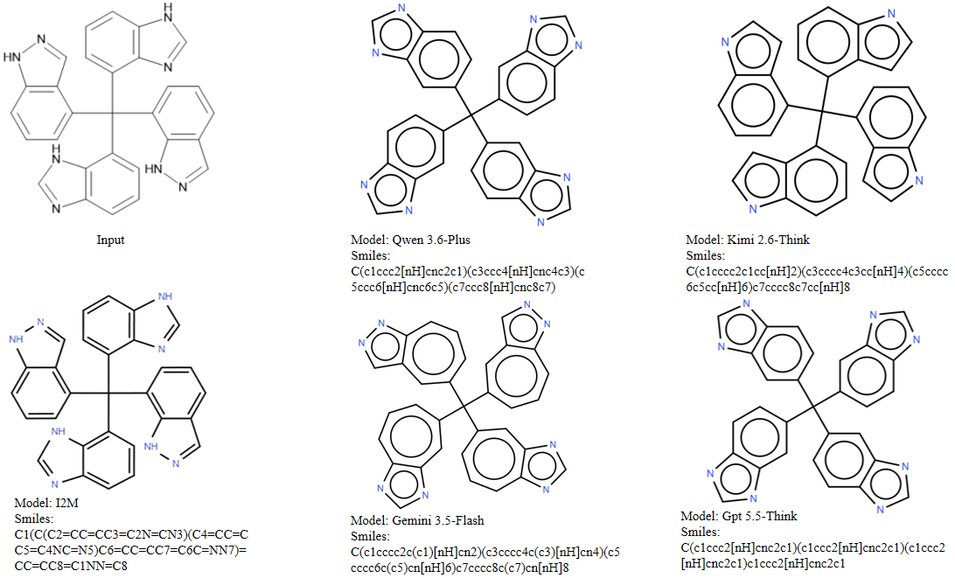
Fig.S4 An example comparison between frontier multimodal models and I2M.

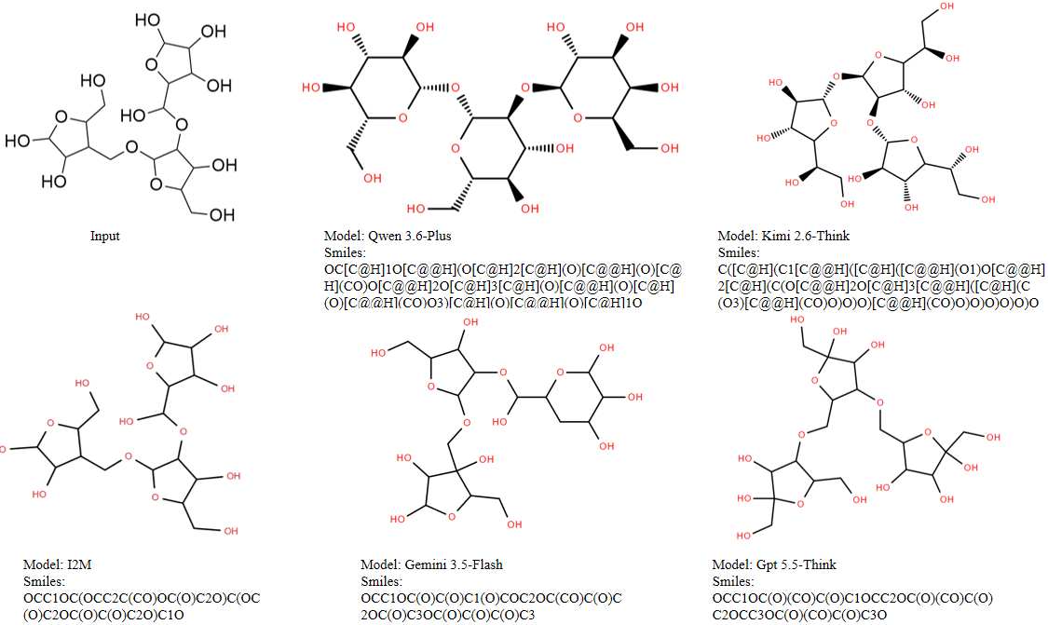
Fig.S5 An example comparison between frontier multimodal models and I2M.

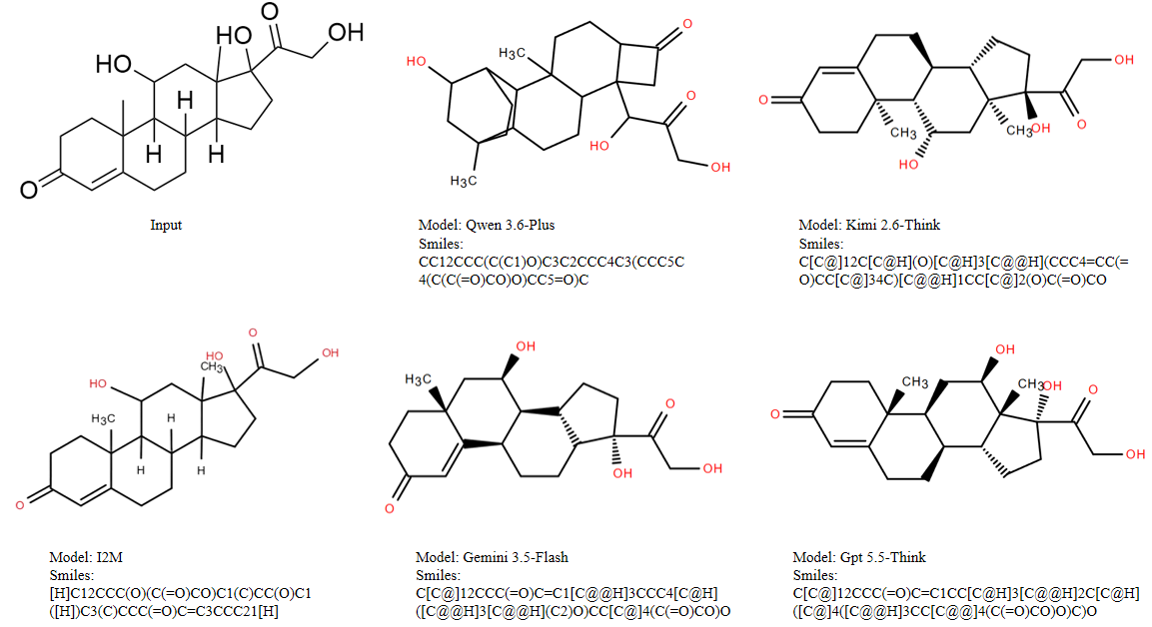
Fig.S6 An example comparison between frontier multimodal models and I2M.

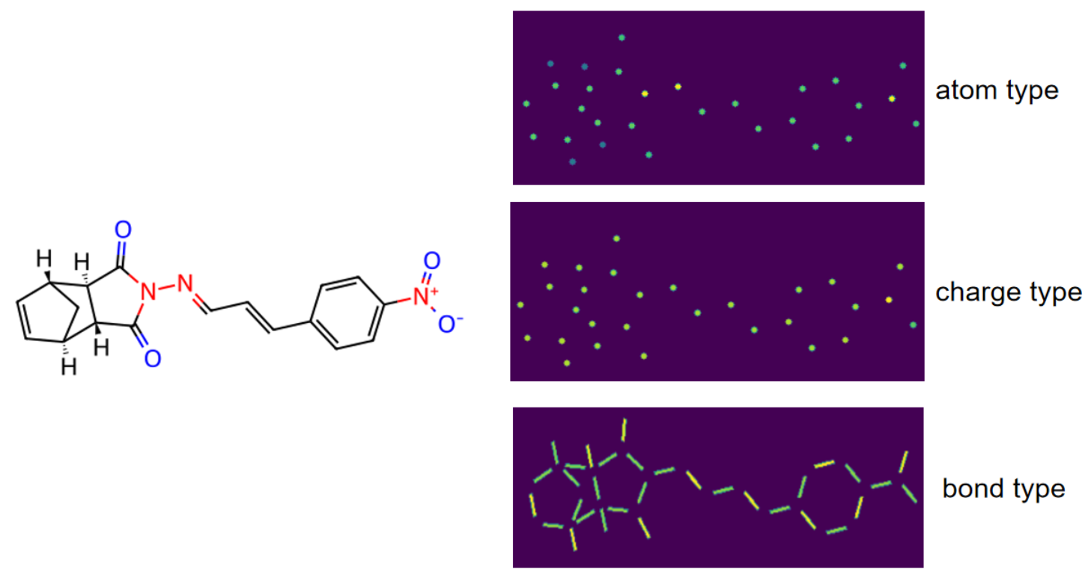
Fig.S7 An example of training data image and related atom, charge, bond labels for training ChemSAM. Atom and charge are represented by filled circle. Bond are represented by filled rectangles. Different types filled with different target values.

Table S1. Predefined abbreviation-to-SMILES mapping used in I2M
The table lists the predefined chemical abbreviations used in I2M.; R-group symbols entries are represented by "*".
Abbreviation | SMILES
R | *
R1 | *
R2 | *
R3 | *
R4 | *
R5 | *
R6 | *
R7 | *
R8 | *
R9 | *
R10 | *
R11 | *
R12 | *
Ra | *
Rb | *
Rc | *
Rd | *
X | *
Y | *
Z | *
Q | *
A | *
E | *
Ar | [c]1ccccc1
NO2 | [N+](=O)[O-]
O2N | [N+](=O)[O-]
CHO | [CH1](=O)
OHC | [CH1](=O)
CO2Et | [C](=O)OCC
COOEt | [C](=O)OCC
OAc | [O]C(=O)C
NHAc | [NH]C(=O)C
Ac | [C](=O)C
OBz | [O]C(=O)c1ccccc1
Bz | [C](=O)c1ccccc1
OBn | [O]Cc1ccccc1
Bn | [CH2]c1ccccc1
NHBoc | [NH1]C(=O)OC(C)(C)C
NBoc | [NH1]C(=O)OC(C)(C)C
Boc | [C](=O)OC(C)(C)C
Cbm | [C](=O)N
Cbz | [C](=O)OCc1ccccc1
Cy | [CH1]1CCCCC1
Fmoc | [C](=O)OCC1c(cccc2)c2c3c1cccc3
Mes | [c]1c(C)cc(C)cc(C)1
OMs | [O]S(=O)(=O)C
Ms | [S](=O)(=O)C
Ph | [c]1ccccc1
PMB | [CH2]c1ccc(OC)cc1
Py | [c]1ncccc1
SEM | [CH2]CSi(C)(C)C
Suc | [C](=O)CCC(=O)O
TBS | [Si](C)(C)C(C)(C)C
TBZ | [C](=S)c1ccccc1
OTf | [O]S(=O)(=O)C(F)(F)F
Tf | [S](=O)(=O)C(F)(F)F
TFA | [C](=O)C(F)(F)F
TMS | [Si](C)(C)C
Ts | [S](=O)(=O)c1ccc(C)cc1
OMe | [O]C
MeO | [O]C
SMe | [S]C
MeS | [S]C
NMe | [NH]C
MeN | [NH]C
Me | [CH3]
OEt | [O]CC
EtO | [O]CC
Et | [CH2]C
C2H5 | [CH2]C
Pr | [CH2]CC
nPr | [CH2]CC
n-Pr | [CH2]CC
Bu | [CH2]CCC
nBu | [CH2]CCC
n-Bu | [CH2]CCC
iPr | [CH1](C)C
i-Pr | [CH1](C)C
iBu | [CH2]C(C)C
i-Bu | [CH2]C(C)C
OiBu | [O]CC(C)C
OtBu | [O]C(C)(C)C
tBu | [C](C)(C)C
t-Bu | [C](C)(C)C
CF3 | [C](F)(F)F
F3C | [C](F)(F)F
NCF3 | [NH]C(F)(F)F
F3CN | [NH]C(F)(F)F
OCF3 | [O]C(F)(F)F
F3CO | [O]C(F)(F)F
CCl3 | [C](Cl)(Cl)Cl
CO2H | [C](=O)O
HO2C | [C](=O)O
COOH | [C](=O)O
CN | [C]#N
NC | [C]#N
OCH3 | [O]C
H3CO | [O]C
SO3H | [S](=O)(=O)O

Table S2. Paired bootstrap analysis of I2M and MolGrapher* accuracy on six public test datasets.
Accuracy values are reported as percentages with 95% bootstrap confidence intervals in brackets. Differences are absolute percentage-point differences calculated as I2M minus MolGrapher*. Confidence intervals and empirical p-values were estimated using 10,000 paired bootstrap resamples applied to sample-level success/failure predictions under the same evaluation protocol.
Dataset | N | MolGrapher* accuracy (%)  [95% CI] | I2M accuracy (%)  [95% CI] | I2M - MolGrapher*  (pp) [95% CI] | Empirical  p-value | Significant
CLEF | 992 | 49.8 [46.7, 52.9] | 94.7 [93.2, 96.1] | 44.9 [41.6, 48.1] | <0.0001 | Yes
JPO | 450 | 58.9 [54.4, 63.3] | 82.4 [78.9, 86.0] | 23.6 [18.2, 28.9] | <0.0001 | Yes
UOB | 5,740 | 84.5 [83.6, 85.4] | 93.2 [92.5, 93.9] | 8.7 [7.6, 9.8] | <0.0001 | Yes
USPTO | 5,719 | 66.1 [64.9, 67.3] | 95.9 [95.3, 96.4] | 29.8 [28.5, 31.1] | <0.0001 | Yes
ACS | 331 | 37.5 [32.3, 42.6] | 91.2 [88.2, 94.3] | 53.8 [48.0, 59.5] | <0.0001 | Yes
Staker | 50,000 | 0.1 [0.0, 0.1] | 80.5 [80.2, 80.9] | 80.5 [80.1, 80.8] | <0.0001 | Yes
Note: pp, percentage points. The empirical p-value is reported as <0.0001 because no bootstrap replicate supported a non-positive paired difference in 10,000 resamples; the true p-value should not be interpreted as exactly zero. Confidence intervals were computed from bootstrap percentiles. MolGrapher* denotes re-implemented results.

