Supplementary Information
Integrating Multi-Criteria Decision-Making and Machine Learning for Optimized Fingerprint Selection and Discovery of Acetylcholinesterase (AChE) Inhibitors.
Moruf A. Adeagbo^{∗1,2}, Waliyullah A. Ibrahim³ and Sabrina A. Silveira¹
¹Department of Computer Science, Universidade Federal de Vicosa, 36570-900, Minas Gerais, Brazil.
²Department of Computer Sciences, Abiola Ajimobi Technical University, Ibadan, 200255, Nigeria.
³Department of Intelligent Systems Engineering, Obafemi Awolowo University, Ife, 610101, Nigeria.
E-mail: moruff.adeagbo@ufv.br; waliyu2006@gmail.com; sabrina@ufv.br
corresponding author: moruff.adeagbo@ufv.br

Supplementary Material

Tables
Table S1. PR-AUC Pairwise post-hoc comparison (p-values) among the evaluated machine learning classifiers.
Classifier | AdaBoost | Decision Tree | Extra Trees | Gradient Boosting | KNN | LightGBM
AdaBoost | 1.000000 | 0.998676 | 0.036454 | 0.979692 | 0.999486 | 0.036454
Decision Tree | 0.998676 | 1.000000 | 0.001994 | 0.640024 | 0.892400 | 0.001994
Extra Trees | 0.036454 | 0.001994 | 1.000000 | 0.514151 | 0.236924 | 1.000000
Gradient Boosting | 0.979692 | 0.640024 | 0.514151 | 1.000000 | 0.999990 | 0.514151
KNN | 0.999486 | 0.892400 | 0.236924 | 0.999990 | 1.000000 | 0.236924
LightGBM | 0.036454 | 0.001994 | 1.000000 | 0.514151 | 0.236924 | 1.000000
Logistic Regression | 0.979692 | 0.640024 | 0.514151 | 1.000000 | 0.999990 | 0.514151
Naive Bayes | 0.923797 | 0.999829 | 0.000125 | 0.236924 | 0.514151 | 0.000125
Random Forest | 0.001994 | 0.000053 | 0.998676 | 0.101845 | 0.027451 | 0.998676
SVM | 0.392034 | 0.062280 | 0.993828 | 0.979692 | 0.853940 | 0.993828
Note: Bold values indicate statistically significant differences at p < 0.05.

Table S2. ROC-AUC Pairwise post-hoc comparison (p-values) among the evaluated machine learning classifiers.
Classifier | AdaBoost | Decision Tree | Extra Trees | Gradient Boosting | KNN | LightGBM
AdaBoost | 1.000000 | 0.999953 | 0.015098 | 0.988384 | 0.853940 | 0.027451
Decision Tree | 0.999953 | 1.000000 | 0.001994 | 0.853940 | 0.514151 | 0.004063
Extra Trees | 0.015098 | 0.001994 | 1.000000 | 0.283815 | 0.640024 | 1.000000
Gradient Boosting | 0.988384 | 0.853940 | 0.283815 | 1.000000 | 0.999953 | 0.392034
KNN | 0.853940 | 0.514151 | 0.640024 | 0.999953 | 1.000000 | 0.757112
LightGBM | 0.027451 | 0.004063 | 1.000000 | 0.392034 | 0.757112 | 1.000000
Logistic Regression | 0.966695 | 0.757112 | 0.392034 | 1.000000 | 0.999999 | 0.514151
Naive Bayes | 0.966695 | 0.999486 | 0.000082 | 0.392034 | 0.128037 | 0.000191
Random Forest | 0.000944 | 0.000082 | 0.999486 | 0.047904 | 0.195335 | 0.996992
SVM | 0.451901 | 0.159094 | 0.948359 | 0.979692 | 0.999829 | 0.979692
Note: Bold values indicate statistically significant differences at p < 0.05.
Table S3. BEDROC Pairwise post-hoc comparison (p-values) among the evaluated machine learning classifiers.
Classifier | AdaBoost | Decision Tree | Extra Trees | Gradient Boosting | KNN | LightGBM
AdaBoost | 1.000000 | 0.892400 | 0.757112 | 0.757112 | 0.999829 | 0.015098
Decision Tree | 0.892400 | 1.000000 | 0.036454 | 0.036454 | 0.996992 | 0.000021
Extra Trees | 0.757112 | 0.036454 | 1.000000 | 1.000000 | 0.335712 | 0.757112
Gradient Boosting | 0.757112 | 0.036454 | 1.000000 | 1.000000 | 0.335712 | 0.757112
KNN | 0.999829 | 0.996992 | 0.335712 | 0.335712 | 1.000000 | 0.001378
LightGBM | 0.015098 | 0.000021 | 0.757112 | 0.757112 | 0.001378 | 1.000000
Logistic Regression | 1.000000 | 0.757112 | 0.892400 | 0.892400 | 0.996992 | 0.036454
Naive Bayes | 0.640024 | 0.999990 | 0.007983 | 0.007983 | 0.948359 | 0.000002
Random Forest | 0.236924 | 0.001994 | 0.998676 | 0.998676 | 0.047904 | 0.993828
SVM | 0.808626 | 0.047904 | 1.000000 | 1.000000 | 0.392034 | 0.700456
Note: Bold values indicate statistically significant differences at p < 0.05.

Table S4. Predictive performance and estimated collision-related statistics across Morgan fingerprint dimensions.
Panel A. Cross-validated predictive performance
Fingerprint representation | Dimension | ROC-AUC (Mean ± SD) | PR-AUC (Mean ± SD) | F1-score (Mean ± SD) | MCC (Mean ± SD)
Morgan bit | 1,024 | 0.9704 ± 0.0083 | 0.9754 ± 0.0094 | 0.9270 ± 0.0098 | 0.8318 ± 0.0233
Morgan bit | 2,048 | 0.9700 ± 0.0081 | 0.9751 ± 0.0090 | 0.9253 ± 0.0082 | 0.8284 ± 0.0194
Morgan bit | 4,096 | 0.9702 ± 0.0081 | 0.9757 ± 0.0090 | 0.9273 ± 0.0073 | 0.8333 ± 0.0177
Morgan count | 1,024 | 0.9718 ± 0.0072 | 0.9771 ± 0.0075 | 0.9288 ± 0.0098 | 0.8358 ± 0.0234
Morgan count | 2,048 | 0.9715 ± 0.0074 | 0.9760 ± 0.0095 | 0.9287 ± 0.0097 | 0.8358 ± 0.0228
Morgan count | 4,096 | 0.9715 ± 0.0076 | 0.9770 ± 0.0076 | 0.9273 ± 0.0104 | 0.8328 ± 0.0246

Panel B. Estimated collision-related statistics
Dimension | Mean unique unhashed Morgan environments | Mean occupied hashed bins | Mean estimated collisions | Mean estimated collision fraction (%)
1,024 | 49.953 | 48.842 | 1.111 | 2.052
2,048 | 49.953 | 49.408 | 0.545 | 1.004
4,096 | 49.953 | 49.755 | 0.198 | 0.368
Note: Values in Panel A are mean ± standard deviation across stratified 10-fold cross-validation. Morgan bit and Morgan count fingerprints were generated using radius 2. The Random Forest configuration, cross-validation partitions, and all other modeling settings were held constant across fingerprint dimensions. F1-score and MCC were calculated using a fixed classification threshold of 0.5. In Panel B, collision-related statistics were estimated by comparing the number of unique unhashed Morgan environment identifiers with the number of occupied positions after hashing. Mean estimated collisions were calculated as the difference between the number of unique unhashed Morgan environments and occupied hashed bins, and the estimated collision fraction was calculated relative to the number of unique unhashed environments. Because Morgan bit and Morgan count representations were generated from the same radius-2 molecular environments and hashing procedure, collision-related statistics are reported once per dimension. These estimates provide a descriptive measure of collision-related compression and should not be interpreted as demonstrating the complete absence or exact number of all hash-collision events.
Table S5. Paired statistical comparisons of predictive performance between the original 2,048-dimensional Morgan representations and alternative fingerprint dimensions
Fingerprint representation | Metric | Reference dimension | Comparison dimension | Mean (2,048) | Mean (comparison) | Mean difference | Wilcoxon statistic | p-value
Morgan bit | ROC-AUC | 2,048 | 1,024 | 0.9700 | 0.9704 | −0.0004 | 17 | 0.3223
Morgan bit | ROC-AUC | 2,048 | 4,096 | 0.9700 | 0.9702 | −0.0002 | 24 | 0.7695
Morgan bit | PR-AUC | 2,048 | 1,024 | 0.9751 | 0.9754 | −0.0003 | 23 | 0.6953
Morgan bit | PR-AUC | 2,048 | 4,096 | 0.9751 | 0.9757 | −0.0006 | 11 | 0.1055
Morgan bit | F1-score | 2,048 | 1,024 | 0.9253 | 0.9270 | −0.0017 | 17 | 0.3223
Morgan bit | F1-score | 2,048 | 4,096 | 0.9253 | 0.9273 | −0.0020 | 11 | 0.1731
Morgan bit | MCC | 2,048 | 1,024 | 0.8284 | 0.8318 | −0.0034 | 23 | 0.6953
Morgan bit | MCC | 2,048 | 4,096 | 0.8284 | 0.8333 | −0.0049 | 11 | 0.1731
Morgan count | ROC-AUC | 2,048 | 1,024 | 0.9715 | 0.9718 | −0.0003 | 20 | 0.4922
Morgan count | ROC-AUC | 2,048 | 4,096 | 0.9715 | 0.9715 | −0.0000 | 25 | 0.8457
Morgan count | PR-AUC | 2,048 | 1,024 | 0.9760 | 0.9771 | −0.0011 | 15 | 0.2324
Morgan count | PR-AUC | 2,048 | 4,096 | 0.9760 | 0.9770 | −0.0010 | 20 | 0.4922
Morgan count | F1-score | 2,048 | 1,024 | 0.9287 | 0.9288 | −0.0001 | 21 | 0.8590
Morgan count | F1-score | 2,048 | 4,096 | 0.9287 | 0.9273 | 0.0014 | 11 | 0.1731
Morgan count | MCC | 2,048 | 1,024 | 0.8358 | 0.8358 | 0.0000 | 21 | 0.8590
Note: Statistical comparisons were performed using paired two-sided Wilcoxon signed-rank tests on corresponding fold-level performance values from stratified 10-fold cross-validation. The original 2,048-dimensional representation was used as the reference condition. Mean difference was calculated as mean performance at 2,048 dimensions minus mean performance at the comparison dimension; therefore, negative values indicate numerically higher mean performance for the comparison dimension, whereas positive values indicate numerically higher mean performance for the 2,048-dimensional representation. No comparison was statistically significant at α = 0.05. The fingerprint-length analysis was conducted post hoc as a sensitivity analysis and was not used for fingerprint selection or model optimization.

Table S6. The shared motif was defined as the propoxyphenyl substructure (CCCOc1ccccc1-*) and identified using RDKit substructure matching. Bemis–Murcko scaffolds were generated using RDKit. Pairwise molecular similarities were calculated as Tanimoto coefficients using 2,048-bit Morgan fingerprints with radius 2. Motif enrichment was calculated as the ratio of motif prevalence among active compounds to motif prevalence among inactive compounds. Statistical association between motif occurrence and activity class was evaluated using a two-sided Fisher’s exact test.
Panel A. Shared motif occurrence and Bemis–Murcko scaffolds
Compound | SMILES | Shared propoxyphenyl motif present | Bemis–Murcko scaffold
C1 | CCCOc1ccc(-c2ccc3oc(=O)ccc3c2)cc1 | Yes | O=c1ccc2cc(-c3ccccc3)ccc2o1
C2 | CCCOc1ccc(-c2cncc(CN3CCCC3)c2)cc1 | Yes | c1ccc(-c2cncc(CN3CCCC3)c2)cc1
C3 | CCCOc1ccc(-c2nc(C)nc3c2CCCC3)cc1 | Yes | c1ccc(-c2ncnc3c2CCCC3)cc1
C4 | CCCOc1ccc(-c2ncccc2CN2CCCC2)cc1 | Yes | c1ccc(-c2ncccc2CN2CCCC2)cc1

Panel B. Pairwise molecular similarity among prioritized compounds
Compound 1 | Compound 2 | Tanimoto similarity
C1 | C2 | 0.357
C1 | C3 | 0.345
C1 | C4 | 0.310
C2 | C3 | 0.393
C2 | C4 | 0.538

Panel C. Prevalence and enrichment of the shared propoxyphenyl motif in the ChEMBL development dataset
Active with motif | Active without motif | Inactive with motif | Inactive without motif | Active prevalence (%) | Inactive prevalence (%) | Enrichment ratio | Odds ratio | Fisher’s exact-test p-value
270 | 2,338 | 140 | 1,872 | 10.35 | 6.96 | 1.49 | 1.54 | 5.65 × 10⁻⁵

Table S7. Nearest-neighbor analysis of the four prioritized compounds against the ChEMBL development dataset.
Candidate | Maximum Tanimoto similarity | Mean similarity of top 10 neighbors | Active neighbors (n/10) | Inactive neighbors (n/10) | Proportion of active neighbors
C1 | 0.415 | 0.374 | 9/10 | 1/10 | 0.90
C2 | 0.385 | 0.366 | 10/10 | 0/10 | 1.00
C3 | 0.353 | 0.342 | 6/10 | 4/10 | 0.60
C4 | 0.375 | 0.327 | 8/10 | 2/10 | 0.80
Note: For each prioritized compound, the 10 nearest compounds in the ChEMBL development dataset were identified using Tanimoto similarity calculated from 2,048-bit Morgan fingerprints with a radius of 2. Maximum similarity represents the similarity to the single closest training compound, while mean similarity represents the average similarity across the ten nearest neighbors. Active and inactive neighbor counts were determined using the activity labels assigned during preparation of the ChEMBL development dataset.

Table S8. Protein–ligand interactions between ML-consensus compound and AChE (Chain A)
Residue | Position | Chain | Interaction type
ALA | 127 | A | Hydrophobic
ARG | 296 | A | Electrostatic / H-bond
ASN | 87 | A | Hydrogen bond
ASP | 74 | A | Hydrogen bond
GLN | 71 | A | Hydrogen bond
GLN | 291 | A | Hydrogen bond
GLU | 202 | A | Hydrogen bond
GLU | 292 | A | Hydrogen bond
GLY | 120 | A | Van der Waals
GLY | 121 | A | Van der Waals
GLY | 122 | A | Van der Waals
GLY | 126 | A | Van der Waals
GLY | 342 | A | Van der Waals
GLY | 345 | A | Van der Waals
GLY | 448 | A | Van der Waals
HIS | 447 | A | Hydrogen bond
LEU | 76 | A | Hydrophobic
LEU | 130 | A | Hydrophobic
LEU | 289 | A | Hydrophobic
PHE | 295 | A | π–π / Hydrophobic
PHE | 297 | A | π–π / Hydrophobic
PHE | 338 | A | π–π stacking
PHE | 346 | A | π–π / Hydrophobic
PRO | 344 | A | Hydrophobic
SER | 125 | A | Hydrogen bond
SER | 203 | A | Hydrogen bond (catalytic)
SER | 293 | A | Hydrogen bond
SER | 347 | A | Hydrogen bond
THR | 75 | A | Hydrogen bond
THR | 83 | A | Hydrogen bond
TRP | 86 | A | π–π stacking
TRP | 286 | A | π–π stacking
TYR | 72 | A | π–π / Hydrophobic
TYR | 124 | A | π–π / Hydrophobic
TYR | 133 | A | π–π / Hydrophobic
TYR | 337 | A | π–π stacking
TYR | 341 | A | π–π stacking
VAL | 294 | A | Hydrophobic

Figures
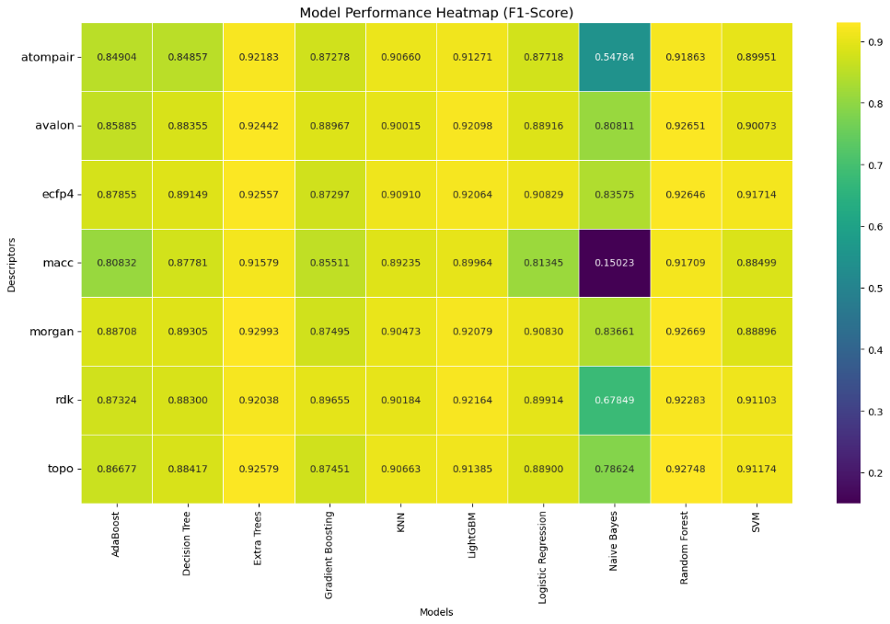
Fig. S1 F1-Score analysis across descriptors and models on the ChEMBL dataset. Each row corresponds to a molecular descriptor, while each column represents a machine learning mode
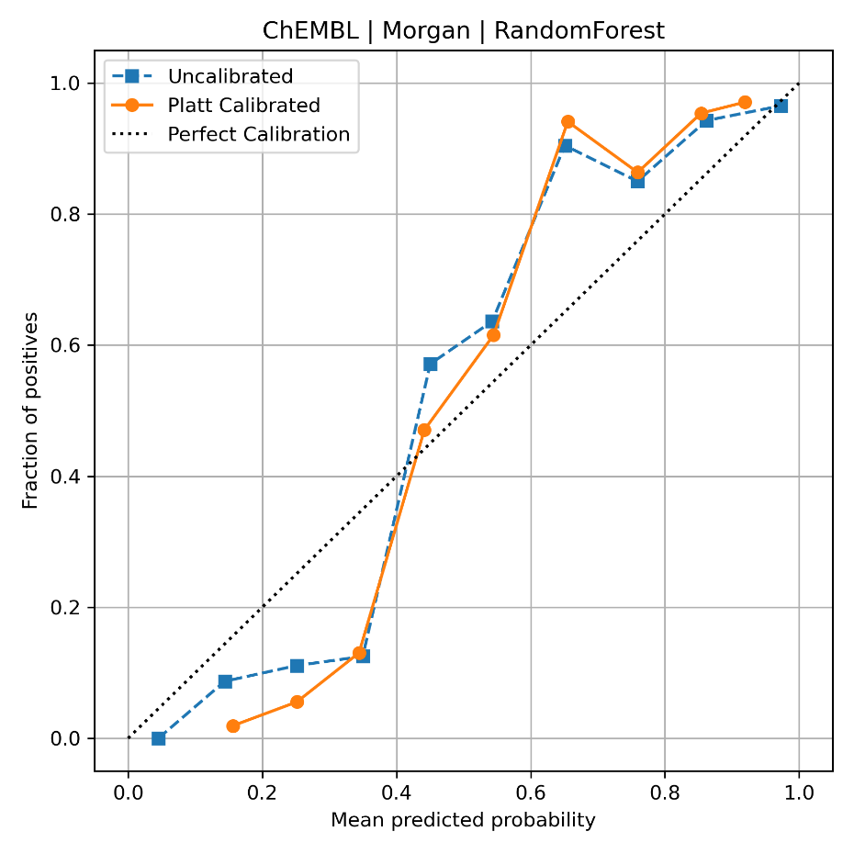
Fig. S2 Reliability diagram illustrating probability calibration performance of the Random Forest model with Morgan count fingerprints on the ChEMBL dataset. The uncalibrated model (blue) and Platt-calibrated model (orange) are compared against the ideal calibration line (diagonal).

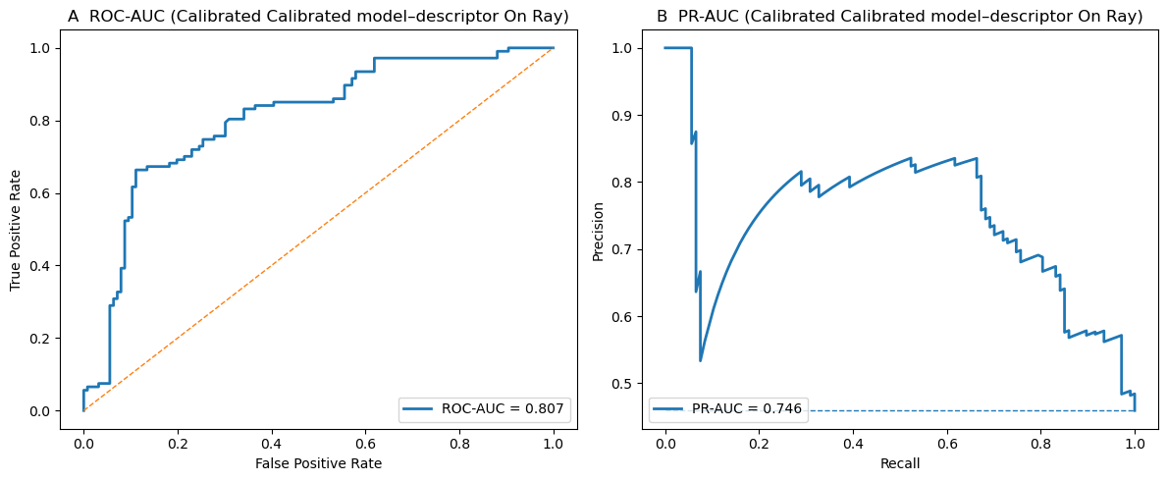
Fig. S3 Performance of calibrated model–descriptor on Ray. (A) ROC-AUC (left) and (B) PR-AUC (right).

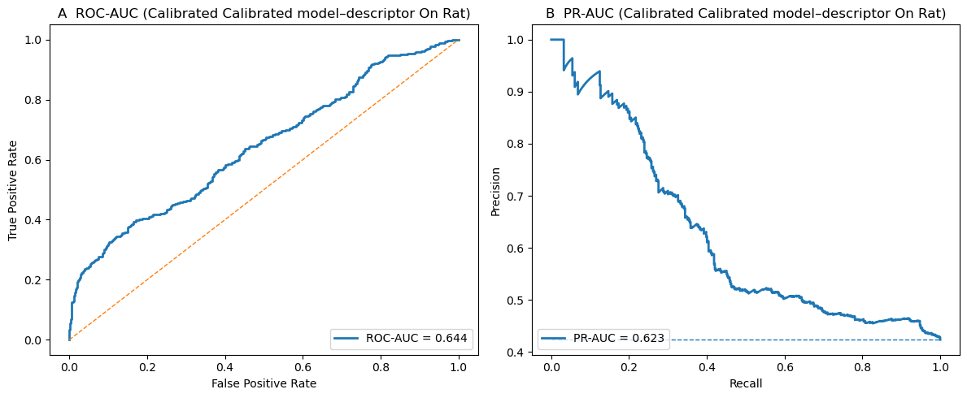
Fig. S4 Performance of calibrated model–descriptor on Rat. (A) ROC-AUC (left) and (B) PR-AUC (right).

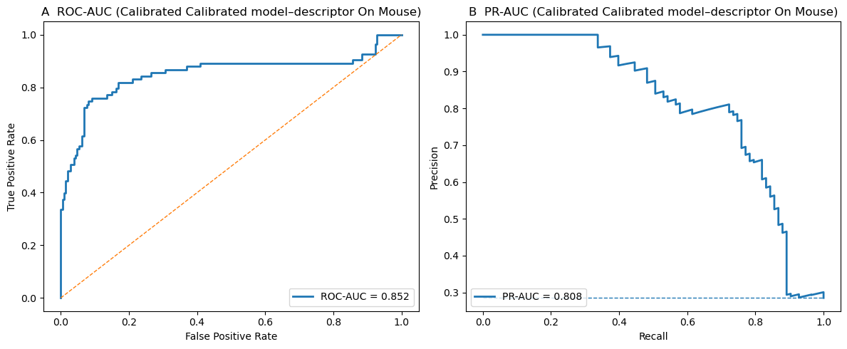
Fig. S5 Performance of calibrated model–descriptor on Mouse. (A) ROC-AUC (left) and (B) PR-AUC (right).

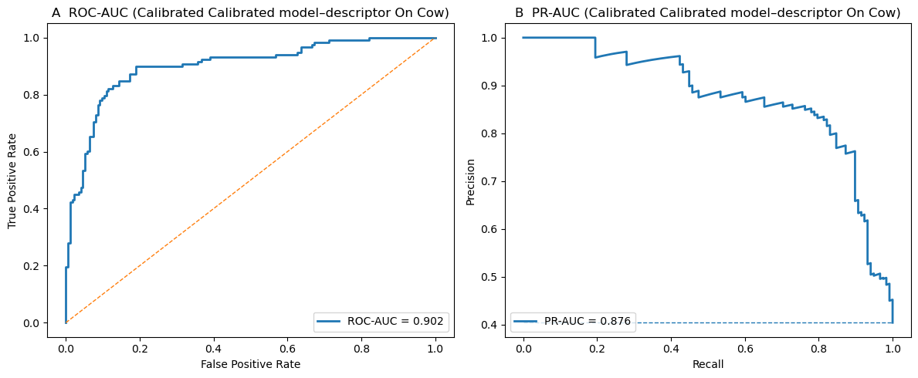
Fig. S6 Performance of calibrated model–descriptor on Cow. (A) ROC-AUC (left) and (B) PR-AUC (right).

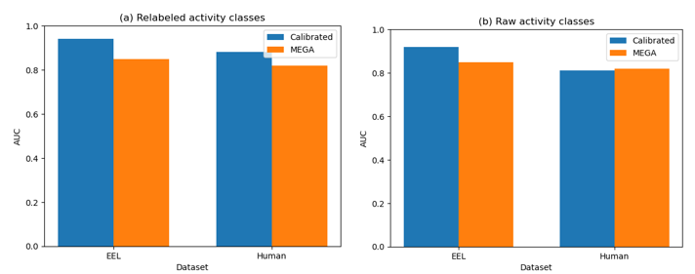
Fig. S7 Comparison of model performance (AUC) between calibrated models and the MegaAChE baseline on EEL and human datasets under two labeling strategies. (a) Results obtained using activity-class relabeling based on the proposed pipeline design. (b) Results obtained using raw activity-class labels. Bars indicate AUC values for each model, with color coding distinguishing calibrated (blue) and MEGA (orange) model.

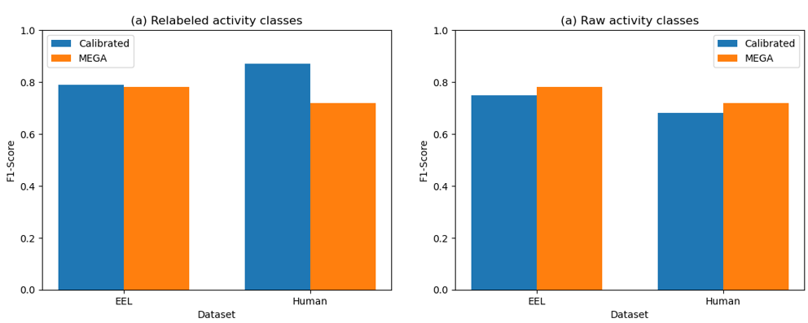
Fig. S8 Comparison of model performance (F1-Scores) between calibrated models and the MEGA baseline on EEL and human datasets under two labeling strategies. (a) Results obtained using activity-class relabeling based on the proposed pipeline design. (b) Results obtained using raw activity-class labels. Bars indicate F1-Scores values for each model, with color coding distinguishing calibrated (blue) and MEGA (orange) model.

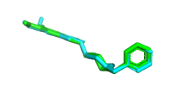
Fig. S9. Docking protocol validation by redocking of donepezil. Superimposition of the co-crystallized donepezil ligand (green sticks) and its redocked pose (cyan sticks) within the AChE active site.

Sections
Section 1
Receiver Operating Characteristic Area Under the Curve (ROC–AUC)
ROC–AUC represents the probability that a randomly selected positive sample is ranked higher than a randomly selected negative sample.
It is mathematically represented is:
ROC-AUC = ∫₀¹ TPR(FPR⁻¹(x)) dx
Where:
- TPR = True Positive Rate
- FPR = False Positive Rate

Section 2
Precision–Recall Area Under the Curve (PR–AUC)
PR–AUC summarizes the Precision–Recall curve.
PR-AUC = ∫₀¹ Precision (Recall) d(Recall)
Where:
- Precision = $\frac{TP}{(TP + FP)}$
- Recall = $\frac{TP}{(TP + FN)}$

Section 3
Boltzmann-Enhanced Discrimination of ROC (BEDROC)
BEDROC emphasizes early recognition performance in virtual screening.
$$BEDROC= \frac{\sum_{i=1}^{n}{e^{-αrᵢ /N}}}{Rα} X C$$
Where:
- α = weighting factor for early recognition
- rᵢ = rank of active compound
- N = total number of compounds
- Rα and C = normalization constants

Section 4
Multi-Criteria Decision-Making (MCDM)

For WSM, each model score was first normalized using min–max normalization:
$$x_{ij}^{norm}= \frac{x_{ij}-min⁡(x_{j})}{max(x_{j})-min⁡(x_{j})}$$
where $x_{ij}$ is the original performance score of model i under criterion j, and min(x_{j}) and max(x_{j}) denote the minimum and maximum values of criterion j across all models.
The WSM score for model i is computed as:
$$WSM=\sum_{j=1}^{m}{w_{j} . x_{ij}^{norm}}$$
where w_{j} is the weight assigned to criterion j, and m is the total number of evaluation criteria.

In TOPSIS, vector normalization is first applied:
$$r_{ij}= \frac{x_{ij}}{\sqrt{\sum_{i=1}^{n}{x_{ij}^{2}}}}$$
where n is the number of models.
Weighted normalization is then performed:
$$v_{ij}=w_{j} . r_{ij}$$
The ideal best and worst solutions are defined as:
$$A^{+}= \left\{max⁡(v_{ij})\}, \right. { A}^{-}= \left\{min⁡(v_{ij})\} \right.$$
Distances to the ideal solutions are computed as:
$$D_{i}^{+}= \sqrt{\sum_{j= 1}^{m}{{(v_{ij} - A_{j}^{+})}^{2}}}, { D}_{i}^{-}= \sqrt{\sum_{j= 1}^{m}{{(v_{ij} - A_{j}^{-})}^{2}}}$$
Finally, the TOPSIS score is calculated as:
$$TOPSIS=\frac{D_{i}^{-}}{D_{i}^{+}+ { D}_{i}^{-} }$$
A higher TOPSISi value indicates better overall performance.
Finally, the WSM and TOPSIS scores were combined to obtain a composite score:
$$S_{i}=\frac{{WSM}_{i}+ {TOPSIS}_{i}}{2}$$
Final model weights were obtained through normalization:
$$w_{i}=\frac{S_{i}}{\sum_{k=1}^{n}{S_{k}}}$$

where w_{i} is the normalized weight assigned to model i, and n is the total number of models.

Section 5
Brier Score
The Brier Score measures the difference between predicted probabilities and actual outcomes. 0 indicates perfect probabilistic predictions; lower values indicate more accurate predictions and higher values indicates poorer probability estimates
The formula is:
Brier Score = $\frac{1}{N}\sum_{i=1}^{N}{(pᵢ - oᵢ)²}$
Where:
- N = number of samples
- pᵢ = predicted probability for sample i
- oᵢ = observed outcome (0 or 1)
For binary classification:
- oᵢ = 1 for positive class
oᵢ = 0 for negative class

Section 6
Expected Calibration Error (ECE)
ECE measures how well model confidence matches actual accuracy. 0 indicates perfectly calibrated model; lower ECE indicate confidence scores closely match true accuracy and higher ECE indicates model is overconfident or underconfident.
$ECE= \sum_{m=1}^{M}{\frac{{|B}_{m}|}{n}\left|acc {(B}_{m}\right)-conf{(B}_{m})}$|
Where:
acc(B_{m}​) = actual accuracy in bin m
conf(B_{m}) = average confidence in bin m
ECE becomes 0 when:
acc(B_{m})=conf(B_{m})

