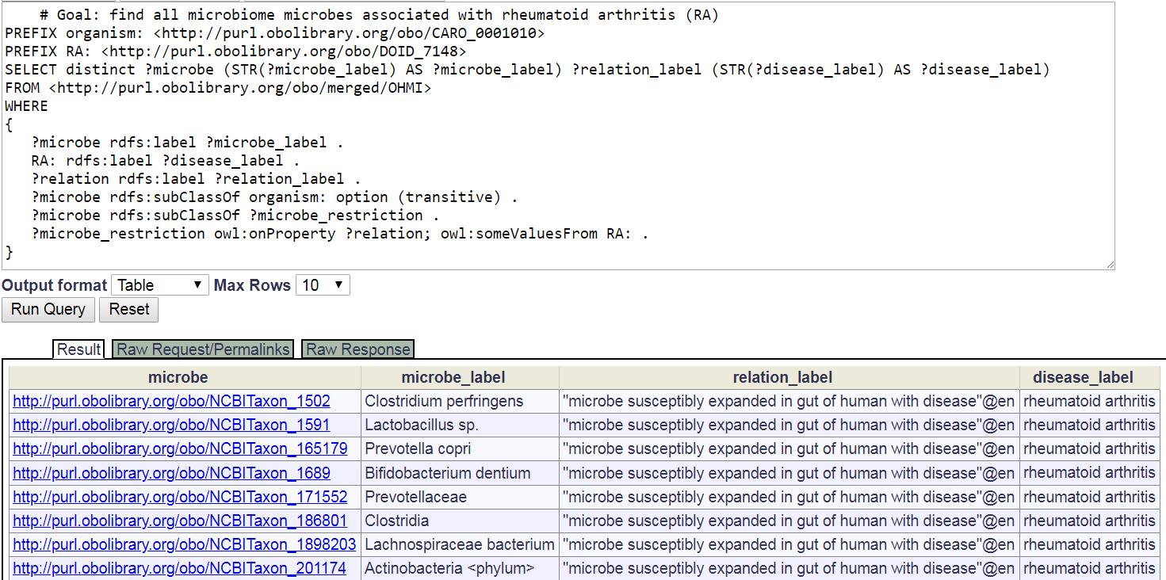

Supplemental Figure 1. SPARQL query for all microbes associated with RA and their relations. The query was conducted using the Ontobee SPARQL platform.

