Description of a fossil camelid from the Pleistocene of Argentina, and a cladistic analysis of the Camelinae
Swiss Journal of Paleontology
Sinéad Lynch, Marcelo R. Sánchez-Villagra, Ana Balcarcel
Palaeontological Institute and Museum, University of Zurich, Karl-Schmid-Strasse 4, 8006 Zurich, Switzerland
Corresponding Authors : Marcelo R. Sánchez-Villagra, m.sanchez@pim.uzh.ch ; Ana Balcarcel, ana.balcarcel@gmail.com

Appendix 3: Figures of measurements for ratio characters (chars. 44 - 49)
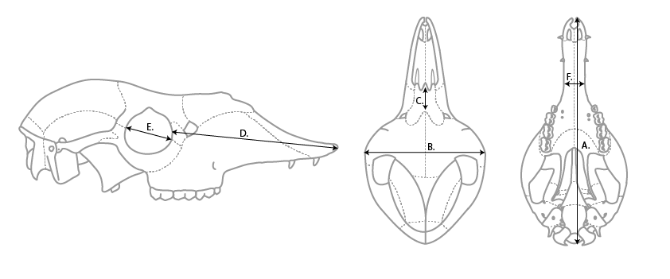
Schematic drawing of a skull of Lama guanicoe (from left to right: lateral view, dorsal view, occlusal view)
- Length of the skull (from the most anterior end of the rostrum, to the back of the condyle)
- Width of the skull (maximum width on postorbital bars)
- Length of the internasal suture (from the most anterior point to the most posterior point of the internasal suture)
- Rostrum length (from the most anterior end of the rostrum to its closest point on the border of the orbit)
- Width of the orbit (from the lacrimo-jugal suture on the anterior border of the orbit to the suture between the frontal and jugal bones on the posterior border of the orbit)
- Minimum postcanine width (narrowest width of the rostrum in ventral view )
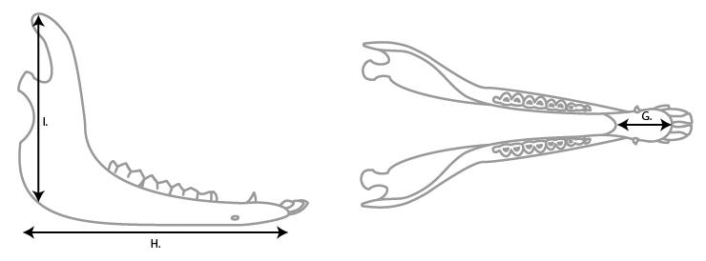
Schematic drawing of a mandible of Lama guanicoe (from left to right: lateral view, occlusal view)
- Length of the symphysis (from the most anterior point to the most posterior point of the symphysis)
- Length of the mandible (from the most anterior of the symphysis to the most posterior end of the angular process)
- Height of the mandible (from the highest point on the coronoid process to the ventral border of the mandible)

