Description of a fossil camelid from the Pleistocene of Argentina, and a cladistic analysis of the Camelinae
Swiss Journal of Paleontology
Sinéad Lynch, Marcelo R. Sánchez-Villagra, Ana Balcarcel
Palaeontological Institute and Museum, University of Zurich, Karl-Schmid-Strasse 4, 8006 Zurich, Switzerland
Corresponding Authors : Marcelo R. Sánchez-Villagra, m.sanchez@pim.uzh.ch ; Ana Balcarcel, ana.balcarcel@gmail.com

Appendix 7: Phylogeny based on matrix by Scherer (2013) with PIMUZ A/V 4165
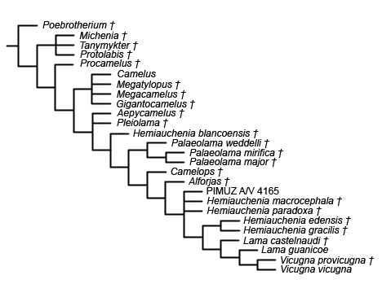
Strict consensus (L = 82 ; CI = 0.439 ; RI = 0.763 ; RC = 0.335) of 12 most parsimonious trees. Analysis based on matrix by Scherer (2013), conducted in TNT (Goloboff and Catalano 2016) using a traditional search with 6000 replicates and 10 trees saved per replications. Scoring for PIMUZ A/V 4165: ?110012?01100111100010?1111111?1?00. The scoring for all other taxa follows Scherer (2013).

