Supplementary Material 1
Supporting Information
Double-helical macrostructure aids the passive movement of extinctive graptolites (Dicellograptus) revealed by CFD simulation
by Gao Shijia, Jingqiang Tan and Wenhui Wang
Plate 1 Typical morphologies of Dicellograptus and Jiangxigraptus specimens presented in publications.
A–B: Dicellograptus with straight turbaria. A. Dicellograptus ex gr. ornatus from Malachis Hill Formation (Ian et al., 2015); B. Dicellograptus cambriensis from the Llanfawr Quarries.
C–E: Jiangxigraptus and Dicellograptus with two crossed turbaria. C. Jiangxigraptus gurleyi from Shuangjiakou B section (Gao et al., 2022); D. J. vagus from Baimachong Formation (Gao et al., 2022); E. D. szechuanensis from Wufeng Formation (Mu et al., 1993).
F: Dicellograptus sp. illustrate independent spiralling of stipes (Williams, 1981).
G–H: D. szechuanensis from Wufeng Formation exhibiting distinct thecal and proximal end (Mu et al., 1993).
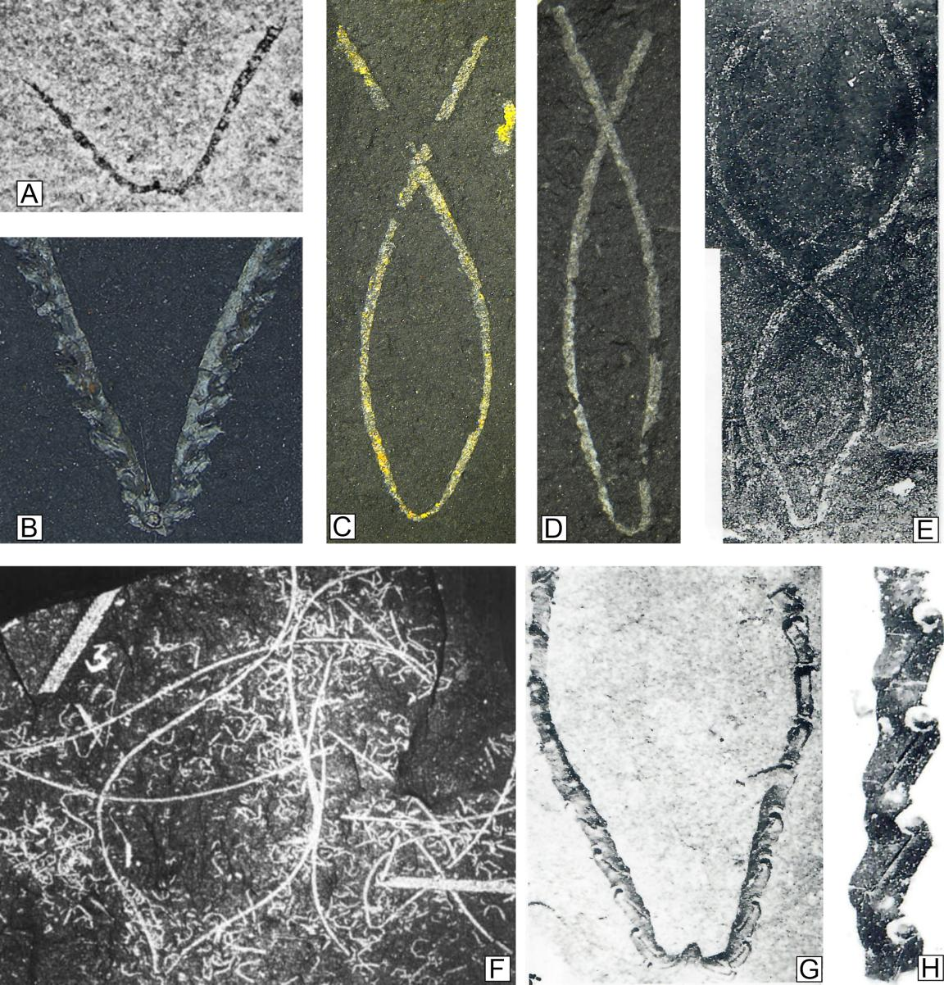

Reference
Ian, G. P., Petr, K., Zhang, Y. and Lawrence, S.P. (2015). A long-overdue systematic revision of Ordovician graptolite faunas from New South Wales, Australia. Stratigraphy, 12, 47-53.
Gao, S., Du, M., Wang, W. (2022). Jiangxigraptus Yu and Fang 1966 from the Upper Ordovician of southern Hunan Province. Acta Palaeontologica Sinica, 61: 177–196. DOI: 10.19800/j.cnki.aps.2021054
Williams, H., 1981. Form and mode of life of Dicellograptus (Graptolithina). Geological Magazine, 118, 401–408.
Mu, E. Z., Li, J. J., Ge, M. Y., Chen, X., Lin, Y. K., & Ni, Y. N. (1993). Upper Ordovician graptolites of central China region. Palaeontologia Sinica B, 29, 1–393.

