Supplementary File S3. Detailed trees from the phylogenetic analysis

Figure S3A. Strict consensus tree from the first analysis
Settings and results: Matrix (357x100, 16 states); Space for 10000 trees in memory; Max. Mem =3GB; Collapsing branches if supported ambiguously ("rule 1"); Implied Weighting is ON; Weighting strength is 11.00000; Constraints is ON, 28 positive tree-constraints, other taxa left as floaters; Random seed is 1. Search using “new technology search”. This included activating the ratchet, tree drifting, sectorial searches, and tree fusing algorithms, driven search set at 7 initial additional sequences (set level = 30), best score hit =30 times. We also performed a second round of TBR on the MPTs in RAM to search for all the MPTs. Total rearrangements examined: 1,516,725,031; Best score = 74.17123, 3 trees found after second round of TBR. Consistency index = 0.241; Retention index = 0.675. Tree length = 1714.
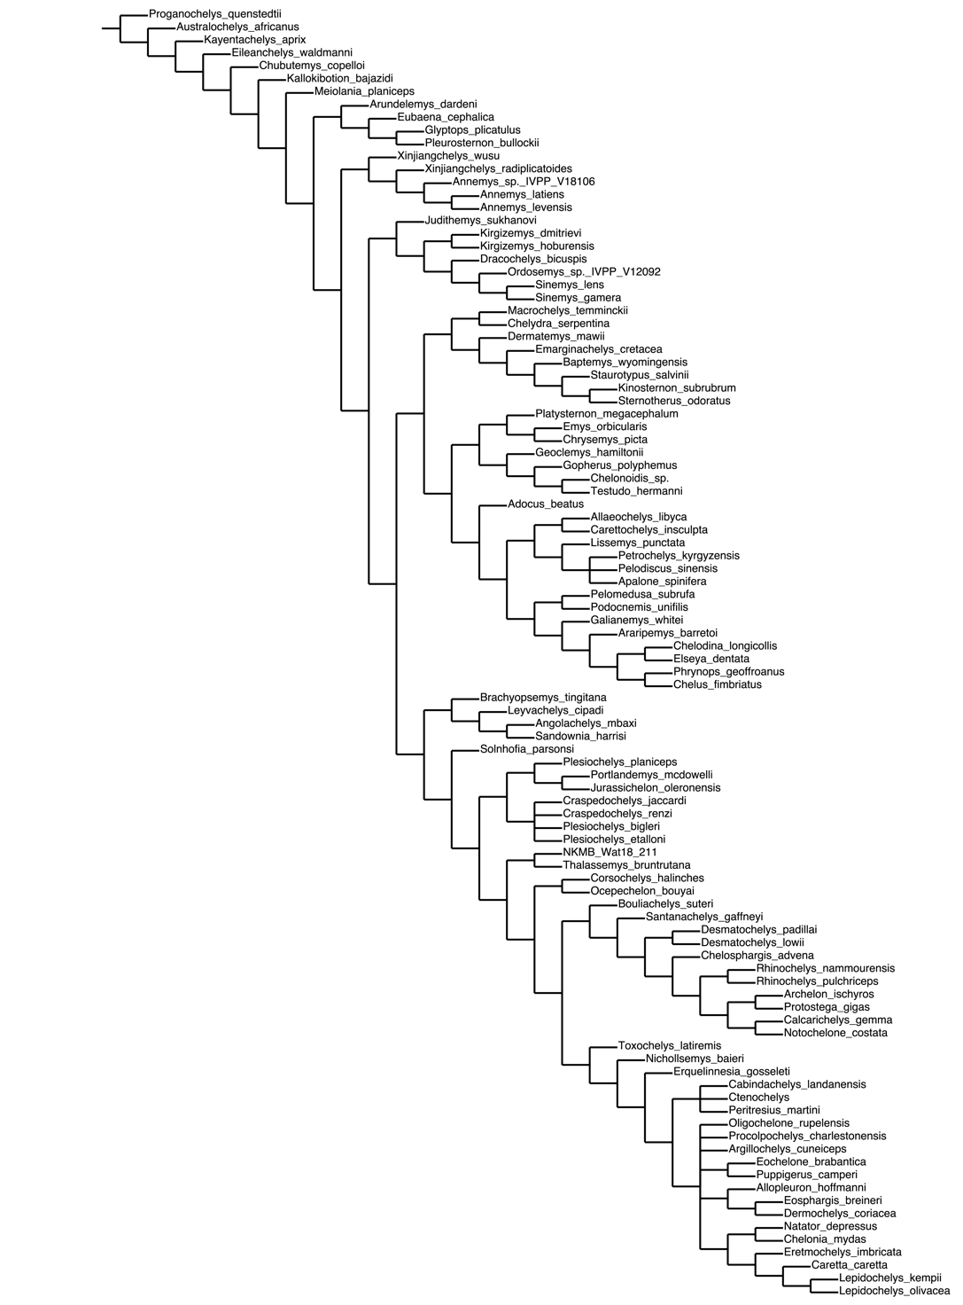
Figure S3B. Strict consensus tree from the second analysis
Settings and results: Equal settings as in the first analysis but removing (inactivating) “wildcard” taxa and the whole clade Pleurodida: Argillochelys cuneiceps, Pleurodira (Chelus fimbriatus, Phrynops geoffroanus, Elseya dentata, Chelodina longicollis, Araripemys barretoi, Podocnemis unifilis, Pelomedusa subrufa, and Galianemys whitei). Total rearrangements examined: 1,519,164. Best score (TBR): 64.09238. 9 trees found after second round of TBR. Consistency index = 0.277; Retention index = 0.731; Tree length = 1492.
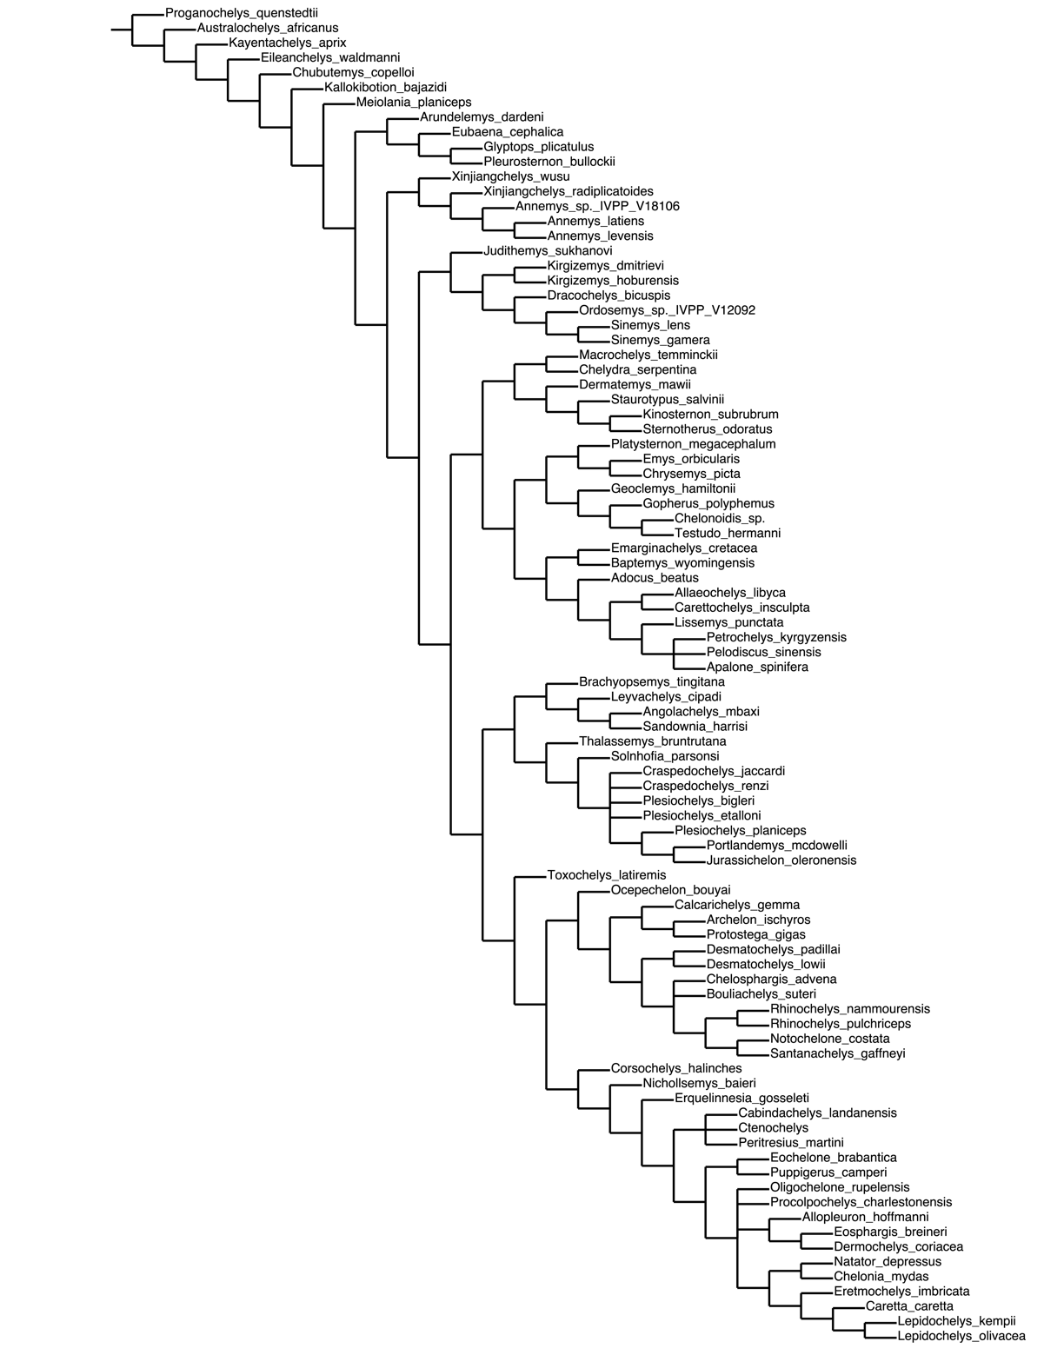

Figure S3C. Strict consensus with combined Bremer via TBR of the second analysis

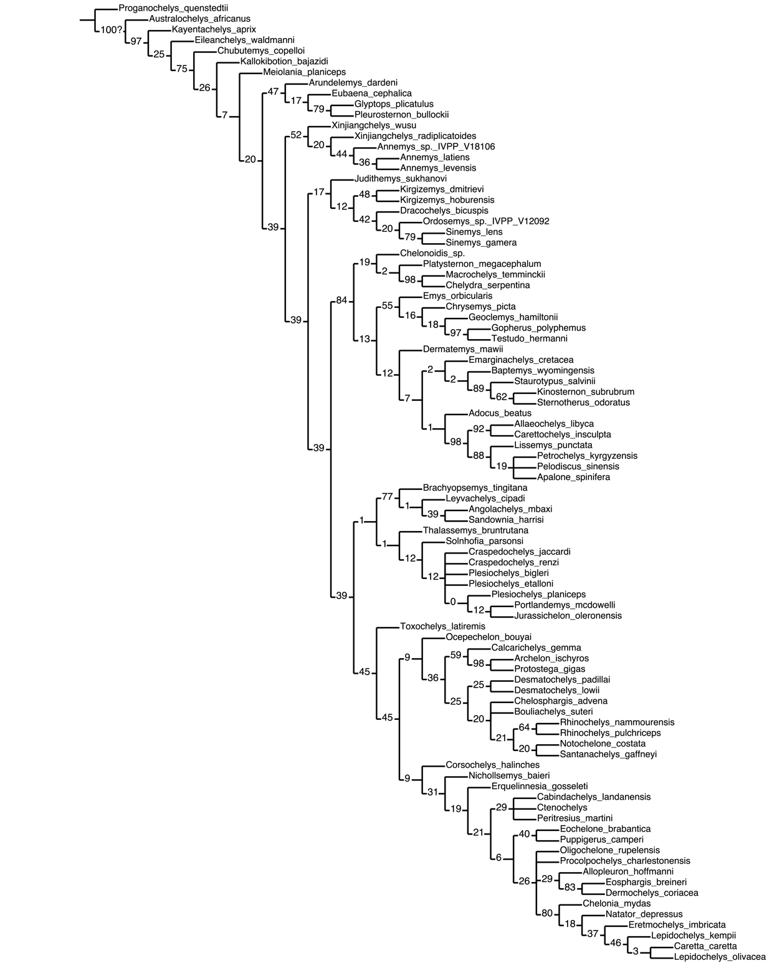

Figure S3D. Full map of common synapomorphies resulted from the second analysis.

