Supplementary Material 1 – Titin repeated region

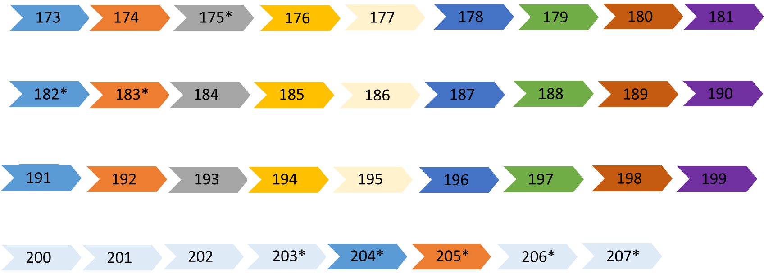

Titin repeated region is composed of nine exons (here represented by different colors) repeated three times. Therefore, by using an NGS traditional approach, each ´copy´ of a repeated exon is indistinguishable from the others (for example, exon 173 is indistinguishable from exons 182 and 191; 174 is indistinguishable from exons 183 and 192 and so on). Moreover, two further exons (204 and 205) are a copy of previous exons.
Within the repeated region, the only expressed exons in human adult muscle are 175-182-183-203-204-205 (indicated by an asterisk). The remaining exons are thought to be metatranscript-only exons.
During the mapping phase, NGS-reads are split among the repeated exons, i.e. reads spanning exons 173 and 174 are mostly indistinguishable from those spanning exons 182-183; 191-192; 204-205; 173-183; 173-192; 173-205; 182-192; 182-205 and 191-205. In other words, it is possible to detect reads linking ‘the blue exons’ (173-182-191-204) to the ´orange ones´ (174-183-192-205) without reliable information about the specific exons connected.
In order to overcome the technical issues due to such a complex genetic organization, we used a pragmatic approach.
1) We counted all reads supporting expected, canonical junctions (Additional file 4 – Table S3);
2) We counted all the reads suggesting previously unreported linear junctions (Additional file 5 – Table S4);
3) We counted all the reads supporting not canonical junctions, i.e. connecting exons out of the repeated area and exons within the repeated region (Additional file 5 – Table S4);
4) We counted all the reads supporting not canonical junctions, i.e. connecting exons within the repeated region (Additional file 5 – Table S4).
Similarly, we included in Table S3 and S4 the number of reads supporting each junction identified in publicly available Encode data from adult skeletal muscle (gastrocnemius medialis).

