Image Acquisition and image format
- Microscope: Zeiss Axio
- Objective: 10X objective
- Channel 1: Membrane, FICT 488 (green)
- Channel 2: MyHC, Cy549 (red)
- Format: from the Axio microscope, export the images of the individual channels in a TIF format without compression (16 bit).
  - In the Axio Click on the Processing tab
Method Image Export
    - File type: Tagged Image File Format (tiff)
    - 8bit - deselect
    - Compression: NONE
    - Original Data - select
    - Apply Display Curve and Channel Color - deselect
    - Export to: choose file where all images are
    - Create folder – select
- You will have an ORG file for each channel. These file names are recognized by the macroIMRB: FileNameNoSpaces_C1_ORG, and FileNameNoSpaces_C2_ORG

Automated Morphometric Analyses using the MacroIMRB
The macro can run in Fiji in a computer with available Java 8 runtime. The image processing is compatible with Windows 64-bit (XP, Vista, 7, 8 and 10), Mac OS (X 10.8), Mac OS X and Linux (64 and x86 architectures).
- Download the macro script (text file) and save it into a suitable folder.
- Install and open FIJI- ImageJ (https://fiji.sc/)
- Go to Plugins macros run and click on the macro file
- It is possible to modify the following variables for detection in a pop-up window that will appear before running the analysis. These are the default parameters:
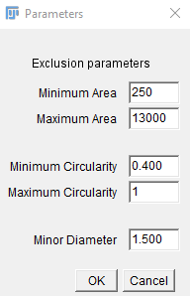
- A window will open: choose the folder were the images to analyze (with the appropriate format for the macroIMRB) are saved. Images can be saved in subfolders within the main folder.
- The macro will run automatically and will analyze all the images contained in the main folder (including those in subfolders).
- The morphometry parameters: CSA (µm²), perimeter (µm), major (µm) and minor diameters (µm), and circularity (0-1) will be computed for all myofibers. The results obtained will be automatically saved as excel (.xls) files for all, type I, and type II myofibers separately.
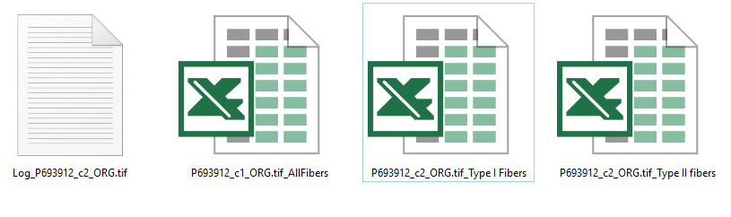

- To facilitate visual analysis of fiber size distribution (area and minor diameter), a color-coded map for each section will be created (these parameters can be modified by the user directly in the macro script – default parameters are set up for adults).

Table 1. Color key for Area and minor diameter size maps
 | Cross-Sectional Area (µm²) |  |  |  | Minor Diameter (µm)
 | Adults |  | Children |  | Adults/Children
Dark orchid | ≤1000 |  | ≤300 |  | ≤10
Night Blue | > 1000 to ≤1500 |  | > 300 to ≤ 600 |  | > 10 to ≤ 20
Cyan blue | >1500 to ≤ 2000 |  | > 600 to ≤ 1000 |  | >20 to ≤ 30
Dark Cyan | >2000 to ≤ 2500 |  | >1000 to ≤ 1300 |  | >30 to ≤ 40
Dark Sea Green | > 2500 to ≤ 3000 |  | > 1300 to ≤ 1600 |  | > 40 to ≤ 50
Yellow | > 3000 to ≤ 3500 |  | > 1600 to ≤ 2000 |  | > 50 to ≤ 60
Orange | >3500 to ≤ 4000 |  | >2000 to ≤ 3000 |  | >60 to ≤ 70
Red | >4000 |  | >3000 |  | >70

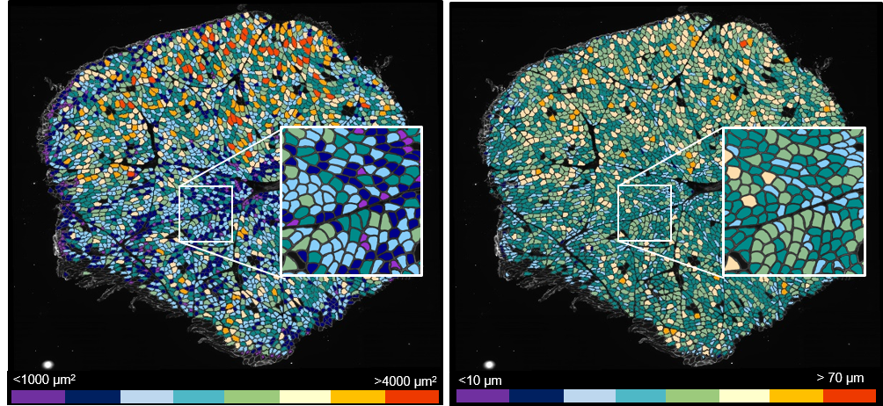

- A log file for each sample with the total area of tissue detected (µm²), and the number of total, type I, and type fibers quantified will be saved in the same folder selected for analysis.

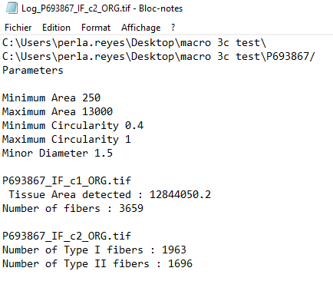
- The program runs in a loop, and once analyses are completed, a pop-up message in the computer screen will appear to inform the user.

