Supplemental Data

Materials & Methods
Measurement of HIF-1α transcriptional activity using a luciferase assay
The activity of the hypoxia pathway was measured using the HRE-luciferase reporter plasmid (26731; Addgene, 26731; Cambridge, MA, USA). Freshly isolated mrSCs were transfected with 200 µg of HRE-luciferase plasmid 3 days after being seeded in a 24-well plate in serum-free DMEM containing 1 µL of Fugene 6™ (Promega, Madison, WI, USA) and were cultured for 24 h. The medium was replaced with DMEM supplemented with 5% (v/v) HS and 1% (v/v) P/S and the mrSCs were cultured for a further 24 h. They were then cultured for 6 h or 24 h in normoxic incubator conditions or in hypoxia. The transcriptional activity of the hypoxia pathway was measured using a Luciferase Assay System kit (Promega) and a Titertek-Berthold luminometer (Pforzheim, Germany). The data were normalized to the protein content measured using the Bradford method.
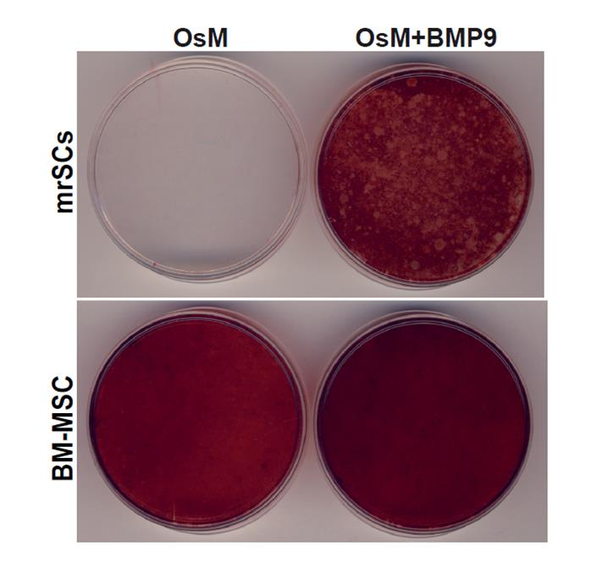
Figure S1. Comparison of the osteogenic potential of mrSCs and BM-MSCs
Representative micrographs of the in vitro osteogenic differentiation of mrSCs and BM-MSCs with or without BMP9. Without BMP9, only the BM-MSCs differentiated into osteoblasts, as revealed by Alizarin Red S staining. When 1 nM of BMP9 was added to the osteogenic medium, the mrSCs also differentiated into osteoblasts.
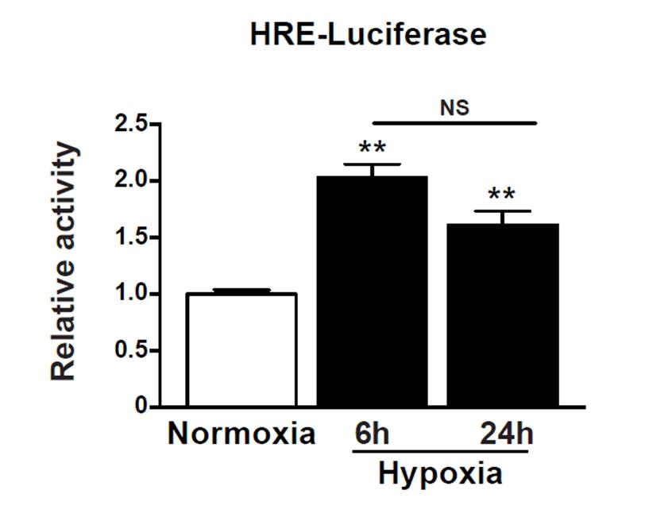
Figure S2. In vitro induction of HIF-1α activity
The transcriptional activity of HIF-1α was measured as a function of time. The reporter plasmid HRE-luciferase was transfected into mrSCs cultured in normoxic incubator conditionsor hypoxia (1% O₂). There was a significant increase in luciferase activity in mrSCs cultured in hypoxia after 6 and 24 h, indicating that 1% O₂ is sufficient to activate the HIF-1α pathway in mrSCs (mean ± SEM of two independent experiments, n=3/experiment; **p<0.01).

Table S1. Compositions of the osteogenic and adipogenic differentiation media
Type | Basal Medium | Supplements | Staining
Osteogenic | DMEM, 5% (v/v) HS | 20 µg/ml ascorbic acid | Alizarin Red S
 | 1% (v/v) antibiotics | 100 nM dexamethasone
 |  | 10 mM β-glycerophosphate
Adipogenic  (Induction) | DMEM, 10% (v/v) FBS | 1 µM dexamethasone
 | 1% (v/v) antibiotics | 5 µg/mL insulin
 |  | 0.5 mM isobutyl methylxanthine (IBMX)
Adipogenic | DMEM, 10% (v/v) FBS | 5 µg/ml insulin | Oil red O
 | 1% (v/v) antibiotics

Table S2. Primer sets used for the qPCR
Gene | Forward Primer | Reverse Primer | NM NCBI
BMP2 | TGGAAGGTGGCCCATTTAGAG | TGACGCTTTTCTCGTTTGTG | NM_001200
BMP7 | GAAAACAGCAGCAGTGACCA | GGTGGCGTTCATGTAGGAGT | NM_001719
BMP9 | GGCTGAGCTCCGACTCTATG | AACCTGGAGGGACACTGATG | NM_016204
HIF-1α | TCAAGTCAGCAACGTGGAAG | TATCGAGGCTGTGTCGACTG | NM_010431
18S | AGGAATTGACGGAAGGGCAC | CGACATCTAAGGGCATCACA | NR_003286

