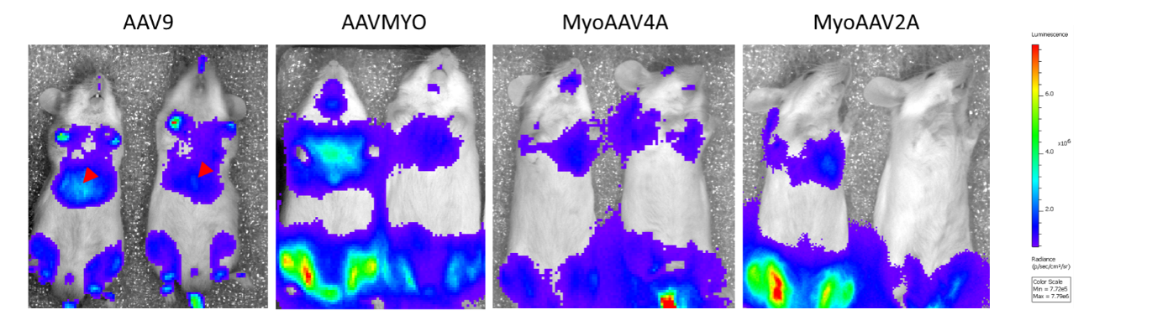
Supplementary figure 2. In vivo bioluminescence 1 week after injection of myotropic AAVs. Intensity of whole-body luminescence in WT CD1 7-week-old mice systemically injected at 6 weeks with 4.5E+13 vg/kg of AAV9-, AAVMYO-, MyoAAV2A-, or MyoAAV4A-CMV-luc-IRES-eGFP. Liver signals are indicated with red arrowheads. Color scale: 7,72E+5 – 7,79E+6 photons per second per centimeter square per steradian (p/sec/cm²/sr).

