SUPPLEMENTARY FIGURES
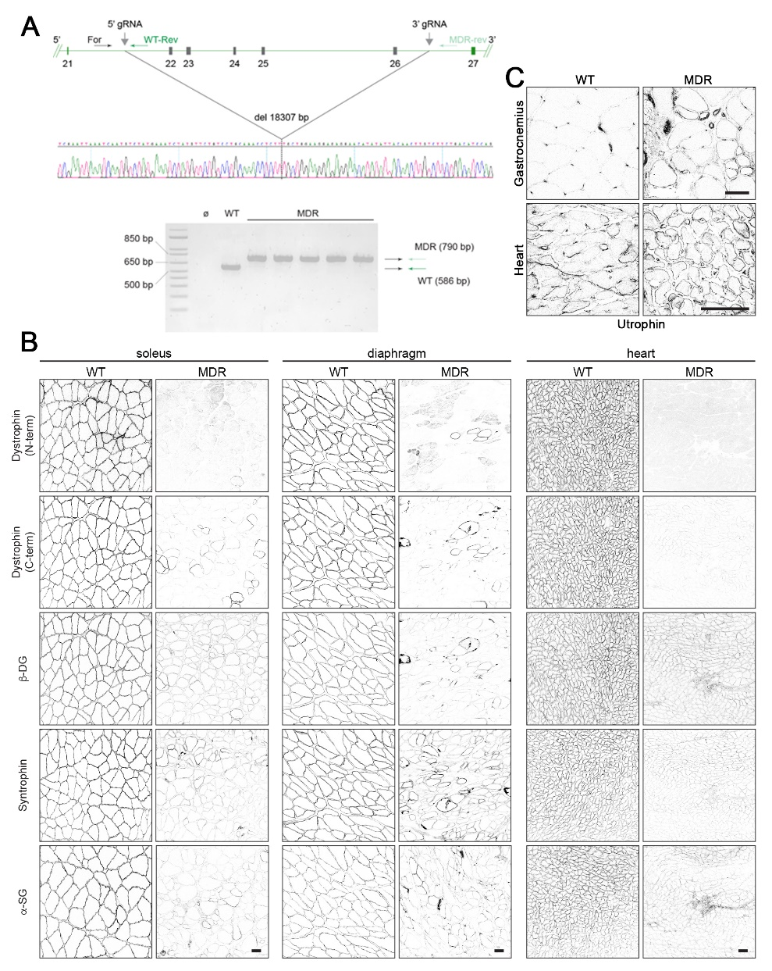
Figure S1. MDR genotyping and DGC localization. (A) A set of three primers are used to genotype the rats. For WT, two primers placed within the intronic region between exons 21 and 22a common forward primer (For) and a WT reverse primer (WT rev) situated 5’ and 3’, respectively, to the sequence targeted by 5’ gRNA yield a 568 bp product. For MDR, For and a MDR reverse primer (MDR rev) – latter situated 3’ to the 3’ gRNA – yield a 790 bp product. Examples of the PCR products that match predicted sizes are visible after separation within an agarose gel. A portion of the sequence trace of the 790 bp products confirms the deletion of 18,307-bp stretch of rat Dmd that includes exons 22-26. (B) Immunofluorescence was used to investigate sarcolemmal localization of dystrophin and the DGC members of β-dystroglycan (β-DG), α-dystrobrevin (α-DB), α-sarcoglycan (α-SG), and syntrophins in WT and MDR soleus, diaphragm, and heart, as well as (C) utrophin localization in the WT and MDR gastrocnemius and heart (scale bars = 50 µm).

Figure S2. Reduced myofiber diameters of MDR skeletal muscles. The frequency distribution of WT and MDR diaphragm and soleus muscle fibers minimum Feret’s diameter was performed at 3 and 12 months of age (n = 3-4). There is a left shift (towards smaller diameter) for dystrophic rat muscle fibers. The vertical bars above the frequency distribution plot indicate the average minimum Feret’s diameter, with the arrow indicating the WT-to-MDR shift. Data are displayed as mean±SEM and were analyzed using multiple T-tests (α = 0.05; * p < 0.05, ** p < 0.01, *** p < 0.001).

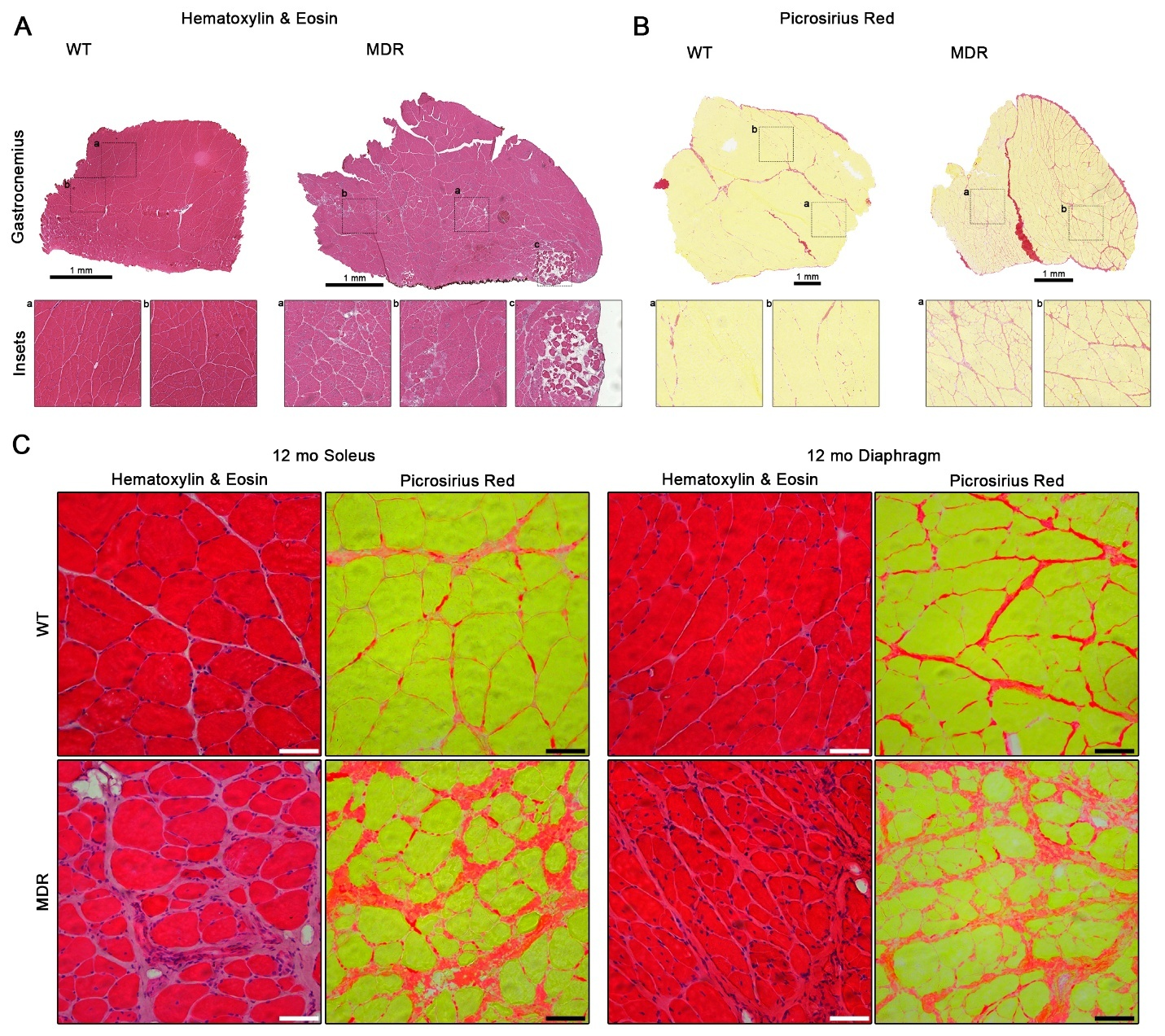
Figure S3. Histopathological features in MDR muscle. Histology was performed on 6 month-old wild-type (WT) and dystrophic (MDR) gastrocnemius muscles using (A) hematoxylin & eosin and (B) picrosirius red (scale bar = 1 mm). (C) Representative hematoxylin & eosin and picrosirius red images from 12 mo WT and MDR soleus and diaphragm muscles (scale bar = 100 µm).

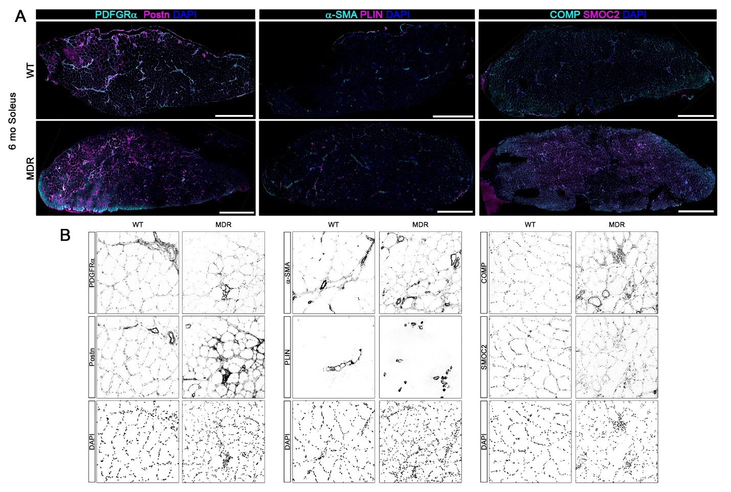
Figure S4. Extracellular matrix markers in MDR muscle. (A) Immunofluorescence was performed on 6 month-old soleus muscles to investigate the localization of PDGFRα, Postn, α-SMA, PLIN, COMP, and SMOC2 (scale bars = 1 mm). The merged images of (B) are located in Figure 4E.

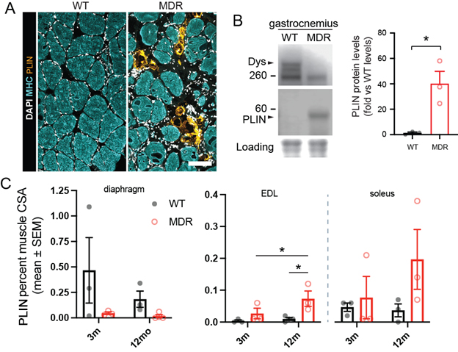
Figure S5. Adipocytes in MDR skeletal muscles. (A) Transverse sections of the soleus muscle labeled for myosin heavy chain (MHC) and perilipin 1 (PLIN) reveal the presence of intramuscular fat deposition in the dystrophic animals (Scale bar = 100 µm). (B) Western blots of gastrocnemius muscle lysates also show increased PLIN protein expression with MDR vs WT rats by Student’s T-test (n = 3). (C) Analysis of muscle transverse sections stained for perilipin shows an increase in the PLIN-positive fraction of muscle cross sectional area in 12-month-old MDR EDL muscles, but not in diaphragm or soleus (n = 3-4), by 2-way ANOVA for age and strain following by Fisher’s LSD test. Data are displayed as mean ± SEM with individual values.

