Supplementary material
Assessment of Emerin Gene Transfer in Models of X-linked Emery-Dreifuss Muscular Dystrophy

Ji-Yeon Shin^{1,*}, Yi Peng Zhao², Qi Jin^{2,3}, Nicholas Rouse⁴, Peter L. Nagy⁴, Michael J. Lee³, Kurenai Tanji³, Barry M. Fine², Howard J. Worman^{2,3,*}

¹Hackensack-Meridian Health Center for Discovery and Innovation, Nutley, NJ, USA
²Department of Medicine, Vagelos College of Physicians and Surgeons, Columbia University, New York, NY, 10032, USA
³Department of Pathology and Cell Biology, Vagelos College of Physicians and Surgeons, Columbia University, New York, NY 10032, USA
⁴Praxis Genomics, LLC, Atlanta, GA 30328, USA

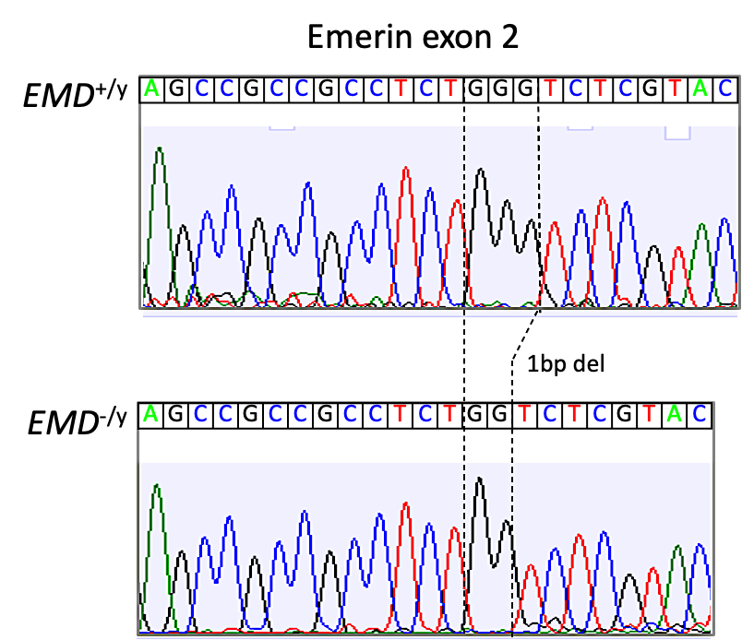
Supplementary Fig. 1 Sanger sequencing chromatograms showing a single nucleotide deletion in EMD^{-/y} iPSCs. The nucleotide sequences shown are those of the strand complementary to the coding strand.

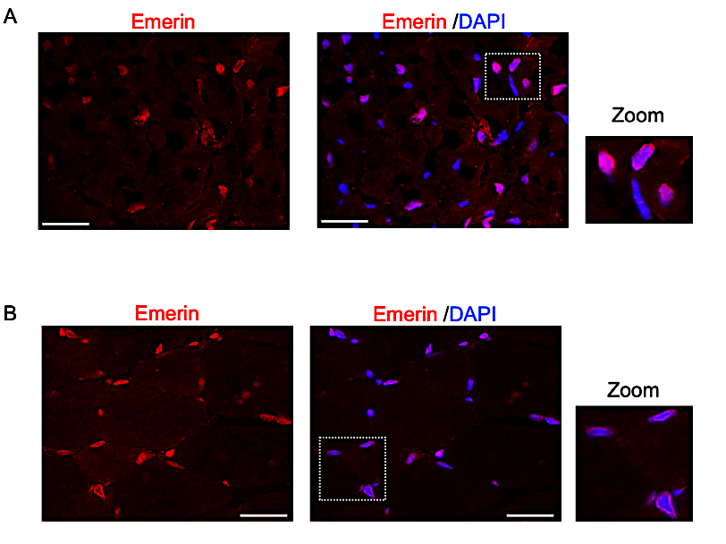
Supplementary Fig. 2 (A) Representative confocal immunofluorescence micrographs of heart sections from wild-type mice. Sections were labeled with antibodies against emerin and stained with DAPI to detect nuclei. The far-right panel is a zoomed image of the dotted square region. Scale bars: 40 µm. (B) Representative confocal immunofluorescence micrographs of gastrocnemius sections wild-type mice. Sections were labeled with antibodies against emerin and stained with DAPI to detect nuclei. The far-right panel is a zoomed image of the dotted square region. Scale bars: 40 µm.

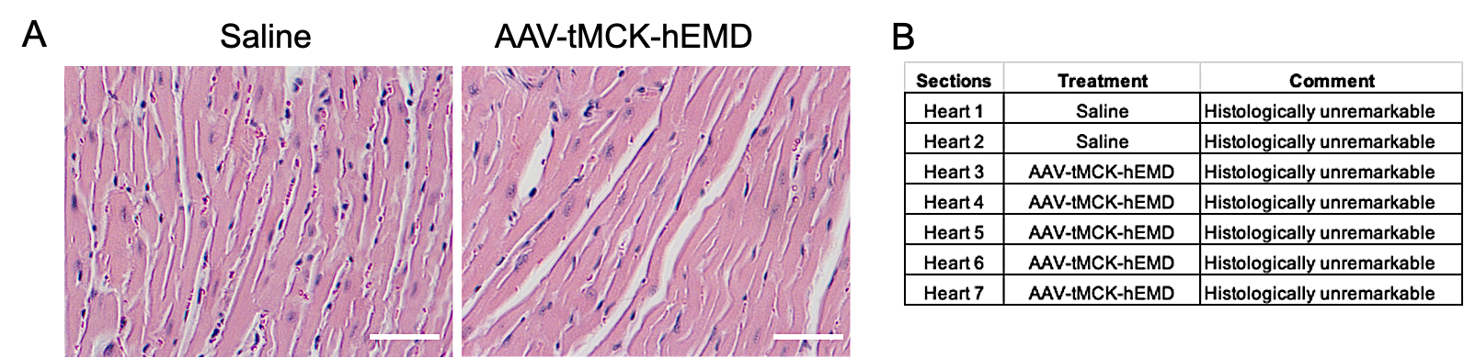
Supplementary Fig. 3 (A) Representative H & E-stained heart sections from Emd^{-/y} mice treated with saline or AAV-tMCK-hEMD. Scale bars: 50 µm. (B) Histopathological evaluation results from a pathologist blind to treatment.

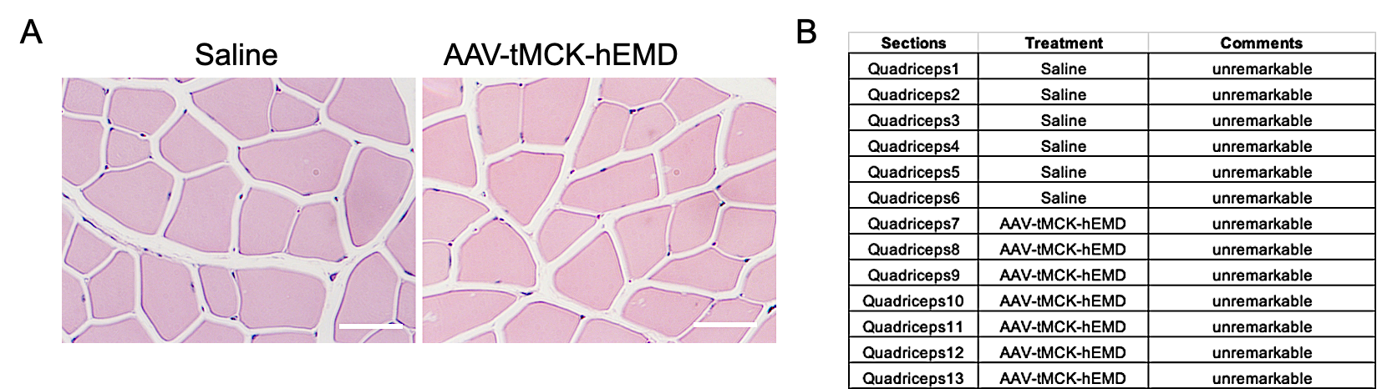
Supplementary Fig. 4 (A) Representative H & E-stained quadriceps sections from Emd^{-/y} mice treated with saline or AAV-tMCK-hEMD. Scale bars: 50 µm. (B) Histopathological evaluation results from a pathologist blind to treatment.

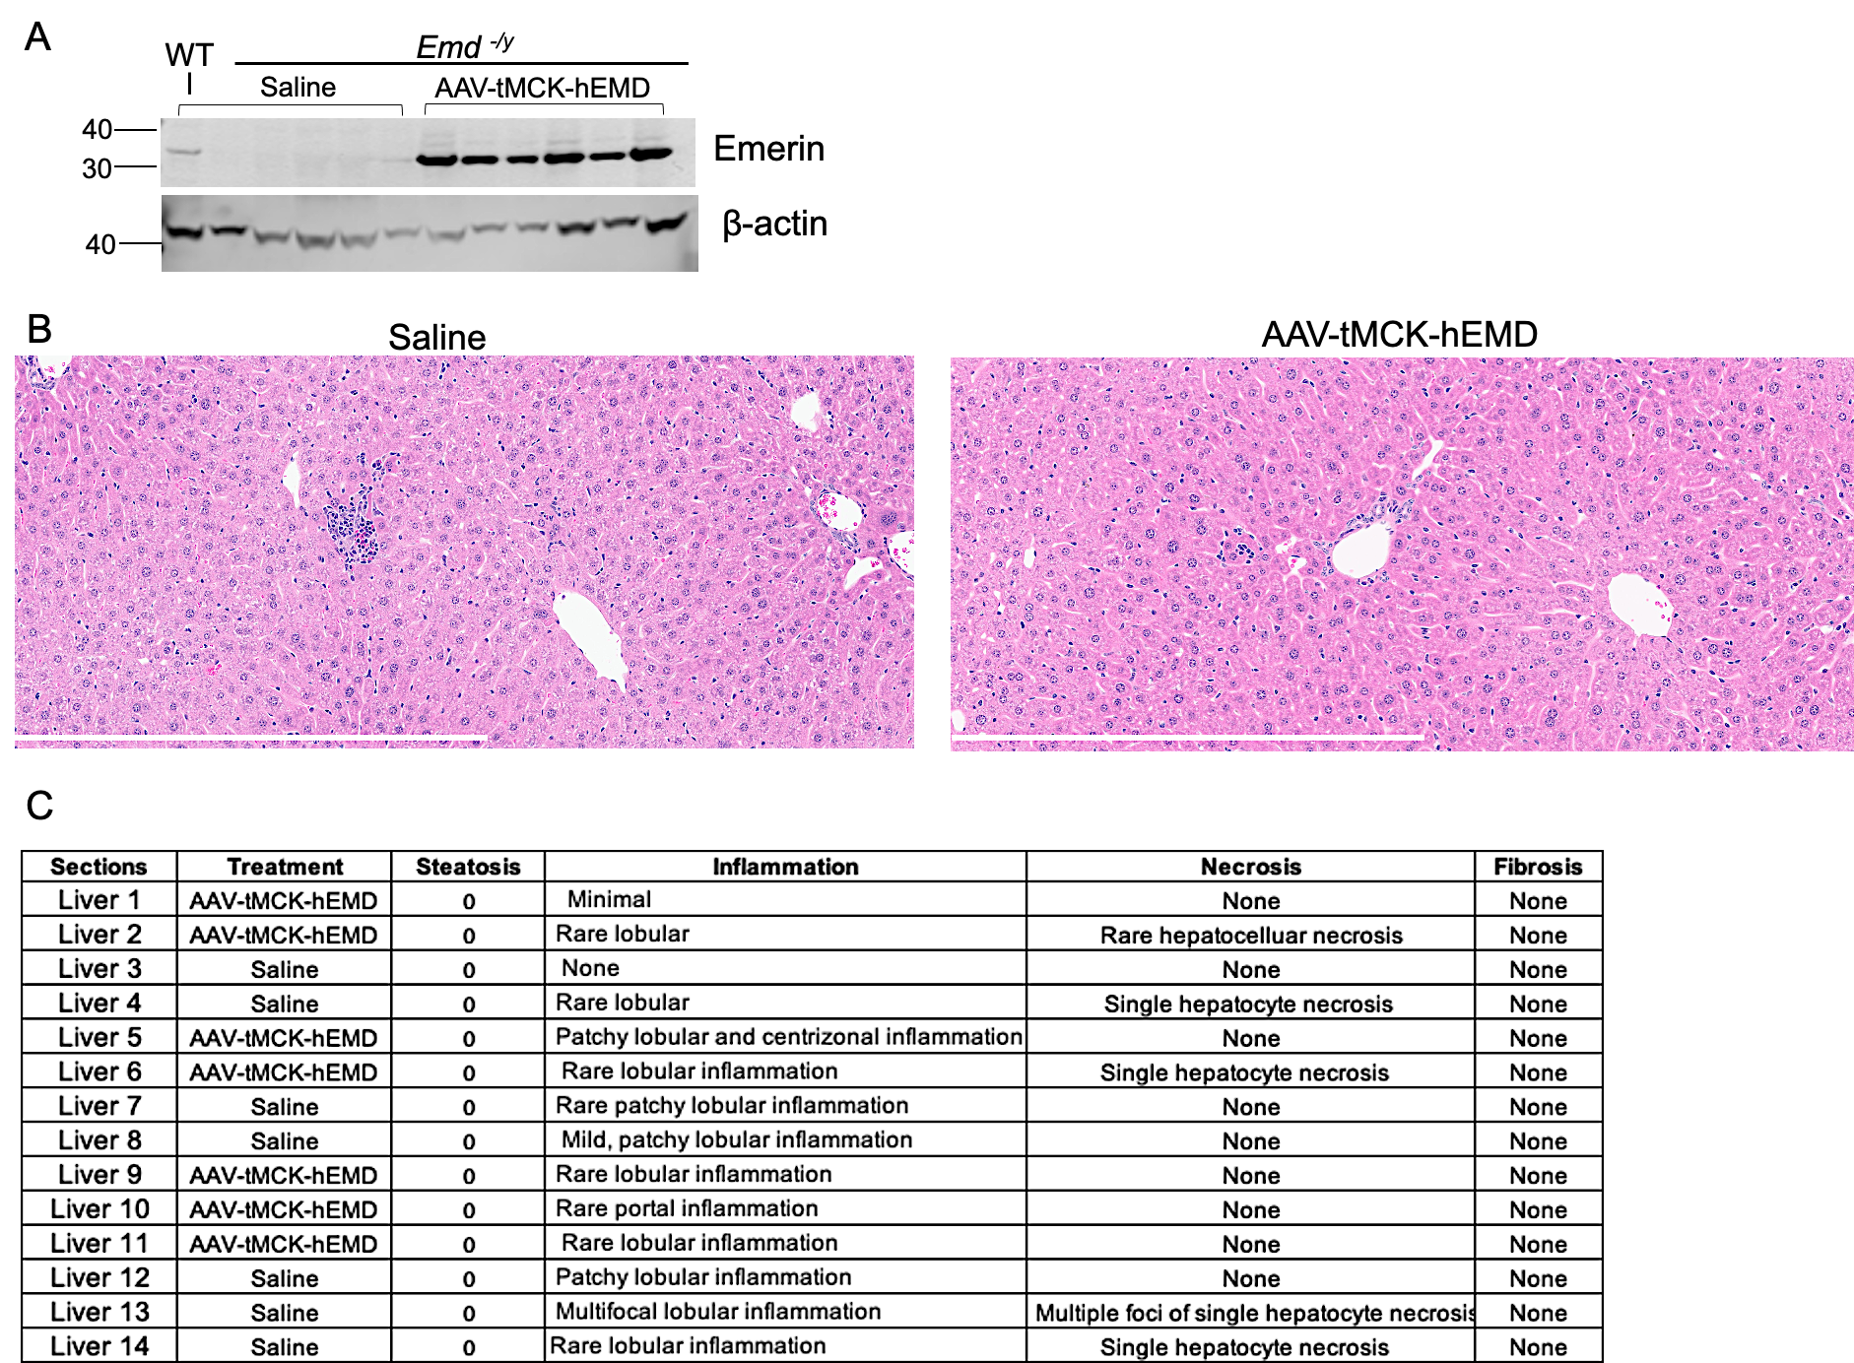
Supplementary Fig. 5 (A) Immunoblot of liver protein lysates from a wild-type mouse (WT) treated with saline and Emd^{-/y} mice treated with either saline or AAV-tMCK-hEMD probed with antibodies against emerin and β-actin. Each lane contains a sample from an individual mouse. Migration of molecular mass standards in kDa is shown at the left of the blot. (B) Representative H & E-stained liver sections from Emd^{-/y} mice injected with saline or AAV-tMCK-hEMD. Scale bars: 500 µm. (C) Histopathological evaluation results from a pathologist blind to treatment.

Supplementary Table 1 The list of upregulated and downregulated genes shown in Figure 5C.
Upregulated
Gene Symbol | Log2FC | Padj
Zbtb16 | 1.15 | 1.7962E-10
Per2 | 1.06 | 3.1907E-08
Chac1 | 1.14 | 0.000016018
Sox30 | 1.64 | 0.00015854
Kcnq5 | 1.05 | 0.02874673
Gm12185 | 2.02 | 0.04168019
Downregulated
Gene Symbol | Log2FC | Padj
Ppp1r10 | -1.11 | 3.2318E-18
Arntl | -1.5 | 3.4925E-13
Slc15a2 | -3.83 | 0.00100029
Gm31678 | -1.1 | 0.00136592
Gm49980 | -1.55 | 0.00317929
Il1b | -1.37 | 0.00712689
Cpxm2 | -1.12 | 0.010565
Kctd16 | -1.07 | 0.01269916
Pak5 | -1.02 | 0.01683037
D430019H16Rik | -1.29 | 0.01918219
Ano5 | -1.15 | 0.02760026
Gm43660 | -1.01 | 0.04322598

