Discovery and characterization of a high affinity and specificity peptide ligand LXY30 for in vivo targeting of α3 integrin-expressing human tumors

Wenwu Xiao†, Tianhong Li^{‡,§,ǁ}, Fernanda C. Bononi†, Diana Lac†, Ivy A. Kekessie†, Yanlei Liu#, Eduardo Sanchez†, Anisha Mazloom†, Ai-hong Ma†, Jia Lin†, Jimmy Tran†, Kevin Yang‡@, Kit S. Lam†,‡,§, and Ruiwu Liu*,†,§

†. Department of Biochemistry and Molecular Medicine, University of California Davis, Sacramento, California 95817, USA

‡. Division of Hematology/Oncology, Department of Internal Medicine, University of California Davis, Sacramento, California 95817, USA

§. University of California Davis Comprehensive Cancer Center, Sacramento, California 95817, USA
ǁ. Veterans Affairs Northern California Health Care System, Mather, CA 95655, USA

#. Department of Pathology and Laboratory Medicine, University of California Davis, Sacramento, California 95817, USA

@. Current address: the College of the University of Chicago, Chicago, IL 60602, USA

Table S1. HR ESI-MS data of resynthesized peptide ligands

Peptide | Molecular Formula | Calculated MW* | Measured MW*
LXY5 | [C₃₆H₄₉F₃N₁₁O₁₄S₂ + H]⁺ | 980.2854 | 980.2870
LXY6 | [C₄₃H₅₃F₂N₁₂O₁₃S₂ + H]⁺ | 1047.3265 | 1047.3347
LXY7 | [C₃₈H₅₄F₃N₁₄O₁₃S₂ + H]⁺ | 1035.3388 | 1035.3391
LXY8 | [C₃₃H₅₂N₁₁O₁₅S₂ + H]⁺ | 906.3086 | 906.3152
LXY9 | [C₃₅H₄₈F₂N₁₁O₁₄S₂ + H]⁺ | 948.2792 | 948.2872
LXY10 | [C₃₁H₄₉N₁₀O₁₄S₂ + H]⁺ | 849.2871 | 849.2907
LXY11 | [C₃₈H₅₅F₂N₁₂O₁₃S₂ + H]⁺ | 989.3421 | 989.3405
LXY12 | [C₃₅H₄₈F₂N₁₁O₁₄S₂ + H]⁺ | 948.2792 | 948.2824
LXY13 | [C₃₆H₄₇F₃N₁₁O₁₅S₂ + H]⁺ | 994.2647 | 994.2721
LXY14 | [C₃₅H₄₇F₃N₁₁O₁₄S₂ + H]⁺ | 966.2697 | 966.2785
LXY15 | [C₃₈H₅₅F₂N₁₂O₁₃S₂ + H]⁺ | 989.3421 | 989.3494
LXY16 | [C₃₅H₄₈F₂N₁₁O₁₄S₂ + H]⁺ | 948.2792 | 948.2891
LXY17 | [C₃₄H₄₆F₂N₁₁O₁₃S₂ + H]⁺ | 918.2686 | 918.9217
LXY18 | [C₄₃H₅₃F₂N₁₂O₁₃S₂ + H]⁺ | 1047.3265 | 1047.3374
LXY19 | [C₃₁H₄₂F₂N₉O₁₂S₂ + H]⁺ | 834.2362 | 834.2401
LXY20 | [C₃₂H₄₈N₉O₁₁S₃ + H]⁺ | 830.2635 | 830.2713
LXY21 | [C₃₇H₄₆F₂N₉O₁₂S₂ + H]⁺ | 910.2675 | 910.2762
LXY22 | [C₃₁H₅₃N₁₂O₁₁S₂ + H]⁺ | 833.3398 | 833.3464
LXY23 | [C₄₁H₆₁N₁₂O₁₂S₂ + H]⁺ | 977.3973 | 977.4066
LXY29 | [C₃₈H₅₅F₂N₁₄O₁₃S₂ + H]⁺ | 1017.3483 | 1017.3534
LXY30 | [C₃₈H₅₅F₂N₁₄O₁₃S₂ + H]⁺ | 1017.3483 | 1017.3498
LXY32 | [C₃₅H₅₉N₁₄O₁₃S₂ + H]⁺ | 947.3827 | 947.3905
LXY33 | [C₃₅H₅₉N₁₄O₁₄S₂ + H]⁺ | 963.3777 | 963.3853
LXY34 | [C₃₈H₅₄F₃N₁₄O₁₃S₂ + H]⁺ | 1035.3388 | 1035.3484
LXY36 | [C₃₈H₅₄F₃N₁₄O₁₃S₂ + H]⁺ | 1035.3388 | 1035.3482
LXY37 | [C₃₅H₅₉N₁₄O₁₃S₂ + H]⁺ | 947.3827 | 947.3915
LXY38 | [C₃₈H₅₅F₂N₁₄O₁₃S₂ + H]⁺ | 1017.3483 | 1017.3577
LXY39 | [C₃₈H₅₅F₂N₁₄O₁₄S₂ + H]⁺ | 1033.3432 | 1033.3525

Abbreviations: MW, molecular weight. *: dalton

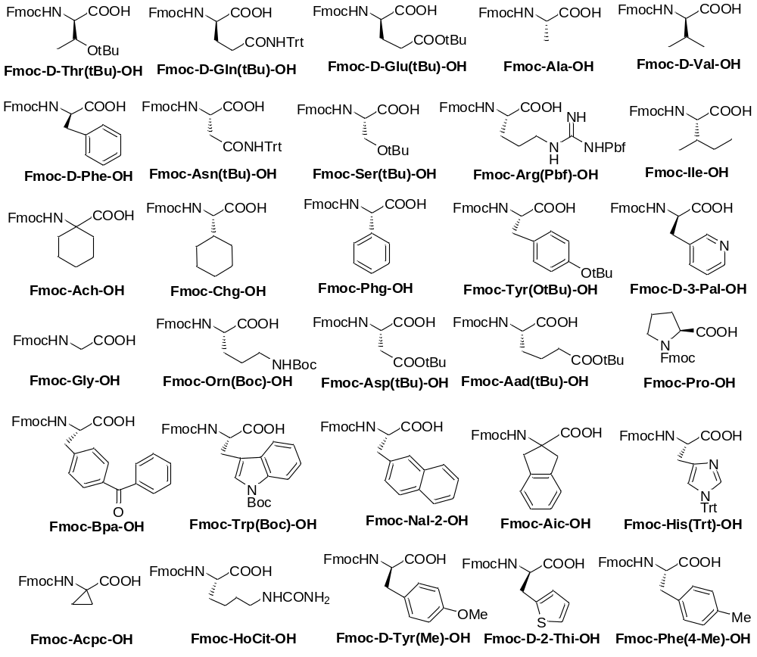

Figure S1. Thirty Fmoc-amino acids used at position X₃-X₇ in the three focused OBOC libraries

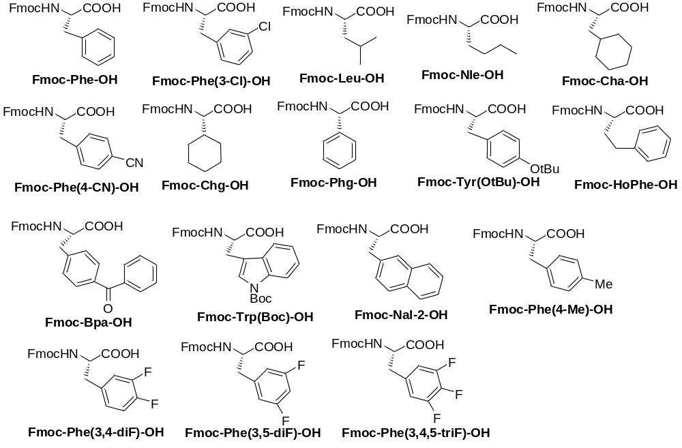

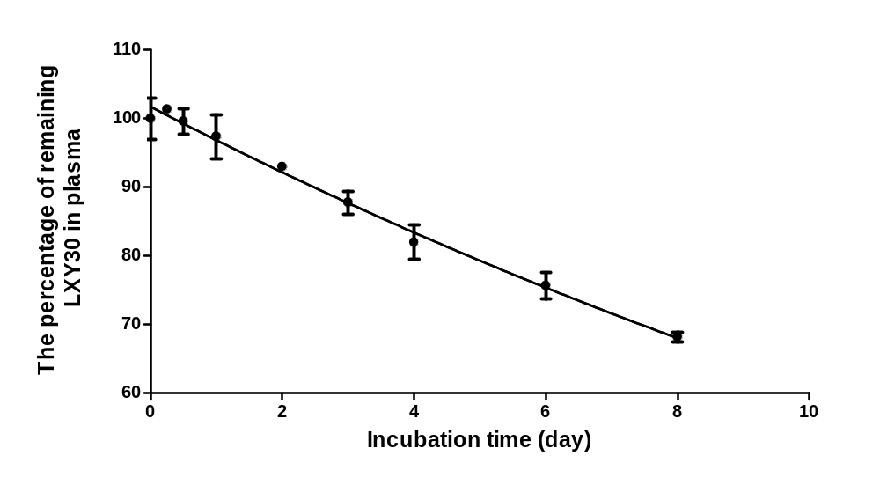Figure S2. Seventeen Fmoc-amino acids used at position X₁ in the three focused OBOC libraries
Figure S3. The in vitro stability of LXY30 in human plasma. LXY30 was incubated with 90% human plasma from healthy donor at 37°C for up to 8 days. The peptide concentrations were determined by integration of the LXY30 peak (area) from reversed-phase high-performance liquid chromatography (RP-HPLC) chromatograms at UV 214 nm. The half-life of LXY30 in the plasma was calculated as 16.0 days using the formula t_{1/2}=1/k_{obs}·ln(2). Assays were performed in triplicate.

Figure S4. Integrin α3 expression of U-87MG xenografts. The orthotopic and subcutaneous U-87MG xenografts showed positive staining for integrin α3 expression. (Scale bar: 50 µm, Blue: DAPI staining, Green: anti-α3 integrin staining. NB: normal brain)

Figure S5. Flow cytometry analysis of LXY30 binding to a panel of breast cancer (A) and lung cancer (B) cell lines (also see Table S2). Black curves represent the negative controls. Red curves represent the cell binding after the addition of LXY30-Biotin.

Table S2. Summary of LXY30 binding to various cancer cells by flow cytometry

Cell Line | Tumor Type  (Tissue, subtype) | Clinically Relevant  Molecular Biomarkers | (MFI W/ LXY30)/  (MFI W/O LXY30)* | α3 integrin RNA level
MDA-MB 231 | Breast, basal like | ER-/PR-/HER2- | 4+ | 15.7
BT-20 | Breast, basal like | ER-/PR-/HER2- | 2+ | 13.2
MCF7 | Breast, luminal A | ER+/PR-/HER2- | 2+ | 11.5
T47D | Breast, luminal A | ER+/PR+/HER2- | 1+ | 11.3
SKBR3 | Breast, HER2 | ER-/PR-/HER2+ | 1+ | 11.1
H3255 | Lung, adenocarcinoma | EGFR L858R | 2+ | NA
H1975 | Lung, adenocarcinoma | EGFR L858R/T790M | 4+ | 15.1
HCC827 | Lung, adenocarcinoma | EGFR E19Del | 4+ | 15.3
H1650 | Lung, bronchoalveolar | EGFR E19Del/T790M | 4+ | 14.7
H2228 | Lung, adenocarcinoma | EML4-ALK V3a/b | 4+ | 15.7
A549 | Lung, adenocarcinoma | KRAS G12S | 4+ | 14.9
H460 | Lung, large cell | KRAS Q61H | 1+ | 11.3

*(MFI W/ LXY30)/ (MFI W/O LXY30): Mean Fluorescence Intensity of cells incubated with 1µM LXY30 divided by Mean Fluorescence Intensity of cells without incubation with LXY30.
Mean Fluorescence Intensity (MFI) was used as the quantitative measurement. The binding strength was grouped into five categories based on the value. “0”: 1 “1+”: 1.1~4.9 “2+”: 5~19.9 “3+”: 20~79.9 “4+”: > or = 80-fold

Abbreviations: ER, estrogen receptor; PR, progesterone receptor; HER, human EGF (Epidermal Growth Factor) receptor; EGFR, epidermal growth factor receptor; EML4, echinoderm microtubule-associated protein-like 4; ALK, anaplastic lymphoma kinase; WT, wild-type gene; E19Del, exon 19 deletion; KRAS, Kirsten rat sarcoma viral oncogene homolog.

Method S1: ¹H NMR of LXY30

LXY30: ¹H NMR (800 MHz, DMSO-d₆) δ 8.94 (d, J - 8.3 Hz, 1H), 8.37 (s, 6H), 8.24 (t, J - 5.5 Hz, 1H), 8.21 (d, J - 9.2 Hz, 1H), 7.81 (d, J - 7.9 Hz, 1H), 7.77 (s, 1H), 7.64 (d, J - 4.8 Hz, 2H), 7.46 (s, 1H), 7.37 (s, 2H), 7.24 (s, 1H), 7.18 (s, 1H), 7.11 (t, J - 8.2 Hz, 3H), 7.10 – 7.07 (m, 1H), 7.05 (dd, J - 8.6, 2.2 Hz, 4H), 7.02 (s, 1H), 4.69 (dd, J - 13.5, 8.2 Hz, 1H), 4.66 – 4.60 (m, 2H), 4.44 (s, 1H), 4.39 (t, J - 8.2 Hz, 1H), 4.36 – 4.31 (m, 1H), 4.27 – 4.12 (m, 4H), 4.09 (dd, J - 13.8, 6.7 Hz, 1H), 3.91 (dd, J - 16.7, 7.7 Hz, 1H), 3.76 (d, J - 12.8 Hz, 1H), 3.25 (d, J - 10.2 Hz, 2H), 3.18 – 3.08 (m, 7H), 3.03 – 2.94 (m, 2H), 2.85 (dd, J - 15.1, 4.0 Hz, 1H), 2.81 – 2.75 (m, 2H), 2.72 (dd, J - 16.5, 8.4 Hz, 1H).

Table S3. MALDI-TOF MS of synthesized peptide-conjugates

Peptide-Conjugate | Molecular formula | Calculated MS* | Measured MS*
LXY7-Biotin | [C₇₄H₁₁₆F₃N₂₂O₂₄S₃ + H]⁺ | 1849.76 | 1849.77
LXY30-Biotin | [C₇₄H₁₁₇F₂N₂₂O₂₄S₃ + H]⁺ | 1831.77 | 1831.48
S-LXY30-Biotin | [C₇₄H₁₁₇F₂N₂₂O₂₄S₃ + H]⁺ | 1831.77 | 1831.62
LXY30-FITC | [C₈₅H₁₁₄F₂N₂₁O₂₇S₃ + H]⁺ | 1994.73 | 1994.81
S-LXY30-FITC | [C₈₅H₁₁₄F₂N₂₁O₂₇S₃ + H]⁺ | 1994.73 | 1994.81

Abbreviations: MW, molecular weight. *: dalton

Method S2: In vitro stability assay of LXY30 in human plasma
Human plasma was separated from the peripheral blood collected in the EDTA-containing blood collection tube from healthy donors. One hundred microliters of LXY30 solution (2 mM in water) was mixed with 900 µL of plasma (final concentration of LXY30 was 200 µM) and incubated at 37°C under sterile conditions. Then 100 µL of the drug-plasma mixture was removed at appropriate intervals based on expected half-life and degradation was stopped by precipitation of the sample with 10 µL of acetonitrile (ACN)/trifluoroacetic acid (TFA) (50:50 v/v). The sampling intervals were 0.1 min, 0.25d, 0.5d, 1d, 2d, 3d, 4d, 6d and 8d. A control plasma sample without LXY30 but treated in the same manner was also analyzed. The precipitated plasma samples were centrifuged at 12,000 rpm at room temperature for 20 min. The supernatant was transferred to an empty tube and centrifuged for additional 10 min at 12,000 rpm. Fifty microliter of the resulting supernatant was injected to RP-HPLC to determine the concentration of LXY30. These assays were performed in triplicate.
RP-HPLC analysis was performed on the Waters 2996 HPLC system equipped with a Luna® analytical column from Phenomenex (5 µm, C18, 100 A°, 250 x 4.6 mm). A linear gradient was run from 100% solution A (water/0.05% TFA) to 48% solution B (ACN/0.05% TFA) within 12 min with a flow rate at 1.0 mL/min. The relative concentrations of the remaining LXY30 were analyzed by the integration of the absorbance at 214 nm (area).
Half-life (t_{1/2}) for LXY30 in the plasma solution was calculated from plots of the natural logarithm of the residual concentration against time using the formula t_{1/2}=1/k_{obs}·ln(2), where k_{obs} is the apparent first order rate constant for the observed degradation.

Method S3: Xenografts stained with anti- α3 antibody
Ten-micron cryosections of intracranial and subcutaneous U-87 MG xenografts were fixed in 4% paraformaldehyde at room temperature for 20 min. After washing with PBS, the sections were stained with mouse anti-α3 antibody (Chemicon International, Inc., Billerica, MA) at 1:250 for 1 h and followed by chicken anti-mouse IgG-Alexa488 (1:500) incubation for another hour. Then the sections were stained with DAPI and visualized under fluorescence microscope.

Method S4: RNA sequencing data analysis
RNA expression, copy number variation (CNV) and single-nucleotide polymorphism (SNP) data for the α3β1 integrin in 11 of the 12 breast and lung cancer cell lines in Table S2 were assessed from a recently published database of RNA sequencing and single-nucleotide polymorphism (SNP) array analysis of a large panel of human cancer cell lines [1]. In this database, RNA expression levels for ITGA3 and ITGAB1, the subunits for the α3β1integrin heterodimer, were available as variance stabilized counts as outputted by the DESeq-based pipeline. Total RNA expression for the α3β1 integrin was calculated by summing the composite expression levels of ITGA3 and ITGAB1 for each cancer cell line. CNV data were available for both genes as a transformed copy number value which normalizes the absolute copy number per gene by estimated ploidy for each cell line. Specifically, a copy number greater than 1 represents amplification over the normal ploidy number, and an absolute copy number smaller than -0.75 represents deletion. Finally, the data analysis provided a list of somatic mutations for each cancer cell line, called by comparison with a panel of normal genomes.

Reference:
- Klijn C, Durinck S, Stawiski EW, Haverty PM, Jiang Z, Liu H, Degenhardt J, Mayba O, Gnad F, Liu J, Pau G, Reeder J, Cao Y, Mukhyala K, Selvaraj SK, Yu M, Zynda GJ, Brauer MJ, Wu TD, Gentleman RC, Manning G, Yauch RL, Bourgon R, Stokoe D, Modrusan Z, Neve RM, de Sauvage FJ, Settleman J, Seshagiri S, Zhang Z. A comprehensive transcriptional portrait of human cancer cell lines. Nat Biotechnol. 2015;33:306-12.

