Oxygen-15 labeled CO₂, O₂ and CO PET in small animals: evaluation using a 3D-mode microPET scanner and impact of reconstruction algorithms

Genki Horitsugi¹; Tadashi Watabe^{1,3}; Yasukazu Kanai^{2,3}; Hayato Ikeda¹; Hiroki Kato^{1,3}; Sadahiro Naka¹; Mana Ishibashi¹; Keiko Matsunaga^{2,3}; Kayako Isohashi^{1,3}; Eku Shimosegawa^{2,3}; Jun Hatazawa^{1,3}

Department of Nuclear Medicine and Tracer Kinetics¹, Molecular Imaging in Medicine², Medical Imaging Center for Translational Reseach³, Osaka University Graduate School of Medicine, Japan

Corresponding author:
Jun Hatazawa, MD, PhD
2-2 Yamadaoka, Suita, Osaka 565-0871, JAPAN
TEL: +81-6-6879-3461 FAX: +81-6-6879-3469
E-Mail: hatazawa@tracer.med.osaka-u.ac.jp

Additional files
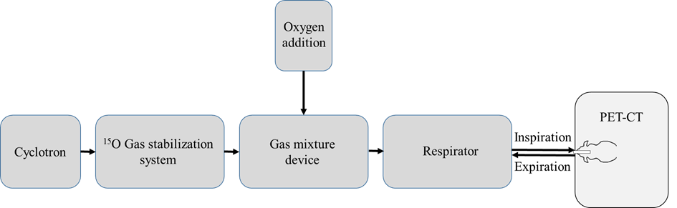

Figure S1. Schema of the tube connection for the ¹⁵O-gas supply.

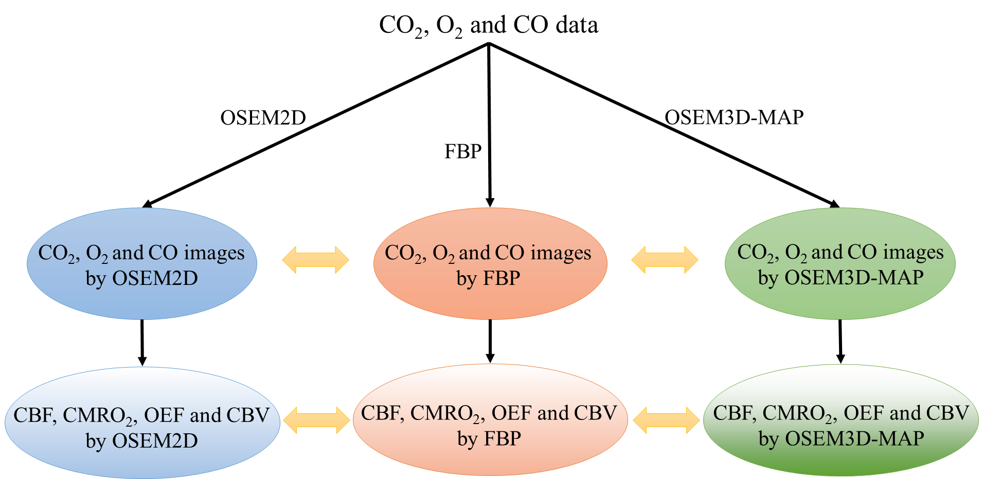

Figure S2. Workflow for image reconstruction and data analysis.

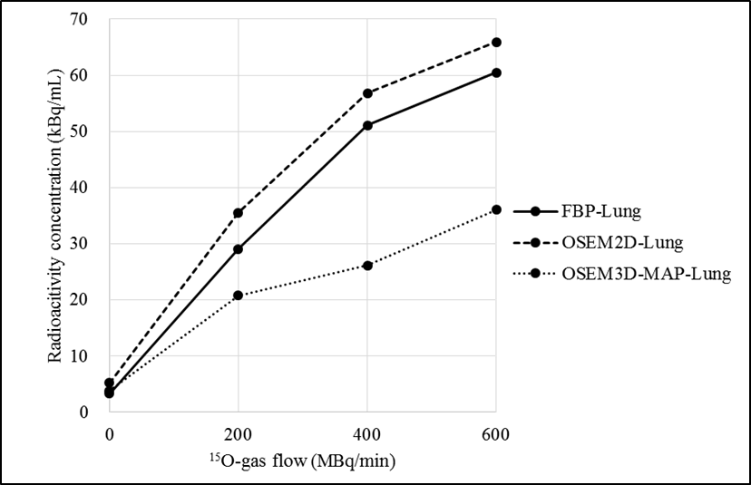
Figure S3. Relationship between the radioactivity of ¹⁵O-gas flow and the radioactivity concentration in the lung.

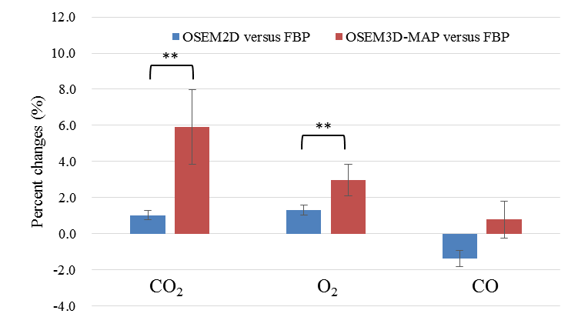

Figure S4. Percent change in the radioactivity concentration against FBP (**P < 0.01)

