Initial biological evaluations of ¹⁸F-KS1, a novel ascorbate derivative to image oxidative stress in cancer

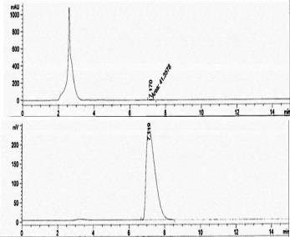
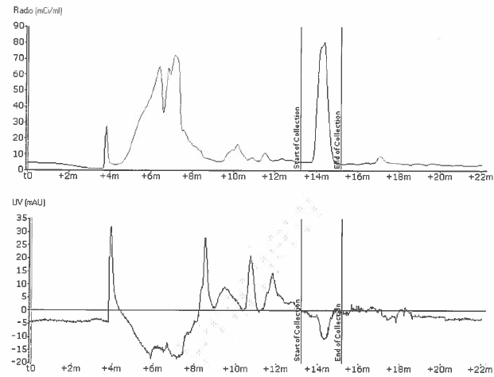
B.
A.

Figure 1. (A) Representative semiprep HPLC chromatogram with upper UV and lower radio γ trace of ¹⁸F-KS1 using C18 Phenomenex Luna HPLC column (250 X 10 mm, 10 µA) with 30% acetonitrile in 0.1M aqueous ammonium formate buffer (pH 6.5) at a flow rate of 5.0 mL/min and UV @ 254 nm.; (B) QC analytical spectrum of ¹⁸F-KS1 single injection using a C18 Phenomenex Prodigy HPLC column (250 X 4.6 mm, 5 µA) with 45% acetonitrile in 0.1M aqueous ammonium formate buffer (pH 6.5) at a flow rate of 1.0 mL/min and UV @ 254 nm. UV-mass (top) and radioactive peak (bottom window) were highlighted with arrow marks for the corresponding ¹⁸F-KS1 product

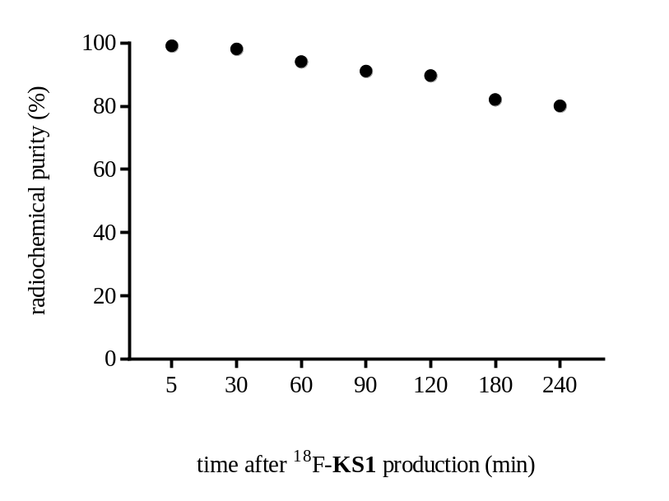
Figure 2: Ex vivo stability of ¹⁸F-KS1 in human serum sample; radiochemical purity analyzed until 240 min after production

