Article title
Quantitative evaluation of hepatic integrin α_{v}β₃ expression by positron-emission tomography imaging using ¹⁸F-FPP-RGD₂ in rats with non-alcoholic steatohepatitis
Journal name
European Journal of Nuclear Medicine and Molecular Imaging Research
Author names
Shuichi Hiroyama, Takemi Rokugawa, Miwa Ito, Hitoshi Iimori, Ippei Morita, Hiroki Maeda, Kae Fujisawa, Keiko Matsunaga, Eku Shimosegawa, Kohji Abe
Corresponding author
Shuichi Hiroyama
Translational Research Unit, Biomarker R&D Department, Shionogi & Co., Ltd., Osaka, Japan
3-1-1 Futaba-cho, Toyonaka, Osaka 561-0825, Japan.
E-mail: shuichi.hiroyama@shionogi.co.jp

Additional file 1: Fig. 1 TLC autoradiograms of plasma and liver extracts from rats 30 or 90 min after the intravenous administration of ¹⁸F-FPP-RGD₂

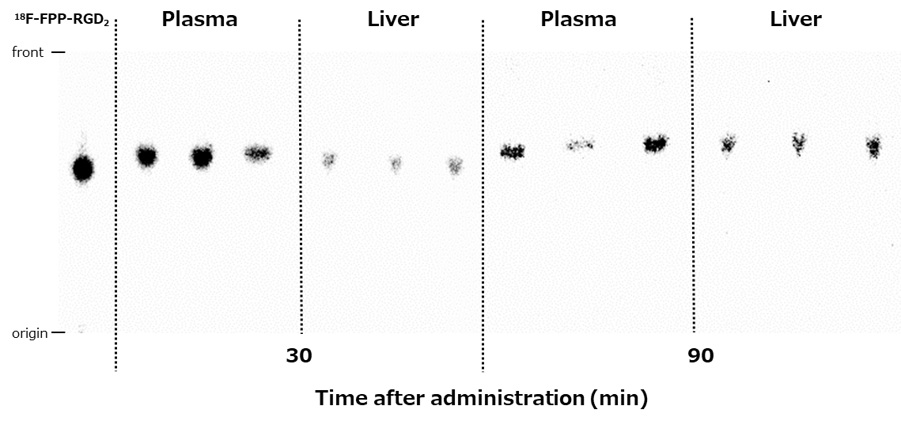

Additional file 1: Table 1 Percentages of non-metabolised ¹⁸F-FPP-RGD₂ in the plasma and liver
Time (min) | Plasma |  | Liver
30 | 99.8 ± 0.05 |  | 99.2 ± 0.17
90 | 96.9 ± 2.14 |  | 97.5 ± 0.36
Values are expressed as means ± SDs (n = 3).

