Supplementary Material

We attempted to divide patients into training and validation set in another chronological order in the ratio of 2 to 1. 99 patients performed PET/CT scan between May 2009 and August 2014 were taken as the training set, whereas the other 50 patients treated between September 2014 and January 2016 constituted the validation set (Supplement Fig. 1). But the distribution between two sets was not even (Supplement Table 1), with the lymphatic metastasis demonstrated significant difference between the training and validation set (p<0.001). We did not adopt this grouping method at last.
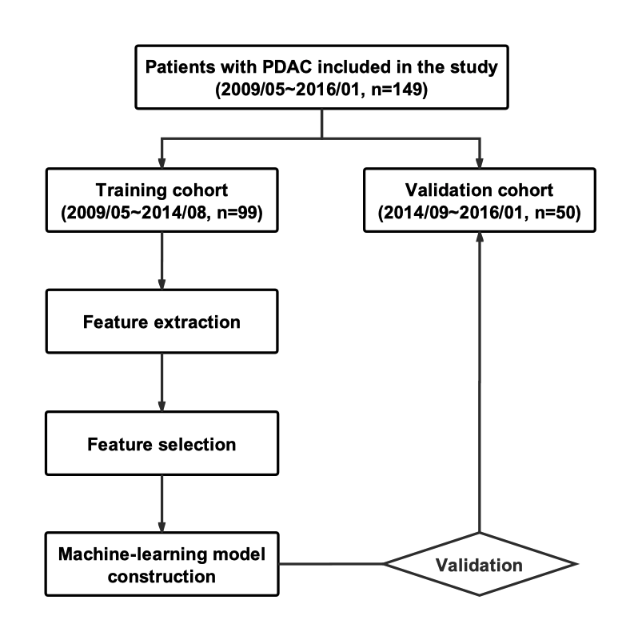
Supplement Fig. 1 Analysis flowchart.

Supplement Table 1 Characteristics of patients with PDAC in the training set and validation set
Characteristics | Training set (n=99) | Validation set (n=50) | p value
Gender  Male  Female | 60 (60.6)  39 (39.4) | 23 (46.0)  27 (54.0) | 0.090
Age (years) | 61.03±9.06 | 60.92±11.97 | 0.950
Localization of tumor  Head-neck  Body-tail | 57 (57.6)  42 (42.4) | 38 (76.0)  12 (24.0) | 0.027
Pathological grade  Grade 1  Grade 2/3  PET/CT findings  SUV_{max}  SUV_{mean}  MTV (ml)  TLG  Lymphatic metastasis | 33 (33.3)  66 (66.7)  5.09 (3.62, 7.17)  3.35 (2.48, 4.29)  8.54 (3.23, 18.08)  29.19 (9.74, 63.84) | 9 (18.0)  41 (82.0)  4.32 (3.18, 6.85)  2.92 (2.11, 4.09)  12.96 (5.14, 20.59)  37.61 (13.64, 67.59) | 0.049  0.376  0.137  0.118  0.469  <0.001*
Present  Absent | 21 (21.2)  78 (78.8) | 25 (50.0)  25 (50.0)
*Statistical significance of lymphatic metastasis on PET/CT images between training and validation set.
Continuous data were expressed as mean ± standard deviation or median, with first and third quartile in parentheses. Categorical variables were expressed as numbers, with percentages in parentheses.

